Risk-Return Trade-offs of LightGBM and NSGA-II Trading Rules:
A Retrospective Walk-Forward Study of Three NSE Equities
Ashish Ranjan, Khuushi Maheshwari, Satyanarayan H.
Department of Computer Science, Manipal Institute of Technology
B.Tech in Computer Science
Draft Academic Manuscript — October 2026
Abstract— Machine learning models in financial forecasting frequently fail to preserve portfolio capital because directional predictions are disconnected from dynamic risk management. This study conducts a retrospective walk-forward evaluation of a Two-Tier Computational Intelligence (CI) architecture across three large-cap Indian equities (RELIANCE.NS, TCS.NS, INFY.NS) over a 6-year period (2020–2025, 1,487 trading sessions per asset). Tier 1 employs a LightGBM gradient-boosted decision tree to estimate forward 3-day directional return probabilities from 20 technical indicators. Tier 2 leverages the Non-dominated Sorting Genetic Algorithm II (NSGA-II) to evolve real-valued trading rule chromosomes (probability hurdles, dynamic ATR stop-loss and take-profit multipliers, trailing stops, and volatility-conditioned position sizing) simultaneously optimizing Annualized Sharpe Ratio and Maximum Drawdown. All backtests enforce strict next-bar Open execution, transaction costs (0.05% commission + 0.05% slippage per side, approximately 10 bps per side and 20 bps round-trip; sensitivity testing doubles both components to 0.10% commission + 0.10% slippage per side, 0.20% per side, approximately 40 bps round-trip), conservative intrabar bracket conflict ordering, horizon purging, and scheduled fold-end liquidation barring final-day entries. Across 18 annual test folds and three GA seeds, LightGBM achieves an average out-of-sample directional AUC of 0.5324, a test accuracy of 52.68% (compared to the training-class majority baseline of 52.66%), and no Brier score improvement (0.2501 vs baseline 0.2500). The Full Hybrid strategy reduced annual maximum drawdown relative to Buy & Hold in 17 out of 18 folds (94.4%). However, by remaining in cash during sustained market expansions, the Hybrid underperformed Buy & Hold total return in 13 out of 18 folds (72.2%), delivering multi-year stitched seed-median returns of -0.35% for RELIANCE.NS, +25.60% for TCS.NS, and +9.10% for INFY.NS, compared to Buy & Hold compound growth of +128.74%, +65.13%, and +152.78%, respectively. An evolutionary ablation without machine learning signals yields comparable or higher multi-year returns. These results show that defensive metaheuristic rules achieved lower median annual drawdowns in corrective periods but resulted in substantially lower compounded wealth in trending equity markets.
Keywords— Computational Intelligence, Algorithmic Trading, LightGBM, NSGA-II, Multi-Objective Optimization, Walk-Forward Validation, National Stock Exchange of India (NSE), Backtest Overfitting.
1. Introduction & Research Question
The application of machine learning (ML) to financial market forecasting has expanded rapidly, yet practical deployment consistently confronts the realities of low signal-to-noise ratios, non-stationarity, and market efficiency [3], [5], [6]. A central challenge in computational finance literature is the conceptual gap between directional statistical prediction and dynamic capital preservation. Directional accuracy alone does not determine portfolio profitability because trade payoff distributions, position sizing, and transaction costs also matter [3]. Conversely, traditional rule-based algorithmic strategies rely on static technical indicators that fail to adapt across changing volatility regimes.
To investigate this trade-off, this study examines a Two-Tier Computational Intelligence (CI) architecture that decouples directional statistical inference from multi-objective policy search. Tier 1 trains a gradient-boosted decision tree (LightGBM) to estimate forward 3-day directional return probabilities from engineered technical indicators. Tier 2 applies the Non-dominated Sorting Genetic Algorithm II (NSGA-II) [1] to evolve continuous trading rule parameters—including entry/exit probability thresholds, Average True Range (ATR) stop-loss and take-profit multipliers, trailing stop percentages, and regime-conditioned capital allocations. By framing strategy selection as a bi-objective optimization between risk-adjusted return (Sharpe Ratio) and capital risk (Maximum Drawdown), the evolutionary engine constructs a Pareto frontier of candidate trading policies.
We ground our investigation in three specific research questions: (1) Does gradient tree boosting provide measurable directional predictive edge on large-cap National Stock Exchange of India (NSE) equities over simple training priors? (2) Does evolving multi-objective risk parameters dampen out-of-sample portfolio drawdowns during historical market downturns? (3) How does cash preservation under defensive probability hurdles affect multi-year compounded capital accumulation relative to passive benchmark holding?
[METHODOLOGICAL CONTRIBUTION & BOUNDARY DISCLOSURE]
Our primary contribution is methodological rigor, audit provenance, and reproducible empirical evaluation rather than claims of algorithmic novelty or guaranteed investment alpha. All experiments are conducted retrospectively over 2020–2025 using frozen parquet data snapshots, versioned audit corrections (protocol_correction.json v1.1.0), and verified code execution. The universe is restricted to three surviving large-cap equities (RELIANCE.NS, TCS.NS, INFY.NS) evaluated individually without cross-asset portfolio rebalancing.

2. Related Work & Theoretical Foundations
The theoretical foundation of empirical market predictability is rooted in the Efficient Market Hypothesis (EMH) formulated by Fama [6], which posits that historical prices reflect available trading information, providing the benchmark against which technical trading strategies must be judged. In modern econometrics, Halbert White [5] established that empirical outperformance in trading rule evaluations is frequently an artifact of data snooping bias: searching across numerous parameter permutations risks selecting rules that appear profitable purely due to random chance. Bailey and López de Prado [4] formalized this hazard via the Deflated Sharpe Ratio (DSR), demonstrating that observed Sharpe ratios must be evaluated in light of sample size, return non-normality, and the effective number of strategy trials.
To mitigate backtest overfitting, López de Prado [3] proposed rigorous protocols for financial machine learning, notably purged and embargoed cross-validation. When overlapping forward labels are utilized (e.g., multi-bar holding returns), standard random cross-validation leaks information across adjacent folds. Purging trailing samples equal to the prediction horizon prevents this forward-looking contamination.
In the domain of multi-objective metaheuristics, Deb et al. [1] introduced NSGA-II, which eliminated the high computational complexity of early genetic algorithms through fast non-dominated sorting, elitist parent-offspring combining, and a parameter-less crowding distance operator that preserves population diversity. In tabular machine learning, Ke et al. [2] developed LightGBM, combining Gradient-based One-Side Sampling (GOSS) and Exclusive Feature Bundling (EFB) to provide high-speed, scalable gradient boosting. Our work integrates these established paradigms into an auditable, causal walk-forward backtesting framework.
3. Methodology & System Architecture
The system decouples directional prediction from risk-constrained decision execution across two computational tiers coupled to a vectorized simulator. Figure 1 illustrates the end-to-end data processing, feature engineering, model training, evolutionary search, and test evaluation pipeline.
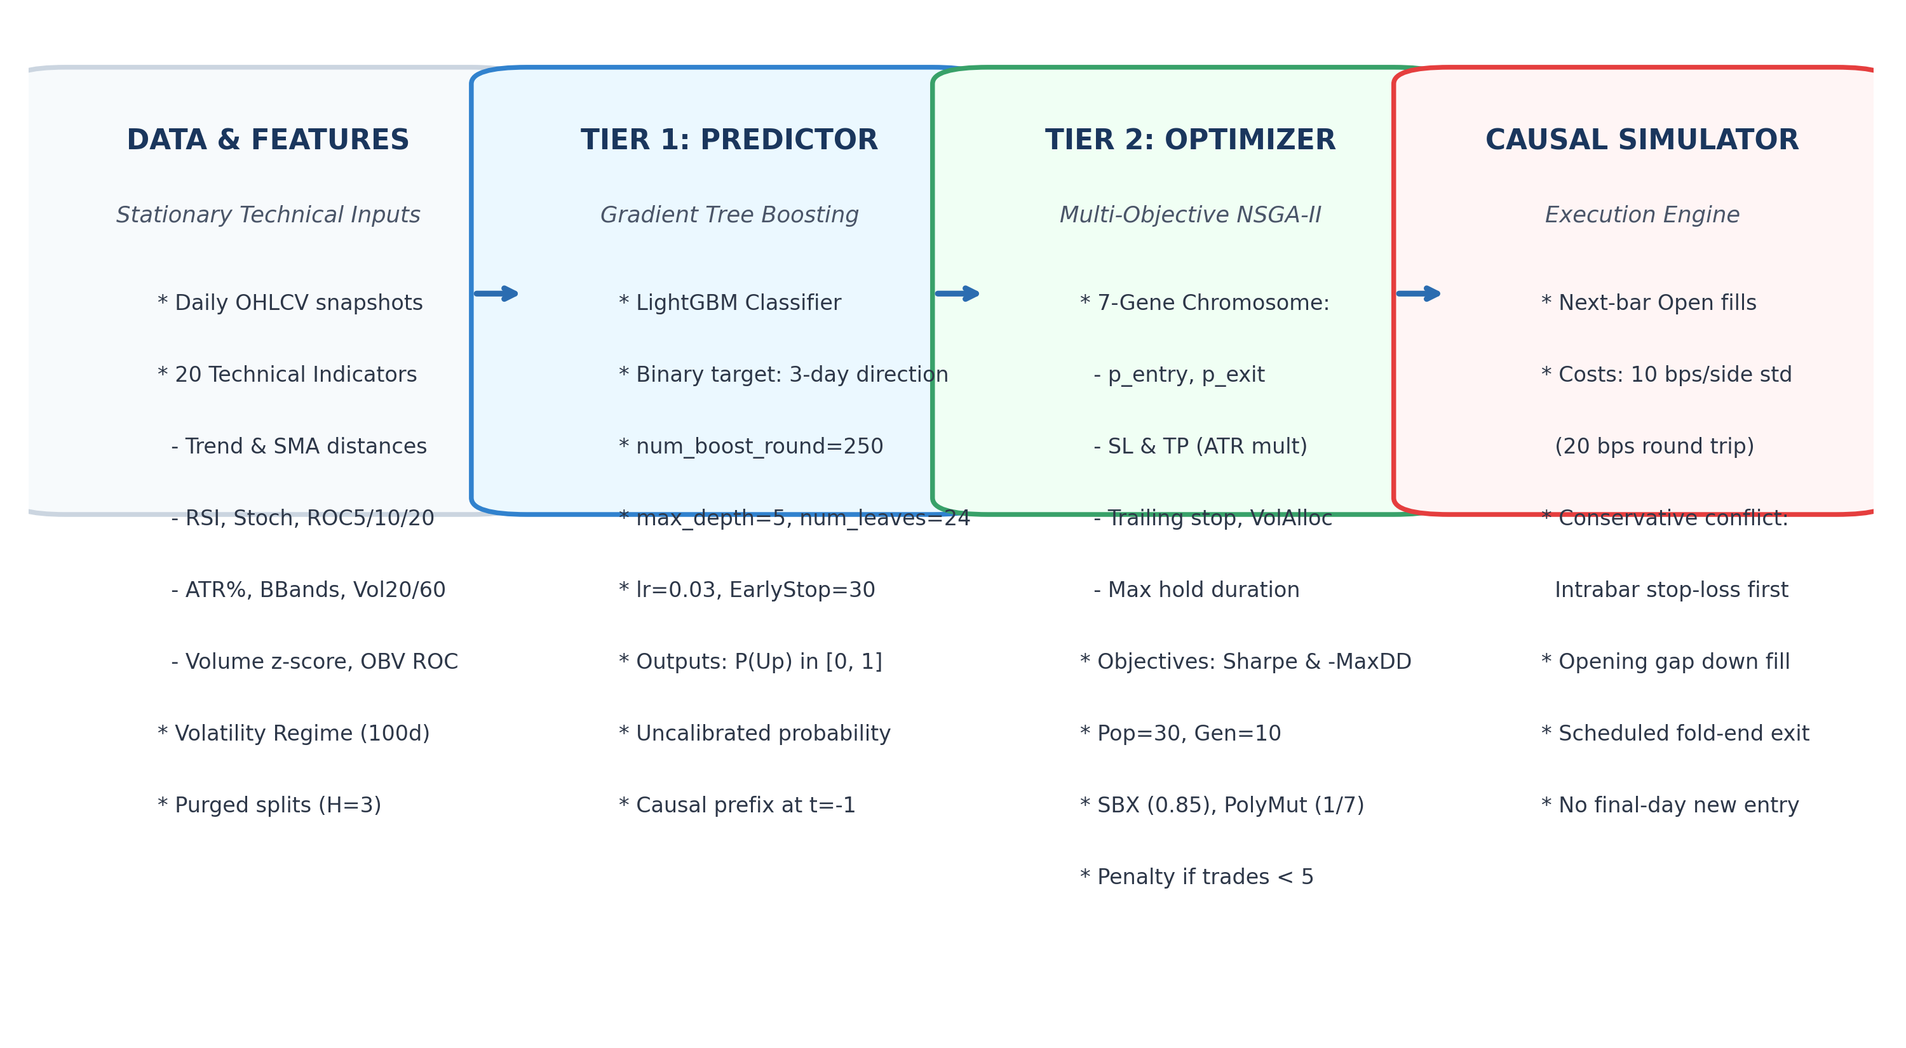
Figure 1. Two-Tier Computational Intelligence system architecture: Data engineering with purged splits (H=3), Tier 1 LightGBM classifier, Tier 2 NSGA-II optimizer, and causal backtest engine.
3.1 Tier 1: Feature Engineering & Predictive Classifier
From historical daily OHLCV series, the feature pipeline computes 20 technical and regime indicators: (1) Trend Distances: percentage distances to 10-day, 50-day, and 200-day Simple Moving Averages (dist_sma_10, dist_sma_50, dist_sma_200); (2) Momentum Indicators: MACD ratio (macd / close), MACD histogram, 14-day RSI (rsi_14), Stochastic %K and %D (stoch_k, stoch_d), and Rate of Change over 5, 10, and 20 days (roc_5, roc_10, roc_20); (3) Volatility Indicators: ATR percentage (atr_14 / close), 20-day and 60-day annualized realized return volatility (volatility_20, volatility_60), Bollinger Bands %B (bb_pct_b), and Bandwidth (bb_width); (4) Volume Indicators: 20-day volume z-score (volume_zscore) and 5-day On-Balance Volume Rate of Change (obv_roc_5); (5) Market Regimes: Volatility Regime flag (regime_high_vol = 1 if volatility_20 exceeds its rolling 100-day median, else 0) and Trend Regime flag (regime_trend = 1 if Close > SMA50 > SMA200; -1 if Close < SMA50 < SMA200; 0 otherwise). No stationarity transformations or formal unit root tests are claimed; features are evaluated directly as continuous inputs.
The supervised prediction target is a binary directional indicator over a 3-day holding horizon: y_t = 1 if (Close_{t+3} - Close_t) / Close_t > 0, and y_t = 0 otherwise. A LightGBM classifier is trained on historical data with parameters: num_boost_round=250, learning_rate=0.03, max_depth=5, num_leaves=24, feature_fraction=0.8, bagging_fraction=0.8, and early stopping of 30 rounds on the validation partition. LightGBM outputs conditional class probabilities P(Up) in [0, 1]. No post-hoc probability calibration (Platt scaling or isotonic regression) is applied.
3.2 Tier 2: NSGA-II Multi-Objective Evolutionary Engine
The evolutionary decision layer optimizes a 7-dimensional real-valued chromosome: g = [p_entry, p_exit, SL, TP, Trail, VolAlloc, MaxHold], bounded strictly by domain constraints: p_entry in [0.52, 0.85], p_exit in [0.35, 0.50], Stop-Loss multiplier SL in [1.0, 4.5] x ATR, Take-Profit multiplier TP in [1.5, 7.0] x ATR, Trailing Stop percentage Trail in [0.01, 0.06], Volatility discount allocation fraction VolAlloc in [0.10, 1.00], and Maximum holding duration MaxHold in [5, 45] bars.
NSGA-II evaluates each candidate chromosome across the 2-year Development partition under two conflicting objective functions: (1) Maximize Annualized Sharpe Ratio f_1 = (mu_r / sigma_r) * sqrt(252) (assuming a 0.0% risk-free rate); (2) Minimize Maximum Drawdown f_2 = max_t ((Peak_t - Equity_t) / Peak_t). To discourage inactivity during evolutionary search, candidate rules generating fewer than 5 completed trades during development receive a penalty: Sharpe is decremented by 2.0 (Sharpe -= 2.0) and MaxDrawdown is floored at 0.5 (MaxDD = max(MaxDD, 0.5)). The population of size N=30 evolves across G=10 generations using Simulated Binary Crossover (SBX, crossover probability pc=0.85, eta_c=15) and Polynomial Mutation (per-gene mutation probability pm = 1/7, eta_m=20). Following development search, the individual with the highest development Sharpe ratio among feasible candidate rules (those with >= 5 completed development trades) is selected as the representative trading policy. If no candidate achieves >= 5 development trades, the system defaults to 100% Cash during out-of-sample evaluation.
3.3 Causal Simulator & Execution Mechanics
The backtest engine enforces realistic causal timing: (1) Next-Bar Execution: Signals evaluated at bar t Close execute strictly at bar t+1 Open at price P_entry = Open_{t+1} * (1 + slip); (2) Transaction Friction: Standard costs are 0.05% commission and 0.05% slippage per side (approximately 10 bps per side, 20 bps round-trip); sensitivity testing doubles both components to 0.10% commission and 0.10% slippage per side (0.20% per side, approximately 40 bps round-trip); (3) Conservative Intrabar Priority: If both stop-loss and take-profit price levels are touched within the same session's high-low range, the simulator prioritizes the stop-loss; (4) Opening Gaps: Gaps below stop-loss or above take-profit fill at the opening price with slippage penalty; (5) Zero-Volume Prohibition: No trade fills occur on zero-volume sessions; (6) Scheduled Fold-End Policy: New entries are barred on the scheduled last tradable session (i < last_tradable_idx); open positions liquidate at final session Close.
4. Empirical Evaluation Setup & Walk-Forward Protocol
We implement a rolling walk-forward protocol evaluated annually across six test years (Y in [2020, 2025]) on three large-cap equities: Reliance Industries (RELIANCE.NS), Tata Consultancy Services (TCS.NS), and Infosys (INFY.NS). Historical daily OHLCV series were acquired from Yahoo Finance via yfinance with dividend and split adjustments applied. For each test year Y, partitions are chronologically non-overlapping:
Partition Stage | Calendar Window | Duration | Purging / Causal Gate
Model Training | [Y-8, Y-4] | 5 Years (~1,230 bars) | Purged trailing 3 bars (H=3)
Model Validation | [Y-3] | 1 Year (~246 bars) | Early stopping; purged trailing 3 bars
Rule Development (GA) | [Y-2, Y-1] | 2 Years (~493 bars) | NSGA-II search; t=-1 context preserved
Out-of-Sample Test | [Y] | 1 Year (~248 bars) | Scored on first N-3 bars; liquidated at fold end
The model seed is held constant at 42. To evaluate metaheuristic sensitivity, NSGA-II is evaluated across three independent random seeds (42, 43, 44). In total, the campaign comprises 54 walk-forward optimization runs (3 assets x 6 years x 3 GA seeds) spanning 1,487 out-of-sample trading days. All runs execute offline against immutable parquet snapshots documented in campaign_audit.json.
5. Experimental Results & Performance Analysis
5.1 Machine Learning Directional Predictive Performance
Table 1 reports out-of-sample classification performance across all 18 annual folds. Across the entire campaign, LightGBM achieved an average out-of-sample AUC of 0.5324, directional accuracy of 52.68% (compared to the training-class base rate of 52.66%), and a Brier score of 0.2501 (vs baseline 0.2500). Asset-specific mean AUCs were 0.5469 for RELIANCE.NS, 0.5304 for TCS.NS, and 0.5199 for INFY.NS. These metrics reflect a small average AUC above 0.5, near-equal accuracy to the majority prior, and no Brier score improvement over naive training priors in liquid Indian equities.
Asset | Mean AUC | Min AUC | Max AUC | Test Acc | Base Acc | Brier | Scored N
RELIANCE.NS | 0.5469 | 0.4415 | 0.6246 | 52.01% | 52.21% | 0.2494 | 244.8
TCS.NS | 0.5304 | 0.4774 | 0.6182 | 50.91% | 50.78% | 0.2516 | 244.8
INFY.NS | 0.5199 | 0.4509 | 0.5766 | 55.12% | 54.99% | 0.2493 | 244.8
Table 1. Out-of-sample directional classification performance across 18 annual test folds (2020–2025).
5.2 Stitched 6-Year Compounded Performance
Stitched multi-year curves carry capital forward across test folds by compounding annual net wealth ratios starting from ₹100,000 on 2020-01-01 through 2025-12-31. Note that Buy & Hold is evaluated under an annually liquidated and re-entered convention at fold boundaries matching the strategy's annual evaluation, incurring transaction friction each year. Table 2 reports terminal compound performance. Multi-seed variants show medians and ranges across seeds 42, 43, 44; note that metric-wise medians across seeds are computed independently per metric and may correspond to different individual seed runs rather than a single executable median strategy. Figure 2 displays the stitched equity curves and underwater drawdowns.
Asset | Strategy Variant | Total Ret | CAGR | Sharpe | MaxDD | Terminal ₹
RELIANCE.NS | Buy & Hold | +128.74% | 15.05% | 0.64 | 44.08% | ₹228,740
 | Full Hybrid (Median) | -0.35% | -0.06% | 0.04 | 23.01% | ₹99,652
 | Full Hybrid (Range) | [-6.58%, +5.18%] | [-1.15%, +0.86%] | [-0.07, 0.14] | [21.88%, 26.18%] | [₹93k, ₹105k]
 | No-ML Ablation (Median) | +42.42% | 6.18% | 0.45 | 20.03% | ₹142,415
TCS.NS | Buy & Hold | +65.13% | 8.87% | 0.48 | 34.57% | ₹165,134
 | Full Hybrid (Median) | +25.60% | 3.94% | 0.44 | 28.66% | ₹125,600
 | Full Hybrid (Range) | [+10.60%, +41.86%] | [+1.72%, +6.10%] | [0.21, 0.54] | [18.29%, 30.12%] | [₹111k, ₹142k]
 | No-ML Ablation (Median) | +47.37% | 6.79% | 0.50 | 31.62% | ₹147,369
INFY.NS | Buy & Hold | +152.78% | 17.02% | 0.71 | 35.93% | ₹252,783
 | Full Hybrid (Median) | +9.10% | 1.49% | 0.18 | 37.16% | ₹109,103
Table 2. Stitched 6-year multi-year compound performance (2020–2025, 1,487 trading bars).
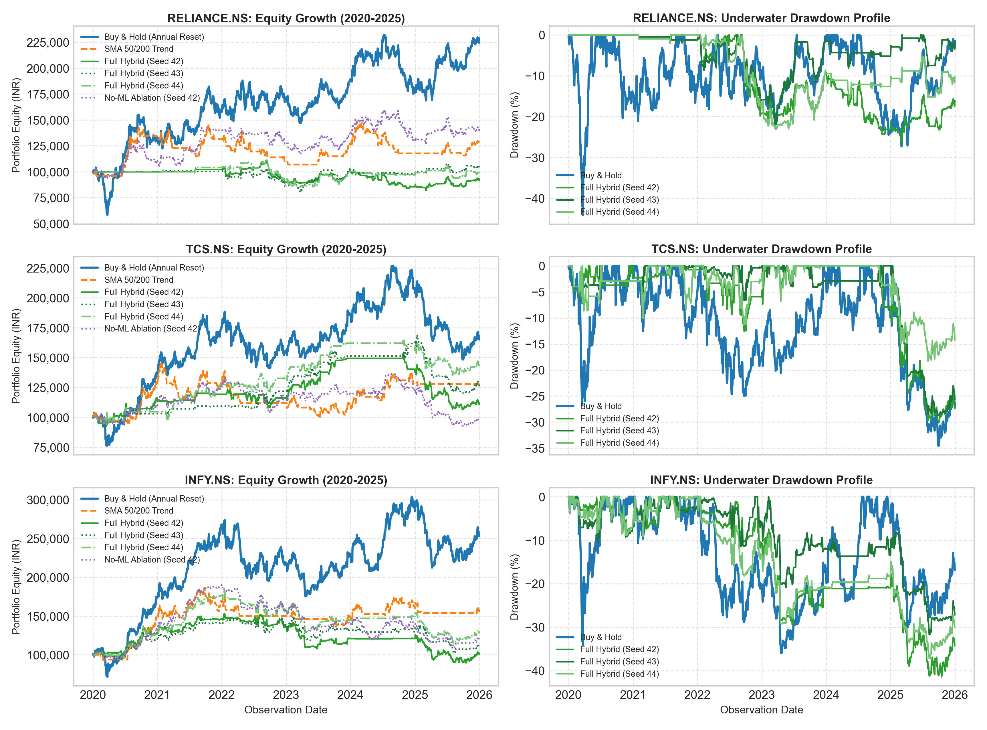
Figure 2. Stitched 6-year compounded equity curves (left) and underwater drawdown profiles (right) across 2020–2025 for Buy & Hold vs. individual Full Hybrid seeds (42, 43, 44) and No-ML Ablation (Seed 42).
5.3 Annual Paired Strategy Differences & Scorecard
Evaluating the 18 annual folds individually reveals the structural asymmetry between annual drawdown dampening and secular compounding: (1) Positive Hybrid Return: Achieved in 10 out of 18 folds (55.6%); (2) Return Outperformance vs Buy & Hold: Hybrid exceeded Buy & Hold in 5 out of 18 folds (27.8%)—specifically during market corrections in 2022 (TCS +16.55% diff, INFY +11.44% diff), 2023 (RELIANCE +2.00% diff, TCS +3.92% diff), and 2024 (RELIANCE +1.97% diff); (3) Buy & Hold Outperformance: Buy & Hold exceeded Hybrid in 13 out of 18 folds (72.2%), particularly during strong bull markets such as 2020 (INFY B&H +74.69% vs Hyb +27.83%) and 2021 (INFY B&H +52.73% vs Hyb +17.22%); (4) Maximum Drawdown Reduction: Hybrid exhibited lower annual maximum drawdown in 17 out of 18 folds (94.4%). The sole exception was RELIANCE.NS in 2022, where Buy & Hold had a 17.27% drawdown vs Hybrid median drawdown of 17.45%.
5.4 Ablation and Exposure-Matched Diagnostic
To isolate the contribution of the ML classifier, a Constant Probability Ablation (p=0.60) evolved rules omitting LightGBM features. The Ablation achieved 6-year stitched returns of +42.42% for RELIANCE.NS (vs Hyb -0.35%), +47.37% for TCS.NS (vs Hyb +25.60%), and +18.69% for INFY.NS (vs Hyb +9.10%). Furthermore, an Exposure-Matched Buy & Hold diagnostic blending passive holding with cash based on the Hybrid's development exposure fraction (w_dev) outperformed the Full Hybrid in 29 out of 54 runs (53.7%), while the Hybrid outperformed in 22 runs (40.7%), with 3 ties (RELIANCE 2020 cash fallbacks). Exposure-Matched Buy & Hold exhibited lower maximum drawdown than the Full Hybrid in 43 of 54 runs (79.6%). This diagnostic assumes daily frictionless rebalancing and 0% cash return. Across these historical folds, technical metaheuristic rules provided lower annual drawdowns, but LightGBM probability hurdles restricted market participation without producing higher compound returns.
5.5 Transaction Cost Sensitivity & Slippage Dynamics
Evaluating frozen Development chromosomes under doubled transaction friction (0.10% commission + 0.10% slippage per side, 0.20% per side, approximately 40 bps round-trip) caused substantial performance drops: RELIANCE.NS Seed 42 total return declined from -6.58% to -25.41% (-18.83 pp); TCS.NS Seed 43 declined from +25.60% to +19.61% (-5.99 pp); and INFY.NS Seed 44 dropped from +27.88% to -7.97% (-35.85 pp). Mechanistically, slippage does not act as a simple linear fee. Because execution price shifts upward (P_entry = Open * (1 + slip)), the dynamic ATR stop-loss threshold (P_stop = P_entry - SL * ATR) is mechanically elevated. On sessions where prices touch the stop band, trades exit prematurely, altering subsequent cash levels and eliminating future trade signals.
6. Discussion, Risk Attribution & Methodological Limitations
The empirical findings highlight several critical trade-offs in quantitative portfolio design: (1) Asymmetric Risk-Return Profile: NSGA-II discovers defensive chromosome parameters that truncate downside drawdowns during market contractions. However, because the classifier's directional probabilities hover narrowly around 0.50, high entry thresholds cause the system to remain in cash during sustained bull market regimes, resulting in substantial compounding penalties relative to passive index compounding. (2) Multi-Year vs Annual Drawdown Asymmetry: Lower annual drawdowns in 17 of 18 folds do not guarantee lower multi-year risk. On INFY.NS, the Hybrid 6-year maximum drawdown reached 37.16% compared to 35.93% for Buy & Hold, illustrating how compounded capital erosion can produce deeper multi-year drawdowns. (3) Capital Exposure as an Overnight Proxy: In our evaluation, capital exposure is defined as session-close invested value divided by equity (Shares_t * Close_t / Equity_t). This proxy reflects overnight capital commitment and omits intraday capital utilization for same-day round trips. (4) Survivorship and Single-Asset Constraints: The study evaluates three surviving large-cap equities individually without cross-asset portfolio diversification. (5) Retrospective Protocol Adjustments: While data snapshots and random seeds remained strictly frozen, the final experimental protocol incorporated retrospective corrections (versioned in protocol_correction.json v1.1.0) following initial simulator inspection. No formal statistical significance tests are asserted; results represent retrospective empirical observations.
7. Conclusion
This research evaluated the integration of gradient tree boosting (LightGBM) with multi-objective evolutionary optimization (NSGA-II) for algorithmic trading across three major Indian equities over 2020–2025. Across 18 annual walk-forward folds, the LightGBM classifier demonstrated modest predictive capability (AUC 0.5324), tracking majority-class baselines without Brier score improvements. While NSGA-II evolved risk-management rules that lowered annual maximum drawdowns in 94.4% of folds, passive Buy & Hold generated substantially higher multi-year compounded wealth across all assets. Ablation analysis confirmed that metaheuristic technical parameter search without ML signals provided equivalent or superior capital growth. These results illustrate that machine learning directional predictors do not automatically improve quantitative trading performance, underscoring the substantial opportunity costs associated with defensive cash-allocation rules in trending markets.
References
[1] K. Deb, A. Pratap, S. Agarwal, and T. Meyarivan, "A fast and elitist multiobjective genetic algorithm: NSGA-II," IEEE Transactions on Evolutionary Computation, vol. 6, no. 2, pp. 182–197, Apr. 2002. DOI: 10.1109/4235.996017.
[2] G. Ke, Q. Meng, T. Finley, T. Wang, W. Chen, W. Ma, Q. Ye, and T.-Y. Liu, "LightGBM: A highly efficient gradient boosting decision tree," in Advances in Neural Information Processing Systems 30 (NIPS 2017), Long Beach, CA, USA, 2017, pp. 3146–3154.
[3] M. López de Prado, Advances in Financial Machine Learning. Hoboken, NJ, USA: John Wiley & Sons, 2018. ISBN: 978-1119482086.
[4] D. H. Bailey and M. López de Prado, "The deflated Sharpe ratio: Correcting for selection bias, backtest overfitting and non-normality," The Journal of Portfolio Management, vol. 40, no. 5, pp. 94–107, 2014. DOI: 10.3905/jpm.2014.40.5.094.
[5] H. White, "A reality check for data snooping," Econometrica, vol. 68, no. 5, pp. 1097–1126, Sep. 2000. DOI: 10.1111/1468-0262.00152.
[6] E. F. Fama, "Efficient capital markets: A review of theory and empirical work," The Journal of Finance, vol. 25, no. 2, pp. 383–417, May 1970. DOI: 10.2307/2325486.
[7] R. Aroussi et al., "yfinance: Download market data from Yahoo! Finance," Python package documentation, 2024–2026. [Online]. Available: https://github.com/ranaroussi/yfinance.

