PLACEMENT PORTAL MANAGEMENT SYSTEM
Project Report
Submitted By: Sheetal Bajaj
Roll Number: 25F1001114

1. Introduction
The Placement Portal Management System is a web-based application designed to simplify and automate the campus recruitment process. Traditionally, placement activities involve manual coordination between students, companies, and administrators. Managing job postings, student applications, and company approvals manually can be inefficient and error-prone.
This project provides a centralized digital platform where students can view placement opportunities, companies can post job drives, and administrators can manage and approve recruitment activities.
The system ensures secure user authentication, role-based access control, and a structured workflow for handling placement drives and student applications.

2. Problem Statement
In many institutions, placement processes are handled manually through spreadsheets, emails, or notice boards. This results in several issues such as:
• Lack of centralized information
• Delayed communication between stakeholders
• Difficulty tracking applications
• Data redundancy and inconsistencies
• Lack of transparency in approvals
Therefore, a structured web-based platform is needed to manage placement activities efficiently.

3. Objectives
The primary objectives of the Placement Portal Management System are:
• To develop a centralized platform for placement activities.
• To implement role-based access for students, companies, and administrators.
• To allow companies to register and create placement drives.
• To allow administrators to approve companies and job drives.
• To enable students to apply for approved placement drives.
• To allow companies to track student applications.

4. System Approach
The system is developed using a modular architecture with Flask as the backend framework.
The application follows a structured workflow:
Step 1: User Registration
Users register as either Student or Company.
Step 2: Company Approval
After company registration, the administrator must approve the company before it can create placement drives.
Step 3: Drive Creation
Approved companies can create job drives including job title, job description, eligibility criteria, and application deadline.
Step 4: Drive Approval
The administrator reviews and approves placement drives before they become visible to students.
Step 5: Student Application
Students can view approved drives and apply for suitable job opportunities.
Step 6: Application Management
Companies can review applications and update application status.

5. Technologies Used
Python – Core programming language
Flask – Web application framework
Flask-Login – User authentication and session management
Flask-SQLAlchemy – Database ORM
SQLite – Database storage
HTML – Page structure
CSS – Page styling
Bootstrap – Responsive UI design

6. System Architecture
The system follows a three-tier architecture.
Presentation Layer:
• HTML templates
• Bootstrap UI
• User interaction interface
Application Layer:
• Flask application logic
• Authentication system
• Business logic
Data Layer:
• SQLite database
• SQLAlchemy ORM models

7. Project Structure
placement_portal/
│
├── app.py
├── models.py
├── config.py
├── extensions.py
│
├── templates/
│ ├── login.html
│ ├── register.html
│ ├── student_dashboard.html
│ ├── company_dashboard.html
│ ├── admin_dashboard.html
│ └── create_drive.html
│
├── static/
│
│ └── uploads/
│
├── instances/placement.db
└── requirements.txt
File Descriptions:
app.py – Main Flask application routes and logic.
models.py – Database models including User, PlacementDrive, and Application.
config.py – Configuration settings.
extensions.py – Database and login manager initialization.
templates/ – HTML pages rendered by Flask.
static/ – CSS and static resources.

8. Database Design
User Table: id, name, email, password, role, approved
PlacementDrive Table: id, job_title, job_description, eligibility, deadline, company_id, status
Application Table: id, student_id, drive_id, status

9. System Modules
Admin Module:
• Approves companies
• Approves placement drives
• Views statistics
• Monitors applications
Company Module:
• Company registration
• Creating placement drives
• Viewing applications
• Updating application status
Student Module:
• Student registration
• Viewing approved drives
• Applying for jobs
• Tracking applications

10. Key Features
• Secure login system
• Role-based access control
• Company approval system
• Placement drive approval workflow
• Student application management
• Dashboard interfaces for each user role

11. Testing and Validation
The system was tested using manual testing methods.
Tests performed:
• User registration validation
• Login authentication
• Company approval workflow
• Drive creation and approval
• Student application functionality
• Dashboard data display verification

12. Future Enhancements
• Resume upload functionality
• Email notifications for job updates
• Interview scheduling module
• Admin analytics dashboard
• Cloud deployment

13. Conclusion
The Placement Portal Management System successfully automates the campus recruitment process by providing a structured platform for students, companies, and administrators.
The system improves efficiency, ensures transparency, and reduces manual effort involved in managing placement activities.
With further enhancements, the platform can evolve into a fully integrated recruitment management system.

Screenshots
Following are the screenshots of my project:

Home Page

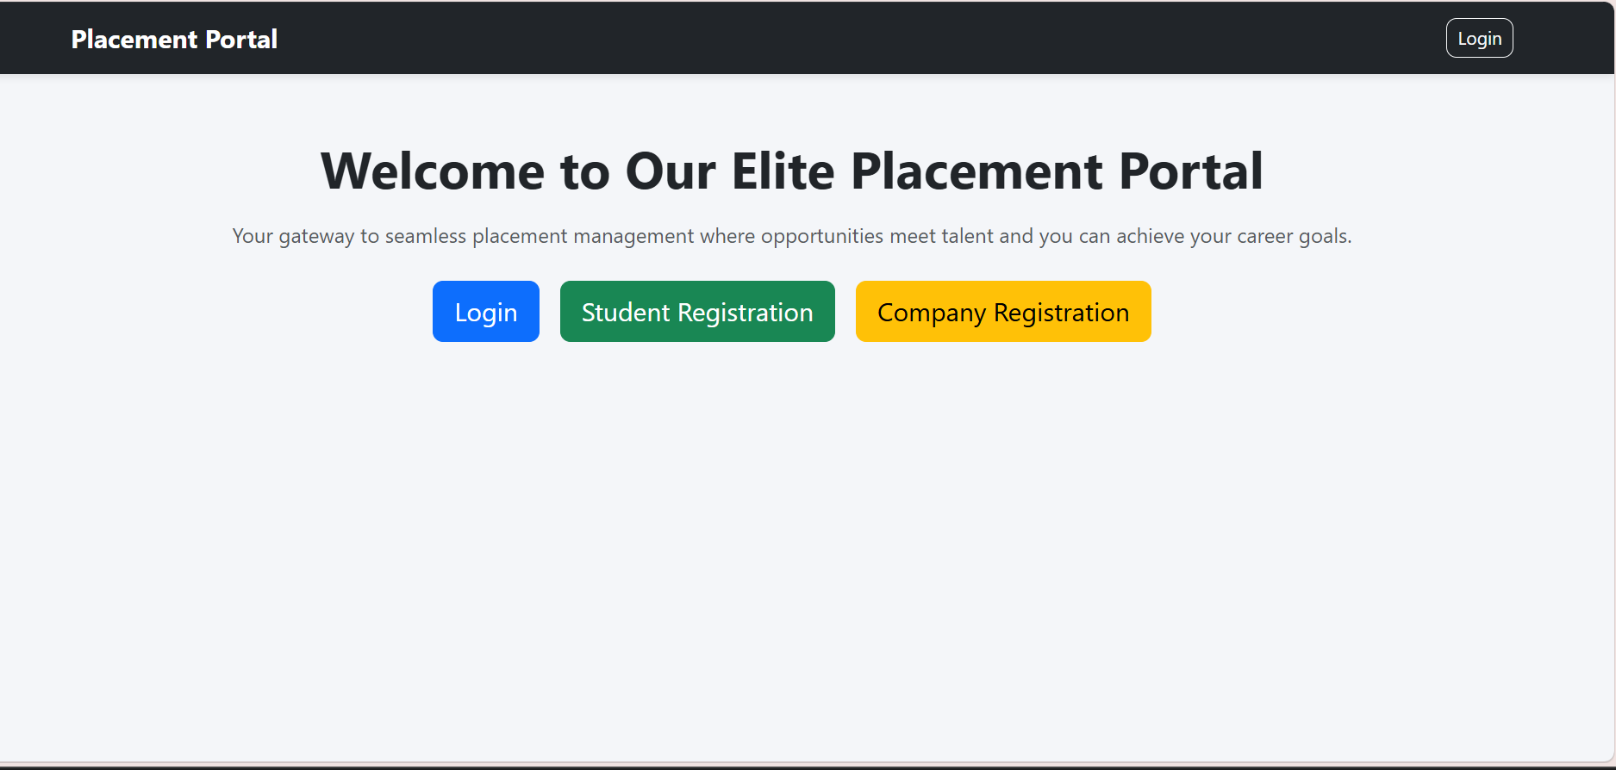

Registration Page
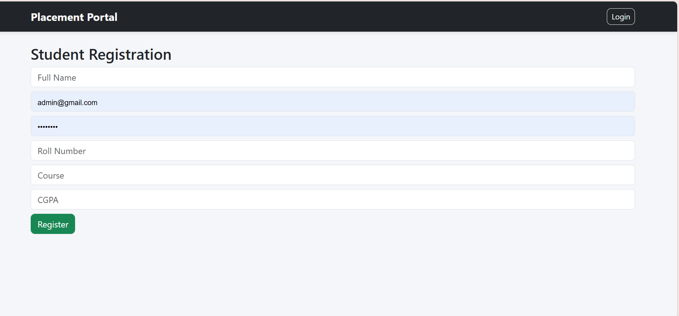

Login Page

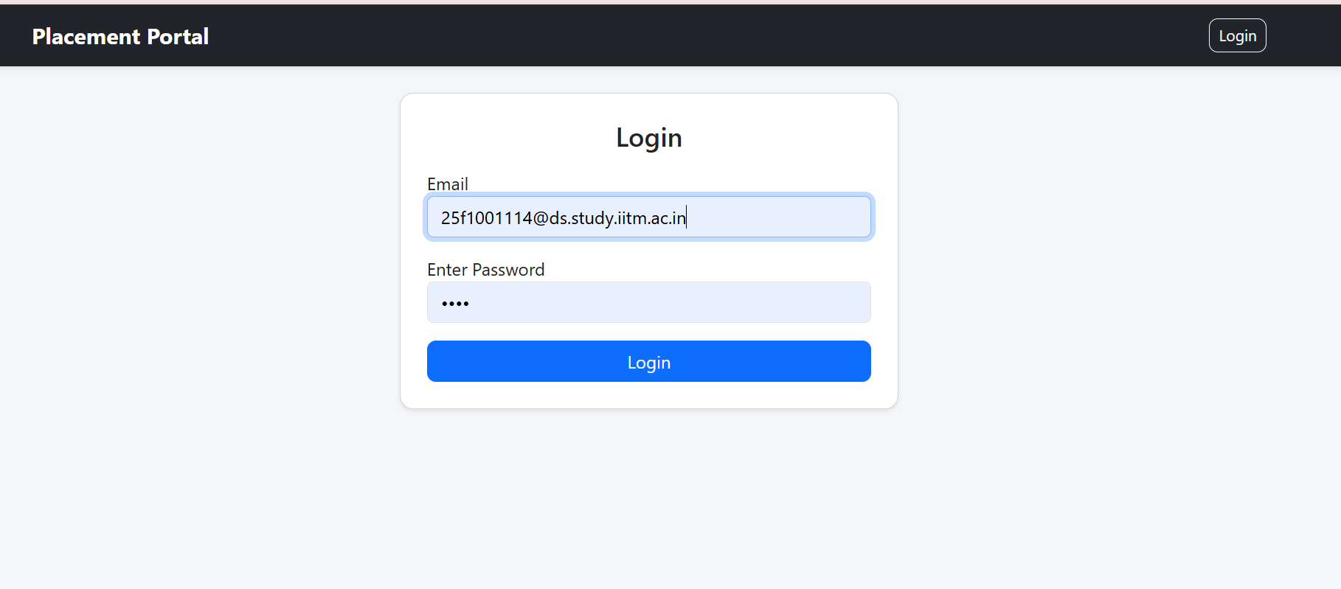

Admin Dashboard

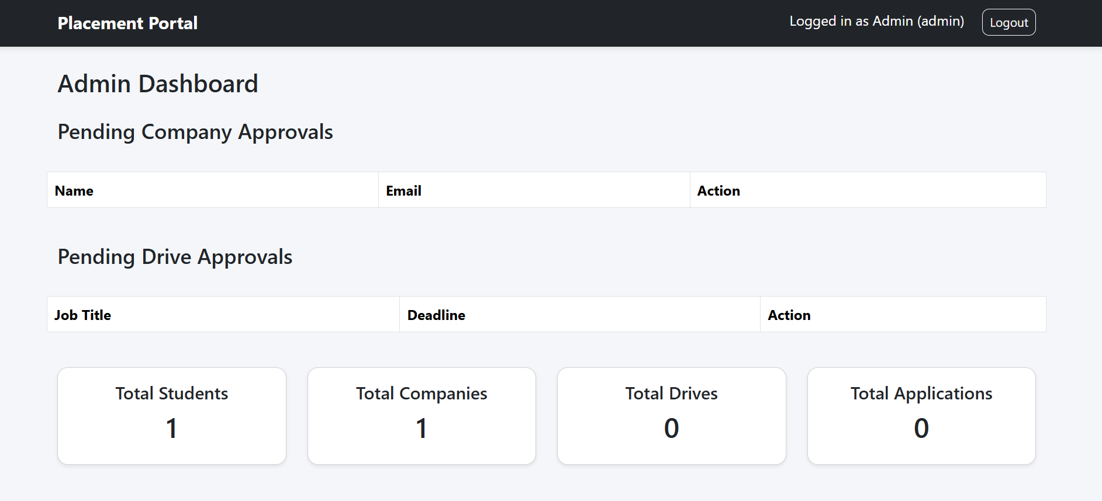

Company Dashboard

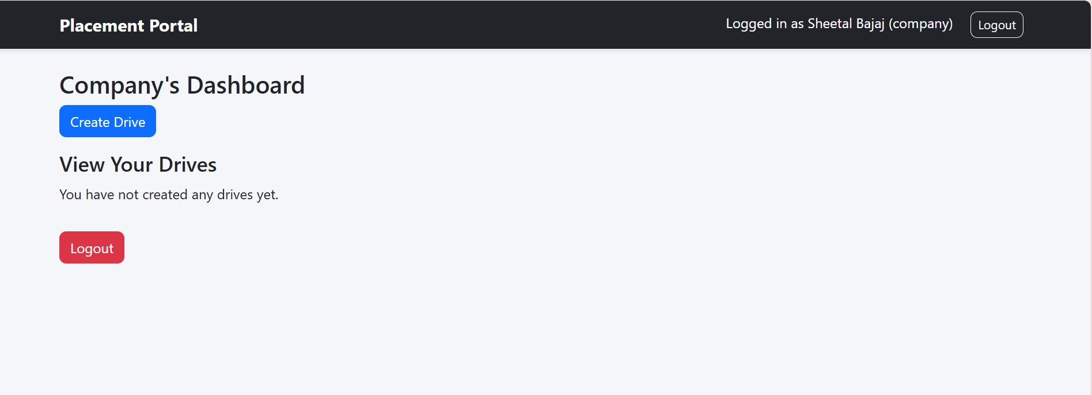

Create Drive Page

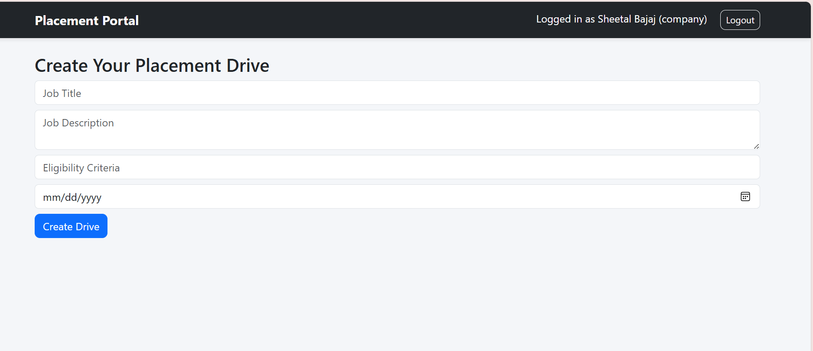

Student Dashboard

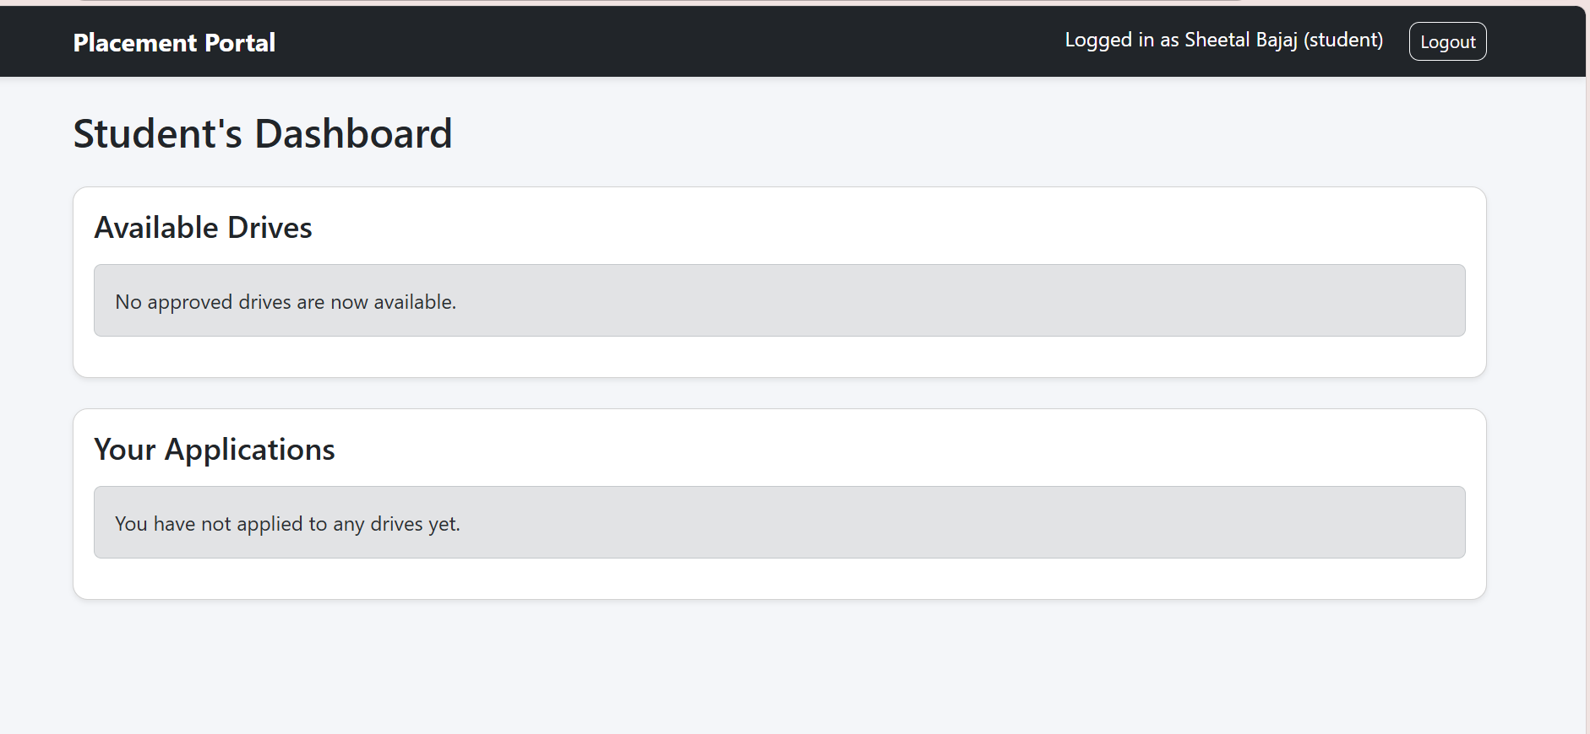

Apply for Drive Page

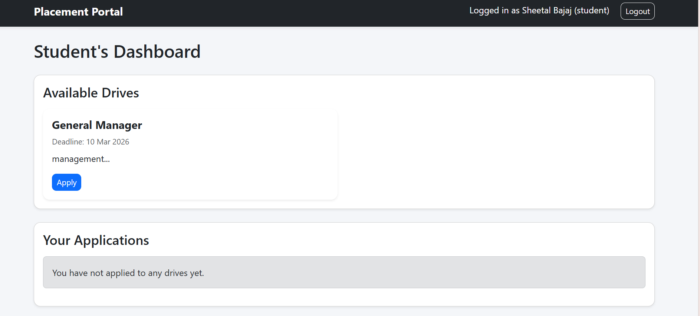

Application Status Page

