**Generate**

app.py

index.html

wishlist.html

styles.css

**Folder Structure**

/stationery_wishlist  
├── app.py               # Main Flask application file  
├──/ templates           # Folder for HTML templates  
 |  ├── index.html       # Main HTML file for adding items  
 | └── wishlist.html     # New HTML file for displaying the wishlist  
└──/ static              # Folder for static files (CSS, images, etc.)  
    └── styles.css       # CSS file for styling the HTML

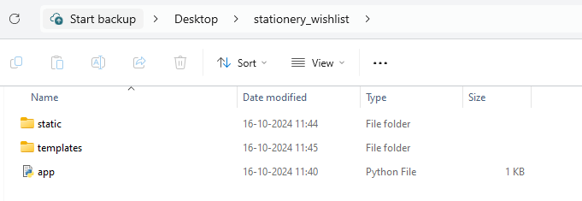

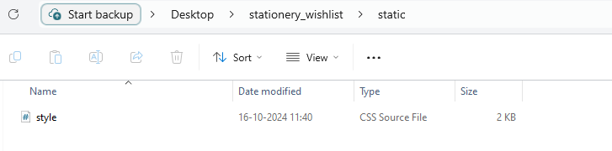

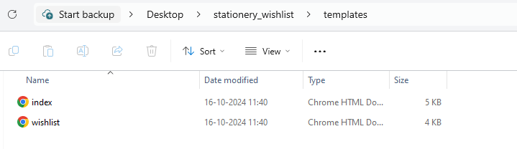

**In Command Prompt we execute**

cd Desktop\stationery_wishlist

C:\Users\pc25\Desktop\stationery_wishlist>pip install Flask

C:\Users\pc25\Desktop\stationery_wishlist>pip install pymongo

C:\Users\pc25\Desktop\stationery_wishlist>python app.py

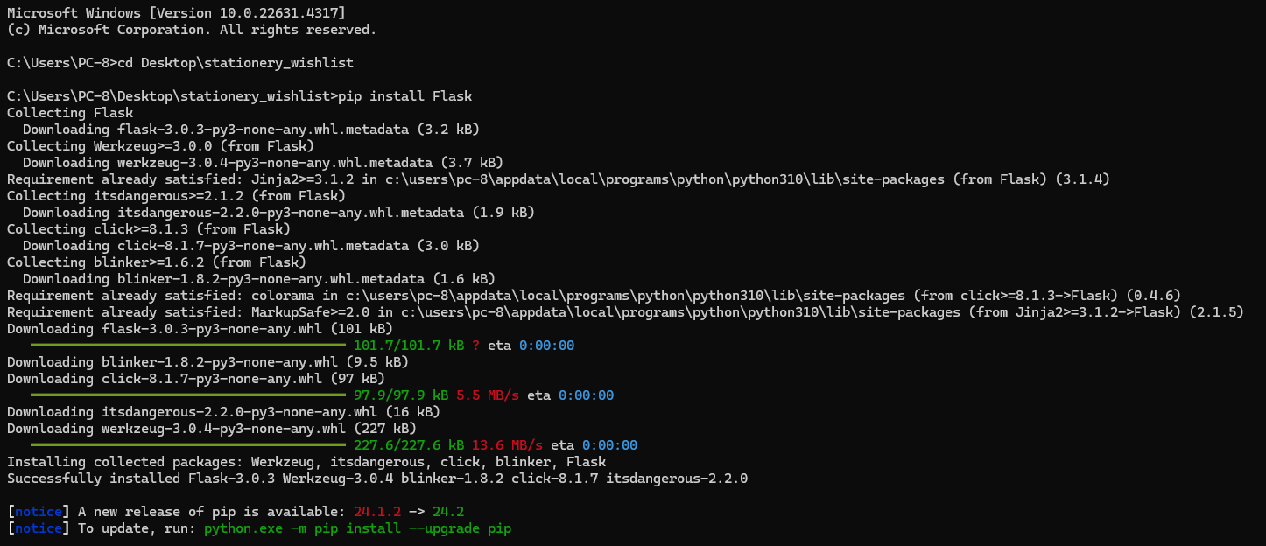

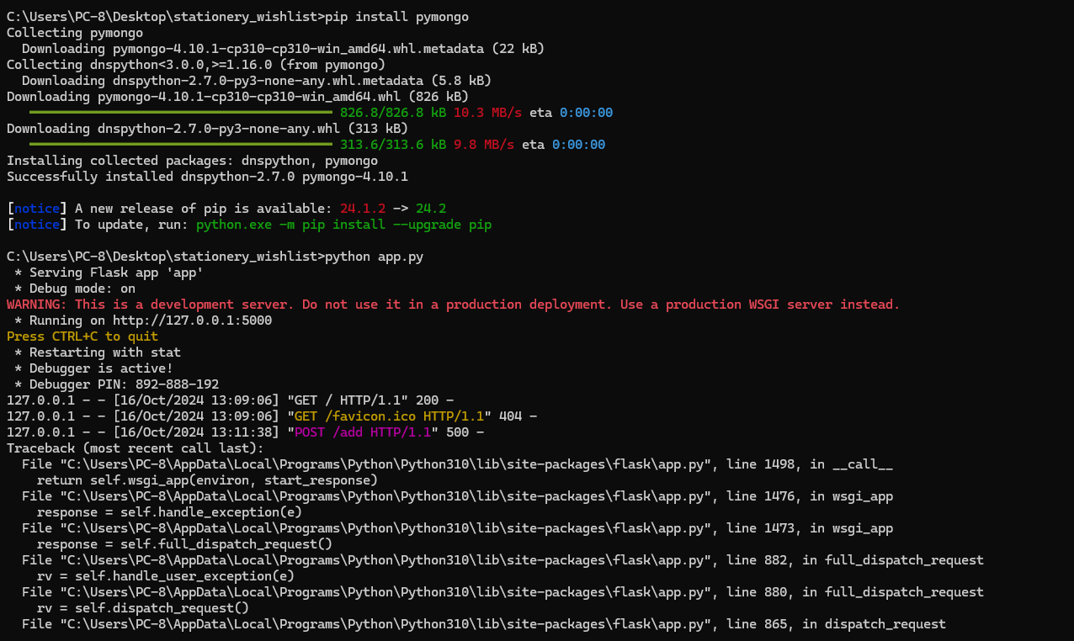

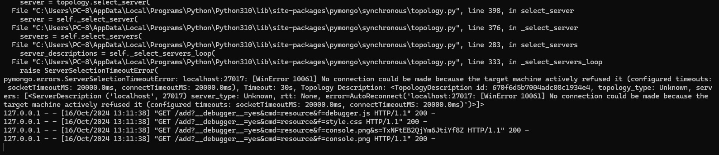

[http://127.0.0.1:5000](http://127.0.0.1:5000/)

