select * from customer_landing ; --956

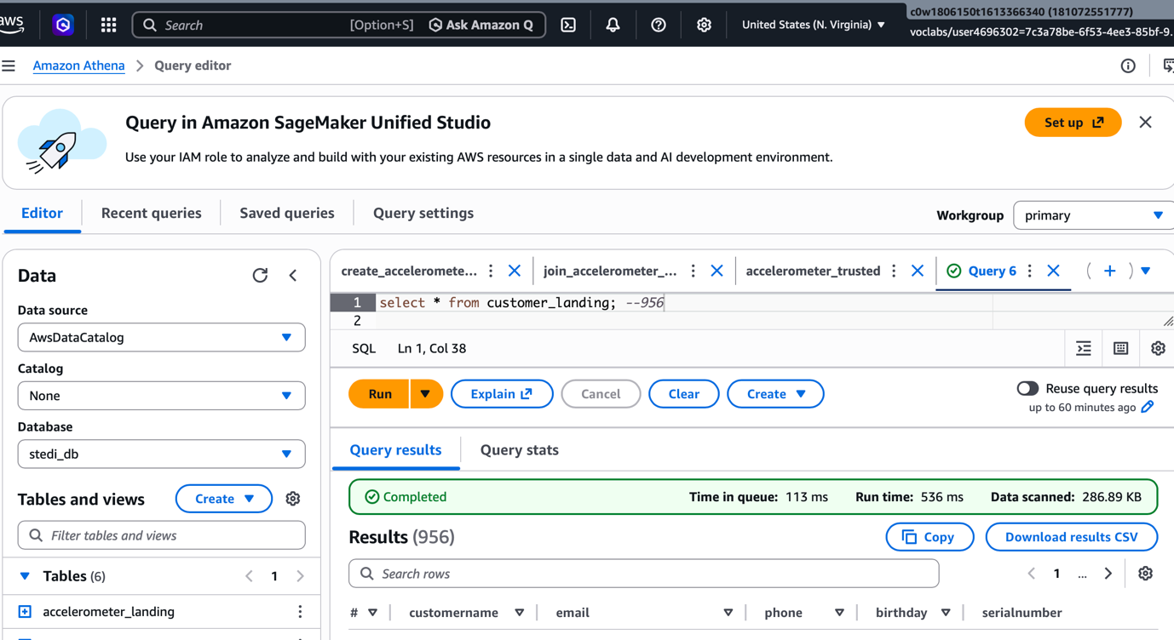

select * from accelerometer_landing; --81,273

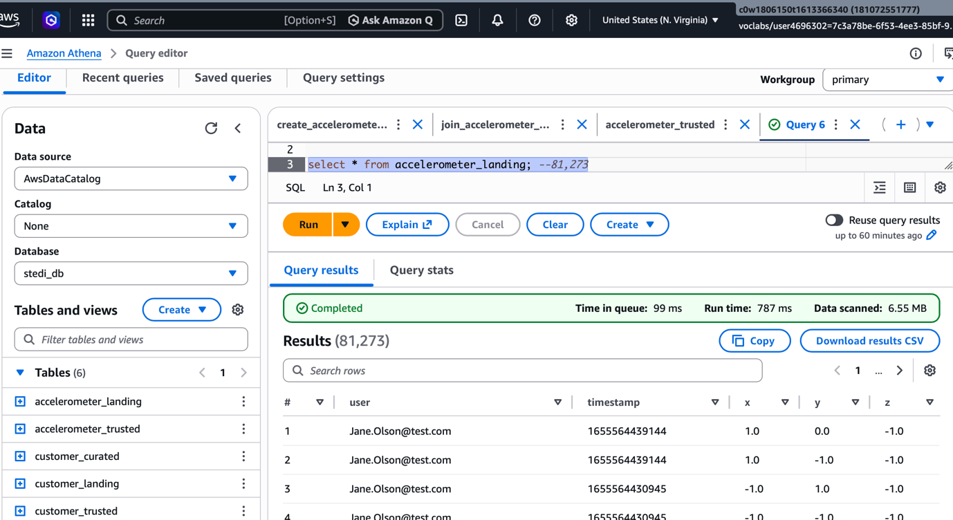
select * from step_trainer_landing; --26,680 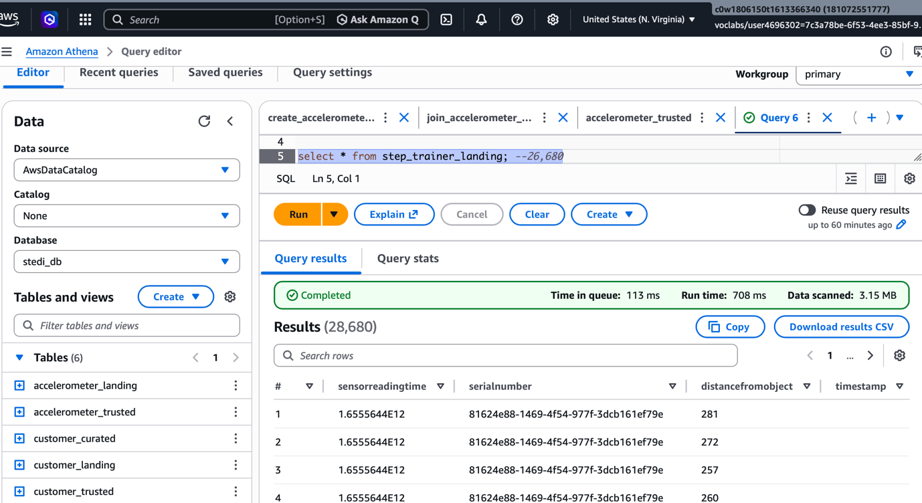

select * from customer_landing where shareWithResearchAsOfDate is null; --474

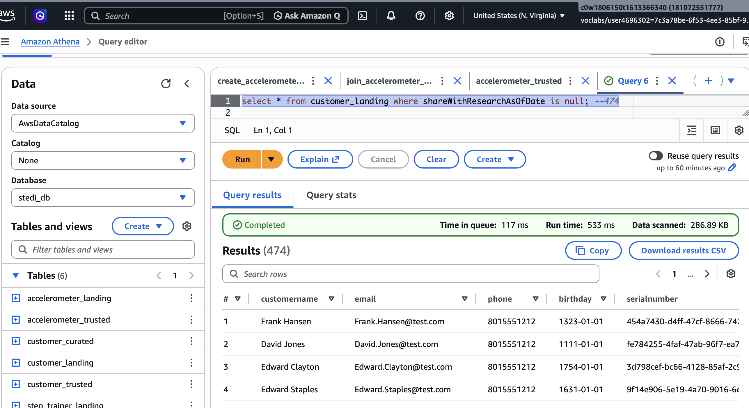

Trusted Data is Correct

select count(*) from customer_trusted; -- 482

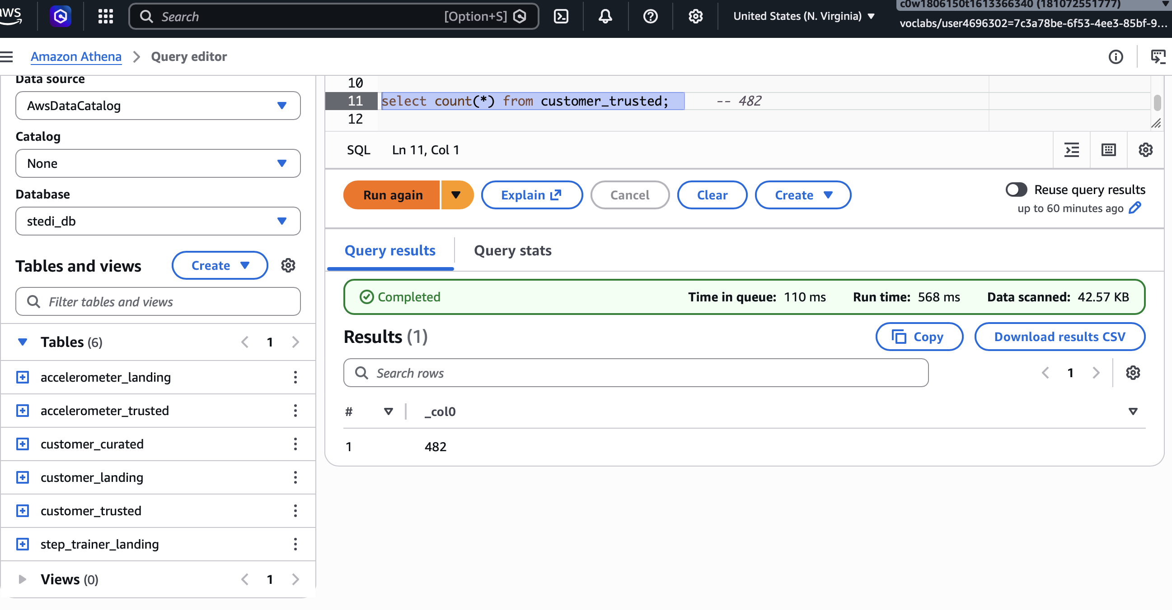

select * from customer_trusted where sharewithresearchasofdate is null -- 0

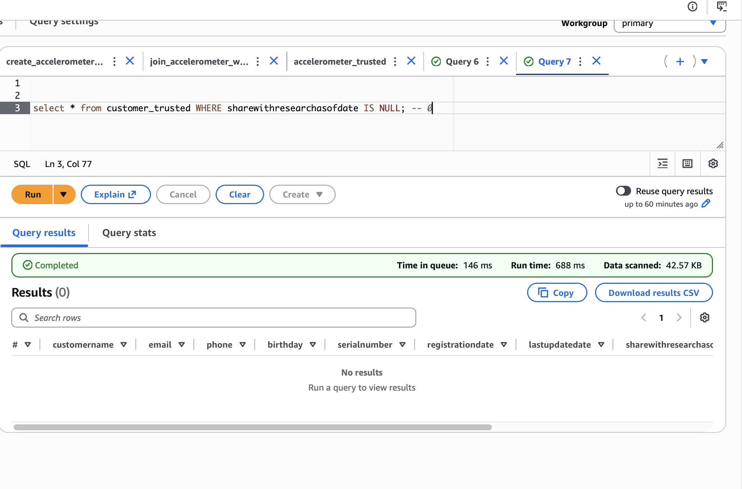

select count(*) from accelerometer_trusted; -- 40,981

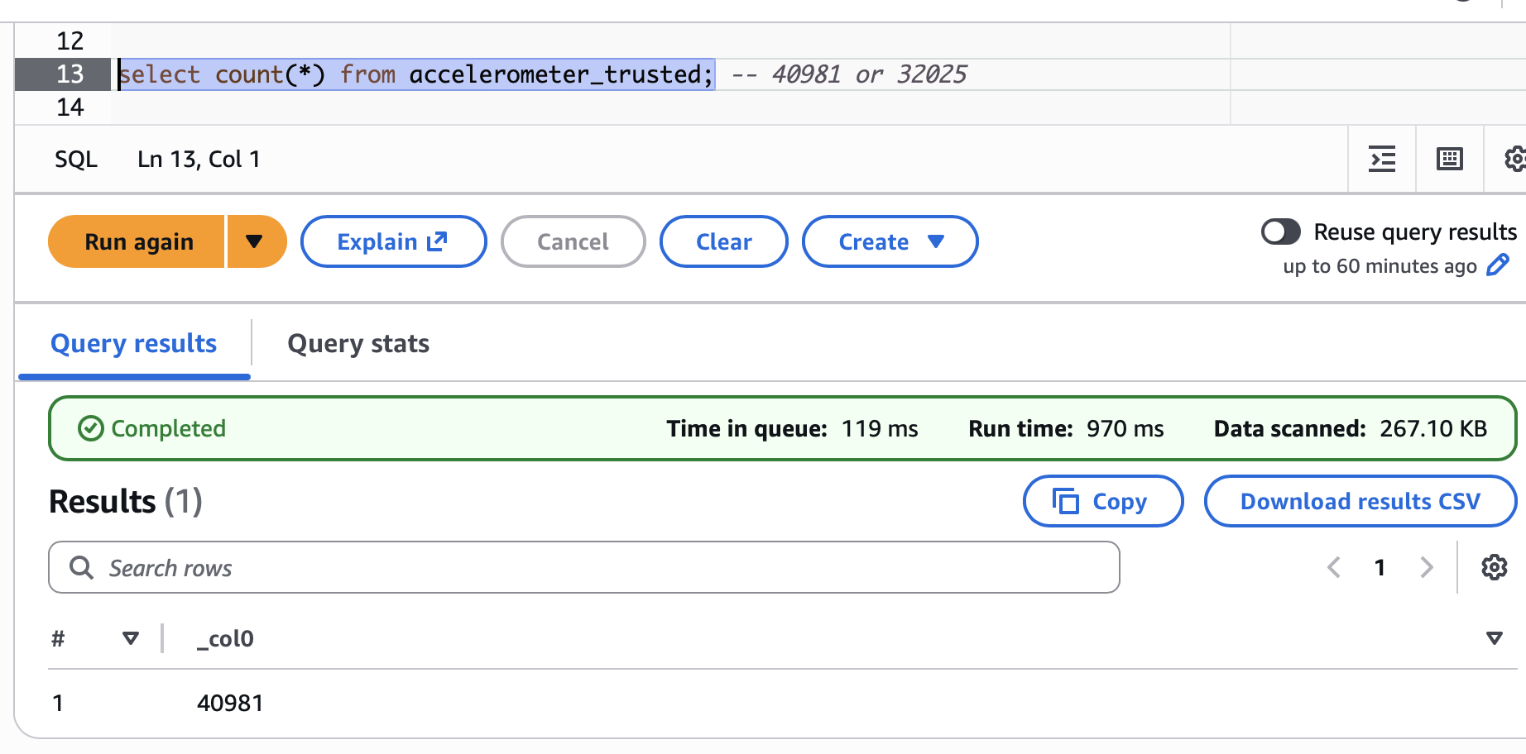

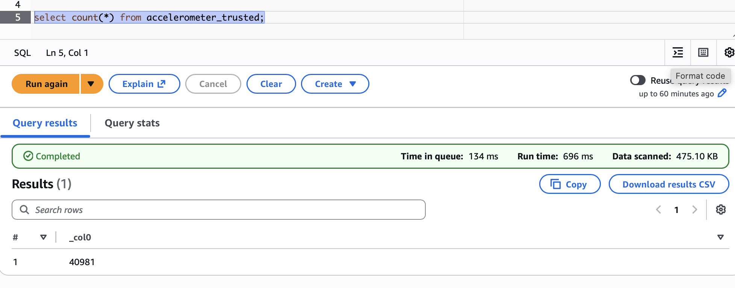

select * from customer_curated; --482

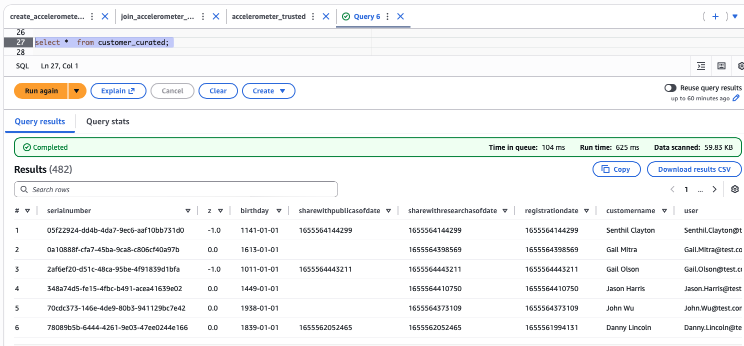

SELECT * FROM step_trainer_trusted; --14,460

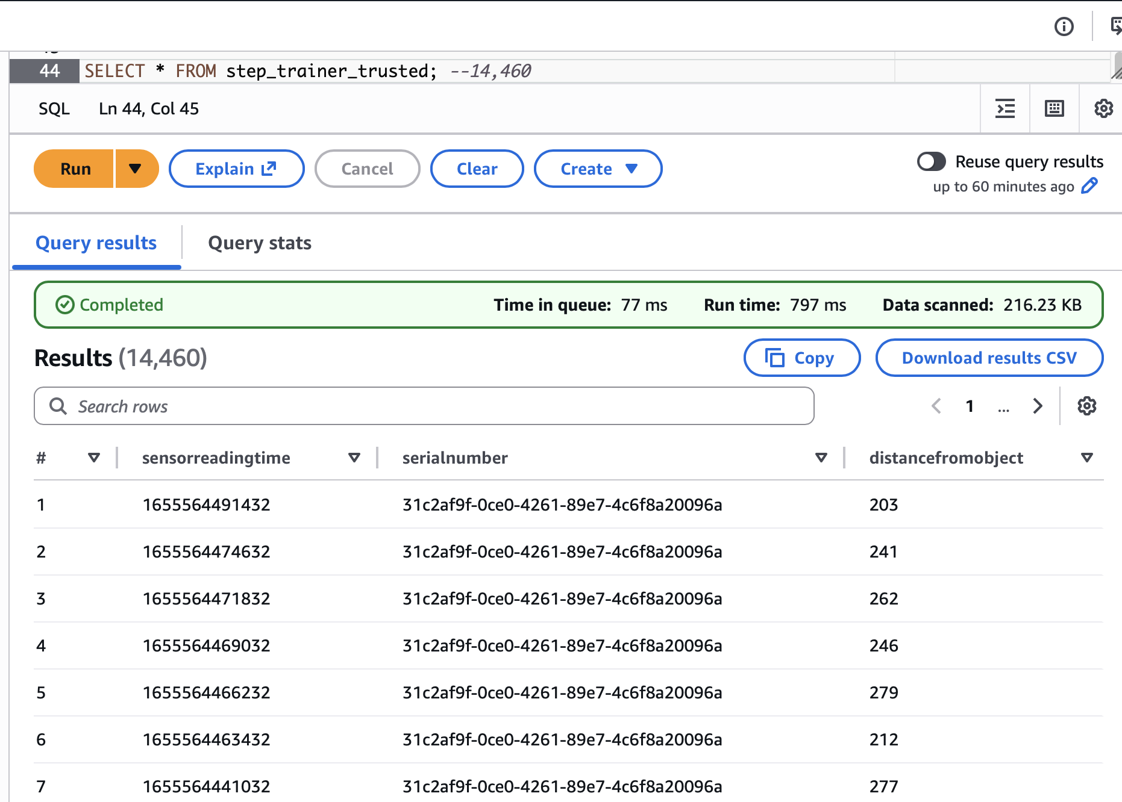

select * from machine_Learning_curated. -- 43,681

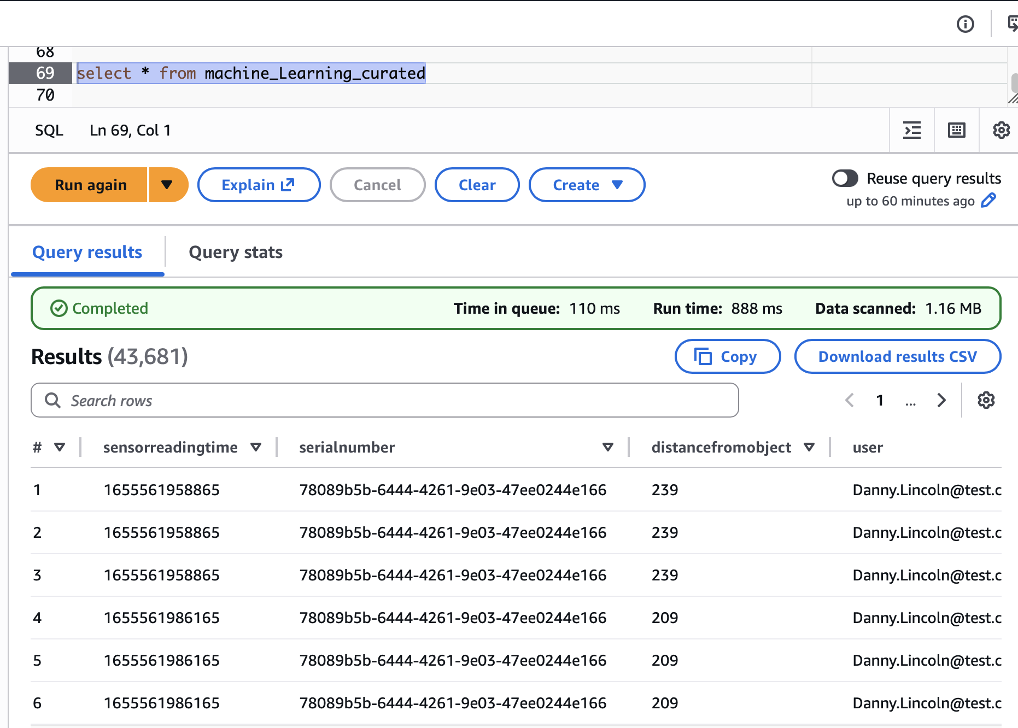

select * from customer_landing ; -- can see many sharewithresearchasofdate as null

