**Northwind Business Dashboard – Power BI Project Documentation**

**Overview**

This project uses Power BI to transform Northwind Traders’ raw data into strategic insights, enabling data-driven decision-making across departments such as Sales, Customer Relations, Inventory, Employee Management, and Shipping.

**Objective**

To create a comprehensive, interactive Power BI dashboard that consolidates multi-dimensional data and reveals actionable patterns in sales performance, customer behavior, stock levels, shipping reliability, and employee contributions.

**Significance**

* Empowers stakeholders with real-time visibility into business metrics
* Enhances inventory planning and customer targeting
* Identifies delays and inefficiencies in shipping and logistics
* Improves employee performance management
* Streamlines decision-making with visual summaries and data stories

**Data Dictionary**

| **Table Name** | **Key Fields** |
| --- | --- |
| **Orders** | OrderID, CustomerID, EmployeeID, OrderDate, ShipCity, ShipCountry, Freight |
| **Customers** | CustomerID, CompanyName, ContactName, Country, ContactTitle |
| **Employees** | EmployeeID, FirstName, LastName, Title, City, Country, HireDate, ReportsTo |
| **Shippers** | ShipperID, CompanyName, Phone |
| **Suppliers** | SupplierID, CompanyName, Country, ContactTitle |
| **Categories** | CategoryID, CategoryName, Description |
| **Products** | ProductID, ProductName, UnitPrice, UnitsInStock, SupplierID, CategoryID |
| **Order Details** | OrderID, ProductID, Quantity, UnitPrice, Discount |

**ER Diagram (Entity Relationship Overview)**

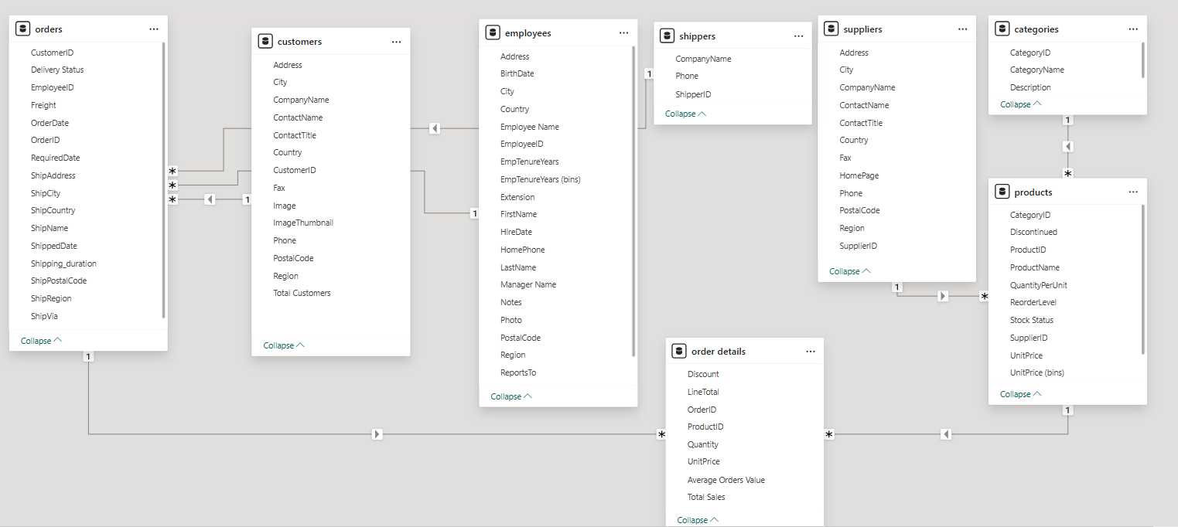

**Steps to Connect Data in Power BI**

1. **Import Data** from CSV, Excel, or database sources using Power BI's Get Data option
2. **Model Relationships** using the Data tab or auto-detect mode
3. **Transform Data** with Power Query (e.g., formatting dates, removing nulls)
4. **Create Calculated Columns/Measures** using DAX expressions
5. **Design Visuals**: Add slicers, bar charts, maps, KPIs, and drill-through pages

**Problem Statements with Solutions & Insights**

**1. How do sales trends vary over time?**

**Insight**: Sales peaked in Q1 1996, with top-performing months in Oct 1995 and Jan 1996  
**Solution**: Introduced time-based filters and line charts to analyse seasonal trends

**2. Which products/categories are most profitable?**

**Insight**: Tarte au sucre and Beverages lead in quantity sold  
**Solution**: Used stacked bar visuals and category drill-downs to optimize product strategy

**3. What’s the customer distribution across geographies?**

**Insight**: USA, France, and Germany are top countries for orders  
**Solution**: Map visualization and segmented analysis helped in regional targeting

**4. How is inventory managed?**

**Insight**: Several products like Steeleye Stout flagged as low stock or overstock  
**Solution**: Created alerts and reorder threshold indicators using DAX logic

**5. Which shipping companies perform best?**

**Insight**: Speedy Express had the shortest average delivery time  
**Solution**: Vendor performance KPIs were added to highlight delivery efficiency

**6. How loyal and experienced are Northwind employees?**

**Insight**: The majority of employees have long tenures ranging from **32 to 33 years**, suggesting strong retention and institutional knowledge. Senior team members like **Andrew Fuller** and **Janet Leverling** also contribute significantly to sales—indicating a blend of loyalty and performance.

**Solution**: Used **clustered column charts** and **histogram visuals** to showcase employee tenure, role distribution, and sales impact. This helped highlight how experienced staff strengthen business continuity and results.

**Conclusion**

The Northwind dashboard reveals meaningful trends in product sales, customer behaviour, and operational efficiency. Power BI enabled dynamic storytelling with insights that drive smarter decisions and continuous improvement. The project showcases data analytics' power in simplifying complexity, illuminating opportunities, and maximizing business impact.