**Team**: Sheetal Kandhare, Manjeeri Ghanekar, Chandrashekhar Pawar, Ritu Priya **PROTOTYPES  
  
1. Event Register, Notification, and Saving Scenario**Link: [Event Register, Notification, and Saving Scenario Paper Prototype](https://youtu.be/NXjPXtDGopo)  
**[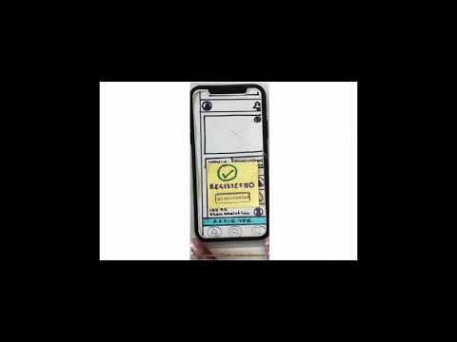](https://www.youtube.com/embed/NXjPXtDGopo?feature=oembed)**  
  
  
The idea in the prototype is that the user can register for an event and check who are all the students that have registered for the event and going to attend the event. It also allows the user to add notification and customize it, view the saved and notified items specific to the user. **Strength:** The Prototypes represent the flow of the event registration. The homepage was selected according to the Norman rules as it had **consistency** and **similarity**. Also, we used **hick’s law** that the design page should have less number of options which makes the user easy to take decisions.  
The Event listing page which is second in the prototypes, follows the principle of **consistency** and is also a clean design. The third important principle we followed was Fits law which is used in the section of details and student going tab. And also on the register button which is spread through the width of the screen. We also included error handling and user feedback. **Weakness:** We haven’t implemented participants to chat with each other whichever user registered for the event. We can also implement a schedule calendars interface but due to time constraints and implementation deadline currently, it is not a feasible option for us. As the user base grows, managing and displaying the list of attendees may become challenging without proper scalability measures in place. **Feasibility :**The event Registration process currently has no option to see who the students going to the event which is solved in our application, The design also helps the user to get all the club events and all events in one place. Each event has details listed for the event. The notification for the user is also implemented and has an option to customize the times. The designs implement feedback to the user and help the user to engage and be notified about his action.  
 **Originality:**The prototype design has a customizing notification feature. And the design is fully user-centric and taking the interview and analysis of the user perspective we have designed the pages.  **Why these ideas, tasks, or features?**This particular idea is implemented according to the problems taken into consideration during the interview and code evaluation. The tasks are focused on user feedback and notifications and help students to know each other and become familiar with. Features that are necessary and stated in the code evaluations as notifications and following multiple Instagram accounts and not being able to view who are the students going and exactly needed to solve students' listed issues. As stated in Strengths the ideas follows the principle and needed error and feedback for the students.

**2. Create trip and user profile prototype:**

[**https://youtube.com/shorts/mewNESrNjnM?feature=share**](https://youtube.com/shorts/mewNESrNjnM?feature=share)   
[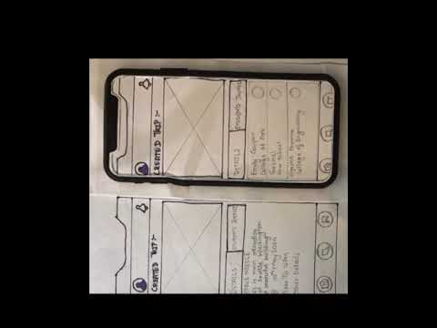](https://www.youtube.com/embed/mewNESrNjnM?feature=oembed)

The prototype of creating a trip allows users to create a trip to a place they are thinking of visiting. They can add details of the place like name, pictures, location, date and time they plan to visit, and other details they feel are important. They can also see who all have joined their group to visit that place. The user can also go and delete the created trip, once they visit the place or whenever they feel so, just by having the option in their user profile.

**Strengths:** It gives a clear idea of how our application will look to the user. It is easy and simple for the user to understand and interact with. The design for the prototype is symmetric and consistent. It allows users to have control and customize trip details which will enhance the user experience for planning the trip. Providing the chatting options provides users with effective communication.

**Weakness:** Here, the one who creates the trip will have the sole responsibility of the data for the trip. If the user makes mistakes while entering the details or enters incomplete details, it could lead to confusion.

**Why these ideas are more promising than the others regarding feasibility and originality:**

Creating a trip and allowing other participants to join is commonly addressed and so is a feasible concept. This prototype allows users to plan and organize their trips efficiently, which is practical.

Here the user can see who else has joined the trip and also has the option to leave the group or delete the group for one who has created something that is unique. It is different from general planning tools as it allows other students to willingly join the group and accompany you for the trip which helps the users to network and feel secure at the same time.

3. **Go on outing Scenario and join group for outings.**

<https://youtu.be/OI3A-yzndxU>

In the prototype, users will be able to view a list of all available trips. They can select a specific trip to see its details. Additionally, users can join any trip they choose. Furthermore, the prototype will allow users to check the list of students who are attending each trip.

**Strength:**

This prototype shows the flow of going on an outing and joining the group. The homepage was selected according to the Norman rules as it had **consistency** and **similarity**. We have adopted the **Fitts' law** to design the page which has components in comfortable interaction areas that will help the user while using the app. We also used Fitts’ law to present a big “JOIN” button which makes the target bigger and grabs users’ attention.

**Weakness:**

The students' details info is lacking the contact details (for example email id and phone number) of the student who has already joined the group. Another missing thing is that the number of counts in students details page is not showing how many students have joined the group which will let the user know the total number of people part of the trip already.

**Feasibility:**

This design concept is very feasible to implement. It doesn't require any complex functionalities. The concept is clear and easy for users to understand.

**Originality:**

Using the "JOIN" button is a common design pattern across mobile apps which grabs the attention of the user and notify the user that they joined a trip once they click on the “join” button.

**Why these ideas, tasks, or features?**

We took this task because while conducting interviews we came to know that such a feature is not available in existing apps. This feature will help the user to communicate or get any kind of trip-related information.