Customer Churn Analysis

1. Executive Summary
Customer churn poses a direct threat to recurring revenue and long-term business growth. This project establishes an end-to-end data processing and analytics framework designed to centralize customer data, compute core churn metrics, and prepare datasets for executive dashboarding in Power BI.
By leveraging SQL Server Management Studio (SSMS) to clean raw staging data and execute metric-driven SQL queries, this phase establishes a reliable data pipeline to track state-level retention, churn categories, and customer demographics.

2. Dataset Overview
- Kaggle dataset
- Entries: 6,419 records

3. Key Components:
- Staging Environment: Raw transactional and demographic data is ingested into the SQL database table stg_Churn.
- SQL Transformation Layer: Queries run directly in SQL Server to compute proportions, total counts, and percentage contributions across multiple dimensions.
- Power BI Connection: Cleaned datasets and views are pulled into Power BI for dashboard development.

4. Core Metrics & SQL Analysis Findings
During the SQL analysis phase, several key performance indicators (KPIs) and demographic breakdowns were calculated:
- Overall Customer & Churn Overview
- Customer Status Distribution: SQL queries calculate total customer counts and percentage contributions grouped by customer status (e.g., Joined, Stayed, Churned).
- Revenue Contribution: Evaluates revenue generated versus lost revenue from churned users to highlight financial exposure.

- Geographic Breakdown (State-Level Metrics)
State-by-state analysis was conducted to pinpoint geographic concentrations of total accounts and churn percentage:
- High-Density States: States like Uttar Pradesh, Tamil Nadu, and Maharashtra represent the largest customer concentrations.

- Primary Drivers & Category Explorations
SQL queries were structured to analyse distribution across key operational fields:
- Contract Types: Evaluating churn rates across Month-to-Month, 1-Year, and 2-Year plans.
- Payment Methods: Mapping churn distribution against manual versus automated payment methods.
- Churn Categories & Reasons: Identifying core categories driving service cancellations (e.g., Competitor offers, price points, service quality).

5. Key Takeaways & Initial Findings
- Geographic Concentration: A significant portion of the customer base resides in key regional hubs, requiring targeted local retention strategies.
- Data Cleanliness: Running preliminary aggregations in SQL Server ensures that data inconsistencies are resolved before creating visual reports in Power BI.
- Pipeline Efficiency: Preparing data views and aggregated queries in SQL optimizes Power BI performance by delegating heavy calculations to the database server.

6. Data Analysis using SQL
- Total churn by Gender:
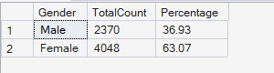

- Churn Based on Contract:

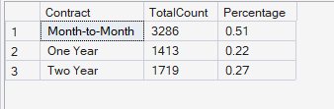

- Total Revenue by Customer Status:
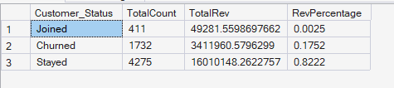

- Churn by State:

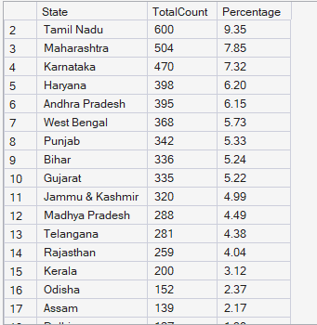

- Null Value Check:

- Replace Null Values:

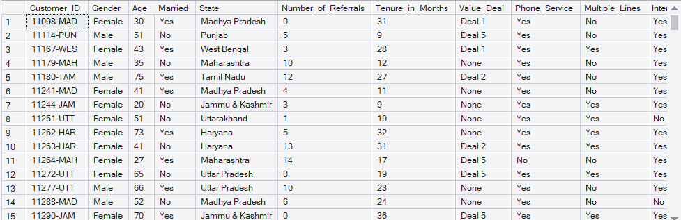

7. Dashboard in Power BI
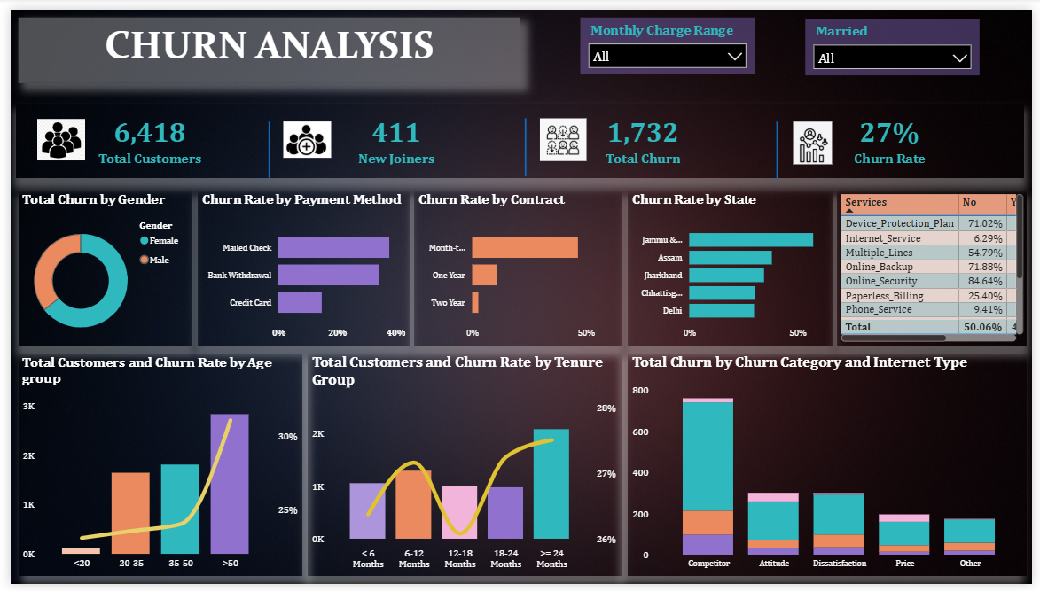

8. Recommendations
- Incentivize Long-Term Contracts: Transition month-to-month subscribers to annual plans using targeted discounts to counter the high ~46% churn rate on short-term commitments.
- Implement Competitor Win-Back Strategies: Address the leading churn driver ("Competitor") by running price-matching programs, enhancing core features, and highlighting product differentiation.
- Automate Auto-Pay Adoption: Reduce payment-friction churn by offering small billing incentives for switching to automatic credit card or bank payments instead of manual checks.

