**MEAN Bootcamp**

**Session 1: Introduction to Node + NPM**

Ques 1.Installing node latest version and npm.

Ans.Commands for installing Nodejs and npm-

sudo apt-get install nodejs

sudo apt-get install npm

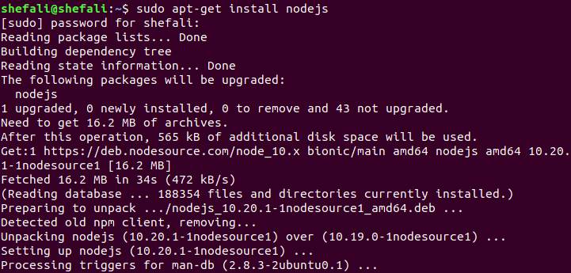

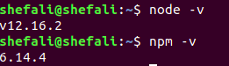

Ques.3 Install dependencies and devdependencies.

Ans.For installing dependencies, we simply write npm install <package-name> --save

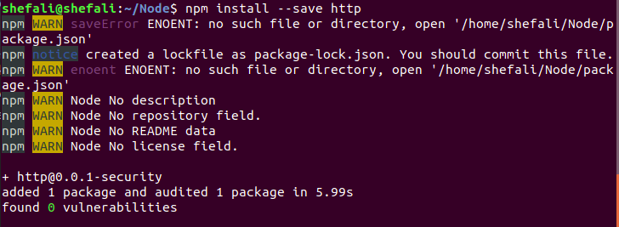

For installing devdependencies, we simply write npm install <package-name> --save-dev

