Diffusion Curve Generator Output

09 January, 2019

# 1. Introduction

These results are produced by diffusion curve generator hosted at [insert URL] and developed by The University of Sheffield. The method underpinning the calculations is based on a paper by Sabine Grimm (see citation information at the end of this report)

The method takes probability distributions for three diffusion parameters to generate curves based on the Bass Model of Product Diffusion. The parameters, $m$, $N1$ and $t′$, represent the maximum number of adoptions attained, the number of adoptions in the first year and the time at which the rate of diffusion reduces, respectively.

# 2. Elicitation Input

Input distributions

## Expert M N1 t'  
## 1: Expert A Triangle(54.2, 10, 150) Triangle(2.3, 0, 5) Normal(5.1, 1.5)  
## 2: Expert B Triangle(158.8, 30, 230) Triangle(5.7, 2, 15) Normal(9.9, 1.5)  
## 3: Expert C Triangle(204.4, 30, 410) Triangle(7.1, 2, 10) Normal(3.5, 1.1)

Distributions of the input parameters (200 samples). The parameters were sampled from mixture distributions.

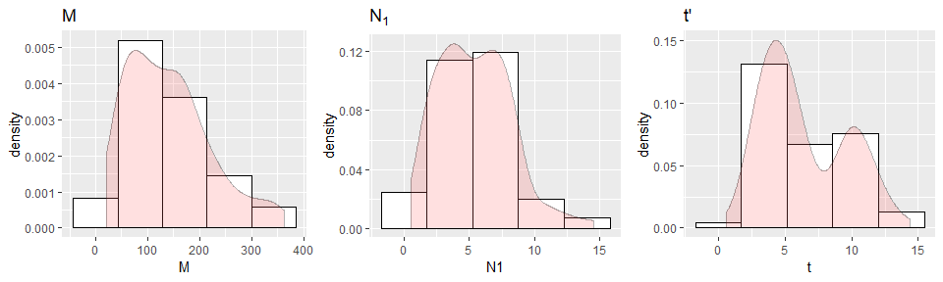

Summary of sample input parameters

## M N1 t   
## Min. : 20.16 Min. : 0.496 Min. : 0.6166   
## 1st Qu.: 72.96 1st Qu.: 3.339 1st Qu.: 3.8628   
## Median :126.99 Median : 5.338 Median : 5.4487   
## Mean :139.96 Mean : 5.405 Mean : 6.3979   
## 3rd Qu.:181.63 3rd Qu.: 7.333 3rd Qu.: 9.4939   
## Max. :362.62 Max. :14.508 Max. :14.3494

# 3. Parameter fitting

Distributions of the fitted parameters (200 samples). 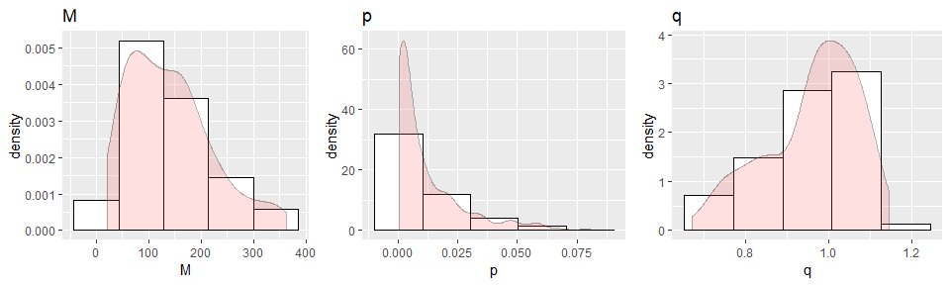

Summary of sample input parameters

## M p q   
## Min. : 20.16 Min. :0.000102 Min. :0.6707   
## 1st Qu.: 72.96 1st Qu.:0.001315 1st Qu.:0.8802   
## Median :126.99 Median :0.004354 Median :0.9791   
## Mean :139.96 Mean :0.011244 Mean :0.9604   
## 3rd Qu.:181.63 3rd Qu.:0.015487 3rd Qu.:1.0452   
## Max. :362.62 Max. :0.080653 Max. :1.1452

# 4. Generated diffusion curves

Generated diffusion curves.

* $N(t)$ Number of cumulated adoptions at $t$
* $dN(t)$ New adoptions at $t$

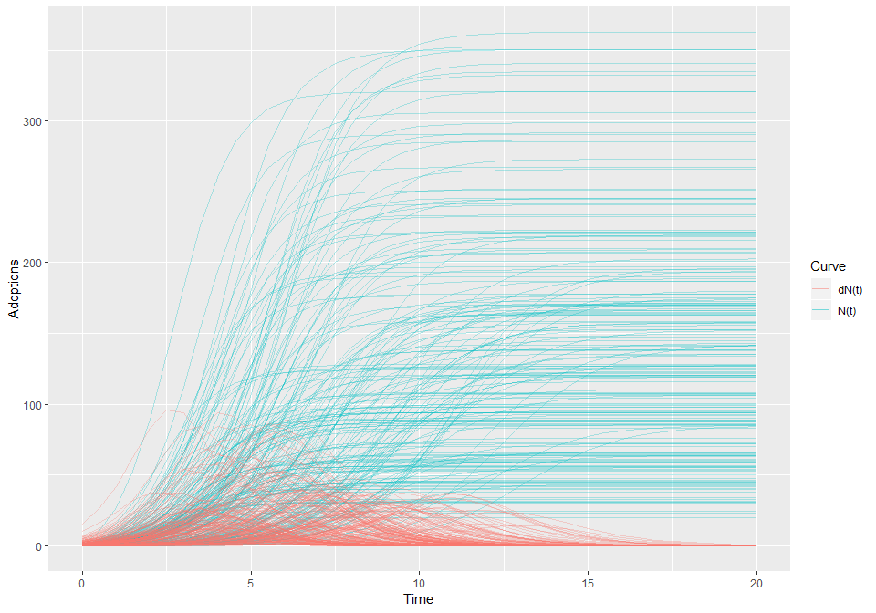

Mean curves

## Time N dN  
## 0 0.00 1.11  
## 2 6.81 7.33  
## 4 36.10 21.93  
## 6 83.04 21.46  
## 8 115.83 11.62  
## 10 132.61 5.81  
## 12 140.69 2.54  
## 14 143.81 0.83  
## 16 144.75 0.22  
## 18 144.99 0.06  
## 20 145.05 0.01

## Reference

Grimm SE, Stevens JW, Dixon S. Estimating Future Health Technology Diffusion Using Expert Beliefs Calibrated to an Established Diffusion Model. Value Health. 2018 Aug;21(8):944-950.