Diffusion Curve Generator Output

25 February, 2019

# 1. Introduction

These results are produced by diffusion curve generator hosted at [insert URL] and developed by The University of Sheffield. The method underpinning the calculations is based on a paper by Sabine Grimm (see citation information at the end of this report)

The method takes probability distributions for three diffusion parameters to generate curves based on the Bass Model of Product Diffusion. The parameters, $m$, $N1$ and $t′$, represent the maximum number of adoptions attained, the number of adoptions in the first year and the time at which the rate of diffusion reduces, respectively.

# 2. Elicitation Input

Input distributions

## Expert M N1 t'  
## 1: Expert A Gamma(3.03, 0.06) Gamma(4.19, 1.88) Gamma(22.21, 4.36)  
## 2: Expert B Gamma(12.37, 0.08) Gamma(5.08, 0.91) Gamma(38.27, 3.84)  
## 3: Expert C Gamma(2.81, 0.01) Gamma(11.1, 1.67) Gamma(14.35, 4.06)

Distributions of the input parameters (200 samples). The parameters were sampled from mixture distributions.

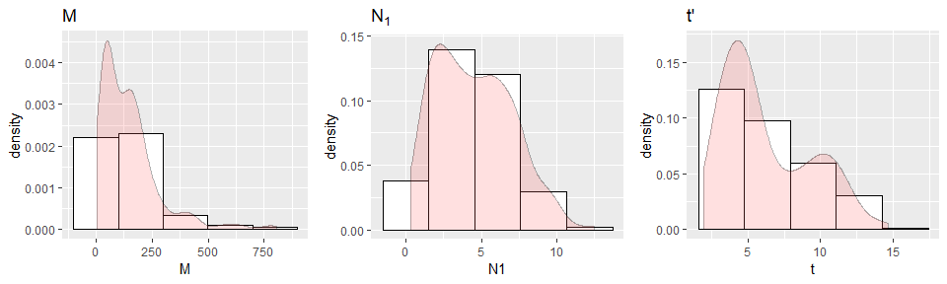

Summary of sample input parameters

## M N1 t   
## Min. : 6.196 Min. : 0.3128 Min. : 1.967   
## 1st Qu.: 50.388 1st Qu.: 2.4126 1st Qu.: 3.893   
## Median :122.644 Median : 4.3044 Median : 5.161   
## Mean :147.667 Mean : 4.5083 Mean : 6.237   
## 3rd Qu.:192.606 3rd Qu.: 6.1946 3rd Qu.: 8.816   
## Max. :803.985 Max. :12.4756 Max. :14.639

# 3. Parameter fitting

Distributions of the fitted parameters (200 samples). 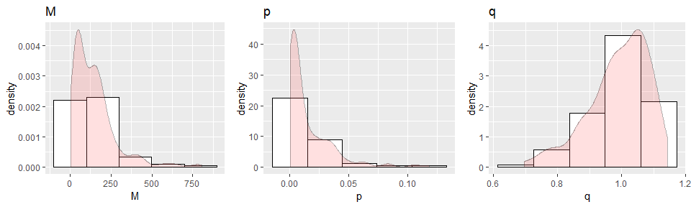

Summary of sample input parameters

## M p q   
## Min. : 6.196 Min. :0.0002144 Min. :0.6959   
## 1st Qu.: 50.388 1st Qu.:0.0020199 1st Qu.:0.9381   
## Median :122.644 Median :0.0070858 Median :1.0035   
## Mean :147.667 Mean :0.0152706 Mean :0.9898   
## 3rd Qu.:192.606 3rd Qu.:0.0231071 3rd Qu.:1.0591   
## Max. :803.985 Max. :0.1182255 Max. :1.1424

# 4. Generated diffusion curves

Generated diffusion curves.

* $N(t)$ Number of cumulated adoptions at $t$
* $dN(t)$ New adoptions at $t$

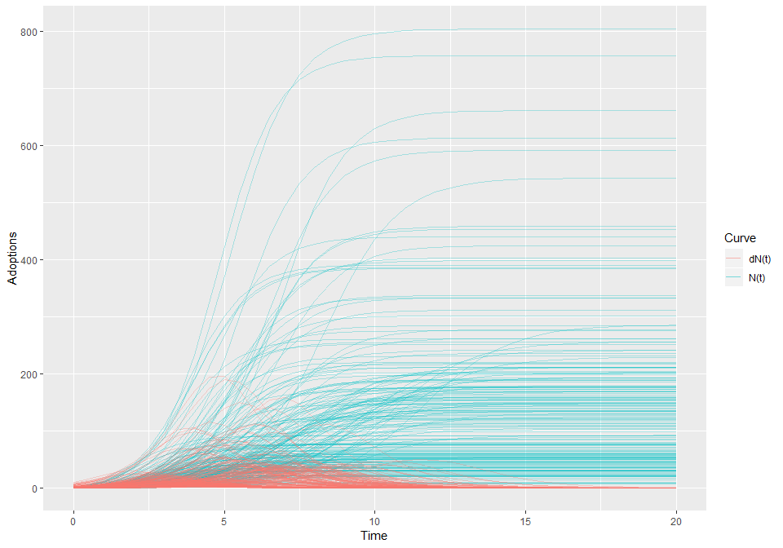

Average curves (median)

## Time N dN  
## 0 0.00 0.69  
## 2 4.37 4.67  
## 4 22.17 11.38  
## 6 50.55 14.51  
## 8 76.87 6.87  
## 10 109.99 1.05  
## 12 120.66 0.14  
## 14 121.57 0.02  
## 16 122.41 0.00  
## 18 122.59 0.00  
## 20 122.63 0.00

## Reference

Grimm SE, Stevens JW, Dixon S. Estimating Future Health Technology Diffusion Using Expert Beliefs Calibrated to an Established Diffusion Model. Value Health. 2018 Aug;21(8):944-950.