Diffusion Curve Generator Output

09 January, 2019

# 1. Introduction

These results are produced by diffusion curve generator hosted at [insert URL] and developed by The University of Sheffield. The method underpinning the calculations is based on a paper by Sabine Grimm (see citation information at the end of this report)

The method takes probability distributions for three diffusion parameters to generate curves based on the Bass Model of Product Diffusion. The parameters, $m$, $N1$ and $t′$, represent the maximum number of adoptions attained, the number of adoptions in the first year and the time at which the rate of diffusion reduces, respectively.

# 2. Elicitation Input

Input distributions

## Expert M N1 t'  
## 1: Expert A Triangle(54.2, 10, 150) Triangle(2.3, 0, 5) Normal(5.1, 1.5)  
## 2: Expert B Triangle(158.8, 30, 230) Triangle(5.7, 2, 15) Normal(9.9, 1.5)  
## 3: Expert C Triangle(204.4, 30, 410) Triangle(7.1, 2, 10) Normal(3.5, 1.1)

Distributions of the input parameters (300 samples). The parameters were sampled from mixture distributions.

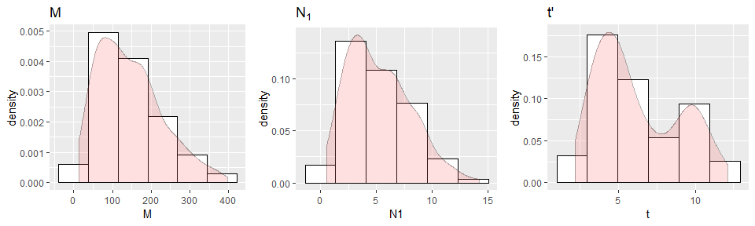

Summary of sample input parameters

## M N1 t   
## Min. : 14.54 Min. : 0.5253 Min. : 2.195   
## 1st Qu.: 76.83 1st Qu.: 3.0567 1st Qu.: 4.101   
## Median :129.28 Median : 4.6671 Median : 5.350   
## Mean :145.07 Mean : 5.2531 Mean : 6.227   
## 3rd Qu.:196.47 3rd Qu.: 7.1450 3rd Qu.: 8.736   
## Max. :397.43 Max. :14.1997 Max. :12.133

# 3. Parameter fitting

Distributions of the fitted parameters (300 samples). 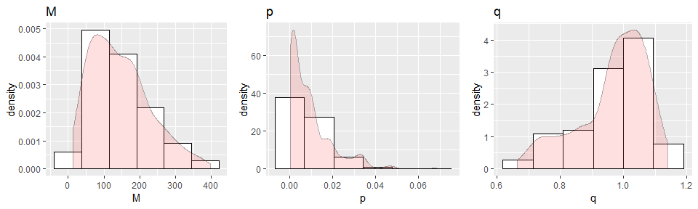

Summary of sample input parameters

## M p q   
## Min. : 14.54 Min. :0.0001348 Min. :0.6644   
## 1st Qu.: 76.83 1st Qu.:0.0014658 1st Qu.:0.9133   
## Median :129.28 Median :0.0066614 Median :0.9904   
## Mean :145.07 Mean :0.0091952 Mean :0.9665   
## 3rd Qu.:196.47 3rd Qu.:0.0115413 3rd Qu.:1.0474   
## Max. :397.43 Max. :0.0684298 Max. :1.1403

# 4. Generated diffusion curves

Generated diffusion curves. Statistics of mean and 70% quantiles showed.

* $N(t)$ Number of cumulated adoptions at $t$
* $dN(t)$ New adoptions at $t$

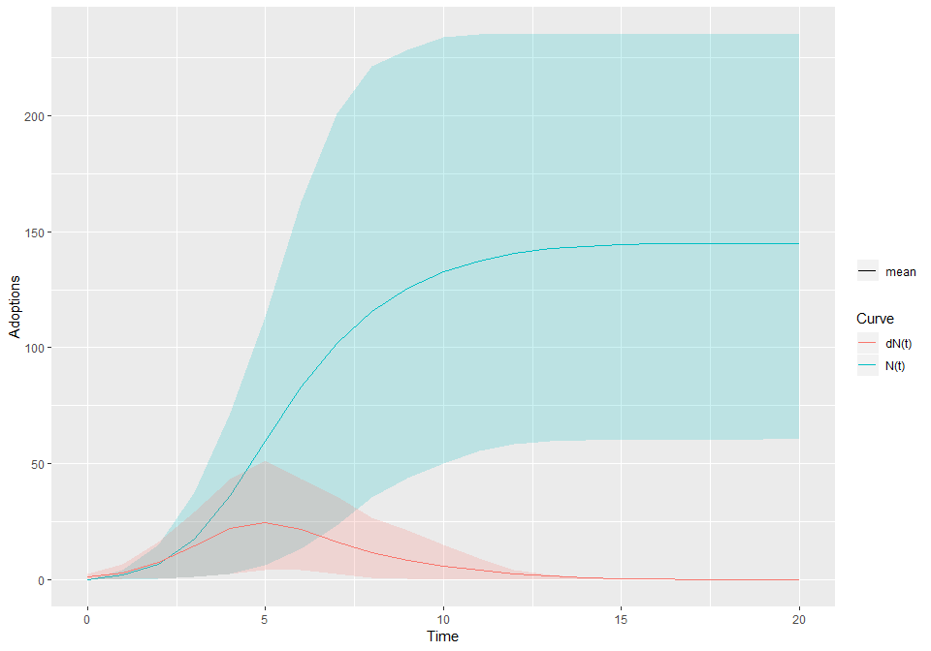

Mean curves

## Time N dN  
## 0 0.00 1.11  
## 2 6.81 7.33  
## 4 36.10 21.93  
## 6 83.04 21.46  
## 8 115.83 11.62  
## 10 132.61 5.81  
## 12 140.69 2.54  
## 14 143.81 0.83  
## 16 144.75 0.22  
## 18 144.99 0.06  
## 20 145.05 0.01

## Reference

Grimm SE, Stevens JW, Dixon S. Estimating Future Health Technology Diffusion Using Expert Beliefs Calibrated to an Established Diffusion Model. Value Health. 2018 Aug;21(8):944-950.