**Running RG Core Visualisation**

On your chosen internet browser go to:

<http://127.0.0.1:5000>

You should see a screen that looks like:

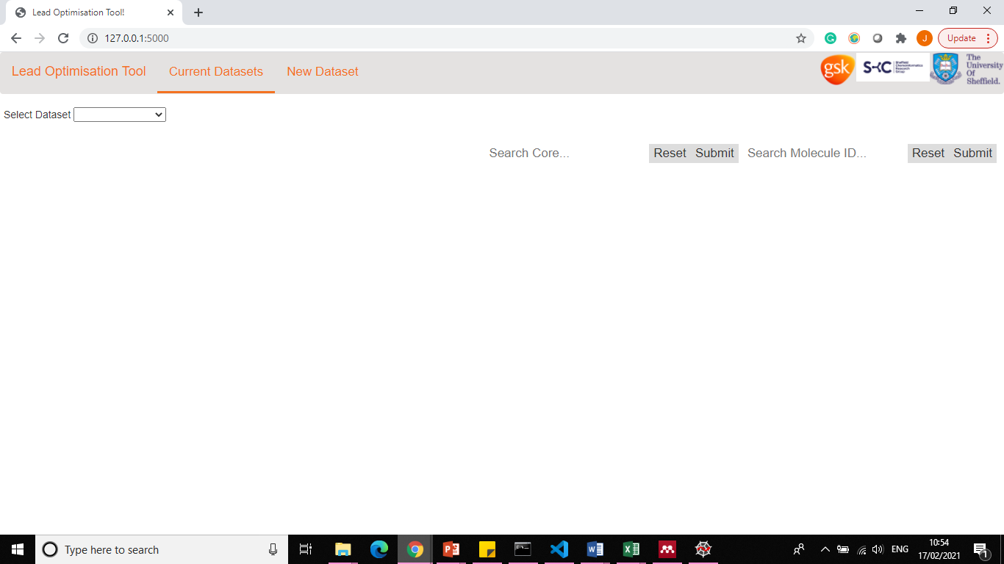

Figure : Initial Page of the RG Core Visualisation

The tool loads on the ‘**Current Datasets**’ page.

**Examining an Existing Dataset**

Select the dataset that you are interested in using the ‘**Select Dataset**’ dropdown menu.

If there is round data within this dataset the first round is displayed and it can then be changed via the dropdown menu labelled as ‘**Select Round’**. Additionally, if the dataset does contain round data a table can be displayed of the progression of the cores that have been found within this dataset.

Once selected a scatterplot of the dataset is shown. You may have to zoom out to see all the plot. Initially, a PCA plot is displayed but this can be switched to a TSNE plot using the selection panel. An image of the plot can be download by clicking the Save Plot Button.

Each point within the scatterplot can be **hoovered** over and a pop up appears displaying the SMILES, ID and Core that this molecule represents.

It is also possible to highlight the molecule(s) that associate to a RG core or Molecule ID these can be searched in the top **two search bars** and if they are present they become highlighted within the scatterplot or the RG core visualisation.

To generate the RG cores and the main visualisation select the ‘**RG Core Visualisation**’.

This initially focuses on all of the RG cores extracted from the dataset. There are two main features on this page the RG Core visualisation that demonstrates each of the RG Cores where the nodes are pie charts to show the level of exploration of each of the nodes. Along with a table of the each of the cores and each of the unique combination of the node substructural fragments. Once again, the search bars can be used to highlight the core and molecule ID.

The pie charts (nodes) can be **hoovered** over to quickly received a brief roundup of that node: SMILES (RG code), Number of functional groups and image of the example with the number of. The pie charts can also be **clicked** which introduces a pop-up menu that shows that node in greater depth. It provides a table of the substructural fragments and their following information.

The RG core visualisation can be saved as an image by clicking the ‘**Download RG Core as Image**’. The node labels can be switched on and off using the ‘**Node Labels:**’ selector. The cores can be filtered on the number of examples that they equate to using the ‘**Filter Cores on Existing Number of Examples:**’ the RG core that have the number of examples between the selected max and min should be displayed.

An excel table can be downloaded of the table data too by clicking the ‘**Download Table**’ button that lies just above the table. If round data is present, the core header states whether it is a new core by displaying ‘*NEW*’.

If one core wants to be examined further on its own. Select the ‘**Single Core**’. This brings up a dropdown menu where the core can be selected. This brings up the RG core with pie charts, which has the same functionality as before. The table, however, is different and shows molecules that relate to this core and how and where this is done. This table can also be downloaded as an excel table.

Additionally, the final RG core visualisation option compares cores by clicking ‘**Core Comparator**’ in the third navigator. The cores that are selected to be compared are shown once they have been selected using the radio buttons. However, this shows all the data as the first RG core visualisation screen, just for the RG cores that have been selected.

**Examining a New Dataset**

To run a new dataset through the visualisation the ‘**New Dataset**’ button in the top navigator should be selected.

The user is then present with a table of parameters to set to run the new dataset through the RG core process. The file should be in the format in a tab format with headers: ‘SMILES ID pIC50 Round’. The round column does not need to be present, however, if it is please state the round names within the ‘Round Data’ row separate each round name by a space i.e. ‘round1 round2’. If two rounds are present called round1 and round2. Then click submit and let it process the data, this may take some time. However, the screen will be the same as before and have all the same functionality.