S.O.D.A

Sheffield Obstetric Difficult Airway Course

SODA Course Application Form

Sheffield Teaching Hospitals NHS Foundation Trust
Medical Education Department, R Floor,
Royal Hallamshire Hospital
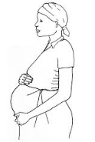
Glossop Road, Sheffield, S10 2JF
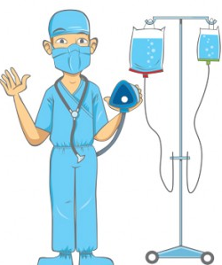

Monday 12 November 2018/ Monday 20th May 2019

Personal details:

Name:

Email address:

Contact Tel No:

Current Hospital Base:

Grade and Specialty:

Dietary Requirements:

COST: (Consultant grade £100, Trainee/non-Consultant grade £50, ODP and Obstetrics £20)

If you wish to pay over the phone by card, please contact

Kate Guest on (0114) 2711793 to arrange payment

Please note we do not accept American Express

OR
I enclose a cheque payable to “Sheffield Hospitals Charity” to the total amount of £

PLEASE SEND TOGETHER WITH YOUR APPLICATION FORM TO:

Mrs Kate Guest
Sheffield Teaching Hospitals NHS Trust
Medical Education Department, R Floor
Royal Hallamshire Hospital
Sheffield
S10 2JF

PTO

I wish to apply for a place on the Sheffield Obstetric Difficult Airways (SODA) course. I have read and agreed the full terms and conditions as below.

Date of course: (circle as required)….. 12th Nov 2018……. 20th May 2019………..

Signed:

Print Name:

Please read carefully the terms and conditions below

Terms and conditions:

- Booking will only be confirmed on receipt of a fully completed registration form and full payment.

- Cheques to be issued in Sterling only.

- Cancellation requests will only be accepted when BOTH VERBALLY requested and subsequently CONFIRMED IN WRITING and will be accepted ONLY from the date the request is received in writing.

- The amount of refund granted will be according to the following scale

Cancellation received up to 21 days before 8.30 am on 1st day of course: 100% refund
Cancellation received up to 14 days before 8.30 am on 1st day of course: 75% refund
Cancellation received less than 14 days before 8.30 am on 1st day of course: 0% refund

PLEASE SEND TO:

Mrs Kate Guest
Sheffield Teaching Hospitals NHS Trust
Medical Education Department, R Floor
Royal Hallamshire Hospital
Sheffield
S10 2JF
Kate.Guest@sth.nhs.uk

Confirmation will be sent to you following receipt of payment

