NAAVN DDBMS Frontend Project Report
Project: AVN DDBMS (Nigerian Army Aviation Dashboard Frontend)
Workspace: /Users/ram/projects/avn-frontend
Report Date: 2026-05-21
Platform Targets: Web (Vite/React), Desktop (Tauri + Electron configs present)

1. Executive Summary
This project is a modular, enterprise-scale operational dashboard for Nigerian Army Aviation. It is built with React 19 + TypeScript and organized by features, supporting role-based access, real-time capabilities, finance workflows, inventory and procurement lifecycles, operations, maintenance tracking, document handling, reporting, messaging, and user/security administration.

2. Technology Stack
- Frontend framework: React 19 + TypeScript + Vite
- Routing: React Router with lazy-loaded route modules
- State/API: Redux Toolkit + RTK Query + Axios base query
- Styling: Tailwind CSS v4 + design tokens
- Utilities: html2canvas + jsPDF for PDF export, xlsx for spreadsheet workflows
- Realtime: Laravel Echo + Pusher
- Desktop packaging: Tauri 2 and Electron build paths
- Testing: Vitest + Testing Library

3. Major Feature Areas
- Authentication: Login, registration, forgot-password, OTP verification flow, guarded routes.
- Finance: Expenses and budgets/accounts, budget statements, income recording, dynamic currency handling, expense edit/view slider and PDF export.
- Inventory & Procurement: Inventory CRUD views, requisitions, suppliers, RFQ details, purchase orders, procurement lifecycle.
- Operations: Operations list/detail/create/edit, after-action reporting, map/location workflows.
- Maintenance: Work orders, defects, planning/compliance/tracking flows, maintenance program CRUD.
- Assets: Asset listing/details and create/edit for aircraft, vehicles, facilities; defect workflows.
- Personnel & Units: Personnel directory/detail and unit management pages.
- Security & Users: Security module plus user details/add-user views, role/permission route gating.
- Reports & Documents: Dedicated modules for reporting and document management.
- Messaging: Message module with compose and realtime support scaffolding.

4. Routing Coverage Snapshot
- /auth/login, /auth/register, /auth/forgot-password, /auth/verify-otp
- /dashboard/finance, /dashboard/finance/add, /dashboard/finance/budgets/add, /dashboard/finance/budgets/:id, /dashboard/finance/budgets/:id/statement
- /dashboard/inventory and related requisition/purchase-order/rfq/procurement-lifecycle routes
- /dashboard/operations and add/edit/details/after-action-report routes
- /dashboard/maintenance and work-order/details/defects/compliance/tracking routes
- /dashboard/assets, /dashboard/personnel, /dashboard/units, /dashboard/documents, /dashboard/reports, /dashboard/messages, /dashboard/security, /dashboard/users

5. Build & Deployment Readiness
- Production web build: tsc -b && vite build
- Desktop build: Tauri (macOS Intel x86_64 verified)
- Electron build scripts available for Windows packaging
- Firebase deploy workflow present in workspace operations

6. Screenshots

Login Screen (/auth/login)
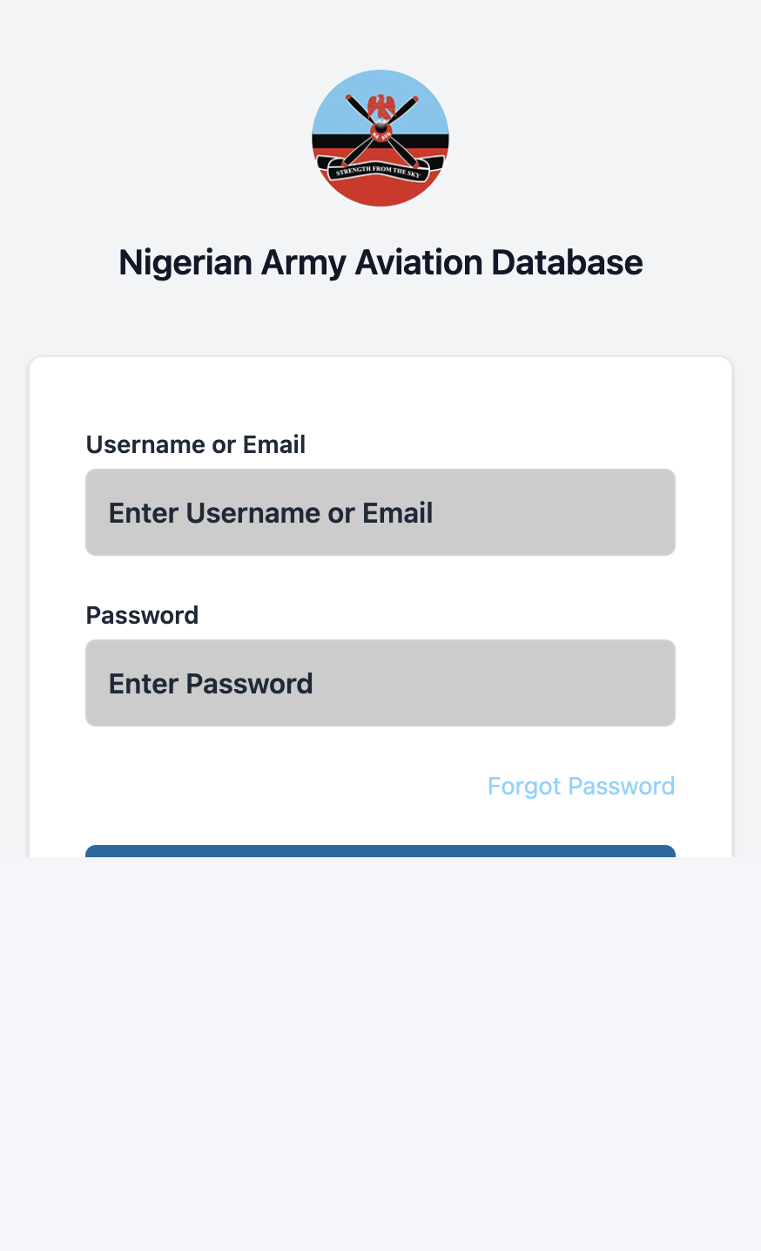
Captured from: login.png

Registration Screen (/auth/register)
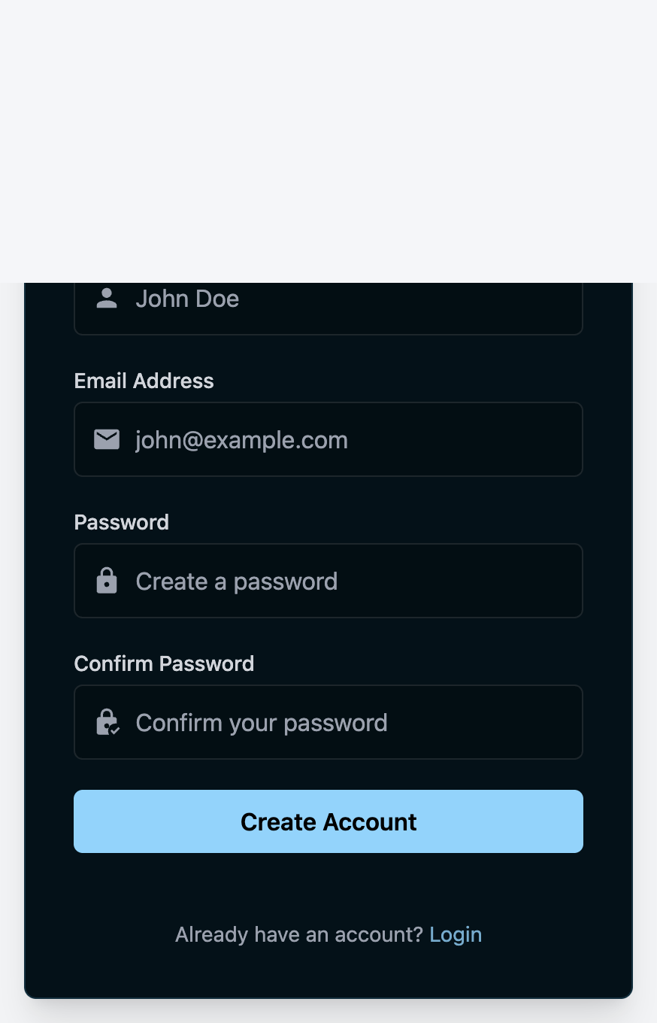
Captured from: register.png

Forgot Password Screen (/auth/forgot-password)
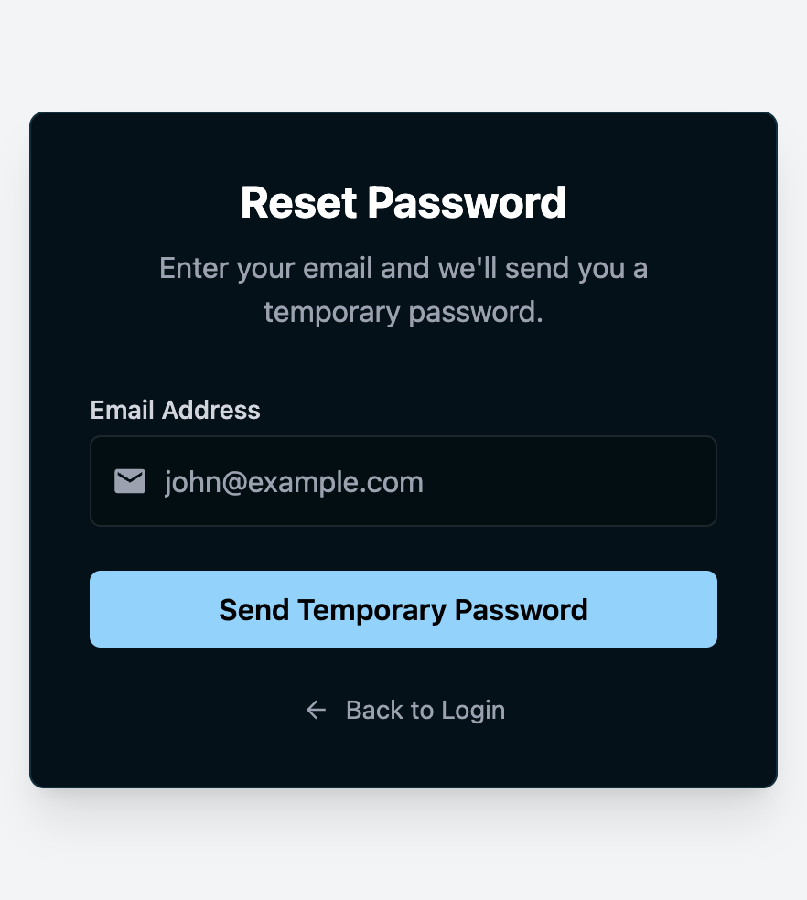
Captured from: forgot-password.png

7. Notes
Authenticated internal module screenshots (finance dashboard, inventory, maintenance, etc.) require valid login credentials. This report includes all publicly reachable entry/auth screens captured from the running app.

