| PyramidTech Summer  Internship (PTI22) |
| --- |
| **RTL Design, Validation, and Implementation of Elevator Controller**  **Project Documentation** |
|  |
| Prepared by:  **Shehab Bahaa** |
|  |

**Table of Contents**

1. FSM State Diagram **2**

2. ASM Chart **2**

**Elevator Controller**

# 1. FSM State Diagram

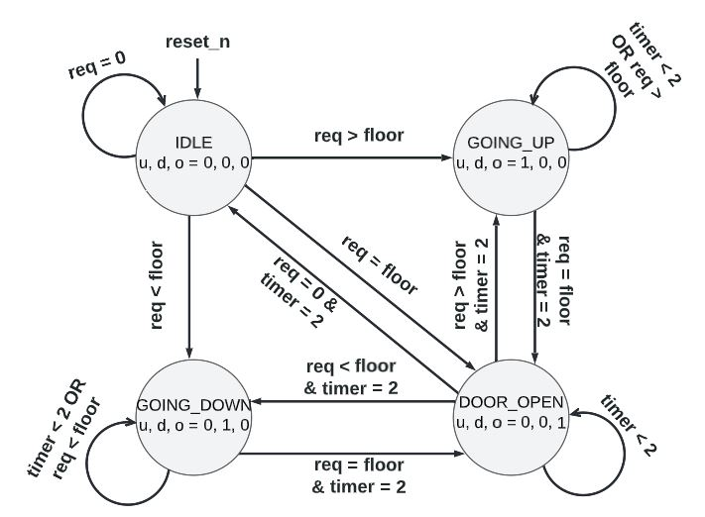

# 2. ASM Chart

