**CSE212 Web Programming, Fall semester 24/25**

**Assignment #1: Websites conceptual design and mock up**

**222100828 – Shehab Essam Hassan**

# Part 1: Research

(Q1)

# Web 2.0 Characteristics:

* + - 1. **User-Generated Content**: Emphasis on content created by users (blogs, social media posts, videos).
      2. **Interactivity**: Websites became more interactive and dynamic, allowing users to engage with content and each other.
      3. **Social Networking**: The rise of social media platforms (Facebook, Twitter) transformed how users connect and share information.
      4. **Collaboration**: Tools for collaboration emerged, enabling users to contribute collectively to projects.
      5. **Software as a Service (SaaS)**: Increased use of APIs to allow different applications to communicate and share data.
      6. **Rich User Experiences**: To create smoother, faster, and more interactive user interfaces.
      7. **Folksonomy**: The users who add a tag or label to identify a piece of content (Tags/Social Bookmarking).
      8. **Centralized**: Major platforms in Web 2.0, such as Google, Facebook, and Twitter, store huge amounts of user data, requiring central control.

# Web 3.0 Characteristics:

1. **Semantic Web**: Focus on making internet data machine-readable, allowing for better data and more intelligent applications.
2. **Decentralization**: Ensures secure, transparent transactions and governance via blockchain, fostering platforms like DeFi and DAOs.
3. **AI and Machine Learning**: Use of artificial intelligence to analyze data, personalize user experiences, and automate tasks.
4. **User Ownership**: Users have more control over their data, often facilitated by decentralized identity solutions.
5. **Blockchain Technology**: Used to let users own and manage their data without relying on central authorities and gives users greater control over their personal data.
6. **computing**: involves moving computing and storage functions closer to data sources at the edge of the network.
7. **Ubiquity and Connectivity**: Facilitates seamless internet access from any device, advancing digital connectivity with IoT and 5G technologies.

# Web 4.0 Characteristics:

1. **Symbiotic Relationship**: Seamless interaction between humans and machines.
2. **Intelligent Web**: Integration of advanced AI and machine learning to create highly personalized and context-aware experiences.
3. **Ubiquitous Computing**: Technology is embedded in everyday objects, leading to a more connected and interactive environment.
4. **Emotional Interaction**: Development of systems that can recognize and respond to human emotions, improving user engagement.
5. **Metaverse**: Virtual reality environment for interaction with others and digital objects.
6. **Internet Of Things**: Connecting a vast array of devices, sensors, and objects to the web.
7. **Artificial Intelligence**: Understanding and responding to human input, Natural language processing and object recognition.
8. **Brain-Computer Interfaces (BCIs)**: Direct communication between the brain and computers.

(Q2)

# Web 2.0 features include:

**Comment Sections**: Allowing users to interact and discuss content directly on a webpage.

**Like/Share Buttons**: Facilitates user engagement by allowing them to quickly respond to or share content.

**User Profiles and Personalization**: Allows users to have profiles, customize settings, and receive personalized content.

**APIs and Data Sharing**: Many Web 2.0 sites offer APIs that allow developers to integrate or interact with their platforms.

Tagging and Hashtags: Enable better content organization and discovery by users. Wikis: Platforms like Wikipedia where users can collaboratively edit and manage content.

Features are the actual tools and elements that provide the Web 2.0 experience.

# -Web 2.0 empowers networks by transforming users from passive viewers into active participants, which enhances connectivity, collaboration, and information sharing. Here’s how:

1. **User-Driven Content**: Communities form around shared interests, with users creating and sharing their own content.
2. **Real-Time Communication**: Tools like messaging and live streaming enable instant interactions, strengthening connections.
3. **Collective Intelligence**: Collaborative platforms, like wikis, harness group knowledge for shared goals.
4. **Social Capital and Peer Influence**: Networks of followers amplify influence, spreading information rapidly.
5. **Enhanced Discovery**: Tagging and algorithms improve content discovery and foster community building.
6. **Global Reach**: Accessible to anyone, Web 2.0 breaks down barriers and supports a truly global network.

(Q3)

# Web 3.0 features include:

1. **Cryptocurrency Integration**: Enables decentralized transactions and smart contracts, transforming online asset management and security.
2. **Token-Based Economies**: Digital tokens incentivize participation and reward users in decentralized networks.
3. **Personal Data Ownership**: Users have greater control over their data and can choose how it is used and shared.
4. **Blockchain Technology**: Enables secure, transparent, and tamper-proof transactions and data storage.
5. **Smart Contracts**: Automated contracts executed on blockchain networks, enabling secure and transparent transactions.
6. **Artificial Intelligence**: Enhances user experiences with personalized recommendations and predictive analytics, revolutionizing sectors from healthcare to finance.
7. **Open network**: Web 3.0 is an open network, and all applications and programs are developed with open-source software.
8. **Decentralization**: Ensures secure, transparent transactions and governance via blockchains.
9. **Development of Technology 3.0**: Integrates AI, blockchain, and IoT for a decentralized and intelligent internet, driving innovations in finance, gaming, and education.

# Web 3.0 enhances the Meaning of Data and Knowledge Connections through several key mechanisms:

1. **Decentralized Knowledge Sharing**: Direct peer-to-peer interactions enable

users to share knowledge without centralized platforms, fostering diverse contributions.

1. **Interoperability**: Facilitates seamless integration of data across platforms, enabling effective connections and utilization of knowledge.
2. **Semantic Web Technologies**: It provides context and meaning to data, improving search capabilities and enabling deeper exploration of information.
3. **Personalized Learning**: AI-driven recommendations tailor knowledge acquisition to individual needs, enhancing the learning experience.
4. **Collective Intelligence**: Crowdsourced knowledge bases empower communities to collaboratively create and validate information, ensuring reliability.
5. **Tokenization of Knowledge**: Tokenization incentivizes contributions, allowing users to maintain ownership and monetize their insights.
6. **Trust and Integrity**: Blockchain technology ensures immutable records of contributions, fostering trust and accountability.
7. **Global Accessibility**: Web 3.0 breaks down barriers to knowledge access, promoting cultural exchange and enriching collective understanding.
8. **AI and Machine Learning**: Analyzes data for insights and tailors' knowledge delivery to user preferences, enhancing relevance and engagement.

(Q4)

# Web 4.0 features include:

1. **Improved Security**: Utilizes advanced Cryptographic technologies and decentralized architectures to provide enhanced security and privacy. It also facilitates safeguarding users’ sensitive data.
2. **Augmented Interactivity between Humans and Machines**: Allows for real- time interactions and dynamic content updates, improving the overall user experience and enhancing online engagement. It enables users to engage with information and services innovatively through immersive experiences like virtual and augmented reality.
3. **Personalization**: Aims to deliver personalized online experiences by utilizing AI algorithms to analyze user preferences and behaviors. This analysis enables the provision of tailored and customized content, product suggestions, and services to users.
4. **Efficiency and Automation**: Leverages AI and the Internet of Things to automate tasks, streamline processes, and improve productivity as well as convenience for users.
5. **Data-driven innovation**: Enhances decision-making by providing data-driven insights and predictions. It enables businesses and individuals to make informed choices through the analysis of extensive data. Leveraging this data, businesses, and industries can drive innovation, develop new products and services, and remain competitive by adapting to shifting market demands and trends.
6. **Important Technologies Behind Web 4.0**: Aims to enhance web accessibility, particularly for individuals with disabilities. It aims to empower them to navigate web content seamlessly with the aid of assistive technologies. Below are some of the top technologies that can improve Web 4.0’s credibility and usage.
7. **Brain-Computer Interfaces (BCIs)**: Let people control computers using their thoughts. These systems measure brain activity and turn it into commands that computers can follow. While BCIs are still being worked on, they could change how we use technology in the future.
8. **Metaverse**: A virtual reality space, could serve various purposes in Web 4.0 such as social networking, gaming, education, and business. It enables people to interact with each other and with computer-generated characters. The metaverse has the potential to transform the way we communicate and engage with the world around us.
9. **Artificial Intelligence and Big Data**: Web 4.0 relies on Artificial Intelligence to understand and adapt, analyzing user behavior for personalized online experiences. It also harnesses Big Data to gather insights, enhance services, and guide data-driven decision-making, guaranteeing adaptability and competitiveness across businesses and industries.
10. **Internet of Things (IoT)**: Actively embraces the Internet of Things, linking an extensive range of devices, sensors, and objects to the web. This integration fosters a seamless and immersive user experience, blending physical and virtual environments.
11. **Assistive technology**: A generic term that describes tools used by people with disabilities to accomplish tasks.
12. **3D Environment**: That can be accessed by anyone with an internet connection.

# Web 4.0, often characterized as the "Symbiotic Web," empowers Intelligence Connections in several transformative ways:

1. **Artificial Intelligence (AI)**: At the core of Web 4.0 is AI, which enables the internet to understand, learn, and adapt. AI systems can analyze user behavior, providing highly personalized and efficient online interactions.
2. **Big Data Utilization**: Web 4.0 harnesses the power of big data. Enormous volumes of data generated by users and devices are collected and analyzed to provide insights, improve services, and support data-driven decision-making.
3. **Cloud Computing Integration**: Cloud computing is the backbone of Web 4.0. It offers scalable and flexible resources for data storage and processing. This scalability is crucial to meet the increasing demands of a highly connected world.
4. **Internet of Things (IoT)**: IoT plays a central role in Web 4.0 It connects devices, sensors, and everyday objects to the internet, creating a network that can share data and perform tasks autonomously. This interconnectedness is transforming various aspects of life, from smart homes to industrial automation.
5. **Efficiency and Automation**: With AI and IoT, Web 4.0 offers increased efficiency and automation. This means processes are streamlined, and tasks can be automated, enhancing productivity and convenience.

(Q5)

1. **Collective Intelligence**: Improves coordination, it allows workers to find new, more efficient ways of getting things done. In turn, this reduces the need for supervision, which saves managers time and allows them to concentrate on other things, whilst also cutting transaction costs.
2. **Social Networking**: Connects individuals and businesses by allowing them to share information, ideas, and messages. Companies also use social networks to

create and strengthen brand recognition, promote products and services, and answer customer queries and concerns.

1. **Social media**: An important part of today's world. It helps people stay connected and share ideas, thoughts, and opinions with others in a safe and secure environment. It can also be used to promote businesses, organizations, and causes, as well as to stay informed about current events and trends.
2. **Social Bookmarking**: People visit social bookmarking sites because they can create and share links to popular websites. Businesses can effortlessly generate an attractive profile and participate in this community. By creating content there, you welcome website traffic.

(Q6)

Collective Intelligence, social networks, social media, and social bookmarking play pivotal roles in empowering current and future business strategies.

By bringing together a wide range of viewpoints, they fuel innovation and creativity, support well-informed decisions through crowd-sourced insights, and foster a nimble approach to evolving market trends.

Social Networks broaden the reach to prospective clients, partners, and industry influencers, while fostering direct interactions that strengthen customer loyalty.

Social Media boosts brand visibility and optimizes marketing efforts, facilitating real- time customer engagement and providing crucial analytics on consumer preferences to refine approaches.

Social bookmarking contributes by establishing industry credibility, improving teamwork, and managing resources effectively. Together, these tools drive innovation, engagement, collaboration, and marketing impact, positioning businesses to thrive in a digital environment and adapt seamlessly to changing market needs.

(Q7)

I would use the latest technologies to develop responsive, interactive, and secure websites that offer exceptional user experiences.

AI-powered tools support adaptive layouts and personalized content, while AR/VR integrations add immersive elements, which are particularly advantageous in e- commerce. Blockchain technology enhances security, especially for decentralized applications.

Incorporating accessibility features, progressive web apps, and 3D graphics makes sites more inclusive, mobile-optimized, and visually engaging.

Additionally, no-code tools and automation simplify the design workflow, enabling faster prototyping and better collaboration with clients.

This strategy aligns with current web standards, helping clients distinguish themselves in a digital-centric world.

# Part 2: Website Planning

1. **Define the Purpose of the Website**

The website is a virtual store dedicated to selling gym equipment. Its primary goal is to provide an easy-to-navigate platform where customers can browse, select, and purchase various types of gym equipment for home or commercial use.

# What Would You Like the Website to Accomplish?

The website should offer a seamless shopping experience, showcasing a range of gym equipment, from weights and treadmills. It should aim to simplify the purchasing process, encourage user engagement, and help build trust with customers through clear, honest product descriptions and customer reviews.

# Who is Your Intended Audience?

The target audience includes:

Gym owners looking to upgrade or expand their equipment Casual exercisers seeking quality equipment to use at home Personal trainers or fitness professionals

# What Opportunities, Problems, or Issues Does the Planned Website Address?

Opportunity: Capitalize on the growing trend of home workouts and fitness.

Problem: Many fitness enthusiasts face difficulty finding quality gym equipment online at fair prices.

Issue: Lack of guidance or advice on suitable equipment for different fitness goals.

# What kind of content could be incorporated on your website?

Product Pages: Dedicated pages for each product with high-quality images, detailed descriptions, specifications, pricing, and availability to help users make informed purchasing decisions.

Customer Reviews: A section for users to submit reviews and ratings, providing social proof that builds trust and influences new customers.

FAQs: A dedicated section addressing common questions about shipping, returns, and product use, which helps reduce customer service inquiries and enhances user satisfaction.

About Us Page: A page that shares your business story, mission, and values, personalizing your brand and fostering trust with customers.

Contact Information: Clear access to contact details, including email, phone numbers, and a contact form, encouraging customer inquiries and enhancing support.

# How Will the Site Serve the Client?

The site will provide a reliable and convenient shopping experience with secure transactions, clear product information, and personalized recommendations based on user preferences.

# What's the Best Method for the User to Do What's Wanted?

Easy Navigation and Search: Organize products into clear categories and include a prominent search bar to help users quickly find items, enhancing the shopping experience.

Clear Call to Action (CTA) Buttons: Use distinct buttons for actions like “Add to Cart” and “Buy Now” to guide users through the purchasing process and encourage engagement.

Wish List Feature: Allow users to save products for later consideration, potentially including notifications for discounts, which encourages return visits and future purchases.

Cross-Selling Suggestions: Display related products on item pages and during checkout to increase average order value by encouraging users to consider complementary items.

# How will users find the function?

Navigation Bar: A fixed bar at the top for easy access to key sections like Home, Shop by Category, and Contact, enhancing site exploration.

Search Bar: A prominently placed search feature on every page, allowing users to quickly find specific products.

Filters on Product Pages: Options to filter by price, brand, equipment type, and user ratings, making it easier for users to find products that meet their criteria.

Clear Visual Cues: Consistent icons, colors, and fonts to highlight important actions, improving usability and guiding users through their shopping journey.

Help Options: Easily accessible support features like FAQs and live chat to assist users with questions or concerns, enhancing customer satisfaction.

# How Will the Results of the Function Be Received?

Email Notifications: Automated emails for order confirmations, shipping updates, and customer support responses to keep customers informed.

SMS Notifications: Option for users to receive SMS alerts for important updates and promotions, utilizing services like Twilio for automation.

User Feedback: If users are using a filtering or search function, the website should instantly display matching products or results, giving users immediate feedback on their actions.

Real-Time Updates: If any product is out of stock or unavailable, users should see this in real time to avoid disappointment at checkout.

# What Will the Receiver Do with the Received Entries?

1. Order Confirmation and Inventory Update: Confirm customer orders and update inventory levels to reflect sales and product availability.
2. Responding to Inquiries and Feedback: Address customer inquiries and feedback promptly, aiding with product questions and order statuses.
3. Updating Wish Lists and Account Information: Allow users to update their wish lists and manage account information

# How Will the Receiver Deal with Results?

Order Status Tracking and Shipment Processing: Manage and track customer orders, ensuring timely shipment and communication of order statuses to customers.

Customer Support: Any support requests or feedback will be monitored and addressed by the customer service team, creating a continuous improvement cycle for the website’s user experience.

# What Follow-Up Will Be Needed?

Sending Order Confirmation and Shipping Notifications: Automatically send emails confirming orders and providing shipping details, including tracking information and estimated delivery dates.

Conducting Customer Satisfaction Surveys: Implement post-purchase surveys to gather customer feedback, assess satisfaction and identify areas for improvement.

Following Up on Abandoned Carts: Send reminder emails to users who abandon their shopping carts, potentially offering special deals to encourage them to complete their purchases.

# List at least two related or related sites found on the Web. Explain why you chose them.

1. Walmart Fitness Equipment

* Reason for Choice: Walmart’s website offers competitive pricing on fitness equipment and a straightforward shopping experience. Their integration of online and offline shopping options (such as in-store pickup) is worth studying for its convenience.

1. Fitness Superstore

* Reason for Choice: This specialized retailer offers a wide variety of gym equipment and accessories, with a focus on customer service and expert advice. Their approach to personalized shopping experiences can provide valuable insights into your store.

1. ProForm:

* Reason for Choice: ProForm focuses specifically on fitness equipment like cardio machines. Their site showcases how to effectively market specific brands and products, providing inspiration for product presentation and customer engagement.

# 14. Prepare the Planning Analysis Sheet that includes the following:

1. Website Goal: To create an engaging and user-friendly online store dedicated to selling gym equipment, providing an exceptional shopping experience through intuitive navigation, detailed product information, customer support.
2. Working Title of Pages (Excluding Home Page): 1- Products
3. About Us
4. FAQs
5. Contact Us
6. Shopping Cart
7. Wishlist
8. My Account
9. Description of Page Contents:
10. Homepage:

Contents: Engaging hero image or video, featured products, promotional banners, brief introduction to the store, navigation menu.

1. Products:

Contents: Comprehensive listings of gym equipment categorized by type (e.g., cardio, strength training), with product images, descriptions, prices, reviews, and filtering options.

1. About Us:

Contents: Company history, mission statement, and images related to the brand. 4- FAQs:

Contents: Common questions about products, ordering, shipping, returns, and customer support, presented in a clear, organized format.

1. Contact Us:

Contents: Contact form for inquiries, phone number, email address, and physical address. Maps or directions for a physical location, if applicable.

1. Shopping Cart:

Contents: List of selected products, quantities, prices, and total cost. Options for updating quantities, removing items, and proceeding to checkout.

1. Wishlist:

Contents: A list of products the user has saved for later purchase. Options to move items to the shopping cart or remove them.

1. Account Management:

Contents: User dashboard for account settings, order history, and saved addresses. Users can view past orders, track current orders, and update personal information. This page allows users to manage their account details easily.

1. User Forms:
2. Contact Form: Located on the “Contact Us” page, where users can submit inquiries.

Includes fields for name, email, and message.

1. Wishlist: Requires users to create an account or log in to save equipment. By creating an account, the system can track their saved items for future access.
2. Account Registration/Login Form: Allows users to create an account on the “My Account” page, with fields for name, email, and password.
3. Product Reviews: Users can submit reviews with a simple form that includes fields for rating, comments, and possibly an image upload.

e.

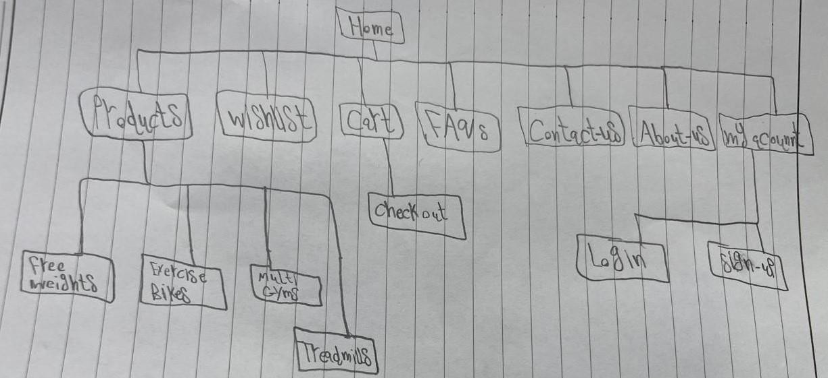

f. For the wireframes, you can use any design tool such as Figma, Adobe XD, or Canva to create the layouts.

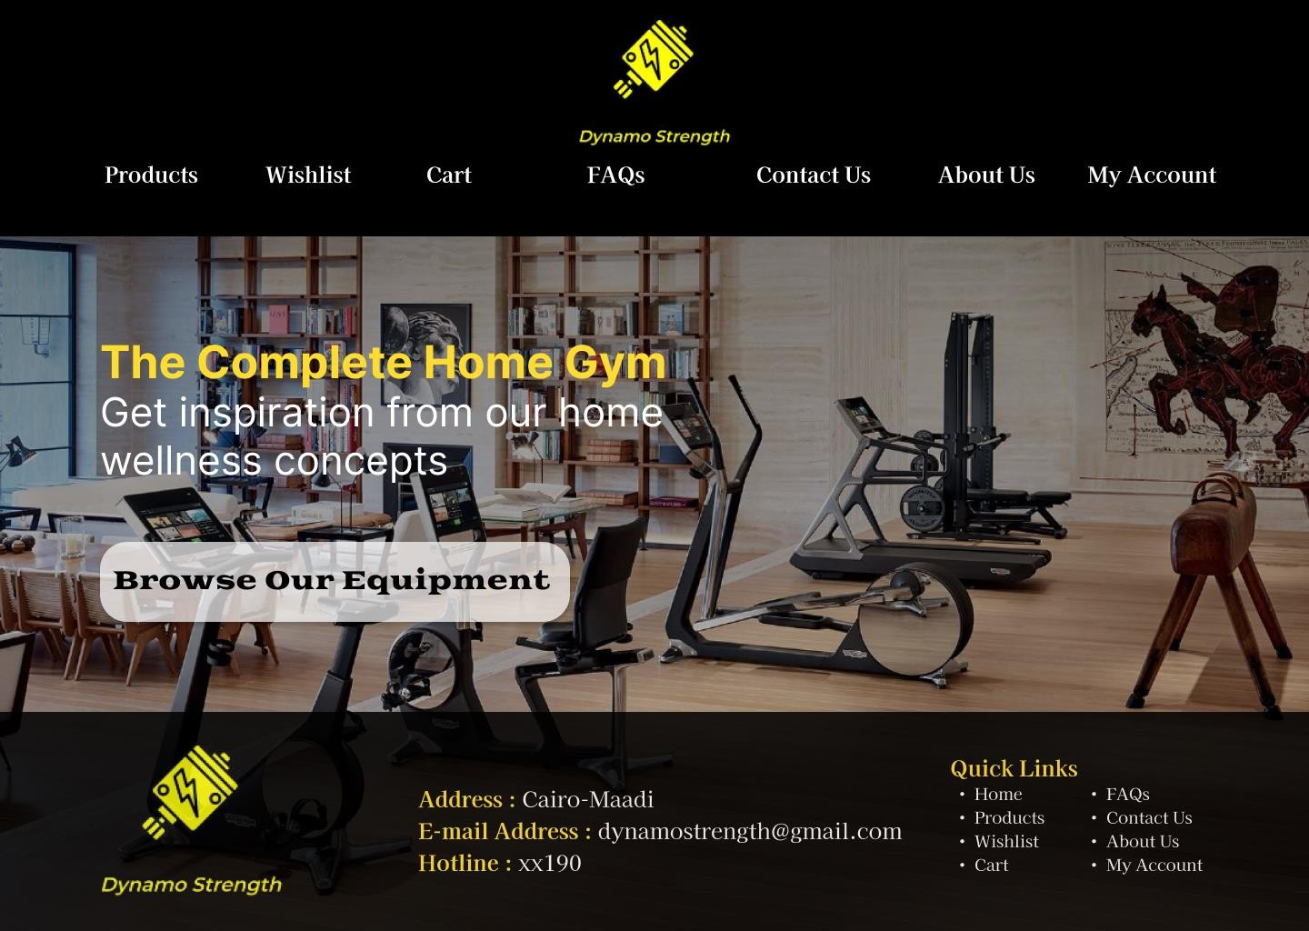

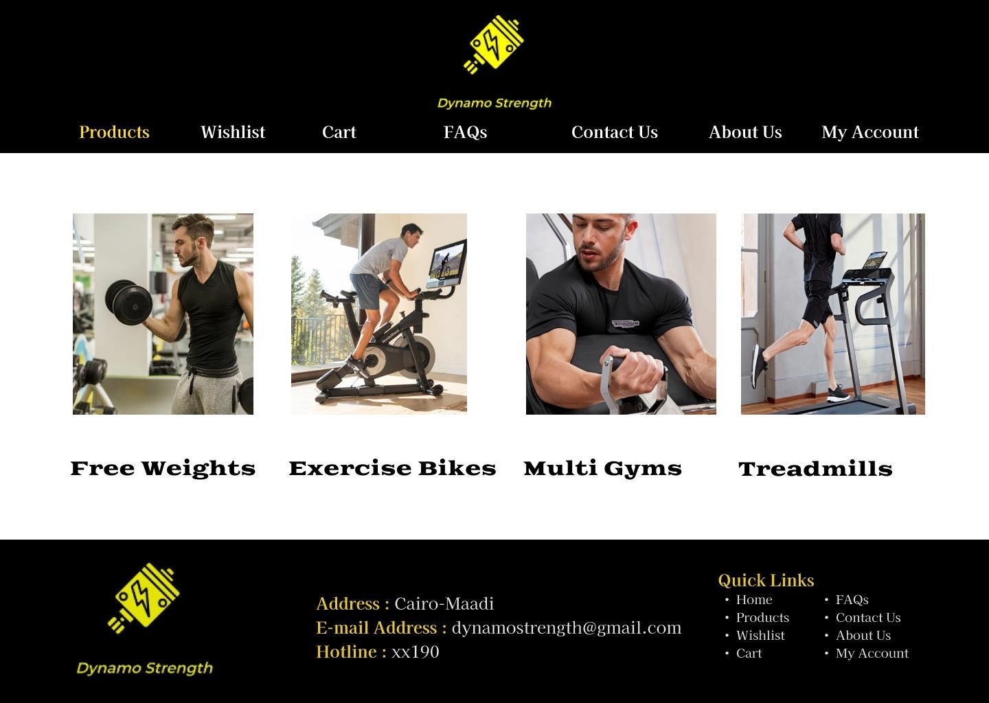

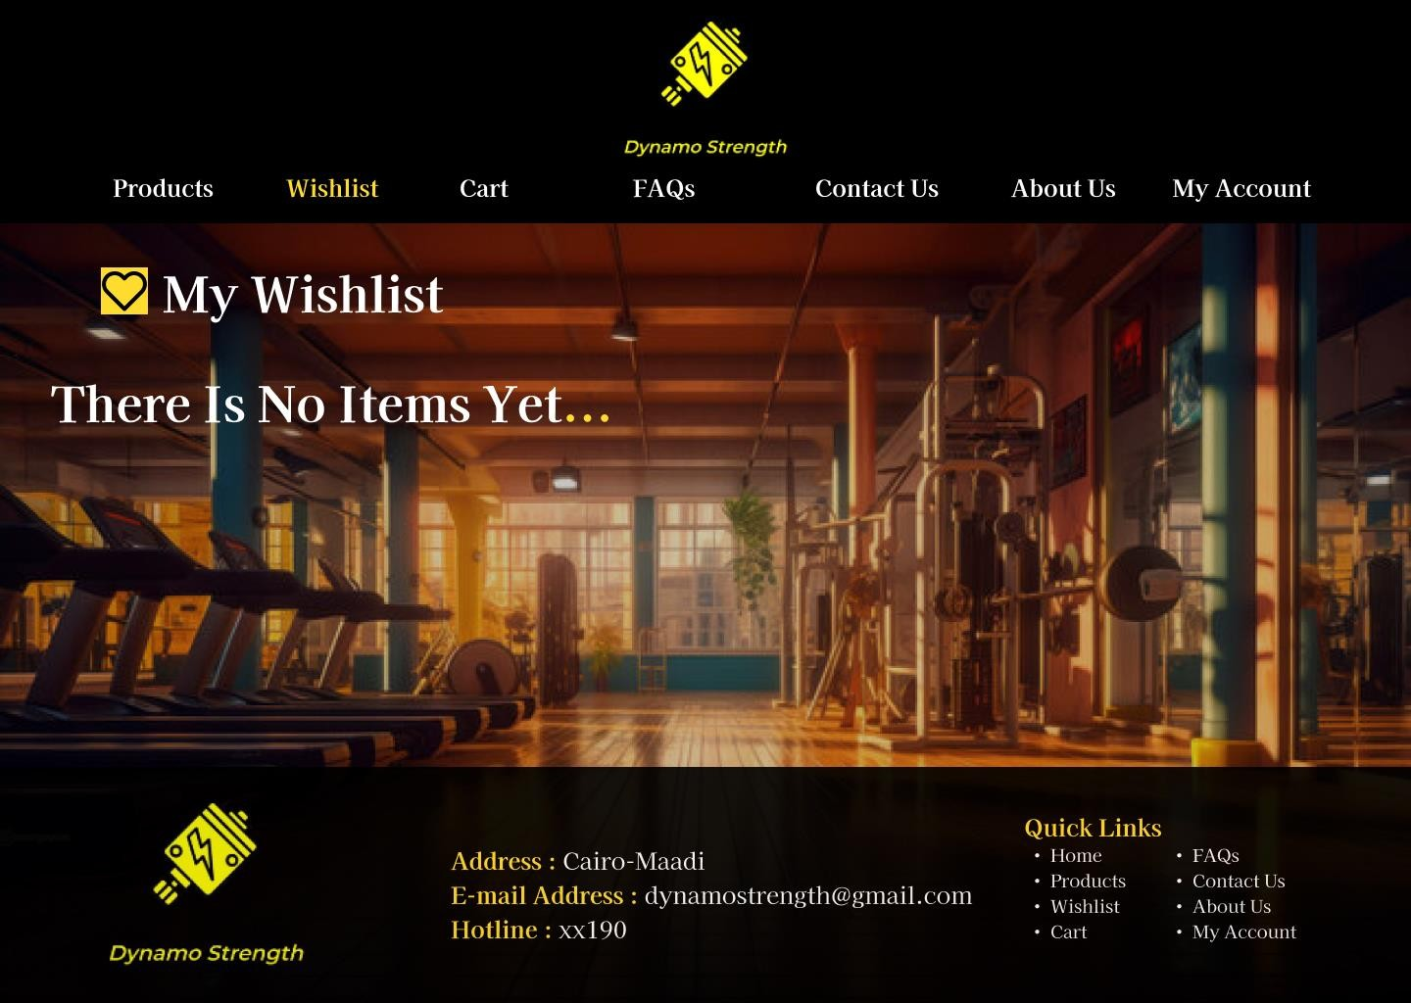

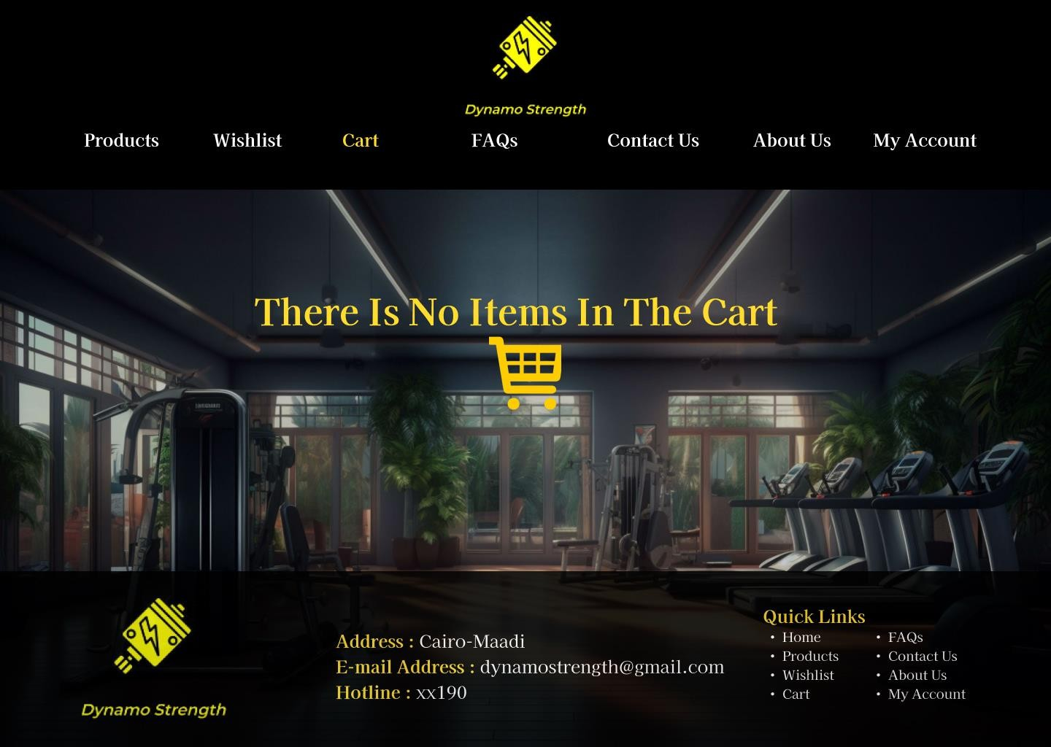

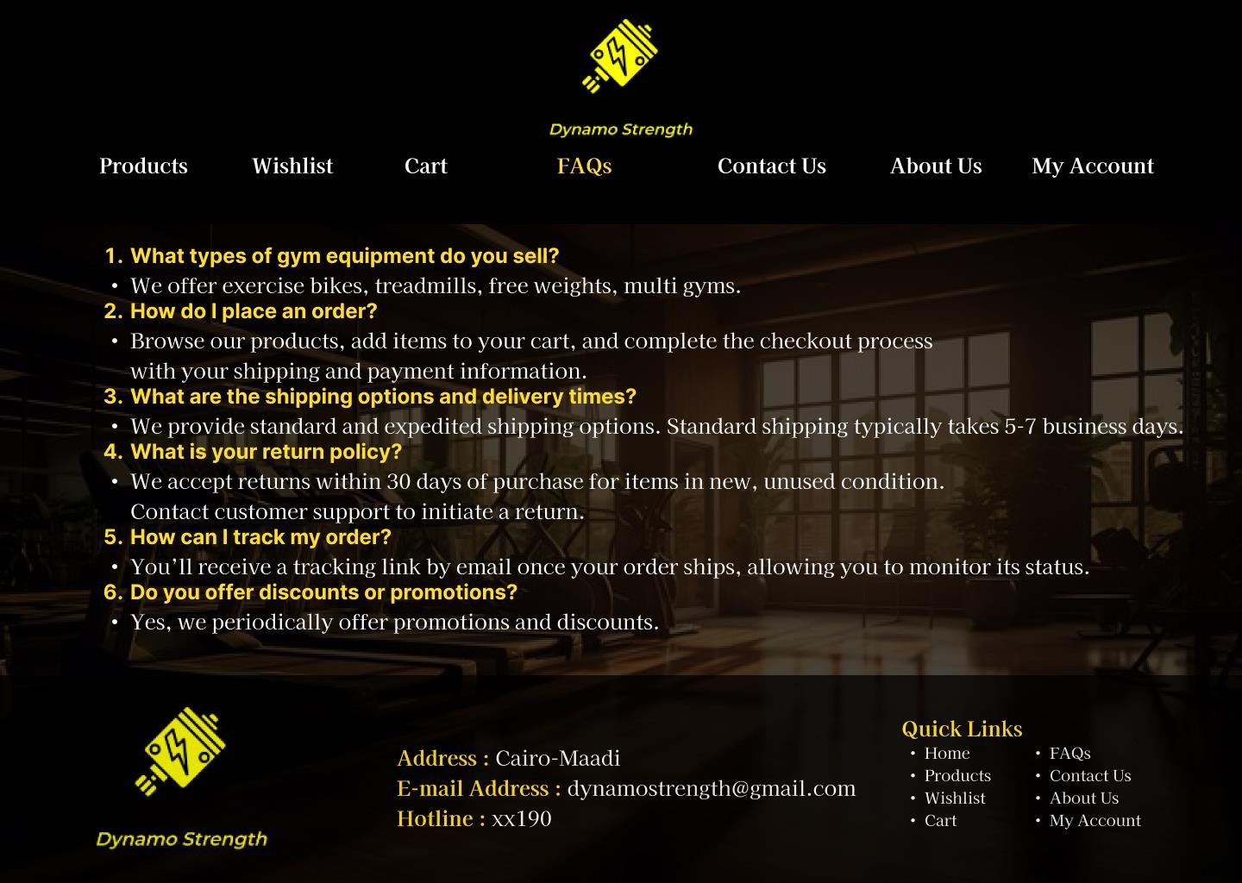

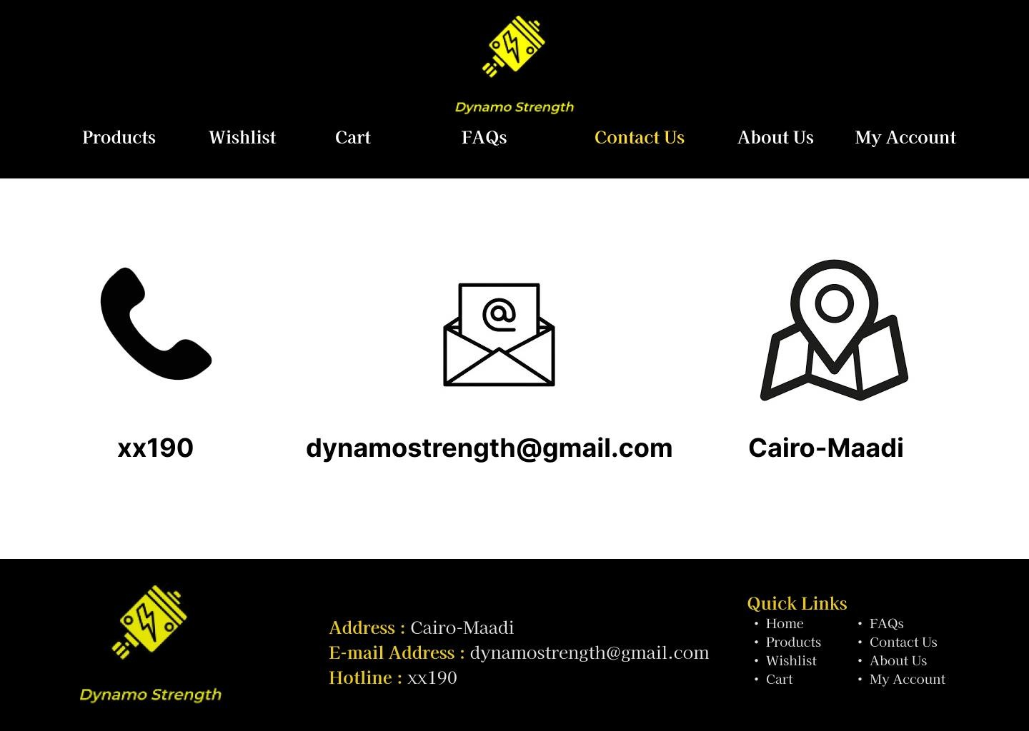

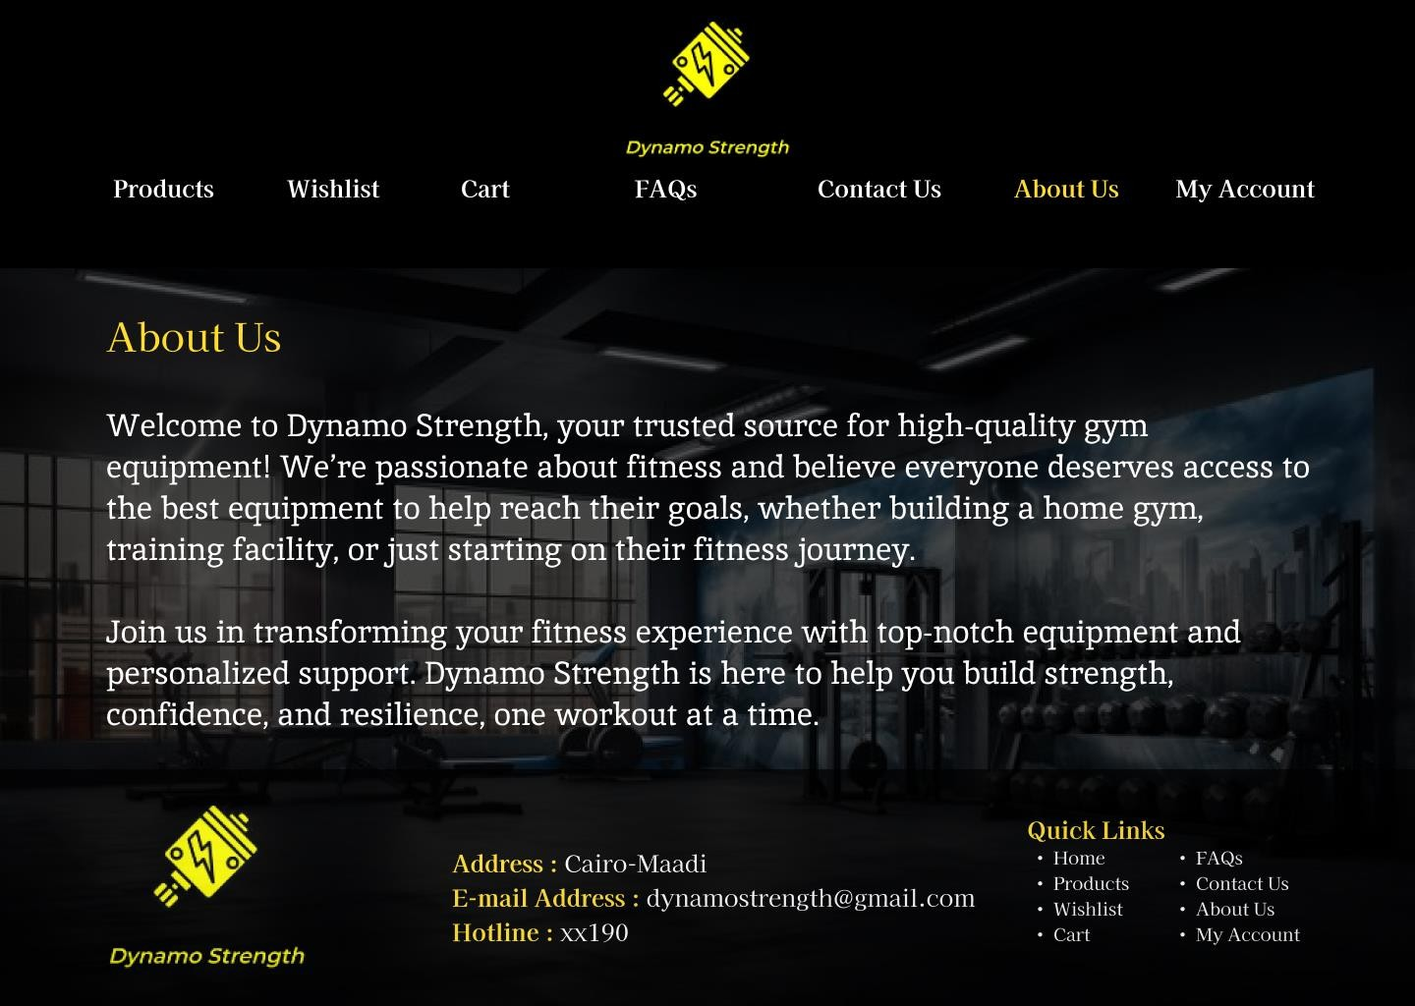

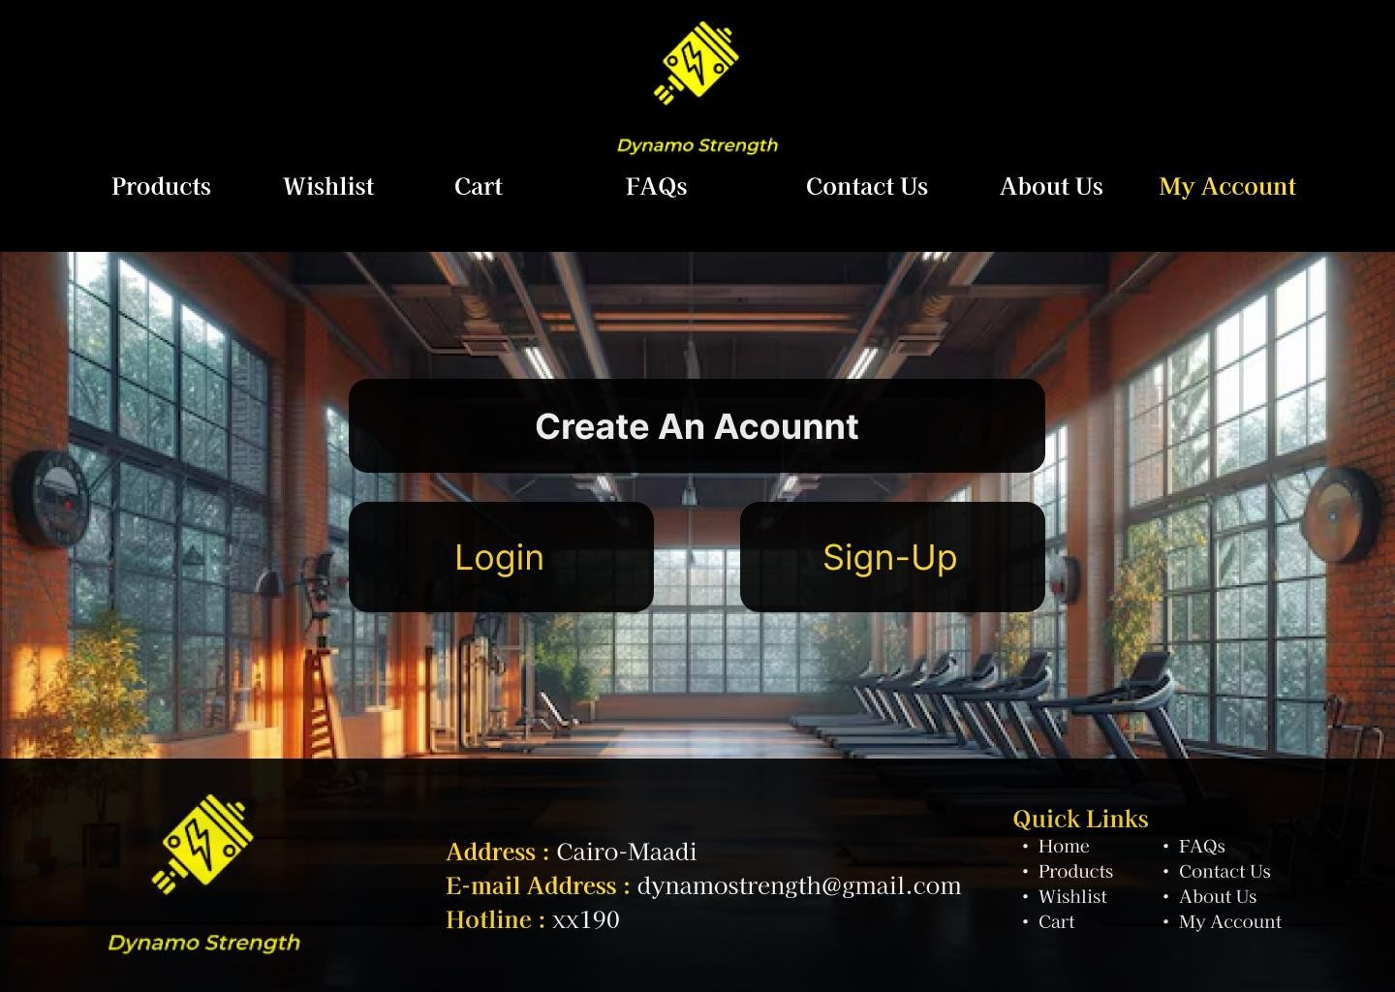

-Here’s a description for each wireframe component:

1. Logo: Placed in the top-left corner, linking back to the Home Page.
2. Navigation Menu: Horizontal menu with links to main pages (Products, Wishlist, About Us, FAQs, Contact Us, My Account).
3. Content Region: The primary content area will differ for each page:

a-Home Page: Visual banner, featured products, and links to categories. b-Products: Grid of product listings with filter options.

c-Wishlist: Grid of saved items for logged-in users.

d-About Us: Text and images about the brand’s story.

e-FAQs: List of common questions with expandable answers.

f-Contact Us: Contact form and company contact information.

g-My Account: User account dashboard showing order history and settings.

h-Shopping Cart: Summary of selected items with total price and checkout button. 4-Footer: Consistent across all pages with links to FAQs, Contact Us, About Us.

# Part 2: Website Design (A)

**Q1-** Clean, minimal layout to focus on core information.

**Q2-** Frames or containers around sections for a cohesive look.

**Q3-** Balanced layouts for easy readability.

**Q4-** White space around products for clear focus.

**Q5-** Apply consistent colors and fonts across the website, especially for elements like buttons or product titles. This creates a unified feel, linking sections like “Shop All Perfumes” and “My Account” as parts of a cohesive experience.

**Q6-** Backgrounds to group related items (e.g., Treadmills products).

**Q7-** Related items placed close together, ample white space.

**Q8-** Guide the user’s eye naturally across the page with aligned elements or

breadcrumb navigation.

**Q9-** Present promotional items or collections (e.g., Exercise Bikes) in a way that groups them visually

**Q10-** Align text, images, and product sections in parallel rows or columns.

**Q11-** Keep similar design elements, like icons, colors, and fonts, across related pages (e.g., Wishlist, Cart, and My Account) to maintain visual coherence.

**Q12-** Use familiar icons and navigation cues, such as a shopping cart icon or a search bar, to make the site intuitive for users who have experience with other online stores.

# (B)

1- 1440*1024 (Desktop)

2-

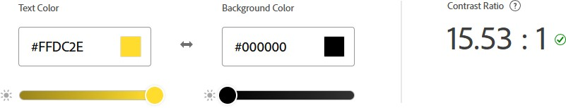

3- 4.5:1

1. HTML because it is the backbone of any website, CSS to control website formatting and layout, JavaScript to enable interactive elements on the website.
2. Each CMS offers different advantages depending on the store's size, budget, and customization needs. For Dynamo Strength, **Shopify** or **WooCommerce** might be ideal if you’re looking for simplicity and scalability, while **Magento** could work if you anticipate needing robust features for a large inventory.

# PHP (Hypertext Preprocessor)

* + PHP framework with built-in user interface, flexibility, API support, creativity, and extensive range of libraries for secure web application development.

# Laravel

* + Open-source backend framework based on Model View Controller (MVC) architecture.

# Node.js

* + Open-source, cross-platform JavaScript framework for building server-side and networking applications.

1. Benchmark to measure website performance. 8- Code:

<!DOCTYPE html>

<html lang="en">

<head>

<meta charset="UTF-8">

<meta name="viewport" content="width=device-width, initial-scale=1.0">

<title>Dynamo Strenght</title>

<link rel="stylesheet" href="style.css"> </head>

<body>

<h1>Dynamo Strenght</h1>

<header>

<nav>

<ul>

<li><a href="#">Home</a></li>

<li><a href="#">Products</a></li>

<li><a href="#">Wishlist</a></li>

<li><a href="#">Cart</a></li>

<li><a href="#">FAQs</a></li>

<li><a href="#">Contact Us</a></li>

<li><a href="#">About Us</a></li>

<li><a href="#">My Acounnt</a></li>

</ul>

</nav>

</header>

<main>

<h1>Welcome to Dynamo Strenght</h1>

<p>Your destination for premium gym equipment. Whether you're a fitness enthusiast or a beginner, we offer high-quality cardio machines, strength tools, multi gyms, and free weights. Enjoy expert support and a seamless shopping experience as you start your journey with us.</p>

<h2>Latest News</h2>

<p>Exciting updates at Dynamo Strength! We’ve added new arrivals to our cardio machines and multi-gym collections, just in time for the season. Get ready for our upcoming holiday deals and special promotions to help you upgrade your fitness setup. Don’t miss out—subscribe to our newsletter for exclusive updates and offers!</p>

</main>

<footer>

</footer>

</body>

</html>

**My Figma Link**: https://[www.figma.com/design/DJznXjqbBnqnTpB3OkZYEf/WEB212?node-id=0-](http://www.figma.com/design/DJznXjqbBnqnTpB3OkZYEf/WEB212?node-id=0-) 1&t=uGMgwmfTRQubLTnS-1