

Team members:

1-shehab mohamed

2-marwan osama

3-mohamed aziz

4-salema abdeltawab

5-heidi hussin

**Canny edge detection** is a popular image processing technique used to identify edges in images with high accuracy and low error rates.

**It consists of several key steps to detect edges in images effectively:**

**1.Gaussian Smoothing:**

**•** The algorithm starts by applying a Gaussian filter to the input image to reduce noise and create a smoothed version of the image. This step helps in preparing the image for accurate edge detection by removing unwanted details**.**

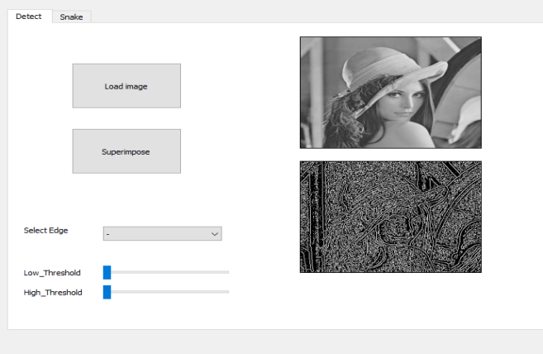

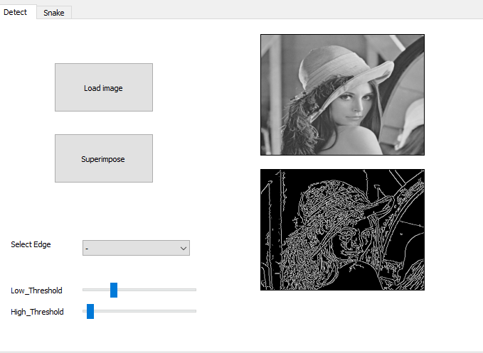

**2.Gradient Calculation:**

**•** Next, the algorithm calculates the gradients of the smoothed image using the Sobel operator. This process identifies the intensity gradients in the image, highlighting areas of rapid intensity changes that often correspond to edges.

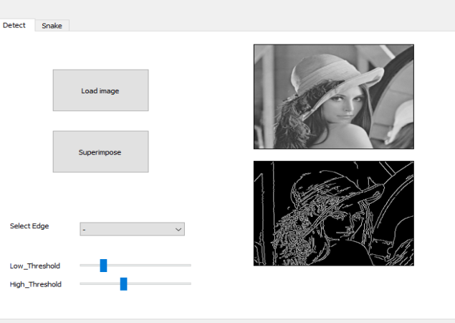

**3.Non-maximum Suppression:**

**•** After obtaining gradient magnitudes and directions, the algorithm performs non-maximum suppression. This step ensures that only the local maxima in the gradient direction are preserved, thinning out the detected edges and enhancing edge localization.

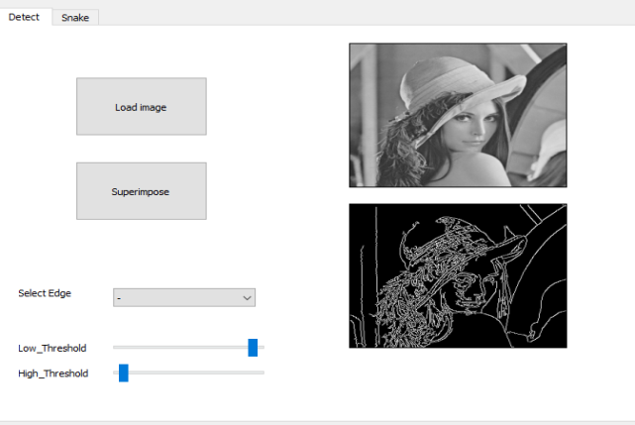

**4.Thresholding with Hysteresis:**

**•** The Canny edge detector applies dual thresholding to classify pixels as strong edges, weak edges, or non-edges based on their gradient magnitudes. Pixels with gradient magnitudes above the high threshold are considered strong edges, while those between the high and low thresholds are weak edges. Weak edges connected to strong edges are retained using hysteresis to form continuous edge contours.

1. **Low threshold:** This controls how weak edges are detected. A lower threshold will include more edges in the final image, including faint edges and potentially noise.
2. **High threshold:** This controls how strong edges are detected. A higher threshold will result in fewer edges being detected, with only the strongest and most well-defined edges remaining.

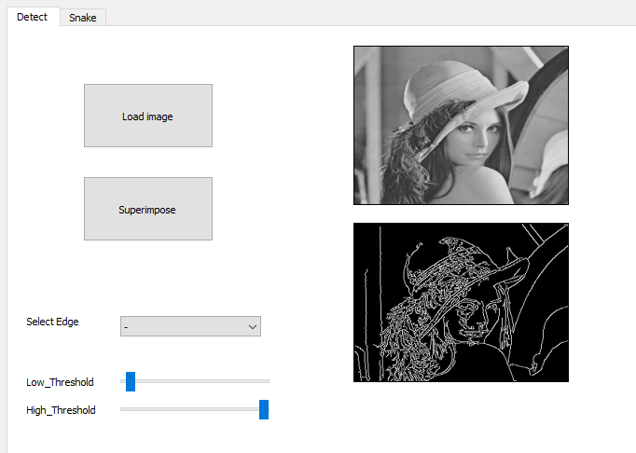

**Active Contour Models - Mastering Object Boundary Detection:**

**Introduction**

Active contour models, commonly referred to as "snakes," have emerged as powerful tools in the domain of image processing and computer vision. In the previous section, we introduced the fundamental principles of active contour models, highlighting their capability to delineate object boundaries through iterative refinement. This report aims to provide a deeper exploration into the intricacies of active contour models, shedding light on their adaptability to diverse object shapes and boundary complexities.

**Understanding Active Contour Models**

Active contour models represent a class of techniques used for image segmentation, focusing on the delineation of object boundaries within images. Unlike traditional segmentation methods, which often rely on fixed criteria or thresholds, active contour models offer a dynamic approach by iteratively adjusting a parametric curve, or "snake," to align with object edges. This iterative refinement process involves energy minimization, where the snake evolves under the influence of internal and external forces, aiming to converge towards the desired object boundary.

The energy function is comprised of E(total)=E(internal)+E(external),where the External energy is the energy is responsible for attracting the contour towards edges in the image and it is based on the gradient magnitude.Is computed using an energy map derived from the image, incorporating both line and edge energies, We need to apply a gaussian blur on the image firsthand and then detect edges using any algorithm in our case we used the sobel detection so edges now have higher gradient magnitude . As for the internal energy it is the measure of elasticity and smoothness of the contour , where abrupt changes in contour are penalized promoting smoothness & high curvature, ensuring the contour maintains a reasonable shape.

We control both the elasticity with the (alpha) and the smoothness parameter with (beta). In summary   
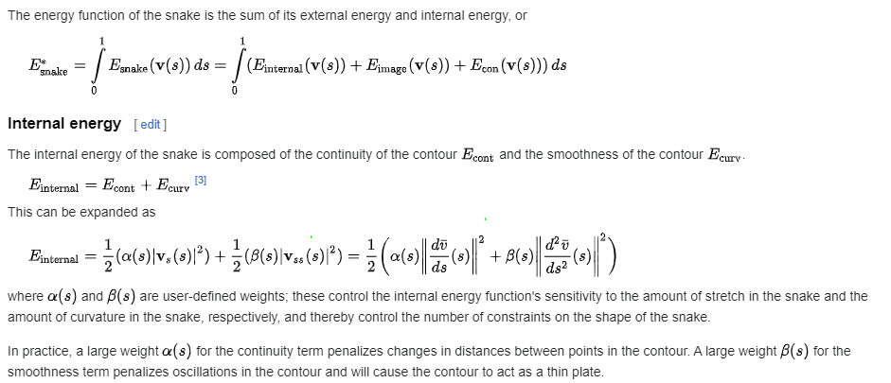

**Adaptability to Varying Object Boundaries**

One of the key strengths of active contour models lies in their ability to adapt to varying object boundaries, regardless of shape or texture complexities. Through the interplay of internal forces, such as elasticity and curvature, and external forces derived from image gradients or features, snakes can gracefully conform to intricate object shapes. This adaptability enables active contour models to excel in scenarios where traditional segmentation methods struggle, such as in the presence of noise, occlusions, or overlapping objects.

For the square contour we initialize a square by creating four sets of points in each of the X,Y directions. Then concatenates these points to form the contour coordinates contour_x and contour_y. we define the specific location for where we want our square to be created.Then we generate a window coordinate These coordinates are crucial for our contour optimization algorithm as they define the local neighborhood around each point on the contour. By systematically exploring these local regions, we can iteratively refine the contour to achieve the desired shape and alignment with image features.

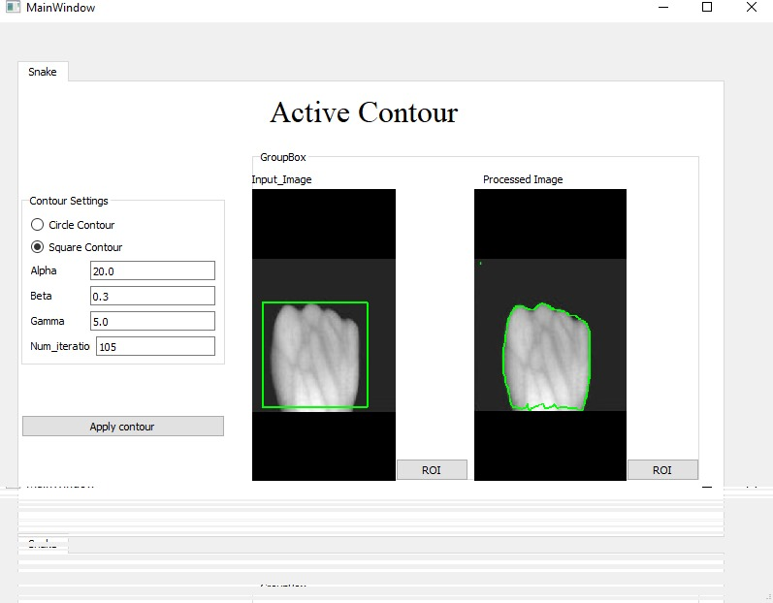

As for the ellipse contour,we also initialize a circular shape to serve as the starting point for our algorithm. This circular contour is created by defining a set of points along the circumference of the circle . Once these points are defined, we obtain the X and Y coordinates of these points along the circle using trigonometric functions. For each image specific values are used to match the needs for the contour for each image . These coordinates are stored in arrays contour_x and contour_y, representing the X and Y coordinates respectively. We can add offset values as well to shift the location for our circle and by decreasing or increasing or the radii it could look more like an ellipse then we calculate as previous the window coordinates.  
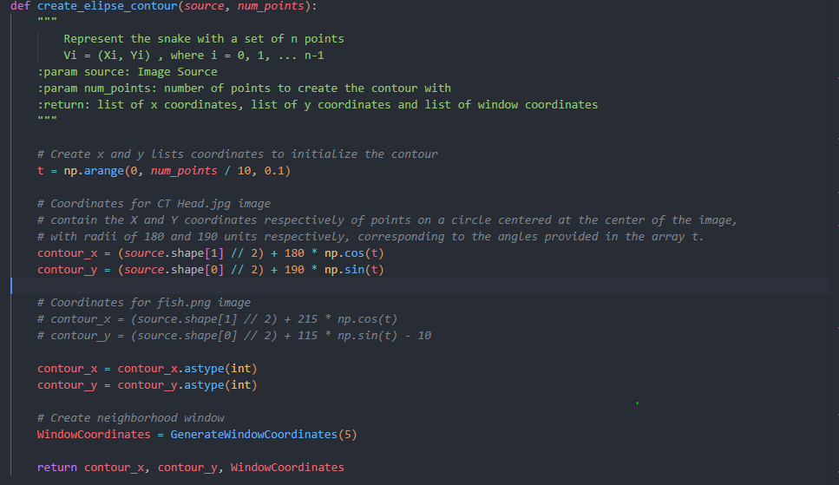

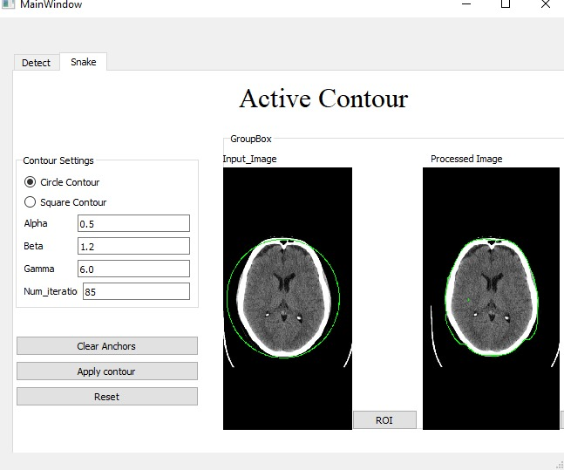

**Handling Complex Shapes**

Active contour models demonstrate remarkable prowess in handling complex object shapes within images. By leveraging sophisticated energy formulations and optimization techniques, snakes can navigate through concavities, protrusions, and irregularities inherent in object boundaries. Moreover, advanced variants of active contour models, including geometrically constrained snakes and multi-resolution approaches, further enhance their ability to accurately delineate complex shapes, facilitating tasks such as medical image analysis, industrial inspection, and biometric recognition.

**Conclusion**

Active contour models, or snakes, represent a sophisticated paradigm in image segmentation, offering a dynamic and adaptable approach to object boundary detection. Through the interplay of internal and external forces, these models elegantly navigate through diverse object shapes and boundary complexities, achieving high levels of accuracy and robustness. As the field of computer vision continues to evolve, active contour models remain at the forefront of research and applications, empowering advancements in fields ranging from biomedical imaging to autonomous robotics.