

**Assignment_1 “Filtering and Edge Detection”**



# Supervised by: Dr. Ahmed Badawy

**Submitted to:**  Eng. Laila Abbas &

Eng. Omar Dawah

|  |  |  |  |  |
| --- | --- | --- | --- | --- |
| **Name** | |  | **Section** | **B.N** |
|  | Marwan Osama |  | 2 | 26 |
|  |
| **Shehab Mohamed** | |  | 1 | 33 |
| Heidi Hussin | |  | 2 | 44 |
| **Salema AbdalTawab** | |  | 1 | 29 |
| **Mohamed Aziz** | |  | 2 | 18 |

1. **Noise Addition.**

We introduce artificial noise to the image to simulate real-world scenarios. Digital images undergo various forms of degradation due to environmental factors, transmission errors or limitations in the device. So we introduce several types of additive noise such as (Uniform noise, Gaussian noise and Salt & Pepper noise).

1) Uniform noise: as it says from the name the intensity variations is distributed uniformly.

2) Gaussian noise: follows a gaussian distribution and encountered in natural phenomena and electronic systems. It is characterized by a symmetrical bell-shaped curve around a mean value.

3) Salt & Pepper noise: is a type of noise characterized by sporadic occurrences of very bright (Salt) or very dark (Pepper) pixels within the image

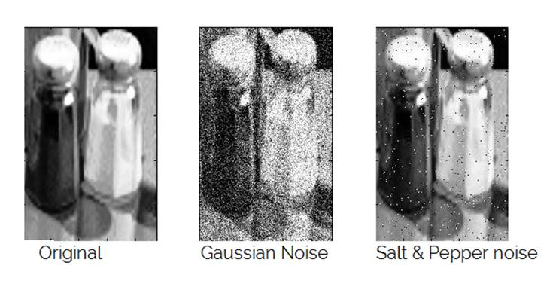

1. **Filter the Noise.**

Filtering the noisy image involves applying various types of filters to reduce or eliminate unwanted noise while preserving important image features.

1. Average filter: calculates the average intensity value within a local neighborhood of each pixel. It replaces the intensity value of each pixel with the average value.
2. Gaussian filter: applies a weighted average to the pixels within a neighborhood, with the weights determined by a Gaussian distribution centered at the pixel of interest.
3. 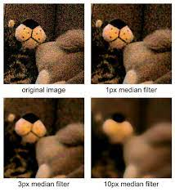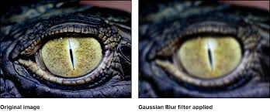Median filter: replaces the intensity of each pixel with the median value of its neighboring pixels.
4. **Histogram.**

It is a graphical representation that shows the distribution of pixel intensities within an image. Essentially, it provides a summary of the frequency of occurrence of each intensity value in the image.

Each pixel in a digital image has an associated intensity value, which typically ranges from 0 (black) to 255 (white) for grayscale images. For color images, each pixel may have intensity values for multiple color channels (e.g., red, green, and blue).

The histogram divides the range of intensity values into discrete bins or buckets. Each bin represents a range of intensity values, and the histogram displays the number of pixels that fall within each bin.

The histogram graphically represents the frequency count or number of pixels for each intensity value or bin. Higher bars indicate a higher number of pixels with that intensity value, while lower bars indicate fewer pixels.

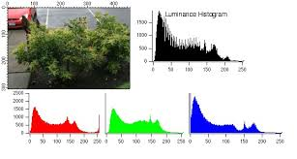

1. **Equalization.**

It is a technique used in image processing to enhance the contrast of an image by redistributing pixel intensities to cove a wider range. Its primary goal is to achieve a more uniform distribution of pixel values in the Histogram, thereby improving the overall contrast and visibility of features in the image.

Histogram equalization operates by transforming the intensity values of pixels in an image such that the cumulative distribution function (CDF) of pixel intensities becomes as uniform as possible.

The basic idea is to stretch the intensity values across the entire dynamic range (usually 0 to 255 for 8-bit images) so that both dark and bright regions of the image are well represented.

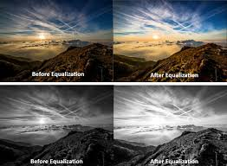

1. **Normalization.**

Normalization in the context of image processing is a technique used to adjust the pixel values of an image to a specified range, typically between 0 and 1. This process ensures consistent scaling across different images or processing steps, making it easier to compare and analyze images under various conditions.

Normalization is often performed to eliminate differences in intensity scales between images, making them directly comparable or suitable for subsequent processing steps such as feature extraction or classification.

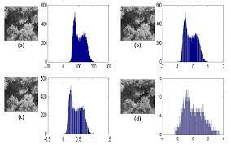

1. **Thresholding.**

It is used to segment an image into regions based on the intensity values of pixels. It involves setting a threshold value and classifying pixels into two categories: those with intensity values above the threshold (foreground) and those below the threshold (background).

* Global thresholding applies a single threshold value to the entire image, dividing it into foreground and background regions based on the intensity values of pixels. Once the threshold value is determined, each pixel in the image is compared to the threshold. If the pixel intensity is greater than or equal to the threshold, it is classified as foreground; otherwise, it is classified as background. It is straightforward and computationally efficient but may not be suitable for images with non-uniform illumination or varying contrast across different regions.
* ****Local thresholding, also known as adaptive thresholding, uses different thresholding values for different regions of the image. Instead of applying a single global threshold to the entire image, local thresholding divides the image into smaller regions or blocks and calculates a threshold value for each region independently. The threshold values for each region are often computed based on the local characteristics of the region, such as the mean or median intensity. It is particularly useful for images with non-uniform illumination, varying contrast, or regions with different lighting conditions.

1. **Hybrid images.**

Hybrid images combines the low-frequency components of one image with the high-frequency components of another image to create an interesting perceptual effect.

The fundamental idea behind hybrid images is to create an image that appears as one image when viewed from a distance but transforms into another image when viewed up close.

This effect is achieved by combining the low-frequency information (smooth features, overall structure) of one image with the high-frequency information (fine details, texture) of another image.

For Image A, extract the low-frequency components using a low-pass filter and extract the high-frequency components using a high-pass filter.

For Image B, do the same: extract low-frequency components with a low-pass filter and high-frequency components with a high-pass filter.

c. Combination of Components:

Combine the low-frequency components of Image A with the high-frequency components of Image B to create the hybrid image.

Hybrid images have applications in visual perception research, artistic expression, and visual communication.

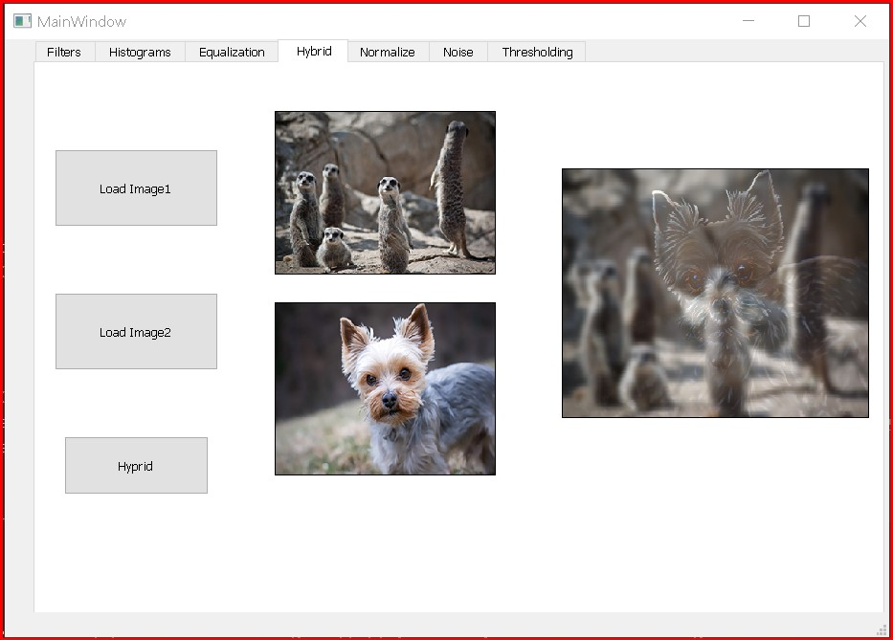They can be used to create visually intriguing images, optical illusions, or images with hidden messages that reveal themselves upon closer inspection.