### 

**Prepared By: Team 14**

Shehab Mohamed Omar Mohamed

Mohamed Hazem Mohamed Aziz

Mahmoud Emad

### ****1.Introduction****

Computed Tomography (CT) imaging is widely used for diagnostic purposes. So, reducing radiation exposure often results in noisy images that can compromise diagnostic accuracy. In this project we try to implement different three denoising techniques (( **wavelet-based denoising**, **bilateral filtering**, and a **deep learning-based approach (DnCNN) ))** to improve image quality.

### ****2.Objectives****

**● Implement**

1. wavelet-based denoising technique.
2. Bilatera denoising technique.
3. Deep learning denoising technique.

**●** Compare the effectiveness of these techniques on noisy CT images.

**●** Evaluate results using quantitative metrics: **PSNR** and **SSIM.**

**PSNR →(Peak Signal-to-Noise Ratio)**,**SSIM→(Structural Similarity Index)**.

**3.Backgrond**

### 3.1 Salt-and-Pepper Noise in CT Imaging

**Definition:** Salt-and-pepper noise, also known as impulse noise, shows as random occurrences of black and white pixels in an image. **[1]**

**Sources: [1]**

1. **Sensor malfunctions:** Defective or dead pixels in the CT detector array can introduce sudden intensity spikes, leading to salt-and-pepper noise.

**2. Data transmission errors:** Errors during the transmission of image data from the detector to the reconstruction system can result in pixel intensity anomalies.

**3. Faulty memory locations:** Corrupted memory cells in storage media can alter pixel values, introducing impulse noise.

**4. Electromagnetic interference (EMI):** External electronic disturbances can cause abrupt changes in pixel intensities.

### **3.2 Gaussian Noise in CT Imaging**

**Definition:** Gaussian noise is characterized by statistical fluctuations in pixel values following a normal distribution, often resulting in a grainy appearance in images.

****Sources: [2]****

**1. Photon statistics (quantum noise):** The random nature of photon emission and detection leads to statistical variations in the number of photons detected, introducing noise.

**2. Electronic circuit noise:** Thermal noise and other electronic disturbances in the CT scanner's circuitry can affect signal.

**3. Image reconstruction errors:** Inaccuracies during the reconstruction process, especially in low-dose CT, can introduce Gaussian noise.

**4. Low signal-to-noise ratio (SNR):** In low-dose CT imaging, reduced photon counts lead to lower SNR, making images more susceptible to noise.

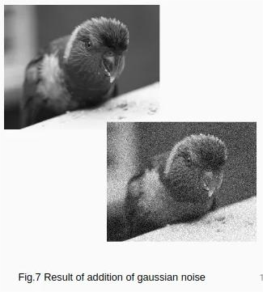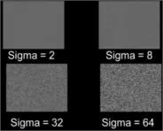

**4.Methodology**

**4.1 Noise Simulation and Dataset Preparation**

**Dataset**: we used a dataset “COVID-19 CT scans” from kaggle website. [3]

**Noise simulation:** we used functions from “****scikit-image”**** library**.**

**●Salt and pepper Noise:**we added salt add pepper noise with using “add_salt_pepper_noise ”function from “****scikit-image”**** library**.**

**●Gaussian:**we added salt add pepper noise with using “add_gaussian_noise_func ”function from “****scikit-image”**** library

**4.2 Noise reduction filters**

**4.2.1 Wavelet filtering [4]**

Wavelet filtering is a method to **remove noise or extract features** from images.By **breaking the image into parts that represent different levels of detail.**

**Steps to implement:**

**1)**Transform the Image from the spatial domain (pixels) to the **wavelet domain.**which separates the image into:**Approximation part** ,**Detail parts** (edges and fine details in horizontal, vertical, and diagonal directions).

**2)**Filter the Detail Components.which often have the noise.

**3)**Rebuild the Image (Inverse Wavelet Transform).

**4.2.2Bilateral filtering.**

The **bilateral filter** is a **non-linear, edge-preserving, and noise-reducing** smoothing filter.works by averaging nearby pixel values, with considerations:

**●Spatial closeness** – Pixels close together are weighted more heavily.

**●Intensity similarity** – Pixels with similar brightness or color to the center pixel are given more weight.

**●** D**oesn't blur across edges**, as pixels on the other side of an edge have different intensity and take less weight.

**4.3 evaluation metrics**

**PSNR** (peak signal-to-noise ratio):**Higher PSNR** → less noise

****SSIM** (**Structural Similarity Index) :**Higher SSIM** → better structural preservation

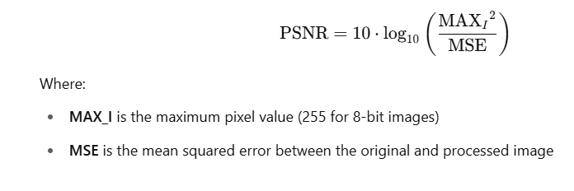

[5]

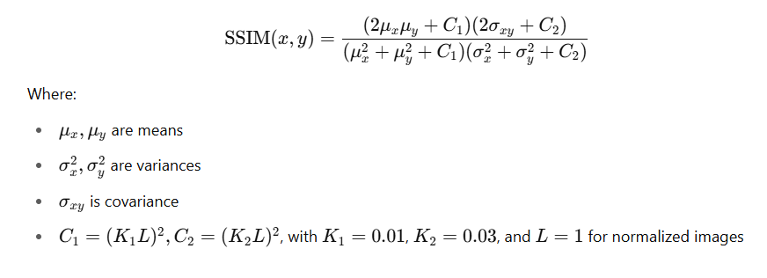

**[6]**

**Higher PSNR** → less noise

**Higher SSIM** → better structural preservation

1. **Results**

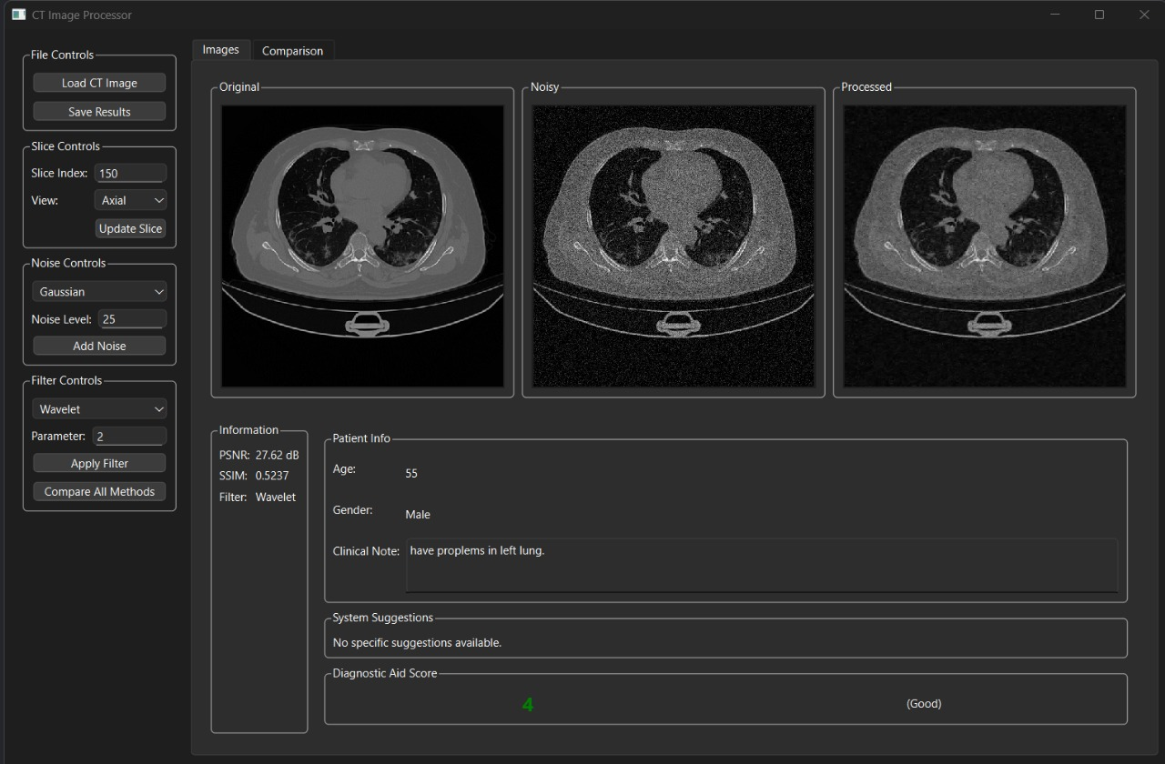

in this figure we added gaussian noise to the ct image ,then applied Wavelet filter to reduce the noise.and we got peak signal to noise ratio 27.62 dB and Structural Similarity Index .5237.

**References**

[1] H. Chen, Y. Zhang, and Y. Xu, "A novel impulse noise removal method for medical images based on non-local means," IET Image Processing, vol. 15, no. 14, pp. 3389–3401, 2021. doi: 10.1049/ipr2.12451

[2] <https://medium.com/@anishaswain/noise-in-digital-image-processing-55357c9fab71>

[3] https://www.kaggle.com/datasets/andrewmvd/covid19-ct-scans/data

[4]V. Subramanian, S. Thomas, A. Devasena, S. Ku. Rabadran, and K. Chouhan, "Image Processing using Wavelet Transform Based Noise Removal Filter."

[5] *<https://www.geeksforgeeks.org/python-peak-signal-to-noise-ratio-psnr/>*

[6] *<https://medium.com/@akp83540/structural-similarity-index-ssim-c5862bb2b520>*

[7] Book: Digital Image Processing Third Edition,Rafael C. Gonzalez,Richard E. Woods