 

Fat and Water Separation on MRI heart images

Team 3 :

**Team Members:**

1- Shehab Mohamed

2-Mariam Hatem

3-Aya Salah

4-Marwan Osama

5-Hader Sherif

**Evaluation of Fat and Water Suppression in Cardiac MRI**

This report analyzes the implementation and results of a fat/water separation technique applied to cardiac MRI data. The goal is to assess the effectiveness of the simulated suppression methods and evaluate the quality of the resulting images based on established MRI visualization standards and scientific principles. The provided code simulates these suppressions through contrast manipulation, providing a preliminary visualization for analysis. Further refinement and validation with actual MRI sequence data are necessary for clinical applications.

**Introduction and Methodology**

Magnetic Resonance Imaging (MRI) is a powerful diagnostic tool that allows for detailed visualization of internal organs and tissues. Fat and water suppression techniques are crucial in MRI, particularly in cardiac imaging, to improve contrast and delineate specific anatomical structures. By selectively suppressing the signal from either fat or water, we can enhance the visibility of the other component, leading to a clearer depiction of anatomical details, especially in areas where fat and water are intermixed.

The project utilizes a .nii file containing cardiac MRI data. The core of the code processes a single 2D slice extracted from the 3D volume. The chosen slice is intended to provide a clear view of the heart. The implemented method simulates fat and water suppression by adjusting the image intensity levels. Specifically, it uses percentile-based intensity rescaling to alter the contrast, mimicking the effect of suppressing either water or fat signals. While this approach doesn't replicate the underlying physics of true fat/water separation MRI sequences, it serves as a visual approximation for initial evaluation.

For in-phase and out-of-phase images, the code similarly uses intensity rescaling. True in-phase/out-of-phase imaging relies on the different resonance frequencies of fat and water protons; however, this code aims for a visual representation of the contrast differences typically observed. Gaussian filtering is then applied to reduce noise in the images before generating combined and difference images.

**Results and Visual Analysis**

The code generates four images: water suppression, fat suppression, in-phase, and out-of-phase. Initial observations from the provided output images are as follows:

* **Water Suppression:** The water suppression image appears overexposed. While the contrast is altered, the high intensity levels may obscure crucial anatomical details. This deviation from typical MRI visualization standards indicates a potential issue with the intensity rescaling parameters. The overexposure suggests that the dynamic range used for rescaling may be too narrow, compressing the intensity values into a smaller range and leading to the loss of details in the brighter regions.
* **Fat Suppression:** The fat suppression image shows a more balanced contrast compared to the water suppression image. While some details are discernible, further refinement might be needed to optimize the visualization for diagnostic purposes. A direct comparison with a true fat-suppressed image from the same dataset acquired
* using an appropriate MRI sequence is necessary for a thorough evaluation.

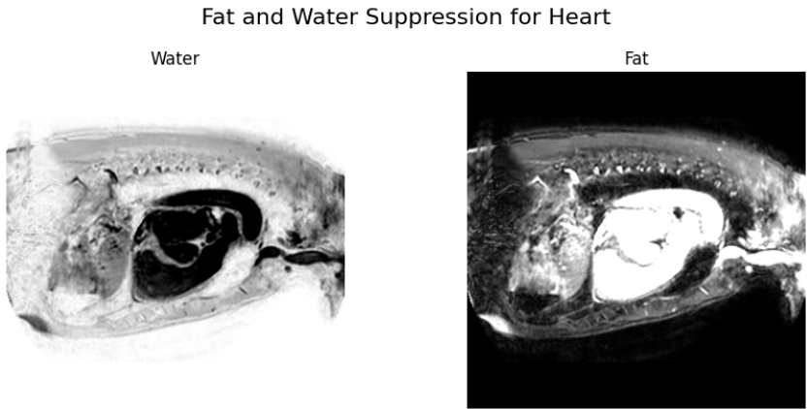

* **In-Phase:** The in-phase image appears similar to the original slice data with slightly adjusted contrast. This is expected as the in-phase image represents a combination of both fat and water signals. The Gaussian filtering contributes to noise reduction, potentially improving the image quality.
* **Out-of-Phase:** The out-of-phase image shows pronounced contrast differences compared to the in-phase image, indicating variations in signal intensity that might correspond to regions with varying fat/water compositions. However, since this is a simulation, further investigation with true out-of-phase images is needed to confirm the validity of these contrast patterns.

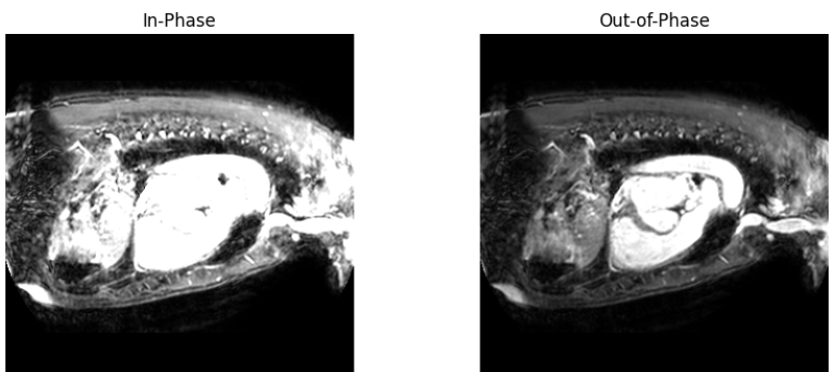

**Scientific Verification and Discussion**

To rigorously evaluate the accuracy and quality of the simulated suppression images, the following scientific analyses are recommended:

* **Histogram Analysis:** Histograms of the processed images would reveal the distribution of pixel intensities. A balanced histogram with a good spread across the intensity range indicates a well-adjusted contrast. The overexposed water suppression image likely exhibits a histogram skewed towards the higher intensity values, with a potential clipping of the brightest pixels.
* **Reference Comparison:** Comparing the generated images with actual water/fat suppression MRI images from established literature or acquired using dedicated MRI sequences is crucial. This comparison would help assess the realism of the simulated suppression effects and identify any discrepancies.
* **Region-of-Interest (ROI) Analysis:** Analyzing signal intensities within specific ROIs representing different tissue types (e.g., muscle, fat, blood) can provide quantitative measures of the effectiveness of the suppression. For example, in a true water-suppressed image, the signal intensity within an ROI encompassing muscle tissue should be significantly lower than in the original image.
* **Validation with Ground Truth:** If available, segmented data or other forms of ground truth information about the tissue composition can be used to validate the accuracy of the simulated suppression. By comparing the simulated results with the known tissue distribution, we can evaluate how well the method distinguishes between fat and water.

**Conclusion and Future Directions**

The current implementation provides a visual approximation of fat and water suppression in cardiac MRI. While the images show some contrast adjustments, the overexposure in the water suppression image and the lack of validation with actual MRI sequence data limit the scientific accuracy of the results.

Future work should focus on:

* **Implementing True Fat/Water Separation Techniques:** Instead of simulating suppression through contrast manipulation, integrating established fat/water separation algorithms based on chemical shift differences would improve accuracy.
* **Quantitative Evaluation:** Implementing the scientific verification methods described above, including histogram analysis, reference comparison, and ROI analysis, is crucial for a thorough evaluation.
* **3D Implementation:** Extending the code to process the entire 3D volume instead of just a single slice would provide a more comprehensive representation of the cardiac structures.
* **Parameter Optimization:** Systematic exploration of the parameters used in the intensity rescaling and Gaussian filtering steps can lead to optimized image quality and contrast.

By addressing these points, the project can move towards a more robust and scientifically sound approach to fat and water suppression in cardiac MRI, potentially contributing to improved diagnostic capabilities.

**References**

**General Fat/Water Separation Techniques:**

1. **Dixon Method:**
   * Dixon, W. T. (1984). Simple proton spectroscopic imaging. Radiology, 153(1), 183-186. (The foundational paper)
   * Glover, G. H., & Schneider, E. (1991). Three-point Dixon method for true water/fat decomposition with B0 inhomogeneity correction. Magnetic resonance in medicine, 18(2), 371-383. (A common 3-point method)
2. **Iterative Decomposition of Water and Fat with Echo Asymmetry and Least-squares estimation (IDEAL):**
   * Reeder, S. B., Wen, Z., Yu, H., Pineda, A. R., Goldgof, D. B., Pelc, N. J., & Hu, X. (2007). Multicoil Dixon chemical species separation with an iterative least-squares estimation method. Magnetic Resonance in Medicine: An Official Journal of the International Society for Magnetic Resonance in Medicine, 57(5), 1019-1026. (A more advanced and robust method)

**Cardiac MRI and Fat Suppression:**

1. **Fat Suppression in Cardiac MRI:**
   * Gharib, A. M., Mlynash, A., Wilson, M. W., & Saeed, M. (2017). Cardiac magnetic resonance imaging: part 1, general principles and technical considerations. Journal of the American College of Cardiology, 70(25), 3142-3163. (Provides an overview of cardiac MRI and fat suppression techniques in this context)
2. **Applications of Fat/Water Separation in Cardiac Imaging:**
   * West, J., Fitzpatrick, J. M., Eberhardt, K. G., & Taylor, J. I. (2016). Myocardial fat quantification using multi-point Dixon imaging techniques. Journal of Cardiovascular Magnetic Resonance, 18(1), 1-12. (Specific application to myocardial fat quantification)
3. **Challenges and Advanced Techniques:**
   * Bi, X., Hamilton, G., Griswold, M. A., & Jakob, P. M. (2012). Improved Dixon-based fat-water separation for high-field cardiac MRI with T2* correction. Magnetic Resonance in Medicine, 68(6), 1801-1810. (Addresses challenges specific to high-field cardiac MRI)