Socket
Channel
TCPSocket
UDPSocket
Clients
Servers (Application)
Class structure and design decisions:
The Channel folder in Drivers folder contains the channel.hpp that have abstract class Channel that handle socket interactions through its Socket member (which can be TCP or UDP). He have a pointer to a Socket object (Socket* channelSocket) -> (either TCPSocket or UDPSocket). Also have pure virtual functions:
▪ virtual void start() = 0;
▪ virtual void stop() = 0;
▪ virtual void send(const std::string& message) = 0;
▪ virtual void receive() = 0;
These functions MUST be implemented in derived classes: serverChannel and clientChannel.

The channel.cpp contains only serverChannel functions with the pointer that points to the virtual functions of Socket.

The Socket folder in Drivers folder conatins socket.hpp that have abstract class Socket that define common socket behaviors (send, receive, connect, shutdown) with pure virtual functions:
▪ virtual void connect() = 0;
▪ virtual void send(const std::string& message) = 0;
▪ virtual void receive() = 0;
▪ virtual void shutdown() = 0;
These functions MUST be implemented in derived classes: TCPSocket and UDPSocket.

tcpsocket.cpp and udpsocket.cpp contains the socket behaviour.

UNICAST_TCPSocket:
the client.cpp contains the clientChannel functions with the client behaviour.

MULTICAST_UDPSocket:
the client.cpp contains the clientChannel functions with the client behaviour.

The Server contains the application behaviour: I made a Time class with a += operator overloading so I can increment the time by 1 and wait 1sec and send the time to clients each 1sec.
Note: To run the application, navigate to either the UNICAST_TCPSocket or MULTICAST_UDPSocket folders and execute the make command in the terminal. This will create an out directory containing the server and client executables, which you can easily run.

Step-by-step guide for setting up the development environment (QEMU) with Yocto:

I made an image with tcp-client and udp-server to try each server and client on Qemu.

For the tcp-client:
Going to: ~/yocto/poky/meta/recipes-example/tcp-client with this tree:
├── files
│ ├── CMakeLists.txt
│ ├── Drivers
│ │ ├── Channel
│ │ │ ├── channel.cpp
│ │ │ └── channel.hpp
│ │ └── Socket
│ │ ├── socket.hpp
│ │ ├── tcpsocket.cpp
│ │ └── udpsocket.cpp
│ ├── include
│ │ └── client.hpp
│ └── src
│ ├── client.cpp
│ └── main.cpp
└── tcp-client_0.1.bb
For the udp-server:
Going to: ~/yocto/poky/meta/recipes-example/udp-server with this tree:
├── files
│ ├── CMakeLists.txt
│ ├── Drivers
│ │ ├── Channel
│ │ │ ├── channel.cpp
│ │ │ └── channel.hpp
│ │ └── Socket
│ │ ├── socket.hpp
│ │ ├── tcpsocket.cpp
│ │ └── udpsocket.cpp
│ ├── include
│ │ └── server.hpp
│ └── src
│ ├── main.cpp
│ └── server.cpp
└── udp-server_0.1.bb

- you will find the recipes and CmakeLists uploaded, take a look on them.

Then going to: ~/yocto/poky/build/conf and open local.conf and add this line:

IMAGE_INSTALL:append = " tcp-client udp-server"

Select:

MACHINE ?= "qemuarm64"
to create an image with this applications by yocto, write these commands:
Note:
-Take the recipes-example folder that I uploaded and place it on ~/yocto/poky/meta
go to: ~/yocto/poky/

source oe-init-build-env build
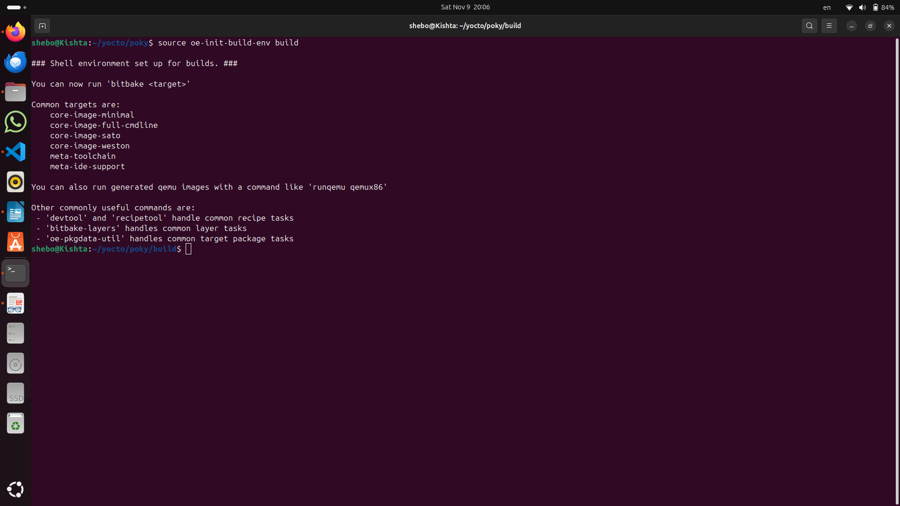
bitbake core-image-minimal
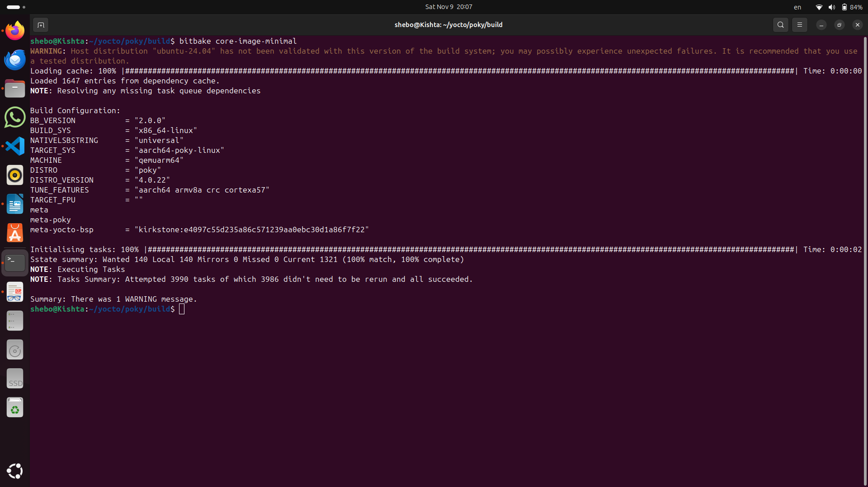

for tcp-client:

runqemu tmp/deploy/images/qemuarm64/ nographic tcp-client

and run:
tcp-client command on qemu and ./server on ubuntu terminal.

Disconnecting the client:
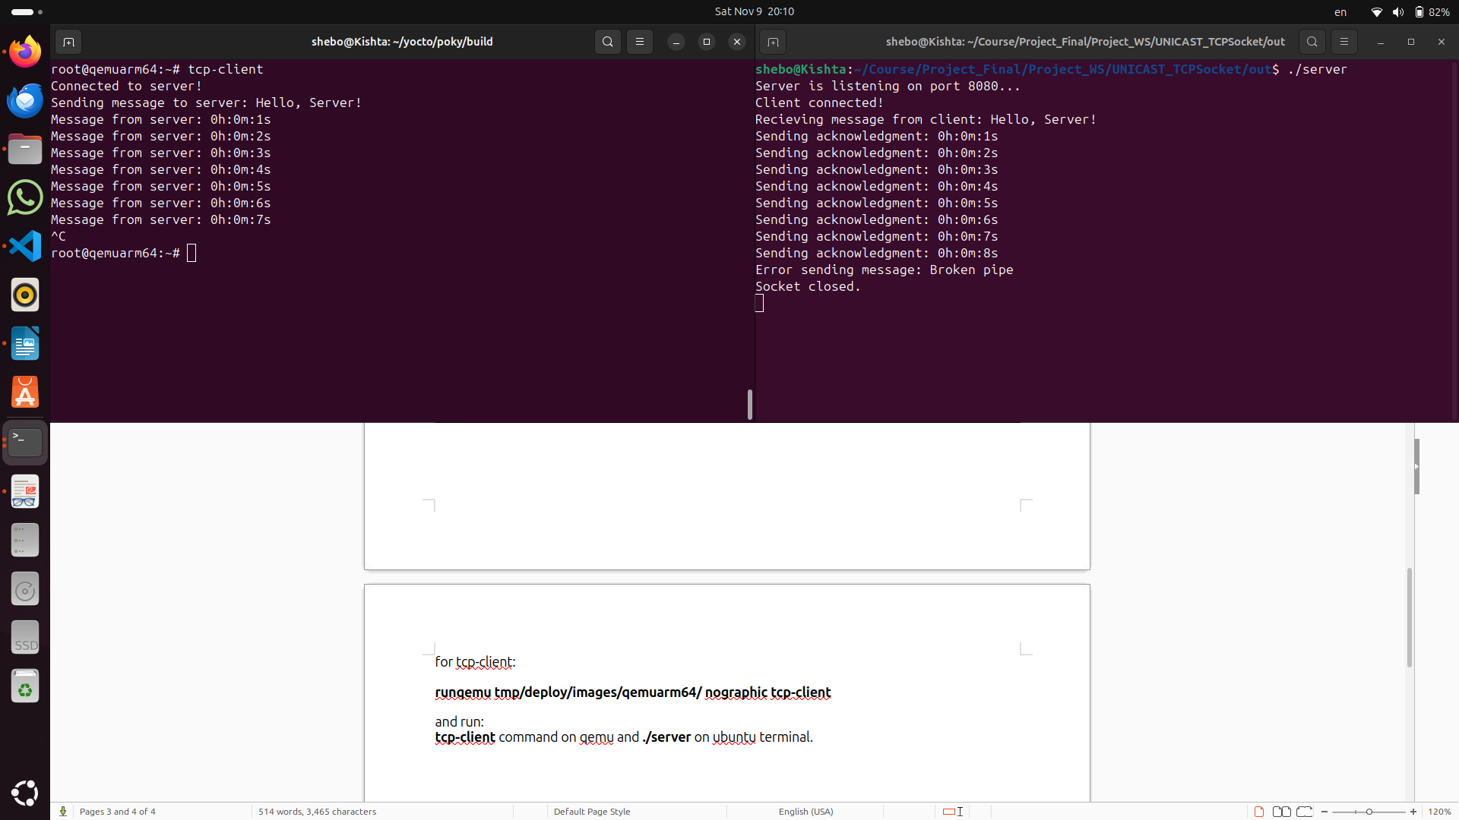
Disconnecting the sever:
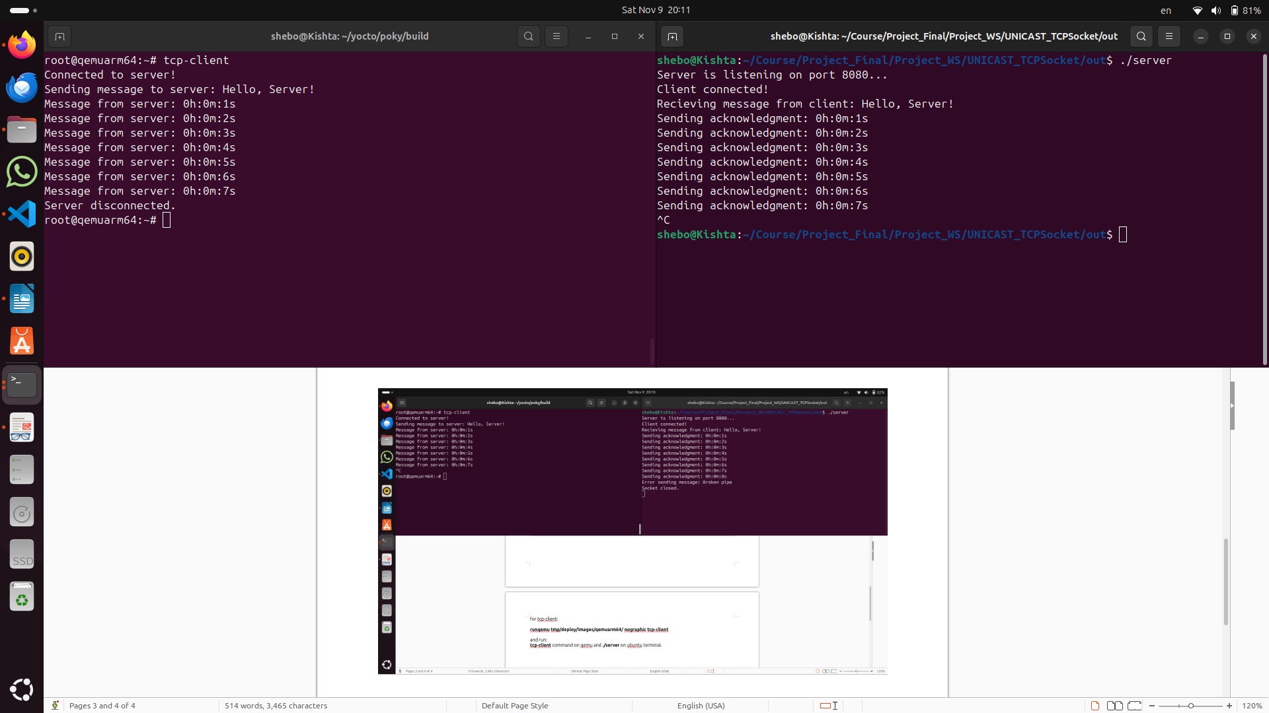

for udp-server:
runqemu tmp/deploy/images/qemuarm64/ nographic udp-server

and run:

udp-server command on qemu and ./client_1 and ./client_2 on ubuntu terminal.

No matters I disconnect any client, the server continue sending the time.
