IT4010 – Research Project

Year 4

Status Document 1

Submitted to Sri Lanka Institute of Information Technology

**MisplaceX-IT device detection and monitoring system in office environments**

Name: S.B.M.B.S.A Gunathilaka

Project ID: 23-345

Student registration no: IT20028046

BSc (Hons) in Information Technology Specializing in Cyber Security​

Date: May 26th, 2023

Gantt Chart

Project View of MS Planner

Work Breakdown Structure of MS Planner

Proof of Virtual and Physical Meetings

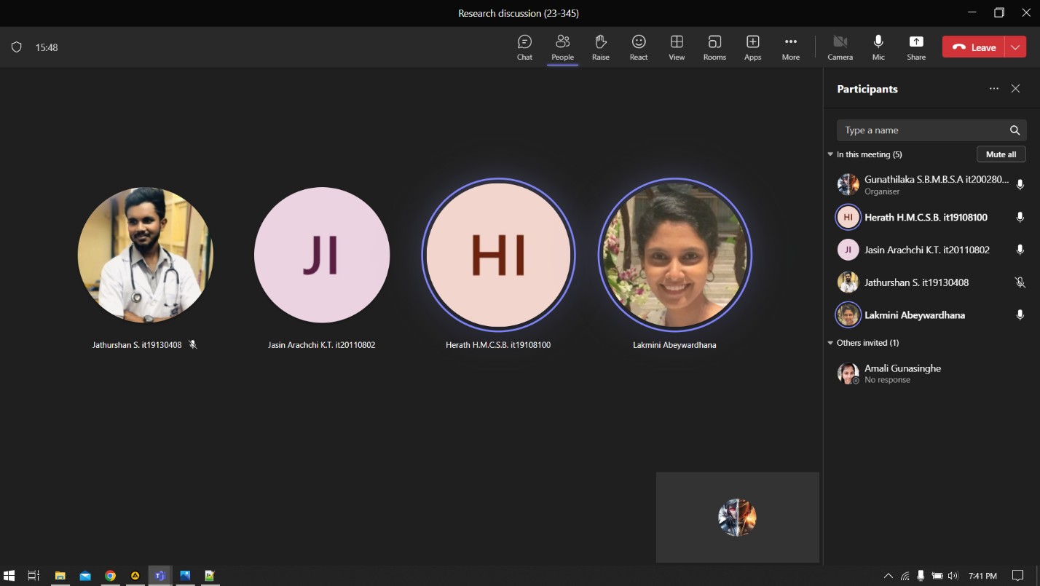

GitLab Contribution Graphs

