|  |
| --- |
| Close-up image showing the leaf-sides of two oversized books side-by-side on a bookshelf, with additional books in soft focus background |
| **Stock Management System With RMI**  **Group Number 10** |
| |  |  |  | | --- | --- | --- | | Shehan Amarasooriya |  |  | |



**Table of Content**

1. Group Members …………………………………………………………. 2
2. Introduction
   1. Stock Management System …………………………………………... 3
   2. How this System Works ……………………………………………… 4
   3. Product Management ………………………………………………… 5
   4. Purchase Management ……………………………………………….. 6
   5. Sales Management …………………………………………………… 7
   6. User Management ……………………………………………………. 8
3. Users of stock management system ……………………………………… 9
4. Objective …………………………………………………………………. 10
5. System Analysis ………………………………………………………….. 13
6. Software Testing …………………………………………………………. 19

**Group Members:-**

1. **PS/2014/304 D.D. W DISSANAYAKE**
2. PS/2014/051 A.A AKILA SELAKA
3. PS/2014/072 G.R.L. AMARATHUNGA
4. PS/2014/213 J.A.D. V SIRIWARDHANA
5. PS/2014/220 E.G.C. D WATTEWA
6. PS/2014/277 K.M. WANIGATHUNGA
7. PS/2014/297 W.A.D. MADURANGA
8. PS/2104/002 P.M.D.S AMARASOORIYA

**What is Stock Management System?**

Stock Management system is a software which is widely used by retailers, shopkeepers, manufacturing units and other merchants across different businesses. It is used for managing stock of products in their warehouse or in the shops.

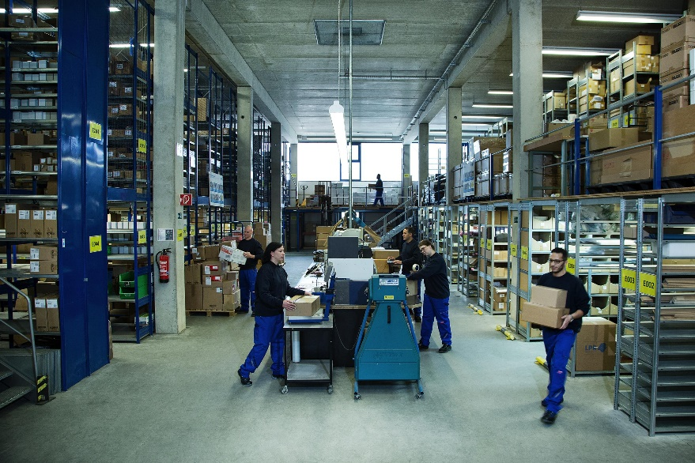

Gone are those days when a shop owner used to manage all his sales and accounts on paper. This job is now performed with these management tools which not only record the sales but also notify the retailer about the items low in stock.

You must have heard of the Retail Giant Wal-Mart. Have you ever wondered how such big companies know about:

* Which products are available in stock or when to reorder a particular product?
* How do they know that a particular product’s stock is finished?
* Which products sales have been high or which products had low sales?

The answer is simple- They use an automated system which helps them in managing their stocks. Stock Management system helps a retailer or shopkeeper in minimizing their stocks in accordance with the sales.

**How this systems Works**

So now let me tell you how the system works. We will understand this with an example of a retailer selling items to its customer as an example.

Suppose you are shopping in a mart. Now when you have picked up the items you intend to buy, you will go to the billing point.

Here the sales person will scan the bar code of each of the item you have picked up. Now the software will interpret the bar code of each of the item and match it with those available in the database of the system.

By this procedure the Manager can track the sales of the items from its shop. The system now gives a clear picture to the manager about the total sales and items available in the stock. It tells him/her the quantities present on shelves or in warehouse.

So now the manager can decide that which items have sufficient stock or which items needs reordering.

The reordering of items is also provided by the Stock Management System. It has an interface to communicate with vendors providing the required goods. The order is placed and payment is done with the use of Internet.

Now let me tell you what happens when the reordered items reach the warehouse. The item is added into the warehouse by reading its bar code through a bar-code scanner and its quantity is updated into the system.

If any new item is ordered then the details of the new product is added in the system. Its barcode and quantity is added in the system. This bar code stored in the system is matched at the time of billing to update the items in stock.

Now let me tell you about the features of this software. There are main 4 modules in the Stock Management system. They are:

* Product Management
* Purchase Management
* Sales Management
* User Management

**PRODUCT MANAGEMENT**

This module is used to manage the items being stocked in warehouse or in the mart. So let us dig deeper and look into the features of this module.

**Add Product**

This sub-module is used for adding new products to the system. It will require some basic details like Product Category, Product Name, cost price, selling price, its quantity.

We can have other additional features like product image, supplier’s name and its bar code.

One other interesting feature this system can have is an alert system.

You can set a particular quantity for each item. Now a notification or alert will be given to the user if a particular item’s quantity gets below the set quantity. This will help the user in getting notifications of the items getting low in stock.

**List Product**

This sub-module lists all the items present in the database of the Stock Management System. It will have options to edit the details of each item or delete a particular item from the list.

**Print Bar Code**

Another feature which is widely used these days by the merchants in their Stock management is generating a bar code and printing its copies so that it can be pasted on the items. This increases efficiency and encourages automation.

**PURCHASE MANAGEMENT**

This module is used to manage all purchases done by the retailer. It helps the retailer in maintaining the records of all its purchases from different suppliers.

**Add Order**

It is used by the manager to add an order into the system. It require details like items ordered and their quantities, date of ordering, suppliers details, total cost.

It will also have a feature of current status of the order which will have options like Ordered, Pending and Received.

It can have an additional feature of importing order details from a csv or excel file.

**List Orders**

This feature is used to display all the orders made by the merchant. It displays all the details like date of ordering, supplier details, payment status, order status.

There will be a option to view details of each order or to download those orders in pdf file format.

**Add Other Expenditures**

The company makes purchases of not only the items it sells but other items as well. Suppose in a store an air conditioner has broken down and it needs to be replaced.

So the owner buys a new air conditioner. This purchase is also funded by the store and will add to its expense list.

This was just an example, but there are many of these types of expenses made by the companies. These expenses are added in this interface.

**Expenditures**

This interface will show the expenditures of the company from ordering different items. It will also have expenditures of the company apart from these orders. It will have filtering option like Total expenditures of Last week or Last Month.

**SALES MANAGEMENT**

**Sell Items**

This option is available to the sales persons who are at the point of sale. Point of sale is the place where billing and other transactions are done.

So here bar code of each product is read using a bar code scanner and billing of the total items is done.

After the billing the quantities of each item bought by the customer is also deducted from the available stock. The main benefit Stock Management system provides here is that the tasks performed here is all automated.

The sales persons just need to scan the bar code of the items being purchased and all other calculations will be performed by the system.

**List Sales**

This option, as the name suggests shows all the sales made by the retailer. It shows details like date, time, total bill, payment status, view bill.

**Home Deliveries**

This option will vary from company to company and we can say that it will only be used by those retailers which have option of home delivery. It will show the details of customer, his/her address, payment status, date, time, option to view bill.

**Return of Items**

Now there might be situations when a customer has to return items bought from the store. For these situations only the system provides interface to return items. This will make sure the returned items quantity is updated in its stock.

**USER MANAGEMENT**

Before discussing the sub-modules of this Module let me tell you the users of Stock Management System. It is required here to understand the functionalities of this module. We will discuss these users in detail later in this post.

The users are Admin, Manager, Sales staff, Purchasing Staff. This module is only available to the Admin or Owner of the company.

**Add Users**

This option is used by the Admin to add new Users into the system. It will ask for all the details of the user like his/her name, email id, phone number, gender. The admin will have the option to set the type of User.

The Admin have to select that whether the new user created will be a Admin, Manager, Sales staff or Purchasing staff. The admin also have to set login credentials of the new user. For that a unique username and password will be set.

After the new user account is successfully created, that user will be notified by email.

**List Users**

This option will show the admin all the users using the system. This will show all the basic details of the user with its date of creation and last login time. It will also have an option to view all login details of each user.

Other important feature in this module is to Activate or deactivate users account. So the admin has option to deactivate the account of any user. After which that particular user won’t be able to login into his account.

**Add Suppliers**

This option will help the company keep a record of suppliers by adding their details to the system. The admin will have to enter details like Name, Address, contact number and email Id.

**List Suppliers**

It will list all the suppliers whose record is available in the database of the Stock Management System. It will also have an option to view all the dealings with that particular supplier.

**USERS OF STOCK MANAGEMENT SYSTEM**

**Admin**

Admin is basically the master controller of the Stock Management System. He has the rights to manage all the modules of the system. He can add users, delete users, check the total sales in a particular month, check the pending orders, cancel a order and all the other functionalities present in the Stock management system.

In short we can say that the admin has total command over the system. Generally there is only one admin, but admin has the right to give any other user the admin rights. Apart from admin all other users will have limited access to the system.

**Manager**

This user will have limited access. There can be many type of manager in a big organization like sales manager, product manager. So each manager will have its own set of rights.

Product manager will only have access to Product management module whereas sales manager will have access rights to sales management module.

**Sales Staff**

These are the staff which will do the billing at the point of sales. So this type of user will have access to Sell Items and do the billing work of customers.

**Purchasing Staff**

This type of user will only have access to Purchase management module of the Stock management system. They can make orders, check previous orders and add other expenditures.

According to the needs of an organization, there can be other users as well. Stock management system is a more of a need based system.

Each company can have different requirements and that’s why there is a variety of this software available in the industry.

So Folks, this is all about Stock management system. Hope you understood the features and functionalities of this software.

## OBJECTIVES OF THE PROJECT

In today’s changing life style computer has become the most essential part of life.Most of the works being performed by the humans is now done by the computer The computer is being used in each and every field now a days. I am developing software for a stock exchange and  This software help in the stock exchange for their database maintaining and generating report corresponding to the data is done on the basis of as per requirement is given.So, we can say that it helps the management of stock exchange and give exact database management of compony according to rules and regulation. It also help in maintaing stock data and also display how many products are present in the stock and also gives the details of these products . This software also gives or stores each and every information about orders.This company uses a huge data base so for security of database we give the facility of backup and also recovery as per when company need it takes backup on floppy or on hard disk.

**Benefits of Stock Manegement System**

* Increases productivity and efficiency.
* Creates a more organised warehouse.
* Helps save time and money.
* Improves accuracy of inventory orders.
* Keeps customers coming back for more.

Efficiently tracking inventory is an imperative component to a small business’ successful operation. By having up-to-date data regarding all needed office supplies, raw manufacturing materials and merchandise for sale, an organization will drastically increase its bottom line. In addition to the money saved by not reordering unnecessary goods, an enterprise will be better positioned to services customers quickly, as well as navigate any unexpected changes in business, such as a supplier abruptly going out of business. Although many companies maintain this information manually, there are benefits to using a computerized inventory system.

## Time Savings

As the old saying goes, “time is money.” The amount of time that can be saved by a business is, perhaps, the biggest benefit of using a computerized inventory system. A great example of this benefit is the retail industry. In cases where a shop maintains all data manually, its manager must reconcile each sales receipt with every piece of physical inventory. Depending on the size of the establishment and how many different products are sold, this can be a daunting and time consuming task. If that same store, however, used a computerized point of sale, POS, system, the master inventory list would be updated electronically each time a sale is made. The only thing a manager would have to do each day is print out the report highlighting the inventory to be restocked.

## Accuracy

An additional benefit of using a computerized inventory system is the accuracy it ensures. Eighteenth century English poet Alexander Pope is often quoted as having said, “To err is human.” When an inventory list is maintained by hand, the margin of error widens with each update. If one mathematical calculation is wrong or one typo is made, disaster may occur. For instance, if a clerk accidentally adds a zero to the end of a purchase order, a business could potentially end up paying for 10,000 units of merchandise as opposed to the 1,000 that is actually needed.

## Consistency

A small business operates most efficiently when its processes are executed in a consistent manner. By using a computerized inventory system, a business owner can ensures that all orders, reports and other documents relating to inventory are uniform in their presentation, regardless of who has created them. This will allow ease of reading. In addition, uniformity creates a professional appearance, which can go a long way to impress associates, such as potential investors.

**Disadvantages of Stock Manegment Sysytem**

Even the smallest businesses need to implement some form of inventory control system to keep an accurate merchandise count, as well as for accounting purposes. Business owners generally have a choice between using a computerized or a manual inventory system. A manual system offers a number of potential advantages and disadvantages.

## Simplicity

For a very small business that carries a limited amount of inventory or that turns over inventory slowly, a mechanized inventory system is unnecessary. The business owner can easily keep track of how much merchandise is on hand with a manual system, or simply by applying the "eyeball test" to see if it is time to order more. The owner won't need to spend money on inventory software or take the time to learn how to operate it.

## Sense of Control

A manual system gives a small business owner a greater sense of control. Rather than relying on a computer to indicate when it's time to reorder, the owner can manage the process on his own. The need to view his merchandise on a regular basis, such as when counting stock before placing an order, gives him the opportunity to assess the condition of his merchandise, reducing the chance of a customer receiving damaged goods.

## Labor-Intensive

A disadvantage of manual inventory systems is that they can be highly labor-intensive to operate. They require continuous monitoring to ensure that each transaction is accounted for and that products are maintained at the appropriate stocking levels. It is also more difficult to share inventory information throughout the business, because the lack of computerization makes accessing inventory records a more cumbersome process. The time spent monitoring inventory levels could be used on more productive activities for the business.

## Human Error

A manual inventory system relies heavily on the actions of people, which increases the possibility of human error. People might forget to record a transaction or simply miscount the number of goods. This results in needless additional orders that increase the company's inventory carrying costs and use up precious storage space.

**System Anyalasis**

Going to a store and request something is a day to day activity of all of us. The neutral procedure in a store is you request some items in different quantities, then the people in the store takes the responsibility of giving you the correct items in the correct quantity. For the recent past this whole procedure was done by the human hand. From giving you the good to billing. But today we live in an advance world of technology. Time is the precious thing in the world today. Handling this procedure by human hand is quite wasting of someone’s valuable time. Store Management System is the solution that we have come up with. Store Management System in today’s world is not a big deal. It goes like this.

Suppose a customer comes to the store and asks for 3 quantities from this and 5 quantities from that. And also suppose that this store issues items only to the registered customers. Then if the above man is a new customer, then the first thing that the cashier would start to do is registering the customer by opening the sub UI for the registration from the main UI for the cashier in his monitor. Only then he can start the procedure of issuing items to the new customer. If the above customer was already a registered customer, then the cashier can start issuing items without being worried of registration. In the issuing sub UI, the casher is able to choose the item that the customer asks by the item code and, then he is showed full details about the item in the shop. He can see the quantity of item that is available in the shop. And also the price. In this sub UI he can choose the quantity of item that is required by the customer, and automatically the sub UI shows the price for the quantity desire using the program written. Also he is able to choose multiple items and finally can issue the items the customer required and the bill. Also in the main UI for the cashier, there is a sub UI where the cashier can see the all items and their quantities in the store.

The most important thing in a store is nothing else but the items. Without a good control the future of the store would be catastrophic. These items are controlled by nobody else but the storekeeper. He is the person who is responsible for the every item that are stored and issued. He need to keep everything in numbers. When new items are stored he has to update the numbers. When some items are issued he has to update the numbers. Writing down every numbers is quite a hard work. In the modern world, this wall is climbed with the ladder of e-Databases. In the database he easily can update the numbers of the present items, include a new item, or delete an existing item. This procedure is done by a UI that is accessible only to the storekeeper. He has a UI for himself, and in this UI there are few sub UIs where he can update the facts about an existing item, where he can include a new item and where he can delete an existing in the store.

So by considering the above facts we can see both cashier and the storekeeper access to a database where everything about the items in the store are stored in numbers. Cashiers access to the database with their UI, and the storekeeper also access to the database with his UI. But note that only the storekeeper has the authority to change the numbers in the database. Cashiers only can see the differences in the database but cannot change anything in the database.

**Difficulty 1**

Suppose that a customer enters the store and ask for an item from the cashier. Then the cashier in his UI chooses the sub UI for issuing and choose the item code the customer asked. Note yet the customer has not decided the quantity of item he needs or asks for more items and the quantity for the first item he asked could get changed. Then consider another customer enters the store and asks for a particular quantity of the same item the previous customer asked from another cashier in the store. Then this cashier also chooses the sub UI for issuing and choose the item code the customer asked. Here a problem arises. As the first customer should be given the first priority here the second cashier cannot issue the item without the first customer is done choosing every items he needs, saved and being given the item he requested.



**Solution 1**

For the above problem that arose, here as soon as the first customer chooses the particular item, the program written logically lock the data for the above item. So even though the second customer asks for the same item, until the first customer is done with his purchase, the second cashier cannot see anything regarding this item. When the first customer is done his purchase the system then unlock the data for the above item and then the second cashier can start the issuing process.

**Difficulty 2**

The above solution seems very fair to an eye, which sees that the first person to ask, should be given the first priority. But the above method could result long queues where people could get easily angry and frustrated. The second customer to ask for the same item the first customer asked takes sometimes. Time is wasted.

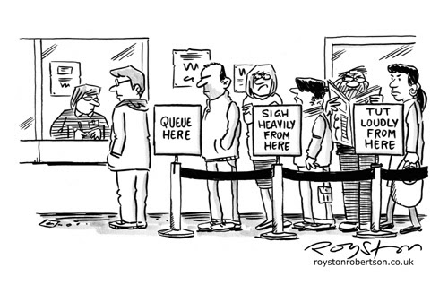

**Solution 2**

Suppose a customer enters the store and asks for a particular item in a particular quantity from a cashier. Then a second customer also enters the store and asks for the same item in a particular quantity from another cashier. In the previous method the second customer had to wait until the first customer is done with his whole purchase. But as a solution to this, as soon as after the first customer asked for the particular item in a particular quantity, when the cashier enters what the customer asked and the quantity, before the first customer to choose other items and save the purchase and make the other customer wait, the program logically deletes the particular quantity of the item from the database the first customer asked. So the data of the particular item mentioned above is visible to the second cashier in a shorter period of time than the time period mentioned above. So this shortens even further the time for two customers who ask for the same item.

**Difficulty 3**

Suppose a customer enters the store and asks for a particular item in a particular quantity. So if the program is written as mentioned in the solution 2, as soon as the cashier chooses item mentioned and the quantity mentioned, the quantity of the particular item available in the store is subtracted in the database according to the customer asked. Then suppose another customer enters the store and asks for the same item mentioned above in a bigger quantity. But as the quantity of the particular item available in the shop is subtracted as soon as the cashier enters what the first customer asked, the store could no longer issue the quantity of the particular item mentioned. If the first person continue his purchase, no problem. But suppose the first customer later says that he no longer need the item mentioned or he needs a lesser quantity of item, it cannot be undone and the chance to issue the item to the second customer may also get reduced. Financially this could result very heavily to a big store.

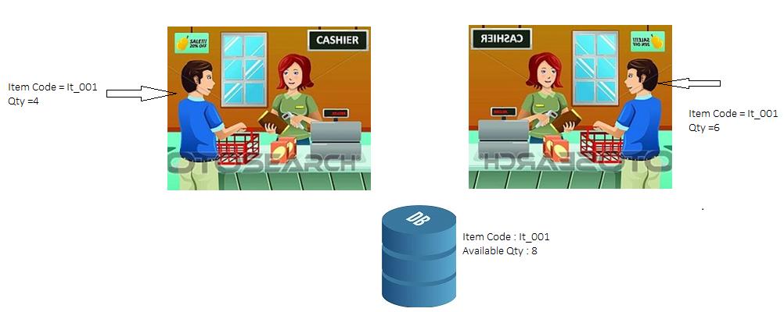

**Solution 3**

So as mentioned in the difficulty 3, it is quite not suitable to subtract the quantity of an item that is available in the store directly in the database. So as a solution to this we came up with an idea to introduce a static variable that is stored in the RAM not in the database. As soon as a customer asks for a quantity of a particular item, this static variable equalizes it value to the quantity available in the store. If the purchase is not yet done and a second customer enters the store and asks for the same item in a larger quantity, he is then shown remain of the item available as a static variable. Then the first customer saves the purchase and then the quantity of item available in the store is gets subtracted to the new one in the static variable and then the quantity in the database also decreases so the second customer cannot afford what he asked for. But suppose the first customer says that he no longer needs the item mentioned above or that he wants lesser than he mentioned before. Then the static variable shown to the second customer is become equal to the quantity available in the store or remain after the first customer changed the quantity he asked for. These are done using the static variables not harming the database variables until the purchase is done. So the chance of the second customer being denied from the queue becomes far too small than the previous difficulties mentioned above.

**Further Difficulties**

* Still in the all the solution mentioned above there is the first customer priority even in a smaller scale.
* More and more static variables should be introduced as the number of customers rises
* Still there is a little waiting in the queues.

.

**UML Digarms**

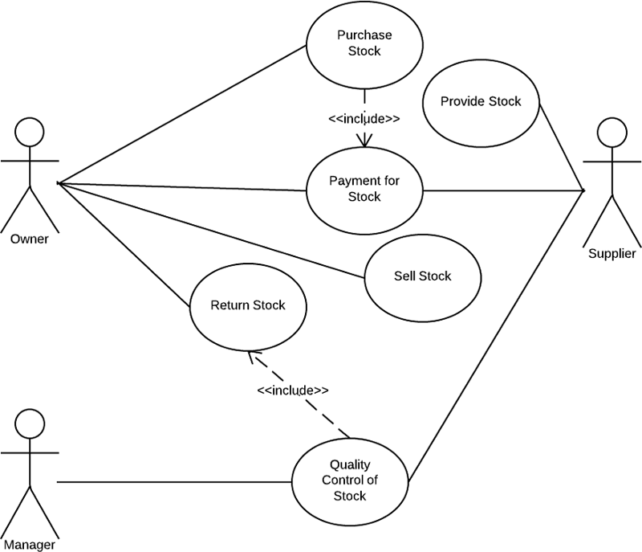

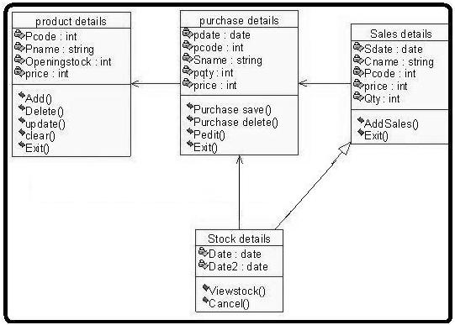

**Software Testing**

**About GUI**

**Cashier’s Home**

This is the home screen of the Cashiers.

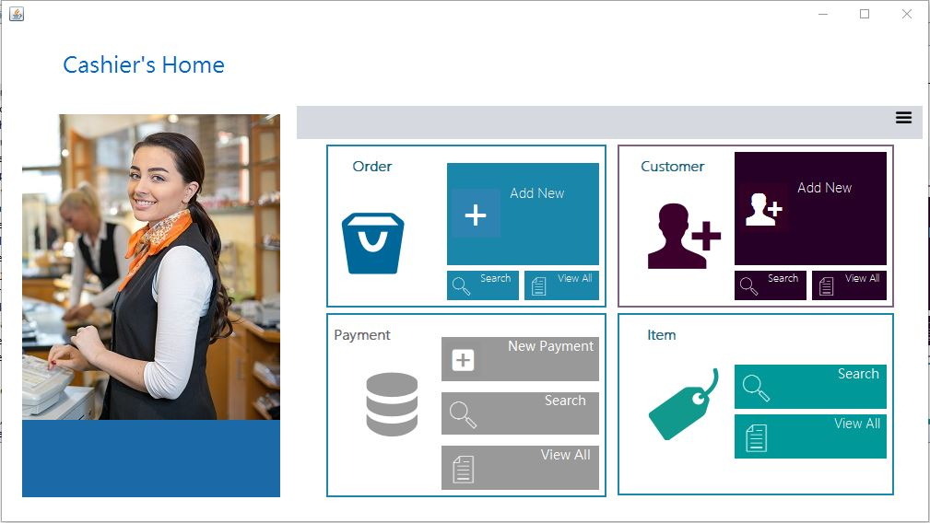

**Order**

* **Add new**

In here we can make new orders.

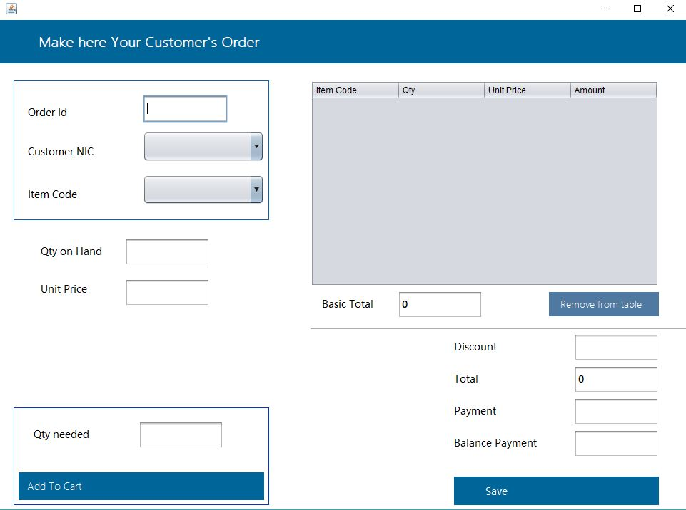

* **Search order details**

In here we can find the order that have issued, customerId, amount and balance.

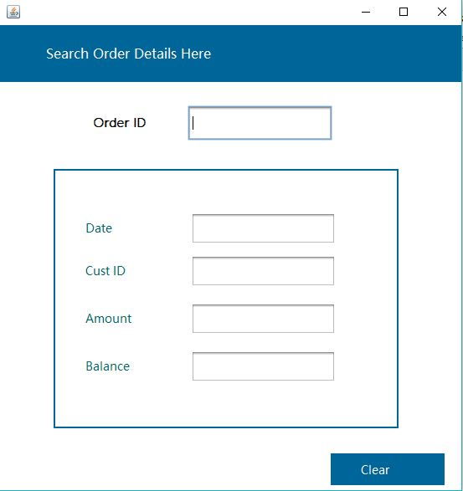

* **View all order details**

This will show the all order details

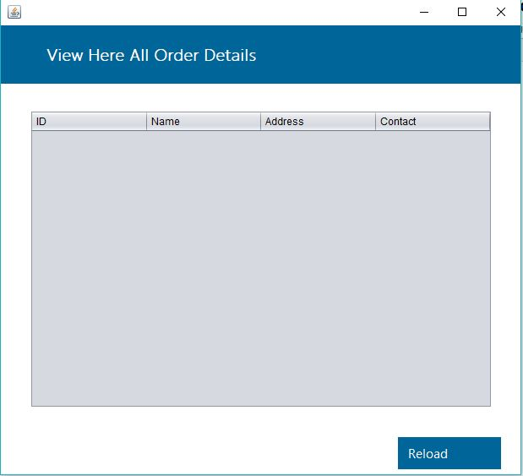

**Customer**

* **Add new customer**

In here we can add new customers

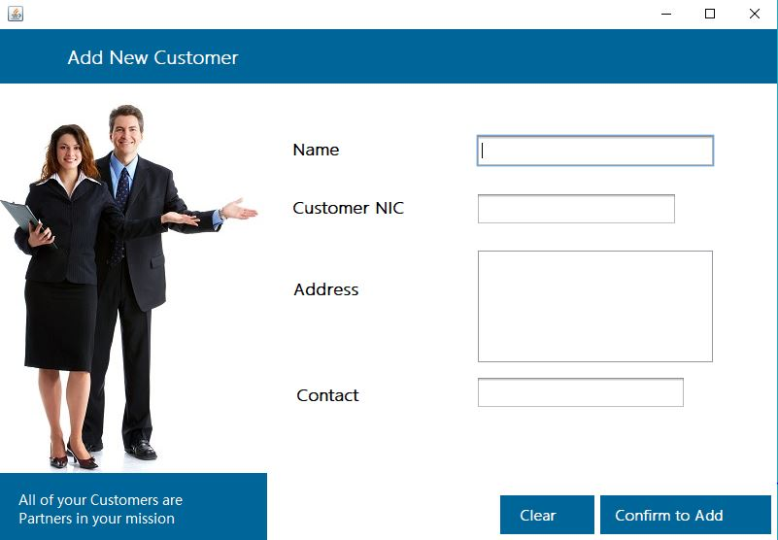

* **Search customer**

In here we can search customers.

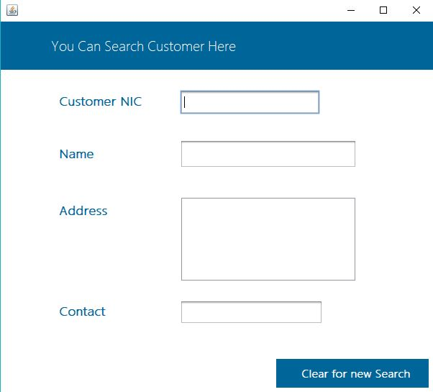

* **View all customers**

In here we can view all customers.

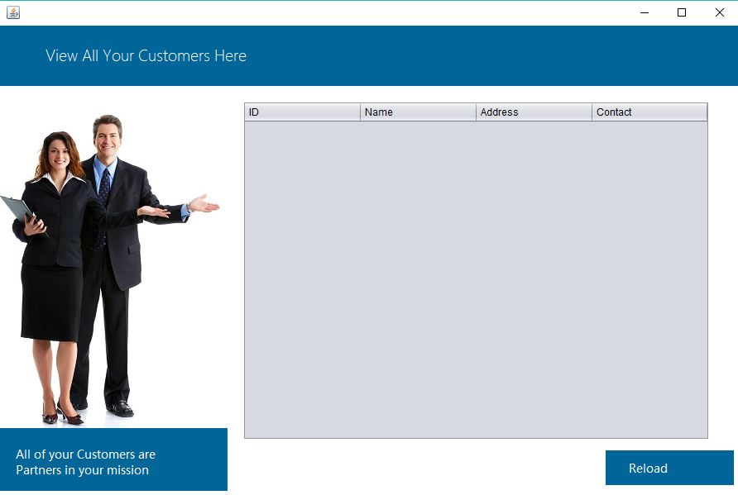

**Payment**

* **New payment**

In here we can make new payments

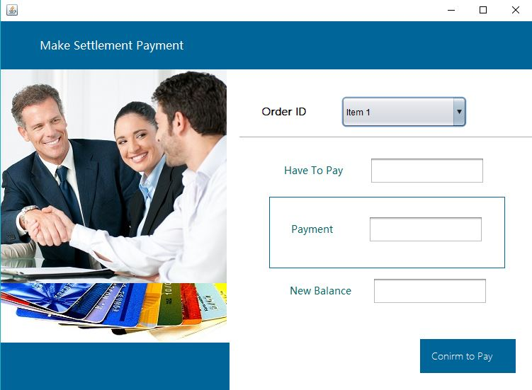

* **View the payments**

In here we can see the all payments

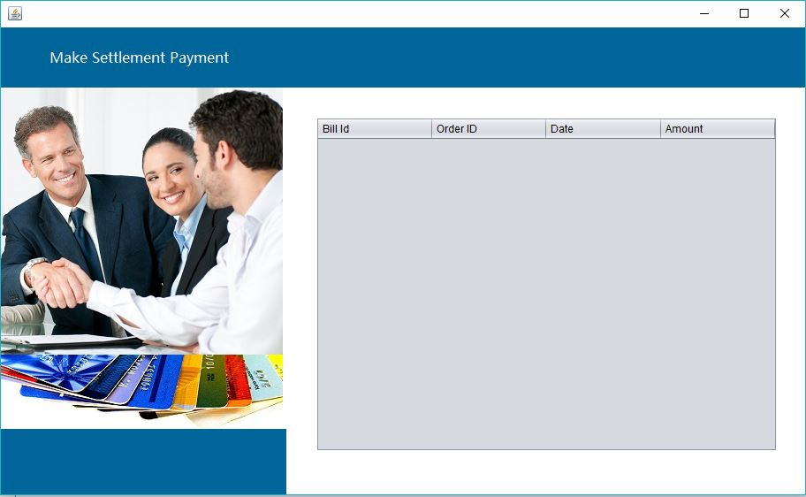

**Item**

* **Search for items**

In here we can search for items

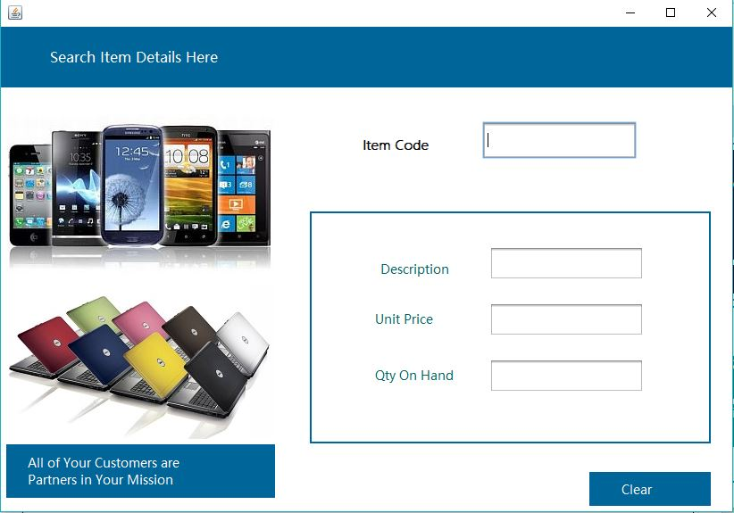

* **View items**

In here we can see all the item.

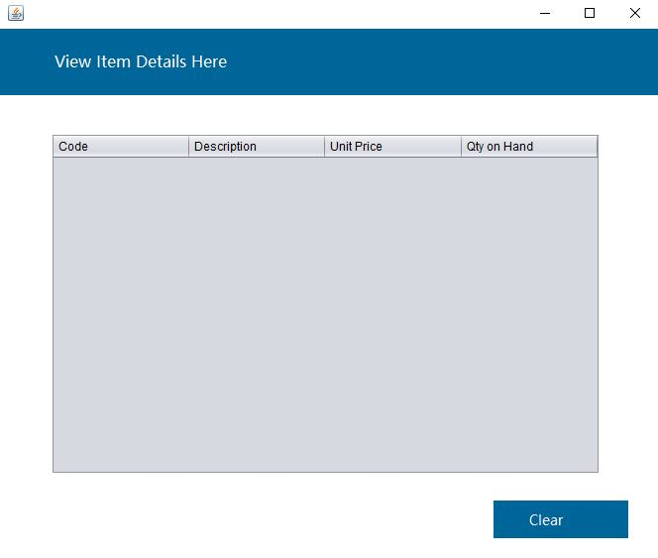

**Store Keeper’s Home**

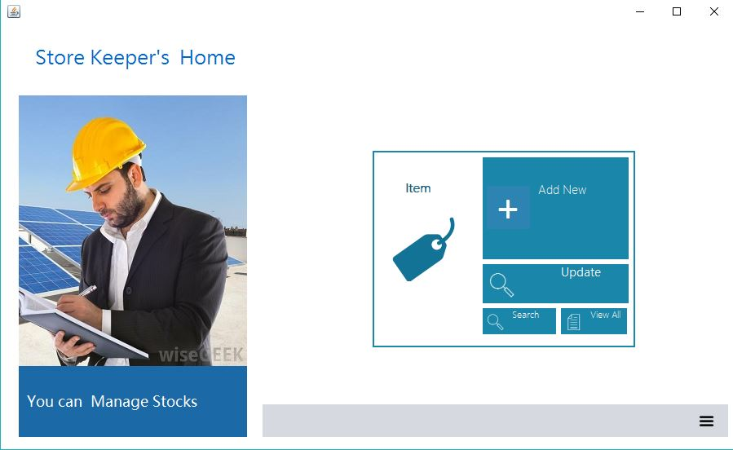

* **Add new items**

In here we can add new items

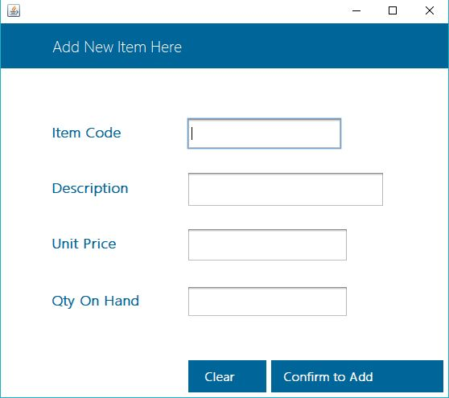

* **Update items**

In here we can update items

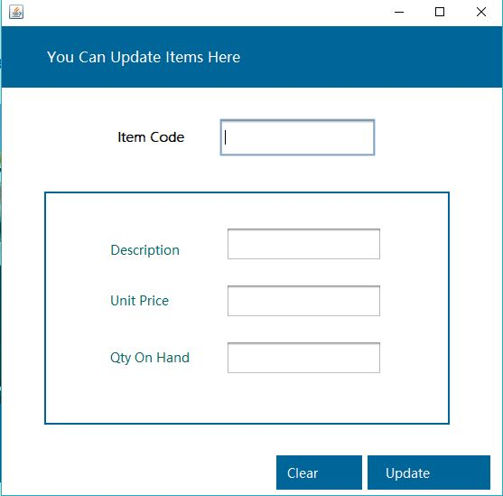

**References**

1. <https://www.fishbowlinventory.com/inventory-management>
2. <https://www.wikipedia.org>
3. <https://www.youtube.com/watch?v=xjsUiLrgIks>
4. http://www.programsformca.com/2012/03/uml-diagrams-for-stock-maintenance.html

**END.**