DL Lab 03

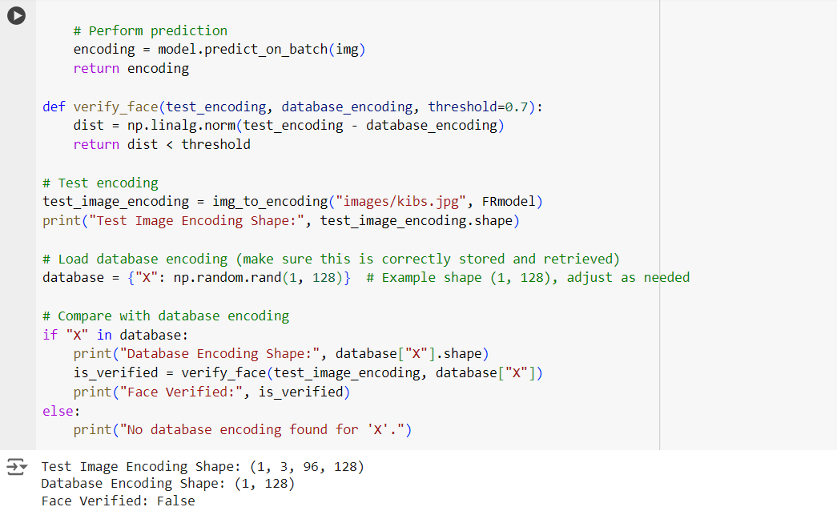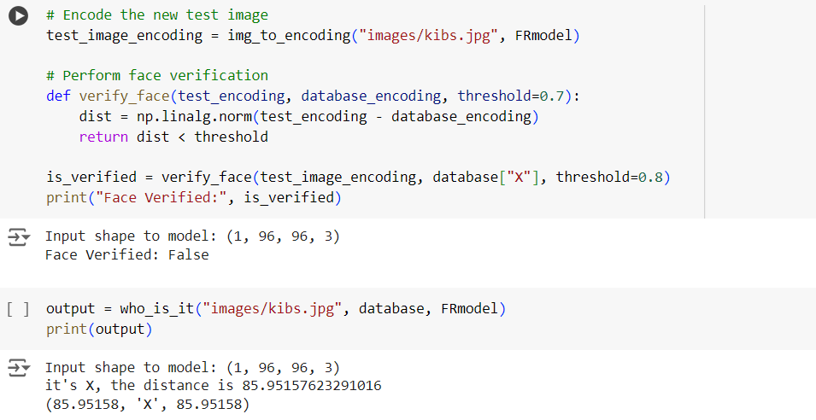

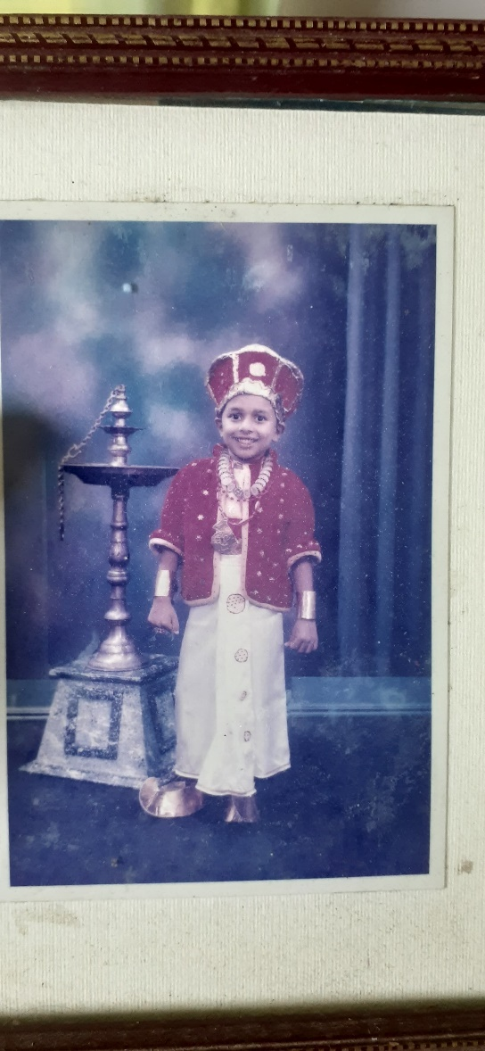lil_nadun.jpg

Kibs.jpg