

## Sri Lanka Institute of Information Technology

SE3030 – Software Architecture

Assignment 01 - FoodZilla

Project ID: CSSE_WE_44

|  |  |
| --- | --- |
| **Registration No** | **Name** |
| IT20639112 | Perera E.T.N. |
| IT20645052 | Liyanage G.L.S. E |
| IT20649562 | Kavinda A. A. T. |
| IT20659158 | Nanayakkara M.A.H. R |

**Introduction**

This is an OSGi system implementation of the producer (Publisher) – Consumer

situation. Microkernel Architecture was used in this program and this was deployed by

Eclipse Equinox. Our Group creates this simple OSGI architecture for Family Restaurant

management system. Microkernel Architecture was used to create this Restaurant

management system Which was built with Java and Apache Felix OSGI Framework.

There are separate service bundles as producers (Publisher) and to consume that service

as a consumer. To get best practices of the OSGi we used producer service interface

only not the implementation Consumers can work through the interfaces.

This Micro Kernal architecture is based on the Family Restaurant management system.

In here there are four main categories as Employee management, Food item

management, Foodservice management and Reservation management. There is a

Producer (Publisher) for each Four Consumers. In Employee management An Employee

can be added to the system by inserting basic details of the employee (Name, Age,

Phone number and Employee NIC). A selected employee’s details can be searched and

all employee details can be retrieved from the system. An employee can be deleted

from the system as well. In Food item management a food item can be added to the

system by inserting basic details of the food item (Food name, Food type and Food

category). The all details of the food item can be retrieved from the system. And also

there are several methods implemented for Method for get food item from Menu by Id,

Method for get food item from Menu by name and Method for get price for food item

from Menu by Id. There is a method implemented for deleting food item from Menu by

Id. In Foodservice management there are several methods for order food for a particular

table, method user can get food price by entering the food id and get all the food that

has been ordered. And also, food can be ordered through the system by inserting Food

Name, Quantity, Total amount and Table ID. In reservation management there are two

main sides as admin and user. User can come up with a reservation. In there a new

reservation can be inserted. There are methods to get all the reservations in the system,

get all the reservations to a specific user, method to delete the user and method to get

all the priority reservations or all the normal reservation.

1. Employee Management:

* User selects "Employee Management" option from the main menu.
* User selects "Add Employee" option.
* User enters the basic details of the employee and submits the form.
* System saves the employee details and displays a success message.
* User selects "Search Employee" option.
* User enters the employee name or ID and submits the form.
* System displays the matching employee details.
* User selects "Delete Employee" option.
* User enters the employee ID and submits the form.
* System deletes the employee from the system and displays a success message.

1. Food Item Management:

* User selects "Food Item Management" option from the main menu.
* User selects "Add Food Item" option.
* User enters the basic details of the food item and submits the form.
* System saves the food item details and displays a success message.
* User selects "Get Food Item Details" option.
* User enters the food item name or ID and submits the form.
* System displays the matching food item details.
* User selects "Delete Food Item" option.
* User enters the food item ID and submits the form.
* System deletes the food item from the menu and displays a success message.

1. Food Service Management:

* User selects "Food Service Management" option from the main menu.
* User selects "Order Food" option.
* User enters the table ID, food name, quantity and total amount and submits the form.
* System saves the order details and displays a success message.
* User selects "Get Food Price" option.
* User enters the food item ID and submits the form.
* System displays the price of the food item.
* User selects "View Ordered Food" option.
* User enters the table ID and submits the form.
* System displays the list of all the food items ordered for that table.

1. Reservation Management:

* User selects "Reservation Management" option from the main menu.
* User selects "Make Reservation" option.
* User enters the reservation details and submits the form.
* System saves the reservation and displays a success message.
* User selects "View All Reservations" option.
* System displays the list of all the reservations in the system.
* User selects "View My Reservations" option.
* User enters the user ID and submits the form.
* System displays the list of all the reservations made by that user.
* User selects "Delete Reservation" option.
* User enters the reservation ID and submits the form.
* System deletes the reservation from the system and displays a success message.
* User selects "View Priority Reservations" option.
* System displays the list of all the priority reservations.

**Diagrammatic Overview**

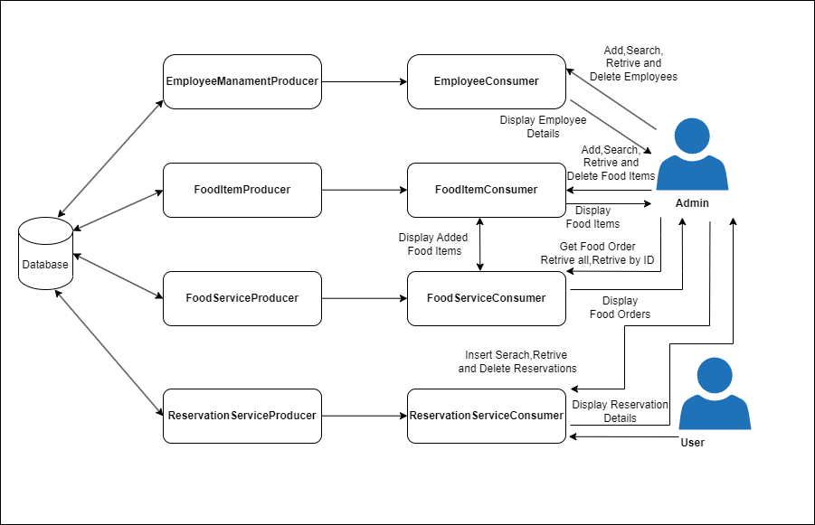

**A) Manifest Implementation**

1.Employee Consumer Manifest

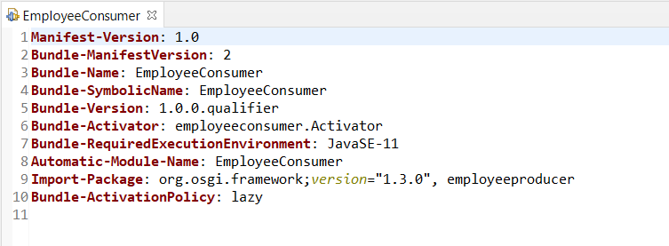

1. Employee Producer Manifest

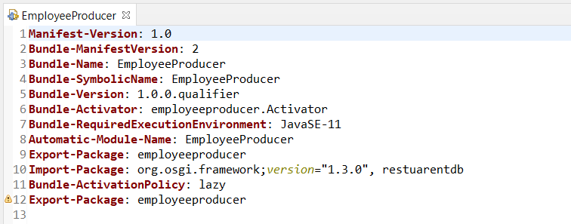

1. Food Item Consumer Manifest

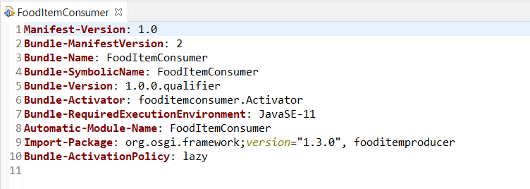

1. Food Item Producer Manifest

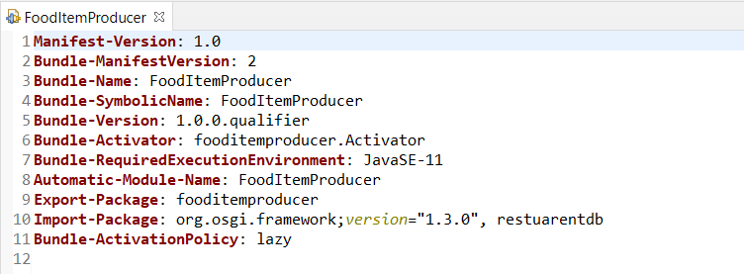

1. Food Service Consumer Manifest

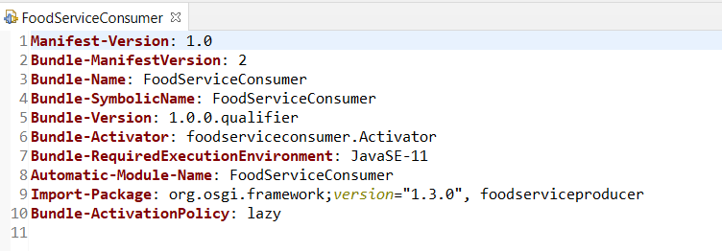

1. Food Service Producer Manifest

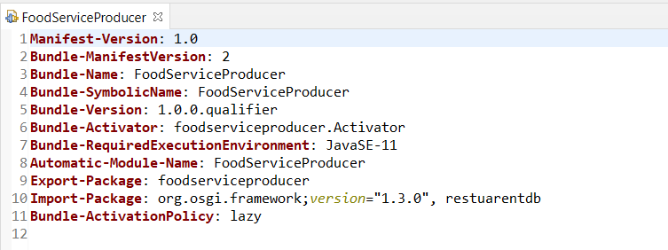

1. Reservation Service Producer Manifest

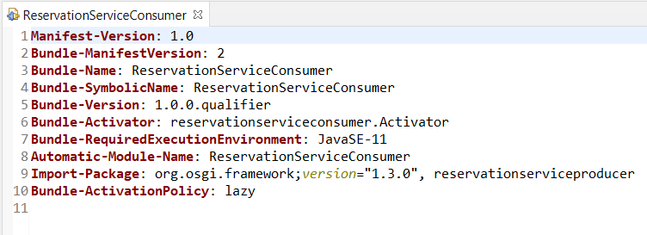

1. Reservation Service Consumer Manifest

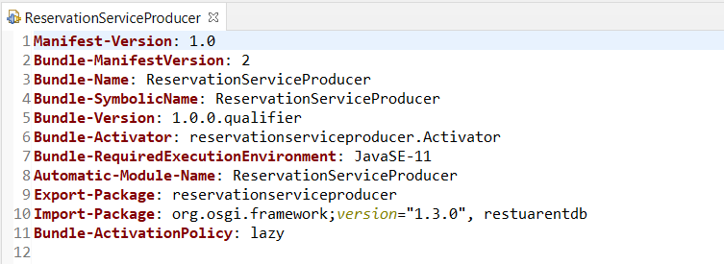

**C) All commands of Bundle install and run in OSGi Framework**.

* 1. Employee Consumer Stop and Start

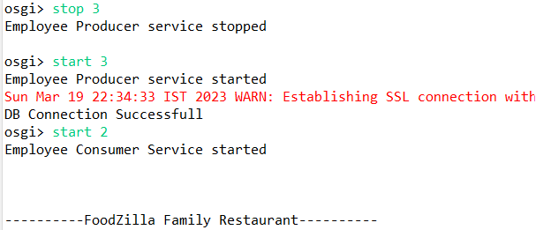

* 1. 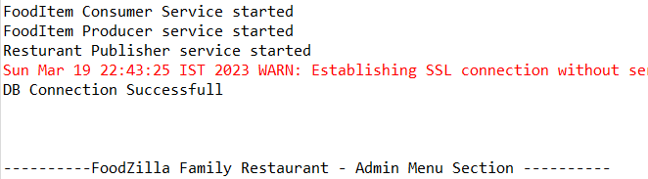Food Item Consumer Stop and Start
  2. Food Service Consumer Stop and Start

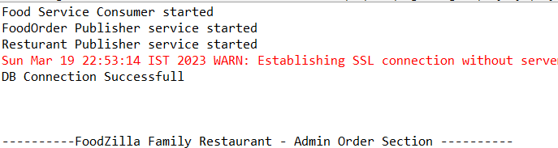

* 1. Reservation Consumer Stop and Start

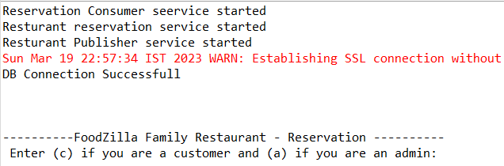

* 1. All Bundlles

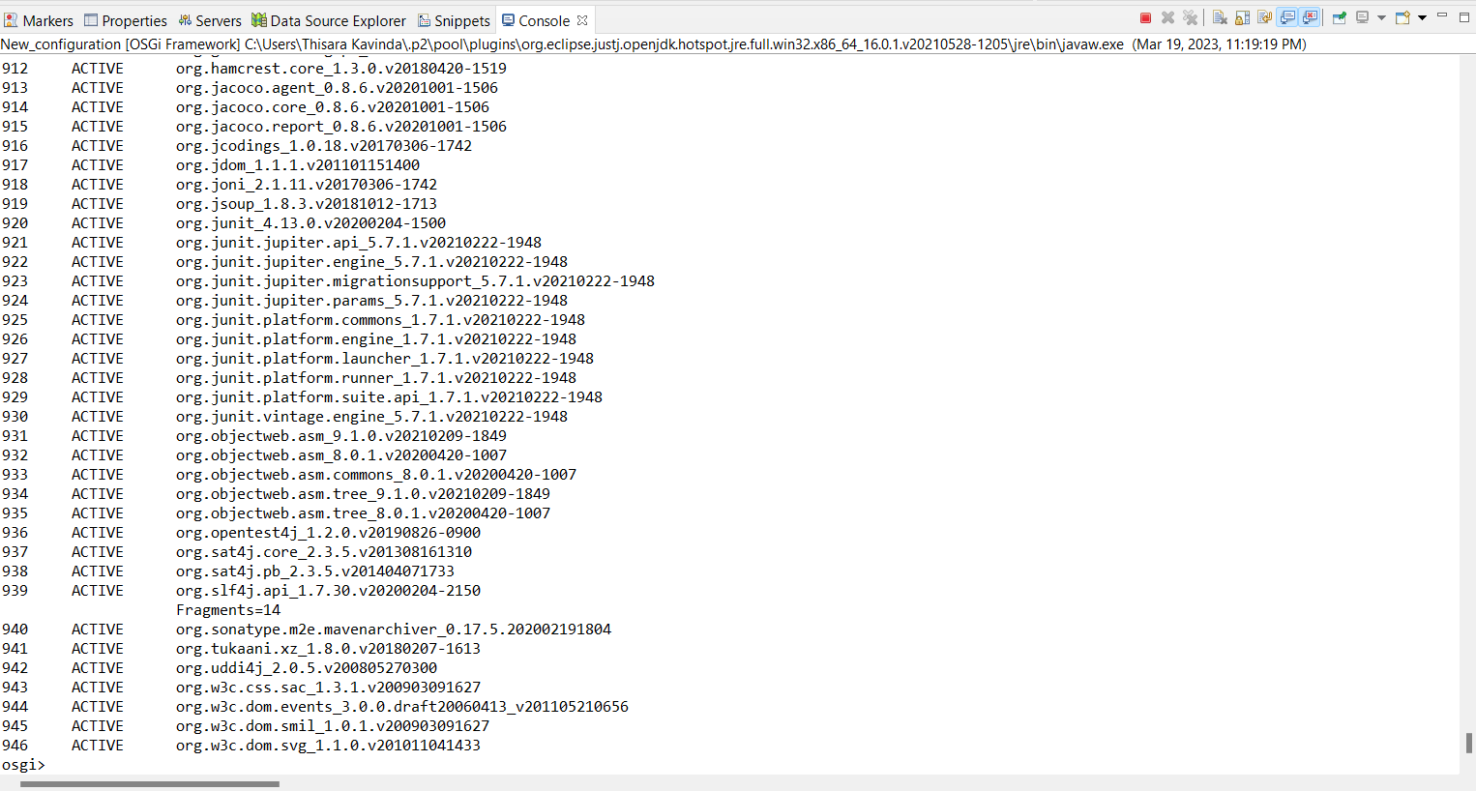

**D) Sample Screenshots of its Behaviour & Outputs**

* 1. Employee Add

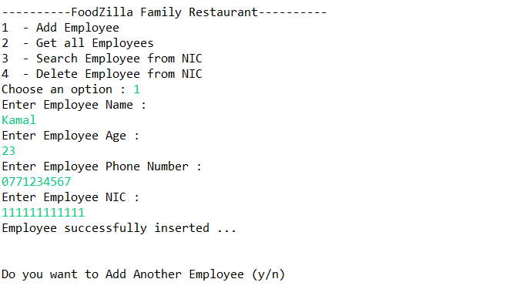

* 1. Employee View All

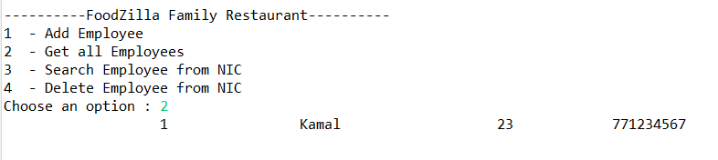

* 1. Employee Delete

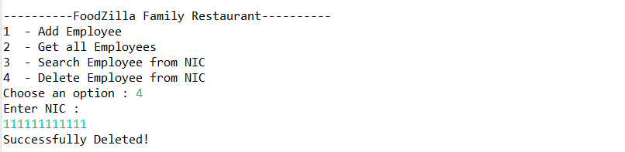

* 1. Food Item Add

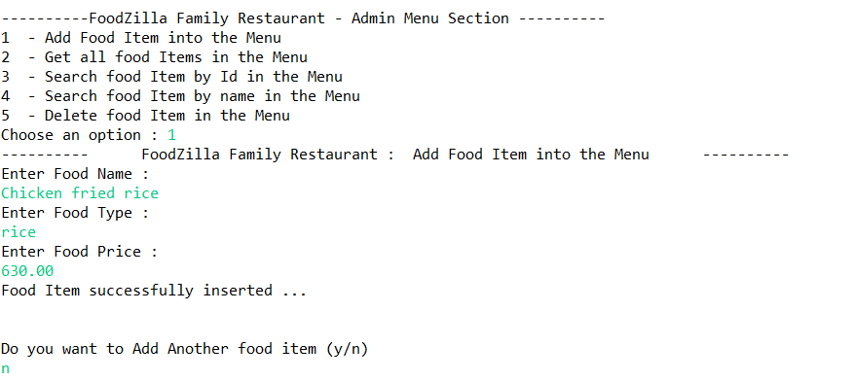

* 1. 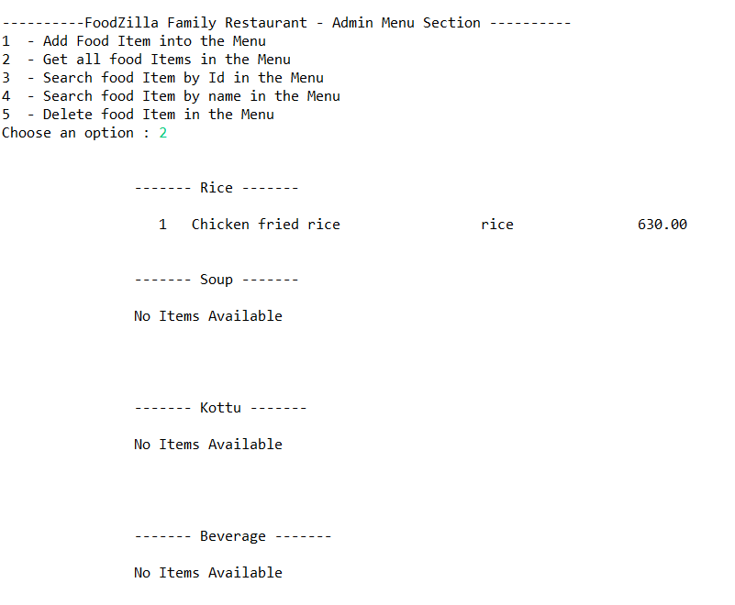Food Item View All
  2. Food Item Delete

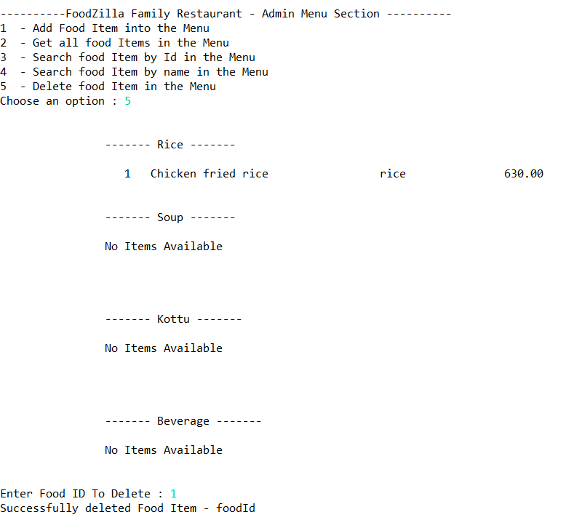

* 1. Food Service Oder Food and get All Ordered Food

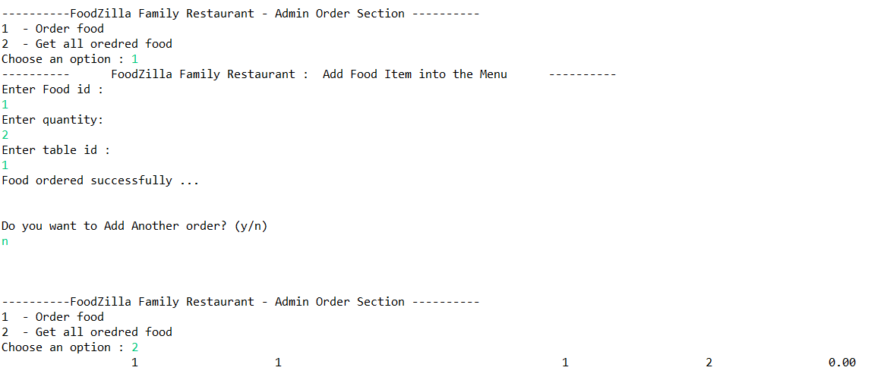

* 1. Reservation Add

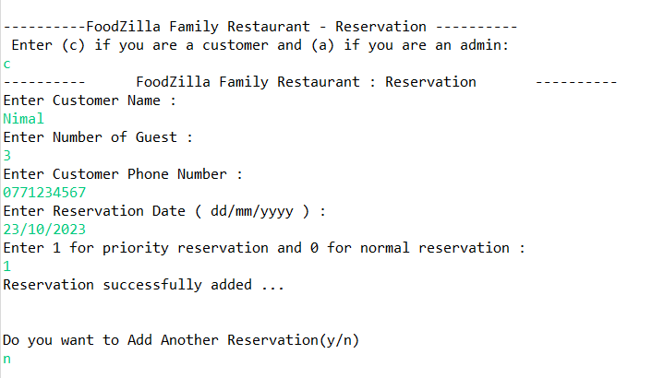

* 1. Reservation View All

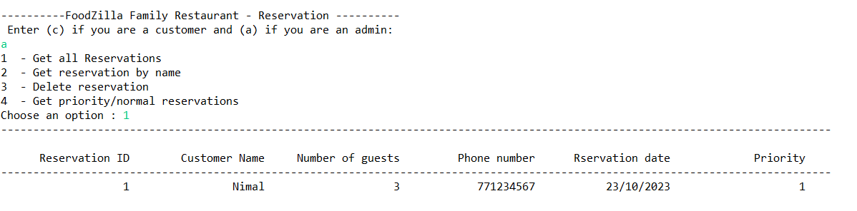

* 1. Reservation Delete

