**Welcome Screen**

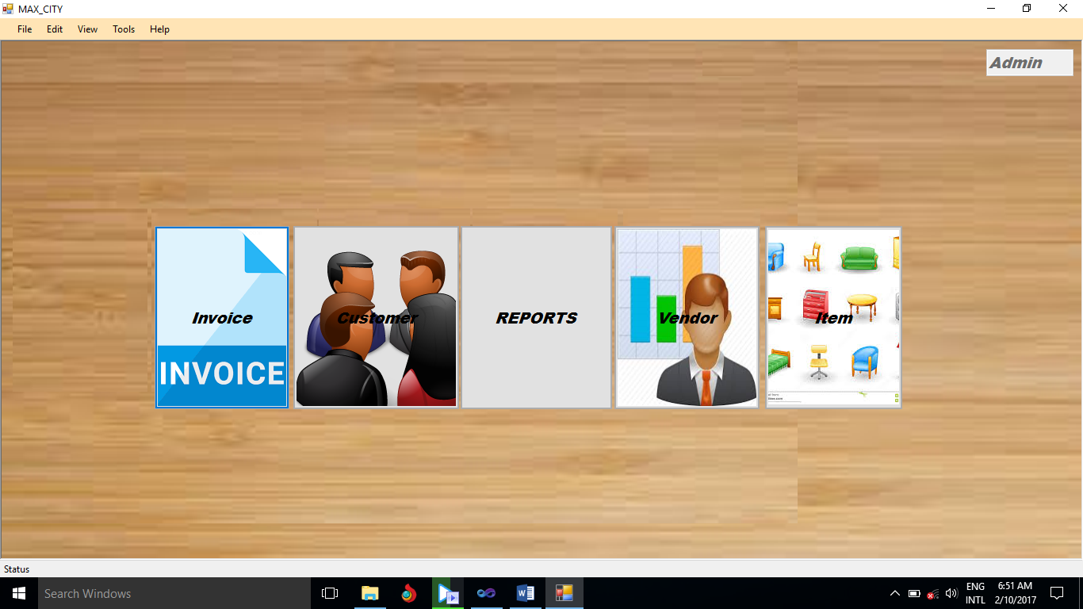

# How to input new data?

1. How to create a new customer?
2. How to create a new item?
3. How to create a new vendor?
4. How to create Invoice?

# Reports

# How to update the data?

1. How to update Customer’s details?
2. How to update Vendor’s details?
3. How to update Item’s details?

# How to preview details?

1. How to preview customer’s details?
2. How to preview Items details?
3. How to preview Vendor’s details?
4. How to preview accounts?
5. How to preview sales?

# How to input new data?

## How to create a new customer?

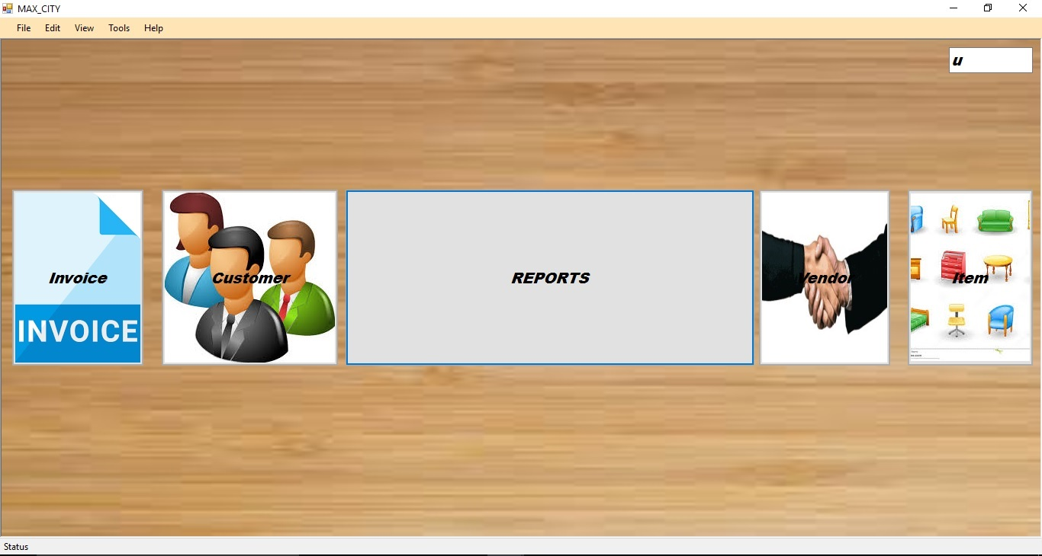

There are two methods to create a new customer.

Go to file New Customer **Or**

Click the customer tab in the welcome screen.

(Then customer create window will be opened.)

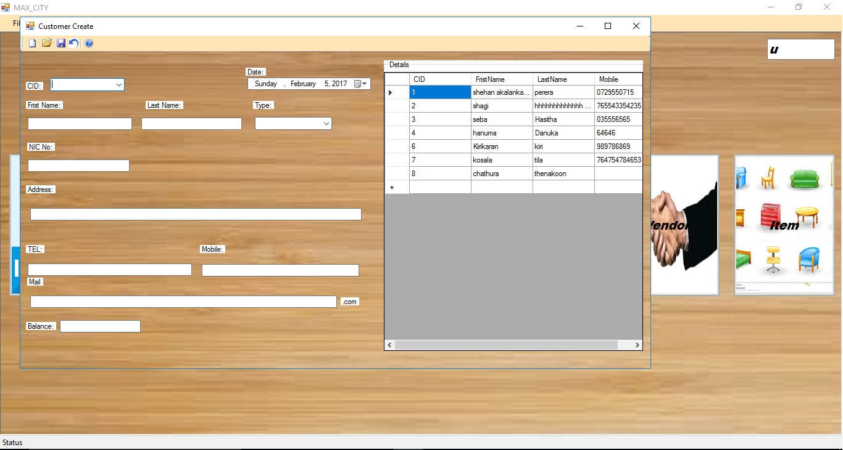

The customer create dialogue box should fill per following guide lines.

CID*: - Customers ID. (This should be integer.)

Date :- The date which customer registered.

First Name :- Customer’s first name.

Last Name :- Customer’s last name.

Type :- The way of paying.

NIC No:- Customer’s NIC number.

Address:- Customer’s permanent address.

Telephone :- Permanent telephone number of office/ home.

Mobile :- Customer’s mobile phone numbers.

Mail :- Customer’s e-mail address.

There are required fields in this tis form marked.

Save the customer’s details by using icon

By using icon close this window.

## How to create a new item?



There are two methods to create a new customer.

Go to file New Item **Or**

Click the item tab in the welcome screen.

(Then item create window will be opened.)

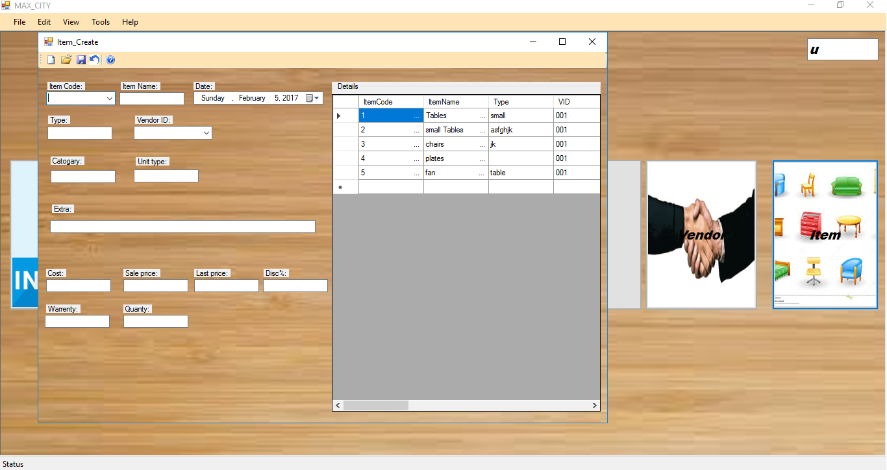

The item create window should fill per following guide lines.

Item Code :- The code of the item.

Item Name :- The name of the item.

Type :- Type of the item.

Vendor ID :- ID of the salesman.

Category :- Brand of Item

Unit type :- Type of item

Extra :- Description of item

Cost :- Cost of item

Sale price :- Sale price of item

Last price:- Last price of item

Disc% :- Discount

Warranty :- Warranty period

Quantity :- Number of items in stock

There are required fields in this form marked.

Save the Item’s details by using icon.

By using icon close this window.

## How to create a new vendor?



There are two methods to create a new customer.

Go to file New Vendor **Or**

Click the Vendor tab in the welcome screen.

(Then Vendor create window will be opened.)

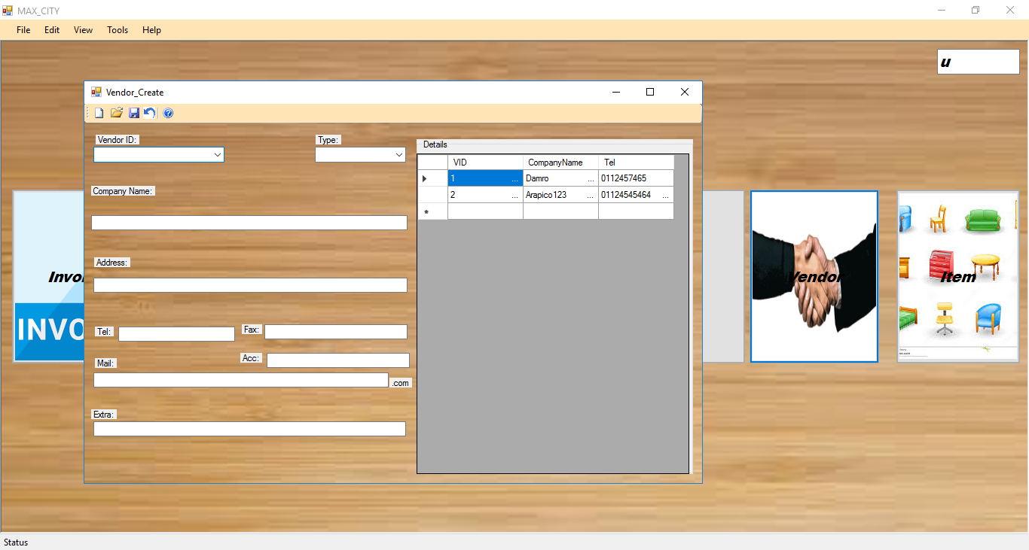

The Vendor create dialogue box should fill per following guide lines.

Vendor ID :- ID of salesman.

Type :- Cash or credit

Company Name :- Vendor’s company name

Address :- Vendor’s permanent address

Tel :- Vendor’s permanent phone number(Office/ home)

Fax :- Vendor’s fax number

Acc :- Vendor’s bank account number

Mail :- Vendor’s e-mail address

Extra :- Description of vendor

There are required fields in this form marked.

Save the Vendor’s details by using icon.

By using icon close this window.

## How to create Invoice?



How to create a new vendor?

There are two methods to create a new customer.

Go to file New Vendor **Or**

Click the Vendor tab in the welcome screen.

(Then Vendor create window will be opened.)



It should fill per following guide lines.

Invoice No :- It will be filled automatically.

CID :- The customer ID which was created. (Give the CID then search) Then Name, Address, Type, Contact Number will be filled automatically.

Then click on the Name and press Enter Key. After you can type item code.

Insert item code and press Search button. Then Item & Price will be filled.

Quantity :- Number of items will be able to buy.

After insert the Quantity, click on the Add button.

There are required fields in this form marked.

Save the Invoice details by using icon.

Click on the icon button to clear the invoice.

Print the invoice by using  and use the  button to preview the print page.

# **Reports**

Use Report tab on the welcome screen to preview Customer(s) who should pay balance & Item(s) which is less than or equal of 10 on the store.

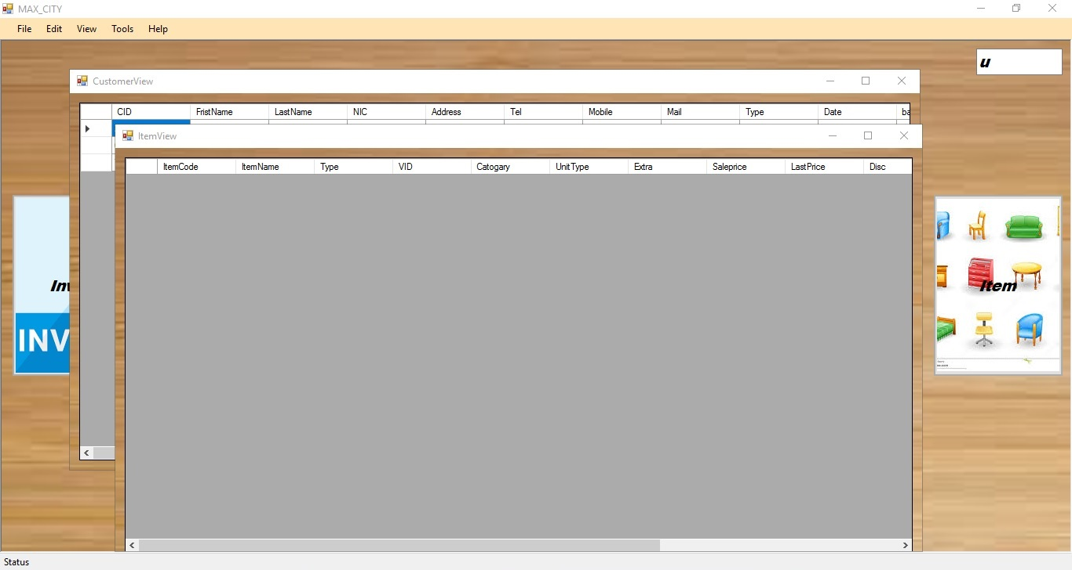

# How to update the data?

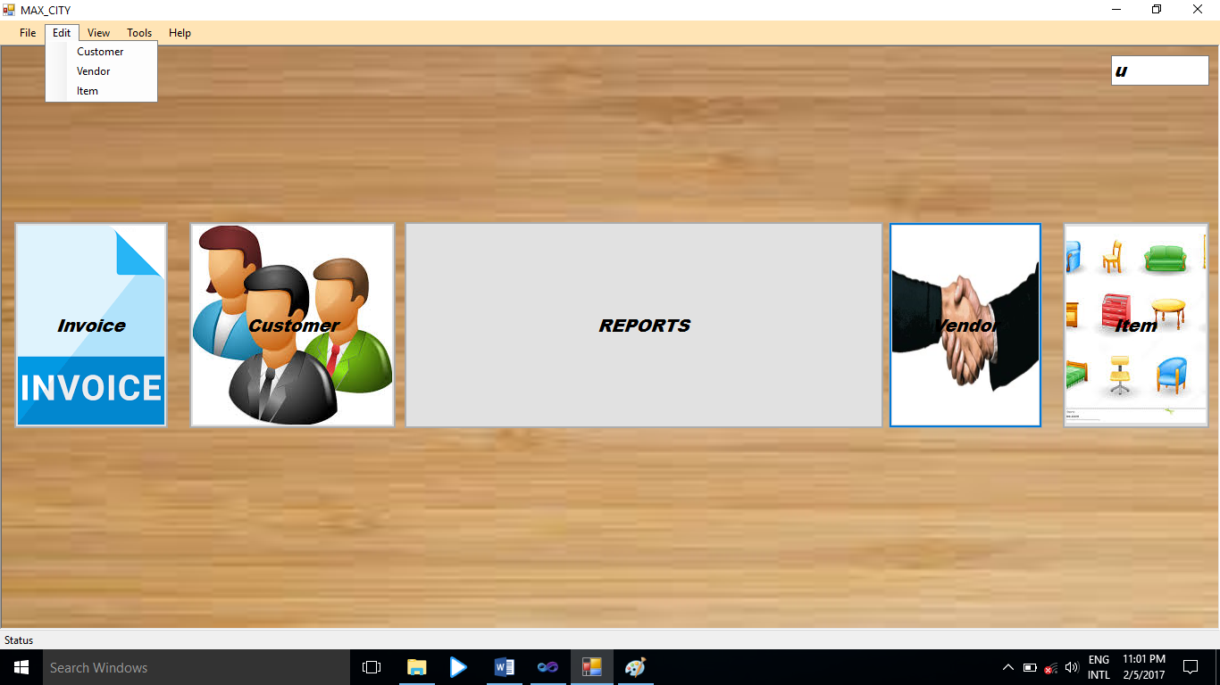

## How to update Customer’s details?



Go to Edit Customer

Then following window will be opened.

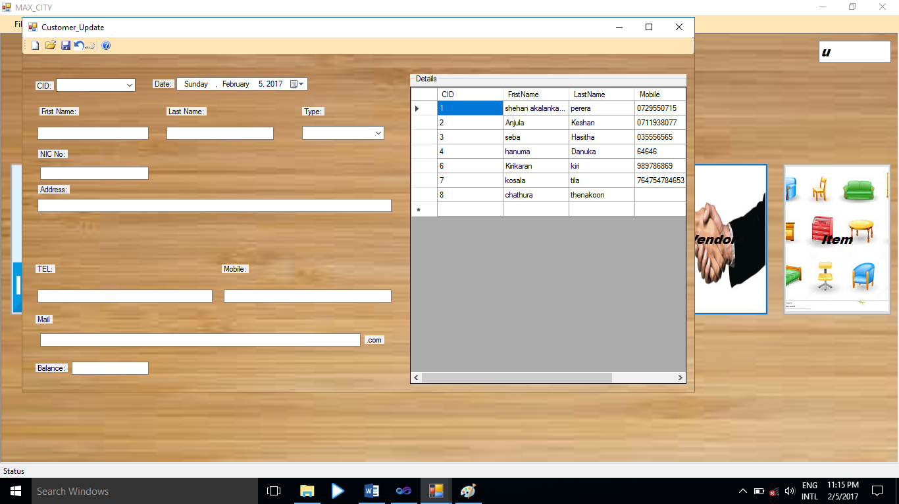

Type or select the Customer’s Id on the CID text box and click on the  icon.

Update require details and press on the icon. And use to close the window.

## How to update Vendor’s details?



Go to Edit Vendor

Then following window will be opened.

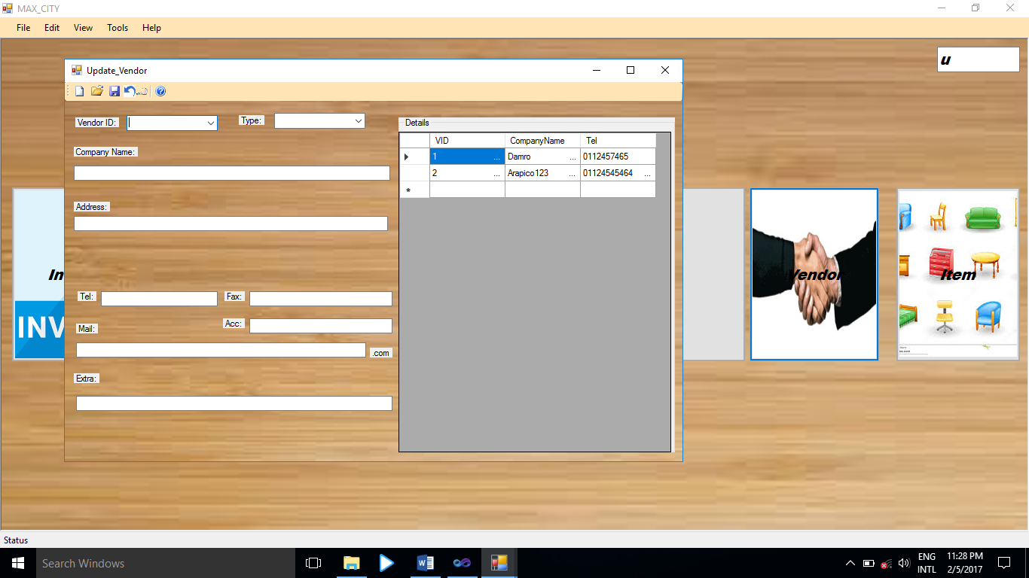

Type or select the Vendor’s Id on the Vendor ID text box and click on the  icon.

Update require details and press on the icon. And use icon to close the window.

## How to update Item’s details?



Go to Edit Item

Then following window will be opened.

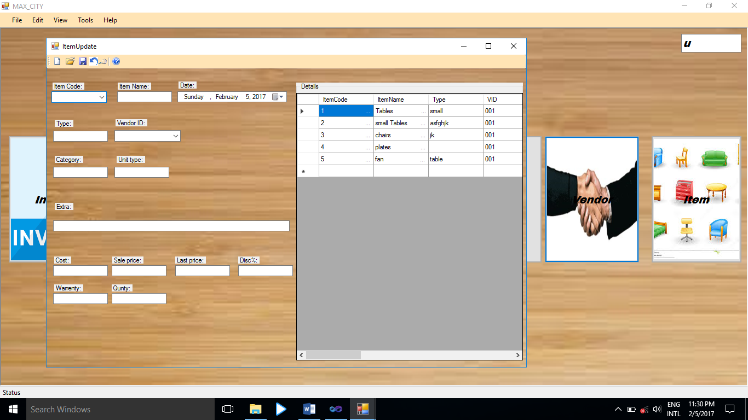

Type or select the Item Code on the Item Code text box and click on the  icon.

Update require details and press on the icon. And use icon to close the window.

# How to preview details?

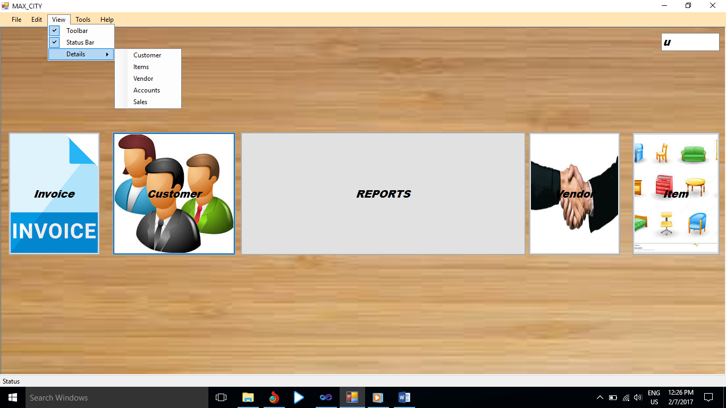

## How to preview customer’s details?

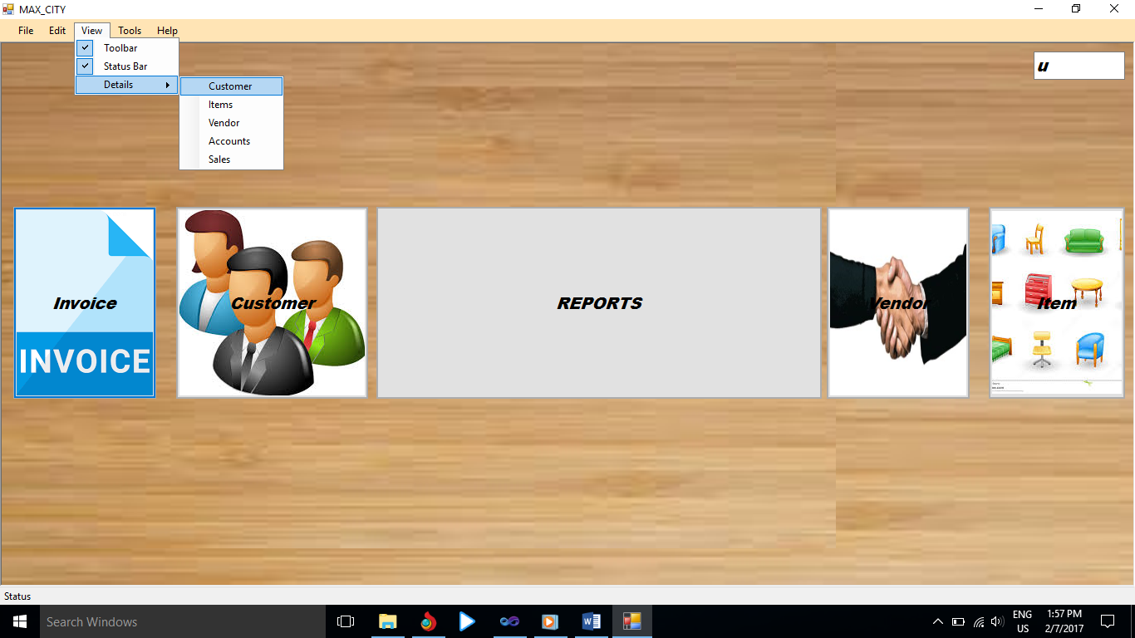

Go to View Details Customer

Customer Details will be shown as above figure.

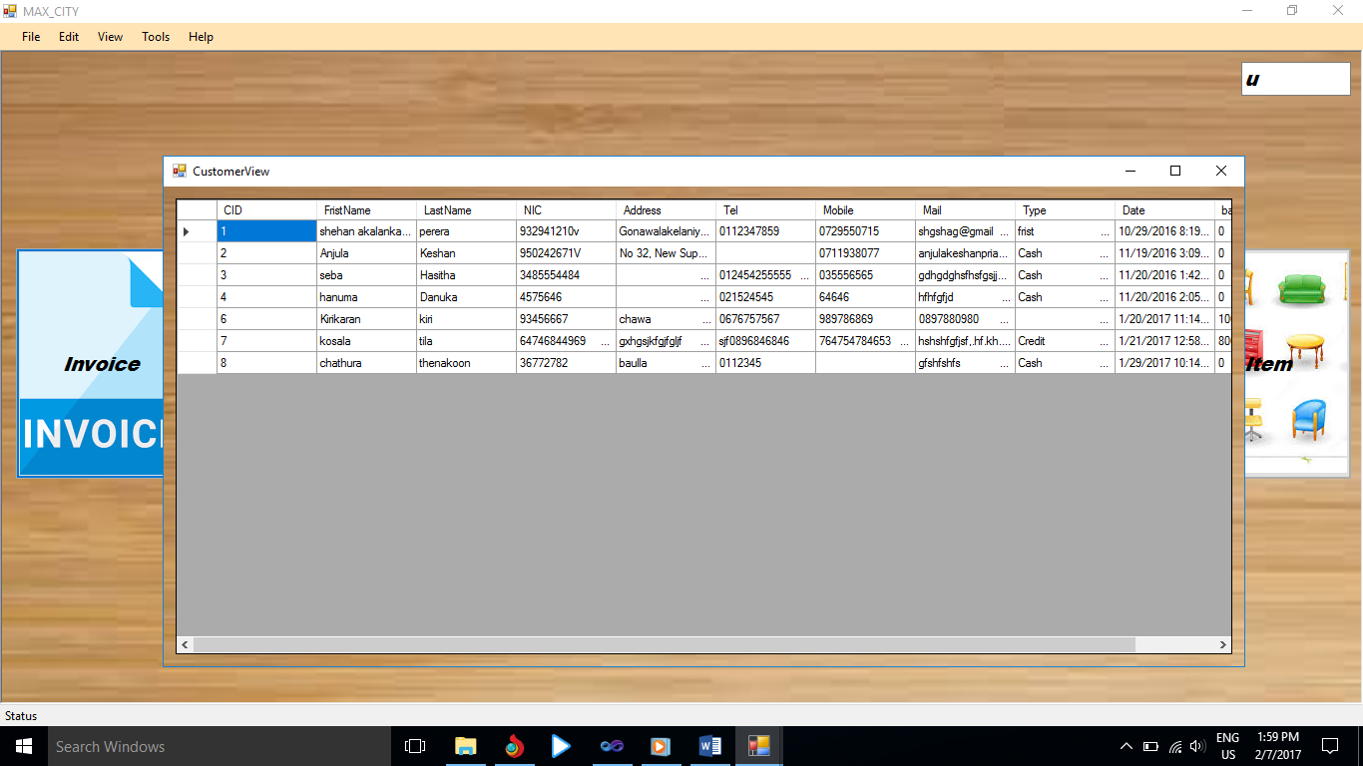

## How to preview Items details?

## How to preview Vendor’s details?

## How to preview accounts?

## How to preview sales?