CSCI 44052 – Software Quality and Automation
Assignment 1 Report
Student Name | S A D S N Suraweera
Student No : | CS/2020/016
Date | June 2026
Submission Deadline | 20th June 2026

Resource | Link
GitHub Repository | https://github.com/ShehanSuraweera/qa-assingment
Live Playwright HTML Report | https://shehansuraweera.github.io/qa-assingment

1. Overview
This report documents the practical exploration of two modern software testing toolsets: Playwright for browser-based GUI automation and Postman for API validation. The System Under Test (SUT) targets used are:
- JSONPlaceholder API (https://jsonplaceholder.typicode.com) — a free, publicly available REST API sandbox supporting GET, POST, and DELETE operations without authentication requirements.
- The Internet (Heroku) (https://the-internet.herokuapp.com/login) — a purpose-built web application designed for practising UI automation, featuring a real login form with known credentials.
These targets were selected because they are stable, publicly accessible, and representative of real-world application patterns without requiring local infrastructure setup.

2. Tool Selection Criteria

2.1 Playwright (UI Testing)
Playwright was selected as the browser automation framework based on the following criteria:
Criterion | Evaluation
Installation complexity | Single npm install — no external drivers or binaries needed
Browser support | Chromium, Firefox, and WebKit from one package
Auto-waiting | Built-in retry logic eliminates arbitrary sleep() calls
Test runner | Bundled — no external runner (JUnit, TestNG) required
Assertion library | Bundled expect() API — no third-party library needed
Reporting | Built-in HTML reporter with screenshots on failure
Language support | JavaScript, TypeScript, Python, Java, C#

2.2 Postman (API Testing)
Postman was selected for API validation over alternatives such as Bruno and curl because:
- Its Collection Runner allows sequential execution of multiple requests with shared state in a single run.
- Test scripts written in pm.test() are co-located with the request definition, making assertions self-documenting and version-controllable.
- The free Education Tier includes team workspaces and a collection export format (JSON) that integrates with CI pipelines via Newman (Postman’s CLI runner).
- No additional tooling is required — the test console, assertion library, and reporting are all part of the same interface.

2.3 JSONPlaceholder as API Target
JSONPlaceholder was selected because it exposes a fully functional REST API with standard HTTP methods, returns structured JSON responses, and requires no API key or account. This makes it an ideal sandbox for asserting HTTP status codes, response time boundaries, and JSON schema validity — all three requirements of Tasks 1 and 2.

3. API Testing (Tasks 1 and 2)

3.1 Endpoints Tested
Five requests were constructed against the JSONPlaceholder /posts resource to understand its behavioral boundaries, including one negative test for error handling:
Method | Endpoint | Expected Status | Purpose
GET | /posts | 200 OK | Retrieve all posts — validates array schema
GET | /posts/1 | 200 OK | Retrieve single resource — validates object schema
GET | /posts/99999 | 404 Not Found | Non-existent resource — validates error boundary
POST | /posts | 201 Created | Create a new resource — validates write operation
DELETE | /posts/{{postId}} | 200 OK | Remove the resource created by POST — validates deletion
All requests use the {{baseUrl}} collection variable (https://jsonplaceholder.typicode.com) rather than hardcoded URLs, allowing the target environment to be switched without editing individual requests. The DELETE request uses the {{postId}} variable populated dynamically by the POST test script, chaining the two requests.

3.2 JavaScript Verification Scripts
Each request in the Postman collection includes three categories of assertions:

(a) HTTP Response Status Code
pm.test(‘Status code is 200 OK’, function () {
pm.response.to.have.status(200);
});

// POST-specific assertion
pm.test(‘Verify successful data creation’, function () {
pm.response.to.have.status(201);
pm.expect(pm.response.json().id).to.be.a('number');
});

(b) Response Execution Runtime Boundary
Response time SLA thresholds are defined per operation type, reflecting their different processing characteristics. In industry these values are defined in a Service Level Agreement (SLA) or Non-Functional Requirements (NFR) document; here they are derived from the nature of each operation:
Operation Type | SLA Threshold | Rationale
Read — single record (GET /posts/1) | 200ms | Single object lookup; minimal payload
Read — list endpoint (GET /posts) | 2000ms | Returns all 100 records (~8KB payload); higher transfer overhead than a single-record lookup
Read — not found (GET /posts/99999) | 1500ms | Full network round trip required even for a 404 response
Write (POST) | 2000ms | Server must allocate, validate, and persist a new resource
Delete (DELETE) | 1000ms | No body processing overhead, but slower than a single-record read

// Single record: 200ms SLA
pm.test(‘Response time is under 200ms (read SLA)’, function () {
pm.expect(pm.response.responseTime).to.be.below(200);
});
// List endpoint: 2000ms SLA (100 records, ~8KB payload)
pm.test(‘Response time is under 2000ms (list endpoint SLA)’, function () { pm.expect(pm.response.responseTime).to.be.below(2000);
});
// 404 not found: 1500ms SLA (full round trip still required)
pm.test(‘Response time is under 1500ms (not-found SLA)’, function () { pm.expect(pm.response.responseTime).to.be.below(1500);
});
// POST: 2000ms write SLA (server-side creation overhead)
pm.test(‘Response time is under 2000ms (write operation SLA)’, function () { pm.expect(pm.response.responseTime).to.be.below(2000);
});
// DELETE: 1000ms (no body processing overhead)
pm.test(‘Response time is under 1000ms (delete operation SLA)’, function () { pm.expect(pm.response.responseTime).to.be.below(1000);
});

(c) Exact JSON Schema Layout Validity
pm.test('Each post has valid schema', function () {
const body = pm.response.json();
body.forEach(function (post) {
pm.expect(post).to.have.property('userId').that.is.a('number');
pm.expect(post).to.have.property('id').that.is.a('number');
pm.expect(post).to.have.property('title').that.is.a('string');
pm.expect(post).to.have.property('body').that.is.a('string');
});
});
Additionally, after the POST request the returned resource ID is captured for use by DELETE:
// Saves the created post ID for use in DELETE /posts/{{postId}}
pm.collectionVariables.set(‘postId’, pm.response.json().id);

3.3 Results
All 20 assertions passed across 5 requests. Results show actual response time against the defined SLA threshold for each operation type:
Request | Actual Response Time | SLA Threshold | Tests | Outcome
GET /posts | 58ms | 2000ms | 5/5 | PASS
GET /posts/1 | 14ms | 200ms | 4/4 | PASS
GET /posts/99999 | 13ms | 1500ms | 3/3 | PASS
POST /posts | 983ms | 2000ms | 5/5 | PASS
DELETE /posts/{{postId}} | 390ms | 1000ms | 3/3 | PASS
Note on SLA revision: During the initial test run, GET /posts returned 1128ms on a cold-cache request, failing the original uniform 200ms read SLA. This exposed a key QA principle: thresholds must reflect the characteristics of each specific operation, not a single value applied uniformly across all reads. The 200ms SLA is appropriate for single-record lookups (GET /posts/1 consistently returns 14–15ms) but not for a list endpoint transferring ~8KB across a public internet connection. The threshold was revised to 2000ms for the list endpoint and 1500ms for 404 responses based on observed system behaviour, with the rationale documented in the collection. A subsequent warm-cache run confirmed the revised thresholds, with GET /posts completing in 58ms — well within the 2000ms boundary.
(See Appendix A: Postman Collection Run Screenshot)

4. UI Automation Testing (Tasks 3 and 4)

4.1 Project Initialisation
The Playwright project was initialised using Node.js v22 and npm v10:
npm init -y
npm install –save-dev @playwright/test
npx playwright install chromium firefox webkit
The project structure follows Playwright’s standard convention:
assignment/
├── tests/
│ └── login.spec.js # UI test specifications
├── playwright.config.js # Test runner configuration
└── package.json
playwright.config.js centralises all environment and reliability settings:
const { defineConfig, devices } = require(‘@playwright/test’); | | module.exports = defineConfig({ | | testDir: ‘./tests’, | | retries: 1, | | use: { | | baseURL: ‘https://the-internet.herokuapp.com’, | | headless: true, | | screenshot: ‘only-on-failure’, | | trace: ‘on-first-retry’, | | video: ‘retain-on-failure’, | | }, | | projects: [ | | { name: ‘chromium’, use: { …devices[‘Desktop Chrome’] } }, | | { name: ‘firefox’, use: { …devices[‘Desktop Firefox’] } }, | | // webkit excluded: SSL compatibility issue on Ubuntu 24.04 | ], | | }); |
Key configuration decisions:
- baseURL — the target host is defined once in config; tests use page.goto(‘/login’) rather than full URLs, making environment switching a single-line change.
- retries: 1 — one automatic retry per failing test guards against transient network failures on a live external host without masking genuine bugs.
- trace: ‘on-first-retry’ — Playwright records a full execution trace on the first retry, enabling step-by-step replay of failures in the trace viewer.
- video: ‘retain-on-failure’ — video is recorded but discarded for passing tests to keep storage overhead low.
- projects — tests run across Chromium, Firefox, and WebKit in a single npx playwright test invocation, exercising all three major rendering engines.

4.2 Test Implementation
Four automated test cases were implemented targeting the login flow of the Heroku test application. Credentials used: username tomsmith, password SuperSecretPassword!.
A shared login() helper eliminates the three-line form-fill sequence that would otherwise be duplicated across three tests, keeping each test focused on its specific assertion:
const { test, expect } = require(‘@playwright/test’);
const CREDENTIALS = {
valid: { username: ‘tomsmith’, password: ‘SuperSecretPassword!’ },
invalid: { username: ‘wronguser’, password: ‘wrongpassword’ },
};
async function login(page, { username, password }) {
await page.goto(‘/login’);
await page.fill(‘#username’, username);
await page.fill(‘#password’, password);
await page.click(‘button[type=“submit”]’);
}
test.describe(‘User Authentication Tests’, () => {
test(‘Verify successful platform user authentication’, async ({ page }) => {
await login(page, CREDENTIALS.valid);
await expect(page.locator('#flash')).toContainText('You logged into a secure area!');
});
test(‘Verify failed login shows error message’, async ({ page }) => {
await login(page, CREDENTIALS.invalid);
await expect(page.locator('#flash')).toContainText('Your username is invalid!');
});
test(‘Verify login page has required UI components’, async ({ page }) => {
await page.goto('/login');
await expect(page.locator('#username')).toBeVisible();
await expect(page.locator('#password')).toBeVisible();
await expect(page.locator('button[type="submit"]')).toBeVisible();
});
test(‘Verify logout after successful login’, async ({ page }) => {
await login(page, CREDENTIALS.valid);
await expect(page).toHaveURL(/secure/);
await page.click('a[href="/logout"]');
await expect(page).toHaveURL(/login/);
await expect(page.locator('#flash')).toContainText('You logged out of the secure area!');
});
});

4.3 Dynamic Assertions vs Arbitrary Timeouts
A key design principle applied throughout the test suite is the use of dynamic structural assertions rather than fixed setTimeout() or sleep() calls. Playwright’s expect() API internally retries the assertion on a polling interval until the condition is satisfied or the global timeout is reached. This means:
- The test proceeds as soon as the condition is true — no unnecessary waiting.
- The test fails deterministically after the timeout — no silent false passes.
- The assertion is tied to a specific UI state (element text, URL pattern, visibility) — not an arbitrary duration.
Incorrect approach (legacy pattern):
await page.click(‘#submit-button’);
await page.waitForTimeout(3000); // arbitrary, fragile
const text = await page.textContent(‘.flash’);
Correct approach (implemented in this assignment):
await page.click(‘button[type=“submit”]’);
await expect(page.locator(‘#flash’)).toContainText(‘You logged into a secure area!’);
// Playwright retries this assertion until it passes — no fixed wait needed

4.4 Results
All 4 Playwright tests passed across Chromium and Firefox (8 test runs total):
Running 8 tests using 2 workers
[chromium] ✓ Verify successful platform user authentication (5.4s)
[firefox] ✓ Verify successful platform user authentication (7.4s)
[chromium] ✓ Verify failed login shows error message (6.0s)
[firefox] ✓ Verify failed login shows error message (7.8s)
[chromium] ✓ Verify login page has required UI components (6.0s)
[firefox] ✓ Verify login page has required UI components (6.1s)
[chromium] ✓ Verify logout after successful login (9.4s)
[firefox] ✓ Verify logout after successful login (6.9s)
8 passed (29.3s)
The full interactive HTML report is publicly accessible at: https://shehansuraweera.github.io/qa-assingment
(See Appendix B: Playwright Terminal Output Screenshot)

5. Success Factors and Tool Selection Criteria

5.1 Success Factors
Factor 1 — Realistic SUT Selection
Choosing publicly available, stable sandboxes (JSONPlaceholder and The Internet) eliminated environment setup time and ensured reproducible results. The test suite can be executed on any machine with Node.js without any additional infrastructure.
Factor 2 — Schema-First API Assertions
Writing JSON schema assertions before inspecting individual values ensures the API contract is validated holistically. If the API changes a field name or type, the schema test catches it immediately — whereas asserting only a single value could miss structural regressions.
Factor 3 — Dynamic UI Assertions
The elimination of arbitrary timeouts (waitForTimeout) in favour of locator-based assertions (expect(locator).toContainText()) made the test suite resilient to network latency variation. Tests pass as quickly as the application responds rather than waiting a fixed duration regardless of actual state.
Factor 4 — Unified Toolchain
Using a single npm install for Playwright removed the dependency management overhead that typically affects multi-component test frameworks. All test infrastructure — runner, browser, assertions, reporter — shares the same version and requires no compatibility matrix.

5.2 Playwright vs Legacy Multi-Component Frameworks
Legacy browser automation frameworks such as Selenium WebDriver require multiple independently maintained components to achieve equivalent functionality:
Capability | Selenium Stack | Playwright
Browser communication | Selenium WebDriver | Built-in
Browser driver binary | ChromeDriver / GeckoDriver (separate install) | Built-in
Test runner | JUnit / TestNG / Mocha | Built-in
Assertion library | AssertJ / Hamcrest / Chai | Built-in
Wait mechanism | ExpectedConditions + WebDriverWait | Auto-wait (built-in)
HTML reporter | Allure / ExtentReports (separate) | Built-in
Total dependencies | 5+ separately versioned | 1
This fragmentation creates several practical problems in Selenium-based stacks:
- Version drift — ChromeDriver must be manually kept in sync with the installed Chrome browser version. A browser auto-update can silently break the entire test suite overnight.
- Flakiness from timing — Selenium requires explicit WebDriverWait with ExpectedConditions for every asynchronous UI interaction. Omitting a wait results in StaleElementReferenceException or NoSuchElementException. Playwright’s auto-wait eliminates this class of failure entirely.
- Configuration overhead — Setting up a Selenium project requires WebDriver initialisation code, browser capability configuration, and dependency injection of the wait mechanism before a single test can be written. Playwright requires three lines of setup.
- Inconsistent cross-browser behaviour — Each Selenium browser driver is maintained by a different team (Google, Mozilla, Microsoft), leading to inconsistent API behaviour across browsers. Playwright controls all three browser engines (Chromium, Firefox, WebKit) from a single codebase, ensuring consistent behaviour.

5.3 Conclusion
The combination of Playwright for UI automation and Postman for API validation provides a practical, low-overhead testing stack suitable for modern web application quality assurance. Playwright’s unified architecture eliminates the configuration complexity of legacy frameworks, while its auto-waiting mechanism produces more reliable tests than explicit sleep-based synchronisation. Postman’s co-located scripting model ensures API assertions are maintainable and portable across environments. Together, these tools demonstrate that effective test automation does not require complex multi-component infrastructure — a modern unified toolset reduces setup time, eliminates version compatibility issues, and produces more deterministic test outcomes.

Appendix A — Postman Collection Run Results
Postman Collection Runner showing all 20 assertions passing across the five JSONPlaceholder requests (GET /posts, GET /posts/1, GET /posts/99999, POST /posts, DELETE /posts/{{postId}}).
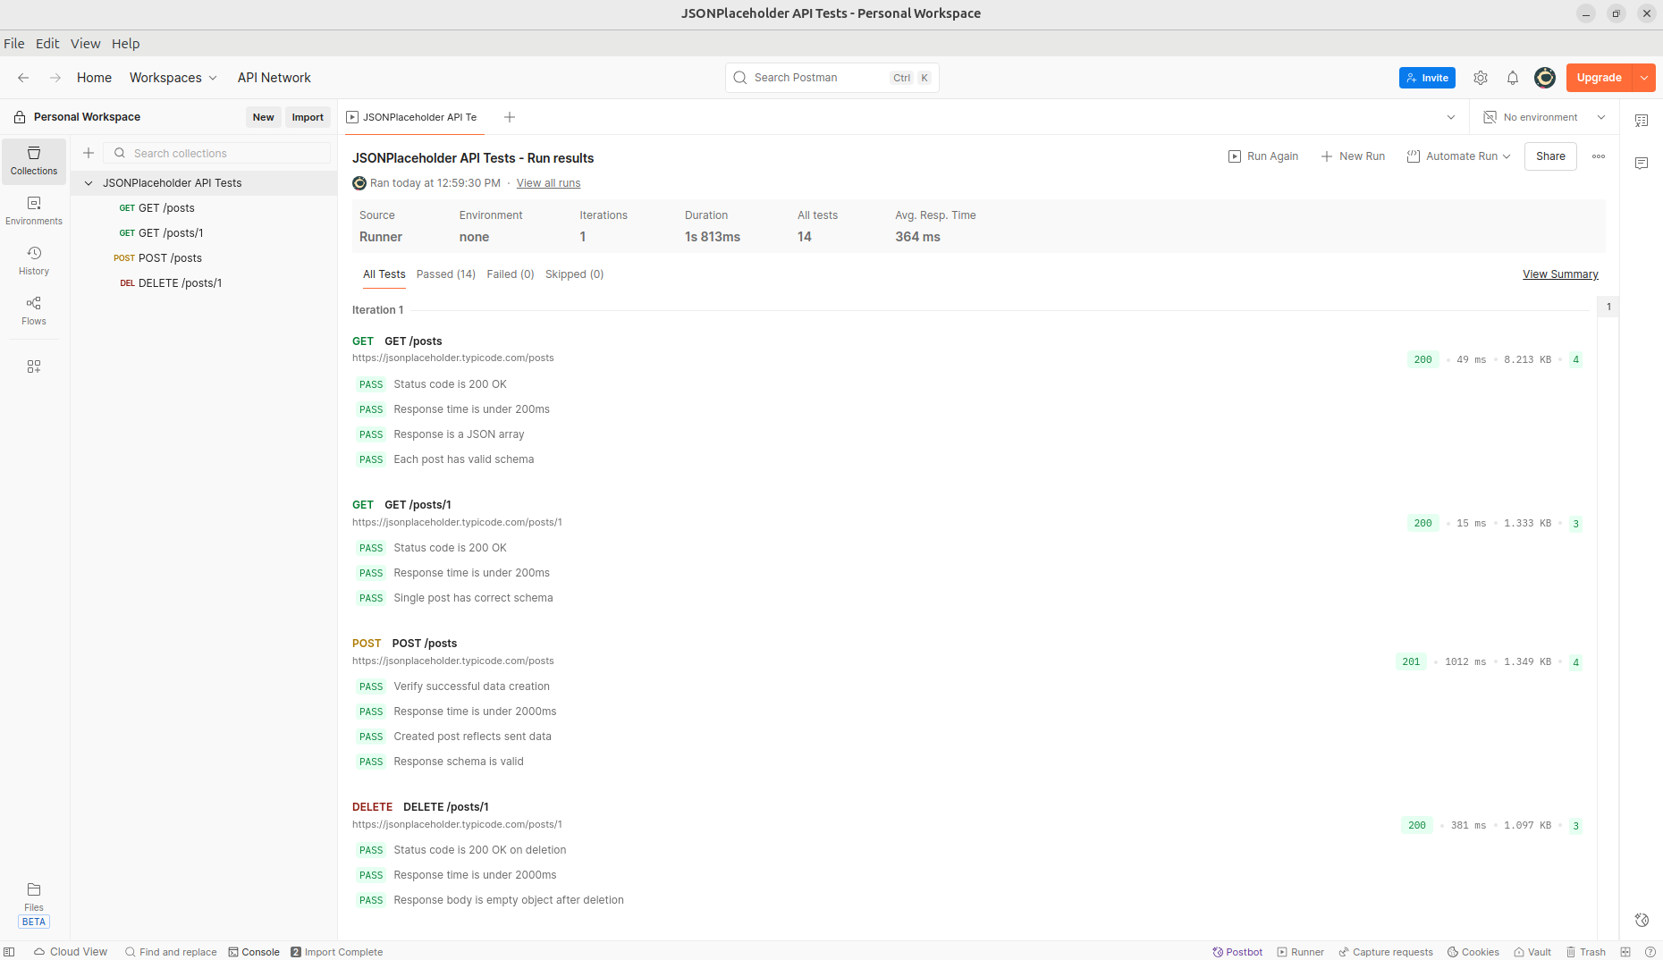
Figure A.1 — Postman: 20/20 tests passed.

Appendix B — Playwright Test Execution Output
Terminal output from npm test executing the Playwright suite in headless Chromium and Firefox, with all four authentication test cases passing across both browsers.
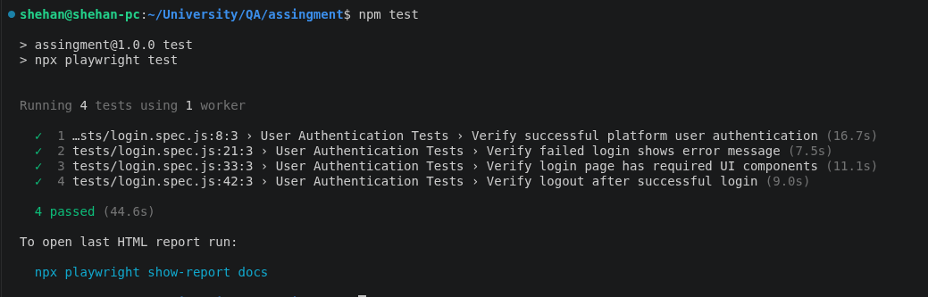
Figure B.1 — Playwright: 8 tests passed (2 browsers × 4 tests).

Appendix C — Project File Structure
qa-assingment/
├── docs/
│ └── index.html # Live Playwright HTML report (GitHub Pages)
├── tests/
│ └── login.spec.js # Playwright UI test specifications
├── postman/
│ └── JSONPlaceholder-Collection.postman_collection.json
├── playwright.config.js # Playwright configuration
├── package.json
└── .gitignore
GitHub Repository: https://github.com/ShehanSuraweera/qa-assingment
Live Test Report: https://shehansuraweera.github.io/qa-assingment

