London Metropolitan University
delivered at ESOFT Metro Campus
CS6P05ES — Computing Research Project
INTERIM REPORT
A Comparative Analysis of Ensemble Learning, Fine-Tuned Models and CNNs for Multi-Class Disease Prediction in Medical Imaging: An Integrated Framework with Systematic Optimization
Student Name | Pattiyage Shehan Kavishka
Registration No. (ID) | E187041
Programme | BSc (Hons) Data Science (Top-Up)
Intake / Batch | February 2026 · Batch 04
First Supervisor | Ms. Hiruni Wimalaweera
Second Supervisor | To be assigned
Module Leader | Prof. Ruvan Abeysekara
Date | 11 August 2026

Declaration
I certify that this interim report and the work it describes are my own, produced independently as part of the CS6P05ES Computing Research Project. All material drawn from other sources has been acknowledged and appropriately referenced in accordance with the University regulations on plagiarism, collusion and academic misconduct.
No part of this report has been submitted for any other award, and no data or results have been fabricated or falsified. The experimental results reported here were generated from original model training conducted during this project on the publicly available Kaggle Brain Tumor MRI dataset.

Field | Detail
Module | CS6P05ES — Computing Research Project
Student ID | E187041
Signature | __________________________
Date | 11 August 2026

Contents

Abstract
The accurate multi-class classification of brain tumours from Magnetic Resonance Imaging (MRI) is a demanding diagnostic task in which delayed or incorrect identification directly affects treatment planning. This project develops an integrated framework that systematically compares three families of machine-learning approaches — custom Convolutional Neural Networks (CNNs), fine-tuned pre-trained architectures (Inception V3 and Xception), and conventional classifiers (SVM, Random Forest and Decision Tree) — under identical experimental conditions, and combines their outputs through ensemble learning. The framework will be extended with a novel Explainable-AI component, Ensemble Attention Agreement (EAA-IoU), and deployed as an interactive web application.
This interim report documents the work completed to the mid-point of the project. A standardised, reproducible training pipeline has been implemented and three of the planned model families have been trained and evaluated on the official Kaggle test split: the custom CNN (91.18% test accuracy), classical machine-learning classifiers on raw pixels (SVM best at 88.26%), and Inception V3 transfer learning (84.63%), together with classical ensembles built on the deep features extracted from these backbones. Trained weights and full result galleries (training curves, confusion matrices, ROC and precision–recall curves) have been published to the Hugging Face Hub for reproducibility. The report also sets out the remaining work — Xception fine-tuning, the six-model integrated ensemble with confidence-weighted voting, the EAA-IoU explainability layer and the clinical web application — and confirms that the project remains on schedule against the original plan.
Keywords: Brain Tumour MRI · Convolutional Neural Networks · Transfer Learning · Ensemble Learning · Explainable AI · Medical Imaging

1. Introduction
Medical imaging plays a central role in the early diagnosis and treatment planning of brain tumours, where timely and precise identification can significantly influence patient outcomes (Yousaf et al., 2023). Conventional diagnosis depends on the manual interpretation of MRI scans by radiologists — a process that is time-consuming and subject to inter-observer variability. The integration of machine learning and deep learning offers an opportunity to improve both the efficiency and the consistency of this diagnostic process (Patel et al., 2019).
This project addresses the problem of multi-class brain tumour classification, distinguishing between four categories — glioma, meningioma, no-tumour and pituitary — from MRI scans.
Rather than relying on a single model, this project builds an integrated framework that combines the complementary strengths of custom CNNs, fine-tuned pre-trained networks and conventional machine-learning classifiers, fusing their predictions through ensemble learning (Zhou et al., 2018). The completed system is intended for deployment as an interactive web application and is further extended with an explainability mechanism that quantifies inter-model attention agreement as a per-sample clinical uncertainty signal.

1.1 Aim and Objectives
The aim of the project is to design, optimise and evaluate an integrated framework for multi-class brain tumour classification that systematically compares CNNs, fine-tuned models and ensemble learning, and to deploy it as a clinically-oriented web application with an explainable uncertainty signal. The objectives are:
- Critically evaluate current machine-learning and deep-learning methods for medical image classification.
- Investigate ensemble learning methodologies and their combination and optimisation strategies in medical imaging.
- Design and implement a modular framework integrating CNN architectures, pre-trained models and conventional classifiers under identical experimental conditions.
- Systematically evaluate individual models and ensembles using consistent metrics (accuracy, precision, recall, F1-score, confusion matrices).
- Develop and evaluate an Ensemble Attention Agreement (EAA-IoU) uncertainty mechanism from GRAD-CAM saliency maps, without requiring tumour-boundary annotations.
- Deploy the framework as an interactive web application and document the methodology for reproducibility.

1.2 Structure of this Report
The remainder of this report is organised as follows. Section 2 (Background) reviews the clinical context and related work, and identifies the research gap. Section 3 (Work Completed) presents the standardised experimental framework and the models trained and evaluated to date, with representative code and results. Section 4 (Further Work) details the remaining components and the planned novel contribution. Section 5 (Progress Review) assesses progress against the original project plan. Sections 6 and 7 provide the references and bibliography.

2. Background

2.1 Clinical Context
Brain tumours vary substantially in type, location and severity, and different tumour types require distinct treatment pathways. The visual distinction between tumour classes on MRI can be subtle, which contributes to inter-observer variability in manual reporting (Tripathi & Bag, 2020). Automated classification systems can act as a decision-support tool for radiologists, providing a fast, consistent second opinion — provided they are accurate and, crucially, able to communicate their confidence.

2.2 Related Work
Deep learning, and CNNs in particular, have demonstrated strong performance in extracting hierarchical features from medical images (Abiwinanda et al., 2018). Transfer learning from large natural-image datasets — using architectures such as Inception V3 and Xception — allows high performance to be reached with comparatively little medical training data. Classical ensemble methods, meanwhile, combine multiple base classifiers to reduce the bias and variance of any single model (Cheng et al., 2010). Table 1 summarises representative prior work.
Author (Year) | Method | Key Finding
Abiwinanda et al. (2018) | Simple CNN | Glioma / meningioma / pituitary classification from T-1 MRI
Minz & Mahobiya (2017) | AdaBoost + GLCM features | 89.90% accuracy for MR image classification
Zhou et al. (2018) | DenseNet + RNN | 92.13% on 3D MRI with an LSTM-DenseNet model
Cheng et al. (2015) | Tumour-region augmentation | 94.68% via region partition and augmentation
Sultan et al. (2019) | Deep neural network | Multi-class brain tumour classification
Patel et al. (2019) | CNN + LSTM (3D CT) | Image-level intracranial haemorrhage identification
Yousaf et al. (2023) | Deep learning | Multi-class disease detection from brain medical imaging
Table 1 — Representative prior work in brain tumour classification.

2.3 Research Gap
The majority of published studies evaluate a single model family in isolation — either deep learning or classical machine learning — and typically conclude at the model-evaluation stage. Two gaps follow. First, there is no widely-reported systematic comparison that develops, optimises and integrates all three paradigms (custom CNNs, fine-tuned networks, and conventional classifiers) under identical conditions on the same dataset. Second, existing ensembles rarely provide clinicians with any indication of how confident or consistent the underlying models are, nor do they flag cases where the models disagree. This project targets both gaps: a rigorous multi-method comparison, and a novel inter-model attention-agreement signal (EAA-IoU) used as a per-sample clinical uncertainty trigger.

3. Work Completed
This section reports the work completed at the interim stage. As agreed with the supervisor, the interim milestone covers the custom CNN, the conventional machine-learning baseline, and the Inception V3 transfer-learning model, together with the classical ensembles built on the deep features of these backbones. The Xception model, the full six-model integrated ensemble and the explainability layer are scheduled for the second half of the project (Section 4).

3.1 Dataset and Pre-processing
The Kaggle Brain Tumor MRI dataset is used, comprising 9,047 JPG MRI scans across four classes. The official split provides 6,984 training and 2,063 testing images. Class balance is preserved through stratified sampling, and the official test folder is held out and used only for final evaluation, ensuring results are directly comparable across all models.
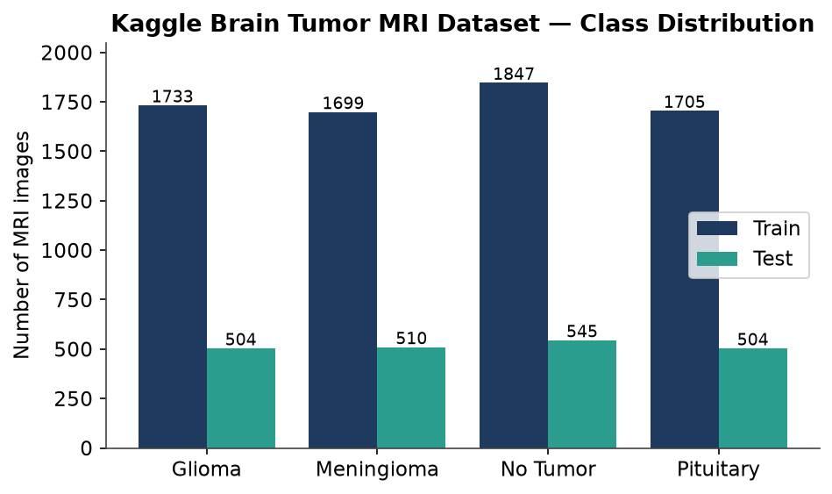
Figure 1 — Class distribution of the Kaggle Brain Tumor MRI dataset across the training and test splits.
Class | Train Images | Test Images
Glioma | 1,733 | 504
Meningioma | 1,699 | 510
No Tumour | 1,847 | 545
Pituitary | 1,705 | 504
Total | 6,984 | 2,063
Table 2 — Dataset split by class.

3.2 A Standardised Experimental Framework
An early review of the original notebooks revealed several inconsistencies that undermined reproducibility: mixed colour/greyscale inputs, differing normalisation formulas, inconsistent label encodings, different train/test protocols and varying batch sizes. To ensure a fair comparison, a single standardised training framework was implemented as a set of Python modules with a central configuration file. Every model now shares the same data loader, normalisation (division by 255 to the range 0–1), random seed, batch size and evaluation protocol.
# training/config.py — single source of truth for every experiment
CLASS_NAMES = ['glioma', 'meningioma', 'notumor', 'pituitary']
N_CLASSES = 4
SIZE_STANDALONE = 256 # CNN / InceptionV3 / Xception direct classifiers
SIZE_ENSEMBLE = 128 # feature extractors that feed classical ML
FEATURE_DIM = 256 # units in every feature-extraction Dense layer
RANDOM_SEED = 42 # applied to random, NumPy and TensorFlow
BATCH_STANDALONE = 32
BATCH_ENSEMBLE = 32 # standardised — identical batch size across models
Listing 1 — Central configuration shared by all training scripts (training/config.py).

3.3 Custom Convolutional Neural Network
The custom CNN follows a four-block convolutional architecture. Each block applies a 3×3 convolution followed by 2×2 max-pooling; the feature maps are flattened into a 256-unit dense layer (also used later as a feature-extraction point), regularised with dropout, and classified by a softmax layer over the four classes. The model is trained with the Adam optimiser and sparse categorical cross-entropy.
# training/models/cnn.py
def build_cnn(input_size, feature_dim=256, feat_layer_name='dense'):
model = models.Sequential([
layers.Conv2D(32, (3,3), activation='relu',
input_shape=(input_size, input_size, 3)),
layers.MaxPooling2D((2,2)),
layers.Conv2D(64, (3,3), activation='relu'), layers.MaxPooling2D((2,2)),
layers.Conv2D(64, (3,3), activation='relu'), layers.MaxPooling2D((2,2)),
layers.Conv2D(64, (3,3), activation='relu'), layers.MaxPooling2D((2,2)),
layers.Flatten(),
layers.Dense(feature_dim, activation='relu', name=feat_layer_name),
layers.Dropout(0.5),
layers.Dense(N_CLASSES, activation='softmax'),
])
model.compile(optimizer='adam',
loss=tf.keras.losses.SparseCategoricalCrossentropy(),
metrics=['accuracy'])
return model
Listing 2 — Custom CNN architecture (training/models/cnn.py).
Trained for 20 epochs at 256×256 resolution, the standalone CNN reaches 91.18% accuracy on the held-out official test set — the strongest individual model at the interim stage. Training accuracy approaches 99%, and the gap to validation accuracy indicates a degree of over-fitting that dropout partially mitigates and that will be addressed with data augmentation in the next phase.

3.4 Conventional Machine Learning on Raw Pixels
A classical baseline is established by flattening each greyscale MRI to a 65,536-dimensional vector (256×256) normalised to 0–1, and training Logistic Regression, SVM, Decision Tree and Random Forest classifiers, together with a soft-voting ensemble. Dimensionality reduction (PCA) was deliberately omitted at this stage to avoid discarding potentially discriminative pixel information.
# Classical ensemble builder (training/models/classical.py)
def build_classical_ensemble():
rf = RandomForestClassifier(n_estimators=100, random_state=42)
dt = DecisionTreeClassifier(random_state=42)
svm = SVC(probability=True, random_state=42)
return VotingClassifier(
estimators=[('rf', rf), ('dt', dt), ('svm', svm)],
voting='soft')
Listing 3 — Soft-voting classical ensemble reused across all feature sources.
On raw pixels, the SVM is the strongest classical model at 88.26%, followed by Logistic Regression (84.0%). A known bug in the original notebook — where the "Random Forest" cell instantiated a Decision Tree — was corrected here, so Random Forest and Decision Tree now report distinct results. Figure 2 summarises the classical baseline.
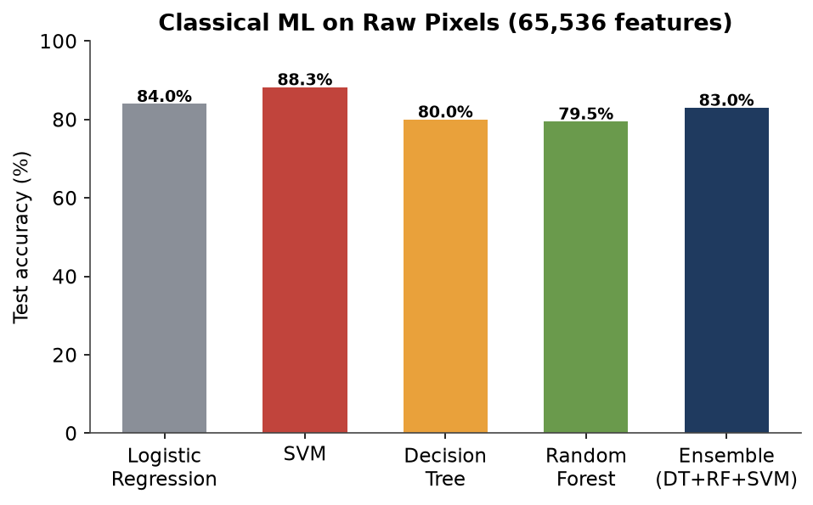
Figure 2 — Classical machine-learning accuracy on raw pixel features (official test set).

3.5 Inception V3 Transfer Learning
Inception V3, pre-trained on ImageNet, is used as a frozen feature backbone. A global average-pooling layer and a softmax classification head are added, and only the head is trained. The standalone model, at 256×256 resolution, achieves 84.63% test accuracy after 10 epochs.
# training/models/transfer.py — InceptionV3 standalone
def build_inception_standalone(input_size=256):
base = InceptionV3(input_shape=(input_size, input_size, 3),
weights='imagenet', include_top=False)
base.trainable = False
x = layers.GlobalAveragePooling2D()(base.output)
out = layers.Dense(N_CLASSES, activation='softmax', name='dense')(x)
model = Model(inputs=base.input, outputs=out)
model.compile(optimizer='adam',
loss='sparse_categorical_crossentropy', metrics=['accuracy'])
return model
Listing 4 — Inception V3 transfer-learning classifier (training/models/transfer.py).

3.6 Classical Ensembles on Deep Features
To assess whether deep features improve classical classifiers, a compact variant of each backbone (128×128 input) exposes a 256-unit dense layer as a feature extractor. The extracted features feed the same RF+DT+SVM soft-voting ensemble. This connects the deep and classical paradigms within one framework.
# Extract deep features, then fit the classical ensemble
train_feats = extract_features(cnn_extractor, 'dense', X_train)
test_feats = extract_features(cnn_extractor, 'dense', X_test)
ensemble = build_classical_ensemble()
ensemble.fit(train_feats, y_train)
for name, clf in ensemble.named_estimators_.items():
acc = (clf.predict(test_feats) == y_test).mean() * 100
print(f'{name.upper():4s} {acc:.2f}%')
Listing 5 — Feeding CNN-extracted features into the classical ensemble (training/train_01_cnn.py).
CNN-extracted features give the best classical results (Random Forest 85.45%, Decision Tree 80.99%, SVM 66.60%; ensemble 83.71%), clearly outperforming Inception V3 features (ensemble 71.20%). Figure 3 shows how classifier accuracy varies with the feature source, and Figures 4–5 give the confusion matrices of the two completed deep-feature ensembles.
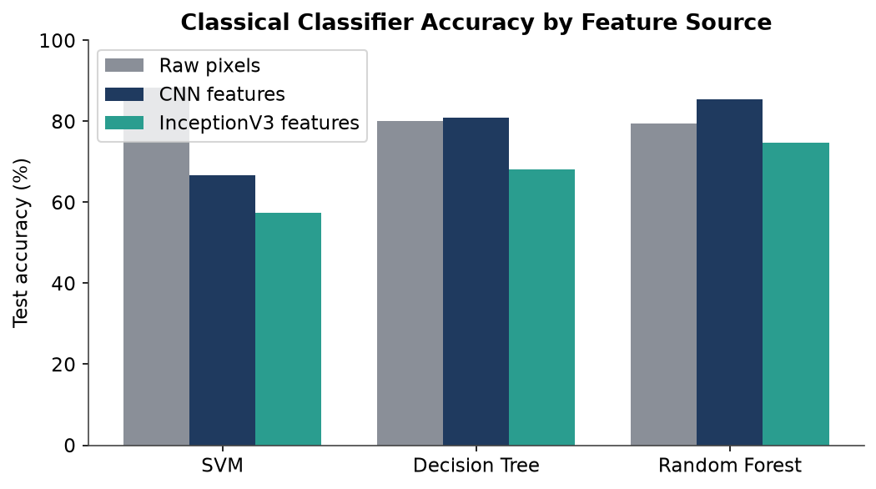
Figure 3 — Classical classifier accuracy by feature source: raw pixels vs CNN vs Inception V3 features.
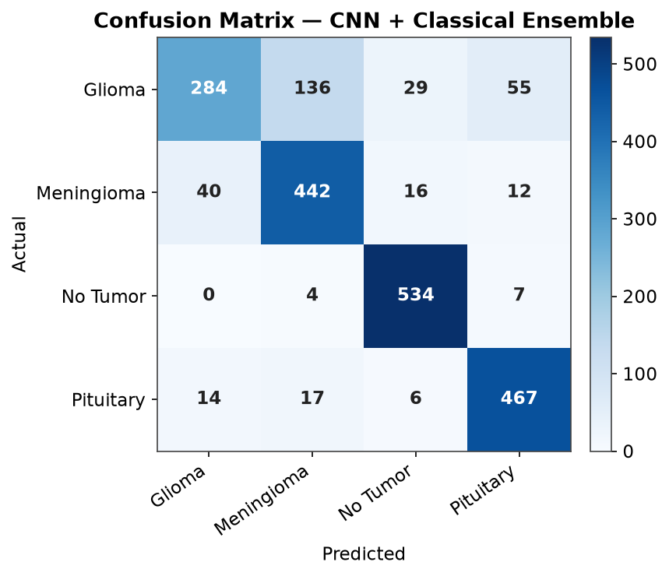
Figure 4 — Confusion matrix of the CNN + classical ensemble on the official test set.
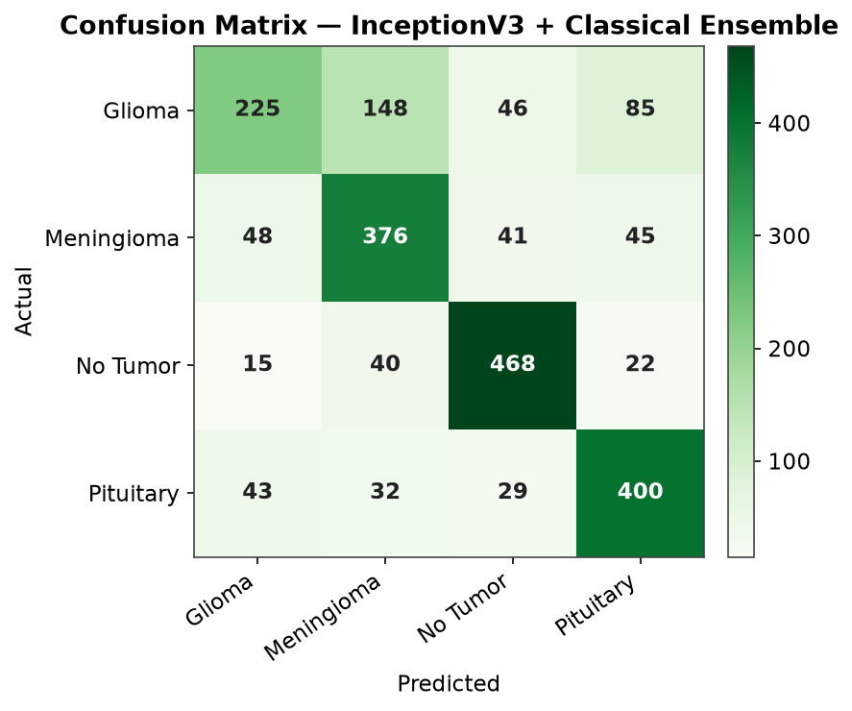
Figure 5 — Confusion matrix of the Inception V3 + classical ensemble on the official test set.
Both confusion matrices confirm that glioma is the most challenging class — it is most often confused with meningioma — while the no-tumour and pituitary classes are recognised with high reliability. This observation directly motivates the planned explainability work, which is expected to reveal the greatest inter-model attention disagreement precisely on the glioma cases.

3.7 Interim Results Summary
Model | Type | Test Accuracy
Custom CNN (standalone) | Deep learning | 91.18%
Inception V3 (standalone) | Transfer learning | 84.63%
SVM (raw pixels) | Classical | 88.26%
Logistic Regression (raw pixels) | Classical | 84.00%
Decision Tree (raw pixels) | Classical | 80.02%
Random Forest (raw pixels) | Classical | 79.52%
Classical ensemble (raw pixels) | Ensemble | 83.00%
CNN features + classical ensemble | Hybrid ensemble | 83.71%
Inception V3 features + classical ensemble | Hybrid ensemble | 71.20%
Table 3 — Summary of all models completed at the interim stage (official test set).
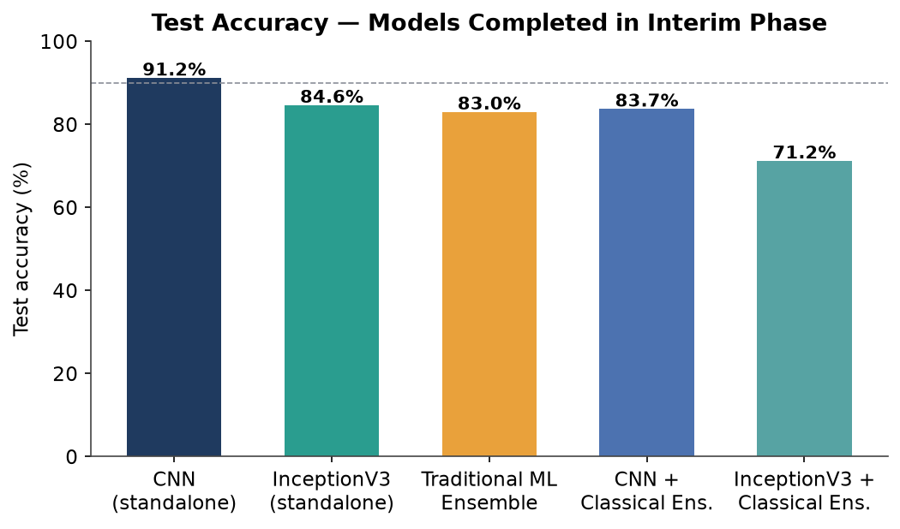
Figure 6 — Comparative test accuracy of the models completed at the interim stage.

3.8 Reproducibility and Model Hosting
Because the trained model files and result galleries exceed the practical limits for a Git repository, all artefacts have been published to the Hugging Face Hub. The repository hosts the trained weights (.h5 and .pkl) and, for every model, a full result gallery: training-history curves, confusion matrices, ROC curves and precision–recall curves. This guarantees that the reported figures are reproducible and independently inspectable.
# Trained models and full result galleries are hosted at:
# https://huggingface.co/shehank98/brain-tumor-mri-models
#
# results/01_CNN_Standalone/ training curve, confusion matrix, ROC, PR
# results/03_InceptionV3_Standalone/ training curve, confusion matrix, ROC, PR
# results/07_TraditionalML_Ensemble/ per-classifier confusion matrices, ROC, PR
# models/ cnn_model.h5, inceptionv3_model.h5, *_ensemble_model.pkl ...
Listing 6 — Hugging Face Hub layout for reproducible artefacts.

4. Further Work
The second half of the project completes the framework and delivers the novel contribution. The remaining components are described below.

4.1 Xception Fine-Tuning
The third deep backbone, Xception, will be trained under the same standardised protocol as Inception V3 — both a 256×256 standalone classifier and a 128×128 feature extractor feeding the classical ensemble. Adding Xception completes the set of three architecturally distinct backbones required for the ensemble and, critically, for the inter-model attention-agreement analysis. The builder is already implemented (Listing 7) and awaits a full training run.
# training/models/transfer.py — Xception (already implemented, to be trained)
def build_xception_standalone(input_size=256):
base = Xception(input_shape=(input_size, input_size, 3),
weights='imagenet', include_top=False)
base.trainable = False
x = layers.GlobalAveragePooling2D()(base.output)
out = layers.Dense(N_CLASSES, activation='softmax', name='dense')(x)
return Model(inputs=base.input, outputs=out)
Listing 7 — Xception builder, ready for the next training phase.

4.2 Six-Model Integrated Ensemble and Confidence-Weighted Voting
Once Xception is trained, the six predictors (CNN, Inception V3, Xception, and their three deep-feature classical ensembles) will be combined. In addition to the baseline majority vote, a confidence-weighted vote — summing the six softmax probability vectors and taking the arg-max — will be implemented and evaluated, providing a genuine per-prediction confidence score for the web application.
# Confidence-weighted voting (planned)
combined = (prob_cnn + prob_inc + prob_xcp +
prob_cnn_ens + prob_inc_ens + prob_xcp_ens)
final_class = np.argmax(combined)
vote_confidence = np.max(combined) / combined.sum()
Listing 8 — Planned confidence-weighted voting over the six base predictors.

4.3 Explainable AI — Ensemble Attention Agreement (EAA-IoU) [Novel Contribution]
The core novel contribution is Ensemble Attention Agreement (EAA-IoU). GRAD-CAM saliency maps will be generated independently from the CNN, Xception and Inception V3 models for each MRI. The three maps are binarised and the pairwise Intersection-over-Union (IoU) computed; their mean is a single EAA-IoU score per image. Unlike existing ensemble-CAM methods, which compare model attention against a radiologist-drawn bounding box, EAA-IoU measures whether the models agree with each other — requiring no segmentation annotations, which the Kaggle dataset does not provide. A low score triggers a clinical-escalation alert. The hypothesis — that low inter-model agreement correlates with misclassification — will be validated on the 2,063 test images, with particular attention to the glioma class identified in Section 3.6.

4.4 Clinical Web Application
An interactive Streamlit web application will allow a user to upload an MRI and view the predicted class and confidence, per-model GRAD-CAM heatmaps and a consensus map, a per-model vote breakdown, the class-probability distribution, and a low-agreement clinical alert driven by the EAA-IoU score. An initial application scaffold (model loader, XAI engine and UI components) has already been created and will be completed alongside the ensemble and XAI work.

4.5 Qualitative Evaluation
To complement the quantitative metrics, structured feedback will be gathered from healthcare professionals on the usability and interpretability of the web application and the EAA-IoU alert, in line with the mixed-methods design set out in the proposal.

5. Progress Review
Progress is assessed honestly against the six-phase, 16-week plan set out in the project proposal. Table 4 maps each phase to its current status.
Phase (Proposal) | Planned | Status
1 — Research & Planning | 3 wks | Complete — literature review, dataset preparation and environment setup done.
2 — Individual Model Development | 4 wks | Largely complete — CNN, classical ML and Inception V3 trained; Xception remaining.
3 — Ensemble Framework | 3 wks | In progress — classical ensembles on CNN/Inception features done; six-model fusion pending.
4 — Performance Evaluation | 2 wks | Partially done — standardised evaluation and result galleries produced for completed models.
5 — Application Development | 2 wks | Started — web-app scaffold created; to be completed with XAI.
6 — Documentation & Finalisation | 2 wks | Ongoing — reproducible pipeline and this interim report produced.
Table 4 — Progress against the project plan.

5.1 Assessment
The project is on schedule. Phases 1 and 2 are essentially complete, and a genuine additional achievement beyond the original plan — the rewrite of the experiments into a single standardised, reproducible framework with all inconsistencies corrected — strengthens the validity of every subsequent comparison. The main remaining risks are the compute cost of training Xception and the correlation study for EAA-IoU; both are mitigated by the fact that the model builders and application scaffold are already implemented, and by hosting heavy artefacts on the Hugging Face Hub. No revision to the overall timeline is required at this stage.

6. References
Abiwinanda, N. et al. (2018) ‘Brain tumor classification using convolutional neural network’, World Congress on Medical Physics and Biomedical Engineering. Singapore.
Cheng, J. et al. (2015) ‘Enhanced performance of brain tumor classification via tumor region augmentation and partition’, PLoS One, 10(10), p. e0140381.
Minz, A. and Mahobiya, C. (2017) ‘MR image classification using AdaBoost for brain tumor type’, IEEE 7th International Advance Computing Conference (IACC). Hyderabad.
Patel, A. et al. (2019) ‘Image level training and prediction: intracranial hemorrhage identification in 3D non-contrast CT’, IEEE Access, 7, pp. 92355–92364.
Sultan, H., Salem, N. and Al-Atabany, W. (2019) ‘Multi-classification of brain tumor images using deep neural network’, IEEE Access, 7, pp. 69215–69225.
Tripathi, P. and Bag, S. (2020) ‘Non-invasively grading of brain tumor through noise robust textural and intensity based features’, Computers in Biology and Medicine, 116, p. 103551.
Yousaf, F. et al. (2023) ‘Multi-class disease detection using deep learning and human brain medical imaging’, Bioengineering, 10(6), p. 704.
Zhou, Y. et al. (2018) ‘Holistic brain tumor screening and classification based on DenseNet and recurrent neural network’, International MICCAI Brainlesion Workshop. Springer.

7. Bibliography
Chollet, F. (2017) ‘Xception: Deep learning with depthwise separable convolutions’, IEEE Conference on Computer Vision and Pattern Recognition (CVPR).
Szegedy, C. et al. (2016) ‘Rethinking the Inception architecture for computer vision’, IEEE Conference on Computer Vision and Pattern Recognition (CVPR).
Selvaraju, R. R. et al. (2017) ‘Grad-CAM: Visual explanations from deep networks via gradient-based localization’, IEEE International Conference on Computer Vision (ICCV).
Pedregosa, F. et al. (2011) ‘Scikit-learn: Machine learning in Python’, Journal of Machine Learning Research, 12, pp. 2825–2830.
Abadi, M. et al. (2016) ‘TensorFlow: A system for large-scale machine learning’, 12th USENIX Symposium on Operating Systems Design and Implementation (OSDI).

