London Metropolitan University
CS6P05ES Computing Project – Final Project Report

A Comparative Analysis of Ensemble Learning, Fine-Tuned Models and CNNs for Multi-Class Disease Prediction in Medical Imaging: An Integrated Framework with Systematic Optimization and Explainable AI

Name: Pattiyage Shehan Kavishka
London Met ID / Student ID: E187041
Programme: BSc (Hons) Data Science (top-up), delivered at ESOFT Metro Campus
First supervisor: Ms. Hiruni Wimalaweera
Module leader: Mr. Thepul Ginige
Submission: November 2026

This report extends the author’s Pearson HND Unit 16 research report (October 2024) with a standardised re-run of all models on held-out data and a new explainable-AI analysis.

Declaration
Module: CS6P05ES Computing Project Student ID: E187041
Module leader: Mr. Thepul Ginige
I confirm that I have read and understood the university regulations on cheating, plagiarism and collusion, including falsifying experimental data and presenting the work of others as my own. This report is my own work. Every source I have used is acknowledged with an in-text citation and an entry in the reference list. All experimental numbers in this report were produced by the code and result files listed in Appendix H.
Signature: Pattiyage Shehan Kavishka Date: ____ / ____ / 2026

Dedication
To my family, whose patience and encouragement made both stages of this project possible.

Acknowledgements
I thank my supervisor, Ms. Hiruni Wimalaweera, for her guidance on the experimental design and on presenting the work honestly, and Mr. Dileepa Lakshan, who supervised the first (HND) stage of this research and introduced me to ensemble learning. I am also grateful to the module team at ESOFT Metro Campus and London Metropolitan University, and to the researchers who made the public MRI data and open-source libraries used in this work available.

Abstract
Brain tumour type affects treatment, yet reading MRI scans is slow and varies between readers. This project builds and tests an integrated framework that compares three families of models for four-class brain MRI classification (glioma, meningioma, pituitary tumour and no tumour): a custom convolutional neural network (CNN), two ImageNet-pretrained networks (InceptionV3 and Xception) used with frozen backbones, and classical classifiers (Random Forest, Decision Tree, Support Vector Machine) trained on raw pixels or on deep features. Six predictors are combined by majority and confidence-weighted voting. The work extends an earlier HND study whose headline 98.20% accuracy was found, on audit, to have been measured on training images. All models were therefore retrained under one standardised protocol and evaluated on 1,600 held-out test images. The six-model majority vote reached 92.50% accuracy (95% bootstrap interval 91.25–93.69%) and was significantly better than every single model. The custom CNN (90.44%) outperformed both pretrained networks, so the hypothesis that pretrained models would extract better features was not supported. Glioma remained the hardest class (77.50% recall), mostly confused with meningioma. A new explainability layer applied Grad-CAM, Grad-CAM++, HiResCAM, LIME, SHAP and occlusion to the saved models and evaluated the explanations with deletion and insertion tests, a weight-randomisation sanity check, a cross-model agreement score (EAA-IoU) and a check for attention outside the brain. Explanations were more faithful than a random baseline and passed the sanity check, but the three networks often attended to different regions, and agreement between them flagged errors less well than the ensemble’s own confidence. The framework is a transparent research prototype for decision support, not a diagnostic device; clinical use would need external validation and radiologist review.
Keywords: brain tumour MRI; convolutional neural networks; transfer learning; ensemble learning; explainable AI; Grad-CAM; SHAP; LIME
Table of Contents
Right-click and choose "Update Field" to refresh this list.
List of Figures
Right-click and choose "Update Field" to refresh this list.
List of Tables
Right-click and choose "Update Field" to refresh this list.
List of Listings
Right-click and choose "Update Field" to refresh this list.

List of Abbreviations
Table 1. Abbreviations used in this report
Abbreviation | Meaning
AUC / AUROC | Area under the (receiver operating characteristic) curve
CAM | Class activation map
CI | Confidence interval
CNN | Convolutional neural network
DT | Decision Tree
EAA-IoU | Ensemble Attention Agreement – intersection over union
Grad-CAM | Gradient-weighted class activation mapping
HiResCAM | High-resolution class activation mapping
IoU | Intersection over union
LIME | Local Interpretable Model-agnostic Explanations
LR | Logistic Regression
MRI | Magnetic resonance imaging
PR | Precision–recall
RF | Random Forest
RO / RQ / H | Research objective / question / hypothesis
ROC | Receiver operating characteristic
SHAP | SHapley Additive exPlanations
SVM | Support Vector Machine
XAI | Explainable artificial intelligence

Chapter 1 Introduction
This chapter sets out why automated brain tumour classification matters, the problem the project addresses, and the objectives, research questions and hypotheses that structure the rest of the report. It also states what changed between the first (HND) stage of the study and this extended version.

1.1 Background and motivation
Magnetic resonance imaging (MRI) is the main imaging test for suspected brain tumours, and the tumour type strongly influences treatment and prognosis (Louis et al., 2021). Gliomas, meningiomas and pituitary tumours differ in location, appearance and behaviour, but on a single two-dimensional slice their appearance can overlap, and visual reporting is time-consuming and varies between readers (Tripathi and Bag, 2019). Computer-aided classification is therefore attractive as a second reader that is fast and consistent (Topol, 2019).
Deep learning has changed medical image analysis, because convolutional networks learn image features directly from data rather than relying on hand-crafted descriptors (LeCun, Bengio and Hinton, 2015; Litjens et al., 2017). Pretrained networks such as InceptionV3 and Xception allow transfer of knowledge from natural images to medical tasks with limited data (Shin et al., 2016), and ensemble learning can combine several imperfect models into a more reliable one (Dietterich, 2000; Ganaie et al., 2022).
High accuracy alone is not enough for clinical adoption. Clinicians need to know what evidence a model used, whether it is looking at the tumour or at irrelevant artefacts, and when it is uncertain (Kelly et al., 2019; Tjoa and Guan, 2021). The first stage of this research focused only on accuracy and listed explainability as future work. This report adds that missing layer.

1.2 Problem statement
Most published brain tumour classifiers evaluate a single model family, and many report accuracy without testing whether the model attends to clinically meaningful regions. In addition, the first stage of this project reported a final ensemble accuracy of 98.20%, but an audit for this report found that this value was computed on the 6,985 training images rather than on held-out data (see AUDIT.md and Section 4.10). The problem addressed here is therefore twofold: (i) to obtain an honest, reproducible comparison of CNN, transfer-learning and classical approaches and their ensemble on unseen data, and (ii) to explain and critically evaluate what the resulting models rely on.

1.3 Aim
To design, evaluate and explain an integrated framework that compares custom CNNs, pretrained transfer-learning models and classical machine-learning classifiers for four-class brain tumour MRI classification, combines them through ensemble voting, and assesses the faithfulness and clinical plausibility of their explanations.

1.4 Research objectives
Objectives RO1–RO4 are carried over from the HND study, reworded for precision. RO5 and RO6 are new.
- RO1 – Evaluate how well a custom CNN extracts discriminative features for brain tumour classification from MRI.
- RO2 – Evaluate pretrained InceptionV3 and Xception networks, used as frozen feature extractors with trained heads, against the custom CNN.
- RO3 – Assess Random Forest, Decision Tree and Support Vector Machine classifiers on raw pixels and on deep features.
- RO4 – Determine whether combining six predictors by majority or confidence-weighted voting improves accuracy and reliability over the best single model.
- RO5 – Apply complementary explanation methods (Grad-CAM, Grad-CAM++, HiResCAM, LIME, SHAP and occlusion) to the trained models for correct and misclassified cases in every class.
- RO6 – Quantitatively evaluate the explanations (deletion/insertion faithfulness, weight-randomisation sanity check, cross-model agreement and attention outside the brain) and relate them to the models’ errors, especially for glioma.

1.5 Research questions
- RQ1 – Do pretrained networks used as feature extractors outperform a custom CNN for four-class brain tumour MRI classification?
- RQ2 – Does a six-model ensemble outperform its individual members on held-out data, and does confidence weighting improve on majority voting?
- RQ3 – Are the explanations produced for these models faithful to the models, sensitive to the model parameters, and consistent across architectures, and do they help explain why glioma is the hardest class?

1.6 Hypotheses
- H1 – Pretrained (InceptionV3, Xception) models achieve higher test accuracy than the custom CNN.
- H2 – The six-model ensemble achieves higher test accuracy than any single member.
- H3 – Saliency explanations of the trained models are faithful (deletion AUC lower and insertion AUC higher than a random baseline) and model-dependent (they change substantially when the model weights are randomised); lower agreement between the explanations of different models is associated with misclassification.

1.7 Scope and boundaries
The study uses one public two-dimensional MRI dataset with four classes. It classifies whole images; it does not segment tumours, grade them or use patient metadata. Explanations are assessed without pixel-level tumour masks, because the dataset provides none. The software is a research prototype intended to support, never replace, a radiologist. No new patient data and no human participants were involved in this stage.

1.8 Significance of the research
- It provides a like-for-like comparison of three modelling paradigms trained and tested under one protocol, with statistical tests rather than single accuracy figures.
- It corrects an inflated accuracy claim and shows how evaluation choices change conclusions, which is a useful lesson for student and practitioner projects.
- It adds a multi-method, quantitatively evaluated explainability analysis, including a cross-architecture agreement score (EAA-IoU) that needs no tumour annotations.
- It offers a plain-language summary of the evidence for clinicians and a prototype web demonstrator that shows predictions, heatmaps and agreement.

1.9 Structure of the report
Chapter 2 reviews the literature on brain tumour classification, ensembles and explainable AI. Chapter 3 describes the data, models, training protocol, evaluation statistics, explanation methods and ethics. Chapter 4 presents the classification results. Chapter 5 presents the new explainability analysis. Chapter 6 discusses the findings against the literature and critically evaluates the methodology, and closes with a summary for clinical stakeholders. Chapter 7 states conclusions and recommendations, and Chapter 8 reflects on the research process. The appendices hold code listings, extra tables, the proposed clinician questionnaire, a mapping to the assessment criteria, a change log and a figures index.

Chapter 2 Literature Review
This chapter reviews work on brain tumour MRI classification with classical and deep models, ensemble learning, and explainable AI in medical imaging. It ends with the research gap and the conceptual framework of the study. The review is organised by technique rather than by date, so that the strengths and weaknesses of each family are visible.

2.1 Clinical context
The World Health Organization classification of central nervous system tumours now combines histology with molecular markers (Louis et al., 2021), so imaging alone cannot provide a final diagnosis. Imaging-based classification is still valuable for triage, for prioritising reporting work and for flagging inconsistent reports. Key barriers to clinical impact include weak external validation, dataset shift and a lack of transparency (Kelly et al., 2019), which motivates both the held-out evaluation and the explainability work in this project.

2.2 Classical machine-learning approaches
Early systems relied on hand-crafted features. Minz and Mahobiya (2017) extracted grey-level co-occurrence texture features and classified them with AdaBoost, reporting 89.90% accuracy. Ismael and Abdel-Qader (2018) combined statistical features with a back-propagation network, and Tripathi and Bag (2019) graded tumours with noise-robust texture and intensity features. Cheng et al. (2015) showed that enlarging the tumour region of interest and partitioning it into rings raised accuracy on a three-class contrast-enhanced T1 dataset to 91.28%. These methods depend on careful feature design and often on a manually outlined tumour region. Support Vector Machines (Cortes and Vapnik, 1995), decision trees (Quinlan, 1986) and Random Forests (Breiman, 2001) remain strong baselines when good features are available, which is why they are retained here, both on raw pixels and on deep features.

2.3 Deep learning and transfer learning
Convolutional networks learn hierarchies of features from pixels (LeCun, Bengio and Hinton, 2015) and now dominate medical image analysis (Litjens et al., 2017). Abiwinanda et al. (2018) showed that even a shallow CNN can separate glioma, meningioma and pituitary tumours on the public figshare dataset of Cheng et al. (2015), and Sultan, Salem and Al-Atabany (2019) reported a deeper network for multi-class classification and grading. Related work applies recurrent models to slices of 3D scans: Zhou et al. (2019) combined DenseNet features with a recurrent network and reported 92.13% accuracy, and Patel et al. (2019) used a CNN–LSTM for haemorrhage detection in CT. Yousaf et al. (2023) extended deep models to detect several brain conditions.
Transfer learning reuses networks pretrained on ImageNet (Deng et al., 2009). Shin et al. (2016) showed that pretrained features transfer well to medical detection tasks. For brain tumours, Deepak and Ameer (2019) used GoogLeNet features with SVM and KNN classifiers and reported a mean accuracy of 98% under patient-level five-fold cross-validation, and Rehman et al. (2020) reported 98.69% with a fine-tuned VGG16. Swati et al. (2019) proposed block-wise fine-tuning of VGG19, Badža and Barjaktarović (2020) showed that a purpose-built lighter CNN can be competitive with pretrained networks, and Talo et al. (2019) reached 100% accuracy for normal-versus-abnormal classification on 613 images with ResNet34. InceptionV3 factorises large convolutions to reduce cost (Szegedy et al., 2016), and Xception replaces Inception modules with depthwise separable convolutions (Chollet, 2017); both are used here. Saeedi et al. (2023) compared CNN models with classical classifiers on a four-class brain MRI dataset of the kind used in this study. A recurring caution is that figures from different datasets, splits and validation schemes are not directly comparable.

2.4 Ensemble learning
Ensembles reduce variance and the effect of individual model biases when their members make different errors (Dietterich, 2000). Ganaie et al. (2022) review deep ensembles and note that diversity among members matters more than the number of members. In brain MRI, Kang, Ullah and Gwak (2021) extracted features from several pretrained networks and fed them to classical classifiers, finding that SVMs with an RBF kernel often performed best and that combining deep features helped. Kakon et al. (2025) stacked several pretrained networks with a meta-learner and added Grad-CAM++ explanations. The HND stage of this project followed the hybrid idea of Kang, Ullah and Gwak (2021) and combined deep and classical predictors by majority voting.

2.5 Explainable AI in medical imaging
Explainable AI aims to make model behaviour understandable to people (Barredo Arrieta et al., 2020). In medical imaging, post-hoc saliency methods dominate (van der Velden et al., 2022; Salahuddin et al., 2022). Gradient-based class activation mapping (Grad-CAM) weights the feature maps of a convolutional layer by the average gradient of the class score (Selvaraju et al., 2017). Grad-CAM++ uses higher-order gradient terms to better localise multiple or small objects (Chattopadhay et al., 2018), and HiResCAM multiplies gradients and activations element-wise, which avoids highlighting regions the model did not use when the network does not end in global average pooling (Draelos and Carin, 2020). Perturbation methods ask how the prediction changes when parts of the image are hidden: occlusion slides a blank patch over the image (Zeiler and Fergus, 2014), and LIME fits a simple local surrogate model on super-pixels (Ribeiro, Singh and Guestrin, 2016). SHAP attributes the prediction to input features using Shapley values (Lundberg and Lee, 2017); for deep networks its gradient-based variant approximates expected gradients, and for tree ensembles it can be computed exactly. Relevance propagation methods such as deep Taylor decomposition offer another family (Montavon et al., 2017).
For brain tumours, Esmaeili et al. (2021) compared CNN saliency maps with tumour locations, Zeineldin et al. (2022) evaluated several explanation methods for MRI segmentation and classification networks, and Nhlapho et al. (2024) applied Grad-CAM, LIME and SHAP to pretrained classifiers. Most of these studies explain a single model and assess the maps visually.

2.6 Evaluating explanations
A visually convincing heatmap is not necessarily faithful. Adebayo et al. (2018) showed that some saliency methods barely change when the model weights are randomised, so they reflect the image rather than the model; they proposed parameter-randomisation sanity checks. Petsiuk, Das and Saenko (2018) introduced deletion and insertion curves, which measure how quickly the class score falls when the most salient pixels are removed, or rises when they are revealed. In medical imaging, Arun et al. (2021) and Saporta et al. (2022) found that common saliency methods often fail to localise abnormalities reliably compared with radiologist annotations. Ghassemi, Oakden-Rayner and Beam (2021) argue that current explanations can give false reassurance, and Rudin (2019) argues that, for high-stakes decisions, inherently interpretable models should be preferred where possible. These critiques shape Chapter 5, which treats explanations as hypotheses to be tested rather than as proof.

2.7 Shortcut learning
Deep networks can succeed by exploiting shortcuts: features that correlate with the label in the training data but are not causally related to it (Geirhos et al., 2020). Zech et al. (2018) showed that a pneumonia detector partly recognised the hospital that produced a radiograph. The dataset used here combines images from several sources, and all no-tumour images come from a single source (Nickparvar, n.d.), so source-specific cues such as image borders, contrast or skull appearance are a realistic risk that explanations should help to detect.

2.8 Research gap
Two gaps follow from the review. First, few studies compare custom CNNs, frozen pretrained networks and classical classifiers on the same split with statistical tests. Second, studies that add explanations usually show heatmaps for one model and seldom test faithfulness, run sanity checks or compare explanations across architectures. Table 2 positions this study against the closest work.
Table 2. Positioning of this study against the closest related work
Study | Models | Ensemble | Explanations | Cross-model agreement
Kang, Ullah and Gwak (2021) | Deep features from several pretrained CNNs + classical classifiers | Feature concatenation | No | No
Nhlapho et al. (2024) | Pretrained CNNs for detection and classification | No | Yes (Grad-CAM, LIME, SHAP) | No
Aasem and Javed Iqbal (2024) | Chest X-ray, several CNNs | Ensemble of CAMs | Yes (fused CAM) | No (maps compared with box annotations)
Kakon et al. (2025) | Pretrained CNN ensemble with meta-learner | Stacking | Yes (Grad-CAM++) | No
This study | Custom CNN + 2 frozen pretrained networks + RF/DT/SVM on deep features | Majority and confidence-weighted vote | Yes (6 methods, faithfulness and sanity tested) | Yes (EAA-IoU and rank correlation, linked to errors)

2.9 Conceptual framework
Figure 1 summarises the framework. Pre-processed MRI images feed three deep feature learners. Their outputs are classified by softmax heads or by classical classifiers, combined by voting, and evaluated with accuracy-based metrics and statistical tests. The new explainability layer sits across the deep models and the classical stage, and its findings feed a clinician-facing summary.
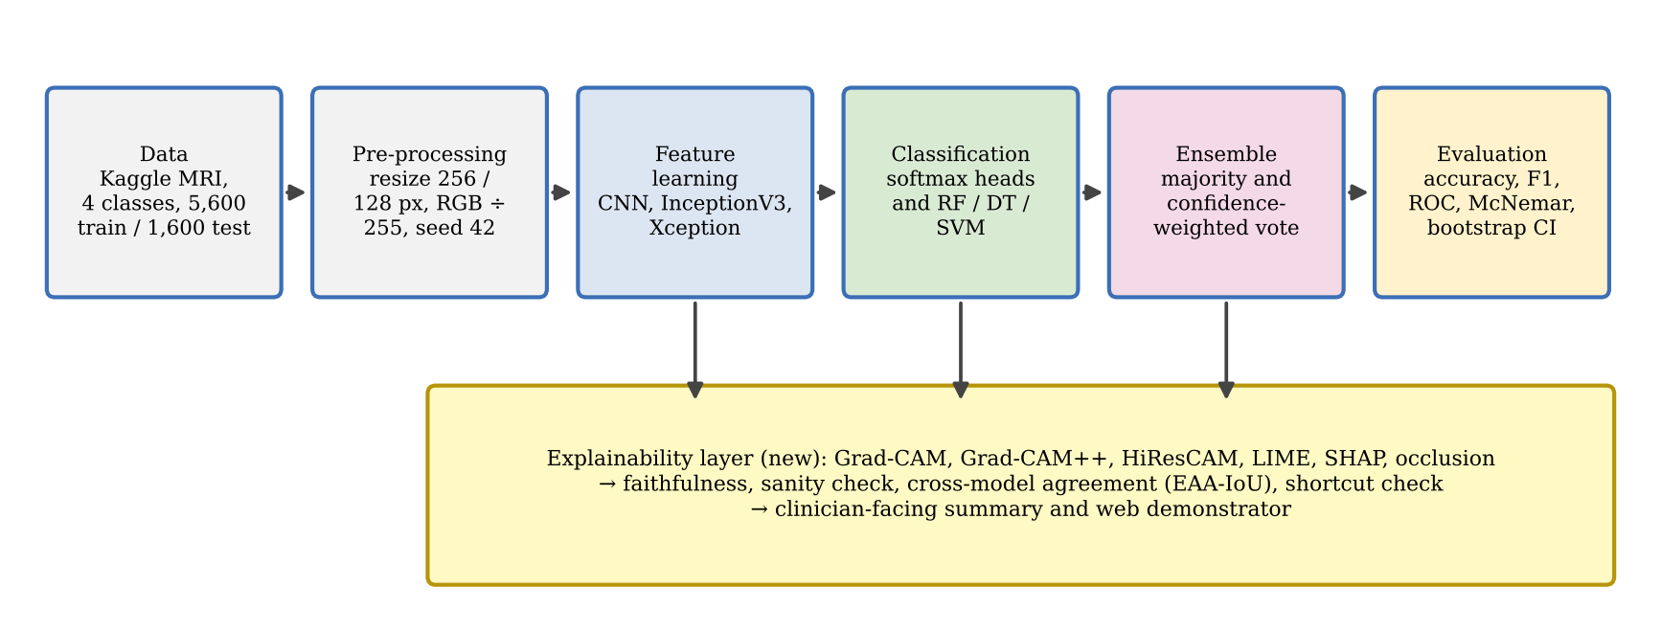
Figure 1. Conceptual framework of the study, with the new explainability layer

Chapter 3 Methodology
This chapter explains how the research was designed and carried out: the philosophy and approach, project management and feasibility, the dataset, the models and their training, the evaluation and statistical tests, the new explainability methods, and the reliability and ethical safeguards. Code excerpts are short and taken from the project code; longer excerpts are in Appendix B.

3.1 Research philosophy
The study takes a positivist stance: claims about model performance are tested against measurable outcomes on data the models have not seen. It also adopts a critical-realist caution. Benchmark accuracy is an imperfect proxy for clinical value, and the mechanisms behind a prediction (for example, whether a network uses the tumour or an artefact) matter as much as the score. The explainability work in Chapter 5 follows directly from this second commitment.

3.2 Research approach and strategy
The approach is deductive. Hypotheses H1–H3 were stated before the final evaluation, and each is tested with a pre-defined metric and statistical test. The strategy is experimental and uses secondary data: a public, labelled MRI dataset (Nickparvar, n.d.) and published literature. The HND proposal planned a mixed-methods design with clinician interviews. No interviews or questionnaire responses were collected, so this report is purely quantitative. The questionnaire is kept in Appendix D as a proposed instrument for future clinician validation, rather than presented as collected data.

3.3 Project management
The project followed the six-phase, sixteen-week plan in the original proposal. Table 3 records the planned phases and what actually happened. The main change was unplanned: the audit (AUDIT.md) showed that the HND evaluation was not on held-out data, so phases 2–4 were repeated with one standardised training notebook that logs every result to CSV and JSON files and uploads models and results to Hugging Face (Kavishka, 2026). Free Colab sessions disconnected several times; per-epoch checkpoints let training resume (the run log records resumes of the CNN at epochs 11 and 15), so no results were lost.
Table 3. Planned phases and final project record
Phase | Planned weeks | Status | Changes and justification
1. Research and planning | 3 | Completed (HND stage, 2024) | Literature review extended with XAI and evaluation sources (2026)
2. Individual model development | 4 | Completed | All models retrained under one protocol after the audit; Colab disconnections handled by per-epoch checkpoints
3. Ensemble framework | 3 | Completed | Added confidence-weighted voting alongside majority voting
4. Performance evaluation | 2 | Completed | Held-out test evaluation replaced the training-set evaluation; statistical tests added
5. Application development | 2 | Prototype | Web demonstrator built; not evaluated with users
6. Documentation and finalisation | 2 | Completed | Explainability chapter, audit and change log added

3.4 Feasibility, cost and access
Time feasibility was achieved by keeping models small enough to train on a free GPU: each deep model trained in minutes on a Colab T4 GPU, while the slowest component was the raw-pixel SVM, which took 5812.1 seconds to train. The CNN-feature SVM took 2.7 seconds (results_master.csv). Cost feasibility: all software is open source, training used free Colab, models and results are hosted free on Hugging Face, and the explainability analysis ran on an ordinary 4-core CPU. Access feasibility: the dataset is public and anonymised, so no data-sharing agreement or ethics committee approval for patient data was needed. Scope feasibility led to two deliberate limits: no fine-tuning of the pretrained backbones and no cross-validation, both of which would have multiplied training time (see Section 6.4).

3.5 Dataset
The data are the Brain Tumor MRI Dataset curated by Nickparvar (n.d.), which combines images from the figshare dataset of Cheng et al. (2015), the SARTAJ collection and the Br35H collection. The current release contains 7,200 two-dimensional JPEG slices in four classes, pre-split into a Training folder (5,600 images, 1,400 per class) and a Testing folder (1,600 images, 400 per class) (dataset_counts.json). The class balance means that accuracy and macro-averaged scores coincide closely. The XAI analysis used an identical copy of the Testing folder from a Hugging Face mirror (BJyotibrat, 2026). Re-running the saved models on this copy reproduced every logged prediction (Section 4.9), which confirms that it is the same test set. The mirror card lists a CC BY 4.0 licence; the licence on the original Kaggle page should be confirmed before any redistribution.
Two properties of the data matter for interpretation. First, 103 of the 400 meningioma test images are augmented copies (file names beginning "Te-aug-me"), so the meningioma test set is less independent than the others. Second, all no-tumour images come from a single source (Br35H), which creates a possible shortcut. The HND study used an older 9,047-image copy with 6,984 training and 2,063 test images, so the old and new results are not directly comparable (Section 4.10).
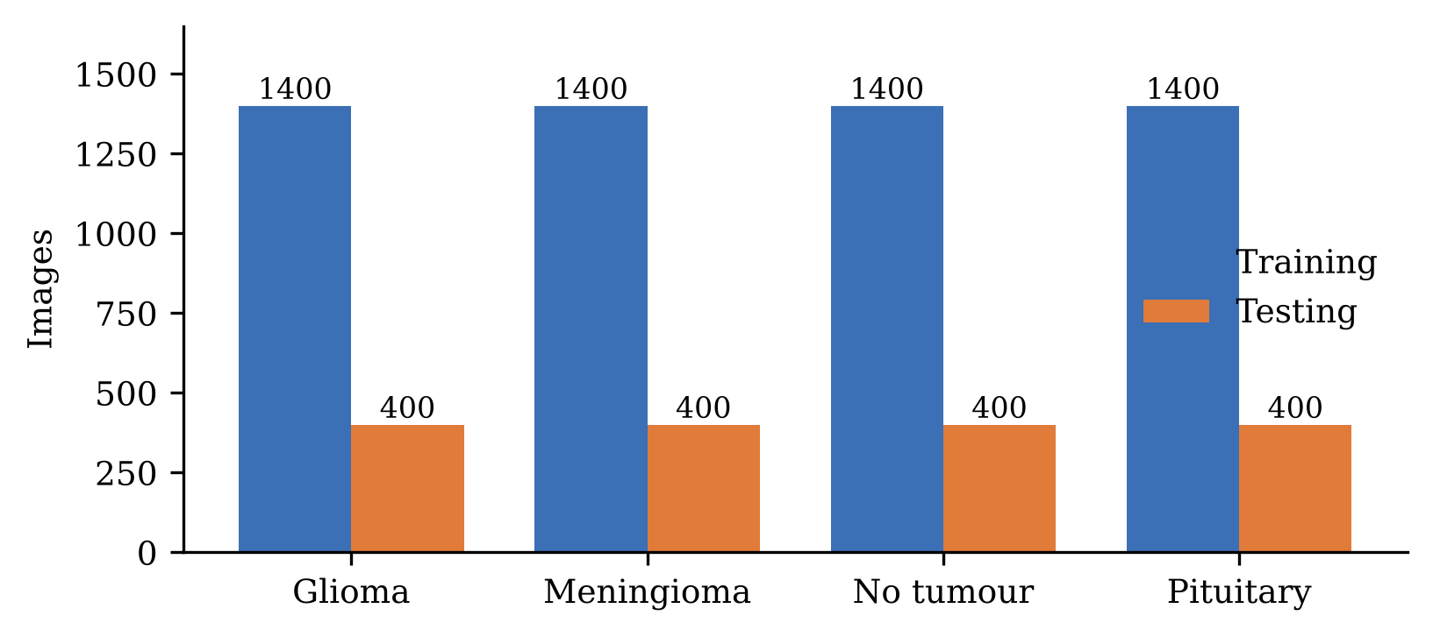
Figure 2. Images per class in the Training and Testing folders
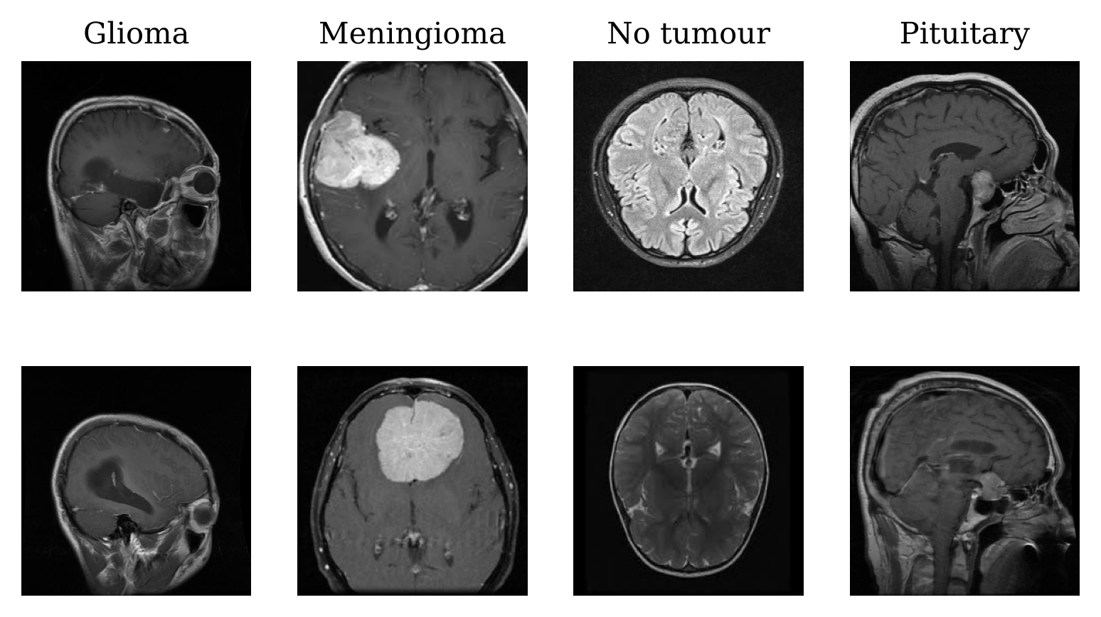
Figure 3. Two randomly selected test images per class, showing axial, coronal and sagittal views

3.6 Pre-processing
Images were resized to 256 × 256 pixels for the standalone deep models, and to 128 × 128 pixels for the feature extractors that feed the classical classifiers. Pixel values were divided by 255 for every model, which removes the mixture of scalings (÷255 and ÷255 − 0.5) used in the HND notebooks. Raw-pixel classifiers used greyscale images flattened to 65,536 values. No noise reduction, skull stripping, registration or augmentation was applied; earlier text implying otherwise has been removed. Listing 1 shows the shared data loader.
Listing 1. Shared data loading and split (from the standardised training notebook)
# Same split and scaling for every deep model (seed 42, 10% of Training held out for validation)
def tf_datasets(size):
common = dict(image_size=(size, size), batch_size=BATCH, label_mode='int', seed=SEED)
tr = tf.keras.utils.image_dataset_from_directory(os.path.join(DATA_DIR, 'Training'),
validation_split=0.1, subset='training', shuffle=True, **common)
va = tf.keras.utils.image_dataset_from_directory(os.path.join(DATA_DIR, 'Training'),
validation_split=0.1, subset='validation', shuffle=True, **common)
te = tf.keras.utils.image_dataset_from_directory(os.path.join(DATA_DIR, 'Testing'),
shuffle=False, image_size=(size, size), batch_size=BATCH, label_mode='int')
norm = lambda x, y: (x / 255.0, y) # RGB scaled to [0, 1]
return tr.map(norm), va.map(norm), te.map(norm) # Testing is only used for final evaluation

3.7 Models

3.7.1 Custom CNN
The custom CNN (Figure 4, Listing 2) has four convolution–pooling blocks, a 256-unit dense layer, dropout and a softmax output. It is trained from scratch. The same design at 128 × 128 pixels serves as the CNN feature extractor.
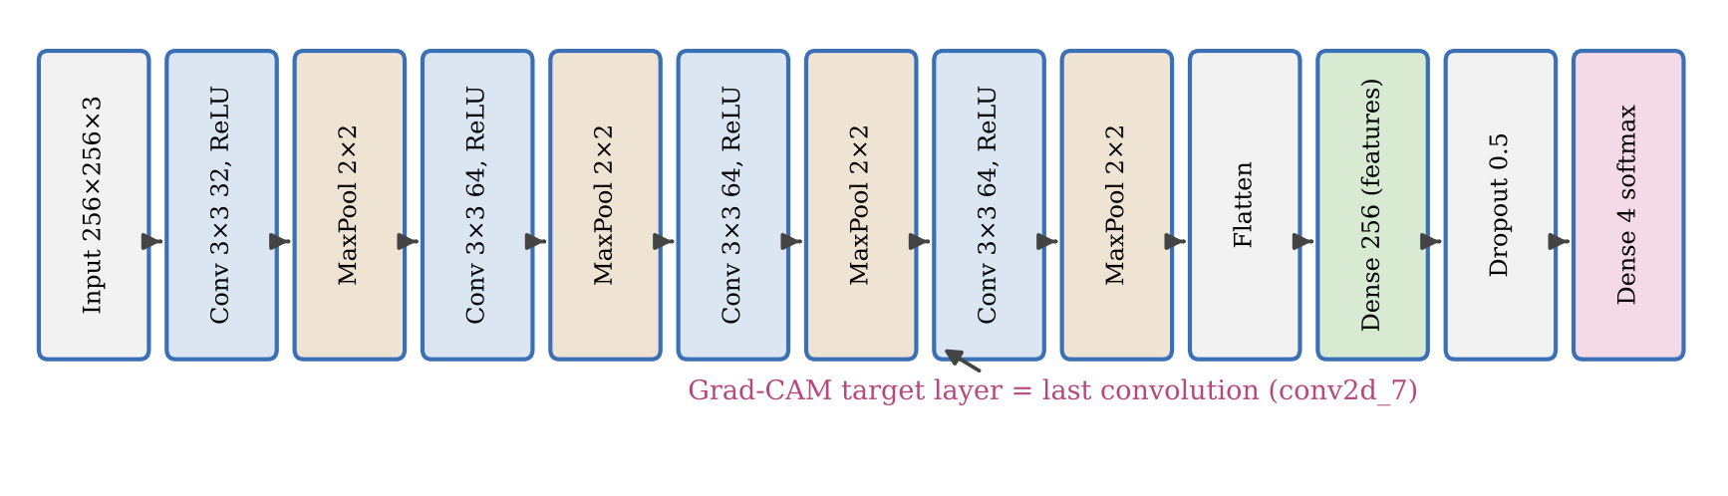
Figure 4. Architecture of the custom four-block CNN
Listing 2. Custom CNN definition
def build_cnn(size, feat_name='dense'):
m = models.Sequential([
layers.Input(shape=(size, size, 3)),
layers.Conv2D(32, (3, 3), activation='relu'), layers.MaxPooling2D((2, 2)),
layers.Conv2D(64, (3, 3), activation='relu'), layers.MaxPooling2D((2, 2)),
layers.Conv2D(64, (3, 3), activation='relu'), layers.MaxPooling2D((2, 2)),
layers.Conv2D(64, (3, 3), activation='relu'), layers.MaxPooling2D((2, 2)),
layers.Flatten(),
layers.Dense(256, activation='relu', name=feat_name), # 256-value feature layer
layers.Dropout(0.5),
layers.Dense(N_CLASSES, activation='softmax')])
m.compile(optimizer='adam', loss='sparse_categorical_crossentropy', metrics=['accuracy'])
return m

3.7.2 InceptionV3 and Xception (transfer learning with frozen backbones)
Both pretrained networks were loaded with ImageNet weights and with their convolutional backbone frozen (trainable = False). Only a new head was trained (Listing 3). The HND report and the project title call these models "fine-tuned", but no backbone weights were updated, so they are more accurately described as frozen feature extractors with trained classification heads. True fine-tuning is listed as future work.
Listing 3. Frozen-backbone transfer models: 256 px classifiers and 128 px feature extractors
def _base(kind, size):
App = tf.keras.applications.InceptionV3 if kind == 'inception' else tf.keras.applications.Xception
b = App(input_shape=(size, size, 3), weights='imagenet', include_top=False)
b.trainable = False # backbone frozen: transfer learning, not fine-tuning
return b

def build_transfer_standalone(kind, size=256): # 256 px classifier: GAP + softmax head
base = _base(kind, size)
out = layers.Dense(N_CLASSES, activation='softmax')(layers.GlobalAveragePooling2D()(base.output))
return Model(base.input, out)

def build_transfer_extractor(kind, feat_name, size=128): # 128 px extractor with a Dense-256 layer
base = _base(kind, size)
x = layers.Dense(256, activation='relu', name=feat_name)(layers.Flatten()(base.output))
out = layers.Dense(N_CLASSES, activation='softmax')(layers.Dropout(0.5)(x))
return Model(base.input, out)

3.7.3 Classical classifiers and the feature-level ensembles
Random Forest, Decision Tree and SVM classifiers were trained (i) on raw greyscale pixels, together with Logistic Regression, and (ii) on the 256 values of the dense feature layer of each 128-pixel extractor. Within each feature source the three classifiers were combined by soft voting (Listing 4). The HND notebook mistakenly instantiated a Decision Tree in place of the Random Forest; this is fixed.
Listing 4. Deep feature extraction and the RF/DT/SVM soft-voting ensemble
# Deep features (256 values per image) -> RF, DT and SVM -> soft vote
ftr = extract_features(extractor, 'dense', X_train) # output of the Dense-256 layer
fte = extract_features(extractor, 'dense', X_test)
specs = {'rf': RandomForestClassifier(n_estimators=100, random_state=SEED, n_jobs=-1),
'dt': DecisionTreeClassifier(random_state=SEED),
'svm': SVC(probability=True, random_state=SEED)}
fitted = {k: clf.fit(ftr, y_train) for k, clf in specs.items()}
probs = sum(fitted[k].predict_proba(fte) for k in ['rf', 'dt', 'svm']) / 3
soft_vote_pred = probs.argmax(axis=1)

3.7.4 Final six-predictor ensemble
The final ensemble (Figure 5) combines six probability vectors: the CNN, InceptionV3 and Xception classifiers, and the three soft-voting classical ensembles built on CNN, InceptionV3 and Xception features. Majority voting gives each predictor one vote. Confidence-weighted voting sums the six probability vectors and takes the largest, which also yields a confidence score (Listing 5).
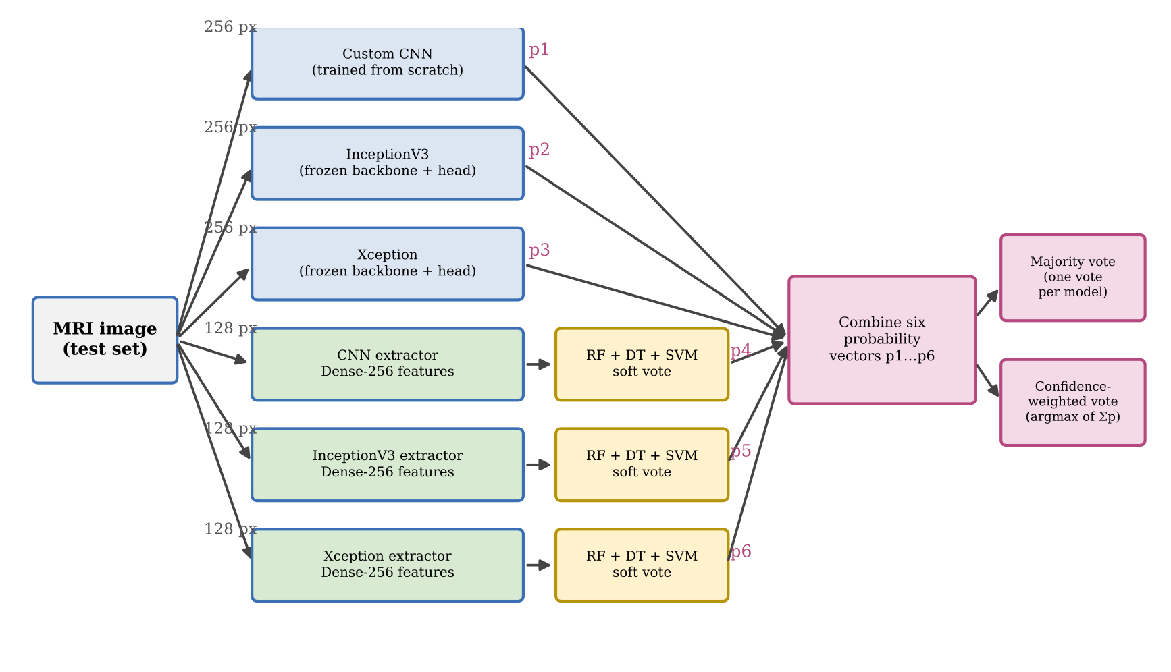
Figure 5. The six-predictor hybrid ensemble
Listing 5. Majority and confidence-weighted voting
# P has shape (6 predictors, N images, 4 classes): three deep softmax outputs and
# three averaged RF/DT/SVM probability vectors from the 128 px feature extractors
summed = P.sum(axis=0)
pred_confidence_weighted = summed.argmax(axis=1) # argmax of the summed probabilities
confidence = summed.max(axis=1) / summed.sum(axis=1) # share of the winning class
votes = P.argmax(axis=2) # one hard vote per predictor
pred_majority = np.array([np.bincount(votes[:, i], minlength=4).argmax()
for i in range(votes.shape[1])]) # ties -> lowest class index

3.8 Training set-up and hyperparameters
Table 4 lists the settings shared across models. Hyperparameters were kept at sensible defaults and identical across models rather than tuned per model. This favours a fair comparison over peak performance, and it avoids tuning on the test set.
Table 4. Training set-up and hyperparameters
Setting | Value
Input size | 256 × 256 × 3 (standalone deep models); 128 × 128 × 3 (feature extractors); 256 × 256 greyscale flattened to 65,536 values (raw-pixel models)
Normalisation | Pixel values ÷ 255 (range 0–1) for every model
Train / validation split | 90% / 10% of the Training folder, seed 42; Testing folder held out
Optimiser and loss | Adam (Keras default learning rate 0.001); sparse categorical cross-entropy
Epochs | Custom CNN 20; InceptionV3 and Xception 10; 128 px extractors 10
Batch size | 32 for all deep models
Regularisation | Dropout 0.5 before the output layer (CNN and extractors); frozen ImageNet backbones
Data augmentation | None applied during training
Model selection | No early stopping; the weights after the last epoch were used
Random Forest | 100 trees, default depth, random_state 42
Decision Tree | Default settings (Gini, unlimited depth), random_state 42
Support Vector Machine | RBF kernel, C = 1, probability estimates enabled, random_state 42
Logistic Regression (raw pixels only) | max_iter 1,000
Ensembles | Soft vote of RF + DT + SVM within each feature source; final six-predictor majority and confidence-weighted votes

3.9 Hardware, software and reproducibility
Training ran in Google Colab on an NVIDIA T4 GPU with TensorFlow 2.21.0, Keras 3.13.2 and scikit-learn 1.6.1 (manifest.json) (Abadi et al., 2016; Pedregosa et al., 2011). Seeds were fixed to 42 for Python, NumPy and TensorFlow. Every result was written as data: one row per model in results_master.csv, a classification report and confusion matrix per model, per-epoch training histories, per-image predictions and a timestamped run log. The explainability analysis was run separately on a 4-core CPU with 15 GB RAM, using the saved models downloaded from Hugging Face. The analysis scripts are in paper_assets/scripts (Appendix H).

3.10 Evaluation protocol and statistical analysis
All models were evaluated once on the 1,600 Testing images, which were never used for training, validation or model selection. Reported metrics are accuracy, per-class and macro-averaged precision, recall and F1-score, confusion matrices, and one-vs-rest ROC and precision–recall curves with their areas. Because a single accuracy figure hides sampling uncertainty, 95% intervals are reported: Wilson score intervals for every model, and percentile bootstrap intervals with 2,000 resamples (Efron, 1979) for the eight predictors with per-image predictions. Pairs of models evaluated on the same images were compared with the exact McNemar test (McNemar, 1947), which Dietterich (1998) recommends for comparing two classifiers on one test set. Holm correction was applied across the ten planned comparisons. The "correlation" and "regression" sections of the HND report were removed, because no correlation or regression model was fitted.

3.11 Explainability methodology
Figure 6 summarises the explainability pipeline. Explanations were computed for the class predicted by the six-model majority vote, so they show what supported the ensemble decision.
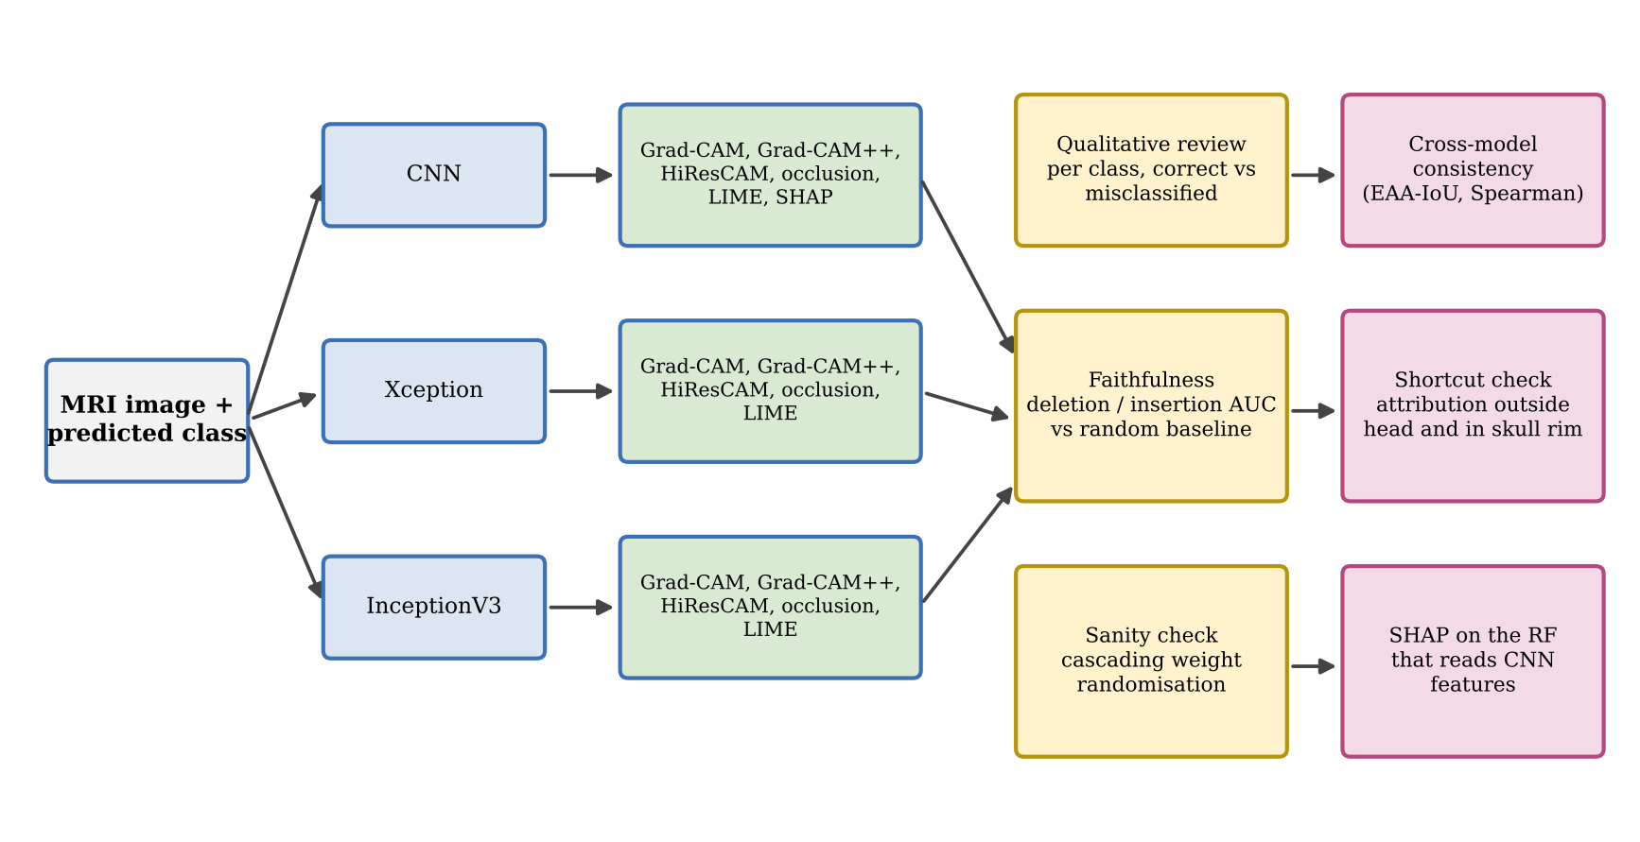
Figure 6. Explainability pipeline: methods (left) and how they are evaluated (right)
- Grad-CAM, Grad-CAM++ and HiResCAM (Selvaraju et al., 2017; Chattopadhay et al., 2018; Draelos and Carin, 2020) were computed from the pre-softmax class score at the last spatial layer of each network: conv2d_7 for the CNN, mixed10 for InceptionV3 and block14_sepconv2_act for Xception (Listing 6). For InceptionV3 and Xception, which end in global average pooling, Grad-CAM and HiResCAM are mathematically equivalent. For the CNN, which ends in Flatten + Dense, they differ.
- Occlusion (Zeiler and Fergus, 2014): a 32 × 32 black patch slid with stride 16; the map is the drop in class probability.
- LIME (Ribeiro, Singh and Guestrin, 2016): quick-shift super-pixels, 600 perturbed samples for the CNN and 400 for Xception, hidden super-pixels set to black.
- SHAP (Lundberg and Lee, 2017): the gradient explainer (expected gradients) on the CNN with 50 background test images and 200 samples, and the exact tree explainer on the Random Forest that classifies CNN features.
Example images: for each class, the correctly classified test image with the highest ensemble confidence was selected, together with a confidently misclassified image from that class’s most frequent error (for example, glioma predicted as meningioma). No-tumour images were never misclassified, so its error example is the most frequent miss into that class: a glioma predicted as no tumour.
Quantitative evaluation used a stratified sample of 160 test images: 30 random images per class plus 40 further images that the ensemble misclassified, with seed 42. Four checks were applied:
- Faithfulness – deletion and insertion curves (Petsiuk, Das and Saenko, 2018): pixels were removed (set to black) or revealed (on a blurred copy) in order of saliency, in 20 steps, and the area under the class-probability curve was computed. A faithful map gives a low deletion AUC and a high insertion AUC compared with a random map.
- Sanity check – cascading model-parameter randomisation (Adebayo et al., 2018): layers were re-initialised from the top down, and the Spearman rank correlation and structural similarity (SSIM) between the original and randomised Grad-CAM maps were measured on 40 images.
- Cross-model consistency – the Ensemble Attention Agreement (EAA-IoU) from the project code: Grad-CAM-family maps of the three networks are binarised at 0.5, the intersection over union of each pair is computed, and the three values are averaged. It was computed for all 1,600 test images in the training run. It is complemented here by the Spearman rank correlation between maps and the IoU of their top-20% regions.
- Shortcut check – the share of Grad-CAM mass falling outside the head (a threshold-based head mask) or in a 12-pixel outer rim that covers the skull and image edge, compared with the share of image area these regions occupy.
Listing 6. Grad-CAM and HiResCAM as implemented for the analysis
def gradcam(cm, X, cls):
A, G = cm.maps_and_grads(X, cls) # feature maps and d(logit)/dA at the target layer
w = G.mean(axis=(1, 2)) # one weight per channel = mean gradient
cam = np.einsum('bhwc,bc->bhw', A, w) # weighted sum of feature maps
return _finish(cam) # ReLU, scale to [0, 1], resize to 256 x 256

def hirescam(cm, X, cls): # element-wise gradient x activation
A, G = cm.maps_and_grads(X, cls)
return _finish((A * G).sum(-1))

3.12 Reliability, validity and generalisability
Reliability is supported by fixed seeds, a single shared training notebook, and logging of all results as data. The saved models were also reloaded and re-run, which reproduced every logged prediction (Section 4.9). Internal validity is supported by the untouched test set and paired statistical tests. Two threats remain: the augmented meningioma test images, and the single-source no-tumour class. External validity is limited: all images come from one public collection of two-dimensional slices, without scanner or patient metadata, so results may not transfer to other hospitals (Zech et al., 2018; Kelly et al., 2019). Cross-validation was not used, so variation due to the training split is not measured.

3.13 Ethical considerations
The dataset is public and anonymised, and no attempt was made to re-identify anyone. No human participants were involved in this stage, so informed consent was not required; if the clinician questionnaire in Appendix D is used later, it will need ethical approval and informed consent. The system is a research prototype for decision support. Its interface states that it is for research use only and must not be used for diagnosis. Explanations are presented with their limitations, because over-trust in saliency maps is itself an ethical risk (Ghassemi, Oakden-Rayner and Beam, 2021). Models and code are published openly for transparency, and no images are redistributed with the report.

Chapter 4 Results
This chapter reports the classification results of the standardised re-run on the 1,600 held-out test images. It moves from training behaviour to the individual models, the ensembles, statistical comparisons, per-class behaviour and reproducibility checks, and ends by comparing the new results with the HND report and testing hypotheses H1 and H2. All values come from the logged result files (Appendix H); figures and tables in this chapter are new because every number was regenerated.

4.1 Training behaviour
Figure 7 and Figure 8 show the training and validation curves. The custom CNN fits the training data almost perfectly (final training accuracy 0.9933, validation 0.9643). Its validation loss is lowest at epoch 6 (0.1374) and then drifts upward to 0.1731, a sign of mild over-fitting that early stopping would have reduced. The CNN history file holds 19 rows because one epoch was lost when training resumed after a disconnection. The frozen InceptionV3 and Xception classifiers learn more slowly and were still improving at epoch 10 (final validation accuracy 0.925 and 0.9321), which suggests they were under-trained rather than over-fitted. Validation accuracy is several points higher than test accuracy for every model (for the CNN, 0.9643 against 0.9044). The validation images come from the same folder as the training images, so this gap is an early warning that performance on new data will be lower.
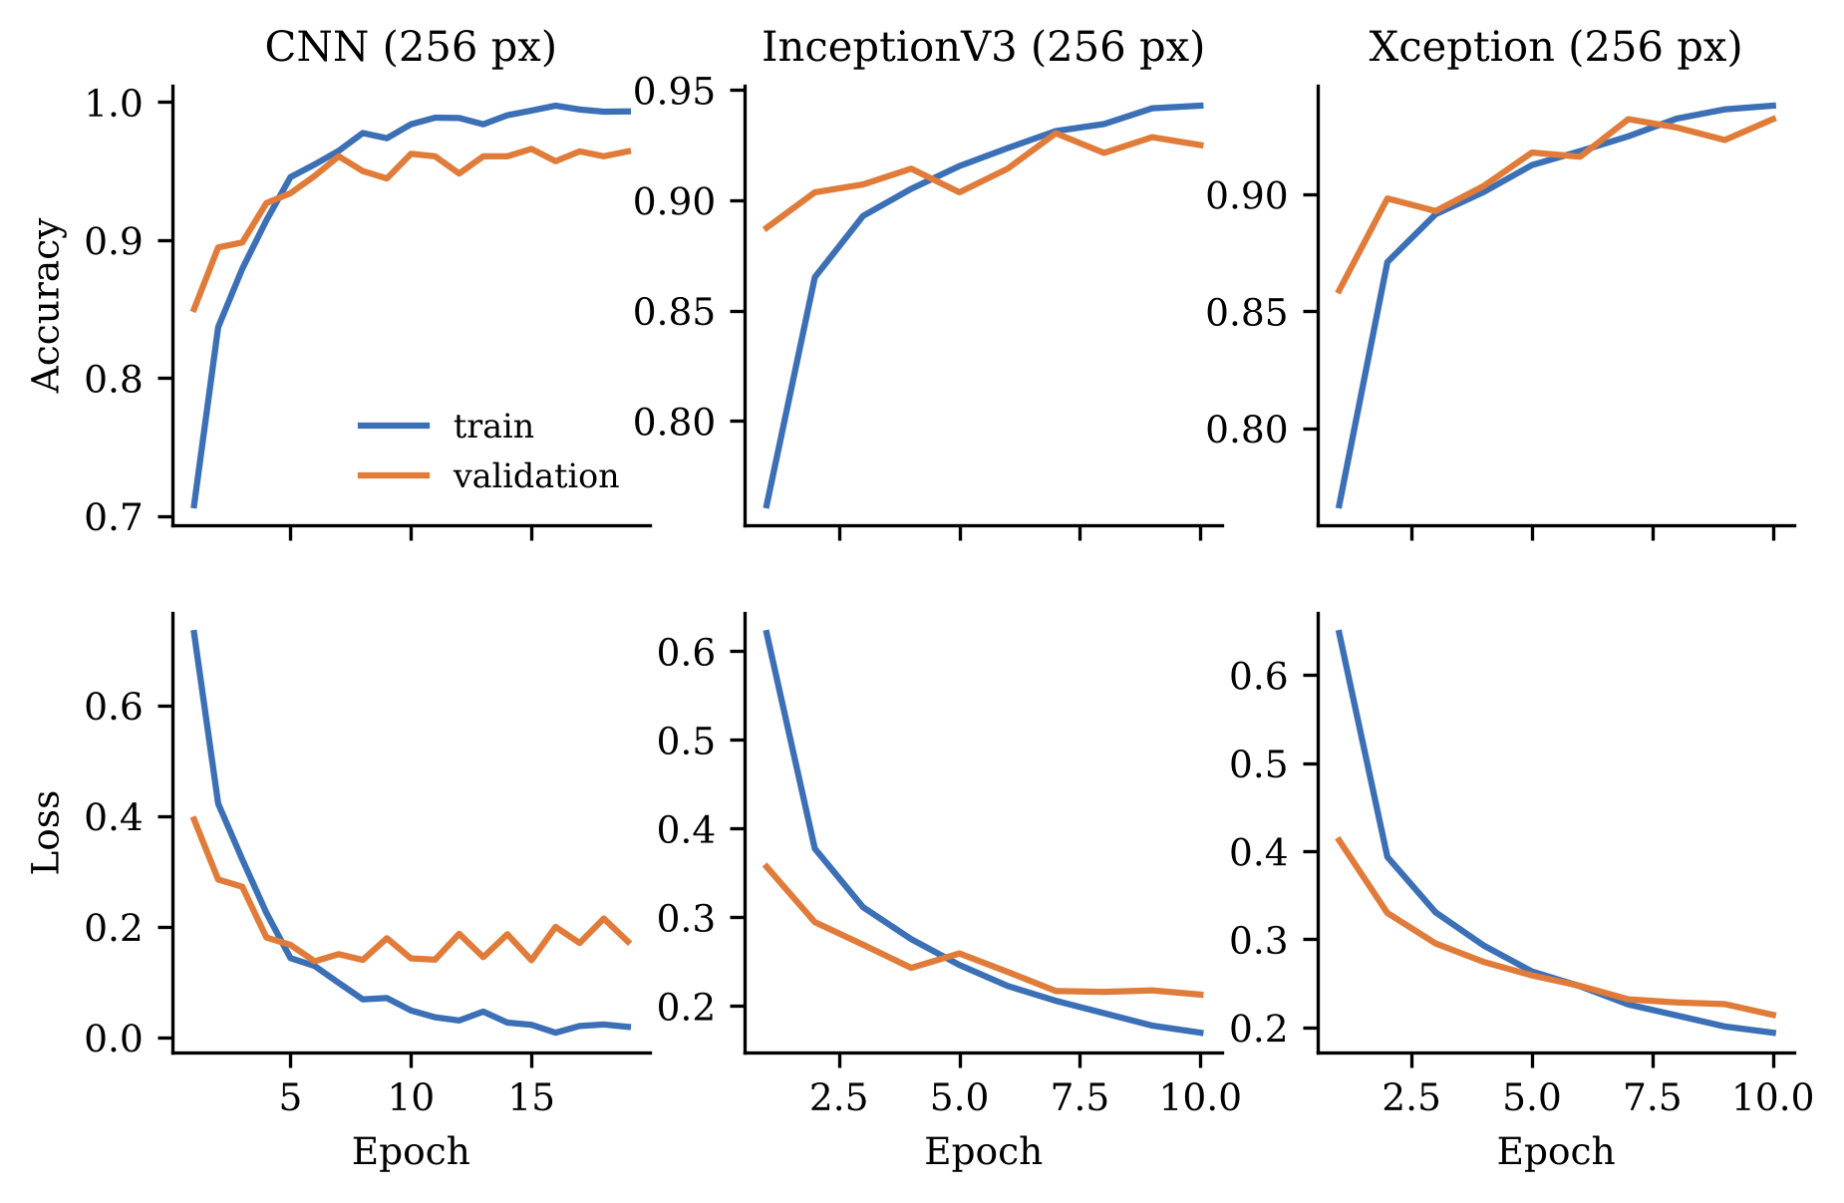
Figure 7. Training and validation accuracy and loss of the standalone deep models (history/*.csv)
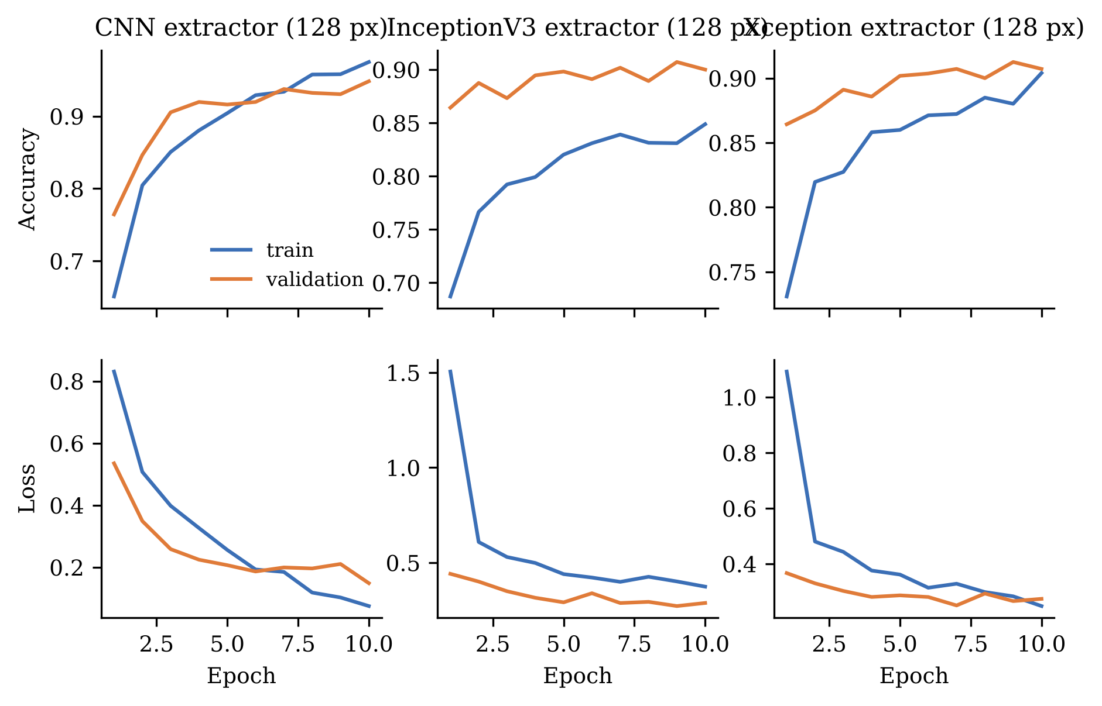
Figure 8. Training and validation curves of the 128-pixel feature extractors

4.2 Standalone deep models
Table 5 gives the test results. The custom CNN is the most accurate single model (90.44%), ahead of Xception (87.62%) and InceptionV3 (86.62%). The difference between the CNN and each pretrained network is statistically significant, but the difference between the two pretrained networks is not (Section 4.6).
Table 5. Test results of the standalone deep models (n = 1,600)
Model | Accuracy (%) | Macro precision | Macro recall | Macro F1 | Wilson 95% CI (%)
Custom CNN (256 px) | 90.44 | 0.911 | 0.904 | 0.903 | 88.9–91.79
InceptionV3, frozen backbone (256 px) | 86.62 | 0.871 | 0.866 | 0.863 | 84.86–88.2
Xception, frozen backbone (256 px) | 87.62 | 0.887 | 0.876 | 0.874 | 85.92–89.14

4.3 Classical classifiers on raw pixels
On 65,536 raw greyscale pixels (Table 6), the Random Forest is the best classical model (87.00%), followed by the SVM (82.25%), Logistic Regression (79.87%) and the Decision Tree (77.88%). Their soft vote reaches 84.06%, below the Random Forest alone. A soft vote does not help when one member (here the Decision Tree) is much weaker and over-confident. These models are also the most expensive: the raw-pixel SVM took 5812.1 seconds to train.
Table 6. Test results of classical classifiers on raw pixels
Model | Accuracy (%) | Macro precision | Macro recall | Macro F1 | Wilson 95% CI (%)
Random Forest | 87.00 | 0.879 | 0.870 | 0.866 | 85.26–88.56
Support Vector Machine | 82.25 | 0.821 | 0.823 | 0.818 | 80.3–84.04
Logistic Regression | 79.87 | 0.798 | 0.799 | 0.796 | 77.83–81.76
Decision Tree | 77.88 | 0.783 | 0.779 | 0.777 | 75.78–79.85
Soft vote (RF + DT + SVM) | 84.06 | 0.845 | 0.841 | 0.837 | 82.19–85.77

4.4 Deep features with classical classifiers
Replacing raw pixels with 256 deep features improves every classical classifier (Table 7). With CNN features, the Random Forest reaches 89.94% and the SVM 89.69%. Xception features come next (Random Forest 88.38%), then InceptionV3 features (Random Forest 86.75%). The SVM benefits most: from 82.25% on raw pixels to 89.69% on CNN features, while its training time fell from 5812.1 to 2.7 seconds. Within each feature source, the soft vote is close to, but not above, the best member.
Table 7. Test results of classical classifiers on deep features (128 px extractors)
Model | Accuracy (%) | Macro precision | Macro recall | Macro F1 | Wilson 95% CI (%)
CNN features + RF | 89.94 | 0.902 | 0.899 | 0.898 | 88.37–91.32
CNN features + SVM | 89.69 | 0.901 | 0.897 | 0.895 | 88.1–91.09
CNN features + DT | 86.50 | 0.867 | 0.865 | 0.864 | 84.74–88.09
CNN features + soft vote | 89.31 | 0.895 | 0.893 | 0.892 | 87.7–90.73
Xception features + RF | 88.38 | 0.891 | 0.884 | 0.882 | 86.72–89.86
Xception features + SVM | 87.69 | 0.882 | 0.877 | 0.875 | 85.99–89.21
Xception features + DT | 86.00 | 0.864 | 0.860 | 0.859 | 84.21–87.61
Xception features + soft vote | 88.31 | 0.889 | 0.883 | 0.881 | 86.64–89.79
InceptionV3 features + RF | 86.75 | 0.870 | 0.868 | 0.865 | 85.0–88.32
InceptionV3 features + SVM | 85.38 | 0.867 | 0.854 | 0.851 | 83.56–87.03
InceptionV3 features + DT | 83.69 | 0.838 | 0.837 | 0.835 | 81.8–85.42
InceptionV3 features + soft vote | 86.12 | 0.863 | 0.861 | 0.859 | 84.34–87.73

4.5 The six-model ensemble
The six-predictor majority vote achieves 92.50% accuracy on the held-out test set (macro F1 0.924), and the confidence-weighted vote achieves 92.25% (macro F1 0.921). This is the headline result of the study. It replaces the 98.20% reported in the HND study, which was measured on training images. Table 8 gives the per-class results of the majority vote, and Figure 9 shows the row-normalised confusion matrices of the deep models and both ensembles.
Table 8. Per-class test results of the six-model majority vote
Class | Precision (%) | Recall (%) | F1-score | Support
Glioma | 97.48 | 77.50 | 0.864 | 400
Meningioma | 83.59 | 95.50 | 0.891 | 400
No tumour | 94.12 | 100.00 | 0.970 | 400
Pituitary | 97.00 | 97.00 | 0.970 | 400

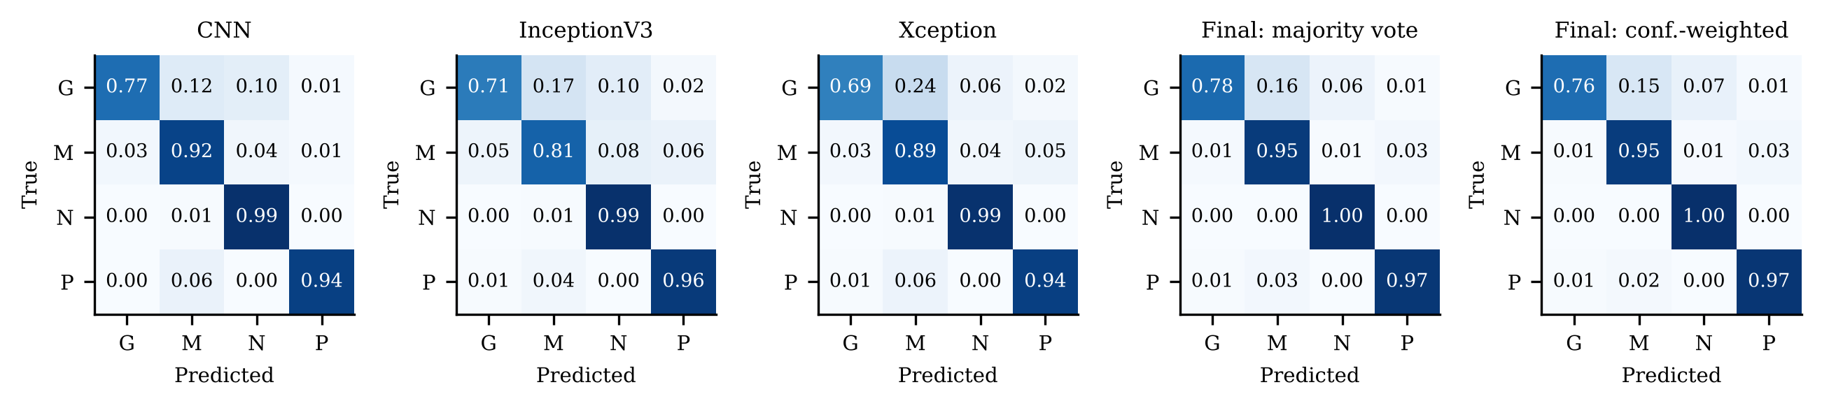
Figure 9. Row-normalised confusion matrices of the standalone deep models and the two final ensembles (G = glioma, M = meningioma, N = no tumour, P = pituitary)
No-tumour images are always recognised (recall 100.00%) and pituitary tumours nearly always (97.00%). Glioma is the weak point: recall is only 77.50%, with 65 of 400 gliomas predicted as meningioma and 23 predicted as no tumour. The second error matters clinically, because it is a missed tumour. The ensemble mostly helps by correcting errors that only a minority of members make. All six members agree on 1153 images, where the vote is 98.44% accurate. On the 74 images where the best class receives only three votes, accuracy falls to 52.7%. At least one member is correct for 96.75% of images, but on 52 images all six are wrong, so the ensemble cannot recover them.
Majority voting and confidence-weighted voting differ on only 22 images (13 favour majority voting and 9 favour confidence weighting). The difference is not significant (exact McNemar p = 0.523). Confidence weighting therefore does not improve accuracy here, but it does provide a useful per-image confidence score (Section 5.7).

4.6 Statistical comparison of models
Table 9 lists the exact McNemar tests. The columns n01 and n10 count the images that only model A, or only model B, classifies correctly. The majority vote is significantly better than every one of its six members after Holm correction. The CNN is significantly better than both Xception and InceptionV3, while Xception and InceptionV3 are not significantly different. Table 10 gives bootstrap 95% intervals, and Figure 10 places all 22 configurations on one chart with Wilson intervals.
Table 9. Exact McNemar tests on the 1,600 test images (Holm-adjusted p over ten comparisons)
Model A | Model B | n01 (A right, B wrong) | n10 (A wrong, B right) | p (exact) | p (Holm)
Majority vote | CNN | 56 | 24 | 4.5 × 10⁻⁴ | 0.002
Majority vote | Xception | 90 | 14 | 9.2 × 10⁻¹⁵ | 7.4 × 10⁻¹⁴
Majority vote | InceptionV3 | 121 | 23 | 2.9 × 10⁻¹⁷ | 2.6 × 10⁻¹⁶
Majority vote | CNN features + soft vote | 69 | 18 | 3.3 × 10⁻⁸ | 2.0 × 10⁻⁷
Majority vote | Xception features + soft vote | 83 | 16 | 4.4 × 10⁻¹² | 3.1 × 10⁻¹¹
Majority vote | InceptionV3 features + soft vote | 123 | 21 | 9.6 × 10⁻¹⁹ | 9.6 × 10⁻¹⁸
Majority vote | Confidence-weighted vote | 13 | 9 | 0.523 | 0.523
CNN | Xception | 99 | 55 | 4.9 × 10⁻⁴ | 0.002
CNN | InceptionV3 | 129 | 63 | 2.2 × 10⁻⁶ | 1.1 × 10⁻⁵
Xception | InceptionV3 | 93 | 71 | 0.101 | 0.201

Table 10. Bootstrap 95% confidence intervals for test accuracy (2,000 resamples, ensemble pipeline)
Predictor | Accuracy (%) | 95% CI (%)
CNN | 90.5 | 89.12–91.81
InceptionV3 | 86.38 | 84.69–88.0
Xception | 87.75 | 86.19–89.38
CNN features + soft vote | 89.31 | 87.75–90.81
InceptionV3 features + soft vote | 86.12 | 84.44–87.75
Xception features + soft vote | 88.31 | 86.75–89.88
Final majority vote | 92.5 | 91.25–93.69
Final confidence-weighted vote | 92.25 | 91.0–93.5
Note: inside the ensemble pipeline images are resized with OpenCV, so the three standalone members score slightly differently (90.50, 86.38 and 87.75%) from the Keras-loader figures in Table 5 (Section 4.9).
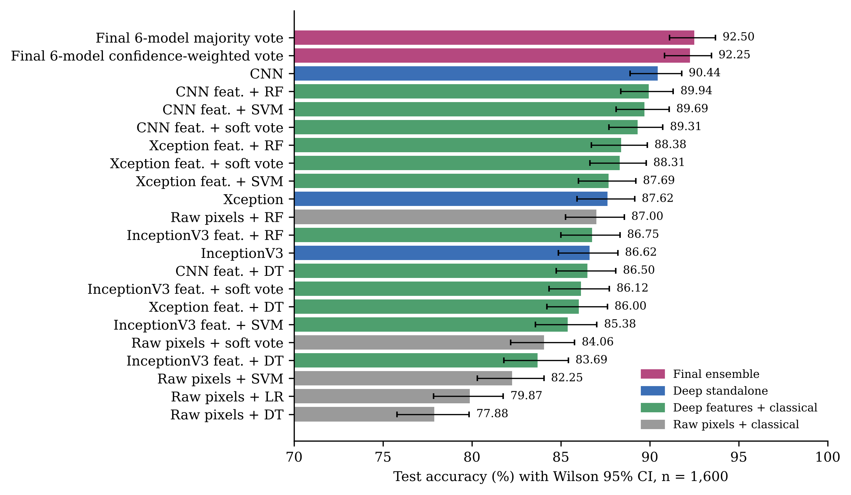
Figure 10. Test accuracy of all 22 configurations with Wilson 95% confidence intervals

4.7 Per-class performance
Figure 11 shows per-class F1 for every configuration. The same pattern holds across all 22: no-tumour and pituitary are easy, meningioma is intermediate, and glioma is hardest. Glioma F1 ranges from 0.688 (raw-pixel Logistic Regression) to 0.864 (majority vote). Among single models, Xception has the lowest glioma recall (68.75%), mainly because it labels 95 gliomas as meningioma. The CNN misses fewer gliomas into meningioma (49) but more into no tumour (40). This complementarity is part of why the vote helps. Confusion matrices of all classical configurations are in Figure 12 and Figure 13.
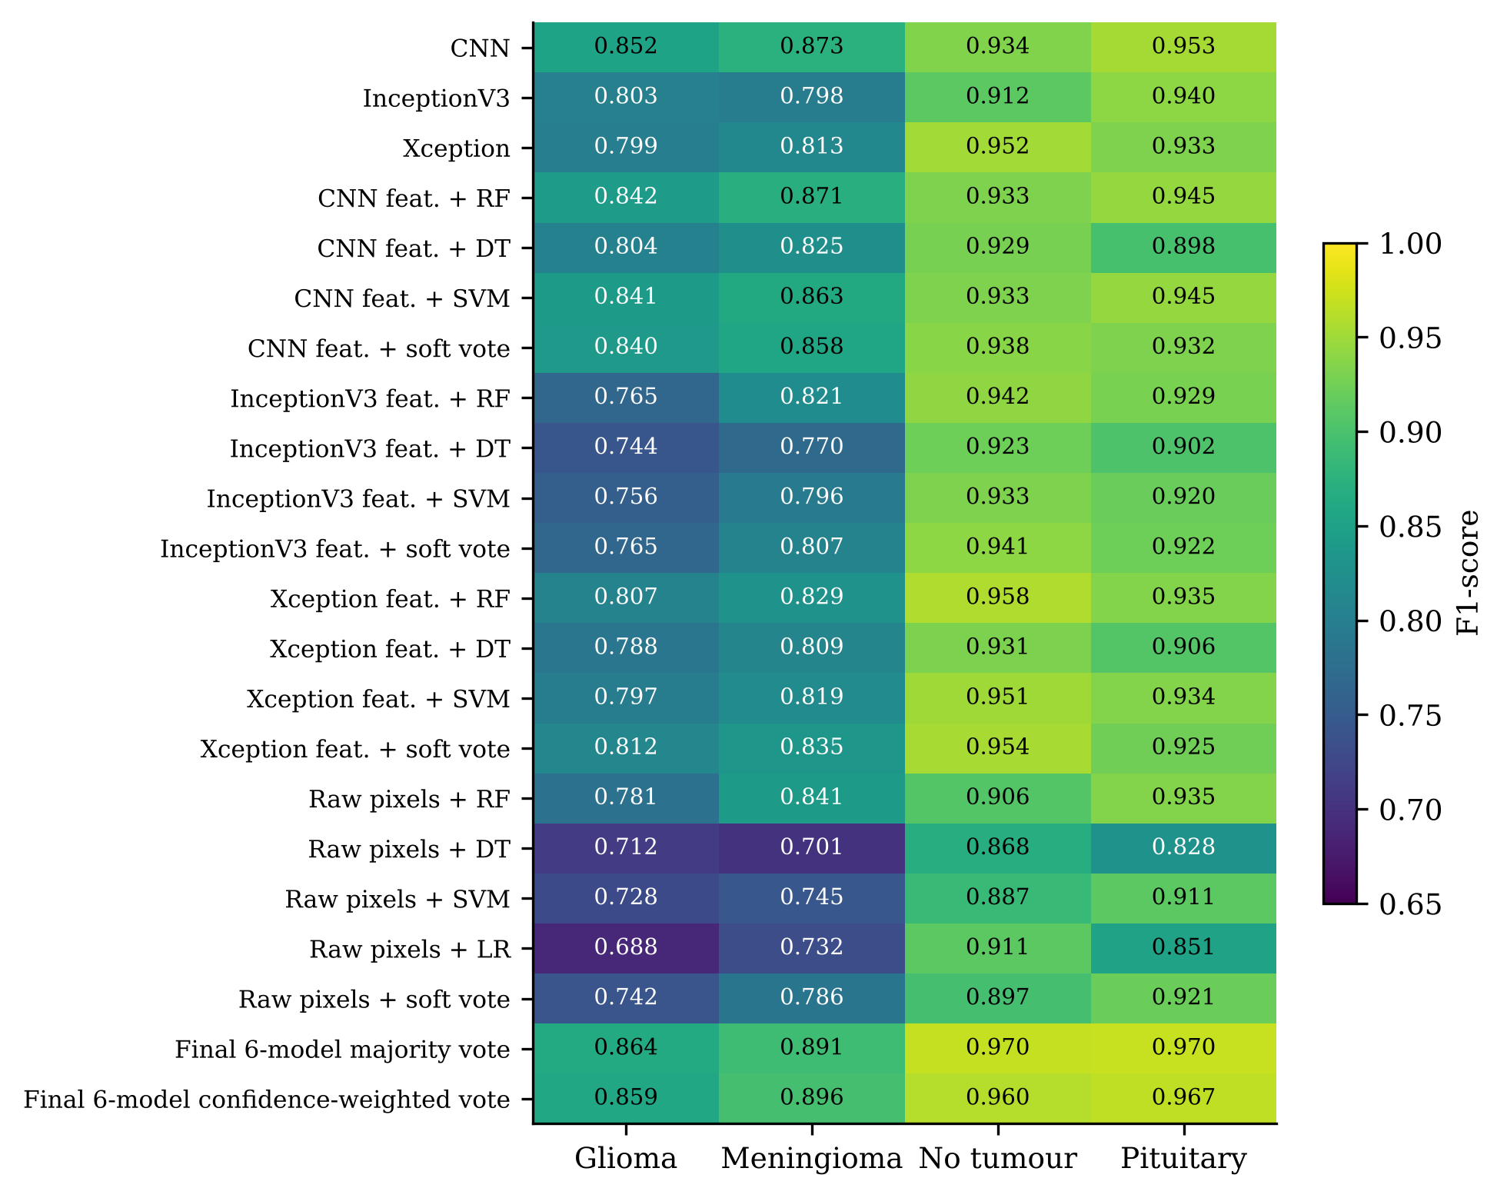
Figure 11. Per-class F1-score of every configuration
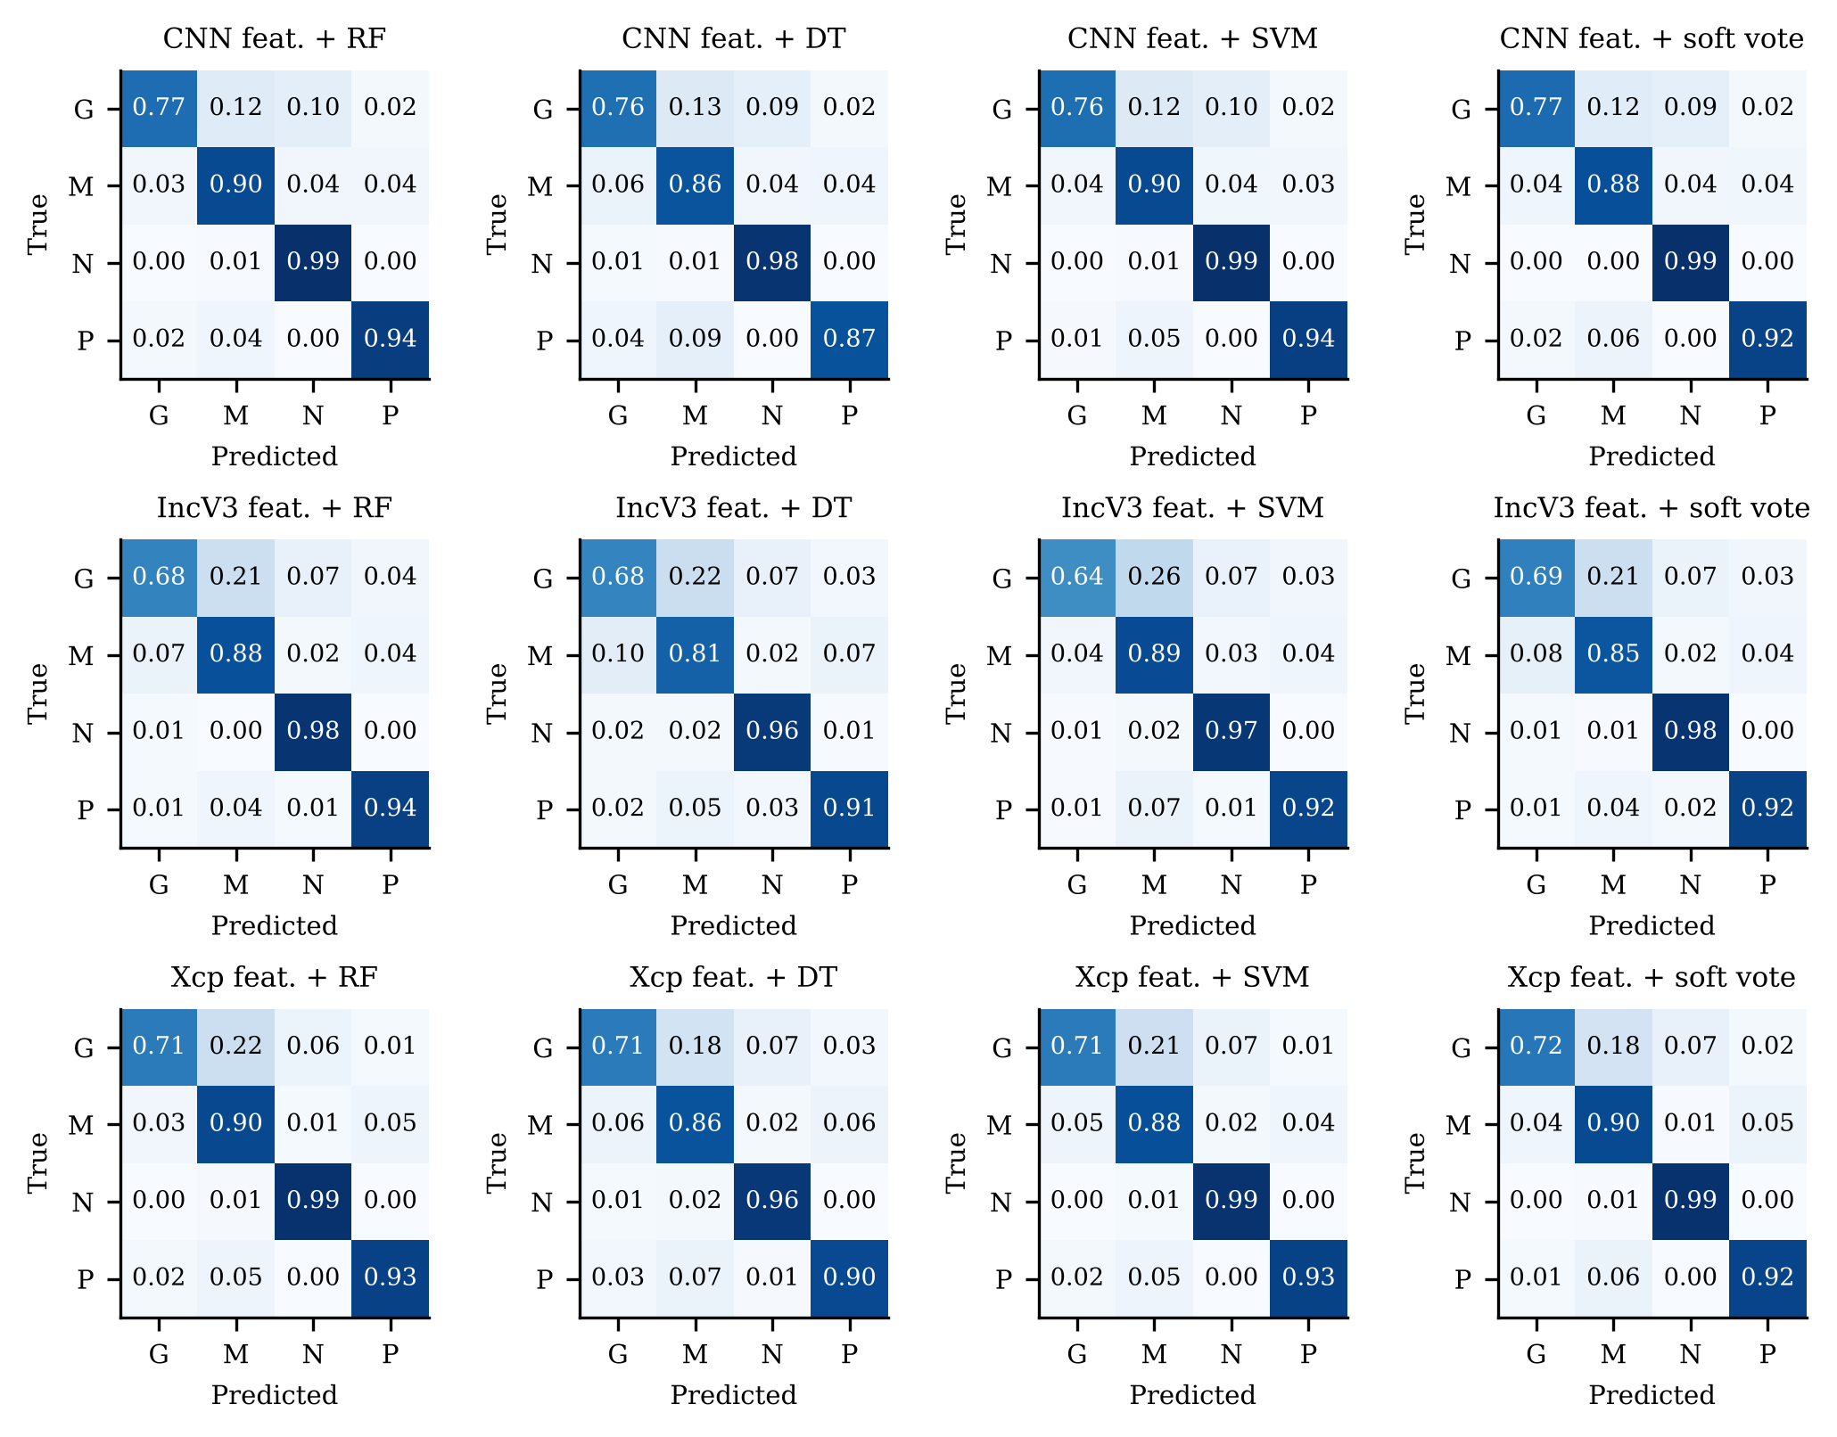
Figure 12. Row-normalised confusion matrices of the classical classifiers on deep features
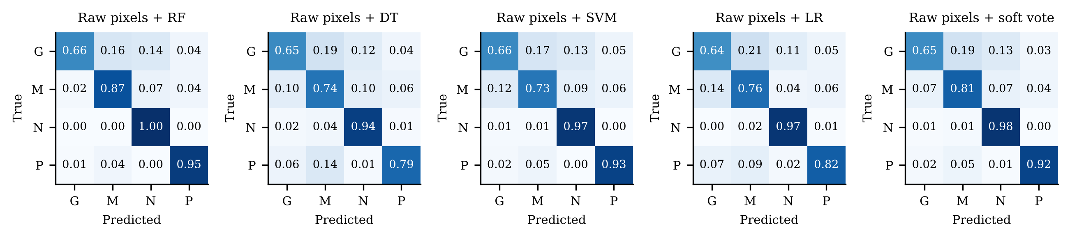
Figure 13. Row-normalised confusion matrices of the classical classifiers on raw pixels

4.8 ROC and precision–recall analysis
The ROC and precision–recall curves of the three deep classifiers are in Figure 14 and the areas in Table 11. Ranking quality is high for all three (macro ROC AUC between 0.9648 and 0.9696). Interestingly, InceptionV3 has the best macro ROC AUC even though it has the lowest accuracy. Its probabilities rank cases well, but its default decision rule (argmax) places the boundaries less well. Glioma has the lowest areas for every model; the CNN’s glioma ROC AUC (0.8995) is the lowest of all, which matches its glioma-to-no-tumour errors.
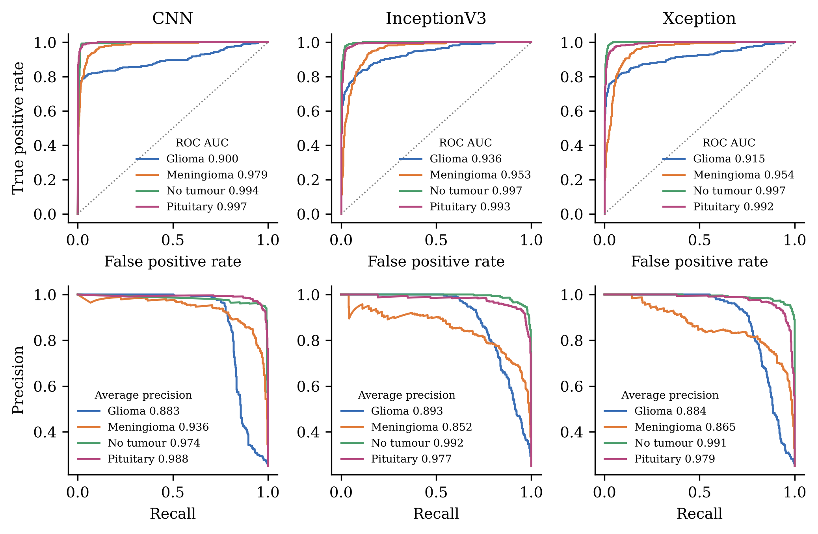
Figure 14. One-vs-rest ROC (top) and precision–recall (bottom) curves of the three deep classifiers
Table 11. ROC AUC / average precision per class and macro ROC AUC
Model | Glioma | Meningioma | No tumour | Pituitary | Macro ROC AUC
CNN | 0.8995 / 0.8827 | 0.9786 / 0.9359 | 0.9941 / 0.9737 | 0.9972 / 0.9883 | 0.9673
InceptionV3 | 0.9356 / 0.8925 | 0.9529 / 0.8519 | 0.9974 / 0.9924 | 0.9926 / 0.9766 | 0.9696
Xception | 0.9152 / 0.8841 | 0.9545 / 0.8652 | 0.9973 / 0.9906 | 0.9922 / 0.9787 | 0.9648

4.9 Reproducibility checks
Three checks were run. First, the three saved standalone models were reloaded and re-run on the test images. Their predictions agreed with the logged per-image predictions for 100% of images (verification.json). Second, the whole six-predictor ensemble was rebuilt from the saved extractors and classical classifiers, and reproduced 92.5% (majority) and 92.25% (confidence-weighted), again with 100% per-image agreement. Third, the Random Forest on CNN features was re-run and gave 89.94%, as logged. One small inconsistency was found: standalone metrics were computed with the Keras image loader, while the ensemble re-loads images with OpenCV. The two resizing routines differ slightly, which moves the standalone accuracies by up to 0.24 percentage points (for example, the CNN scores 90.44% with the Keras loader and 90.50% in the ensemble pipeline). Both figures are reported, and the conclusions do not depend on which is used.

4.10 Comparison with the HND (2024) results
Table 12 and Figure 15 compare the HND figures with the standardised re-run. The comparison is indicative only: the HND study used an older 9,047-image copy of the data, different preprocessing per notebook, a classical baseline tested on a split of the training folder, and a final ensemble evaluated on the training images. The feature-based classical models improve sharply in the re-run, mainly because the HND notebooks used batch size 5, mixed normalisation and, for the CNN pipeline, a crashing notebook. The final ensemble falls from 98.20% (training images) to 92.50% (held-out images). This 5.70-point gap is the clearest evidence that evaluating on training data inflated the original claim.
Table 12. HND (2024) figures compared with the standardised re-run (accuracy, %)
Model | HND report (2024) | Re-run (2026), held-out test
Custom CNN | 94 (test) | 90.44
Xception | 86.91 (test) | 87.62
InceptionV3 | 84.63 (test) | 86.62
CNN features + RF / DT / SVM | 85.45 / 80.99 / 66.60 | 89.94 / 86.50 / 89.69
Xception features + RF / DT / SVM | 73.67 / 68.20 / 56.71 | 88.38 / 86.00 / 87.69
InceptionV3 features + RF / DT / SVM | 74.64 / 68.05 / 57.34 | 86.75 / 83.69 / 85.38
Raw pixels + SVM / DT / RF | 88.26 / 80.02 / 79.52 (split of training folder) | 82.25 / 77.88 / 87.00
Final six-model majority vote | 98.20 (on 6,985 training images) | 92.50 (1,600 held-out images)

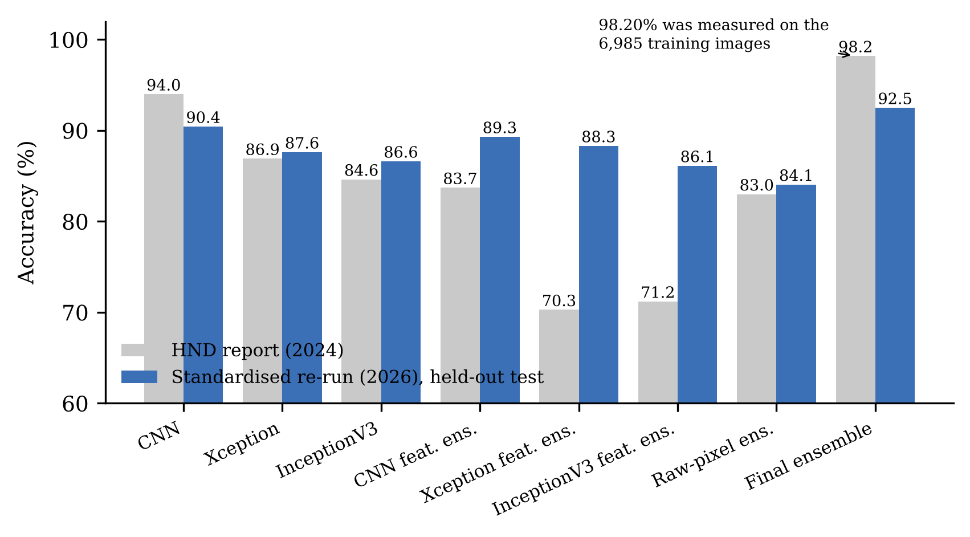
Figure 15. HND (2024) accuracies against the standardised re-run on held-out data

4.11 Hypotheses H1 and H2
H1 is not supported. The custom CNN (90.44%) is more accurate than Xception (87.62%; McNemar p = 4.9 × 10⁻⁴) and InceptionV3 (86.62%; p = 2.2 × 10⁻⁶). The same order holds when the networks are used as feature extractors for classical classifiers. With frozen backbones and ten epochs, ImageNet features did not beat a small network trained directly on MRI. H2 is supported. The majority vote is significantly more accurate than every member (all Holm-adjusted p ≤ 0.002), although its gain over the best member, the CNN, is modest (2.06 points against the Keras-loader CNN figure).

Chapter 5 Explainable AI Analysis
stub

Chapter 6 Discussion
This chapter interprets the results, compares them with published work, evaluates the strengths and weaknesses of the data collection, analysis and methodology, and ends with a plain-language summary for clinical stakeholders.

6.1 Principal findings
Four findings stand out. First, evaluated honestly on held-out data, the hybrid ensemble reaches 92.50%, not 98.20%; the original figure was a training-set score. Second, a small CNN trained from scratch beat ImageNet networks with frozen backbones, both as a classifier and as a feature extractor. This contradicts the original hypothesis but agrees with work showing that compact task-specific networks can match larger pretrained ones on this kind of data (Badža and Barjaktarović, 2020). Third, the ensemble’s advantage is real but modest. It comes from correcting errors made by a minority of members, and it cannot recover the 52 images on which all members fail. Fourth, the explanations are informative but not reassuring. They are measurably faithful and pass a sanity check, yet the three networks often look at different places, sometimes outside the brain, and their disagreement predicts errors less well than the ensemble’s own confidence (Chapter 5).

6.2 Comparison with the literature
Table 13 sets the result beside figures reported in the literature. Most published accuracies are higher. They were obtained on other datasets (most often the three-class figshare set), sometimes with cross-validation, sometimes with fine-tuning, and in some cases without a strictly separate test set. These figures are therefore not directly comparable; the point of the table is to show the range, not to rank studies. The re-run’s performance is in the same region as hand-crafted and early deep approaches. It is below the best transfer-learning results, which fine-tuned their backbones (Rehman et al., 2020). This is consistent with the present models having frozen backbones and no augmentation. Kang, Ullah and Gwak (2021) also found that deep features markedly improve classical classifiers, which the 7.44-point gain of the SVM when moving from raw pixels to CNN features (82.25% to 89.69%) supports. The explainability findings agree with medical-imaging benchmarks that found saliency maps to be inconsistent localisers (Arun et al., 2021; Saporta et al., 2022).
Table 13. Reported accuracy in related studies (as reported by the authors; datasets and protocols differ)
Study | Method | Data and validation | Accuracy (%)
Minz and Mahobiya (2017) | GLCM texture + AdaBoost | Brain MRI (tumour types) | 89.90
Cheng et al. (2015) | Region augmentation + ring partition, bag-of-words | figshare CE-T1, 3 classes | 91.28
Zhou et al. (2019) | DenseNet features + recurrent network | 3D MRI slices | 92.13
Deepak and Ameer (2019) | GoogLeNet features + SVM / KNN | figshare, 3 classes, patient-level 5-fold CV | 98 (mean)
Rehman et al. (2020) | Fine-tuned VGG16 | figshare, 3 classes | 98.69
Talo et al. (2019) | ResNet34 transfer learning | 613 images, normal vs abnormal, 5-fold CV | 100
This study | Six-predictor hybrid ensemble (majority vote) | Nickparvar (n.d.), 4 classes, fixed held-out test (1,600 images) | 92.50

6.3 Merits, limitations and pitfalls of the data collection and analysis
Data collection. Using a public, labelled dataset made the study feasible, cheap and free of patient-privacy risk, and it allows others to reproduce the work. The same choice brings pitfalls. The images are two-dimensional slices without patient identifiers, so slices from one patient may appear in both training and test folders, which would inflate accuracy. The data mix several sources, with all no-tumour images from one source, which invites shortcut learning (Geirhos et al., 2020). About a quarter of the meningioma test images are augmented copies, which makes that class’s test less independent. Labels come from the original collections and cannot be checked here.
Analysis. The analysis has clear strengths. A single held-out test set is used for every model. Results are logged as data rather than screenshots. Uncertainty is quantified with Wilson and bootstrap intervals, and model differences are tested with paired McNemar tests with Holm correction rather than by eye. The explainability claims are tested with deletion/insertion, randomisation and agreement measures, not only shown as pictures. The limitations are equally clear. There is one split and one training run per model, so variation between runs is unmeasured. Hyperparameters were not tuned. The explainability metrics use a sample of 160 images, and without tumour masks, localisation could only be judged qualitatively. A further pitfall, visible in the HND study, is that a pipeline which reloads data in a different way (training folder versus test folder, or Keras versus OpenCV resizing) can silently change the evaluation. Logging per-image predictions was what made this audit possible.

6.4 Critical evaluation of the methodology
The positivist, deductive design suited the research questions, which are about measurable differences between models. Stating hypotheses in advance made it possible to reject H1 cleanly rather than reinterpret it. The experimental design also deliberately favoured fairness over peak accuracy: every model shared the same split, preprocessing, batch size and seed. This makes the comparison credible, but it probably handicaps the pretrained networks. With frozen backbones, ten epochs and 256-pixel inputs (instead of their native 299 pixels), InceptionV3 and Xception were not given the conditions under which transfer learning usually excels. A fairer test of RQ1 would fine-tune the upper blocks with a lower learning rate and use augmentation.
Several alternatives were considered. k-fold cross-validation would give more stable estimates and allow tests across folds (Dietterich, 1998), but it would have multiplied the free-GPU time several-fold. A patient-level split would be more rigorous, but it is impossible without patient identifiers. For the ensemble, stacking with a meta-learner (as in Kakon et al., 2025) could learn better weights than a fixed vote, at the cost of needing a separate validation set to avoid leakage. For explainability, inherently interpretable models (Rudin, 2019) or radiologist-annotated masks would allow stronger claims. The mixed-methods design promised in the proposal was not delivered: no clinician data were collected, which is the largest methodological shortfall of the project and is addressed in the recommendations.

6.5 Threats to validity
- Construct validity – accuracy on balanced classes does not capture clinical cost; missing a glioma (false "no tumour") is worse than confusing two tumour types. Per-class recall and the confusion matrices are therefore reported alongside accuracy.
- Internal validity – possible patient overlap between folders, augmented meningioma test images, and the lack of repeated runs.
- External validity – one public dataset of 2D slices; performance on scans from other hospitals and scanners is unknown (Zech et al., 2018).
- Conclusion validity – ten paired tests were Holm-corrected, and intervals were reported. Small differences (for example, majority vs confidence-weighted voting) are not treated as real.

6.6 Summary for clinical stakeholders
The following summary is written for radiologists, neurosurgeons and hospital managers who will not read the technical chapters.
- What it does. The system reads one MRI slice and suggests one of four labels: glioma, meningioma, pituitary tumour or no tumour. It also shows a heatmap of the image regions that most influenced the suggestion.
- How well it works. On 1,600 images it had never seen, it was right 92.5% of the time. It never called a no-tumour image a tumour, and it was right for 97% of pituitary and 95.5% of meningioma images. It was weakest on gliomas: 22.5% (90 of 400) were mislabelled, usually as meningioma, and 23 of 400 were wrongly called "no tumour".
- When to trust it less. Be cautious when its confidence is low, or when the six internal models disagree. Most of its mistakes happen in these cases. A low score is a reason for a careful human read, not proof of error.
- What the heatmaps mean. A heatmap shows where the model looked, not where the tumour is. Sometimes the heatmap sits on the tumour; sometimes it sits on the skull edge or outside the brain. A heatmap that does not overlap the visible lesion is a warning sign.
- What it is not. It is a research prototype. It has not been tested on images from your hospital, does not use clinical history and cannot grade tumours. It must not be used for diagnosis without radiologist review and proper clinical validation.
A prototype web demonstrator in the project repository (webapp/) presents these elements for an uploaded image: the predicted class, the six members’ votes, per-model heatmaps and an agreement-based alert. Its alert threshold is still the value proposed before the experiments (EAA-IoU below 0.40). Chapter 5 shows that this would flag almost every image, so it should be recalibrated before any user study (Section 7.3).

Chapter 7 Conclusions and Recommendations
This chapter states how far the objectives were met, answers the research questions, and makes recommendations for improving the system and for future research.

7.1 Extent to which the objectives were met
Table 14 summarises, objective by objective, how far the outcomes meet the objectives set in Section 1.4.
Table 14. Achievement of the research objectives
Objective | Status | Evidence
RO1 Custom CNN | Met | Best single model: 90.44% test accuracy; best feature source for classical classifiers.
RO2 Pretrained networks vs CNN | Met (hypothesis rejected) | Xception 87.62%, InceptionV3 86.62%; both significantly below the CNN.
RO3 Classical classifiers | Met | Raw pixels: best RF 87.00%. Deep features improve every classifier (CNN features + RF 89.94%).
RO4 Ensemble | Met | Majority vote 92.50%, significantly better than every member; confidence weighting not better.
RO5 Explanations | Met | Six methods applied to correct and misclassified cases of every class (Chapter 5).
RO6 Evaluating explanations | Largely met | Faithfulness, sanity check, agreement and shortcut checks done; localisation only qualitative (no masks).
Clinician feedback (proposal) | Not met | No responses collected; questionnaire kept as a proposed instrument (Appendix D).

7.2 Answers to the research questions
RQ1. No. Under identical conditions, the frozen-backbone InceptionV3 and Xception models did not outperform a custom CNN, either as classifiers or as feature extractors. H1 is rejected, with the caveat that the backbones were not fine-tuned.
RQ2. Yes for ensembling, no for confidence weighting. The six-model majority vote is the most accurate configuration (92.50%, 95% bootstrap interval 91.25–93.69%) and significantly better than each member. Confidence-weighted voting is equally accurate, but it adds a useful confidence score. H2 is supported.
RQ3. Partly. The explanations are more faithful than random maps and depend on the model weights, so they are not mere edge detectors. However, they differ markedly between architectures and sometimes highlight regions outside the brain. Lower cross-model agreement is significantly associated with errors, but agreement is a weaker warning signal than ensemble confidence. The explanations help explain glioma errors (Chapter 5) but cannot confirm that the models use clinically correct evidence. H3 is therefore partly supported (see Section 5.10).

7.3 Recommendations
- Report only held-out results. Keep the test folder untouched, log per-image predictions, and report confidence intervals and paired tests. This single change corrected the project’s main claim.
- Use confidence, not EAA-IoU alone, to trigger review. Ensemble confidence flagged errors better (AUROC 0.9127) than attention agreement (AUROC 0.7525). If EAA-IoU is kept in the web demonstrator, recalibrate its threshold from the observed distribution (for example, 0.05–0.10) rather than the planned 0.40–0.65, and show it as a secondary cue.
- Strengthen the pretrained models fairly. Fine-tune the upper backbone blocks with a small learning rate, use the native input size, add augmentation and early stopping, then re-test RQ1.
- Fix the data issues. Remove augmented copies from the test set, check for near-duplicate slices across folders, and, if possible, obtain patient-level splits.
- Validate externally and with clinicians. Test on a dataset from another source, and run the Appendix D questionnaire with radiologists once ethical approval is in place, including whether the heatmaps change their decisions.
- Add localisation ground truth. Even a small set of tumour masks would allow pointing-game or IoU evaluation of the explanations against anatomy.

7.4 Limitations
The main limitations are: one public dataset of 2D slices without patient identifiers; augmented meningioma test images; a single-source no-tumour class; one training run per model without cross-validation or hyperparameter tuning; frozen pretrained backbones; explanation metrics computed on a 160-image sample; no pixel-level ground truth for localisation; and no clinician evaluation. Ensembles also cost more to run, because six predictors must be evaluated per image.

7.5 Future work
Beyond the recommendations above, future work should (i) compare post-hoc saliency with inherently interpretable or attention-based models (Rudin, 2019); (ii) explore stacking and calibrated probability averaging; (iii) extend from 2D slices to 3D volumes and multi-sequence MRI; (iv) add multi-task outputs such as tumour location; and (v) study, with clinicians, whether showing explanations and confidence improves decisions or merely increases trust (Ghassemi, Oakden-Rayner and Beam, 2021).

Chapter 8 Reflection
This chapter reflects on how effective the research methods were, which alternatives would have served better, and what I learned.

8.1 Effectiveness of the research methods
The quantitative experimental method answered RQ1 and RQ2 decisively, because every model was evaluated on the same untouched test images and compared with paired tests. Logging results as data proved to be the most effective decision of the project: it exposed the training-set evaluation in the HND report, and it allowed every number in this report to be regenerated and cross-checked by script. The secondary research (literature review) was effective in shaping the explainability evaluation, especially the sanity checks and deletion/insertion tests, which turned the heatmaps from illustrations into evidence. The method was least effective for the clinical side of the research: without clinician input, questions about usability and trust remain open.

8.2 Alternative methodologies and lessons learnt
With hindsight, three alternatives would have strengthened the work. A patient-level, cross-validated design would have given more robust estimates. A smaller qualitative study with two or three radiologists, even informal, would have tested whether the explanations are useful. And a pre-registered analysis plan would have prevented the original evaluation error. The main lessons are practical: check where every reported number comes from; distrust results that are much better than the literature; keep preprocessing identical across training and evaluation code; and treat an explanation as a hypothesis to be tested rather than as an answer.

8.3 Personal reflection

8.3.1 Benefits for the researcher
The project developed my skills in deep learning, classical machine learning, statistical testing and explainable AI. More importantly, it changed how I think about evidence. Finding that my own headline result was measured on training data was uncomfortable, but correcting it publicly taught me more about research integrity than any successful experiment. Writing for clinicians also taught me to separate what a model does from what it appears to do.

8.3.2 Benefits for industry and healthcare organisations
For healthcare organisations, the project offers a transparent, reproducible template for evaluating imaging AI before procurement: held-out testing, intervals, paired tests and stress-tests of explanations. It also shows concretely why vendor accuracy claims should be checked against held-out, external data, and why explanation maps need their own validation before they are shown to clinicians.

References
Aasem, M. and Javed Iqbal, M. (2024) 'Toward explainable AI in radiology: Ensemble-CAM for effective thoracic disease localization in chest X-ray images using weak supervised learning', Frontiers in Big Data, 7, 1366415. doi:10.3389/fdata.2024.1366415.
Abadi, M. et al. (2016) 'TensorFlow: a system for large-scale machine learning', in 12th USENIX Symposium on Operating Systems Design and Implementation (OSDI 16). Savannah, GA: USENIX Association, pp. 265–283. Available at: https://www.usenix.org/conference/osdi16/technical-sessions/presentation/abadi (Accessed: 14 November 2026).
Abiwinanda, N., Hanif, M., Hesaputra, S.T., Handayani, A. and Mengko, T.R. (2018) 'Brain Tumor Classification Using Convolutional Neural Network', in World Congress on Medical Physics and Biomedical Engineering 2018 (IFMBE Proceedings, vol. 68/1), pp. 183–189. doi:10.1007/978-981-10-9035-6_33.
Adebayo, J., Gilmer, J., Muelly, M., Goodfellow, I., Hardt, M. and Kim, B. (2018) 'Sanity checks for saliency maps', in Advances in Neural Information Processing Systems 31 (NeurIPS 2018), pp. 9505–9515. Available at: https://papers.nips.cc/paper/8160-sanity-checks-for-saliency-maps (Accessed: 14 November 2026).
Arun, N. et al. (2021) 'Assessing the Trustworthiness of Saliency Maps for Localizing Abnormalities in Medical Imaging', Radiology: Artificial Intelligence, 3(6), e200267. doi:10.1148/ryai.2021200267.
Badža, M.M. and Barjaktarović, M.Č. (2020) 'Classification of Brain Tumors from MRI Images Using a Convolutional Neural Network', Applied Sciences, 10(6), 1999. doi:10.3390/app10061999.
Barredo Arrieta, A. et al. (2020) 'Explainable Artificial Intelligence (XAI): Concepts, taxonomies, opportunities and challenges toward responsible AI', Information Fusion, 58, pp. 82–115. doi:10.1016/j.inffus.2019.12.012.
BJyotibrat (2026) Masoud-Nickparvar-Brain-Tumor-MRI-Dataset [Dataset mirror]. Hugging Face. Available at: https://huggingface.co/datasets/BJyotibrat/Masoud-Nickparvar-Brain-Tumor-MRI-Dataset (Accessed: 14 November 2026).
Breiman, L. (2001) 'Random Forests', Machine Learning, 45(1), pp. 5–32. doi:10.1023/A:1010933404324.
Chattopadhay, A., Sarkar, A., Howlader, P. and Balasubramanian, V.N. (2018) 'Grad-CAM++: Generalized Gradient-Based Visual Explanations for Deep Convolutional Networks', in 2018 IEEE Winter Conference on Applications of Computer Vision (WACV), pp. 839–847. doi:10.1109/WACV.2018.00097.
Cheng, J. et al. (2015) 'Enhanced Performance of Brain Tumor Classification via Tumor Region Augmentation and Partition', PLOS ONE, 10(10), e0140381. doi:10.1371/journal.pone.0140381.
Chollet, F. (2017) 'Xception: Deep Learning with Depthwise Separable Convolutions', in 2017 IEEE Conference on Computer Vision and Pattern Recognition (CVPR), pp. 1800–1807. doi:10.1109/CVPR.2017.195.
Cortes, C. and Vapnik, V. (1995) 'Support-vector networks', Machine Learning, 20(3), pp. 273–297. doi:10.1007/BF00994018.
Deepak, S. and Ameer, P.M. (2019) 'Brain tumor classification using deep CNN features via transfer learning', Computers in Biology and Medicine, 111, 103345. doi:10.1016/j.compbiomed.2019.103345.
Deng, J., Dong, W., Socher, R., Li, L.-J., Li, K. and Fei-Fei, L. (2009) 'ImageNet: A large-scale hierarchical image database', in 2009 IEEE Conference on Computer Vision and Pattern Recognition, pp. 248–255. doi:10.1109/CVPR.2009.5206848.
Dietterich, T.G. (1998) 'Approximate Statistical Tests for Comparing Supervised Classification Learning Algorithms', Neural Computation, 10(7), pp. 1895–1923. doi:10.1162/089976698300017197.
Dietterich, T.G. (2000) 'Ensemble Methods in Machine Learning', in Multiple Classifier Systems (MCS 2000), Lecture Notes in Computer Science, vol. 1857, pp. 1–15. doi:10.1007/3-540-45014-9_1.
Draelos, R.L. and Carin, L. (2020) 'Use HiResCAM instead of Grad-CAM for faithful explanations of convolutional neural networks', arXiv preprint, arXiv:2011.08891. Available at: https://arxiv.org/abs/2011.08891 (Accessed: 14 November 2026).
Efron, B. (1979) 'Bootstrap Methods: Another Look at the Jackknife', The Annals of Statistics, 7(1), pp. 1–26. doi:10.1214/aos/1176344552.
Esmaeili, M., Vettukattil, R., Banitalebi, H., Krogh, N.R. and Geitung, J.T. (2021) 'Explainable Artificial Intelligence for Human-Machine Interaction in Brain Tumor Localization', Journal of Personalized Medicine, 11(11), 1213. doi:10.3390/jpm11111213.
Ganaie, M.A., Hu, M., Malik, A.K., Tanveer, M. and Suganthan, P.N. (2022) 'Ensemble deep learning: A review', Engineering Applications of Artificial Intelligence, 115, 105151. doi:10.1016/j.engappai.2022.105151.
Geirhos, R. et al. (2020) 'Shortcut learning in deep neural networks', Nature Machine Intelligence, 2(11), pp. 665–673. doi:10.1038/s42256-020-00257-z.
Ghassemi, M., Oakden-Rayner, L. and Beam, A.L. (2021) 'The false hope of current approaches to explainable artificial intelligence in health care', The Lancet Digital Health, 3(11), pp. e745–e750. doi:10.1016/S2589-7500(21)00208-9.
Ismael, M.R. and Abdel-Qader, I. (2018) 'Brain Tumor Classification via Statistical Features and Back-Propagation Neural Network', in 2018 IEEE International Conference on Electro/Information Technology (EIT), pp. 0252–0257. doi:10.1109/EIT.2018.8500308.
Kakon, S.C., Sazid, Z.A., Begum, I.A., Samad, M.A. and Hosen, A.S.M.S. (2025) 'Explainable Deep Ensemble Meta-Learning Framework for Brain Tumor Classification Using MRI Images', Cancers, 17(17), 2853. doi:10.3390/cancers17172853.
Kang, J., Ullah, Z. and Gwak, J. (2021) 'MRI-Based Brain Tumor Classification Using Ensemble of Deep Features and Machine Learning Classifiers', Sensors, 21(6), 2222. doi:10.3390/s21062222.
Kavishka, P.S. (2026) brain-tumor-mri-models: trained models and logged results [Model repository]. Hugging Face. Available at: https://huggingface.co/shehank98/brain-tumor-mri-models (Accessed: 14 November 2026).
Kelly, C.J., Karthikesalingam, A., Suleyman, M., Corrado, G. and King, D. (2019) 'Key challenges for delivering clinical impact with artificial intelligence', BMC Medicine, 17(1), 195. doi:10.1186/s12916-019-1426-2.
LeCun, Y., Bengio, Y. and Hinton, G. (2015) 'Deep learning', Nature, 521(7553), pp. 436–444. doi:10.1038/nature14539.
Litjens, G. et al. (2017) 'A survey on deep learning in medical image analysis', Medical Image Analysis, 42, pp. 60–88. doi:10.1016/j.media.2017.07.005.
Louis, D.N. et al. (2021) 'The 2021 WHO Classification of Tumors of the Central Nervous System: a summary', Neuro-Oncology, 23(8), pp. 1231–1251. doi:10.1093/neuonc/noab106.
Lundberg, S.M. and Lee, S.-I. (2017) 'A unified approach to interpreting model predictions', in Advances in Neural Information Processing Systems 30 (NIPS 2017), pp. 4765–4774. Available at: https://papers.nips.cc/paper/7062 (Accessed: 14 November 2026).
McNemar, Q. (1947) 'Note on the Sampling Error of the Difference Between Correlated Proportions or Percentages', Psychometrika, 12(2), pp. 153–157. doi:10.1007/BF02295996.
Minz, A. and Mahobiya, C. (2017) 'MR Image Classification Using Adaboost for Brain Tumor Type', in 2017 IEEE 7th International Advance Computing Conference (IACC), pp. 701–705. doi:10.1109/IACC.2017.0146.
Montavon, G., Lapuschkin, S., Binder, A., Samek, W. and Müller, K.-R. (2017) 'Explaining nonlinear classification decisions with deep Taylor decomposition', Pattern Recognition, 65, pp. 211–222. doi:10.1016/j.patcog.2016.11.008.
Nhlapho, W., Atemkeng, M., Brima, Y. and Ndogmo, J.-C. (2024) 'Bridging the Gap: Exploring Interpretability in Deep Learning Models for Brain Tumor Detection and Diagnosis from MRI Images', Information, 15(4), 182. doi:10.3390/info15040182.
Nickparvar, M. (n.d.) Brain Tumor MRI Dataset [Dataset]. Kaggle. Available at: https://www.kaggle.com/datasets/masoudnickparvar/brain-tumor-mri-dataset (Accessed: 14 November 2026).
Patel, A., van de Leemput, S.C., Prokop, M., Van Ginneken, B. and Manniesing, R. (2019) 'Image Level Training and Prediction: Intracranial Hemorrhage Identification in 3D Non-Contrast CT', IEEE Access, 7, pp. 92355–92364. doi:10.1109/ACCESS.2019.2927792.
Pedregosa, F. et al. (2011) 'Scikit-learn: machine learning in Python', Journal of Machine Learning Research, 12(85), pp. 2825–2830. Available at: https://jmlr.org/papers/v12/pedregosa11a.html (Accessed: 14 November 2026).
Petsiuk, V., Das, A. and Saenko, K. (2018) 'RISE: randomized input sampling for explanation of black-box models', in Proceedings of the British Machine Vision Conference (BMVC 2018). Available at: https://arxiv.org/abs/1806.07421 (Accessed: 14 November 2026).
Quinlan, J.R. (1986) 'Induction of decision trees', Machine Learning, 1(1), pp. 81–106. doi:10.1007/BF00116251.
Rehman, A., Naz, S., Razzak, M.I., Akram, F. and Imran, M. (2020) 'A Deep Learning-Based Framework for Automatic Brain Tumors Classification Using Transfer Learning', Circuits, Systems, and Signal Processing, 39(2), pp. 757–775. doi:10.1007/s00034-019-01246-3.
Ribeiro, M.T., Singh, S. and Guestrin, C. (2016) '"Why should I trust you?": explaining the predictions of any classifier', in Proceedings of the 22nd ACM SIGKDD International Conference on Knowledge Discovery and Data Mining, pp. 1135–1144. doi:10.1145/2939672.2939778.
Rudin, C. (2019) 'Stop explaining black box machine learning models for high stakes decisions and use interpretable models instead', Nature Machine Intelligence, 1(5), pp. 206–215. doi:10.1038/s42256-019-0048-x.
Saeedi, S., Rezayi, S., Keshavarz, H. and Niakan Kalhori, S.R. (2023) 'MRI-based brain tumor detection using convolutional deep learning methods and chosen machine learning techniques', BMC Medical Informatics and Decision Making, 23(1), 16. doi:10.1186/s12911-023-02114-6.
Salahuddin, Z., Woodruff, H.C., Chatterjee, A. and Lambin, P. (2022) 'Transparency of deep neural networks for medical image analysis: A review of interpretability methods', Computers in Biology and Medicine, 140, 105111. doi:10.1016/j.compbiomed.2021.105111.
Saporta, A. et al. (2022) 'Benchmarking saliency methods for chest X-ray interpretation', Nature Machine Intelligence, 4(10), pp. 867–878. doi:10.1038/s42256-022-00536-x.
Selvaraju, R.R., Cogswell, M., Das, A., Vedantam, R., Parikh, D. and Batra, D. (2017) 'Grad-CAM: Visual Explanations from Deep Networks via Gradient-Based Localization', in 2017 IEEE International Conference on Computer Vision (ICCV), pp. 618–626. doi:10.1109/ICCV.2017.74.
Shin, H.-C. et al. (2016) 'Deep Convolutional Neural Networks for Computer-Aided Detection: CNN Architectures, Dataset Characteristics and Transfer Learning', IEEE Transactions on Medical Imaging, 35(5), pp. 1285–1298. doi:10.1109/TMI.2016.2528162.
Sultan, H.H., Salem, N.M. and Al-Atabany, W. (2019) 'Multi-Classification of Brain Tumor Images Using Deep Neural Network', IEEE Access, 7, pp. 69215–69225. doi:10.1109/ACCESS.2019.2919122.
Swati, Z.N.K. et al. (2019) 'Brain tumor classification for MR images using transfer learning and fine-tuning', Computerized Medical Imaging and Graphics, 75, pp. 34–46. doi:10.1016/j.compmedimag.2019.05.001.
Szegedy, C., Vanhoucke, V., Ioffe, S., Shlens, J. and Wojna, Z. (2016) 'Rethinking the Inception Architecture for Computer Vision', in 2016 IEEE Conference on Computer Vision and Pattern Recognition (CVPR), pp. 2818–2826. doi:10.1109/CVPR.2016.308.
Talo, M., Baloglu, U.B., Yıldırım, Ö. and Rajendra Acharya, U. (2019) 'Application of deep transfer learning for automated brain abnormality classification using MR images', Cognitive Systems Research, 54, pp. 176–188. doi:10.1016/j.cogsys.2018.12.007.
Tjoa, E. and Guan, C. (2021) 'A Survey on Explainable Artificial Intelligence (XAI): Toward Medical XAI', IEEE Transactions on Neural Networks and Learning Systems, 32(11), pp. 4793–4813. doi:10.1109/TNNLS.2020.3027314.
Topol, E.J. (2019) 'High-performance medicine: the convergence of human and artificial intelligence', Nature Medicine, 25(1), pp. 44–56. doi:10.1038/s41591-018-0300-7.
Tripathi, P.C. and Bag, S. (2019) 'Non-invasively Grading of Brain Tumor Through Noise Robust Textural and Intensity Based Features', in Computational Intelligence in Pattern Recognition (Advances in Intelligent Systems and Computing, vol. 999), pp. 531–539. doi:10.1007/978-981-13-9042-5_45.
van der Velden, B.H.M., Kuijf, H.J., Gilhuijs, K.G.A. and Viergever, M.A. (2022) 'Explainable artificial intelligence (XAI) in deep learning-based medical image analysis', Medical Image Analysis, 79, 102470. doi:10.1016/j.media.2022.102470.
Yousaf, F., Iqbal, S., Fatima, N., Kousar, T. and Shafry Mohd Rahim, M. (2023) 'Multi-class disease detection using deep learning and human brain medical imaging', Biomedical Signal Processing and Control, 85, 104875. doi:10.1016/j.bspc.2023.104875.
Zech, J.R., Badgeley, M.A., Liu, M., Costa, A.B., Titano, J.J. and Oermann, E.K. (2018) 'Variable generalization performance of a deep learning model to detect pneumonia in chest radiographs: A cross-sectional study', PLOS Medicine, 15(11), e1002683. doi:10.1371/journal.pmed.1002683.
Zeiler, M.D. and Fergus, R. (2014) 'Visualizing and Understanding Convolutional Networks', in Computer Vision – ECCV 2014, Lecture Notes in Computer Science, vol. 8689, pp. 818–833. doi:10.1007/978-3-319-10590-1_53.
Zeineldin, R.A. et al. (2022) 'Explainability of deep neural networks for MRI analysis of brain tumors', International Journal of Computer Assisted Radiology and Surgery, 17(9), pp. 1673–1683. doi:10.1007/s11548-022-02619-x.
Zhou, Y. et al. (2019) 'Holistic Brain Tumor Screening and Classification Based on DenseNet and Recurrent Neural Network', in Brainlesion: Glioma, Multiple Sclerosis, Stroke and Traumatic Brain Injuries (BrainLes 2018), Lecture Notes in Computer Science, vol. 11383, pp. 208–217. doi:10.1007/978-3-030-11723-8_21.

Appendices

Appendix A Glossary of terms
Table 15 defines the technical terms used in the report in plain language.
Table 15. Glossary
Term | Meaning
Accuracy | Share of all test images classified correctly.
Precision | Of the images given a class, the share that truly belong to it.
Recall (sensitivity) | Of the images of a class, the share that the model finds.
F1-score | Harmonic mean of precision and recall.
Confusion matrix | Table of true classes (rows) against predicted classes (columns).
ROC AUC | Probability that a random positive case receives a higher score than a random negative case.
Transfer learning | Reusing a network trained on another task (here ImageNet) as a starting point.
Frozen backbone | Pretrained layers whose weights are not updated during training.
Fine-tuning | Continuing to train some or all pretrained layers on the new task (not done here).
Ensemble | Combination of several models’ predictions.
Majority vote | Each model casts one vote; the class with most votes wins.
Confidence-weighted vote | Class probabilities of all models are summed and the largest total wins.
Saliency map / heatmap | Image showing how much each region contributed to a prediction.
Grad-CAM / Grad-CAM++ / HiResCAM | Gradient-based class activation maps computed from a convolutional layer.
LIME | Explains one prediction by fitting a simple model to predictions on perturbed copies of the image.
SHAP | Attributes a prediction to inputs using Shapley values from game theory.
Occlusion | Hides one patch at a time and records the drop in the class probability.
Deletion / insertion AUC | Faithfulness metrics: how fast the score falls (or rises) when salient pixels are removed (or revealed).
Sanity check | Test that an explanation changes when the model’s weights are randomised.
EAA-IoU | Mean pairwise overlap of the binarised heatmaps of the three deep models.
Shortcut learning | Reliance on spurious cues that correlate with the label in the training data.
McNemar test | Paired test of whether two classifiers err on different numbers of the same cases.
Bootstrap interval | Uncertainty interval from re-sampling the test set with replacement.
Over-fitting | Learning noise in the training data, so that performance drops on new data.

Appendix B Additional code listings
The listings below complete the code excerpts in Chapter 3: Grad-CAM++ (Listing 7), LIME (Listing 8), SHAP (Listing 9), the deletion and insertion test (Listing 10), the randomisation sanity check (Listing 11), the EAA-IoU agreement score (Listing 12) and the statistical tests (Listing 13). They are shortened for readability; the full scripts are listed in Appendix H.
Listing 7. Grad-CAM++ weights
def gradcam_pp(cm, X, cls):
A, G = cm.maps_and_grads(X, cls)
g2, g3 = G ** 2, G ** 3 # closed form of Chattopadhay et al. (2018)
denom = 2 * g2 + A.sum(axis=(1, 2), keepdims=True) * g3
alpha = np.divide(g2, denom, out=np.zeros_like(g2), where=denom != 0)
w = (alpha * np.maximum(G, 0)).sum(axis=(1, 2)) # positive gradients only
return _finish(np.einsum('bhwc,bc->bhw', A, w))

Listing 8. LIME super-pixel explanation
def lime_map(model, x, cls, num_samples=600, seed=42):
exp = lime_image.LimeImageExplainer(random_state=seed)
seg = lambda im: quickshift(im, kernel_size=4, max_dist=200, ratio=0.2, rng=seed)
e = exp.explain_instance(x.astype('double'),
lambda b: model.predict(b, batch_size=64, verbose=0),
labels=(cls,), top_labels=None, hide_color=0,
num_samples=num_samples, segmentation_fn=seg, random_seed=seed)
w = dict(e.local_exp[cls]) # weight of each super-pixel
m = np.vectorize(lambda s: w.get(s, 0.0))(e.segments)
return np.maximum(m, 0) / max(m.max(), 1e-12) # keep evidence FOR the class

Listing 9. SHAP for the CNN and for the Random Forest stage
# (a) Deep model: expected gradients with 50 background images
ex = shap.GradientExplainer(cnn, X[bg_idx])
sv = ex.shap_values(X_examples, nsamples=200, rseed=42) # one map per class
# (b) Feature-level ensemble: exact TreeSHAP on the RF that reads CNN dense features
F = cnn_dense_features(X128) # (1600, 256)
rf = joblib.load('cnn_feat_rf.pkl')
tree_sv = shap.TreeExplainer(rf).shap_values(F[idx]) # (n, 256, 4)
importance = np.abs(tree_sv).mean(0) # mean |SHAP| per unit and class

Listing 10. Deletion and insertion faithfulness (simplified)
def deletion_insertion(model, X, maps, cls, steps=20):
order = np.argsort(-maps.reshape(len(X), -1), axis=1) # most salient first
blur = np.stack([cv2.GaussianBlur(x, (51, 51), 25) for x in X])
for t in range(steps + 1):
k = round(256 * 256 * t / steps)
deleted = X.copy(); deleted.reshape(len(X), -1, 3)[rows, order[:, :k]] = 0
inserted = blur.copy(); inserted.reshape(len(X), -1, 3)[rows, order[:, :k]] = \
X.reshape(len(X), -1, 3)[rows, order[:, :k]]
p_del[t] = model.predict(deleted)[range(len(X)), cls]
p_ins[t] = model.predict(inserted)[range(len(X)), cls]
return np.trapezoid(p_del, dx=1 / steps, axis=0), np.trapezoid(p_ins, dx=1 / steps, axis=0)

Listing 11. Cascading weight-randomisation sanity check
def cascade(name, groups): # Adebayo et al. (2018)
m = load(name); base = gradcam(CamModel(m, TARGET[name]), Xr, cr)
for g in groups: # from the output layer downwards
for ln in g:
l = m.get_layer(ln)
l.set_weights([rng.normal(0, np.std(w) + 1e-3, w.shape) for w in l.get_weights()])
r = gradcam(CamModel(m, TARGET[name]), Xr, cr)
rho = np.mean([spearmanr(base[k].ravel(), r[k].ravel()).statistic for k in range(len(Xr))])
s = np.mean([ssim(base[k], r[k], data_range=1.0) for k in range(len(Xr))])
print(g[-1], rho, s) # similarity should collapse towards 0

Listing 12. Ensemble Attention Agreement (EAA-IoU)
def iou(a, b, t=0.5): # from the training notebook
A, B = a >= t, b >= t
union = np.logical_or(A, B).sum()
return float(np.logical_and(A, B).sum() / union) if union > 0 else 0.0

maps = {nm: gradcam_batch(m, X_batch, ensemble_pred) for nm, m in models.items()}
p = [iou(maps['CNN'][k], maps['Xception'][k]), iou(maps['CNN'][k], maps['InceptionV3'][k]),
iou(maps['Xception'][k], maps['InceptionV3'][k])]
eaa_iou = np.mean(p) # Ensemble Attention Agreement

Listing 13. Exact McNemar test and bootstrap interval
# exact McNemar test on paired predictions
n01 = int((correct_a & ~correct_b).sum()); n10 = int((~correct_a & correct_b).sum())
p = binomtest(n01, n01 + n10, 0.5).pvalue
# percentile bootstrap 95% CI for accuracy (2,000 resamples)
boot = rng.integers(0, n, (2000, n))
ci = np.percentile(correct[boot].mean(axis=1), [2.5, 97.5])

Appendix C Additional tables
Table 16 lists every configuration of the re-run, Table 17 gives the EAA-IoU threshold analysis, and Table 18 reproduces, for transparency, the HND confusion matrix that was computed on training images.
Table 16. Full results of the standardised re-run (results_master.csv; n = 1,600; F1 per class; training time of classical models in seconds)
Model | Acc. (%) | Macro P | Macro R | Macro F1 | F1 G | F1 M | F1 N | F1 P | Train s
CNN_standalone | 90.44 | 0.911 | 0.904 | 0.903 | 0.852 | 0.873 | 0.934 | 0.953 | 0.0
InceptionV3_standalone | 86.62 | 0.871 | 0.866 | 0.863 | 0.803 | 0.798 | 0.912 | 0.940 | 0.0
Xception_standalone | 87.62 | 0.887 | 0.876 | 0.874 | 0.799 | 0.813 | 0.952 | 0.933 | 0.0
inceptionv3_feat_rf | 86.75 | 0.870 | 0.868 | 0.865 | 0.765 | 0.821 | 0.942 | 0.929 | 0.8
inceptionv3_feat_dt | 83.69 | 0.838 | 0.837 | 0.835 | 0.744 | 0.770 | 0.923 | 0.902 | 0.1
inceptionv3_feat_svm | 85.38 | 0.867 | 0.854 | 0.851 | 0.756 | 0.796 | 0.933 | 0.920 | 3.8
inceptionv3_feat_softvote_ensemble | 86.12 | 0.863 | 0.861 | 0.859 | 0.765 | 0.807 | 0.941 | 0.922 | 0.0
xception_feat_rf | 88.38 | 0.891 | 0.884 | 0.882 | 0.807 | 0.829 | 0.958 | 0.935 | 0.8
xception_feat_dt | 86.00 | 0.864 | 0.860 | 0.859 | 0.788 | 0.809 | 0.931 | 0.906 | 0.2
xception_feat_svm | 87.69 | 0.882 | 0.877 | 0.875 | 0.797 | 0.819 | 0.951 | 0.934 | 2.8
xception_feat_softvote_ensemble | 88.31 | 0.889 | 0.883 | 0.881 | 0.812 | 0.835 | 0.954 | 0.925 | 0.0
raw_rf | 87.00 | 0.879 | 0.870 | 0.866 | 0.781 | 0.841 | 0.906 | 0.935 | 61.9
raw_dt | 77.88 | 0.783 | 0.779 | 0.777 | 0.712 | 0.701 | 0.868 | 0.828 | 340.0
cnn_feat_rf | 89.94 | 0.902 | 0.899 | 0.898 | 0.842 | 0.871 | 0.933 | 0.945 | 3.0
cnn_feat_dt | 86.50 | 0.867 | 0.865 | 0.864 | 0.804 | 0.825 | 0.929 | 0.898 | 1.3
cnn_feat_svm | 89.69 | 0.901 | 0.897 | 0.895 | 0.841 | 0.863 | 0.933 | 0.945 | 2.7
cnn_feat_softvote_ensemble | 89.31 | 0.895 | 0.893 | 0.892 | 0.840 | 0.858 | 0.938 | 0.932 | 0.0
raw_svm | 82.25 | 0.821 | 0.823 | 0.818 | 0.728 | 0.745 | 0.887 | 0.911 | 5812.1
raw_lr | 79.87 | 0.798 | 0.799 | 0.796 | 0.688 | 0.732 | 0.911 | 0.851 | 505.3
raw_softvote_ensemble | 84.06 | 0.845 | 0.841 | 0.837 | 0.742 | 0.786 | 0.897 | 0.921 | 0.0
FINAL_confidence_weighted | 92.25 | 0.928 | 0.922 | 0.921 | 0.859 | 0.896 | 0.960 | 0.967 | 0.0
FINAL_majority_vote | 92.50 | 0.930 | 0.925 | 0.924 | 0.864 | 0.891 | 0.970 | 0.970 | 0.0
Training time is recorded only for the classical classifiers; deep-model rows show 0.0 because training time was not logged for them.
Table 17. EAA-IoU threshold analysis on all 1,600 test images (thresholds 0.05 and 0.1 added in this report)
Threshold | Images flagged (%) | Errors caught (%) | Error rate in flagged (%) | Error rate in unflagged (%)
0.05 | 28.62 | 61.29 | 16.59 | 4.2
0.1 | 50.81 | 82.26 | 12.55 | 2.8
0.2 | 94.19 | 99.19 | 8.16 | 1.08
0.3 | 100.0 | 100.0 | 7.75 | –
0.4 | 100.0 | 100.0 | 7.75 | –
0.5 | 100.0 | 100.0 | 7.75 | –
0.6 | 100.0 | 100.0 | 7.75 | –
0.65 | 100.0 | 100.0 | 7.75 | –
0.7 | 100.0 | 100.0 | 7.75 | –

Table 18. Historical: final-ensemble confusion matrix from the HND report (computed on the 6,985 training images, not test data)
True \ Predicted | Glioma | Meningioma | No tumour | Pituitary | Support
Glioma | 1688 | 34 | 6 | 5 | 1,733
Meningioma | 42 | 1636 | 8 | 13 | 1,699
No tumour | 5 | 5 | 1837 | 0 | 1,847
Pituitary | 4 | 4 | 0 | 1698 | 1,706

Appendix D Proposed clinician-validation questionnaire
The HND report attached a questionnaire for healthcare professionals, but no responses were collected. It is retained and extended here as a proposed instrument for a future, ethically approved validation study (Section 7.3), not as data.
- Section 1 – About you: role (radiologist, neurosurgeon, oncologist, trainee, other); years of experience (0–5, 6–10, 11–15, 16+); previous use of AI decision-support tools (yes / no).
- Section 2 – Attitudes: familiarity with AI-based diagnostic tools (very familiar … not familiar); confidence in AI assistance for brain tumour MRI (very confident … not confident).
- Section 3 – Case review (new): for 10 anonymised test images, record your own class, then the model’s suggestion with its confidence and heatmap; record whether you would change your answer.
- Section 4 – Explanations (new): for each heatmap, rate “the highlighted region is clinically plausible” (5-point scale) and “the heatmap made me more / less / equally confident”.
- Section 5 – Usefulness: expected effect on workflow (improve significantly … slow down); usefulness overall (very useful … not useful); open suggestions for improvement.

Appendix E Mapping to the Pearson Unit 16 assessment criteria
Table 19 shows where each Unit 16 criterion (P3–D3) is addressed in this report.
Table 19. Where each assessment criterion is addressed
Criterion | Requirement | Sections
P3 | Conduct primary and secondary research using appropriate methods, considering costs, access and ethics | Ch. 2 (secondary); 3.3–3.5, 3.13 (primary experiments, cost, access, ethics)
P4 | Apply appropriate analytical tools, analyse research findings and data | Ch. 4 and 5; 3.10–3.11
M2 | Discuss merits, limitations and pitfalls of approaches to data collection and analysis | 6.3, 6.5
D1 | Critically evaluate research methodologies and processes to justify chosen methods and analysis | 6.4, 3.1–3.2
P5 | Communicate research outcomes in an appropriate manner for the intended audience | Ch. 4–5 (technical); 6.6 (clinicians); web demonstrator
M3 | Analyse the extent to which outcomes meet set research objectives | 7.1 (Table of objectives), 4.11, 5.10
D2 | Evaluate outcomes and make valid, justified recommendations | 7.2–7.3
P6 | Discuss the effectiveness of research methods applied | 8.1
P7 | Discuss alternative research methodologies and lessons learnt | 8.2, 6.4
M4 | Analyse results in recommended actions for improvements and future research | 7.3, 7.5
D3 | Demonstrate reflection and engagement in the research process leading to recommended actions | 8.1–8.3, AUDIT.md

Appendix F Change log (differences from the HND report)
Table 20 lists every correction, removal and addition relative to the HND report, with the section where it appears. The audit that motivated the corrections is in AUDIT.md.
Table 20. Change log
Type | Section | Description
Corrected | Abstract, 4.5, 4.10 | Headline accuracy changed from 98.20% (training images) to the held-out 92.50%; old figure kept only as a labelled historical value.
Corrected | 1.6, 4.11, 7.2 | H1 now stated as rejected; H2 supported with McNemar tests.
Corrected | 3.7.2 | "Fine-tuned" models described accurately as frozen-backbone transfer learning.
Corrected | 4.2 | Wrong statement that InceptionV3 beat Xception (84.63 < 86.91) removed; new comparison is tested statistically.
Removed | 1.1, 2.2, Fig. 4 | Unsupported mentions of KNN, U-Net and Naive Bayes.
Removed | 3.2–3.4, Abstract | Claims of focus groups / interviews and "qualitative views" (no data were collected).
Replaced | Ch. 4–5 (old) | "Correlation analysis" and "Regression analysis" sections replaced by per-class metrics, confusion analysis, ROC/PR, McNemar tests, bootstrap and Wilson intervals, learning curves.
Corrected | Annex B (old) | "SPSS charts" title removed; all analysis was done in Python.
Corrected | 3.5, Table 1 (old) | Dataset described accurately (7,200-image release, 5,600 / 1,600); "PITIUTRY" typo, 6,984 vs 6,985 inconsistency explained.
Corrected | 3.6, 3.12 (old 1.5, 3.9) | Claims of noise reduction, registration, cross-validation and augmentation removed (not performed).
Corrected | References | All references completed and verified (DOIs on Crossref); Cheng et al. accuracy corrected to 91.28%; Cortes and Vapnik (1995), Ismael and Abdel-Qader (2018), Tripathi and Bag (2019) and Yousaf et al. (2023) details fixed.
Corrected | 8.3 | "Personnel Reflection" renamed "Personal reflection".
Added | 1.4–1.7 | Objectives RO5–RO6, research question RQ3, hypothesis H3, scope section and report structure.
Added | 2.1, 2.5–2.8 | Clinical context, explainable AI, evaluation of explanations, shortcut learning, research-gap table.
Added | 2.9 | New conceptual framework figure including the XAI layer.
Added | 3.3–3.4, 3.8–3.11 | Project management record, feasibility (time, cost, access, scope), hyperparameter table, hardware/software and reproducibility, statistical protocol, XAI methodology, code listings.
Added | Ch. 4 | Complete re-run results: training curves, all confusion matrices, accuracy with intervals, F1 heatmap, ROC/PR, McNemar and bootstrap tables, reproducibility checks, comparison with the HND results.
Added | Ch. 5 | New explainable-AI chapter: Grad-CAM, Grad-CAM++, HiResCAM, LIME, SHAP, occlusion; deletion/insertion; sanity check; EAA-IoU and consistency; shortcut check; SHAP on the Random Forest; clinical trust.
Added | Ch. 6 | Discussion with literature comparison, merits/limitations/pitfalls, critical evaluation of methodology, threats to validity and a plain-language stakeholder summary.
Added | 7.1–7.3, Ch. 8 | Objective-by-objective evaluation, answers to RQs, recommendations, reflection on methods and alternatives.
Added | Appendices B–H | Code listings, extra tables, proposed questionnaire (reframed), criteria mapping, this change log, figures index, reproducibility artefacts.

Appendix G Figures index
The index below maps every figure to the image file in paper_assets/figures/ that was generated by the analysis scripts at 300 dpi.
Figure | File (paper_assets/figures/) | What it shows
Figure 1 | fig_conceptual_framework.png | Conceptual framework of the study, with the new explainability layer
Figure 2 | fig_dataset_distribution.png | Images per class in the Training and Testing folders
Figure 3 | fig_sample_mri.png | Two randomly selected test images per class, showing axial, coronal and sagittal views
Figure 4 | fig_arch_cnn.png | Architecture of the custom four-block CNN
Figure 5 | fig_arch_ensemble.png | The six-predictor hybrid ensemble
Figure 6 | fig_xai_pipeline.png | Explainability pipeline: methods (left) and how they are evaluated (right)
Figure 7 | fig_training_standalone.png | Training and validation accuracy and loss of the standalone deep models (history/*.csv)
Figure 8 | fig_training_extractors.png | Training and validation curves of the 128-pixel feature extractors
Figure 9 | fig_cm_deep_final.png | Row-normalised confusion matrices of the standalone deep models and the two final ensembles (G = glioma, M = meningioma, N = no tumour, P = pituitary)
Figure 10 | fig_accuracy_all.png | Test accuracy of all 22 configurations with Wilson 95% confidence intervals
Figure 11 | fig_f1_heatmap.png | Per-class F1-score of every configuration
Figure 12 | fig_cm_feature_ensembles.png | Row-normalised confusion matrices of the classical classifiers on deep features
Figure 13 | fig_cm_raw.png | Row-normalised confusion matrices of the classical classifiers on raw pixels
Figure 14 | fig_roc_pr.png | One-vs-rest ROC (top) and precision–recall (bottom) curves of the three deep classifiers
Figure 15 | fig_old_vs_new.png | HND (2024) accuracies against the standardised re-run on held-out data

Appendix H Reproducibility artefacts
- Trained models and logged results: Hugging Face repository shehank98/brain-tumor-mri-models (Kavishka, 2026), folders models/ and results_2026-10-22/.
- Copies of the logged results used in this report: metrics/, confusion/, history/ and logs/ in the project repository.
- Training code: final_code_set_2026-10-22/Brain_Tumor_Train_And_Log.ipynb (one notebook per model in individual_models/).
- Analysis code for this report: paper_assets/scripts/01_verify_models.py to 09_rerun_final_ensemble.py; outputs in paper_assets/xai_results/; figures in paper_assets/figures/.
- Document build and checks: paper_assets/build/ (build_paper.py, check_paper.py); audit of the HND report: AUDIT.md.

