Insurance Self-Service Document Portal
Architecture, component description, end-to-end flow and security

Cloud Architecture
Architecture flow: Customers → Application Load Balancer → Auto Scaling Group / EC2 Docker containers → Amazon S3 → AWS Lambda → Amazon RDS MySQL.
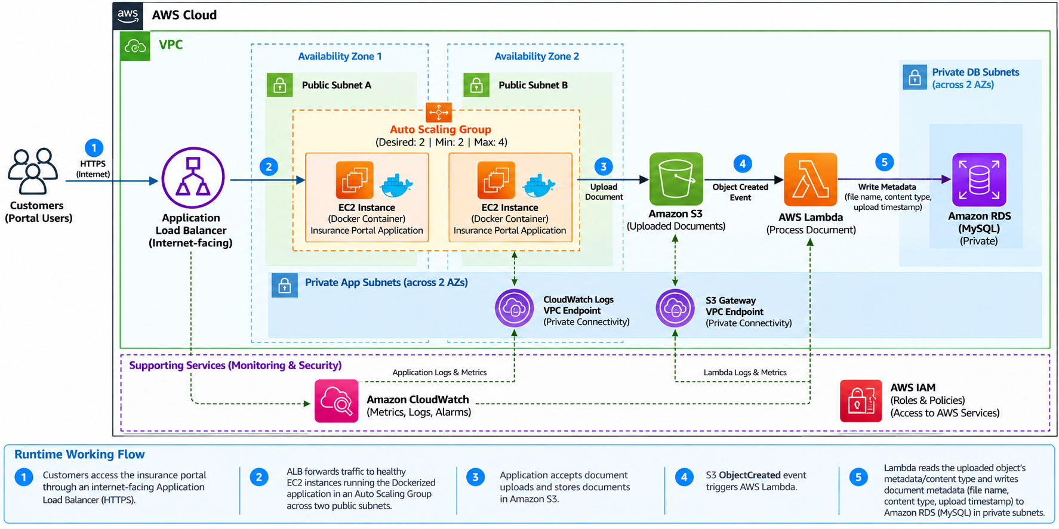
NAT Gateway: conceptual only; not deployed due cost/free-tier constraints.

Component Description
- Amazon Virtual Private Cloud (Amazon VPC) : A logically isolated virtual network containing the application's AWS resources.
Purpose : Provides network isolation and separates the public, private application, and private database tiers. 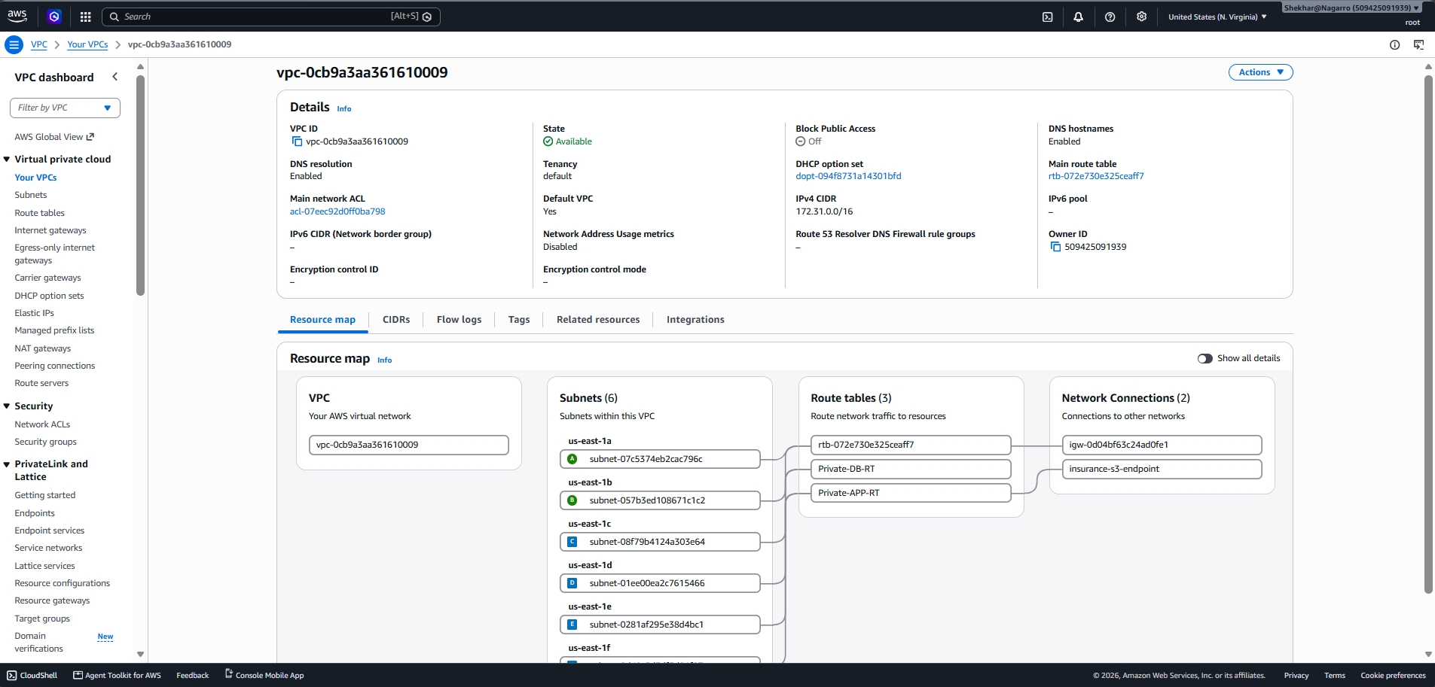
- Amazon VPC Subnets : Provides network segments within the VPC for organizing resources according to their network access requirements.
Purpose : Separates public-facing resources from private application and database resources and provides network connectivity across multiple Availability Zones.
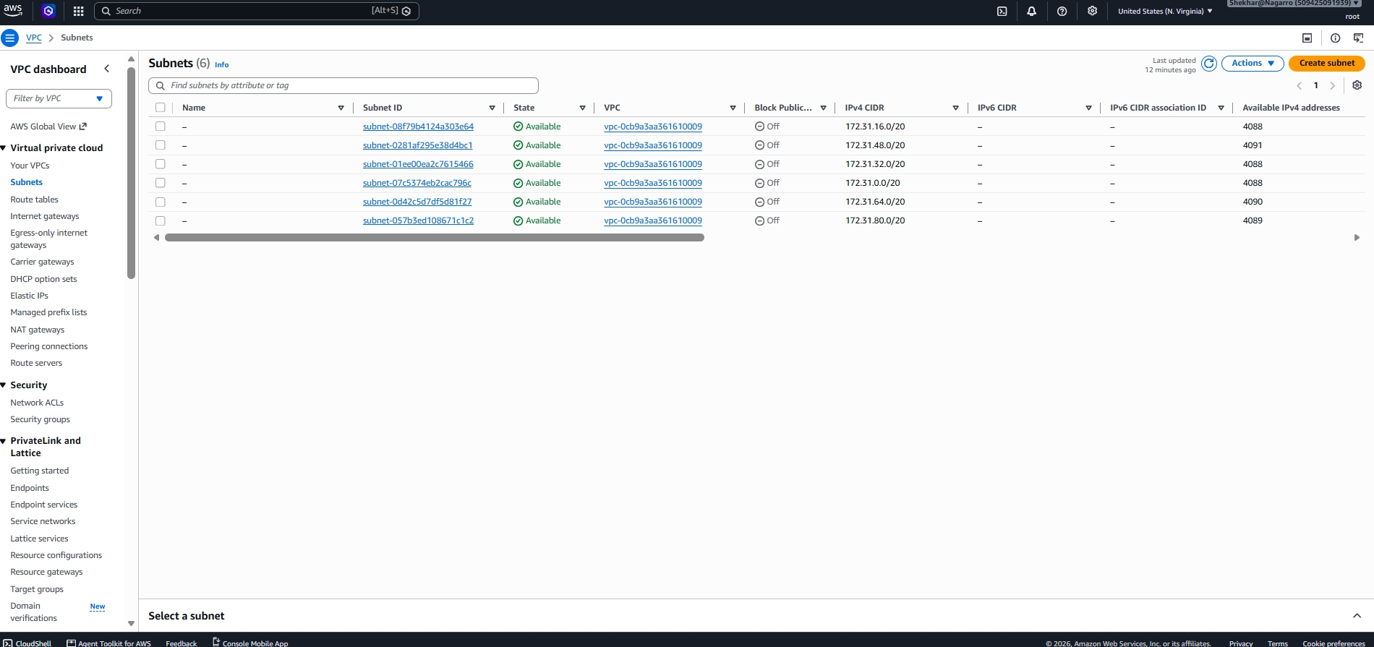
- Application Load Balancer (ALB) : A managed Layer 7 load balancer that distributes incoming HTTP application traffic across healthy targets.
Purpose : Provides a single entry point for users and distributes application traffic across the EC2 instances in the Auto Scaling Group.
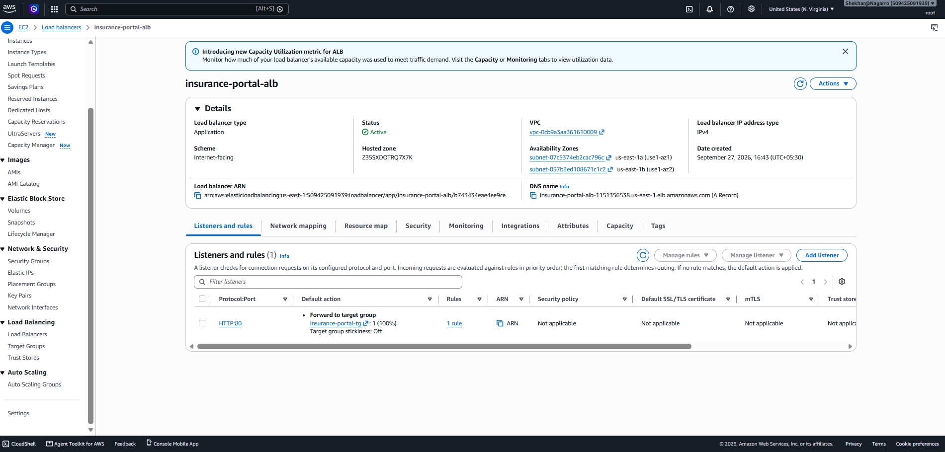
- Amazon EC2 Auto Scaling : A service that automatically manages a group of EC2 instances according to defined capacity and scaling requirements.
Purpose : Maintains application capacity, replaces unhealthy instances, and supports scaling across multiple Availability Zones.
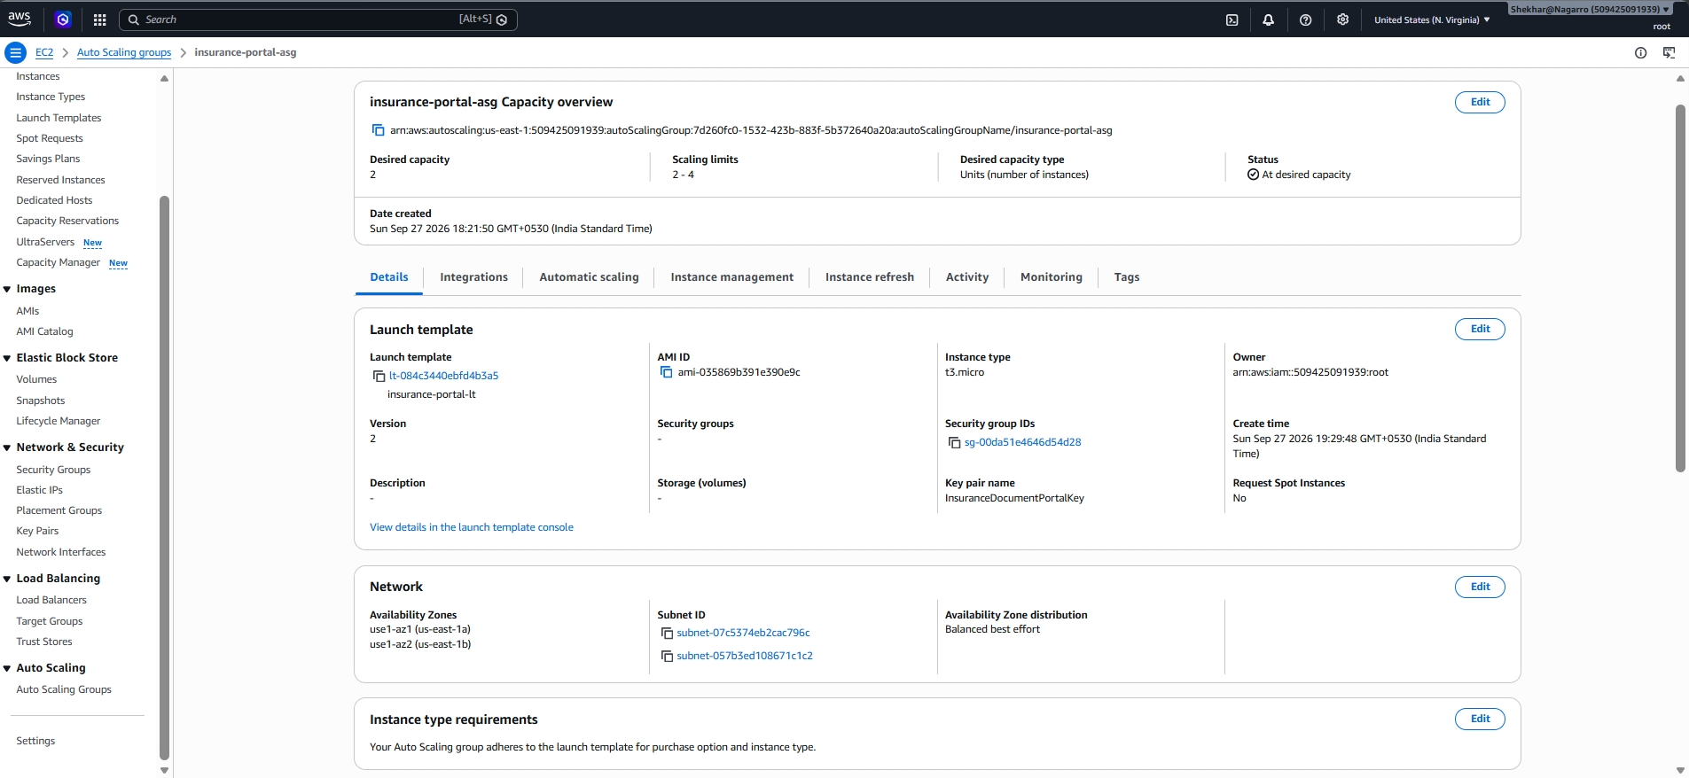
- Amazon Elastic Compute Cloud (Amazon EC2) : Provides virtual compute instances on which the containerized ASP.NET Core insurance application runs using Docker.
Purpose : Hosts and executes the insurance portal application and provides the compute capacity required to serve customer requests.
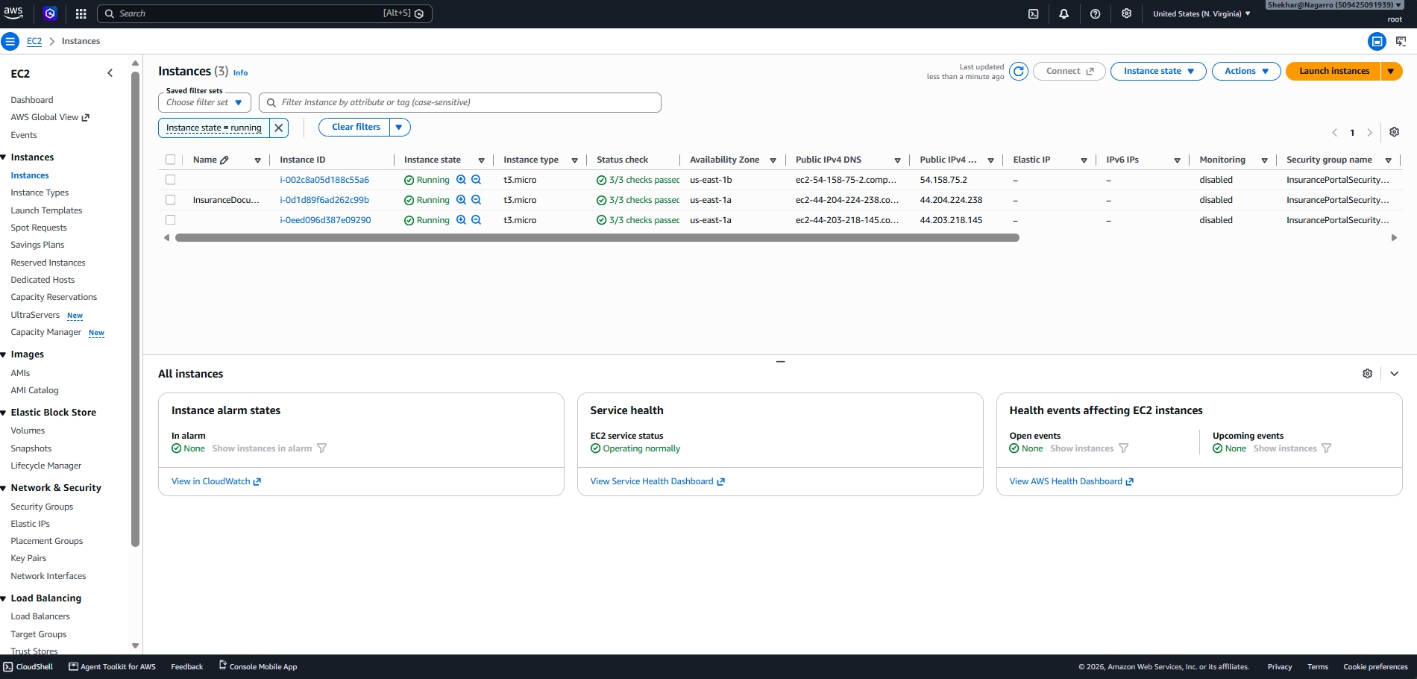
- Amazon Simple Storage Service (Amazon S3) : An object storage service used to store documents uploaded through the insurance portal.
Purpose : Provides durable and scalable storage for customer documents and generates an event when a new document is uploaded.
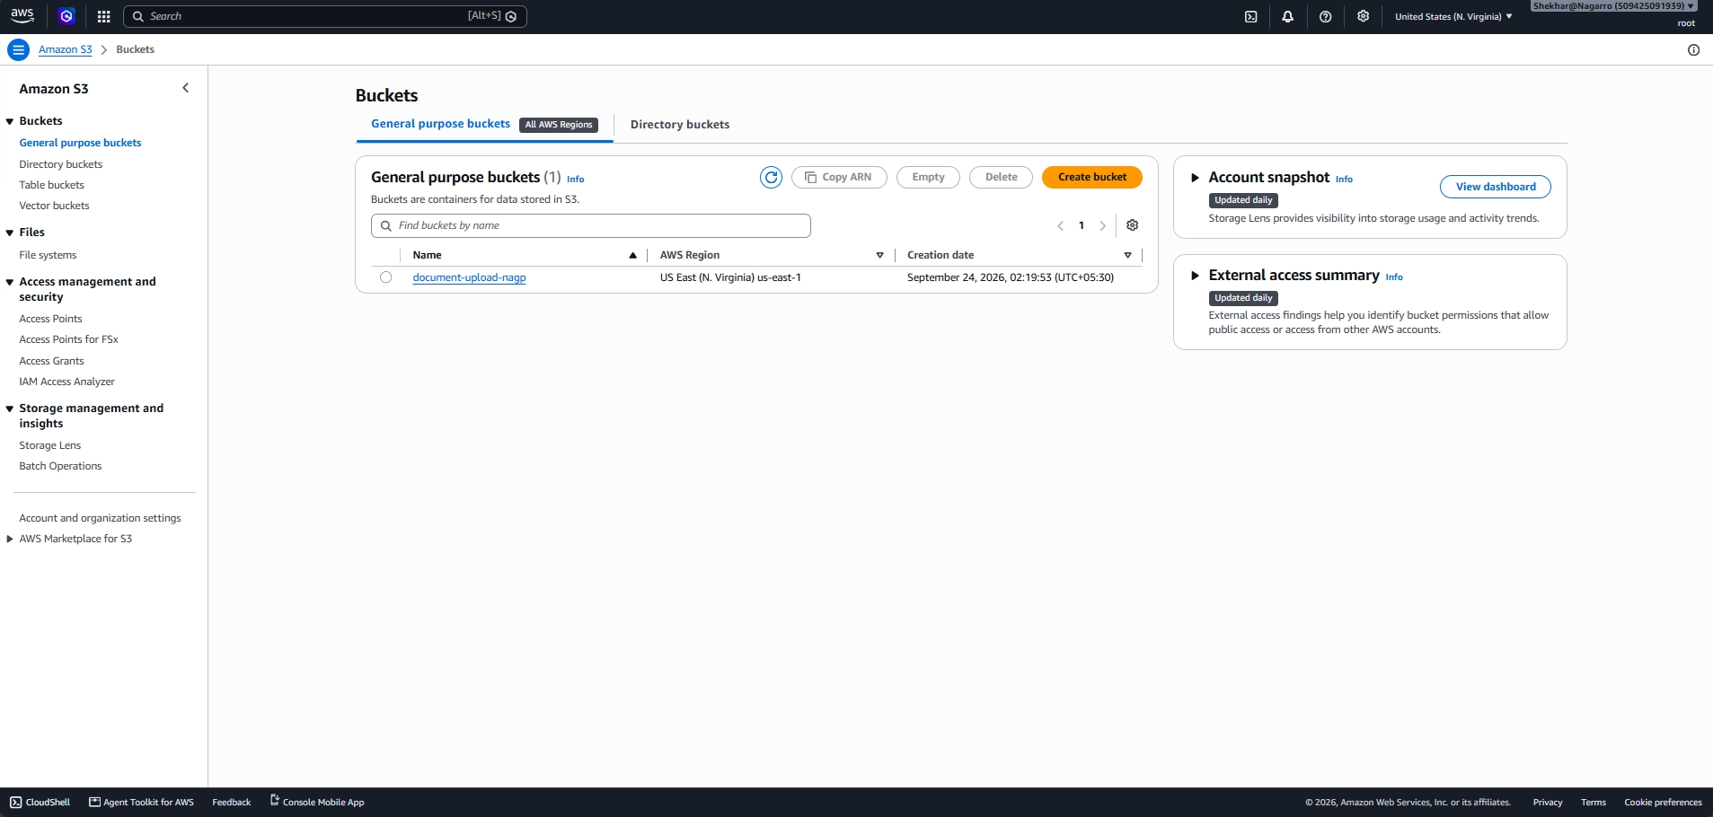
- AWS Lambda : A serverless compute service that executes the document-processing function in response to an Amazon S3 object creation event.
Purpose : Processes uploaded documents, retrieves their metadata and content type, and stores the required document information in Amazon RDS.
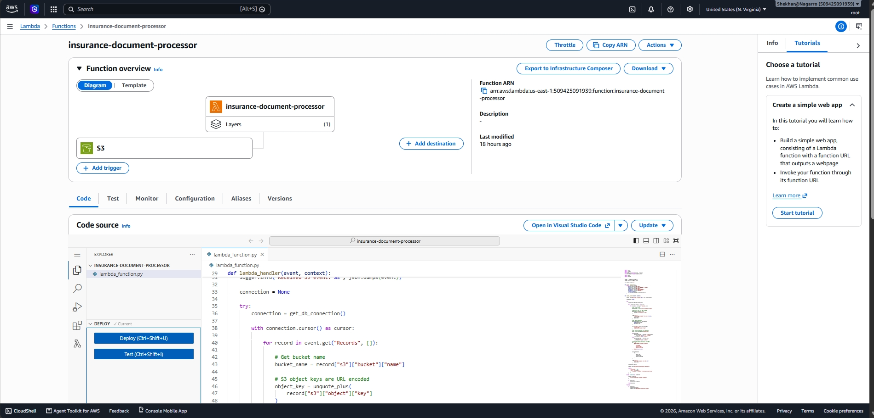
- Amazon Relational Database Service (Amazon RDS) for MySQL : A managed relational database service running MySQL for storing application data.
Purpose : Stores uploaded-document metadata such as file name, content type, and upload timestamp while keeping the database in a private network.
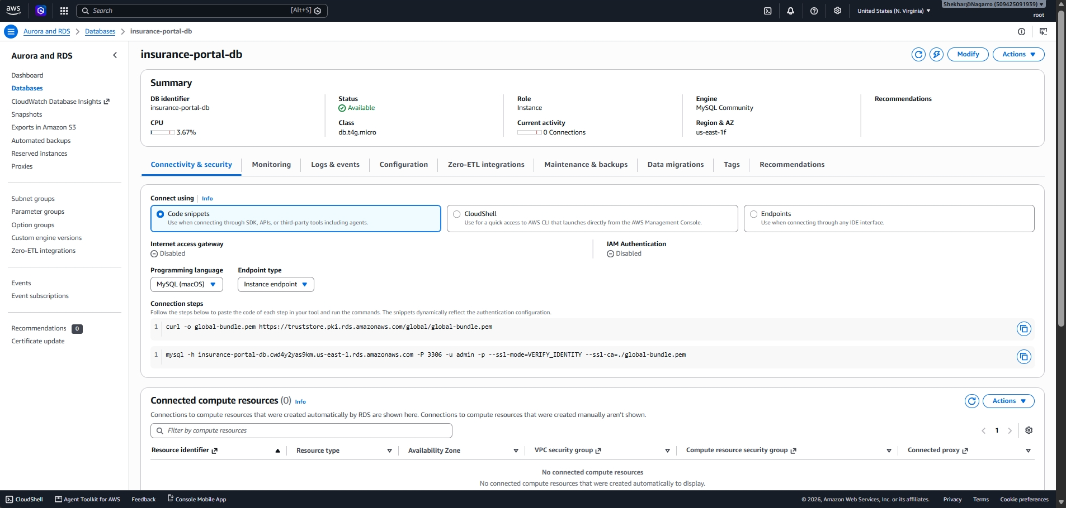
- Amazon Elastic Container Registry (Amazon ECR) : A managed private container registry used to store Docker container images.
Purpose : Provides the Docker image required by the EC2 instances to run the insurance portal application.
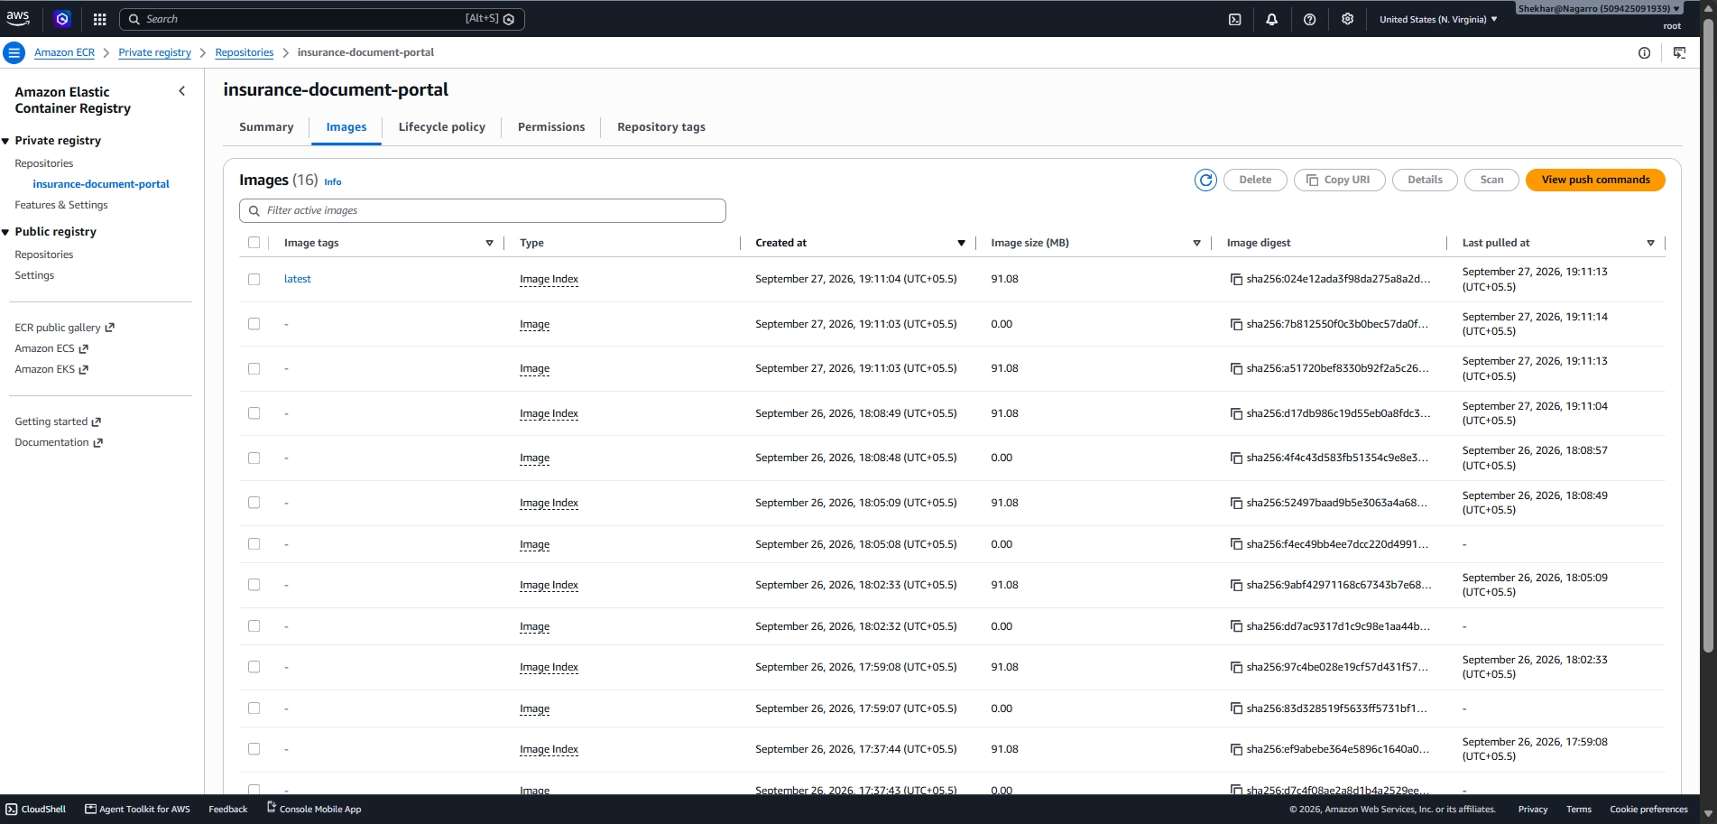
- AWS Identity and Access Management (AWS IAM) : A service used to manage identities, roles, and permissions for accessing AWS resources.
Purpose : Provides secure, role-based and least-privilege access to AWS services without requiring long-term access keys on EC2 instances.
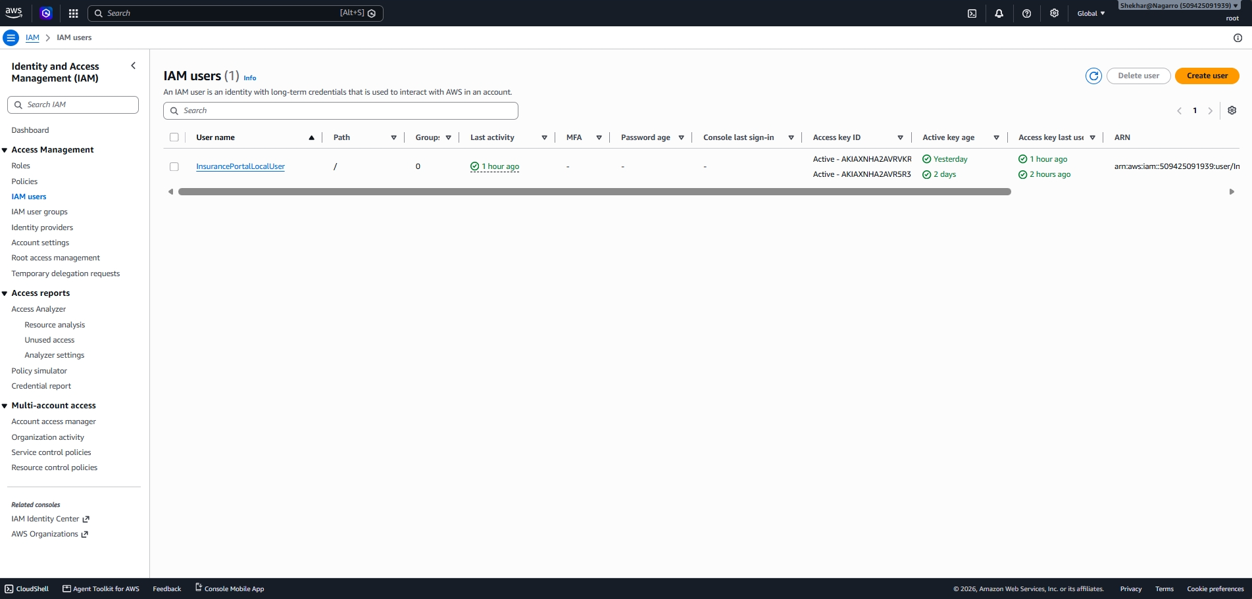
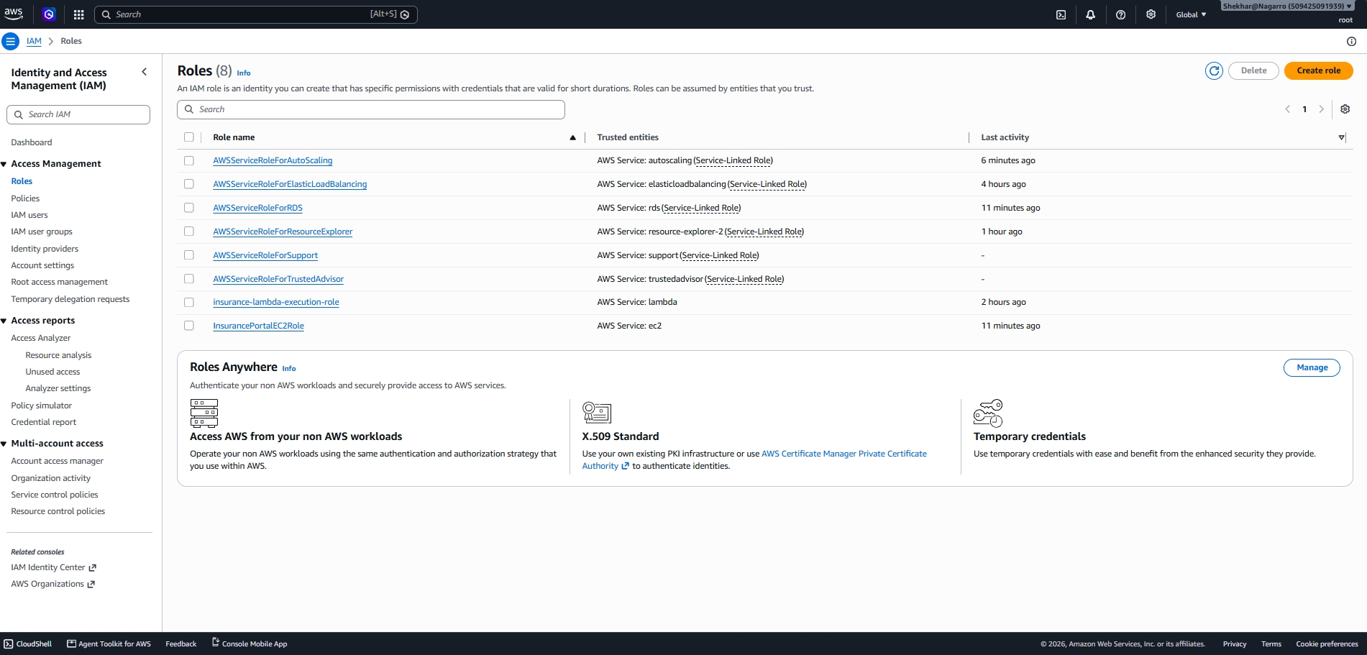
- Amazon CloudWatch : An AWS monitoring and observability service that collects logs, metrics, and monitoring information.
Purpose : Provides visibility into application and infrastructure activity and helps with monitoring, troubleshooting, and operational analysis.
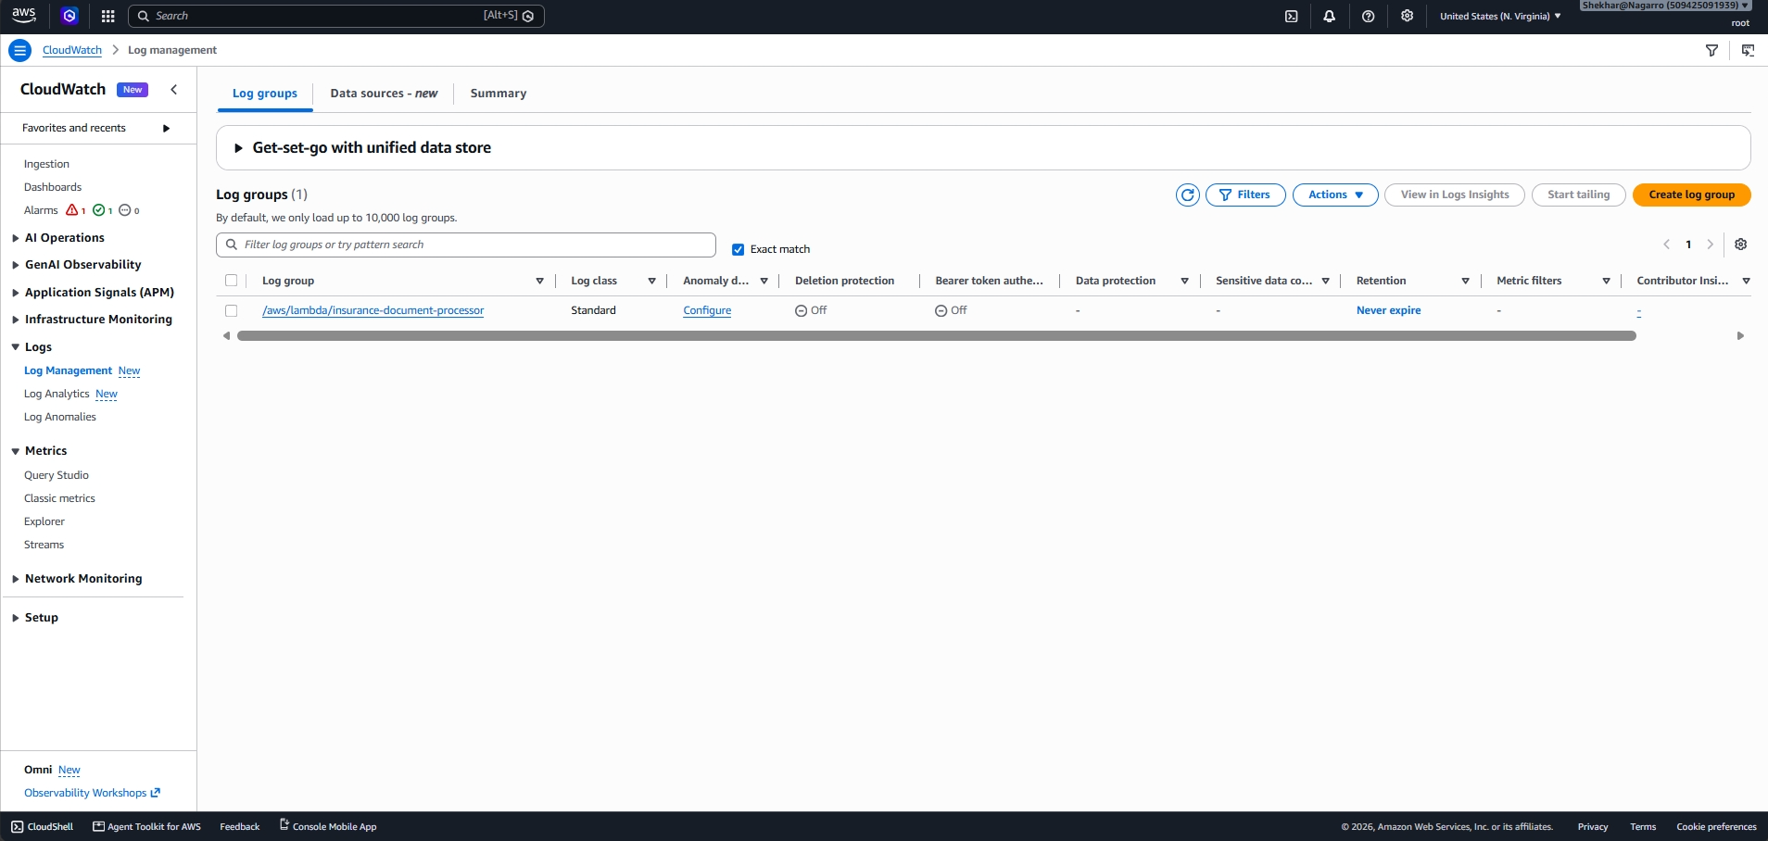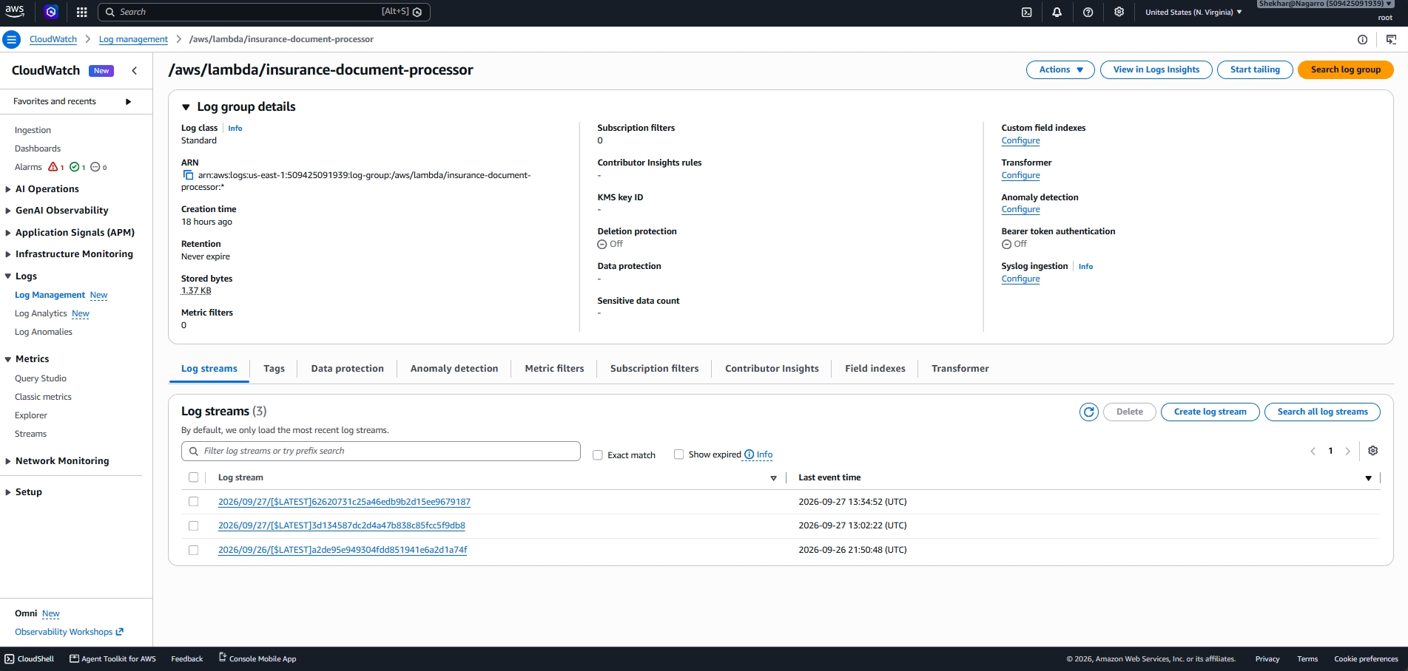
- Amazon VPC Endpoints : Provides private connectivity between resources in the VPC and supported AWS services without requiring communication through the public internet.
Purpose : Enables private connectivity to Amazon S3 and Amazon CloudWatch Logs from private subnets without requiring a NAT Gateway for these services.
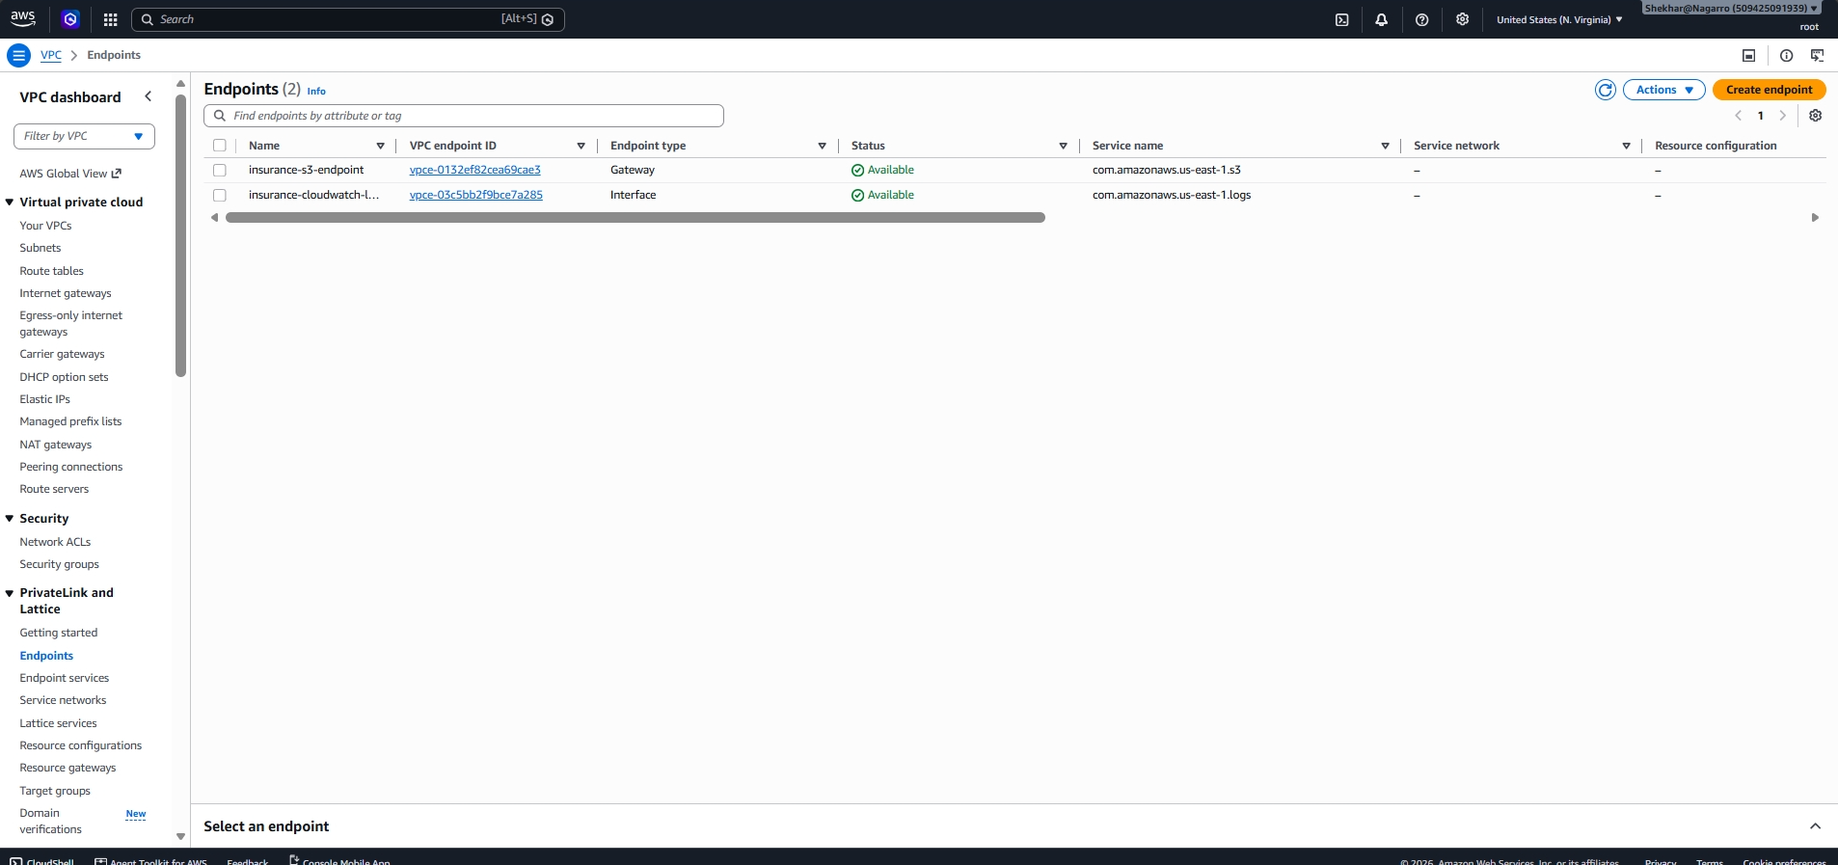

End-to-End Request and Document Processing Flow
- Customer: The customer accesses the insurance portal through the internet-facing Application Load Balancer.
- ALB: The ALB forwards the request to a healthy EC2 instance in the Auto Scaling Group.
- Application: The Dockerized ASP.NET Core application accepts the document upload and stores the document in Amazon S3.
- S3 Event: Amazon S3 generates an ObjectCreated event for the newly uploaded document.
- Lambda: The Lambda function reads the object metadata/content type and connects to the private RDS database.
- RDS: Lambda inserts the file name, content type and upload timestamp into the uploaded_documents table.
- CloudWatch: Application/infrastructure logs and metrics are available through CloudWatch for monitoring and troubleshooting.

Security Groups and Network Controls
- ALB Security Group: Inbound TCP 80 from 0.0.0.0/0. Outbound traffic allowed.
- EC2 Security Group: Inbound TCP 80 only from the ALB security group. SSH should be restricted to the administrator's IP when required.
- Lambda Security Group: No inbound rule required. Outbound traffic permits the Lambda function to reach RDS on TCP 3306.
- RDS Security Group: Inbound TCP 3306 only from the Lambda security group. RDS is not publicly accessible.
- IAM: EC2 uses InsurancePortalEC2Role to authenticate to AWS and ECR. Lambda uses its execution role for AWS service access.

