---------------------------------------------------DEVOPS .NET Assignment-------------------------------------------------

Q1. GitHub Repo:- <https://github.com/SheharJaiswal/BookReadingEvent.git>

Jenkins Logs:

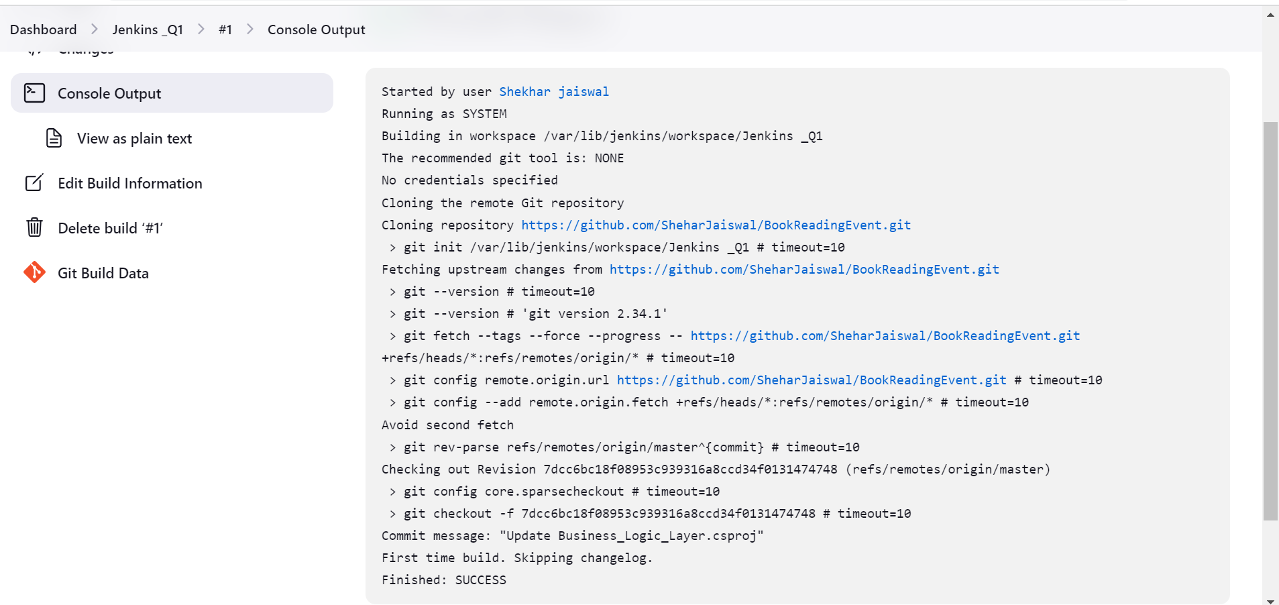

Q2. GitHub Repo:- <https://github.com/SheharJaiswal/BookReadingEvent.git>

Jenkins Logs:

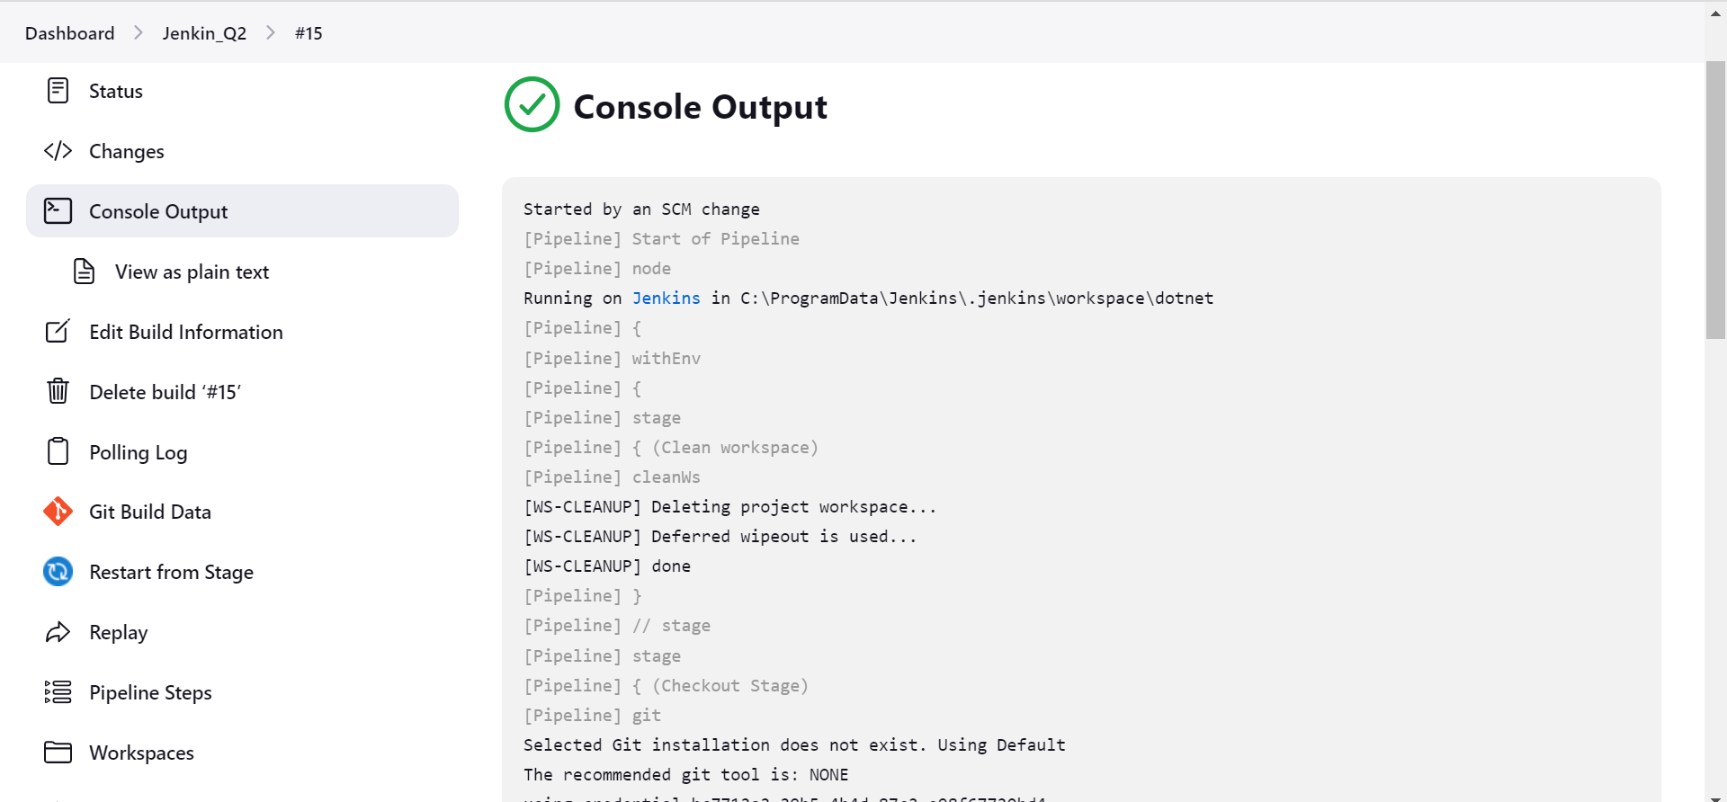

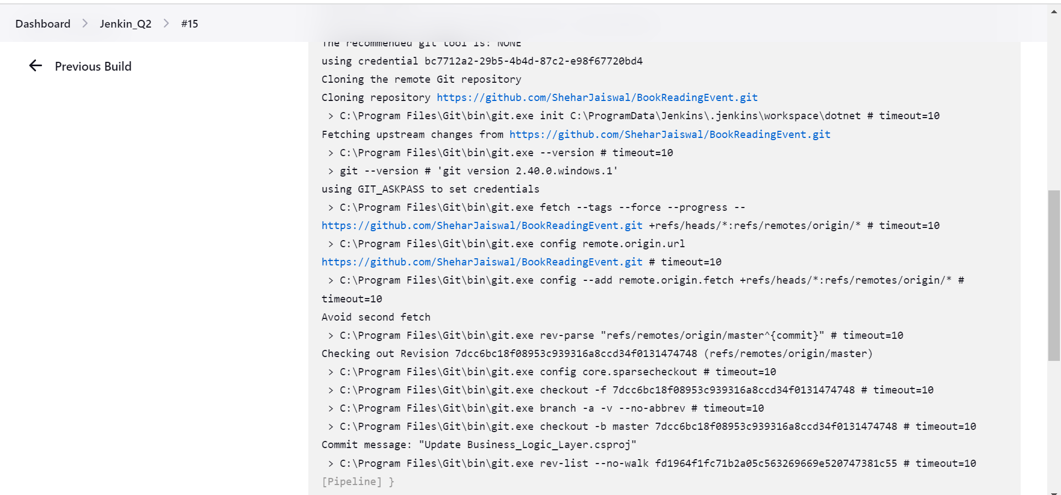

Jenkin File:

Stage View:

Q3. GitHub Repo:- <https://github.com/SheharJaiswal/BookReadingEvent.git>

Jenkins Logs:

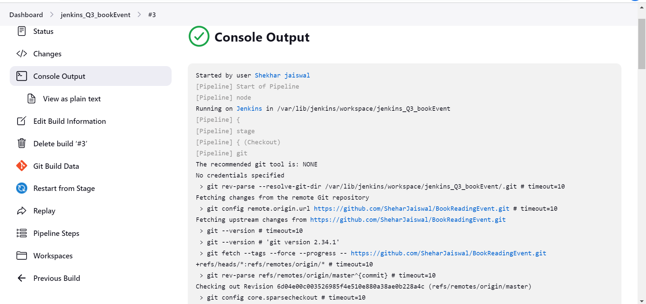

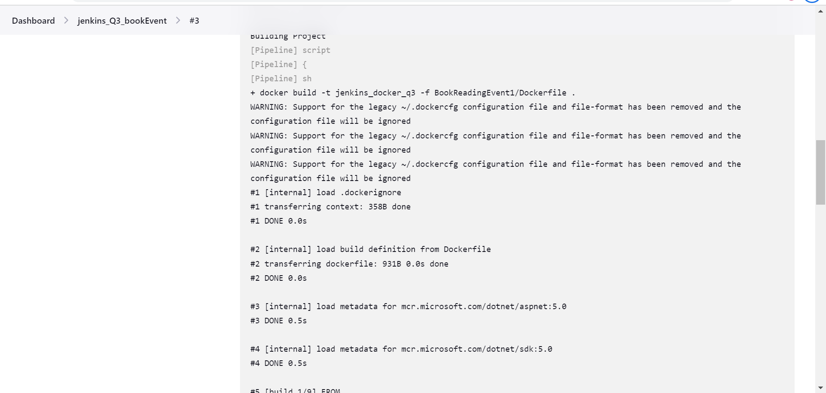

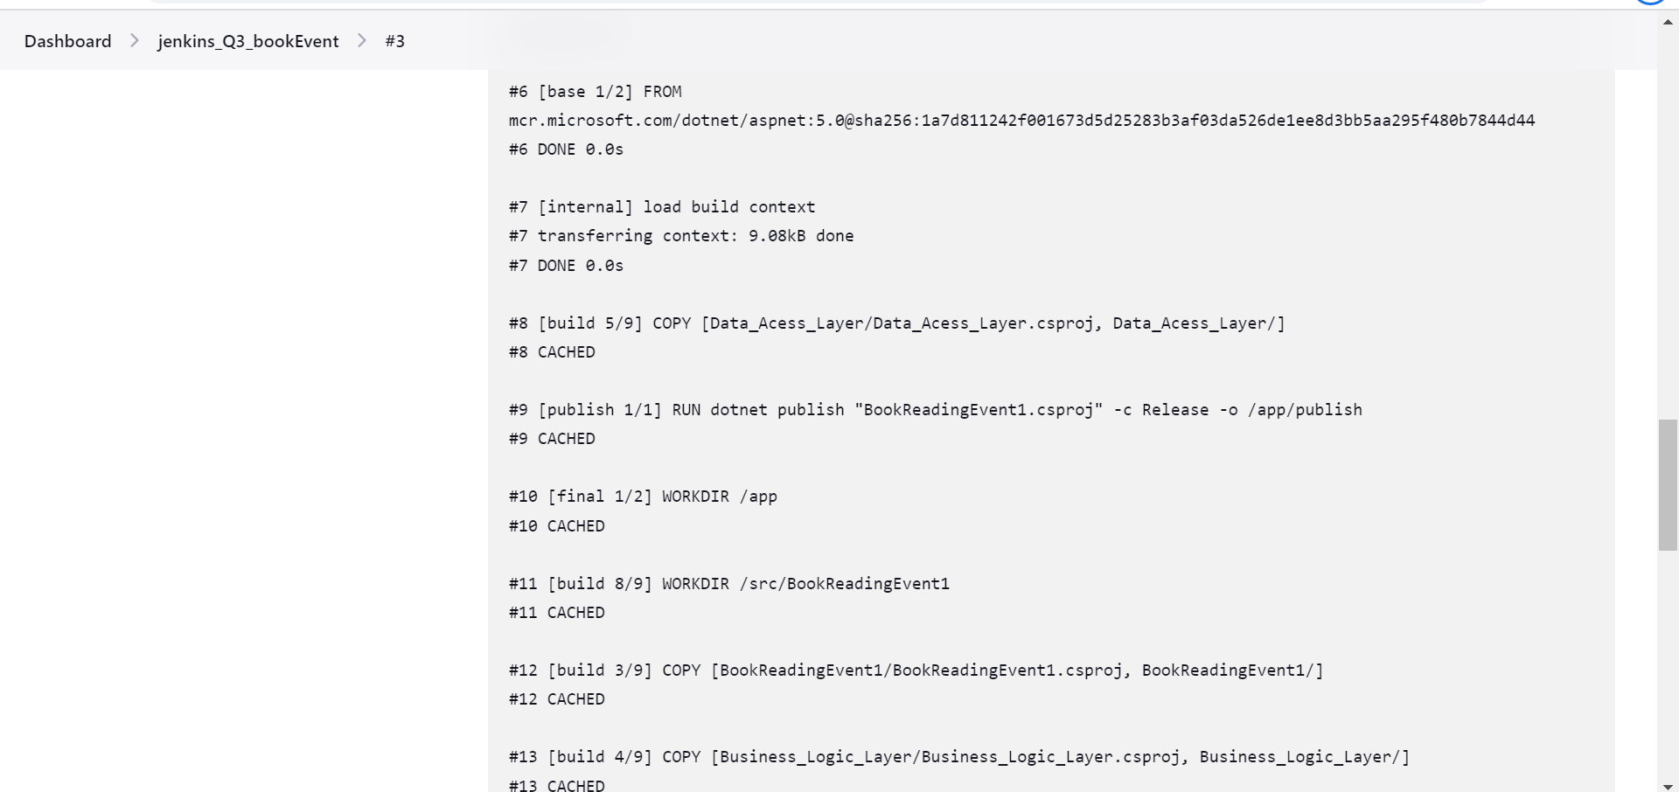

Jenkin file:

Stage View:

