**Crypto Simulator**



**Session 2023 - 2027**

**Submitted by:**

Sheharyar Zahid 2023-CS-30

**Supervised by:**

Prof. Khaldoon Khurshid

**Course:**

Advanced Database

Department of Computer Science

### University of Engineering and Technology Lahore Pakistan

### ****1. Introduction****

**Crypto Simulator** is a mobile app that simulates cryptocurrency trading in a risk-free environment. Users can practice buying and selling top cryptocurrencies using virtual money, understand market trends, and improve their trading strategies — all without spending real money.

### ****2. Features****

• 📊 Real-Time Crypto Prices (e.g., Bitcoin, Ethereum, etc.)

• 💸 Virtual Wallet: Start with 100,000 fake PKR/USDT

• 📈 Buy/Sell Crypto interface with dynamic price changes

• 🔐 User Login/Signup

• 🧾 Transaction History

• 📚 Learning Center: Basic crypto & trading lessons (future upgrade)

### ****3. Technical Specifications****

**3.1 Tech Stack**

• **Frontend**: React Native / Expo (cross-platform)

• **Database**: SQLite

• **APIs**: CoinGecko API (for price data)

**3.2 Database Schema**

• Users

• Wallets

• Cryptocurrencies

• UserHoldings

• Transactions

### ****Wireframes****

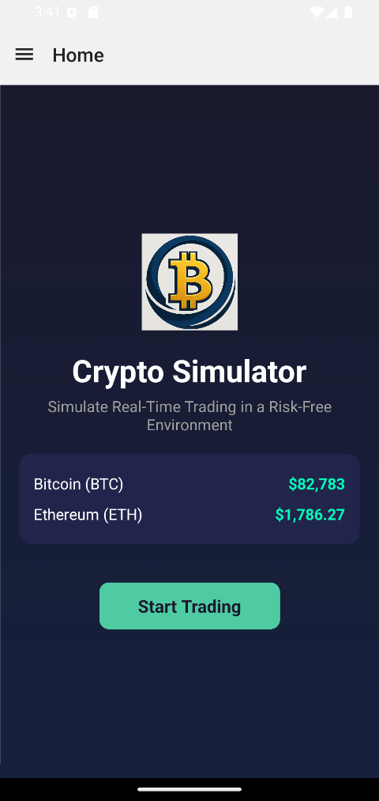

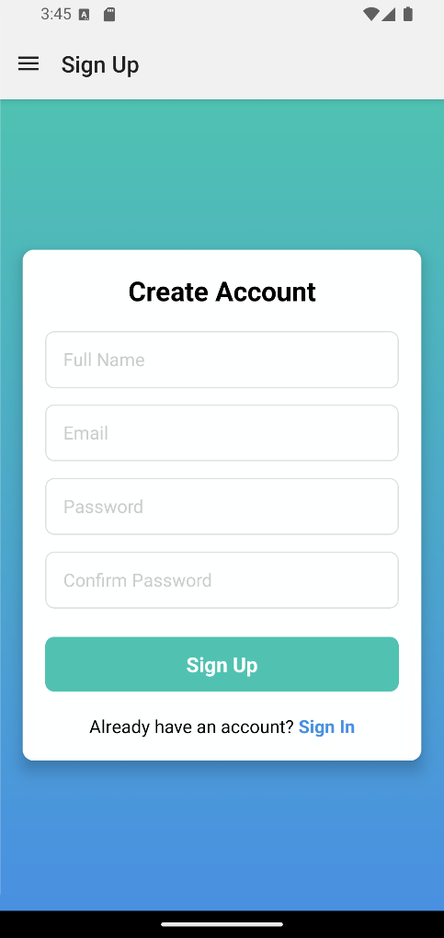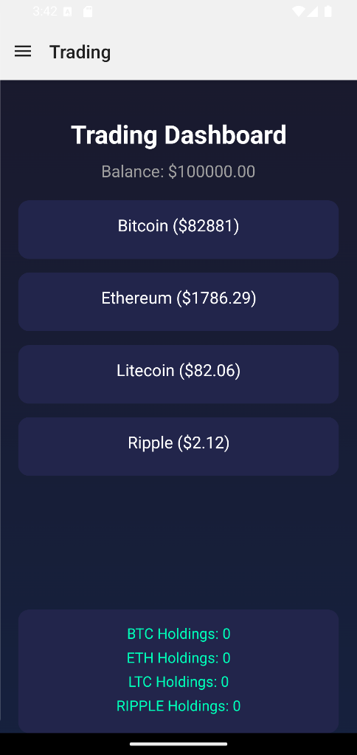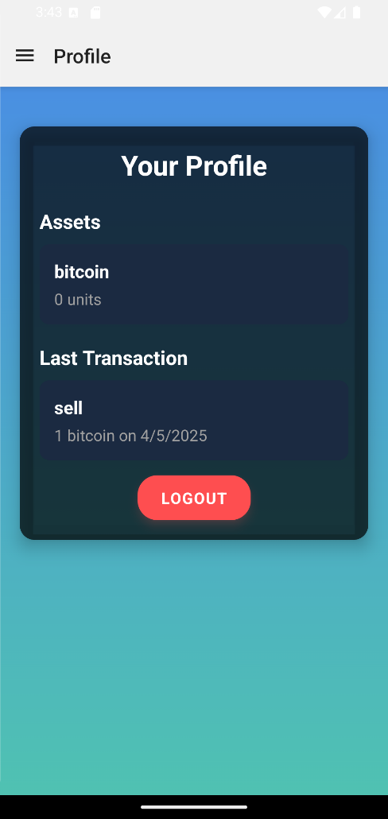

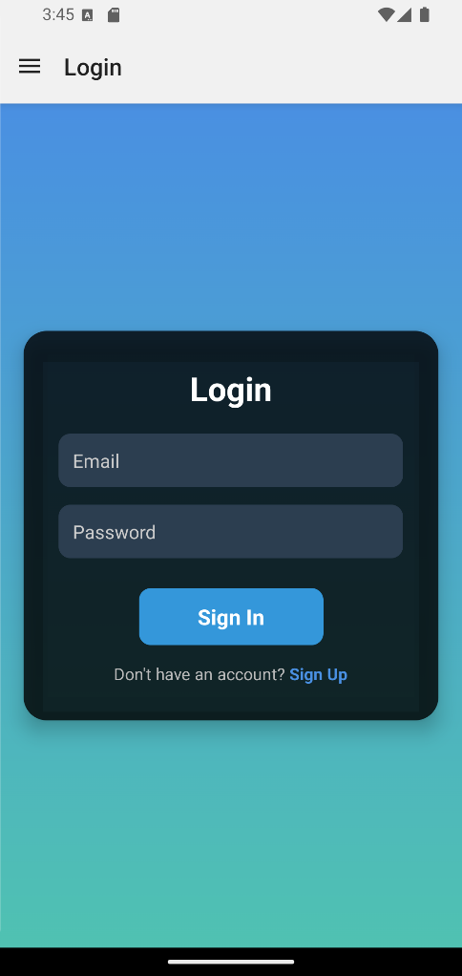

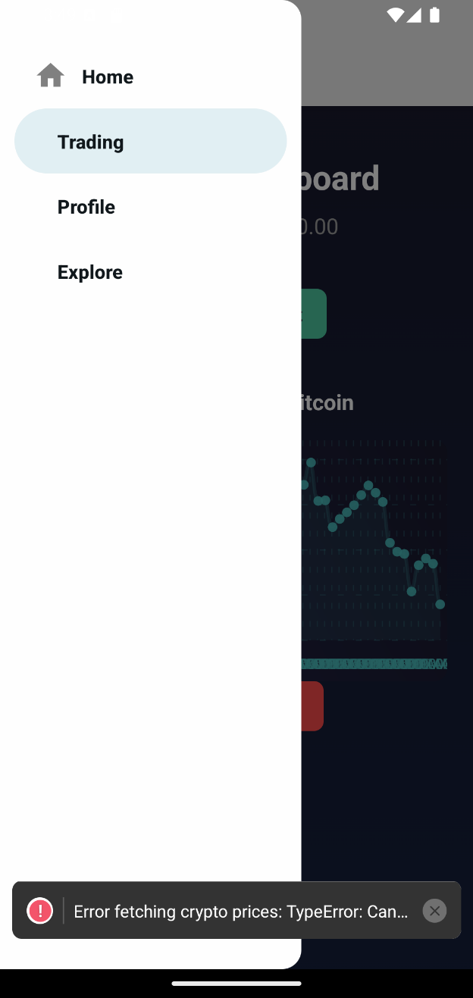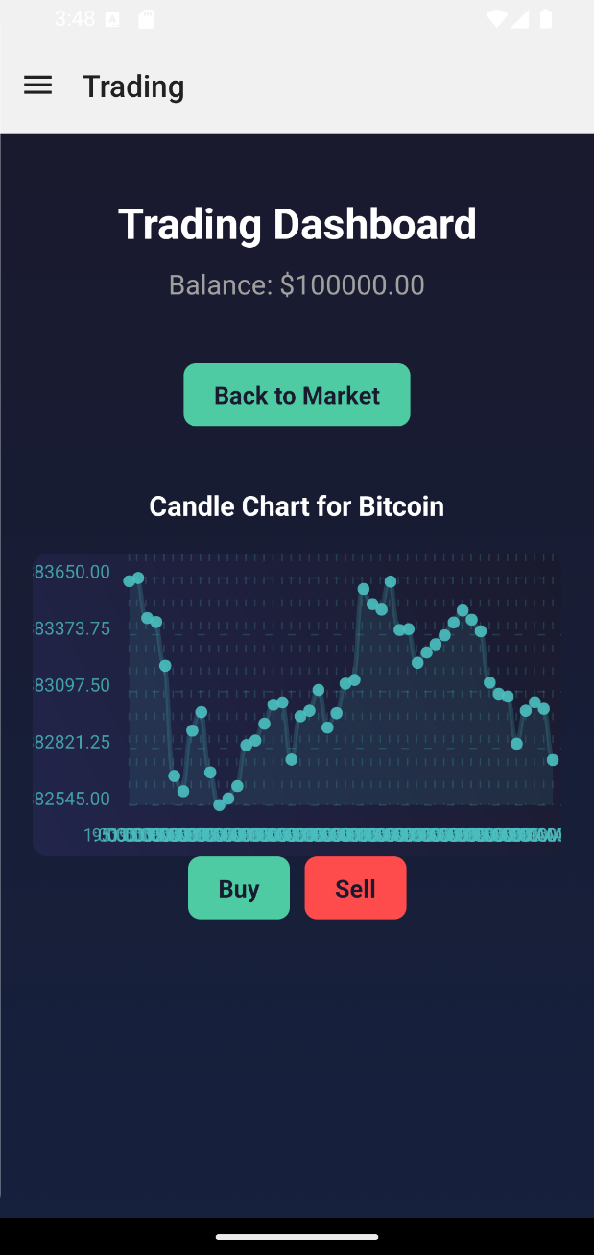

### ****5. Conclusion****

The Crypto Simulator demonstrates the use of **React Native, TypeScript for cross-platform development** and **SQLite for offline data persistence**, making it ideal for educational environments with limited connectivity.

**GitHub Repository:**   
<https://github.com/SheharyarXD/Crypto-Simulator>