Electronic Medical Community
Major Phases:
1.1 Project Manager (PM).
1.2 UI/UX Designer.
1.3 Front-End Developer.
2.1 Back-End Developer.
2.2 Database Engineer (DB).
2.3 Cyber Security Specialist

1.1 Project Manager
1.1.1 Manage plan (create and update WBS and responsibility matrix).
1.1.2 Resource management (ensure the availability of necessary human & technical resources).
1.1.3 Stakeholder management (communicate with doctors and hospitals to understand their integration requirements).
1.1.4 Risk management (Identify potential risks and develop mitigation plans)
1.2 UI/UX Designer
1.2.1 Doctor Dashboard Design (Design a simple and clear dashboard for the doctor, highlighting the Emergency Notification feature clearly and quickly).
1.2.2 Map Design (Design an attractive and effective way to display nearby locations on the map for the patient).
1.2.3 User Flow Design (Design an attractive and effective way to display nearby locations on the map for the patient).
1.3 Front-End Developer
1.3.1 Interface Building (use HTML, CSS, and JavaScript to build the website interface).
1.3.2 Map integration (Integrate ready-made map interfaces (like Google Maps) and display data of nearby hospitals and doctors).
1.3.3 Responsiveness (Ensure the site works perfectly on smartphones and tablets).

2.1 Back-End Developer
2.1.1 Specialization Logic Building (Program the algorithm that analyzes patient answers and determines if their condition falls under a specific specialty).
2.1.2 Emergency System (Develop a rapid notification mechanism from the doctor to the nearest hospital).
2.1.3 Authentication and Security Manage (login and accounts for doctors and patients and ensure data security protocols are followed).
2.2 Database Engineer
2.2.1 Schema Design (Design the necessary tables to store user data, medical question answers, doctor and hospital data, and emergency records).
2.2.2 Performance Optimization (Ensure quick database response time when searching for a nearby doctor or hospital).
2.2.3 Data Security (Apply encryption, backup procedures, and compliance with medical data privacy regulations).
2.3Cyber Security Specialist
3.2.1 Security Compliance Auditing (Review the system design and documentation to ensure compliance with medical data privacy standards).
3.2.2 Data Encryption (Oversee the implementation of encryption techniques for all sensitive data).
3.2.3 Identity and Access Management (IAM) (Establish strict policies for doctor and hospital logins, such as enabling Multi-Factor Authentication (MFA), and defining access privileges for each role).

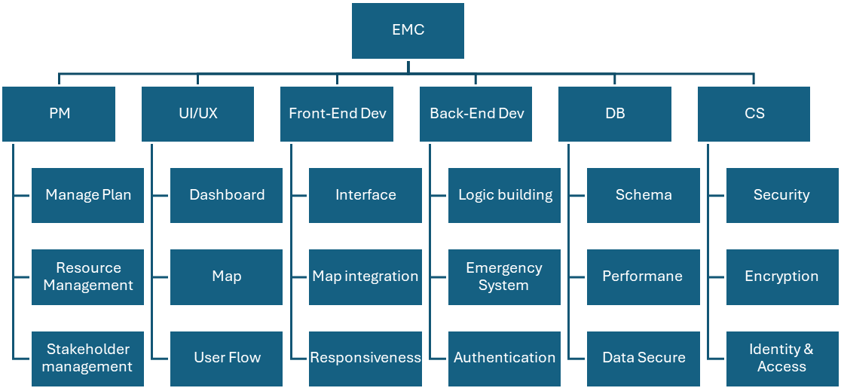

WBS Dictionary
Code Task Description Assigned People Resources Budget Milestone
1.1 Project Manager Hussien Ali 1 9,500 2/10/2025
1.2 UI/UX Designer Bavly Lamey 1 6,500 10/10/2025
1.3 Front-End Dev Mohamed Mortada 2 7,000 20/10/2025
2.1 Back-End Dev Ahmed Mortada 2 8,000 12/10/2025
2.2 Database Engineer Mohamed Salah 1 7,500 8/10/2025
2.3 Cybersecurity Specialist Karim Ashraf 1 10,000 5/11/2025

Responsibility Matrix
Task Name | Hussien  Ali  (PM) | Pavly  Lamey  (UI/UX) | Mohamed Mortada (Frontend) | Ahmed Mortada (Backend) | Mohamed Salah (DB) | Karim Ashraf (CS)
Manage Plan &WBS | R | - | - | - | - | -
Resource Management | R | - | - | - | - | -
Stakeholder Management | R | - | - | - | - | -
Risk Management | R | - | - | S | - | S
Doctor Dashboard | - | R | S | - | - | -
Map Design | - | R | S | - | - | -
User Flow Design | - | R | S | S | - | -
Interface Building | - | S | R | - | - | -
Map Integration | - | S | R | S | - | -
Responsiveness | - | S | R | - | - | -
Specialization Logic Algorithm | - | - | S | R | S | -
Emergency System | - | - | S | R | S | -
Authentication | - | - | S | R | S | S
DB schema | - | - | - | S | R | -
Performance | - | - | - | S | R | -
Backup | - | - | - | S | R | S
Security | - | - | - | S | S | R
Encryption | - | - | - | S | S | R
IAM & Access | - | - | - | S | - | R

