[root@elk-stack ~]# grep -ni path.repo /etc/elasticsearch/elasticsearch.yml

39:path.repo: ["/var/lib/elasticsearch/my_fs_backup"]

[root@elk-stack ~]#

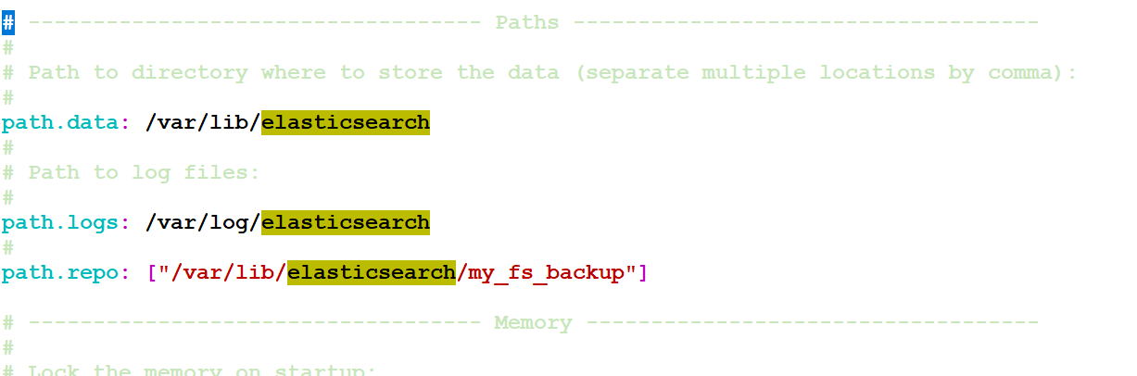

<http://localhost:5601/app/kibana#/management/elasticsearch/snapshot_restore/snapshots>

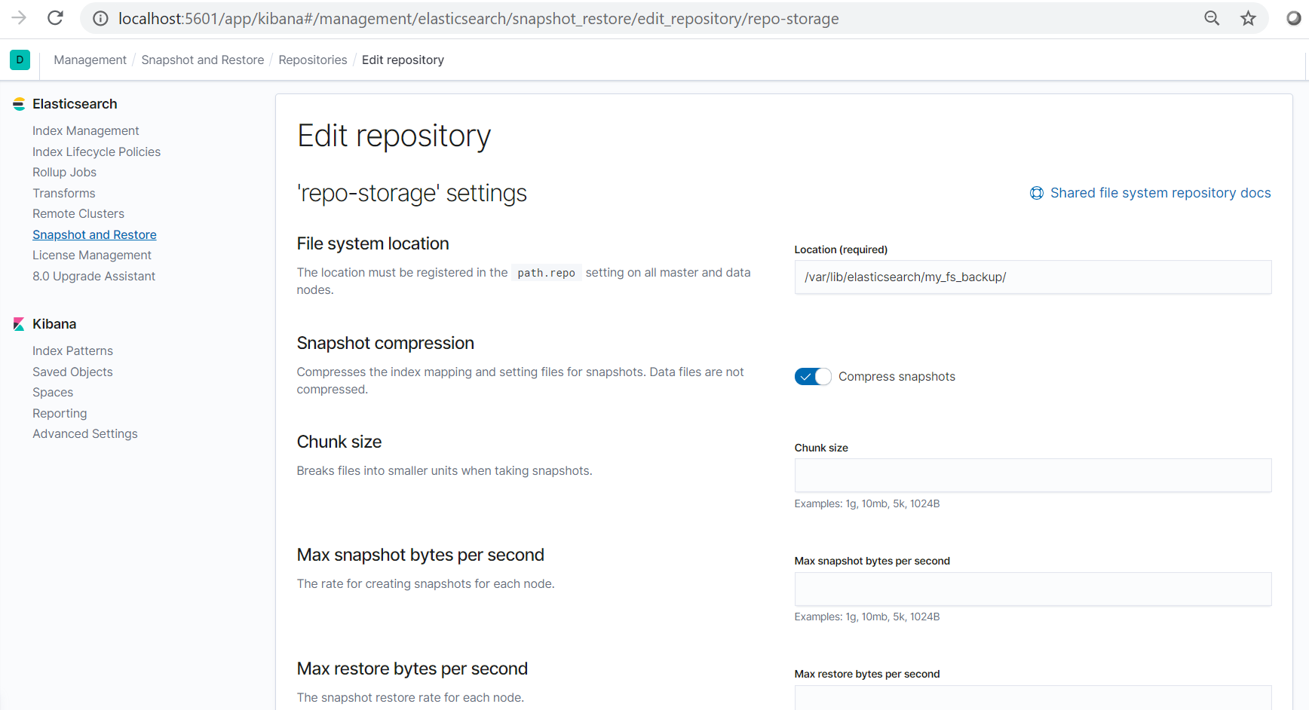

Create a Policy:

