SMART PARKING PLATFORM
Stakeholder Analysis
Power–Interest Grid
Prepared by: WE ARE $oftware ¢orp.
Muhammad Murtaza
CIS 4374 19148
October 29, 2026
Document Status: DRAFT — Living document, updated weekly through end of semester

11. Stakeholder Analysis
The seven stakeholder groups from the project brief were rated from 1 to 10 for power (influence over the project's success) and interest (how much they care about the outcome), then placed on a Power–Interest Grid. The ratings are planning assumptions.

11.1 Power–Interest Grid
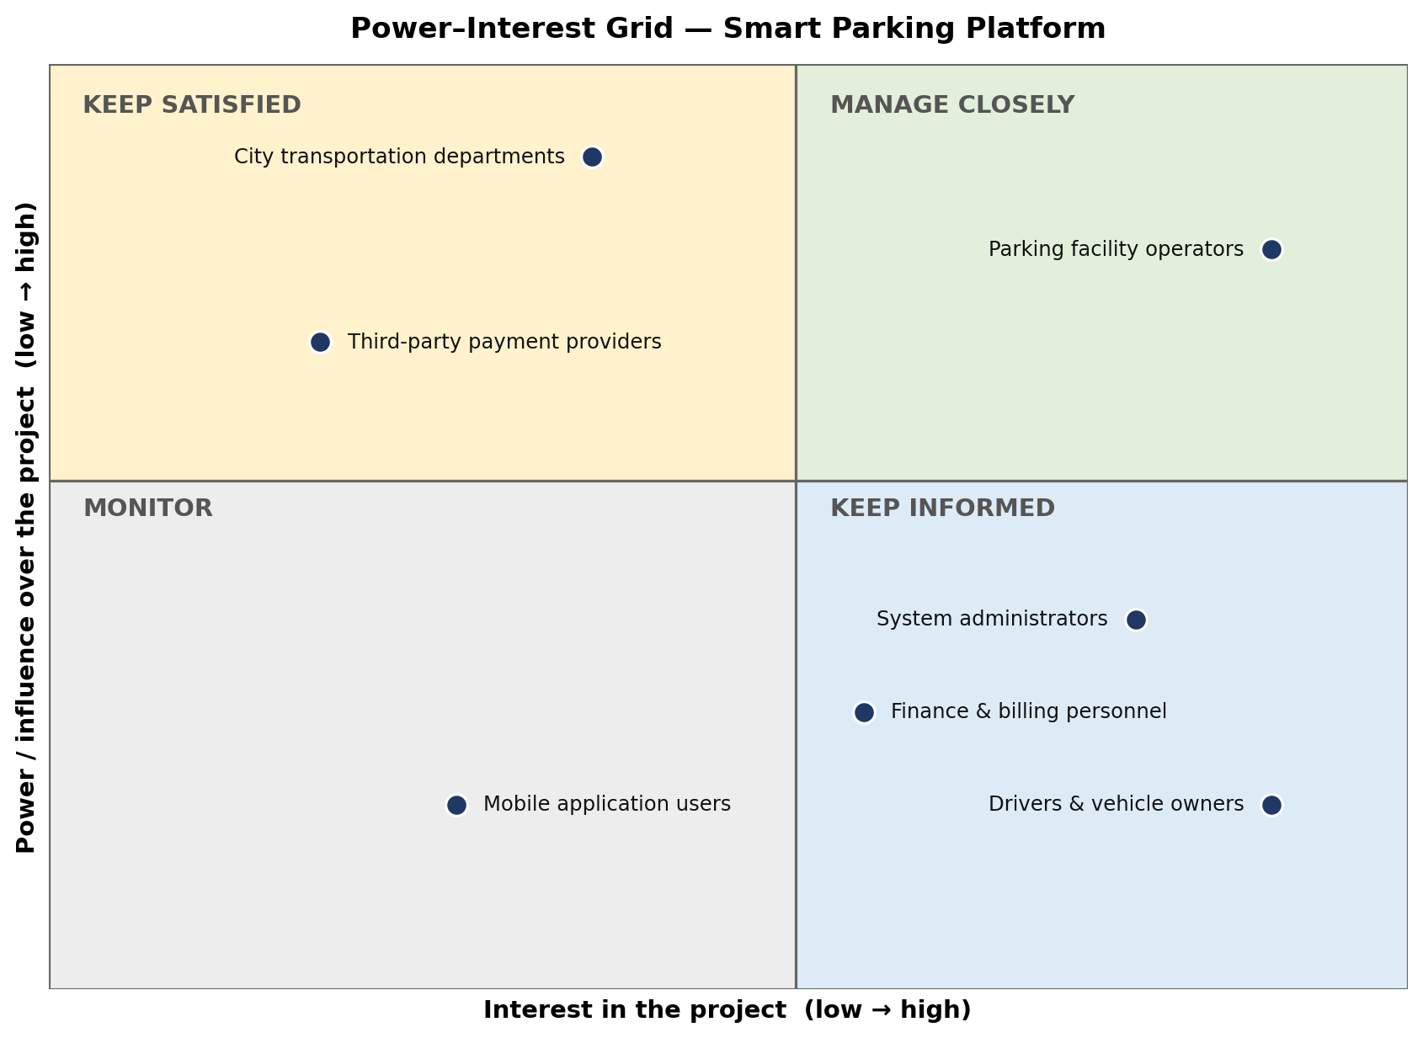
Figure 1: Power–Interest Grid. High power and high interest means Manage Closely; high power and low interest means Keep Satisfied; low power and high interest means Keep Informed; low power and low interest means Monitor.

11.2 Stakeholder Ratings and Engagement Strategy
Stakeholder | Power | Interest | Quadrant | Engagement Strategy
Parking facility operators | 8 | 9 | Manage Closely | Weekly check-ins; include in requirements reviews, dashboard demos, and UAT.
City transportation departments | 9 | 4 | Keep Satisfied | Confirm ordinance and compliance requirements before design sign-off; share milestone summaries.
Third-party payment providers | 7 | 2 | Keep Satisfied | Secure sandbox access early; track API change notices; keep a named technical contact.
System administrators | 4 | 8 | Keep Informed | Share release notes; demo the admin console and gather feedback on roles and permissions.
Finance & billing personnel | 3 | 6 | Keep Informed | Review refund and report formats; send updates at payment and reporting milestones.
Drivers & vehicle owners | 2 | 9 | Keep Informed | Release notes and in-app notifications; short usability tests and feedback surveys.
Mobile application users | 2 | 3 | Monitor | Monitor app-store reviews and usage data; no dedicated meetings.
Table 1: Stakeholder ratings, grid quadrant, and engagement strategy.

