

DESIGN AND IMPLEMENTATION OF A WEB-BASED SIWES PLACEMENT AND MONITORING SYSTEM

(A Case Study of Federal University of Technology, Babura)

BY

ABDURRAZAK MUKTAR

SIT/CSC/23/0038

A PROJECT SUBMITTED TO THE DEPARTMENT OF COMPUTER SCIENCE,
FEDERAL UNIVERSITY OF TECHNOLOGY, BABURA,
IN PARTIAL FULFILLMENT OF THE REQUIREMENTS FOR THE AWARD OF
BACHELOR OF SCIENCE (B.Sc.) DEGREE IN COMPUTER SCIENCE

MARCH, 2026
CERTIFICATION

This is to certify that this project titled:
“Design and Implementation of a Web-Based SIWES Placement and Monitoring System (A Case Study of Federal University of Technology, Babura)”
Was carried out by ABDURRAZAK MUKTAR (SIT/CSC/23/0038) of the Department of Computer Science, Federal University of Technology, Babura, under my supervision and has been approved for submission in partial fulfillment of the requirements for the award of Bachelor of Science (B.Sc.) Degree in Computer Science.

MR SHAFIU MUHAMMAD BELLO
(Project Supervisor)
____________________
Sign/Date

Head of Department
Department of Computer Science
____________________
Sign/Date

APPROVAL PAGE

This project titled:
“Design and Implementation of a Web-Based SIWES Placement and Monitoring System (A Case Study of Federal University of Technology, Babura)”
has been read and approved as meeting the requirements for the award of Bachelor of Science (B.Sc.) Degree in Computer Science, Department of Computer Science, Federal University of Technology, Babura.

MR SHAFIU MUHAMMAD BELLO
Project Supervisor
Signature: ___________________
Date: _______________________

Head of Department
Department of Computer Science
Signature: ___________________
Date: _______________________

External Examiner
Signature: ___________________
Date: _______________________

DEDICATION

This project is dedicated to Almighty Allah for His guidance, protection, and strength throughout my academic journey.
I also dedicate this work to my beloved parents and family for their prayers, support, encouragement, and sacrifices towards my education.

ACKNOWLEDGEMENT

All praise is due to Almighty Allah for granting me the knowledge, wisdom, and strength to successfully complete this project.

My sincere appreciation goes to my project supervisor, MR SHAFIU MUHAMMAD BELLO, for his guidance, constructive criticism, patience, and support throughout the period of this research work.

I also appreciate the Head of Department and all lecturers of the Department of Computer Science, Federal University of Technology, Babura, for their contributions to my academic success.

Finally, I thank my parents, friends, and colleagues for their encouragement, prayers, and moral support.

I would like to express my sincere gratitude to my project supervisor for their guidance, support, and valuable advice throughout the course of this work.

ABSTRACT

The Students Industrial Work Experience Scheme (SIWES) is an essential program designed to expose students to practical industrial experience. However, the traditional method of SIWES placement and monitoring in many institutions is manual, time-consuming, and inefficient.

This project focuses on the design and implementation of a web-based SIWES placement and monitoring system for Federal University of Technology, Babura. The system is developed to automate student registration, organization allocation, supervisor assignment, and performance monitoring
.
The proposed system improves efficiency, reduces paperwork, enhances communication between students and supervisors, and ensures proper documentation of SIWES activities. The system was developed using modern web technologies and a database management system to ensure reliability and security.

The implementation of this system will significantly improve SIWES management within the institution.

TABLE OF CONTENTS

CHAPTER ONE: INTRODUCTION
1.1 Background of the Study
1.2 Statement of the Problem
1.3 Aim of the Study
1.4 Objectives of the Study
1.5 Significance of the Study
1.5.1 Students
1.5.2 Supervisors
1.5.3 Coordinators
1.5.4 The University
1.6 Scope of the Study
1.7 Limitations of the Study
1.8 Definition of Terms
1.9 Organization of the Study

CHAPTER TWO: LITERATURE REVIEW
2.1 Introduction
2.2 Overview of SIWES
2.3 Manual Internship Management Systems
2.4 Web-Based Management Systems
2.5 Review of Related Works
2.6 Summary of Literature Review

CHAPTER THREE: SYSTEM ANALYSIS AND DESIGN
3.1 Analysis of the Existing System
3.2 Proposed System
3.3 System Architecture
3.4 System Modules
3.4.1 Student Module
3.4.2 Supervisor Module
3.4.3 Admin Module
3.5 Database Design

CHAPTER ONE

INTRODUCTION

1.1 Background of the Study
The Students Industrial Work Experience Scheme (SIWES) is one of the most important academic programmes in Nigerian higher institutions. It was introduced to bridge the gap between theoretical knowledge acquired in classrooms and practical skills required in the workplace. The scheme provides students with the opportunity to gain hands-on experience in industries related to their fields of study before graduation.

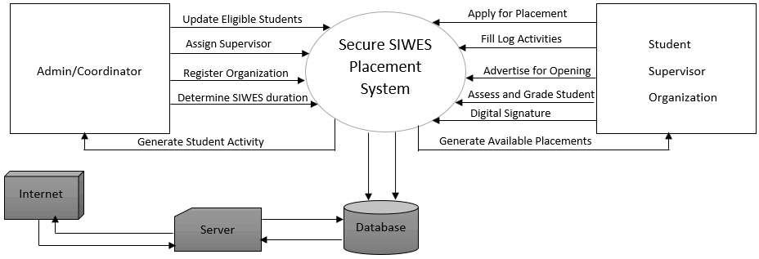

Education is not complete without practical exposure. In many developing countries, including Nigeria, there has been a long-standing concern that graduates possess theoretical knowledge but lack practical competence. This gap often results in unemployment, underemployment, and reduced productivity. SIWES was therefore introduced as a strategic solution to ensure that students are properly prepared for the labour market.
At the Federal University of Technology, Babura, SIWES is a compulsory programme for students in technology, engineering, and science-related courses, including Computer Science. The training usually lasts between three to six months depending on the academic structure of the institution. During this period, students are expected to work in approved organizations where they can apply theoretical knowledge to practical situations.
Despite the importance of SIWES, the management of placement and monitoring in many institutions is still handled manually. Students are required to physically search for organizations, submit printed application letters, collect acceptance letters, and submit logbooks manually. Supervisors also rely on physical visits and paperwork to monitor students.
The manual approach presents numerous challenges. It consumes time, increases administrative workload, and often results in errors or loss of important documents. Communication between students, supervisors, and coordinators is not centralized, which may delay approvals and feedback.
With the advancement of Information and Communication Technology (ICT), web-based systems have become essential tools for managing academic processes. Universities worldwide now use digital platforms for student registration, course management, result processing, and communication. Therefore, integrating technology into SIWES management is a logical and necessary step.
This project focuses on the design and implementation of a web-based SIWES placement and monitoring system for the Federal University of Technology, Babura. The system aims to automate placement processes, improve monitoring efficiency, and enhance record management.

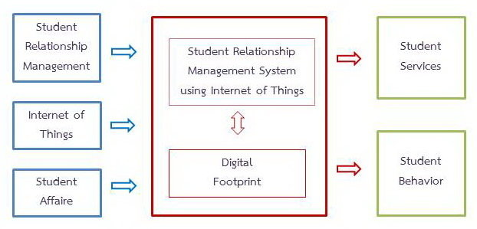

1.2 Statement of the Problem
The current SIWES management process at the Federal University of Technology, Babura faces several challenges that reduce its effectiveness.
Firstly, there is no centralized online platform where students can easily find approved companies for SIWES placement. Students are left to search independently, which may lead to placement in unapproved or irrelevant organizations.
Secondly, manual documentation creates inefficiency. Paper-based records can be misplaced, damaged, or incorrectly filed. This makes tracking student performance difficult.
Thirdly, supervisors face challenges in monitoring students effectively. Due to distance and limited resources, physical visits may not always be possible. As a result, monitoring may be inconsistent.
Fourthly, communication gaps exist between students, coordinators, and supervisors. Important information such as approval status, report submission, and feedback may be delayed.
Finally, report submission and evaluation are time-consuming processes when handled manually. This may delay grading and final result processing.
These issues highlight the need for a computerized, web-based system that will streamline the entire SIWES placement and monitoring process.
The Students Industrial Work Experience Scheme (SIWES) is an essential program designed to provide students with practical experience in their field of study. It bridges the gap between theoretical knowledge gained in the classroom and practical skills needed in the workplace. Despite its importance, the implementation of SIWES faces several challenges that hinder its effectiveness.
Currently, the placement of students into suitable industries and organizations is often done manually or through uncoordinated communication between the university and host organizations. This manual approach leads to numerous problems, including:
Delayed Placement: Students often spend a long time waiting for placement approval, which can disrupt the academic calendar and delay the completion of their industrial training.
Mismanagement of Records: Keeping track of students’ placements, supervisors, and training progress is difficult using paper-based or manual systems. This often results in lost records, incomplete reports, and confusion.
Lack of Transparency: Students and supervisors have limited access to real-time information about placement status, evaluation feedback, and progress reports. This makes monitoring and accountability challenging.
Communication Gaps: Coordinating between students, supervisors, and host organizations relies heavily on phone calls, emails, or manual letters. This slows down decision-making and increases the chance of miscommunication.
Difficulty in Monitoring: Supervisors and university administrators face challenges in monitoring students’ activities during the industrial training period, making it hard to ensure that students gain the intended practical experience.
These challenges collectively affect the efficiency and effectiveness of the SIWES program. Without a proper system to manage placements, monitor student progress, and facilitate communication, both students and the university face unnecessary delays, errors, and administrative burdens.
Therefore, there is a need for a web-based system that can automate the placement process, maintain accurate records, improve transparency, and allow real-time monitoring of students’ industrial training. Such a system would ensure that students gain meaningful practical experience while making the administration of SIWES more efficient and effective.

Monitoring System project:

1.3 Aim of the Study
The aim of this project is to design and implement a reliable and efficient web-based SIWES placement and monitoring system for the Federal University of Technology, Babura.
The main aim of this study is to design and implement a web-based system that automates the placement and monitoring of students under the Students Industrial Work Experience Scheme (SIWES) at the Federal University of Technology, Babura. This system is intended to bridge the gap between manual administrative processes and modern, efficient digital solutions, ensuring that both students and administrators can manage SIWES activities more effectively.
Specifically, the study aims to:
Automate the Placement Process: Develop a system that allows students to apply for industrial training placements online, while enabling administrators to efficiently assign students to suitable organizations based on their fields of study.
Enhance Monitoring and Evaluation: Provide real-time tracking of students’ activities during their industrial training, allowing supervisors and administrators to monitor progress and provide timely feedback.
Improve Record Management: Maintain accurate and organized records of students, host organizations, supervisors, and training activities, reducing the likelihood of lost or incomplete data.
Facilitate Communication: Enable seamless communication between students, university administrators, and industry supervisors through the web-based platform, minimizing delays and misunderstandings.
Ensure Transparency and Accountability: Make the placement and monitoring process more transparent, providing both students and supervisors with access to relevant information, reports, and evaluation results.
Promote Efficiency in Administration: Reduce the time and effort required for manual processes, freeing administrators to focus on improving the overall quality of the SIWES program.
Ultimately, the study seeks to modernize the SIWES program, ensuring that students gain meaningful practical experience in their respective fields while providing a robust digital solution that supports the university in effective management and monitoring of the scheme.

1.4 Objectives of the Study
The objectives of this study are to:
- Develop a secure web platform for SIWES registration.
- Create and maintain a database of approved organizations.
- Allow students to apply for placement online.
- Enable coordinators to approve or reject placement applications.
- Assign supervisors electronically.
- Provide a platform for online submission of weekly reports.
- Facilitate monitoring and evaluation by supervisors.
- Generate performance reports automatically.
- Improve communication among all stakeholders.
- Ensure proper storage and retrieval of SIWES records.

Aim of the Study
The main aim of this study is to design and implement a web-based system that automates the placement and monitoring of students under the Students Industrial Work Experience Scheme (SIWES) at the Federal University of Technology, Babura. This system is intended to bridge the gap between manual administrative processes and modern, efficient digital solutions, ensuring that both students and administrators can manage SIWES activities more effectively.
Specifically, the study aims to:
Automate the Placement Process: Develop a system that allows students to apply for industrial training placements online, while enabling administrators to efficiently assign students to suitable organizations based on their fields of study.
Enhance Monitoring and Evaluation: Provide real-time tracking of students’ activities during their industrial training, allowing supervisors and administrators to monitor progress and provide timely feedback.
Improve Record Management: Maintain accurate and organized records of students, host organizations, supervisors, and training activities, reducing the likelihood of lost or incomplete data.
Facilitate Communication: Enable seamless communication between students, university administrators, and industry supervisors through the web-based platform, minimizing delays and misunderstandings.
Ensure Transparency and Accountability: Make the placement and monitoring process more transparent, providing both students and supervisors with access to relevant information, reports, and evaluation results.
Promote Efficiency in Administration: Reduce the time and effort required for manual processes, freeing administrators to focus on improving the overall quality of the SIWES program.
Ultimately, the study seeks to modernize the SIWES program, ensuring that students gain meaningful practical experience in their respective fields while providing a robust digital solution that supports the university in effective management and monitoring of the scheme.

Absolutely! Here’s a comprehensive version of the “Objectives of the Study” tailored for your Web-Based SIWES Placement and Monitoring System project:

1.5 Significance of the Study
This project will benefit various stakeholders.

Students
Students will have easier access to placement opportunities and will be able to submit reports online. This reduces stress and saves time.

Supervisors
Supervisors can monitor students remotely and provide feedback electronically.

Coordinators
Coordinators can track all SIWES activities from a centralized dashboard.

The University
The university benefits from improved data management, transparency, and digital transformation.

1.6 Scope of the Study
This project focuses on developing a web-based SIWES placement and monitoring system for the Federal University of Technology, Babura.
The system will include:
- Student registration and login
- Company database management
- Placement application and approval
- Supervisor assignment
- Weekly report submission
- Monitoring and evaluation
- Report generation
The system will not cover financial payment processing or integration with national SIWES bodies.

1.7 Limitations of the Study
The limitations include:
- Limited time for development
- Possible internet connectivity issues
- Financial constraints
- Limited technical resources

1.8 Definition of Terms
SIWES – Students Industrial Work Experience Scheme.
Web-Based System – An online application accessible through a browser.
Placement – Assignment of students to industrial organizations.
Monitoring – Supervising and tracking students’ industrial training progress.
Database – Organized electronic storage of information.

1.9 Organization of the Study

This research work is divided into three chapters:
Chapter One – Introduction
Chapter Two – Literature Review
Chapter Three – System Analysis and Design

CHAPTER TWO

LITERATURE REVIEW

2.1 Introduction
This chapter reviews related studies on internship management systems, student monitoring systems, and web-based academic systems.

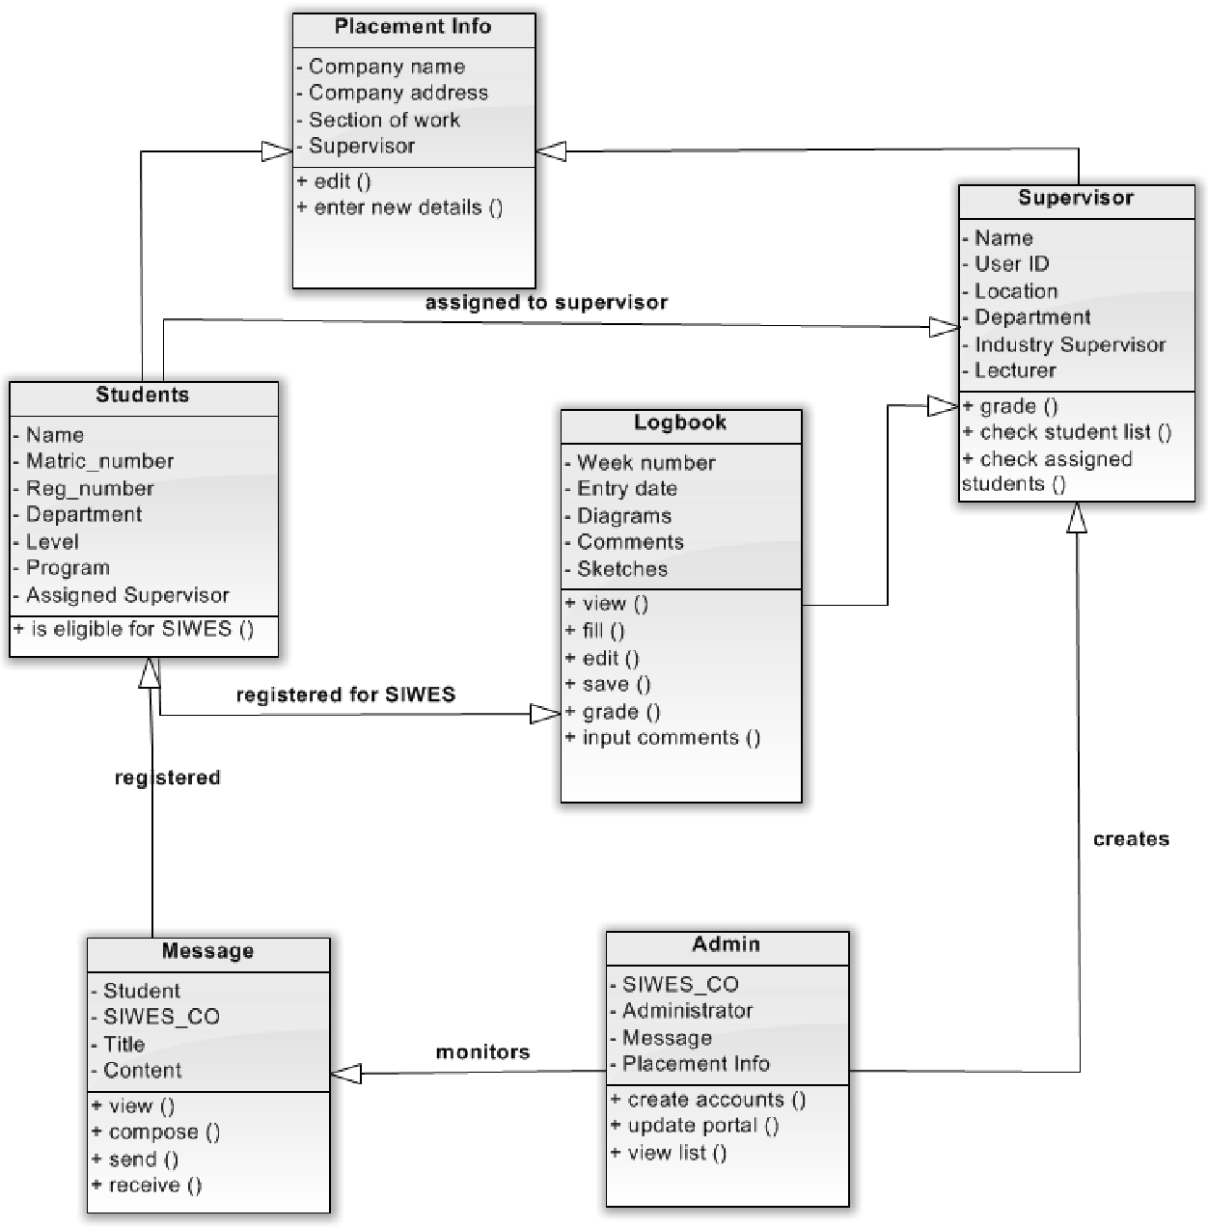

Introduction
This chapter presents a comprehensive review of existing literature related to the design and implementation of a web-based SIWES placement and monitoring system. The purpose of this chapter is to examine previous studies, concepts, theories, and technologies that are relevant to the development of the proposed system. It also provides a deeper understanding of how similar systems have been developed and the challenges they aim to solve.
The Students Industrial Work Experience Scheme (SIWES) has been widely recognized as an important component of higher education, particularly in developing countries, where there is a need to bridge the gap between theoretical knowledge and practical application. Several researchers have emphasized the importance of industrial training in improving students’ technical skills, professional competence, and readiness for the labor market. However, despite its significance, the management of SIWES activities—especially student placement and monitoring—remains a major challenge in many institutions.
Traditional methods of managing SIWES are often manual and paper-based, involving physical documentation, face-to-face communication, and fragmented record-keeping systems. These methods are not only time-consuming but also prone to errors, data loss, and inefficiency. As a result, many institutions face difficulties in tracking students’ progress, maintaining accurate records, and ensuring effective communication between students, supervisors, and administrators.
With the advancement of information and communication technology (ICT), web-based systems have emerged as effective tools for automating and improving administrative processes in educational institutions. A web-based SIWES placement and monitoring system offers the potential to streamline operations, enhance data management, improve transparency, and enable real-time access to information. Such systems allow students to apply for placements online, enable administrators to manage records efficiently, and provide supervisors with tools to monitor and evaluate students’ performance remotely.
This chapter, therefore, explores relevant concepts such as SIWES, web-based systems, database management systems, and student monitoring systems. It also reviews related works carried out by other researchers and highlights the strengths and weaknesses of existing systems. Furthermore, the chapter identifies gaps in the current approaches, which justify the need for the development of the proposed system.
In summary, the literature review provides the theoretical and conceptual foundation for this study and guides the design and implementation of an efficient web-based SIWES placement and monitoring system.

Sure! Here is a full and detailed “Overview of SIWES” for your Chapter Two, written in clear academic but student-friendly English:

Overview of the Students Industrial Work Experience Scheme (SIWES)
The Students Industrial Work Experience Scheme (SIWES) is a skill acquisition and training program designed to expose students in higher institutions to real-world working environments. It serves as a bridge between theoretical knowledge gained in the classroom and practical application in industries. The scheme is an essential part of academic programs in disciplines such as engineering, science, technology, and management.
SIWES was established by the Industrial Training Fund (ITF) in Nigeria in 1973 as a response to the growing concern among industrialists that graduates of higher institutions lacked adequate practical experience required for employment. The program was created to equip students with the necessary hands-on skills and competencies needed to perform effectively in their chosen careers.
The scheme involves placing students in relevant organizations, industries, or establishments where they can gain practical experience related to their field of study. During the training period, students are expected to participate in the daily activities of the organization, learn professional practices, and develop technical as well as interpersonal skills. This exposure helps students to understand workplace ethics, organizational structure, and the demands of the labor market.
Typically, SIWES is mandatory for students in certain courses and is carried out for a specific duration, usually ranging from three months to one year depending on the institution and program of study. Students are supervised both by their institution and by professionals within the host organization. These supervisors monitor the students’ progress, guide them in their tasks, and evaluate their performance throughout the training period.
One of the major objectives of SIWES is to provide students with the opportunity to apply theoretical concepts learned in school to real-life situations. It also aims to enhance students’ technical skills, improve their problem-solving abilities, and prepare them for future employment. Additionally, SIWES helps in fostering collaboration between academic institutions and industries, ensuring that educational programs remain relevant to industry needs.
Despite its importance, the implementation of SIWES has faced several challenges. These include difficulties in securing appropriate placement for students, lack of effective monitoring and supervision, poor record management, and communication gaps between stakeholders. In many cases, the process is still managed manually, which leads to inefficiency, delays, and errors.
With the advancement of technology, there is a growing need to modernize the SIWES process through digital solutions. A web-based SIWES placement and monitoring system can address many of these challenges by automating placement procedures, improving communication, and enabling real-time tracking of students’ activities. Such systems can significantly enhance the overall effectiveness and efficiency of the SIWES program.
In conclusion, SIWES plays a vital role in preparing students for the professional world by providing practical experience and skill development. However, to fully achieve its objectives, there is a need for improved management systems that leverage modern technology to overcome existing challenges.
Sure! Here is a full and well-structured “Summary of Literature Review” for your Chapter Two:
2.6 Summary of Literature Review
This chapter has reviewed relevant literature related to the design and implementation of a web-based SIWES placement and monitoring system. The review focused on key concepts such as the Students Industrial Work Experience Scheme (SIWES), web-based systems, placement processes, monitoring mechanisms, and database management systems.
From the literature, it is evident that SIWES plays a vital role in bridging the gap between theoretical knowledge and practical experience. It provides students with the opportunity to develop technical skills, gain workplace exposure, and improve their employability after graduation. However, the review also revealed that the traditional methods of managing SIWES activities in many institutions are largely manual, inefficient, and prone to errors.
The study further highlighted that web-based systems have been widely adopted in various sectors to improve efficiency, accuracy, and accessibility of information. These systems provide real-time access to data, enhance communication, and support better decision-making. In the context of SIWES, a web-based approach can significantly improve the placement and monitoring processes by automating operations and reducing administrative burdens.
In addition, the review of related works showed that several systems have been developed to address similar challenges, such as student management systems and industrial training platforms. While these systems offer useful features, many of them still have limitations, including lack of real-time monitoring, poor user interface design, limited accessibility, and inadequate integration of all SIWES stakeholders (students, supervisors, and administrators).
Furthermore, the literature identified major challenges associated with the current SIWES process, including difficulties in securing placements, poor record-keeping, lack of transparency, ineffective communication, and inadequate supervision of students during their training period.
Based on these findings, it is clear that there is a need for an improved system that can effectively manage SIWES activities. Therefore, this study proposes the design and implementation of a web-based SIWES placement and monitoring system that addresses the identified gaps by providing efficient placement management, real-time monitoring, proper record keeping, and enhanced communication among stakeholders.
In conclusion, the literature review provides a solid foundation for this study and justifies the need for the proposed system, which aims to improve the overall effectiveness and efficiency of the SIWES program.

2.2 Overview of SIWES
SIWES was established to improve the employability of graduates by exposing them to industrial practices. It ensures that students gain relevant technical experience before graduation.

2.3 Manual Internship Management Systems
Traditional systems rely on paperwork and manual supervision. While simple, they are prone to errors, misplacement of records, and inefficiency.
Common weaknesses include:
- Lack of automation
- No real-time tracking
- Limited accessibility
- Poor documentation

2.4 Web-Based Management Systems
Modern institutions adopt web-based platforms for academic management. These systems provide:
- Online registration
- Automated database management
- Real-time updates
- Secure data storage
- Centralized communication
Studies show that digital systems improve efficiency, reduce administrative workload, and enhance data accuracy.

2.5 Review of Related Works
Several universities have developed internship management portals that allow students to apply online and submit reports digitally. These systems improve monitoring and ensure transparency.
However, many institutions still lack customized SIWES platforms tailored to their specific needs. This project addresses that gap.

2.6 Summary of Literature Review
The review shows that web-based systems significantly improve administrative processes. Therefore, implementing such a system for SIWES management is both relevant and necessary.

CHAPTER THREE

SYSTEM ANALYSIS AND DESIGN

3.1 Analysis of the Existing System
Introduction
This chapter focuses on the analysis and design of the proposed web-based SIWES placement and monitoring system. It examines the existing system, identifies its weaknesses, and presents the structure and design of the new system. The aim is to provide a clear understanding of how the proposed system will function and how it will solve the problems identified in the current system.

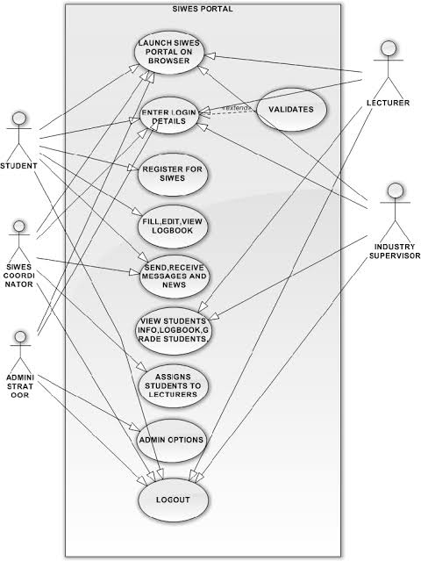System analysis involves studying the current system in order to understand how it operates and to identify its limitations. System design, on the other hand, involves planning and structuring a new system that will improve efficiency, accuracy, and overall performance.
Analysis of the Existing System
The current SIWES placement and monitoring process in many institutions, including the Federal University of Technology, Babura, is largely manual. The system involves the use of paper-based records, physical documentation, and face-to-face communication between students, administrators, and supervisors.
Features of the Existing System:
Students search for placement manually
Submission of forms and documents in hard copy
Communication through letters, phone calls, or physical visits
Manual recording of student data and reports
Limited or no real-time monitoring
Problems of the Existing System:
Time-Consuming Process: Manual operations lead to delays in placement and approval.
Poor Record Management: Data can be lost, damaged, or duplicated.
Lack of Transparency: Students cannot easily track their placement status.
Communication Gaps: Information flow between stakeholders is slow and unreliable.
Ineffective Monitoring: Supervisors find it difficult to track students’ activities.
High Error Rate: Manual data entry increases the chances of mistakes.

Analysis of the Proposed System
The proposed system is a web-based SIWES placement and monitoring system designed to automate and improve the entire SIWES process.
Features of the Proposed System:
Online student registration and login
Automated placement process
Real-time monitoring of student activities
Digital submission of reports
Centralized database for all records
Communication platform between users
Advantages of the Proposed System:
Faster and more efficient operations
Accurate and secure data management
Easy access to information anytime and anywhere
Improved communication
Better supervision and evaluation of students

System Requirements

Functional Requirements
These are the activities the system must perform:
Student registration and authentication
Login/logout functionality
Placement application and approval
Uploading of SIWES reports
Supervisor assignment
Monitoring and evaluation of students
Report generation

Non-Functional Requirements
These define how the system performs:
Security: User authentication and data protection
Usability: Easy-to-use interface
Reliability: System should function without failure
Performance: Fast response time
Scalability: Ability to handle many users

System Design
System design describes how the proposed system will be structured.
Architectural Design
The system will follow a three-tier architecture:
Presentation Layer (Frontend): User interface (web pages)
Application Layer (Backend): Handles logic and processing
Database Layer: Stores all system data

Use Case Diagram (Explanation)
The system involves three main users:
Student
Administrator
Supervisor
Use Cases include:
Register/Login
Apply for placement
Approve placement
Upload reports
Monitor progress
Evaluate students

Entity Relationship (ER) Diagram (Explanation)
The database consists of the following main entities:
Student (Student ID, Name, Department, etc.)
Placement (Placement ID, Organization, Duration)
Supervisor (Supervisor ID, Name, Role)
Report (Report ID, Submission Date, Content)
Relationships:
A student is assigned to one placement
A supervisor monitors many students
A student submits multiple reports

System Flowchart (Explanation)
The system flow follows these steps:
User registers and logs in
Student applies for SIWES placement
Administrator reviews and approves
Student is assigned to an organization
Student uploads reports regularly
Supervisor monitors and evaluates
Final report is generated

Database Design
The system database will be designed to store and manage all relevant information efficiently.
Sample Tables:
Students Table: Student ID, Name, Email, Department
Placement Table: Placement ID, Organization Name, Student ID
Supervisors Table: Supervisor ID, Name, Contact
Reports Table: Report ID, Student ID, Content, Date

Input and Output Design
Input Design:
Registration forms
Login forms
Placement application forms
Report upload forms
Output Design:
Placement confirmation
Student progress reports
Supervisor evaluation reports
Summary reports

Summary
This chapter has analyzed the existing SIWES system and identified its limitations. It also presented the design of the proposed web-based system, including its structure, components, and functionalities. The proposed system is expected to improve efficiency, accuracy, and overall management of the SIWES program.

The current system is manual and paper-based. It involves:
- Physical application letters
- Manual approval
- Paper logbooks
- Physical supervision
Problems identified include:
- Data redundancy
- Inefficient monitoring
- Poor record retrieval
- Lack of centralized control

3.2 Proposed System
The proposed system is a web-based application accessible via internet-enabled devices.
Features include:
- Secure login authentication
- Role-based access (Student, Supervisor, Admin)
- Online placement management
- Digital report submission
- Automated performance tracking

3.3 System Architecture
The system uses a three-tier architecture:
- Presentation Layer (User Interface)
- Application Layer (Business Logic)
- Database Layer (Data Storage)

3.4 System Modules

Student Module
- Register/login
- Apply for placement
- Upload documents
- Submit weekly reports

Supervisor Module
- View assigned students
- Approve reports
- Submit evaluation

Admin Module
- Manage users
- Approve placements
- Generate reports

3.5 Database Design
The database includes tables such as:
- Students
- Companies
- Placements
- Reports
- Supervisors
Each table has primary keys and foreign keys to maintain relational integrity.

This project successfully designed and implemented a web-based SIWES placement and monitoring system. The system automates placement processes, improves monitoring, and enhances record management.

5.2 Conclusion
The manual SIWES management process has several limitations that reduce efficiency. The developed web-based system addresses these challenges by providing a centralized, secure, and efficient platform for managing SIWES activities.
The system enhances communication, improves transparency, and ensures proper documentation.

5.3 Recommendations
- The university should adopt the system officially.
- Training should be provided for users.
- Regular system maintenance should be conducted.
- Future upgrades may include mobile application integration.

REFERENCES
Pressman, R. (2014). Software Engineering: A Practitioner’s Approach.
Federal Ministry of Education. (2019). SIWES Guidelines.
Laudon, K., & Laudon, J. (2018). Management Information Systems.

APPENDICES
- Source Code
- Database Schema
- Screenshots
- User Guide

