**EmotiFace: Real Time Facial Emotion Detection System**

# 1. Project Overview (What’s the Idea?)

This project focuses on building a real-time facial emotion detection system using computer vision and deep learning**. It captures video input via a webcam, detects faces, and classifies the expressed emotion using a Convolutional Neural Network (CNN).** This model can serve as an “emotion detection module” for future big projects mentioned under Future Features heading below.

## Key Features:

• Real-time webcam feed integration

• Facial emotion classification using a trained CNN

## Optional Feature:

If time permits, an optional enhancement can also be integrated into the project. The system will also log detected emotions over time, enabling emotion trend analysis to study behavioral or emotional changes throughout usage periods. Emotion logging for time-based trend analysis (e.g., emotional fluctuations throughout the day/week).

## 2. Rationale & Market Relevance

Emotional awareness in technology is vital, especially in healthcare, education, and support systems. This model can serve as an **“emotion detection module”** for future big AI projects such as ‘Personal Medical Robots’ which are capable of emotion-aware interactions and are designed to use the recognized emotion to trigger personalized conversational responses. In this way, this project can indirectly contribute to the support for dementia and depression patients**.** Additionally, emotion trend tracking (optional feature) can help caregivers, therapists, or users themselves recognize patterns of mood shifts, emotional volatility, or potential mental health issues early.**However, the scope of this project is strictly limited to the development and implementation of the emotion detection only and logging components using computer vision (optional).** **The chatbot and robot integration is envisioned for future work and will not be part of this implementation.**

## Why this project?

• Demonstrates real-world use of computer vision and deep learning

• Foundational system for future intelligent empathetic agents

• Can be integrated in conversational robotic systems Useful in assistive medical applications (e.g., eldercare, therapy)

• Tracks and stores emotional states over time to assist in behavioral analytics optionally.

## Existing Solutions:

• Commercial APIs (Azure, Affectiva, Face++) require paid usage or cloud dependency.

## Value Added:

• Local, open-source, and customizable solution

• Emotion data storage for future analysis and insights

• Can be integrated into larger empathetic systems later

# 4. Workflow & Methodology

## Approach:

• Dataset: FER2013 or AffectNet

• Model: CNN to classify 7 emotions (Happy, Sad, Angry, Surprised, Neutral, Disgusted, Fearful)

• Preprocessing: Face detection via OpenCV, image normalization and resizing

• Tools: Python, TensorFlow/Keras, OpenCV, Flask (for optional UI)

## Workflow Steps:

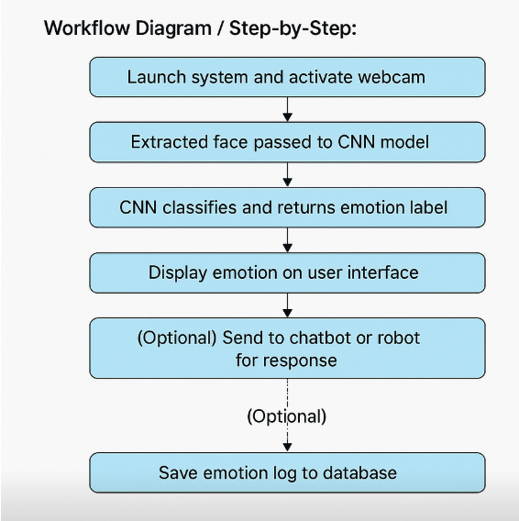

## ERD:

