## NFC IET UNIVERSITY, MULTAN.

## 

## **LAB REPORT**

# ICT (“INFORMATION& COMMUNICATION TECHNOLOGY FUNDAMENTAL”)

# IN COMPUTER SCIENCE

# SESSION [2K24]

# NAME : SHEHREEN FAROOQ

# ROLL NO. : (2K24 -BSCS -414)

# SECTION : Y

# SUBMITTED TO: MS. FABIA HASSAN

# SUBMITTED BY: SHEHREEN FAROOQ

# 18 OCTOBER, 2024.

# **LAB1**

# **TYPING PRACTICE:**

“A systematic and repetitive process of pressing keyboard keys to input text,

Aimed at developing muscle memory ,increasing speed ,and enhancing memory.”

### e.g.

Typing Master is the most famous software for typing practices with 10+ million downloads.

# **INTERNAL COMPONENTS OF COMPUTER**

# **MAIN COMPONENTS**

# CPU (CENTRAL PROCESSING UNIT):

* Brain
* Executes Instructions

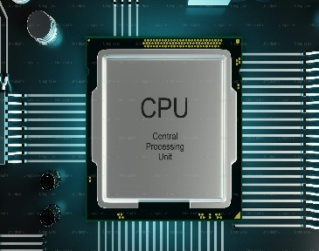

## MOTHERBOARD:

* Connects hardware components.

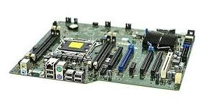

## RAM (RANDOM ACCESS MEMORY):

* Temporary storage for data.

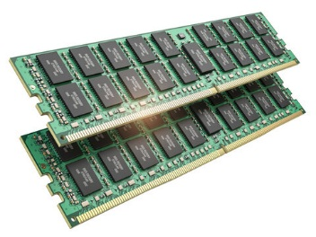

## 4) STORAGE DEVICE (HDD/SSD):

* Permanent storage of data.

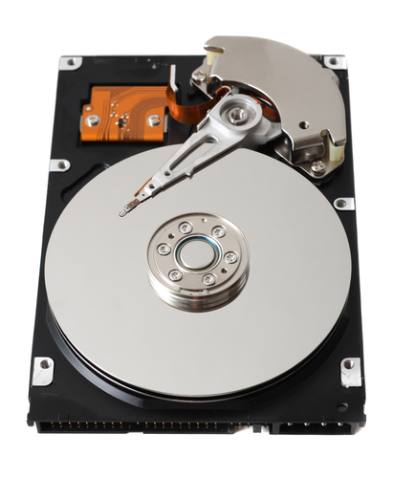

# **LAB2**

## **WINDOWS INSTALLATION STEPS:**

## PRE-INSTALLATION STEPS:

* Backup data.
* Gather unnecessary hardware(CPU,RAM,HDD/SSD)
* Create a bootable USB drive or CD/DVD

## INSTALLATION STEPS:

### PHASE 1: Setup(10-15 minutes)

* Boot from USB/CD.
* Select language and keyboard layout.
* Choose installation type.
* Select installation location.

### PHASE 2: COPYIND FILES:

* Copying window files.
* Expanding files.
* Installed features.

### Phase 3: CONFIGURATION:

* Set up network connection.
* Create user account.
* Set up password.
* Configure privacy settings.
* Install drivers.

## FINAL STEPS:

* Install updates.
* Activate windows.
* Install antivirus software.
* Install unnecessary software.

**TOTAL INSTALLATION TIME: 1-2 HOURS**

## **WINDOWS INSTALLATION STEPS:**

* Clean install.
* Upgrade install.
* Dual boot install

## SYSTEM REQUIREMENTS:

* CPU: 1 GHz or faster.
* RAM: 2 GB or more.
* Dual-Boot install.
* Graphics: DirectX 9 or later

**Installation time and requirements may vary depending on the Windows version and system application.**

# **CPU ASSEMBLING**

## **STEPS:**

### PHASE1: CPU INSTALLATION (10-15 MINUTES)

* Locate the CPU socket on the motherboard.
* Remove the CPU socket cover.
* Align the CPU WITH THE Socket.
* Gently insert the CPU into the socket.
* Secure the CPU with the socket’s locking mechanism..

## PHASE2: Apply CPU COOLER INSTALLATION (10-15 MINS):

Apply thermal paste to the CPU.

Install the CPU cooler:

For stock cooler: clip onto the CPU socket.

For aftermarket cooler: follow manufacturer ’s instructions.

Secure the cooler with screws or clips.

## PHASE3: MOTHERBOARD INSTALLATION (15-30 MINS):

Install stand –offs (if required).

Mount the motherboard to the case.

Connect front panel headers.

Connect fan headers.

Connect USB and audio parts.

## PHASE4: RAM INSTALLATION:

Locate the RAM slots.

Align the RAM modules.

Insert the RAM into slots.

Secure the RAM with clips or screws.

## PHASE5: POWER SUPPLY INSTALLATION:

Mount the power supply to the case.

Connect power cables to the motherboard.

Connect power cables to peripherals.

## PHASE6:FINAL CONNECTIONS:

Connect data cables (HDD/SSD, USB).

Connect fan cables.

Connect audio cables.

Connect monitor and keyboard/mouse.

## FINAL CHECK:

Verify all connections.

Ensure proper cable management.

Power on the system.

## TROUBLESHOOTING TIPS:

Check power supply connections.

Verify CPU and RAM installation.

Check for loose connections.

## CPU ASSEMBLING TOOLS:

Tor x driver.

FLATHEAD screwdriver.

Phillips screwdriver.

Thermal paste.

Cable ties.

## CPU ASSEMBLING PRECAUUTIONS:

Handle components by the edges.

Avoid touching electrical components.

Ground yourself to prevent static electricity damage.

**Remember to consult your motherboard manual for specific instructions.**

# **LAB3**

## **MOTHERBOARD AND ITS INTERNAL STRUCTURE:**

### **MOTHERBOARD:**

#### **DEFINITION:**

“Main circuit board connecting hardware components.”

#### **KEY COMPONENTS:**

* + - * CPU socket
      * RAM slots
      * Chipset
      * PCI/ PCI e slots
      * USB Ports
      * Power Connectors

#### **FUNTIONS:**

* + - * Connects hardware
      * Provides power distribution
      * Manages data transfer
      * Supports expansion cards

#### **TYPES:**

ATX, Micro-ATX, Mini-ATX, Server Motherboards.

#### **FEATURES:**

* + - * Wi-Fi /Bluetooth
      * USB 3.2 /Thunderbolt 3
      * High quality audio
      * Overclocking support
      * RGB lighting

#### **TOP MANUFACTURERS:**

* + - * ASUS
      * MSI
      * Gigabyte
      * Intel
      * AMD

##### **PRICE RANGE:$50-$1000+**

# **INTERNAL STRUCTURE**

#### **LAYERS:**

1. Copper traces (electrical paths)
2. Insulating layers (protective coating)
3. Conductive planes (power/ground)
4. Solder mask
5. Silkscreen

#### **COMPONENTS:**

1. CPU zone
2. Chipset
3. RAM slots
4. PCI/PCI e slots
5. Capacitors
6. Inductors
7. Resistors

#### **SECTIONS:**

1. CPU zone
2. Memory zone
3. Peripheral zone
4. Power delivery zone
5. Storage zone

#### **CONNECTORS:**

1. SATA
2. USB
3. HDMI
4. Ethernet
5. Power connectors

This simplified overview highlights the main internal components and sections of a motherboard.

# **LAB4**

# **BASIC INTRODUCTION TO MICROSOFT WORD**

#### **DEFINITION:**

Microsoft Word is a popular word processing software used for creating, editing, and printing documents.

#### **KEY FEATURES:**

1. Text editing and formatting
2. Document layout and design
3. Tables, charts, and graphics
4. Spell checking and grammar correction
5. Collaboration tools(comments, tracking)
6. Export options (PDF, HTML, etc.)

#### **BASIC COMPONENTS:**

1. Document (file)
2. Toolbar
3. Menu bar
4. Workspace(document area)
5. Status bar

#### **COMMON TASK :**

1. Creating Documents
2. Editing Text
3. Formatting texts and paragraphs
4. Inserting images and tables
5. Printing documents
6. Saving documents

#### **VERSIONS:**

1. Microsoft Word 97-2003(.doc x)
2. Microsoft Word 2007-2013(.doc x)
3. Microsoft Word Online (cloud-based)

#### **SYSTEM REQUIREMENTS:**

1. Operating System: Windows, mac OS
2. Processor: 1GHz or faster
3. RAM: 2 GB or more
4. Storage: 3 GB or more

#### **BENEFITS:**

1. Easy document creation and editing
2. Professional-looking documents
3. Collaborative features
4. Compatibility with other Microsoft Office Tools

#### **BASIC SKILLS REQUIRED:**

1. Typing
2. Basic computer skills
3. Understanding of document layout

Microsoft word is an essential tool for creating professional documents, reports, and presentations.

## **BASIC FEATURES OF MS WORD:**

#### **INSERTION FEATURES:**

1. TEXT: Type and edit test
2. Images: Insert pictures, graphics, and clipart
3. Tables :Create and format tables
4. Charts: Insert charts and graphs
5. Shapes: Draw shapes and objects
6. Headers/Footers: Add headers and footers
7. Footnotes/Endnotes: Add citations and references

#### **FORMATTING FEATURES:**

1. Font :Change font style, size, and color
2. Alignment: Align text left, center, or right
3. Spacing: Adjust line and paragraph spacing
4. Bullet/Numbering: Create lists
5. Indentation: Adjust paragraph indentation
6. Margins: Set document margins
7. Columns: Create multiple columns

#### **EDITIND FEATURES:**

1. Cut/copy/paste: Edit text
2. Undo/Redo: Reverse changes
3. Find/Replace: Search and replace text
4. Spell Check: Check spelling and grammar
5. Thesaurus: Find synonyms

#### **DOCUMENT FEATURES:**

1. Page setup: Set page size, orientations, and margins.
2. Sections: Divide document into sections.
3. Breaks: Insert page, section, or column breaks.
4. Document properties: View and edit document metadata.
5. Save as: Save document in different formats.
6. Export: Export document to other life documents.

#### **REVIEW FEATURES:**

1. Comments: Add and manage comments
2. Compare documents: Compare document versions
3. Protect document: Password-protect document.
4. Digital Signatures: Add digital signatures.
5. Document ID: Assign unique document ID.
6. Track changes: Collaborate with others.

#### **VIEW FEATURES:**

1. Zoom: Adjust document zoom.
2. Layout: Switch between layout views.
3. Full screen: View document full screen.
4. Outline: View document outline.
5. Draft: View document draft.
6. Read mode: View document read mode.

# **LAB5**

## **MS WORD ADVANCED FEATURES INCLUDING:**

### **MAIL MERGE:**

1. Create a data source(Excel, CSV)
2. Use Mail Merge Wizard(Tools>Mail Merge)
3. Insert Merge fields(e.g. name, address)
4. Preview and print merged documents

### **TABLE OF CONTENTS:**

1. Create headings(Heading 1,2,3 )
2. Insert TOC (references> Table of contents)
3. Customize TOC format and levels
4. Update TOC

### **SECTION BREAKS:**

1. Insert section break ( layout> Breaks)
2. Choose Break Type(Next page, continuous)
3. Format Sections separately
4. Use section breaks for:

* Different headers/footers
* Changing layout or margins
* Creating separate sections

### **REFERANCE TOOLS:**

1. Citations and bibliography (References> Citations & Bibliography )
2. Footnotes and Endnotes (references> Footnotes)
3. Index(References> Index)
4. Table of Authorities (Reference> table of authorities)

### **HEADERS/FOOTERS:**

1. Insert header/footer (Insert> header/footer)
2. Customize layout and design
3. Use different headers/footers for sections
4. Link to previous/next header/footer

# **LAB6**

# **MENDELEY (REFERANCE MANAGEMENT AND CITATION TOOL):**

### **PURPOSE:**

Mendeley helps manage and organize your research papers, create citations, and generate bibliographies.

### **FEATURES:**

#### REFERENCE MANAGEMENT:

Import research papers from academic databases like Google Scholar, JSTOR, and more.

#### CITATIONS:

Automatically generate citations in various formats (APA, MLA, Chicago, etc.)

#### BIBLIOGRAPHY GENERATION:

Create bibliographies by selecting references in you Mendeley library.

#### COLLABORATION:

Share references and documents with teams for collaborative work.

## **STEPS:**

#### **INSTALL MENDELEY:**

Download and install Mendeley Desktop from Mendeley’s website.

#### **2 ADD DOCUMENTS:**

Import PDF’s or manually add references using the “ADD DOCUMENT” option.

#### **3 USE MENDELEY WITH WORD:**

Install the Mendeley word Plugin to easily insert citations and generate bibliographies.

#### **INSERT CITATIONS:**

#### Click **References > Insert citation *and search your Mendeley library***

#### **GENERATE BIBLIOGRAPHIES:**

Once all citations are added, Mendeley can create a bibliography with the insert **Bibliography** button.

## **GRAMMARLY (GRAMMAR AND WRITING ASSISTANCE )**

#### **PURPOSE:**

Grammarly, helps with grammar, spelling, punctuation errors, and clarify.

### **FEATURES:**

#### **WRITING STYLE:**

Suggestions to improve sentence structure and redability.

#### **PLAGARISM DETECTION:**

**Checks if content matches online.**

#### **TONE DETECTION:**

Analyzes the tone of your writing (formal, casual).

#### **GRAMMAR CHECK:**

Checks for spelling, grammar, punctuation errors, and clarify

## **PDF ELEMENT:**

#### **PURPOSE:**

PDF element allows for PDF editing and converting PDF s into Word, Excel, Power point, and more.

#### **FEATURES:**

##### PDF to word:

Convert PDF s into editable Word documents without losing and formatting.

##### EDITING PDF s:

Add, delete, or modify text and images in PDF.

##### FORM FILLING:

Fill out PDF forms and save them.

##### OCR (OPTICAL CHARACTER RECOGNITION):

Convert scanned documents into editable formats.

#### **STEPS:**

**Install PDF Element:** Download and install PDF Element form Wonder share’s website.

**Convert PDF to Word:**

* Open the PDF in PDF element.
* Click on **Convert** and select **To Word.**
* **EDIT PDF:**

Use the **Edit** tab to modify text, images, or add annotations.

* **OCR:**

If the PDF is a scanned image, use the **OCR** feature to extract editable text.

## **AUTOMATIC REPETITIVE TASKS WITH MACROS IN WORD:**

#### **PURPOSE:**

Macros automate repetitive tasks in Word, saving time on tasks like formatting, text insertion.

## **STEPS:**

#### **RECORD A MACRO:**

* Go to **View> Macros> Record macro.**
* Name your macro and assign a shortcut key.
* Perform the tasks you want to automate (formatting text, inserting headers).

#### **STOP RECORDING:**

* After completing the actions, click **view> Macros> View recording.**

#### **RUN A MACRO:**

* To run your macro, use the shortcut key or go to **View> Macros> View macros,** select your macro and click **run.**

## **REFERENCING TOOLS FOR CITATIONS, FOOTNOTES, AND ENDNOTES:**

#### **PURPOSE:**

* These rules help you create proper citations, footnotes and endnotes within proper document.

### **STEPS:**

#### **INSERT CITATIONS:**

1. Use **Reference> Citations & Bibliography** to insert citations from your selected referencing styles.
2. Click **Insert citations** to click or add a source.

#### **INSERT FOOTNOTES/ ENDNOTES:**

1. For endnotes, click **Insert Endnotes.**
2. For endnotes, click **insert footnotes.** Both footnotes and endnotes will be numbered automatically.

#### **MANAGE SOURCES:**

Use **manage sources** to store and edit your citations for future use in documents.

## **LAB 7**

## **MAIL MANAGEMENT:**

THE PROCESS OF ORGANIZING, PRIORITIZING AND RESPONDING TI E MAILS IN EFFICIENT AND EFFECTIVE MANNER.

* Using outlook or other mail clients for organized communication.

## **key features:**

* Email organization
* Prioritization
* Automated responses
* Spam filtering

## **collaborative tools:**

Software applications or platforms that enable teams to work together, share information and communicate effectively.

* **TRACK CHANGES AND COMMENTS:**

Efficiently manage edits and feedback.

* **REVIEWING SND COMPARING DOCUMENTS:**

Ensuring consistency across different versions.

**Key Features**:

1. Real-time messaging
2. File Sharing
3. Video Conferencing
4. Task Assignment
5. Project Management

* **Data PROTECTION (PROTECT DOCUMENTS WITH PASSWORDS AND CONTROL EDITING PERMISSIONS)**

Data Protection refers to the practices, policies, and technologies used to secure and protect sensitive data from unauthorized access, theft, corruption, or loss.

* + **Password Protection**: How to secure documents.
  + **Control Editing Permissions**: Restricting access and editing rights for sensitive documents.

**Key Features**::

1. Encryption
2. Access control
3. Backup and Recovery
4. Compliance
5. User Authentication

# **PRACTICAL WORK OF MS WORD PERFORMED IN LAB:**

* SAVE A DOCUMENT → **Ctrl +S**
* Undo a task →**ctrl +z**
* Redo a task→ **ctrl +y**
* New blank document→ **ctrl +n**
* Open a document →**ctrl +o**
* Print a document → **ctrl +q**
* Copy a document →**ctrl +c**
* Paste a document → **ctrl +v**
* Microsoft word → file tab
* Cut → **ctrl +x**

#### **FIRST GROUP:**

* Clear formatting→ **we can format text**
* Second group: Font
* Bold →**ctrl +b**
* Underline→ **ctrl +c**
* Italic→ ***ctrl +I***
* Font style→ **Ctrl + shift + F**
* Font size→ 14
* Strike through→ ~~S h e h re en~~
* Superscript and subscript→ x12 x 12
* To delete a page→ ctrl + backspace

|  |  |  |  |  |  |
| --- | --- | --- | --- | --- | --- |
| |  | | --- | | **STUDENTS DETAILS** | | | | | |
| ROLL NO. | NA**ME** | **CLASS** | **SECTION** | MARKS |
| 1 | **SHEHREEN** | **ICT** | Y | 1099 |
| 2 |  |  |  |  |
| 3 |  |  |  |  |

# **THIRD GROUP →PARAGRAPH**

* Left alignment→ ctrl + L
* Right alignment→ ctrl + R
* Centered→ ctrl + E
* Justified→ ctrl + J

## **Alignment:**

It is necessary to do our lab work regularly and do as much practice as we can to do our type writing more and more professional and to better understand the lab work. In other words, lab work is very exciting and entertaining.

## **BULLETS:**

* Left alignment→ ctrl + L
* Right alignment→ ctrl + R
* Centered→ ctrl + E
* Justified→ ctrl + J

## **NUMBERING:**

1. R
2. T
3. I
4. Y
5. P
6. O

## **LINE SPACING:**

My name is Shehreen.

I am doing CS.

## **LINK:**

NFC-IET-Multan-Logo.jpg

## **DIAGRAM**:

# **PROGRAMMING FUNDAMENTALS**

# STATISTICS

# **BASIC MATHEMATICS**

## **SCREENSHOTS:**

#### 

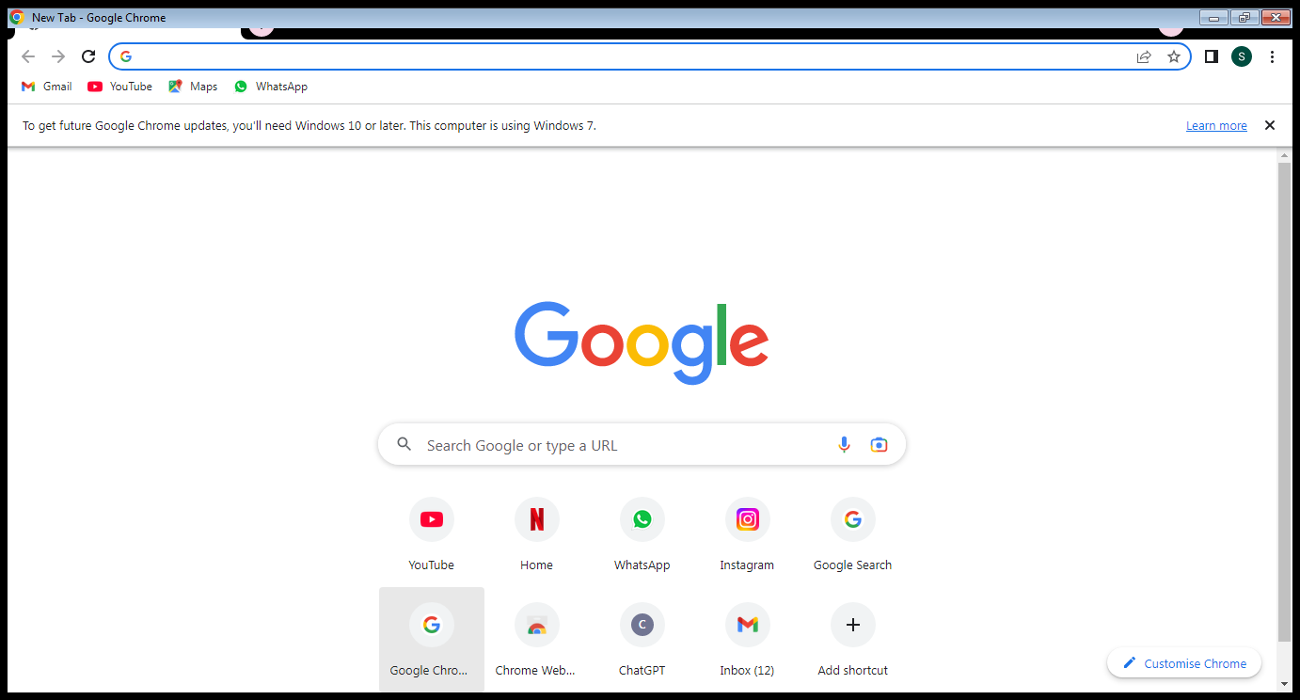

# **TO ADD RANDOM PARAGRAPH:**

INSERT =rand (n)

Video provides a powerful way to help you prove your point. When you click Online Video, you can paste in the embed code for the video you want to add. You can also type a keyword to search online for the video that best fits your document.

To make your document look professionally produced, Word provides header, footer, cover page, and text box designs that complement each other. For example, you can add a matching cover page, header, and sidebar. Click Insert and then choose the elements you want from the different galleries.

Themes and styles also help keep your document coordinated. When you click Design and choose a new Theme, the pictures, charts, and SmartArt graphics change to match your new theme. When you apply styles, your headings change to match the new theme.

Save time in Word with new buttons that show up where you need them. To change the way a picture fits in your document, click it and a button for layout options appears next to it. When you work on a table, click where you want to add a row or a column, and then click the plus sign.

Reading is easier, too, in the new Reading view. You can collapse parts of the document and focus on the text you want. If you need to stop reading before you reach the end, Word remembers where you left off - even on another device.

# **equations:**

# citations:

(Berninger, 2006)

**EXCEL**

**SHORTCUT KEYS:**

**TOTAL ROWS BY:** ctrl+↑KEY

**TOTAL COLUMNS BY:** ctrl+→key

**FOR SELECTING WHOLE COLUMN: ctrl+ space key**

**DELETING ROW: ctrl + ‘-‘**

**INSERTING ROW: ctrl+ shift++**

**ANS OF SUM:** **alt+=**

**FOR SELECTING WHOLE COLUMN’S POWS: SHIFT+SPACEKEY**

## **ZERO FIX:**

## 

# 

# **TO WRITE ANY DIGIT TO THE LEFT:**

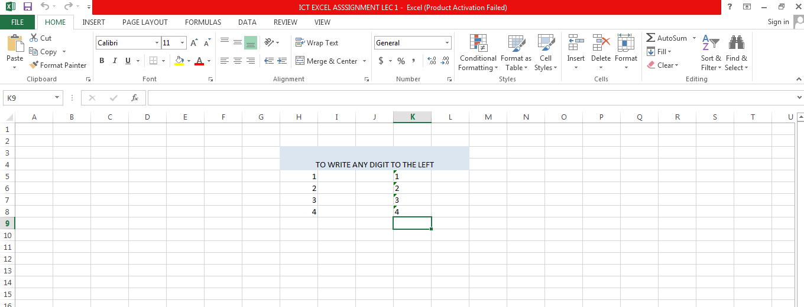

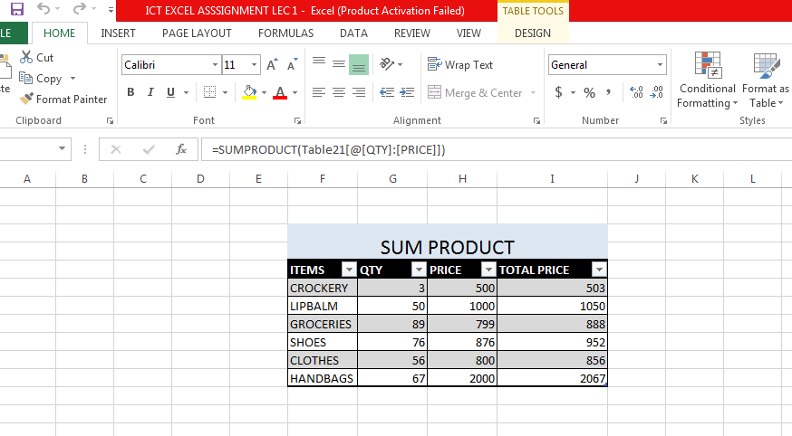

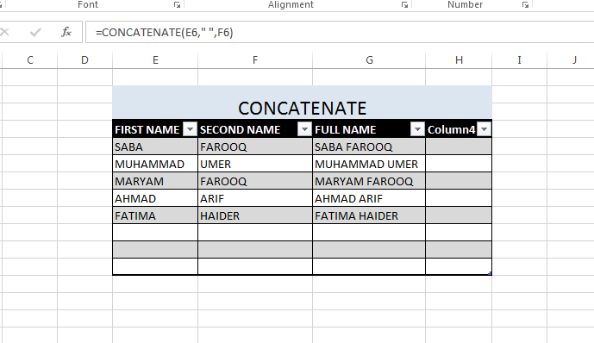

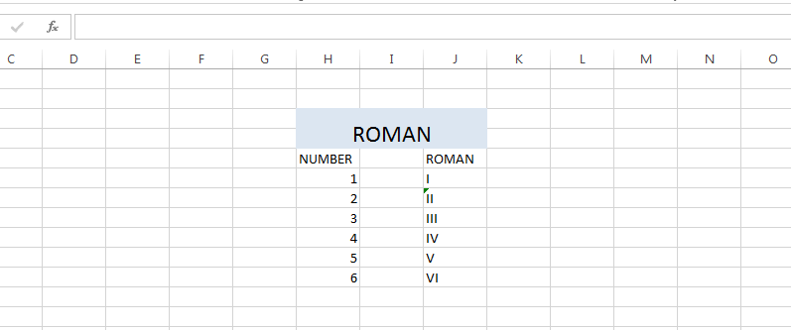

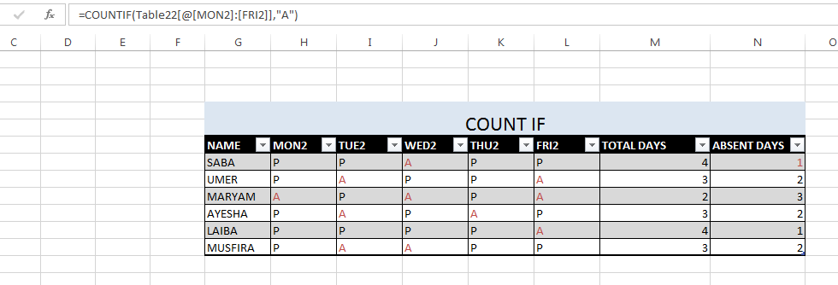

**COUNT BLACK:**

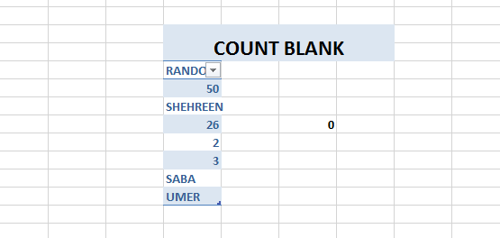

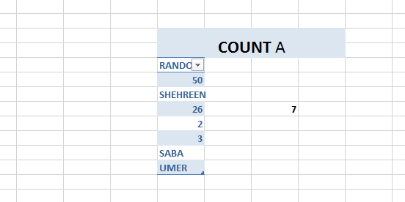

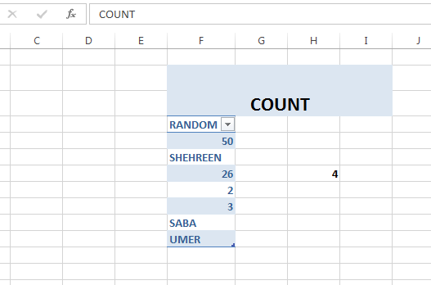

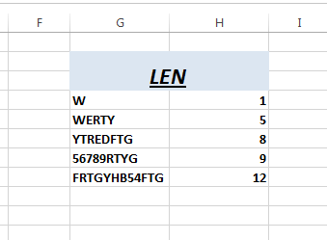

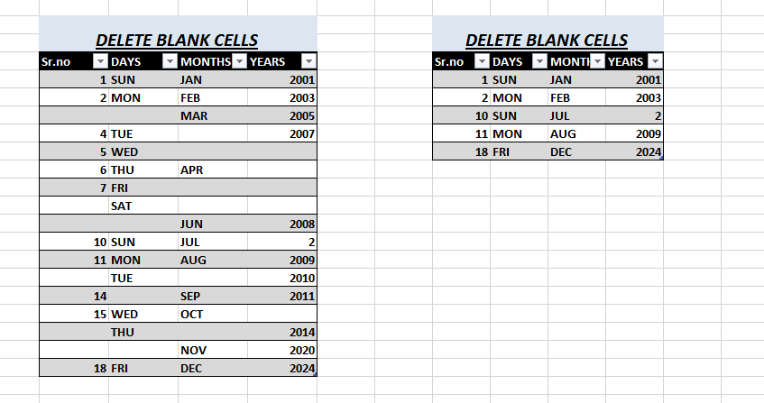

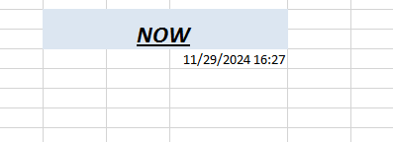

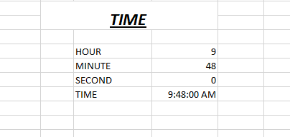

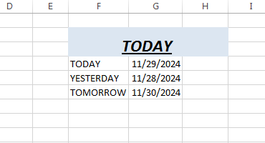

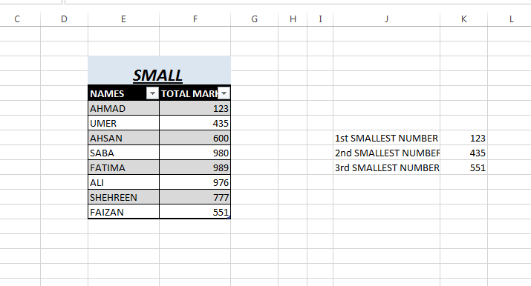

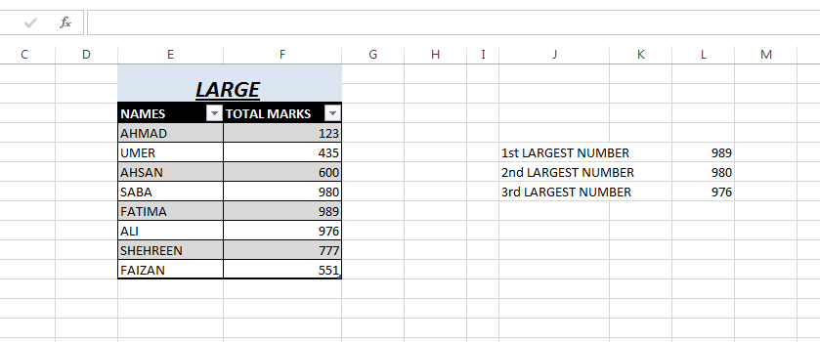

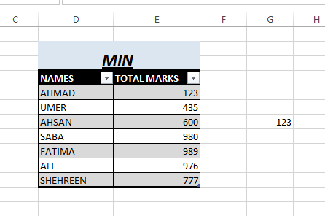

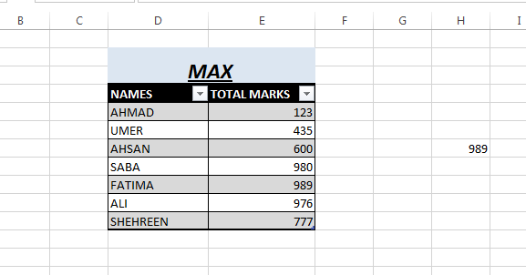

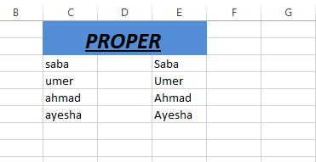

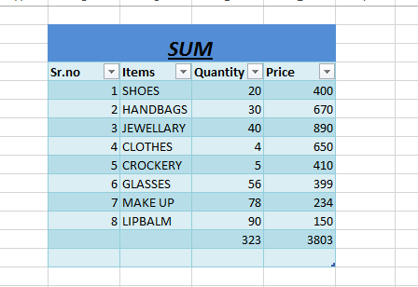

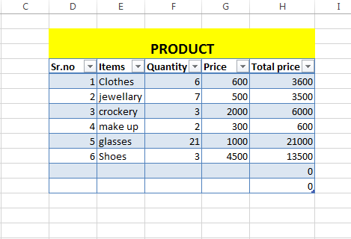

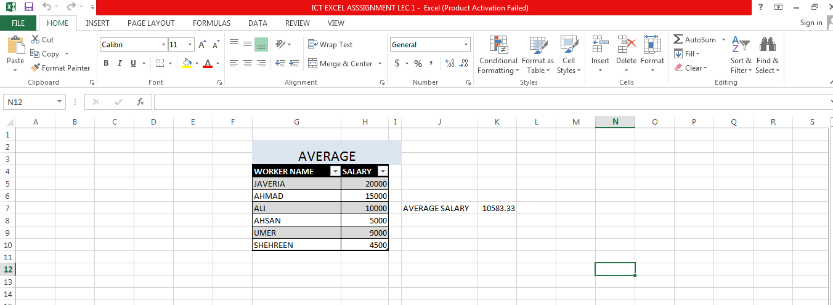

# 

## **ILLUSTRATIONS:**

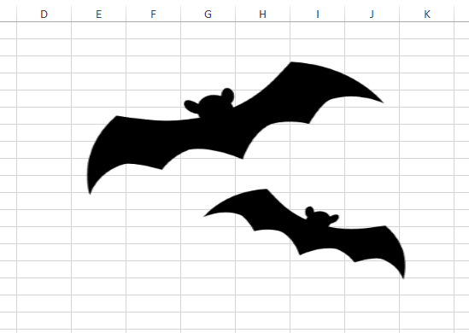

|  |  |  |  |  |  |
| --- | --- | --- | --- | --- | --- |
| **SIGNCOPY:** |  |  |  |  |  |
|  |  |  |  |  |  |
| |  | | --- | |  | |  |  |  |  |  |
|  |  |  |  |  |  |
|  |  |  |  |  |  |
|  |  |  |  |  |  |
|  |  |  |  |  |  |
|  |  |  |  |  |  |
|  |  |  |  |  |  |
|  |  |  |  |  |  |
|  |  |  |  |  |  |
|  |  |  |  |  |  |
|  |  |  |  |  |  |
|  |  |  |  |  |  |
|  |  |  |  |  |  |
|  |  |  |  |  |  |
|  |  |  |  |  |  |
|  |  |  |  |  |  |

## **DATA VALIDATION:**

DROP DOWN->DATA ->DATA VALIDATION->LIST->SELECT A PARTICULAR TABLE->ENTER.

## **vlookup:**

= VLOOKUP (select a cell,select the entire table,no. of column,0)

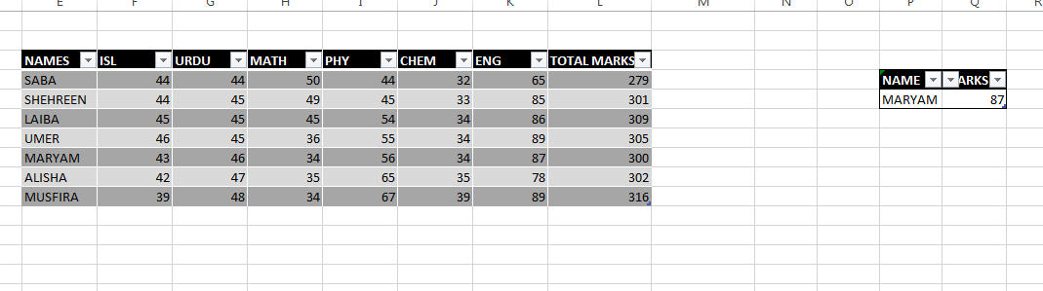

## **hlookup:**

=HLOOKUP (SELECT A CELL, ENTIRE TABLE, NO. OF ROW, TRUE)

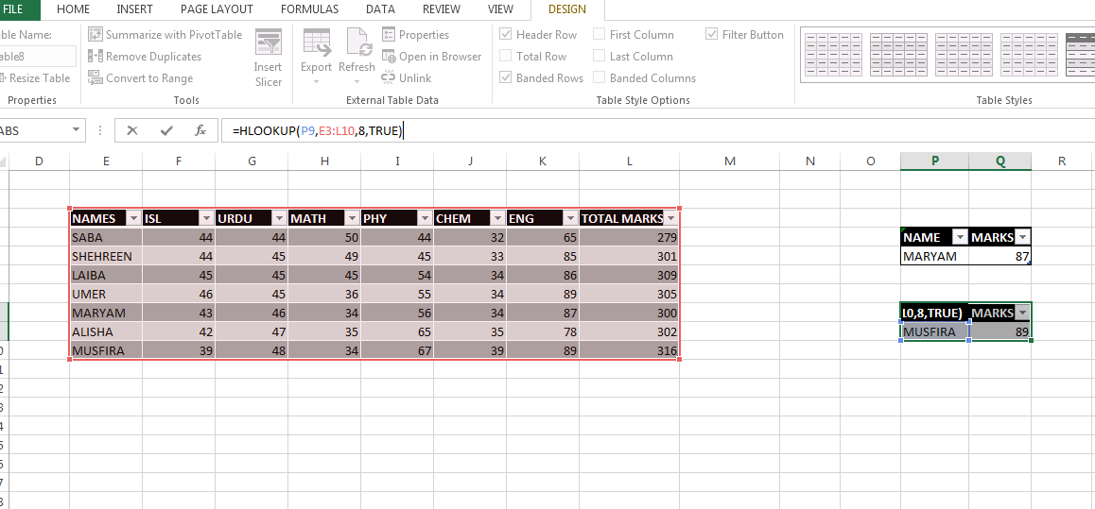

## **CONDITIONAL FORMATTING:**

SELECT-> CONDITIONAL FORMATTING -> NEW RULE->2ND OPTION

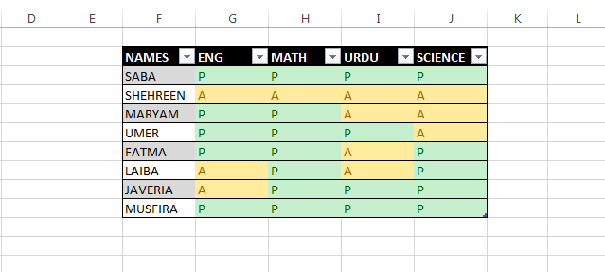

## **TWO WAYS:**

## **ASCENDING FORMATTING:**

INCREASE ORDER.

Alt+ H+ S+ S.

## **DESCENDING FORMATTING:**

DECREASE ORDER.

Alt+ H+ S+ O.

## **FILTERING:**

Ctrl+ shift+ L.

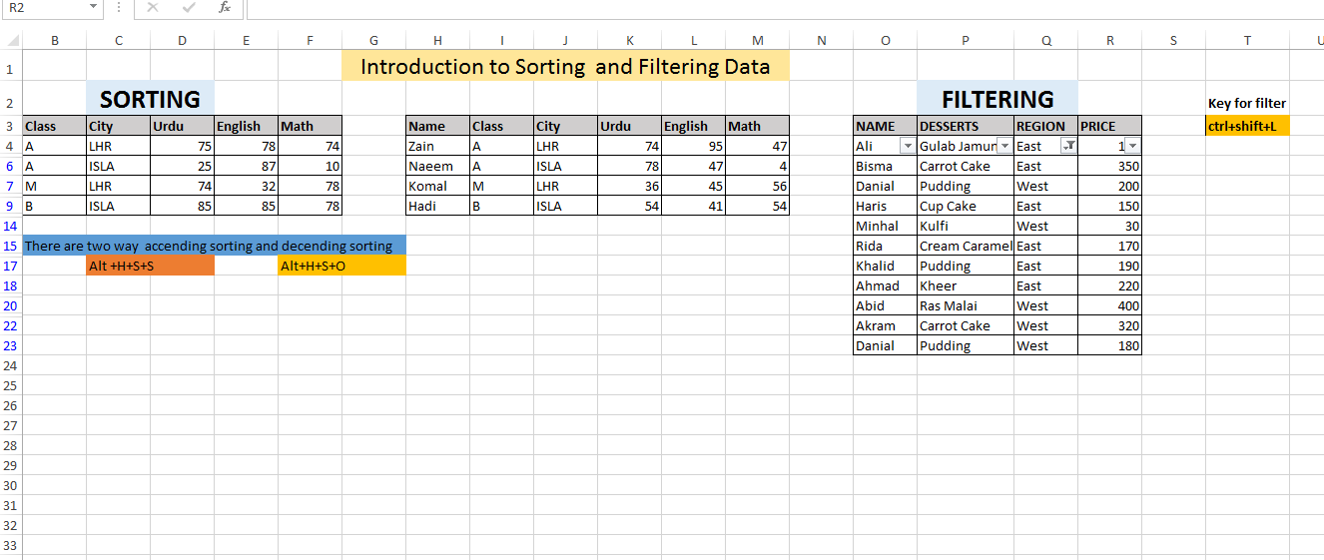

## **REFERENCING:**

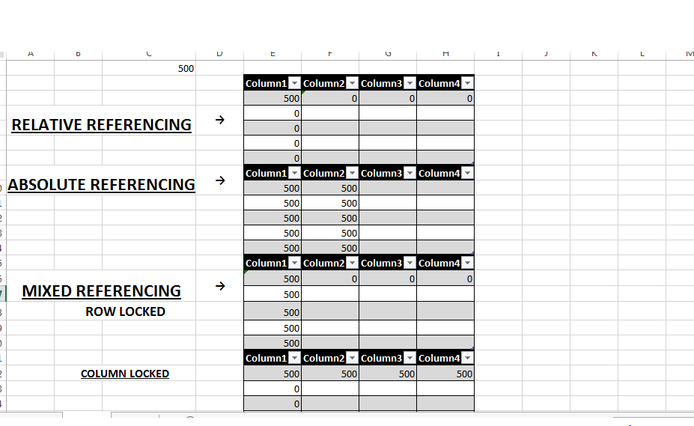

## **DATA FORMATTING:**

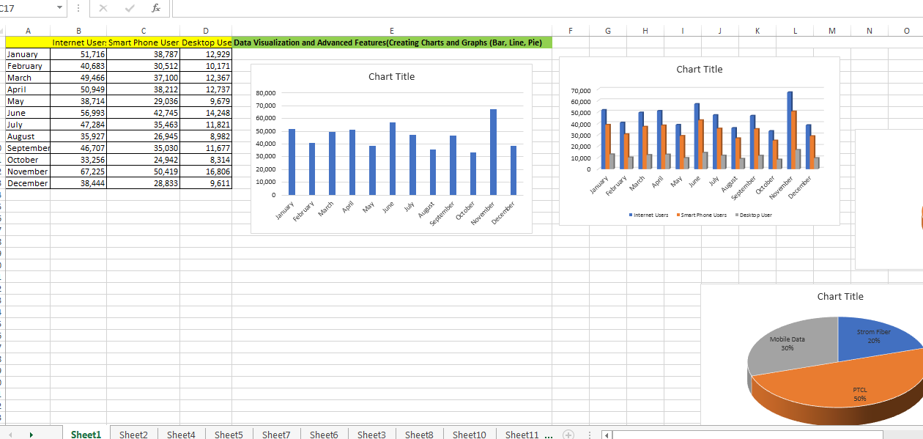

## **BAR CODE:**

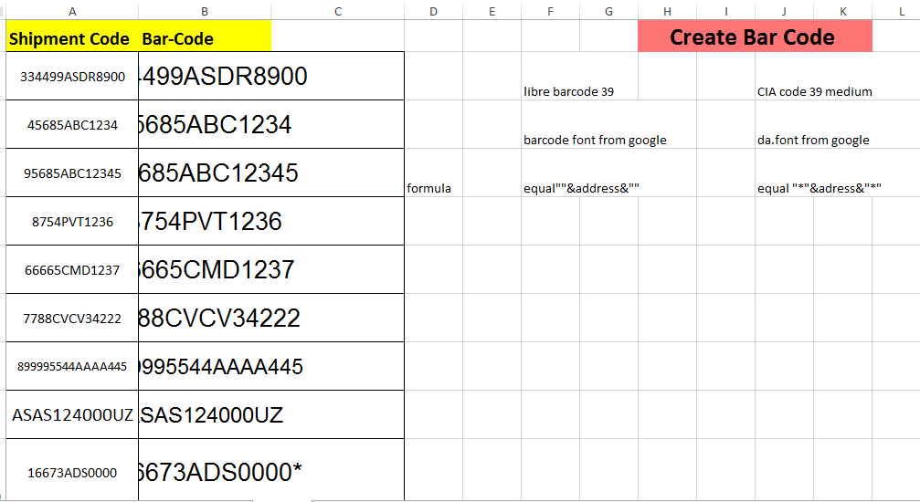

## **QR CODE:**

