☁ CloudDrive
Authentication & User Accounts
Team Module Report

Prepared by: Member 1
Project: CloudDrive — Scalable File Storage on AWS
Repository: github.com/Shehriyar-Ali-Rustam/clouddrive

Table of Contents
1. Project Overview 3
2. My Module: Authentication & User Accounts 3
3. How It Works — Authentication Flow 3
4. Data & Code 4
5. Technologies I Used — Why & Benefit 4
6. My Cloud & DevOps Contribution — Security, IAM & CI 4
7. Testing 5
8. Conclusion & My Contribution 6

1. Project Overview
CloudDrive is a cloud-based file-storage web application — a simplified Google Drive — that lets users securely upload, organise, download and share files on AWS. It was built by a team of three, each owning one feature module (and a slice of the cloud/DevOps work). This report covers my module.
Project module | Team member
Authentication & User Accounts | Member 1 (this report)
File Storage & Upload/Download | Shehriyar Ali Rustam
Sharing & Collaboration | Member 3

2. My Module: Authentication & User Accounts
This module secures the application: it lets users create accounts, log in, and proves their identity on every request. It also enforces per-user storage quotas and guarantees that each user can only ever see their own data.
- Sign-up and login with email and password.
- Passwords stored only as bcrypt one-way hashes — never in plain text.
- Stateless authentication using signed JSON Web Tokens (JWT).
- A reusable 'current user' guard that protects every private endpoint.
- Per-user storage quota shown as a live usage bar.
- Strict per-user isolation — every query is filtered by the owner.
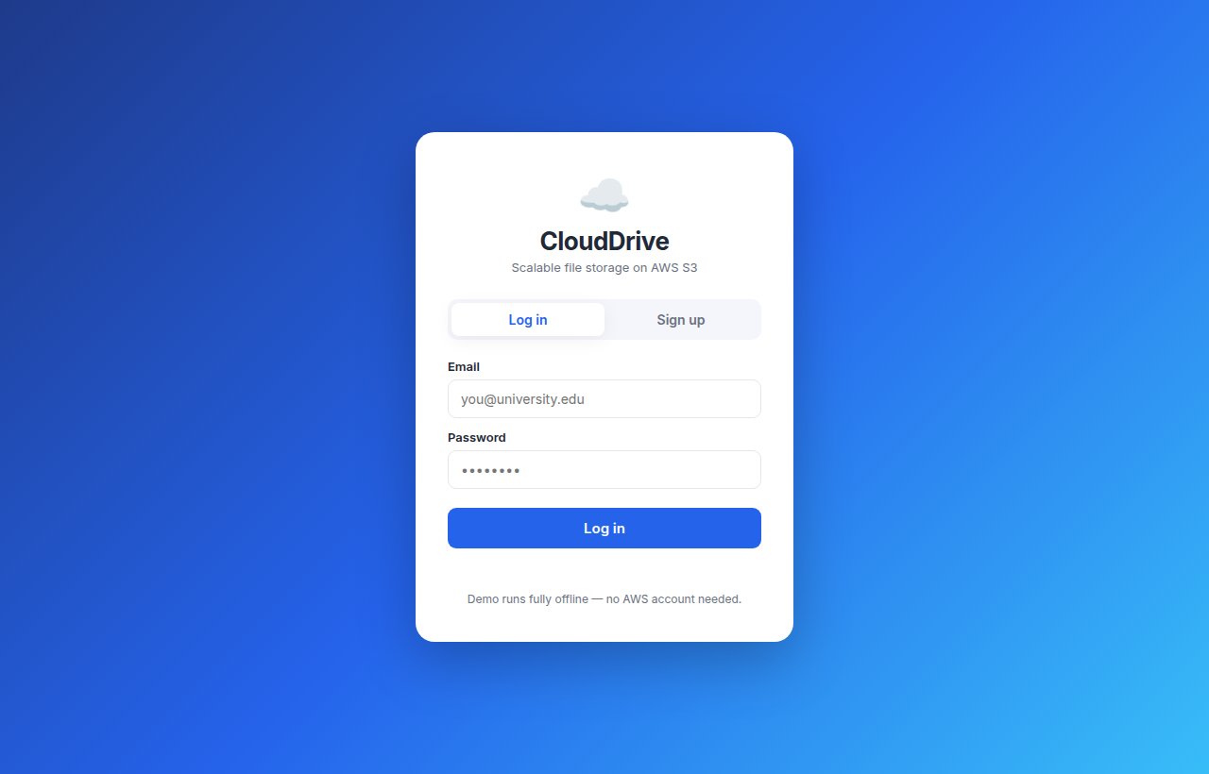
Figure 1: The sign-up / login screen.

3. How It Works — Authentication Flow
Authentication is stateless: the server hands the browser a signed token at login, and the browser presents it on every later request. No server-side sessions are kept.
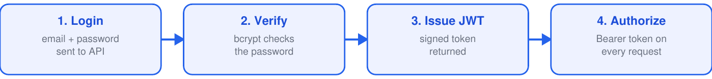
Figure 2: Stateless JWT authentication flow.

4. Data & Code
users table — field | Purpose
email | unique login identifier
password_hash | bcrypt hash of the password (never plaintext)
storage_used / storage_quota | bytes used vs allowed (the quota)
created_at | account creation time
Key endpoints / entry points:
POST /api/auth/signup -> create account, return JWT
POST /api/auth/login -> verify password, return JWT
GET /api/auth/me -> current user + quota (guarded)
Implemented in backend/auth.py (hashing, JWT, the get_current_user guard) and the auth endpoints in backend/main.py; the User model lives in backend/models.py. Frontend logic: submitAuth / enterApp / updateQuota / logout in frontend/app.js.

5. Technologies I Used — Why & Benefit
Tool / Service | Why it was used & its benefit
Python 3.12 | Readable, productive language with a huge ecosystem for web and AWS. Benefit: fast development and excellent library support (FastAPI, boto3).
FastAPI | Modern async web framework with built-in validation and auto-generated API docs. Benefit: high performance, less boilerplate, fewer bugs.
JWT (python-jose) | Stateless, signed bearer tokens for authentication. Benefit: no server-side sessions, so the API scales horizontally.
bcrypt | Industry-standard one-way password hashing. Benefit: passwords stay safe even if the database is ever leaked.
Pydantic | Validates request/response data and app settings using type hints. Benefit: bad input is rejected automatically; configuration is type-safe.
AWS IAM | Defines least-privilege roles and policies. Benefit: the app can touch only its own bucket — limits damage if compromised.
GitHub Actions | Automated CI/CD pipeline. Benefit: every push runs the tests and can auto-deploy — bugs are caught early.
pytest | Automated testing framework (19 tests). Benefit: confidence that new changes don't break existing features.

6. My Cloud & DevOps Contribution — Security, IAM & CI
Beyond the feature, I own the project's security posture and its continuous-integration testing.
- Security model: bcrypt password hashing, expiring JWTs, and per-user isolation.
- AWS IAM least-privilege roles so the application can access only its own S3 bucket.
- GitHub Actions CI that runs the entire test suite automatically on every push.
Security control | How it protects the system
bcrypt hashing | passwords stay safe even if the database leaks
JWT (expiring) | stateless auth, so the API scales horizontally
IAM least-privilege | the app is limited to a single S3 bucket
Per-user isolation | users can never see each other's data
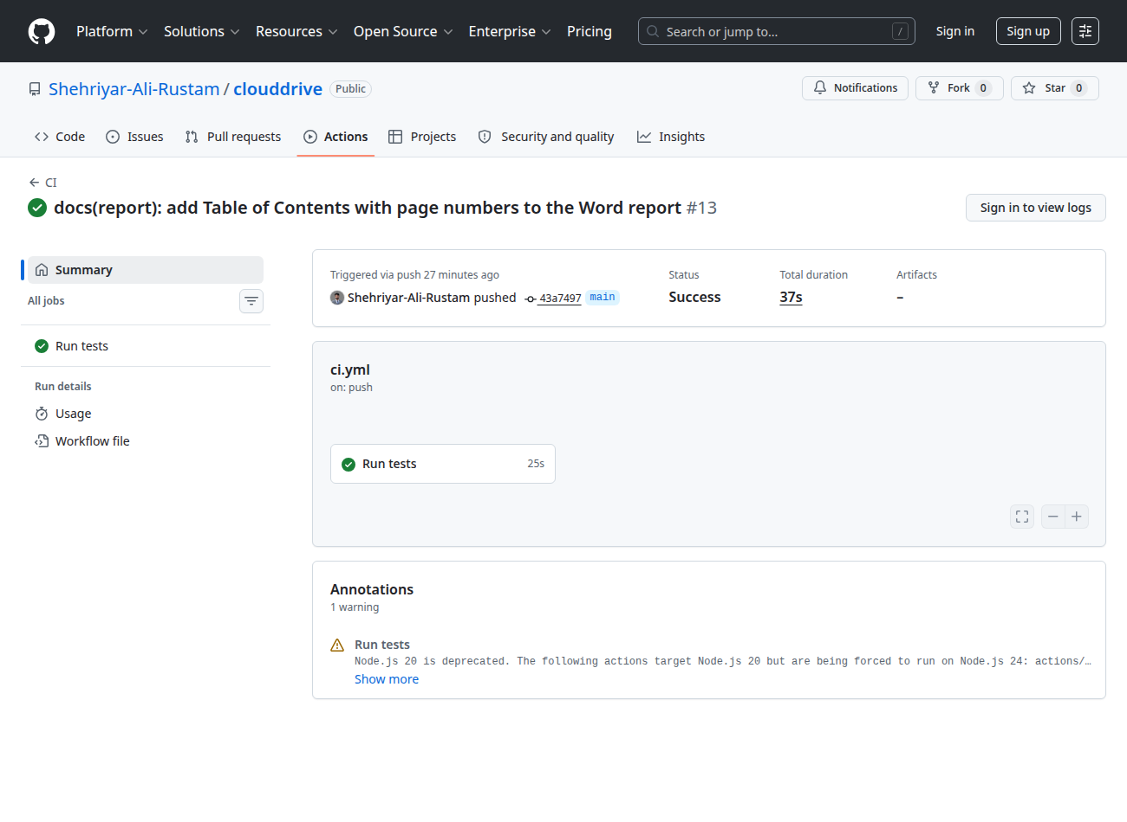
Figure 3: GitHub Actions CI running the automated test suite.

7. Testing
Test (tests/test_auth.py) | What it checks
signup returns token | account creation issues a JWT
duplicate email rejected | no two accounts share an email (400)
login wrong password | rejected with 401
me requires auth | protected endpoint blocks anonymous access
me returns user + quota | identity and quota returned correctly
6 automated tests cover this module (tests/test_auth.py), all passing in CI.

8. Conclusion & My Contribution
I delivered the authentication and account system — secure signup/login with JWT and bcrypt, the guard that protects every endpoint, and per-user quotas and isolation — plus the project's IAM security posture and the GitHub Actions CI that keeps the whole codebase tested.

