☁ CloudDrive
File Storage & Upload/Download
Team Module Report

Prepared by: Shehriyar Ali Rustam
Project: CloudDrive — Scalable File Storage on AWS
Repository: github.com/Shehriyar-Ali-Rustam/clouddrive

Table of Contents
1. Project Overview 3
2. My Module: File Storage & Upload/Download 3
3. How It Works — The Pre-signed Upload Flow 4
4. Data & Code 4
5. Technologies I Used — Why & Benefit 4
6. My Cloud & DevOps Contribution — S3, Terraform & Docker 5
7. Testing 6
8. Conclusion & My Contribution 6

1. Project Overview
CloudDrive is a cloud-based file-storage web application — a simplified Google Drive — that lets users securely upload, organise, download and share files on AWS. It was built by a team of three, each owning one feature module (and a slice of the cloud/DevOps work). This report covers my module.
Project module | Team member
Authentication & User Accounts | Member 1
File Storage & Upload/Download | Shehriyar Ali Rustam (this report)
Sharing & Collaboration | Member 3

2. My Module: File Storage & Upload/Download
This module is the heart of CloudDrive: it stores users' files in the cloud and moves bytes efficiently using pre-signed URLs, so the API server never becomes a bottleneck.
- Upload, download, list and delete files; organise them in folders.
- Files are stored as objects in Amazon S3 — not on the application server.
- Pre-signed URLs let the browser transfer bytes directly to and from S3.
- A pluggable storage layer: real S3 in the cloud, local disk for offline development — same code.
- Quota is checked before an upload, billed after it, and refunded on delete.
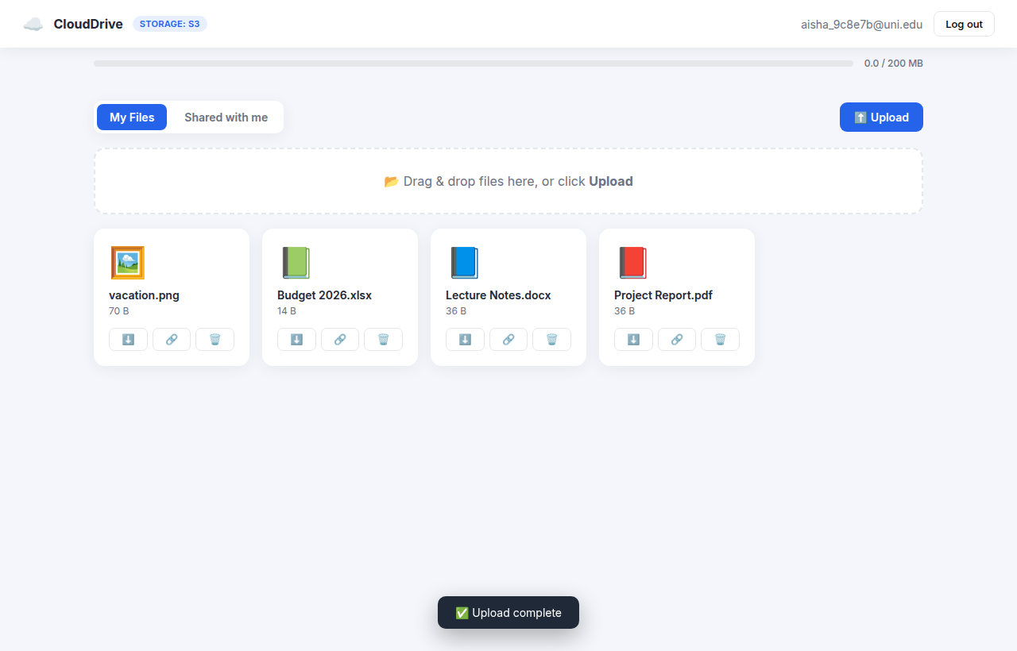
Figure 1: The file dashboard (the badge shows storage: S3).

3. How It Works — The Pre-signed Upload Flow
The API never streams file bytes. It issues a short-lived signed permission slip (a pre-signed URL) and the browser uploads straight to S3 — the single most important decision for scalability.
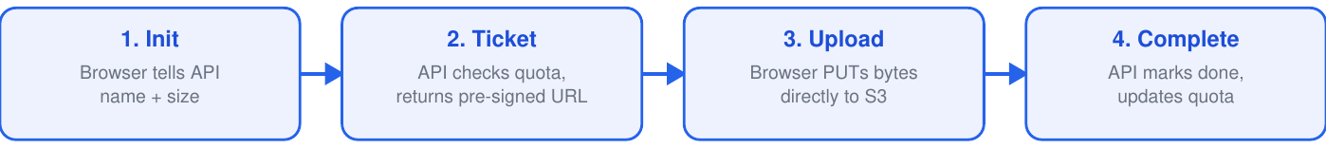
Figure 2: Three-step pre-signed upload — bytes never pass through the API.

4. Data & Code
files table — field | Purpose
s3_key | the object's location in S3
size / content_type | byte size and MIME type
owner_id / folder_id | the owner and the containing folder
uploaded | flipped true once the bytes have landed
Key endpoints / entry points:
POST /api/files/init -> pre-signed upload URL
POST /api/files/{id}/complete -> confirm upload, bill quota
GET /api/files -> list my files
GET /api/files/{id}/download -> pre-signed download URL
DELETE /api/files/{id} -> delete + refund quota
POST/GET /api/folders -> folder management
Implemented in backend/storage.py (the S3/local storage abstraction) and the file/folder endpoints in backend/main.py; the File and Folder models in backend/models.py. Frontend: uploadOne / putWithProgress / loadFiles / renderGrid in frontend/app.js.

5. Technologies I Used — Why & Benefit
Tool / Service | Why it was used & its benefit
Python 3.12 | Readable, productive language with a huge ecosystem for web and AWS. Benefit: fast development and excellent library support (FastAPI, boto3).
FastAPI | Modern async web framework with built-in validation and auto-generated API docs. Benefit: high performance, less boilerplate, fewer bugs.
SQLAlchemy | Database-agnostic ORM mapping Python objects to tables. Benefit: switch SQLite (local) to PostgreSQL (cloud) with no code change; avoids hand-written SQL.
Amazon S3 | Cloud object storage for the actual file bytes. Benefit: virtually unlimited, 99.999999999% durable, cheap, and offloads heavy file traffic from the server.
boto3 | Official AWS SDK for Python. Benefit: generates S3 pre-signed URLs and manages buckets with a few lines of code.
SQLite | Zero-configuration file database for local development. Benefit: run and test instantly with no database server.
Terraform | Defines the whole AWS stack as code. Benefit: reproducible, version-controlled infrastructure built or destroyed with one command (controls cost).
Docker | Packages the app and its dependencies into a container. Benefit: runs identically everywhere — no 'works on my machine' issues.

6. My Cloud & DevOps Contribution — S3, Terraform & Docker
I own the project's cloud storage and its packaging and infrastructure-as-code.
- An Amazon S3 bucket with versioning and AES-256 encryption, with all public access blocked.
- Terraform definitions that provision the S3 bucket and supporting infrastructure as code.
- A Dockerfile that containerizes the whole app; the same image runs locally and on ECS.
FROM python:3.12-slim
WORKDIR /app
RUN pip install --no-cache-dir -r requirements.txt
COPY backend ./backend ; COPY frontend ./frontend
CMD ["uvicorn", "backend.main:app", "--host", "0.0.0.0", "--port", "8000"]
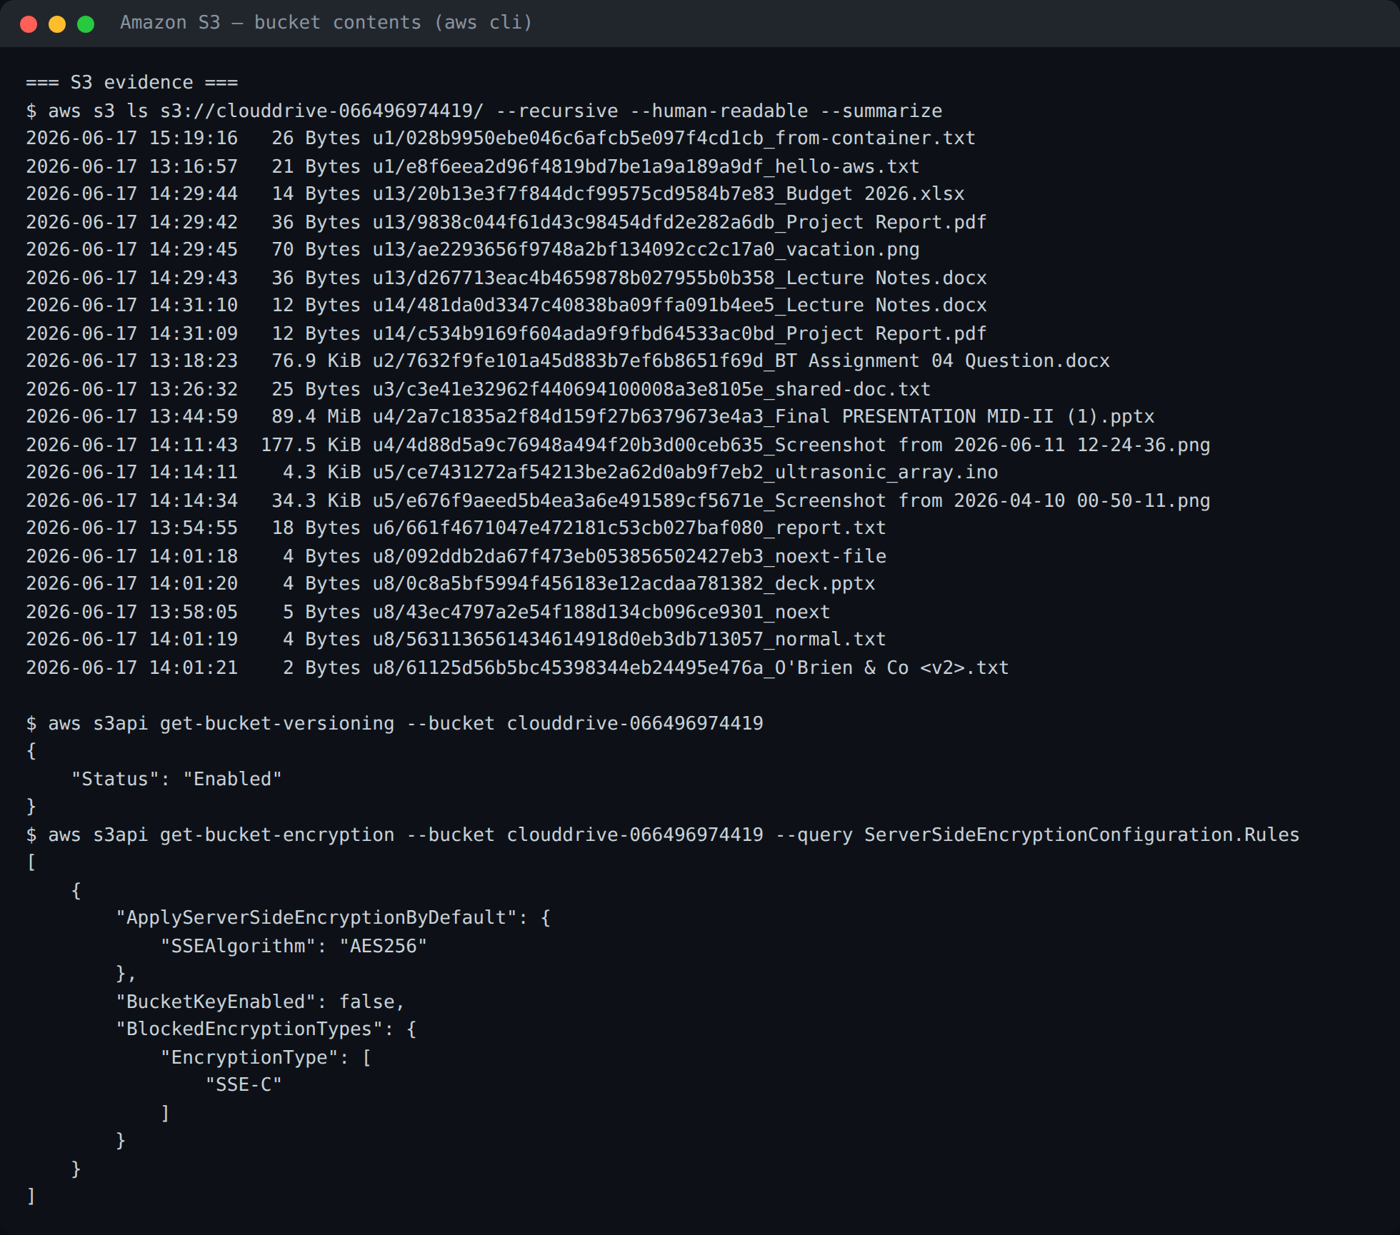
Figure 3: Real objects in the S3 bucket (versioning + AES-256).
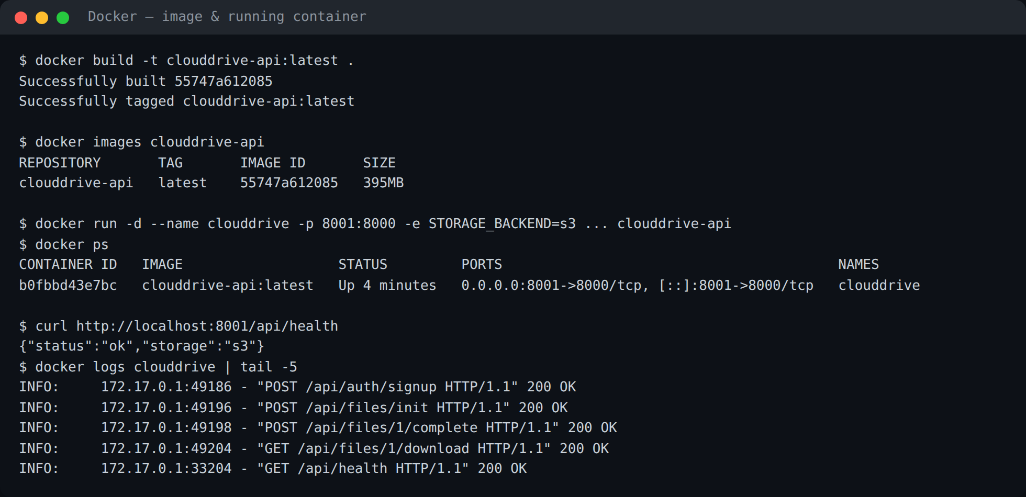
Figure 4: The app running inside a Docker container, serving S3.

7. Testing
Test (tests/test_files.py) | What it checks
upload lifecycle | init -> PUT -> complete succeeds
file appears in list | an uploaded file is listed
download returns bytes | downloaded content matches the original
quota billed / freed | quota updates on upload and on delete
quota exceeded -> 413 | an over-quota upload is rejected
cross-user blocked | a user cannot access another's file
7 automated tests cover this module (tests/test_files.py), all passing in CI.

8. Conclusion & My Contribution
I delivered the cloud storage core — the pre-signed upload/download flow on Amazon S3, the pluggable storage layer, and folder and quota management — plus the Terraform and Docker packaging that make the application deployable to the cloud.

