☁ CloudDrive
Sharing & Collaboration
Team Module Report

Prepared by: Member 3
Project: CloudDrive — Scalable File Storage on AWS
Repository: github.com/Shehriyar-Ali-Rustam/clouddrive

Table of Contents
1. Project Overview 3
2. My Module: Sharing & Collaboration 3
3. How It Works — Sharing Flow 4
4. Data & Code 5
5. Technologies I Used — Why & Benefit 5
6. My Cloud & DevOps Contribution — Deployment & Networking 5
7. Testing 6
8. Conclusion & My Contribution 7

1. Project Overview
CloudDrive is a cloud-based file-storage web application — a simplified Google Drive — that lets users securely upload, organise, download and share files on AWS. It was built by a team of three, each owning one feature module (and a slice of the cloud/DevOps work). This report covers my module.
Project module | Team member
Authentication & User Accounts | Member 1
File Storage & Upload/Download | Shehriyar Ali Rustam
Sharing & Collaboration | Member 3 (this report)

2. My Module: Sharing & Collaboration
This module lets users share their files — either with another registered user, or with anyone via a public link that can expire — and shows each user the files that others have shared with them.
- Share a file with a registered user by email.
- Generate a public link that anyone can open, with an optional expiry time.
- A 'Shared with me' view listing files that others have shared.
- Secure downloads: links are short-lived pre-signed URLs scoped to a single file.
- Public links redirect straight to storage, so the server never streams the bytes.
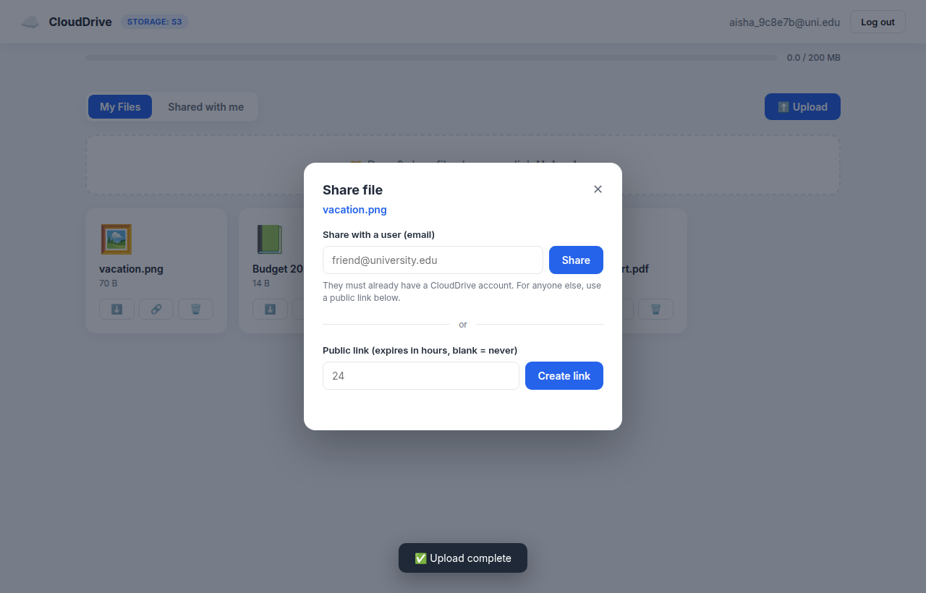
Figure 1: The share dialog — share with a user or create a link.
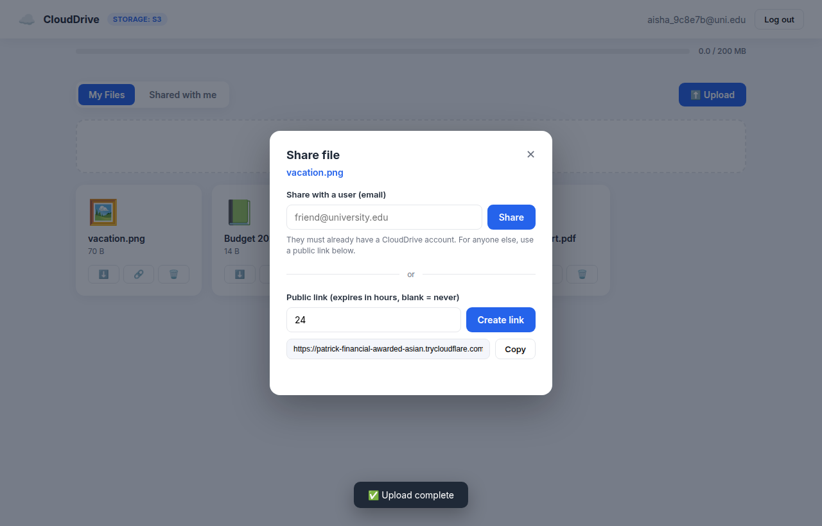
Figure 2: A generated public expiring link.
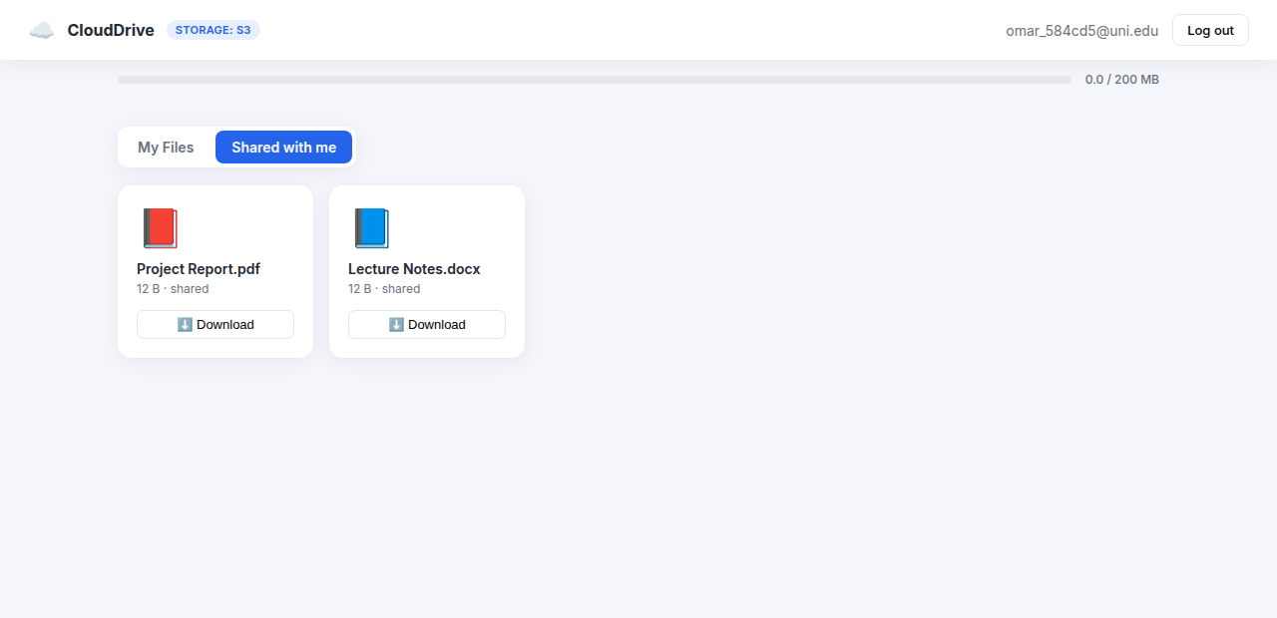
Figure 3: 'Shared with me' — files another user shared.

3. How It Works — Sharing Flow
A share is recorded as a small database row — either pointing at a recipient user or holding an unguessable public token. Downloads always go through a short-lived pre-signed redirect.
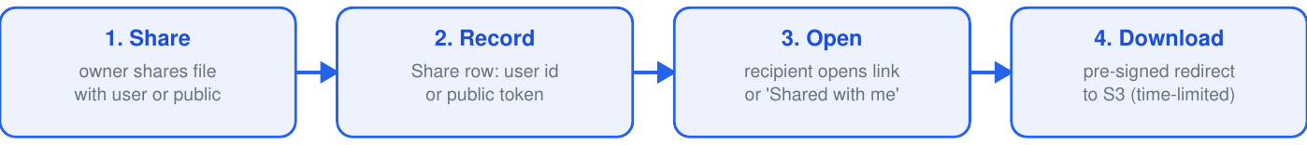
Figure 4: Sharing and secure download flow.

4. Data & Code
shares table — field | Purpose
file_id | the file being shared
shared_with_user_id | the recipient (for a user-to-user share)
public_token | unguessable token (for a public link)
expires_at | optional expiry time after which the link fails
Key endpoints / entry points:
POST /api/shares -> share with user OR create public link
GET /api/shared-with-me -> files shared with me
GET /api/files/{id}/shared-download -> download a file shared with me
GET /api/public/{token} -> public download (redirects to S3)
Implemented in the sharing endpoints of backend/main.py (create_share, shared_with_me, shared_download, public_download); the Share model in backend/models.py. Frontend: openShare / shareWithUser / makePublicLink / loadSharedWithMe in frontend/app.js.

5. Technologies I Used — Why & Benefit
Tool / Service | Why it was used & its benefit
Python 3.12 | Readable, productive language with a huge ecosystem for web and AWS. Benefit: fast development and excellent library support (FastAPI, boto3).
FastAPI | Modern async web framework with built-in validation and auto-generated API docs. Benefit: high performance, less boilerplate, fewer bugs.
SQLAlchemy | Database-agnostic ORM mapping Python objects to tables. Benefit: switch SQLite (local) to PostgreSQL (cloud) with no code change; avoids hand-written SQL.
Render | Platform-as-a-Service for permanent hosting. Benefit: a permanent HTTPS URL plus a free managed PostgreSQL, deployed straight from GitHub.
Cloudflare Tunnel | Exposes the local app on a public HTTPS URL. Benefit: a free, shareable link for live demos with no deployment.
Amazon ECS Fargate | Runs the API in serverless containers. Benefit: auto-scales 1→4 under load with no servers to manage.
Application Load Balancer | Distributes traffic across API containers. Benefit: high availability and automatic health checks.
Amazon VPC | Isolated virtual network with public/private subnets. Benefit: the database and app are not exposed to the public internet.

6. My Cloud & DevOps Contribution — Deployment & Networking
I own getting the application onto the internet and the network that supports it.
- Deployment to Render (a permanent URL plus a managed PostgreSQL) and a Cloudflare tunnel for demos.
- The AWS network: a VPC with public/private subnets and an Application Load Balancer in front of ECS.
- The continuous-deployment workflow that builds the image and ships it.
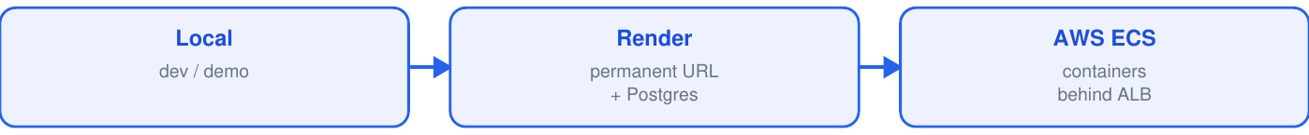
Figure 5: Deployment options (all use Amazon S3 for files).
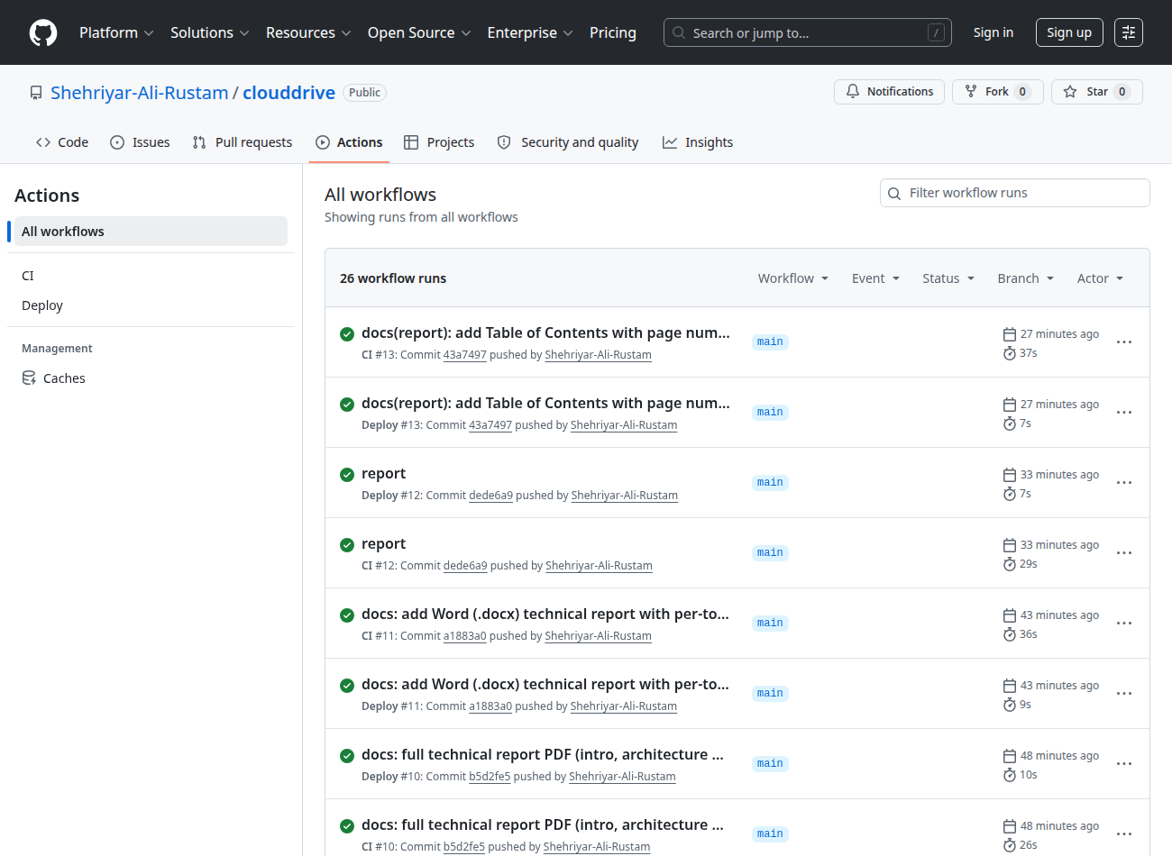
Figure 6: GitHub Actions — CI and Deploy workflows running green.

7. Testing
Test (tests/test_sharing_security.py) | What it checks
share with user | creates a share for that user
unknown user -> 404 | cannot share to a non-existent account
public link download | the token resolves and downloads
unknown token -> 404 | bad links are rejected
tampered signature -> 403 | forged pre-signed URLs are blocked
6 automated tests cover this module (tests/test_sharing_security.py).

8. Conclusion & My Contribution
I delivered the sharing and collaboration features — user-to-user sharing, public expiring links, and the 'Shared with me' view with secure pre-signed downloads — plus the project's deployment (Render / ECS / tunnel) and the network (VPC and load balancer) that put it online.

