☁ CloudDrive
Technical Report
Scalable File Storage on AWS — a Mini Google Drive
Final-Year Cloud Computing Project

Author: Shehriyar Ali Rustam
Repository: github.com/Shehriyar-Ali-Rustam/clouddrive

1. Introduction

1.1 Problem Statement
Storing and sharing files across devices and people is a universal need. Traditional approaches that stream every file through an application server do not scale: the server becomes a bottleneck and a single point of failure. CloudDrive solves this with cloud object storage and pre-signed URLs, keeping the application server stateless and horizontally scalable.

1.2 Objectives
- Provide secure user accounts with authentication and per-user isolation.
- Allow uploading, downloading, organising and deleting files in the cloud.
- Enable sharing — with registered users and via public expiring links.
- Demonstrate a scalable, cloud-native architecture (S3, RDS, ECS, IAM).
- Automate infrastructure (Terraform) and delivery (CI/CD).

1.3 Scope
The system covers authentication, file/folder management, quotas, sharing, and a polished web UI. It runs in two interchangeable modes — local (SQLite + disk) for offline development and AWS (S3 + PostgreSQL) for the cloud — selected purely by configuration, with no code changes.

2. Key Features
Feature | Description
Authentication | Email + password sign-up/login, JWT tokens, bcrypt-hashed passwords
File upload/download | Browser transfers bytes directly to storage via pre-signed URLs
Organisation | Files and folders, isolated per user
Sharing | Share with a registered user, or create a public expiring link
Storage quota | Per-user limit with a live usage bar
Versioning | S3 bucket versioning keeps previous file versions
Two run modes | Local (SQLite+disk) and Cloud (S3+PostgreSQL) via one setting

3. System Architecture
The design separates concerns: the database stores only metadata (who owns what, file names, sizes, storage keys, share rules) while Amazon S3 stores the actual file bytes. The browser talks directly to S3 for the heavy data transfer.
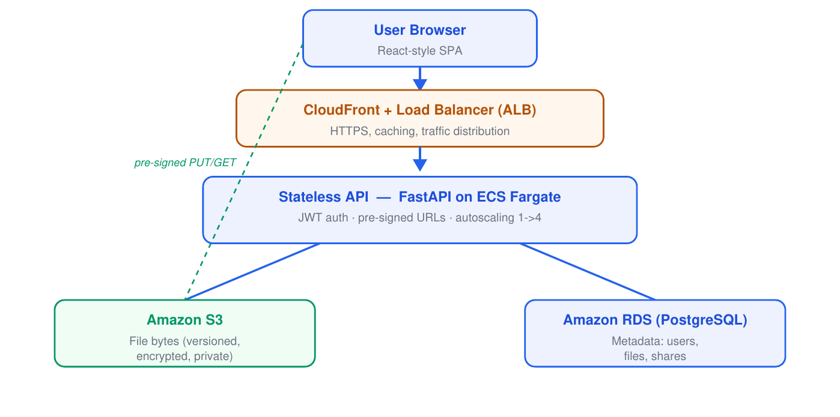
Figure 1: High-level cloud architecture.

3.1 Components
Component | Technology | Responsibility
Frontend | HTML/CSS/JS SPA | Dashboard UI, upload flow, sharing
API | FastAPI on ECS Fargate | Auth, metadata, pre-signed URL issuing
File storage | Amazon S3 | Stores file bytes; versioned & encrypted
Database | PostgreSQL / SQLite | Users, files, folders, shares
Load balancer | Application Load Balancer | Distributes traffic, health checks
Auth | JWT + bcrypt | Stateless authentication
IaC | Terraform | Provisions the entire AWS stack

4. The Pre-signed URL Upload Flow
This is the central cloud concept. The API never streams file bytes; it issues a short-lived signed permission slip (a pre-signed URL) and the browser uploads directly to S3. This keeps the API lightweight and horizontally scalable.
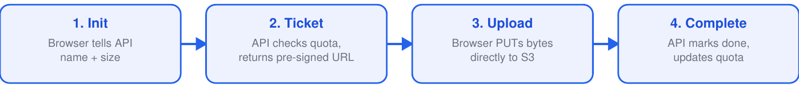
Figure 2: Three-step pre-signed upload sequence.

5. Data Model
Four tables capture all metadata. File bytes live in S3, referenced by a storage key.
Table | Key Fields | Purpose
users | id, email, password_hash, storage_used, storage_quota | Accounts & quota
folders | id, name, owner_id, parent_id | Folder hierarchy
files | id, name, s3_key, size, owner_id, folder_id, uploaded | File metadata
shares | id, file_id, shared_with_user_id, public_token, expires_at | Sharing rules

6. Technology Stack — Why Each Tool & Its Benefit
Every technology below was chosen for a specific reason. The table for each layer explains why it was used and the benefit it brings to CloudDrive.

Backend & Language
Tool / Service | Why it was used & its benefit
Python 3.12 | Readable, productive language with a huge ecosystem for web and AWS. Benefit: fast development and excellent library support (FastAPI, boto3).
FastAPI | Modern async web framework with built-in validation and auto-generated API docs. Benefit: high performance, less boilerplate, fewer bugs.
Uvicorn | Lightning-fast ASGI server that runs the async FastAPI app. Benefit: handles many concurrent requests efficiently.
SQLAlchemy | Database-agnostic ORM mapping Python objects to tables. Benefit: switch SQLite (local) to PostgreSQL (cloud) with no code change; avoids hand-written SQL.
Pydantic | Validates request/response data and app settings using type hints. Benefit: bad input is rejected automatically; configuration is type-safe.

Frontend
Tool / Service | Why it was used & its benefit
HTML5 / CSS3 | Standard markup and styling for the dashboard UI. Benefit: lightweight, responsive, no build tooling required.
Vanilla JavaScript | Implements the upload flow, drag-and-drop and sharing without a framework. Benefit: zero dependencies, fast to load, easy to explain in a viva.

Security & Authentication
Tool / Service | Why it was used & its benefit
JWT (python-jose) | Stateless, signed bearer tokens for authentication. Benefit: no server-side sessions, so the API scales horizontally.
bcrypt | Industry-standard one-way password hashing. Benefit: passwords stay safe even if the database is ever leaked.

Storage, Database & SDK
Tool / Service | Why it was used & its benefit
Amazon S3 | Cloud object storage for the actual file bytes. Benefit: virtually unlimited, 99.999999999% durable, cheap, and offloads heavy file traffic from the server.
PostgreSQL | Robust relational database for metadata in production. Benefit: reliable, ACID-compliant, scales well.
SQLite | Zero-configuration file database for local development. Benefit: run and test instantly with no database server.
psycopg2 | PostgreSQL driver for Python. Benefit: stable, well-supported connectivity to RDS.
boto3 | Official AWS SDK for Python. Benefit: generates S3 pre-signed URLs and manages buckets with a few lines of code.

AWS Cloud Infrastructure
Tool / Service | Why it was used & its benefit
AWS IAM | Defines least-privilege roles and policies. Benefit: the app can touch only its own bucket — limits damage if compromised.
Amazon RDS | Managed PostgreSQL service. Benefit: automated backups, patching and scaling — no manual database administration.
Amazon ECS Fargate | Runs the API in serverless containers. Benefit: auto-scales 1→4 under load with no servers to manage.
Application Load Balancer | Distributes traffic across API containers. Benefit: high availability and automatic health checks.
Amazon VPC | Isolated virtual network with public/private subnets. Benefit: the database and app are not exposed to the public internet.
Amazon ECR | Private registry for Docker images. Benefit: secure, integrates directly with ECS deployments.

DevOps, IaC & Tooling
Tool / Service | Why it was used & its benefit
Terraform | Defines the whole AWS stack as code. Benefit: reproducible, version-controlled infrastructure built or destroyed with one command (controls cost).
Docker | Packages the app and its dependencies into a container. Benefit: runs identically everywhere — no 'works on my machine' issues.
GitHub Actions | Automated CI/CD pipeline. Benefit: every push runs the tests and can auto-deploy — bugs are caught early.
Git & GitHub | Version control and code hosting. Benefit: full history, backup, and collaboration.
pytest | Automated testing framework (19 tests). Benefit: confidence that new changes don't break existing features.

Hosting & Networking
Tool / Service | Why it was used & its benefit
Render | Platform-as-a-Service for permanent hosting. Benefit: a permanent HTTPS URL plus a free managed PostgreSQL, deployed straight from GitHub.
Cloudflare Tunnel | Exposes the local app on a public HTTPS URL. Benefit: a free, shareable link for live demos with no deployment.

7. Security Model
Control | How it protects the system
Password hashing | bcrypt one-way hashes; plaintext never stored
JWT auth | Signed, expiring bearer tokens on every API call
Pre-signed URLs | Time-limited (15 min), scoped to a single object
Private bucket | S3 blocks all public access; encrypted at rest (AES-256)
IAM least-privilege | API role may touch only this one bucket
Per-user isolation | Every query filtered by owner_id
Quota enforcement | Prevents a single user exhausting storage

8. User Interface
Real screenshots of the running application (the badge shows storage: S3).
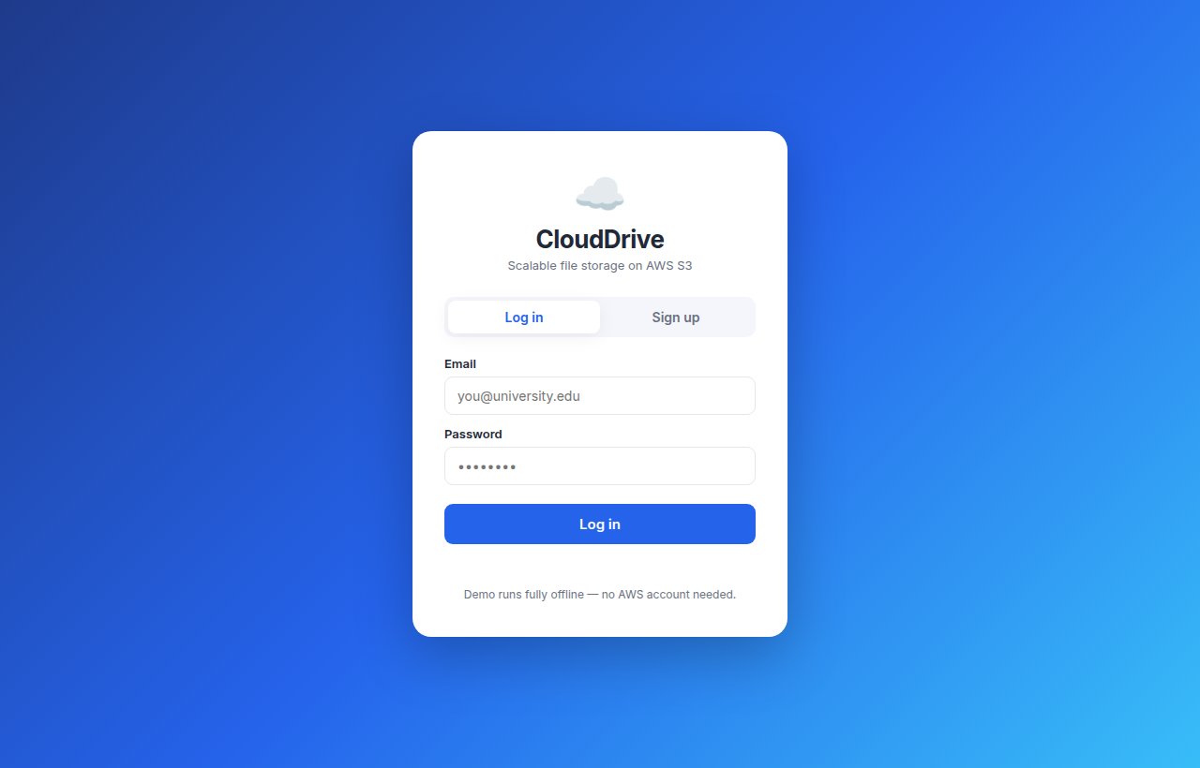
Figure 3: Sign-up / login screen.
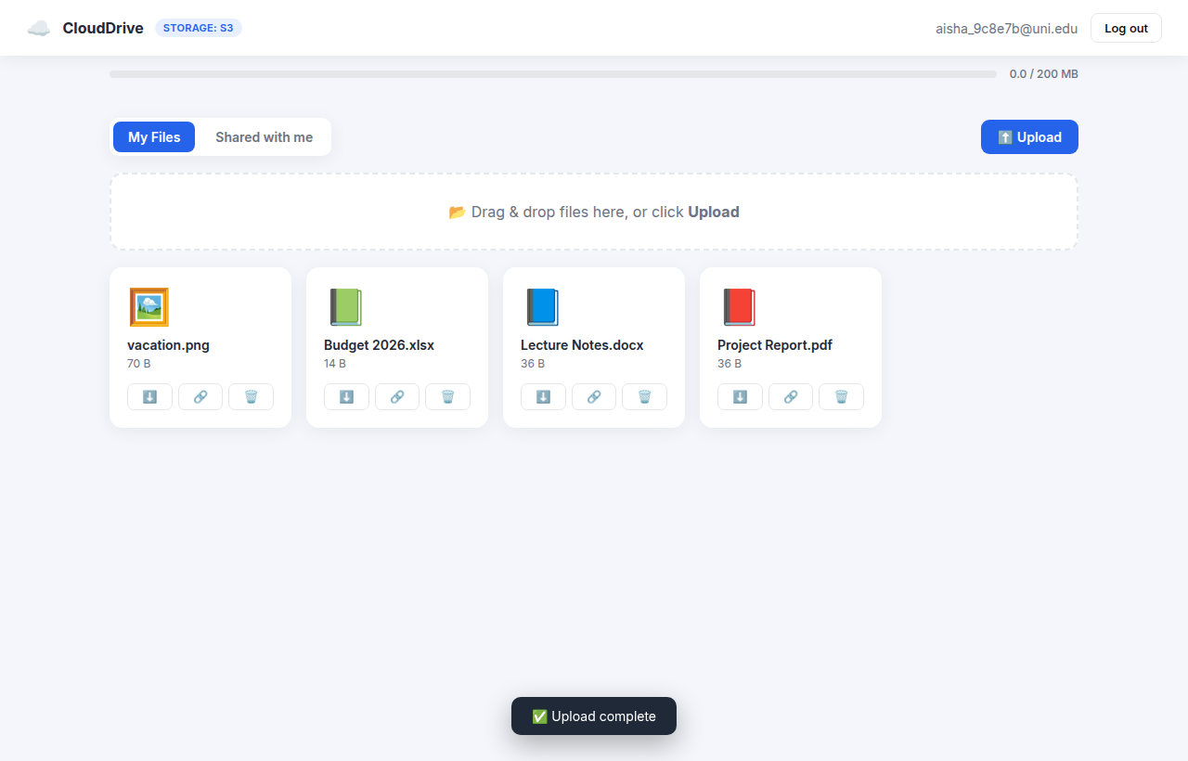
Figure 4: Dashboard — files on AWS S3, quota bar, type icons.
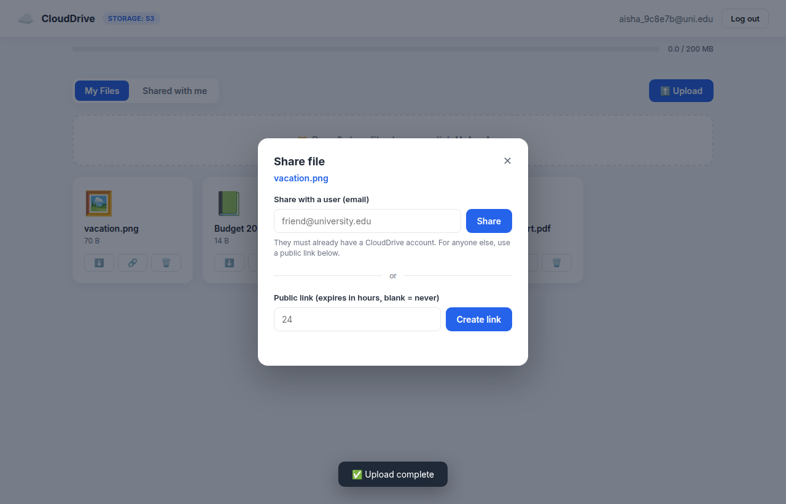
Figure 5: Share dialog — share with a user or create a public link.
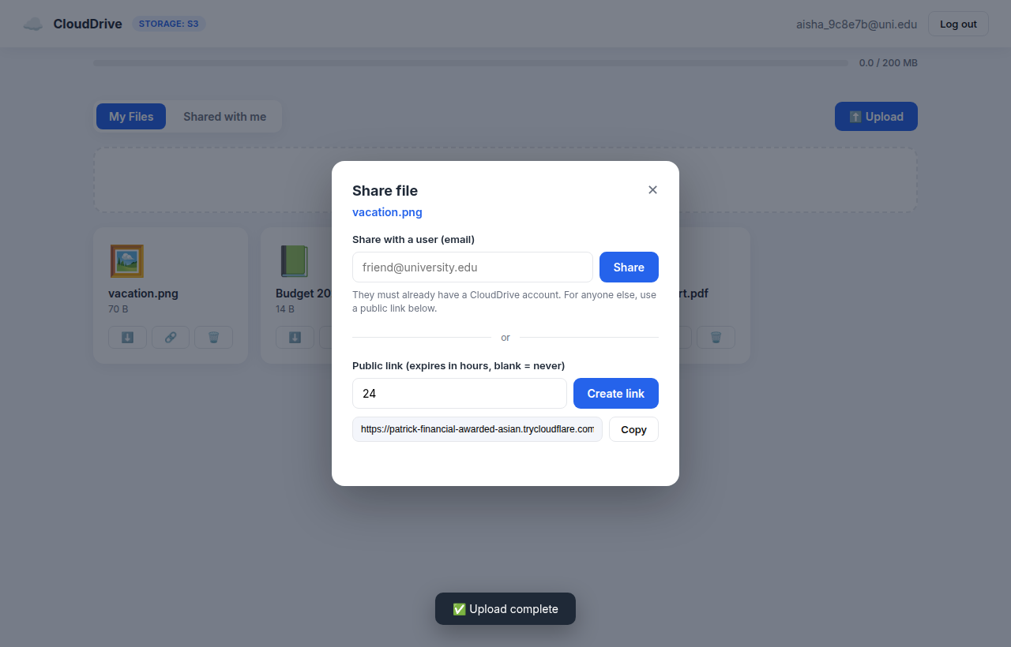
Figure 6: A generated public expiring link.
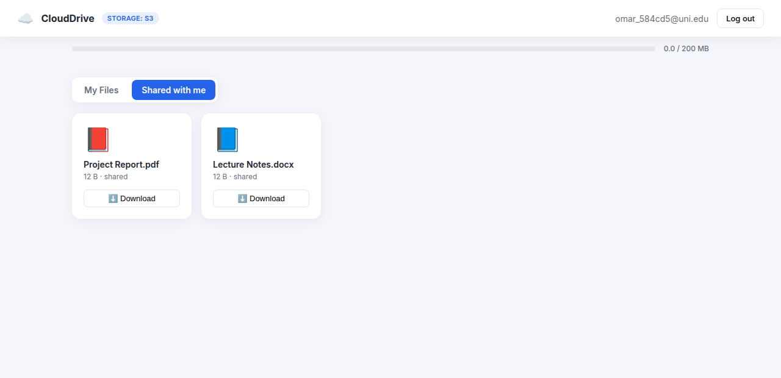
Figure 7: 'Shared with me' — files another user shared.

9. Cloud Deployment
Files are stored in a real Amazon S3 bucket using pre-signed URLs. The application can be run or deployed three ways, all sharing the same S3 storage:
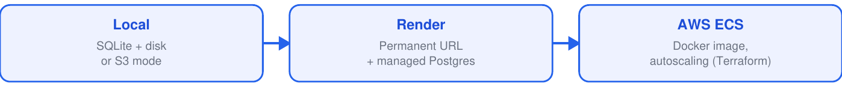
Figure 8: Deployment options (all use Amazon S3 for files).
For demonstrations, a Cloudflare tunnel exposes the local app on a public HTTPS URL so it can be opened from any device. The full AWS stack is defined in Terraform (validated) and deploys via the CI/CD pipeline below.

10. Testing
Nineteen automated tests (pytest) cover the critical paths and security:
Area | Examples | Tests
Authentication | signup, login, wrong password, duplicate email | 6
Files | upload lifecycle, listing, quota, delete, isolation | 7
Sharing & security | user share, public link, tampered/expired URL | 6
All 19 tests pass and run automatically on every push via GitHub Actions.

11. CI/CD Pipeline
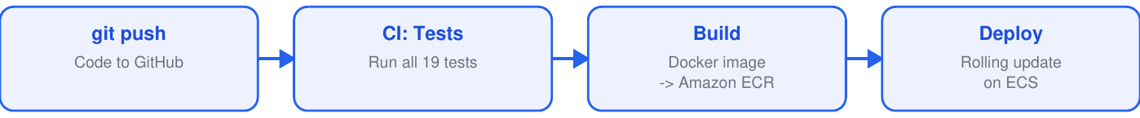
Figure 9: Continuous integration & deployment flow.

12. Cost & Free Tier
Service | Cost note
Amazon S3 | Free tier: 5 GB + 20k GETs + 2k PUTs — demo cost ~ $0
IAM / ECR | Free
RDS (db.t3.micro) | Free-tier eligible for 12 months
ALB / NAT / ECS | Billed hourly — destroyed after demos via 'terraform destroy'
Render / Tunnel | Free tiers

13. Conclusion & Future Work
CloudDrive delivers a complete, working and tested cloud application that demonstrates the key principles of cloud computing — object storage, pre-signed URLs, managed databases, stateless scalable services, least-privilege security, infrastructure as code, and automated delivery. It runs on real AWS S3 and is fully reproducible from version control.
- Future: multipart upload for very large files (S3 multipart + Lambda confirm).
- Future: file previews and full-text search over metadata.
- Future: organisation/team workspaces and granular permissions.
Appendix — Run locally: bash run.sh · Run tests: bash run_tests.sh · Public demo: bash demo.sh

