StreamVault
Secure Video Streaming Platform on Microsoft Azure
Hub-and-Spoke Architecture | Private Networking | Application Gateway

Project Overview:
StreamVault is a secure video streaming web application deployed entirely on Microsoft Azure. Users log in with a username and password, and upon successful authentication are shown a list of videos which they can stream directly in the browser.
The project was built to demonstrate a production-grade hub-and-spoke network architecture, where the database and storage layers are never exposed to the public internet, and all public traffic is funneled through a single, centrally managed entry point (Application Gateway).

Goals
- Keep the database and blob storage completely private (no public endpoints).
- Expose only one public entry point (Application Gateway) to the internet.
- Authenticate users with hashed passwords and JWT tokens.
- Stream video content through the backend rather than exposing storage URLs directly.

Architecture Diagram

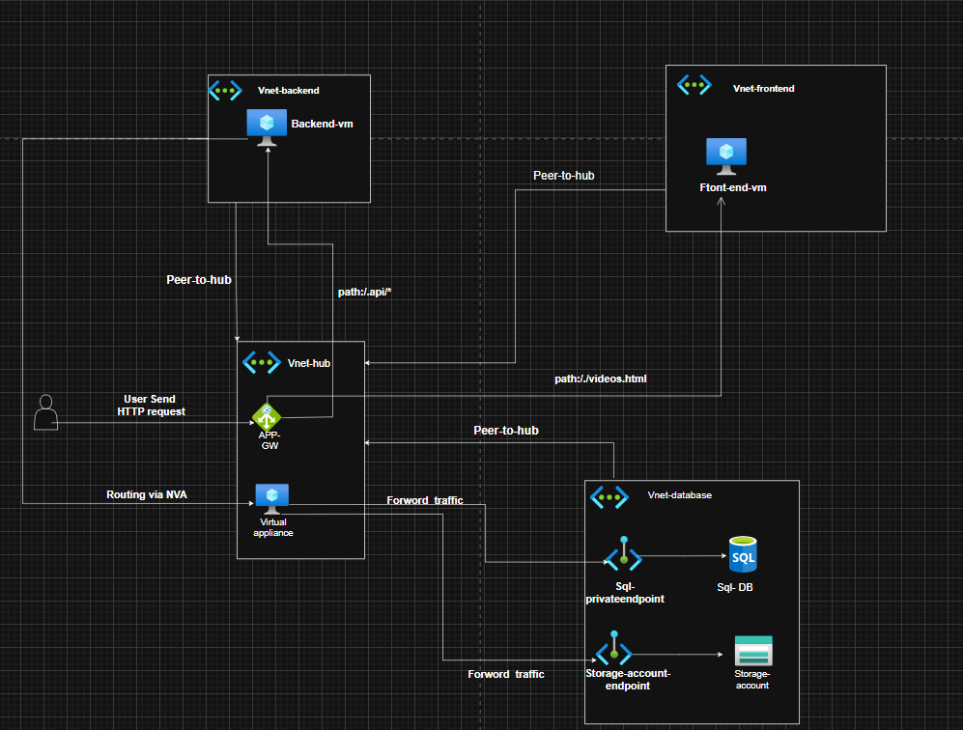

Networking

Created four virtual networks , following hub and spoke model:
Vnet Name | Purpose
Vnet hub | Hosts Application Gateway and the custom router VM
vnet-frontend | Hosts the Frontend VM (Nginx, static site)
vnet-backend | Hosts the Backend VM (Node.js API)
vnet-database | Hosts Azure SQL and Blob Storage private endpoints

Vnet peering:
Each spoke VNet (frontend, backend, database) was peered directly with the hub VNet. Peering allows resources in two VNets to communicate using private IP addresses, as if they were on the same network
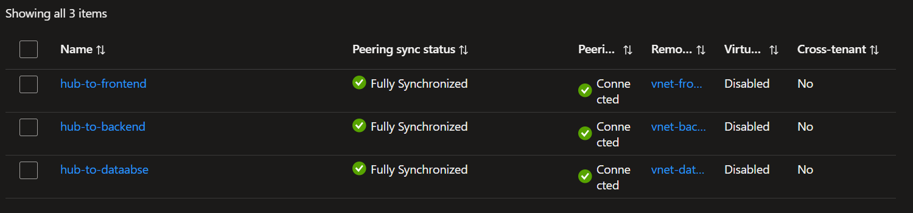

Virtual Machines
Two virtual machines were provisioned to host the application, each isolated in its own private virtual network:
- frontend-vm — Runs Nginx as a web server, serving the static site files (login page and video player page) to users' browsers.
- backend-vm — Runs a Node.js/Express application that handles user authentication, communicates with Azure SQL Database, and streams video content from Blob Storage.
Neither VM has a public IP address; both are only reachable through the Application Gateway, which acts as the single public entry point for the application

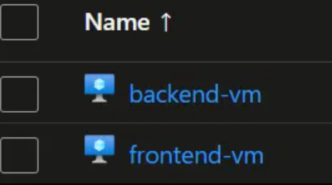

Sql Database:
Created Sql databse for storing users password and username Passwords are hashed using bcrypt before being stored, and are verified using bcrypt.compare() during login. The plain-text password is never written to the database or logged

Storage-Account:
A Storage Account was created to hold the video files. The container is kept completely private (no public access), and videos are only made available to users after they have successfully logged in — the backend verifies the user's authentication token before streaming any video content, ensuring unauthenticated users cannot access the files directly.

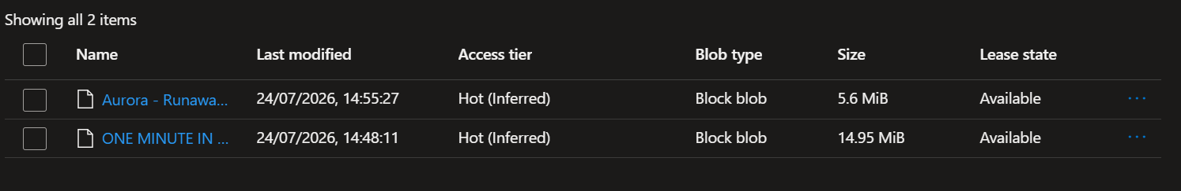

Custom Routing (Network Virtual Appliance)
Since direct peering between vnet-backend and vnet-database was not used, a Network Virtual Appliance (NVA) — a plain virtual machine configured to forward traffic — was deployed inside vnet-hub, named vm-router.
- Created a VM named vm-virtual-appliance in vnet-hub.

Enabled IP Forwarding on the VM's Network Interface (Azure setting).
- Enabled IP Forwarding inside the VM's operating system: net.ipv4.ip_forward = 1 (made persistent via /etc/sysctl.conf).
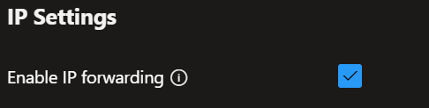

- Created a Route Table associated with the vnet-database subnet, with a route sending vnet-backend's address range to vm-router as the next hop (Next Hop Type: Virtual Appliance).

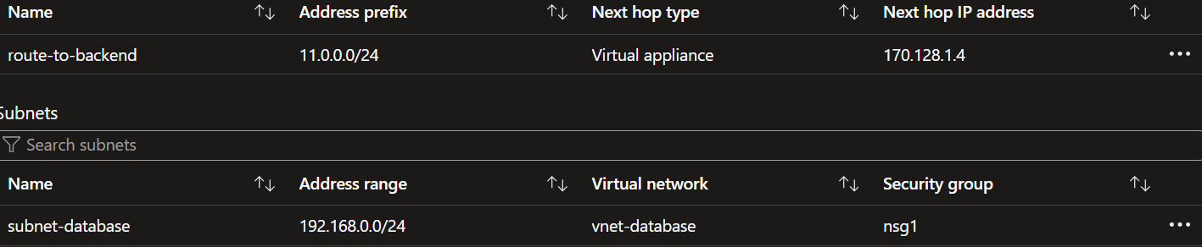

- Created route table associated with vnet-backend subnet with route sending vnet0-database subnet address range to vm-virtual-appliance as the next hop (Next Hop Type: Virtual Appliance).
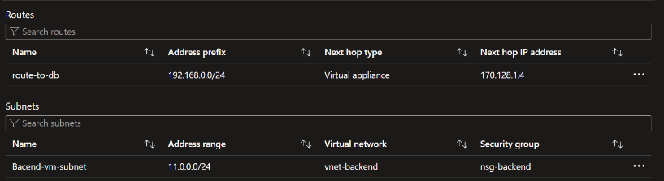

Private-Endpoint For Sql database:
Public network access to the Azure SQL Database is set to Disable. This ensures the database cannot be reached over the internet using its public IP or public DNS name, regardless of firewall rules — the only way to reach it is through the private network.

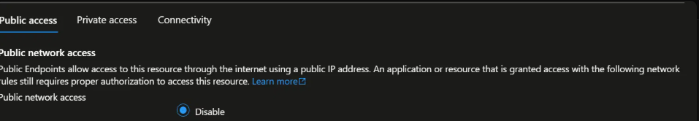

A Private Endpoint named sql-private has been created for the database. This provisions a private IP address inside the database VNet/subnet and maps the SQL server's DNS name to that private IP, so traffic to the database stays entirely within the Azure private network instead of traversing the public interne

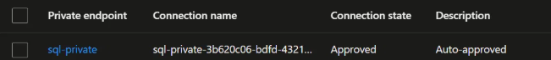

Private-Endpoint For Storage Account:
Public network access to the Storage Account is set to Disable. This ensures the storage account (and the blob containers holding the video files) cannot be reached over the internet using its public endpoint URL, regardless of any firewall or access key configuration — the only way to reach it is through the private network.

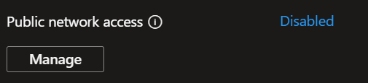

A Private Endpoint named private-endpoint-storageaccount has been created for the Storage Account. This provisions a private IP address inside the storage VNet/subnet and maps the storage account's DNS name (*.blob.core.windows.net) to that private IP, so traffic to Blob Storage stays entirely within the Azure private network instead of traversing the public internet.

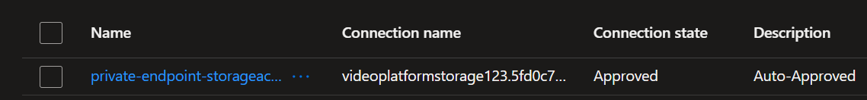

Private DNS Zone Linking
Azure SQL and Blob Storage use Private Endpoints, which are only resolvable via a Private DNS Zone. By default, this DNS zone is only linked to vnet-database. It was additionally linked to vnet-backend, so the Backend VM could resolve the correct private IP address instead of a public one

Network Security Group For Backend:
Created NSGs to allow the incoming traffic from the database to the backend
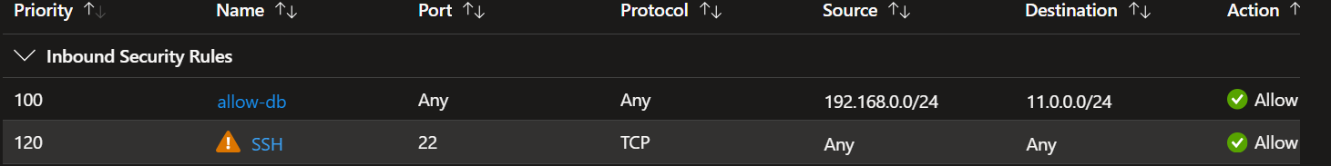

After creating the NSG for backend. I associated with backend-subnet
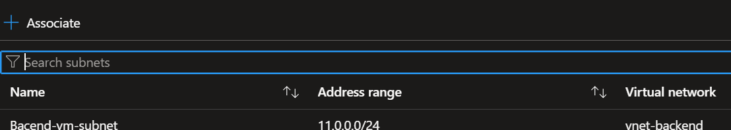

Network Security Group For Database:
Created NSGs to allow the incoming traffic from the backend to the database

After creating the NSG for backend. I associated database-subnet

Connectivity Verification
Connectivity was verified from the Backend VM using the following commands:
nc -zv videoplatform-sqlserver.database.windows.net 1433
nslookup videoplatform-sqlserver.database.windows.net
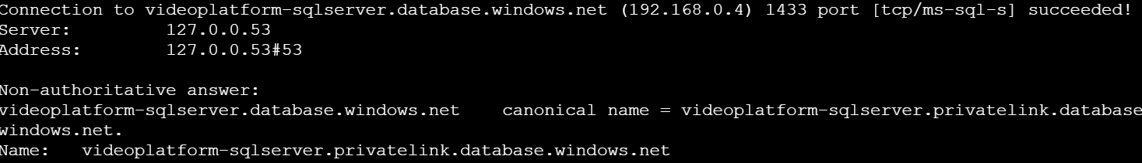

Frontend Code:
The frontend was built using HTML5 for structure and CSS3 (embedded within the HTML files) for styling, giving the login and video pages their layout and visual design. JavaScript (script.js and embedded scripts) was used to add interactivity — handling form submissions, communicating with the backend API, and dynamically updating the page based on the server's response.

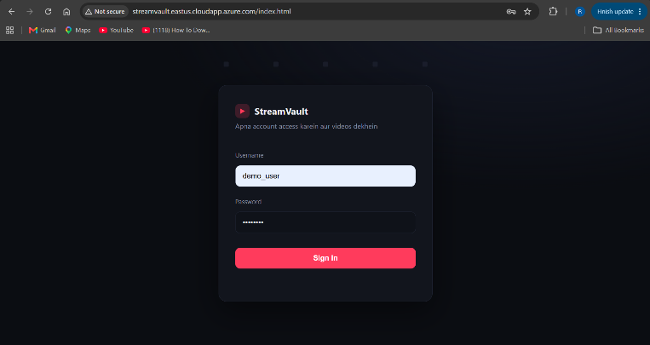

Backend Code:
The backend was built using JavaScript (Node.js runtime) with the Express.js framework. It handles user authentication by verifying credentials against Azure SQL Database (with bcrypt password hashing) and issuing JWT tokens, retrieves the video list from Blob Storage, and streams video files back to the browser through a dedicated API endpoint.

API Endpoint:

Route | Method | Purpose
/health | GET | Used by Application Gateway's health probe
/api/login | POST | Verifies credentials against Azure SQL, issues a JWT token
/api/videos | GET | Returns the list of available videos (requires valid token)
/api/stream/:filename | GET | Streams a specific video file from Blob Storage, with Range-request support

Connection Verififcation with SQL database
nc -zv videoplatform-sqlserver.database.windows.net 1433
nslookup videoplatform-sqlserver.database.windows.net


Enviroment Variables:
Sensitive configuration (database credentials, JWT secret, storage keys) is kept out of the source code, in a .env file loaded at runtime:
- DB_SERVER, DB_NAME, DB_USER, DB_PASSWORD, DB_PORT
- JWT_SECRET, JWT_EXPIRES_IN
- AZURE_STORAGE_ACCOUNT_NAME, AZURE_STORAGE_ACCOUNT_KEY, AZURE_STORAGE_CONTAINER
- PORT

Application Gateway:
Azure Application Gateway is a web traffic load balancer that helps you manage traffic to your web applications.It is the single public entrypoint for all users

Backend Pools:
Two backend pools were configured in the Application Gateway: pool-frontend and pool-backend. When a user accesses the Application Gateway's public IP (or DNS name), a routing rule directs the request based on its URL path. By default, requests are sent to pool-frontend, which serves the website. However, if the request path starts with /api/*, it is instead routed to pool-backend, which handles API calls such as login and video streaming.

Backend HTTP Settings:
Two HTTP settings were configured in the Application Gateway: backend-seeting-01, which forwards traffic to port 80 (used for the frontend), and http-setting-backend, which forwards traffic to port 5000 with a custom health probe (probe-backend) attached, used for the backend API.

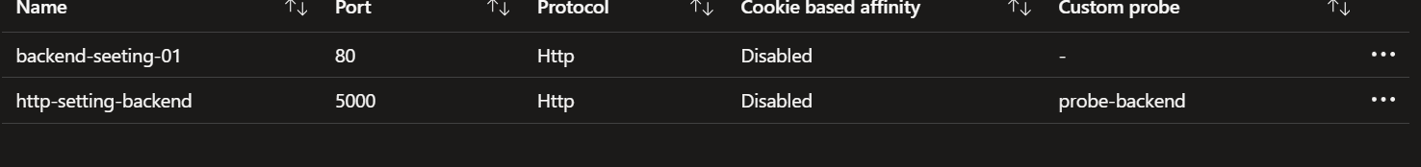

Figure: Custom Health Probe Configuration
A custom health probe named probe-backend was created to monitor the backend VM's health, since the default probe (which checks the root path /) would fail against the backend — no route was defined at /. This probe sends an HTTP request to 11.0.0.4 on the /health path every 30 seconds, and is linked to the http-setting-backend HTTP setting. A successful response confirms the backend is running and ready to receive traffic.

End-to-End Testing:
Once all configurations are complete, we proceed to testing.The user enters the Application Gateway URL — http://streamvault.eastus.cloudapp.azure.com — in their browser. This redirects to the login page, where the user authenticates and verifies their identity before gaining access to the application.
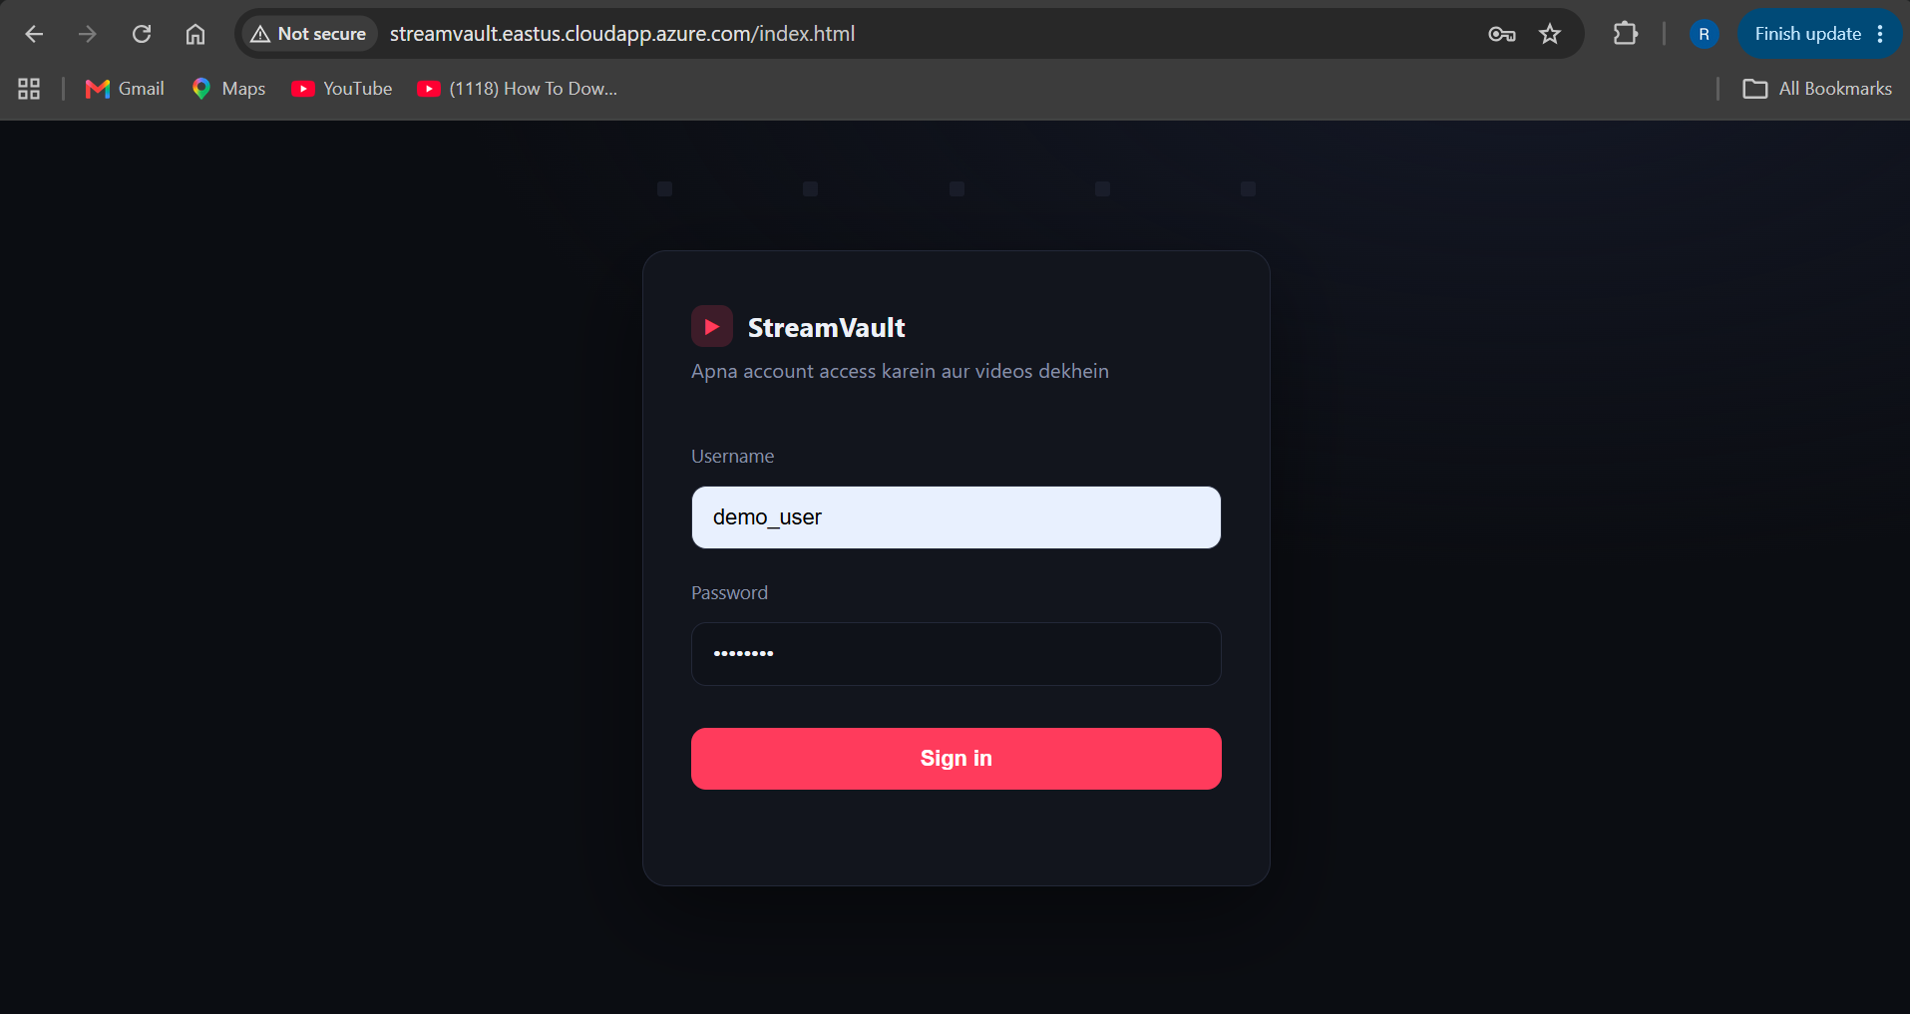
After the verification is done the user is redirected to the videos.html page
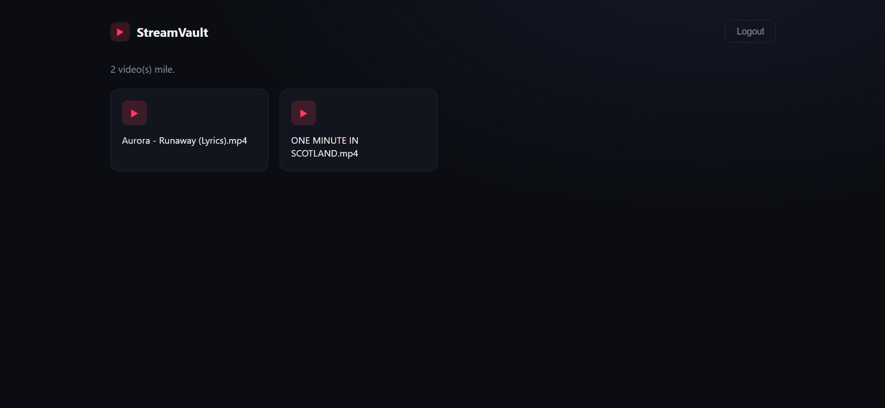

By clicking the video the backend will fetch the video from Storage account and play it to the user browser

