

Name: Shehroz malik

Registration #: SP24-BSE-113

Course: OOPs

**Theory Assignment 1**

**Message Class**

**Variables used in it:**

* private static String sender;
* private int mgID[]=new int[200];
* private String mgContent[]=new String[200];
* private boolean status;
* private LocalDateTime dt[]=new LocalDateTime[200];
* private String receiver;

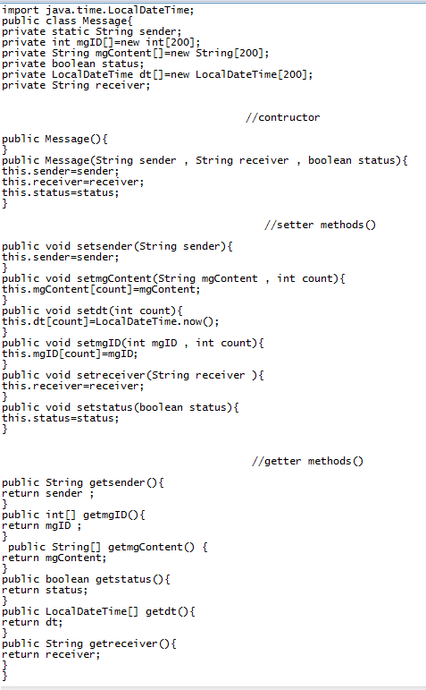

**Method Class**

**Variables and objects used in it:**

* Message m[]=new Message[120];
* int objcount=0;
* int mgcount[]=new int[200];
* int idcount[]=new int[200];

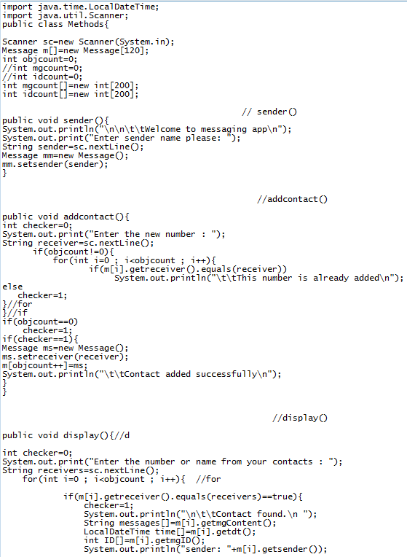

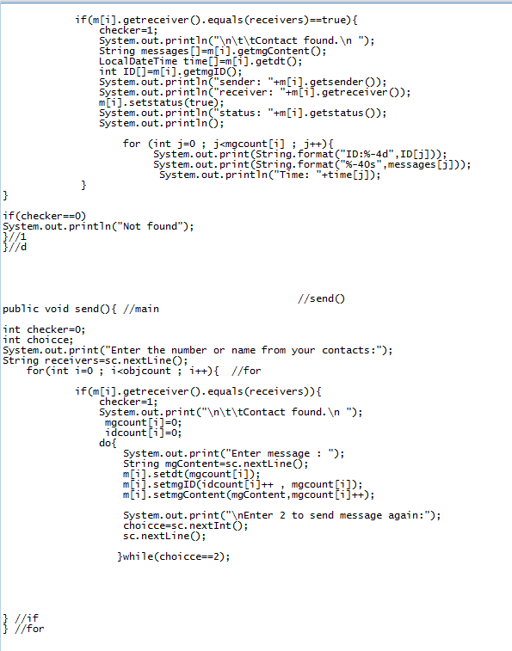

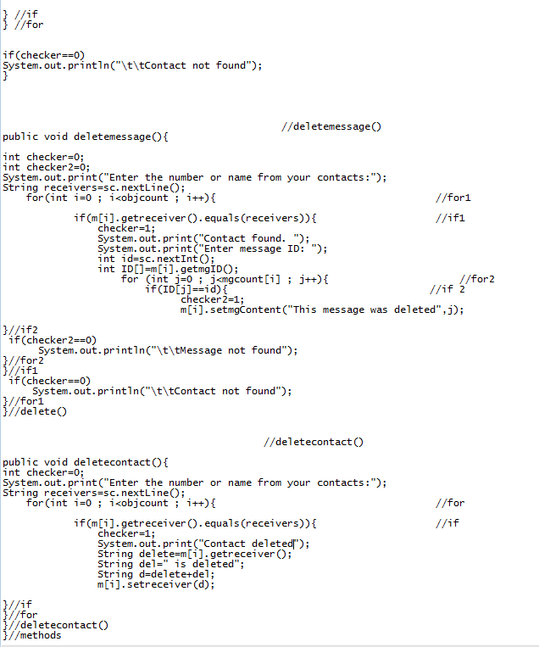

**Test Class**

**Variables and objects used in it:**

* Methods met=new Methods();
* int choice=1;

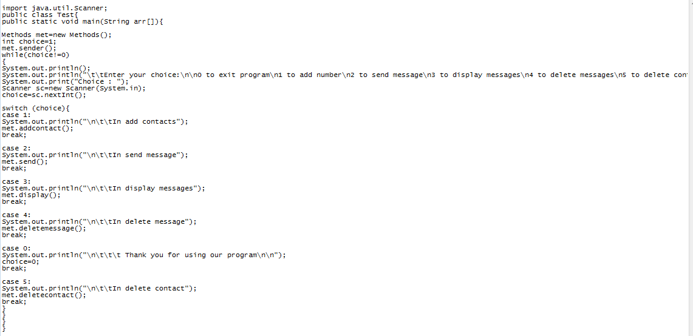

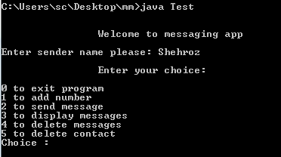**Program output**

* **Program display**
* 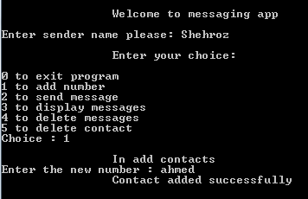**Adding contact**
* **Adding same name contact**

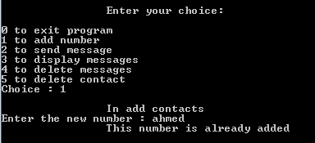

* **Sending message**

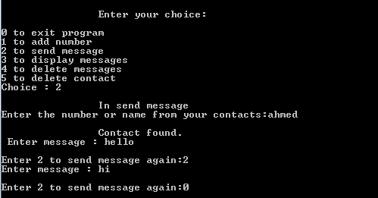

* **Displaying message**

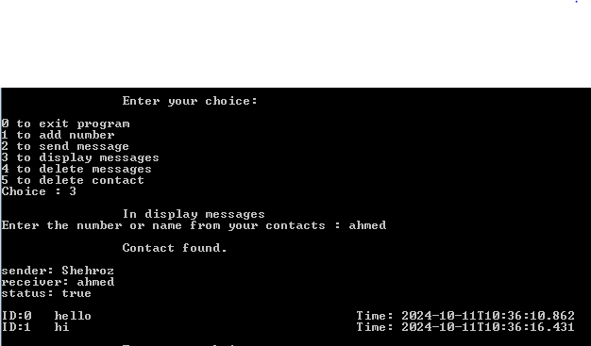

* 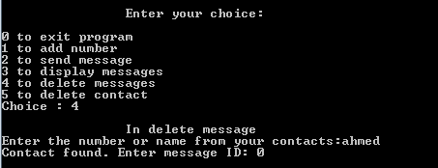**Deleting message**
* **Display after deleting messages**

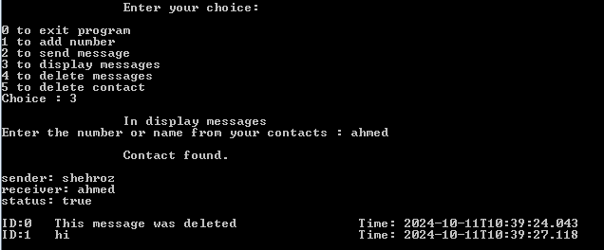

* **Deleting contact**

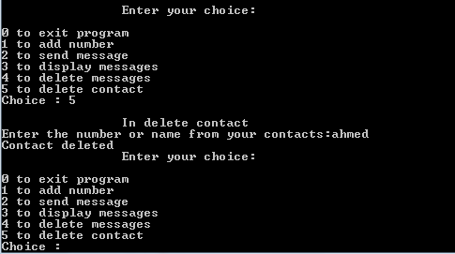

* **End of program**

