

Name: Shehryar

Roll NO: bsf2000745

Class: BS IT Evening (3rd) Semester

Subject: Software Engineering

Concurrent Development Model

The *concurrent development model*, sometimes called *concurrent engineering*, can be represented schematically as a series of framework activities, Software engineering actions of tasks, and their associated states.

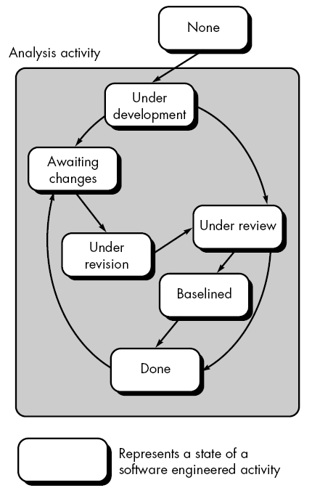The concurrent model is often more appropriate for system engineering projects where different engineering teams are involved.

Figure above provides a schematic representation of one Software engineering task within the modeling activity for the concurrent process model. The activity – modeling- may be in any one of the states noted at any given time.

All activities exist concurrently but reside in different states.

For example, early in the project the communication activity has completed its first iteration and exists in the awaiting changes state. The modeling activity which existed in the none state while initial communication was completed now makes a transition into underdevelopment state.

If, however, the customer indicates the changes in requirements must be made, the *modeling* activity moves from the **under development** state into the **awaiting changes** state.

The concurrent development model Process

* The concurrent development model called as concurrent model.
* It represented schematically as series of major technical activities, tasks, and their associated states.
* The communication activity has completed in the first iteration and exits in the awaiting changes state.
* The modeling activity completed its initial communication and then go to the underdevelopment state.
* If the customer specifies the change in the requirement, then the modeling activity moves from the under development state into the awaiting change state.
* The concurrent process model activities moving from one state to another state

Advantages of the concurrent development model

* This model is applicable to all types of software development processes.
* It is easy for understanding and use.
* It gives immediate feedback from testing.
* It encourages multi-disciplinary collaboration
* It provides an accurate picture of the current state of a project.
* Gives a competitive edge over the competitors

Disadvantages of the concurrent development model

* It needs better communication between the team members. This may not be achieved all the time.
* It requires to remember the status of the different activities.
* Room for mistakes is small as it impacts all the departments or disciplines involved

Difference between Prototype and Concurrent Development Model

|  |  |
| --- | --- |
| Concurrent Development Model | Prototype Model |
| Concurrent models are those models within which the various activities of software development happen at the same time, for faster development and a better outcome | In the prototype model, a working prototype of the software is made before the actual software is built |