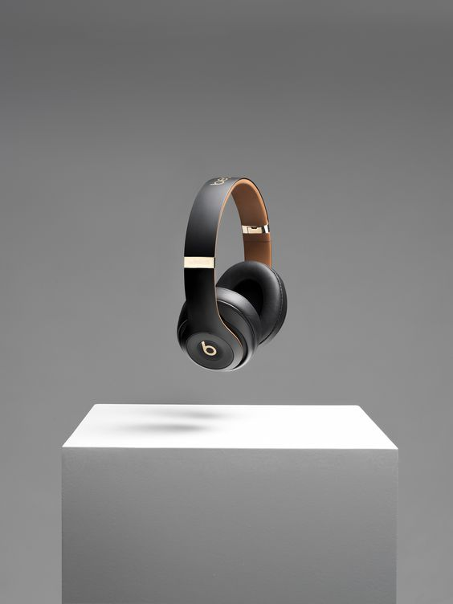

**SOUND**

 SOUND

# PROJECT GROUP MEMBERS

|  |  |
| --- | --- |
| **Student’s ID** | **Student’s Name** |
| **Student1405891** | **M.SHEHRYAR SALEEM** |
| **Student1405839** | **ASAD SHAHID** |
| **Student1414752** | **ABDUL WASAY** |
| **Student1417806** | **SUREMA QADEER** |
| **Student1405282** | **GHOUSIA RASHID** |

|  |  |
| --- | --- |
| **CURRICULM**  **7062** | **BATCH**  **2208E2** |
| **FACULTY**  **“Ms. NEELAM MALIK”** | |
| **CO-ORDINATOR**  **“Ms. WAJEEHA ASHFAQ”** | |

 SOUND

**SCREEN SHOTS OF USER PANEL…**



HOME PAGE

When user open our website, they will see this user-friendly home page.

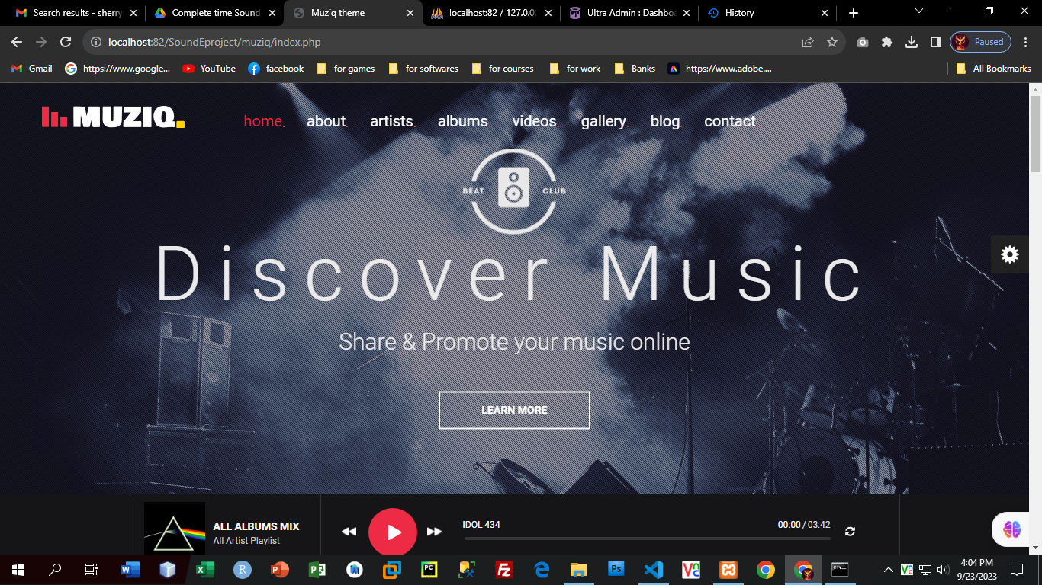





# CONTACT US

Visitor can Login and register themselves

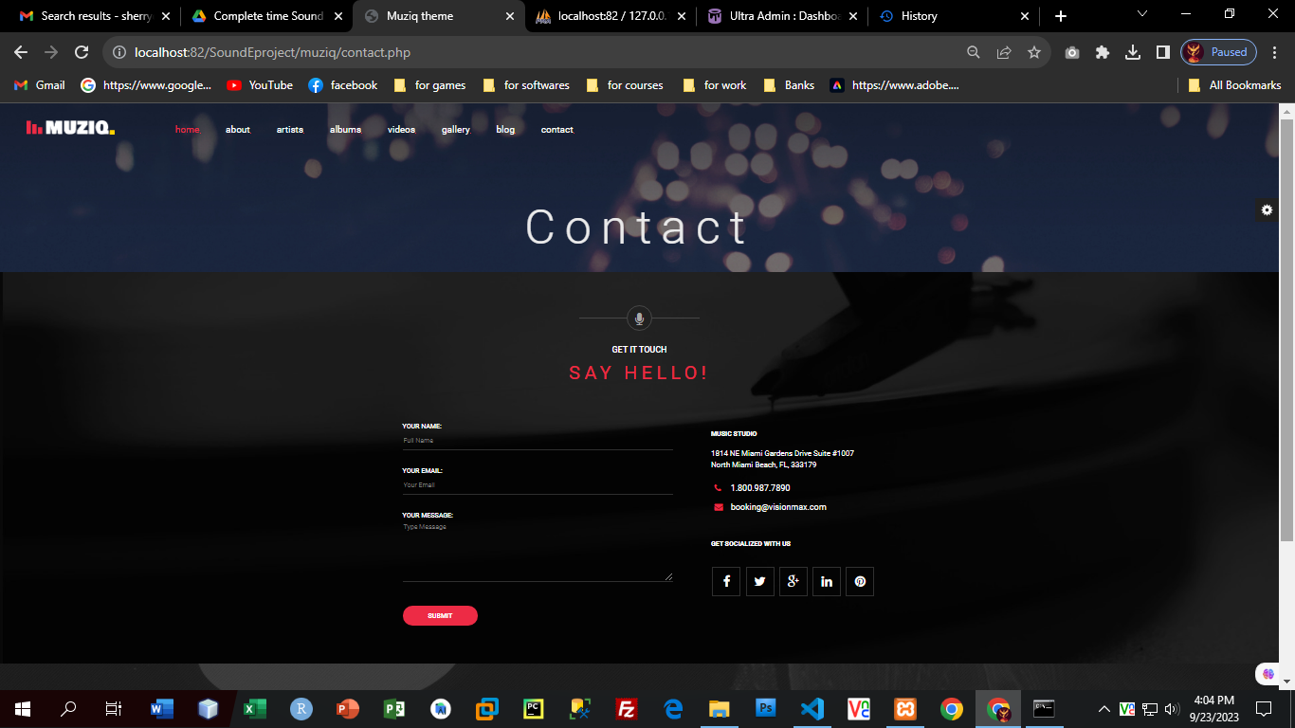



# FOOTER

In the end of the website visitor can see this footer and nav which have some links.



# NAVBAR

# 

# NAVBAR Login

# 