PROJECT PROPOSAL
Distributed Digital Wallet Transaction System
A Highly Available, Horizontally Scalable, Fault-Tolerant Distributed Relational Database System for Real-Time Money Transfers
Course: Distributed Database Systems
Submitted by: Group of 3 Members
Date of Submission: 3 August 2026

# | Name | Roll Number
1 | Shehzad Nisar | B22110006147
2 | Muhammad Ashraf | B22110006090
3 | Daniyal Ahmed | B21110006024

1. Introduction
Digital wallets and mobile banking apps face sudden, heavy spikes in traffic. This happens on salary days, during festive transfers, or when a cash-back offer goes live. A normal single-server, single-database application cannot handle this load. It slows down, crashes, or lets two requests debit or credit the same account at the same time, causing lost or duplicated money.
This project proposes a Distributed Digital Wallet Transaction System built on a proper relational database (PostgreSQL), deployed across multiple sharded and replicated nodes instead of one single instance. The system is designed so that no realistic amount of traffic can bring the server down. Load is spread across many database and application nodes, hot data is cached, sudden bursts are absorbed by a queue, and transfers between accounts on different shards are kept atomic using a two-phase commit (2PC) coordinator built by the team. Since real production traffic is not available for a class project, the design will be tested with a software-based load simulation.

2. Objectives
- Design and build a heavily distributed backend for a digital wallet / mobile banking transaction system.
- Use a proper relational database (PostgreSQL), deployed as a distributed, sharded, and replicated cluster instead of a single instance.
- Expose a REST API that stays reachable and responsive at all times, supporting text-based and numerical search.
- Provide search and sort functionality over accounts, transactions, dates, amounts, and merchants.
- Build a two-phase commit (2PC) coordinator so transfers between accounts on different shards are atomic, meaning they never apply halfway.
- Make sure no amount of incoming traffic can block or crash the server, using load balancing, caching, queuing, and auto-scaling.
- Simulate high concurrent traffic in software using a load-testing tool, and show the system stays up, correct, and responsive.
- Keep the architecture horizontally scalable and fault-tolerant, with automatic failover if any node fails.

3. Problem Statement & Use Case
When salaries are disbursed or a cash-back offer opens, tens of thousands of users may check their balance, search their transaction history, and transfer money within the same few minutes. The system must let users view their balance, search past transactions by merchant name, date, or amount, sort the results, and transfer funds to another account. It must do all this while guaranteeing that a transfer is never applied twice, a debit never happens without a matching credit, and no money is lost even if a server crashes mid-transfer. The surge in traffic must never take the platform offline.
The hardest case is a cross-shard transfer, where the sender's account and the receiver's account sit on two different database shards. The debit and the credit must be treated as one atomic unit even though they live on separate machines. This is the main distributed-systems problem the project solves.

4. System Architecture
The system is organized into six independent, horizontally scalable layers, so no single machine is a bottleneck or a single point of failure.
Layer | Responsibility | Distribution / Scaling Strategy
Client Layer | Web / mobile app used to check balance, search transactions, and transfer funds | Stateless clients that talk only to the API layer
Load Balancer / API Gateway | Routes each request to a healthy API server, runs health checks | NGINX (or HAProxy) in front of N API replicas, least-connections routing
Application (API) Layer | Business logic, search, sort, transfer workflow, 2PC coordination | Stateless REST services, containerized (Docker), auto-scaled (Kubernetes HPA)
Caching Layer | Serves hot reads: account balances, transaction lists, search results | Redis cluster (sharded and replicated) with write-through invalidation
Message Queue | Serializes ledger writes per account to prevent double-spending | RabbitMQ / Kafka, absorbs traffic bursts, decouples writes from spikes
Database Layer | Durable, consistent storage of accounts, transactions, and ledger entries | PostgreSQL cluster: sharded by account_id, primary-replica streaming replication, Raft-based (Patroni/etcd) automatic failover

4.1 Architecture Diagram
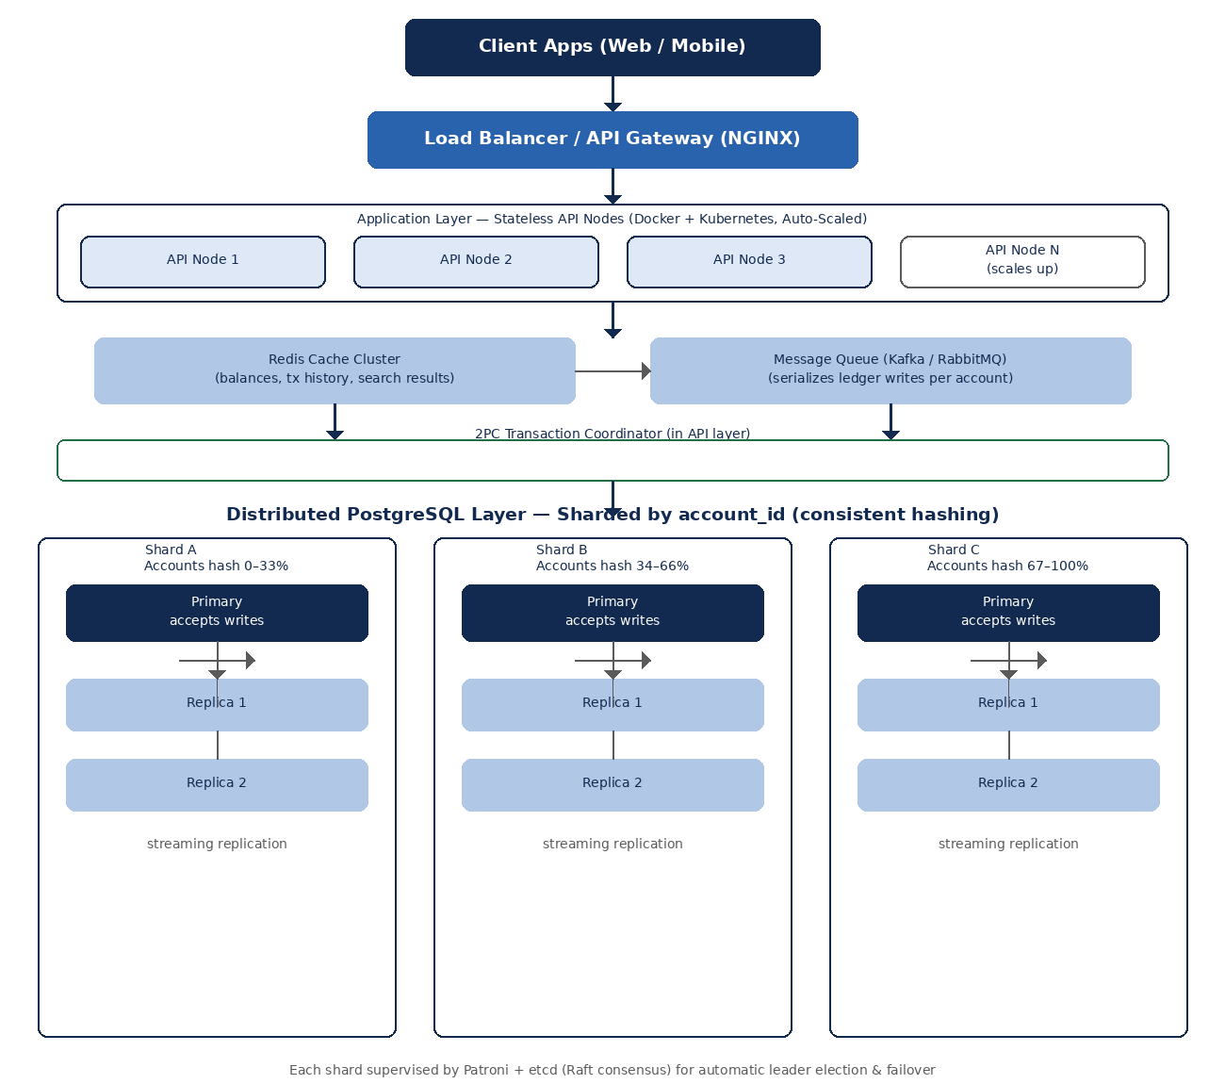
Figure 1: Layered distributed architecture: client, load balancer, auto-scaled API layer, cache/queue, a 2PC coordinator, and a three-shard, replicated PostgreSQL cluster.

4.2 Request Flow
- Client sends a request (search, sort, balance check, or transfer) to the load balancer.
- Load balancer forwards it to the least-busy healthy API node.
- Read requests (search, sort, balance) are served from the Redis cache when possible. On a cache miss, the API node queries the nearest PostgreSQL read replica.
- Transfer (write) requests are pushed onto the message queue, which serializes ledger writes per account so two concurrent transfers on the same account never race.
- If both accounts are on the same shard, the transfer commits as a single local ACID transaction. If they are on different shards, the API layer's 2PC coordinator prepares both legs, waits for both to vote yes, and only then commits both, or aborts both.
- Each shard's primary replicates the write to its standby replicas before acknowledging, so the data survives even if the primary fails right after.
- If a database primary node fails, the Raft-based consensus layer (Patroni + etcd) elects a new primary from the surviving replicas within seconds, with no manual work and no data loss.

4.3 Automatic Failover (Raft Consensus)
The diagram below shows how the etcd/Raft consensus group, coordinated by Patroni, detects a failed primary database node and automatically promotes a replica to take over, keeping the system writable with no manual intervention.
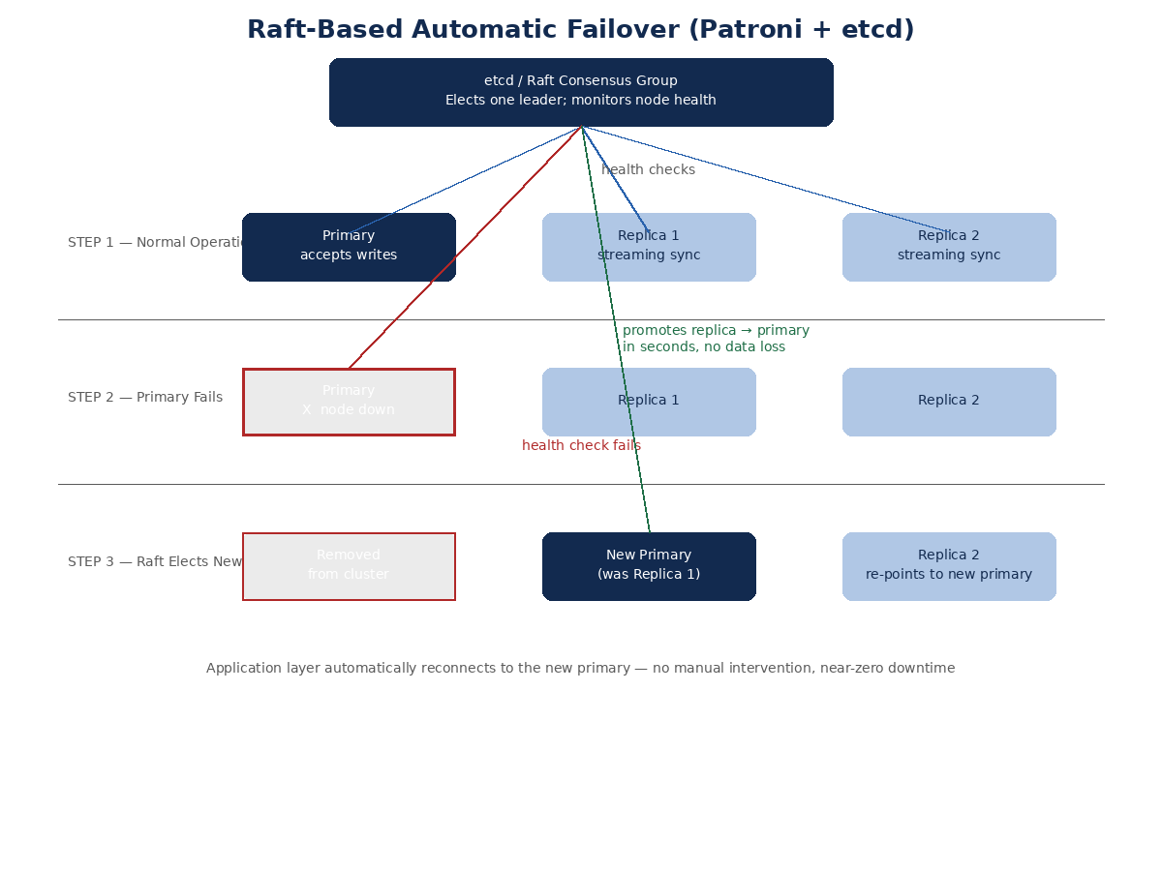
Figure 2: Raft-based leader election automatically promotes a replica to primary when the current primary fails.

4.4 Cross-Shard Atomic Transfers (Two-Phase Commit)
Unlike a booking system where each write touches a single row, a bank transfer between two accounts on different shards must update two rows on two different machines as one operation. The team will build a lightweight two-phase commit (2PC) coordinator in the API layer. It asks both shards to prepare and lock the affected rows, waits for both to vote yes, and only then tells both to commit. If either shard votes no or times out, the coordinator tells both to abort and roll back, so an account is never debited without the matching account being credited.
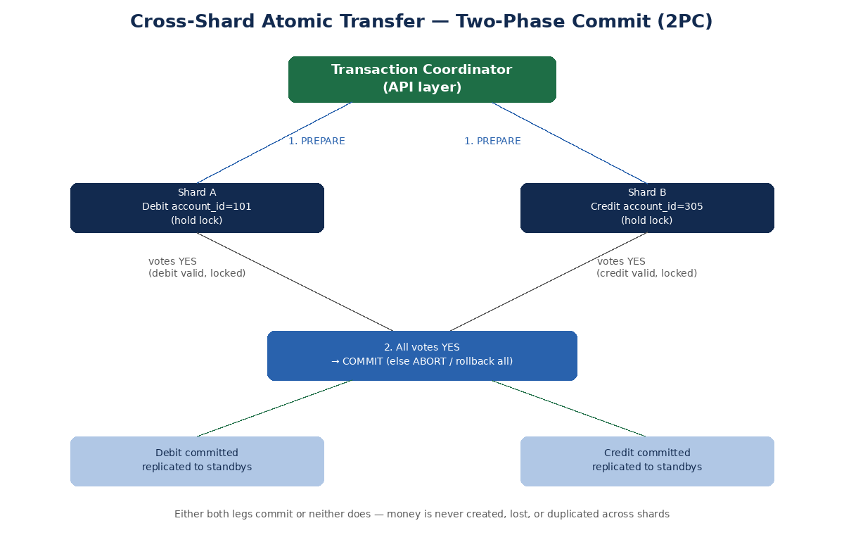
Figure 3: A cross-shard transfer commits on both shards or on neither. Money is never created, lost, or duplicated.

4.5 Security & Authentication
- Every request must carry a signed JWT issued at login. The API gateway validates the token and rejects unauthenticated requests before they reach any API node.
- Account-level authorization ensures a user can only view balances and transactions, and initiate transfers, for accounts they own. The sender account on a transfer is re-checked server-side against the logged-in user, and is never trusted from client input alone.
- TLS is enforced between all layers (client to gateway, gateway to API, API to database), and passwords and tokens are hashed or encrypted at rest.

4.6 Idempotent Transfers
- Each transfer request carries a client-generated idempotency key. If a client retries after a network timeout, the API layer checks whether a transaction with that key was already processed, and returns the original result instead of applying the transfer again.
- This solves the classic problem of not knowing whether a transfer actually went through, where a request succeeds on the server but the client never receives the response. Without this check, a simple retry could debit the sender twice.

5. Distributed Database Design
PostgreSQL is used as the relational engine. The cluster is both sharded, for write and storage scaling, and replicated, for read scaling and fault tolerance:
- Sharding: accounts are split across three shards by account_id using consistent hashing (via the Citus extension for PostgreSQL), so each shard only holds a subset of accounts and write load is spread across nodes.
- Replication: every shard has one primary and two standby replicas using PostgreSQL streaming replication, so read traffic such as balance checks, search, and sort can be served from replicas without touching the primary.
- Consensus and failover: Patroni, backed by an etcd/Raft consensus group, continuously monitors shard health and performs leader election, automatically promoting a replica to primary if the current primary goes down.
- Cross-shard consistency: same-shard transfers commit as a single local ACID transaction. Cross-shard transfers are coordinated by the team's own two-phase commit logic described in Section 4.4, so consistency is not left to the database alone.

5.1 Core Tables
Table | Key Columns | Purpose
accounts | account_id (PK), user_id (FK), balance, shard_key | Wallet / bank account master data, also the shard key
users | user_id (PK), name, email, phone | Registered users
transactions | transaction_id (PK), from_account, to_account, amount, status, type, created_at | One row per transfer request, write-heavy, queue-serialized
ledger_entries | entry_id (PK), transaction_id (FK), account_id, entry_type (debit/credit), amount | Double-entry bookkeeping: every transaction produces exactly one debit row and one credit row
merchants | merchant_id (PK), name, category | Merchant directory for transaction search and categorization

5.2 Indexing for Search & Sort
- GIN / trigram (pg_trgm) index on merchants.name and transactions.type for fast text-based, partial-match search.
- B-tree composite index on (created_at, amount) for fast numerical filtering and sorting by date or amount.
- B-tree index on accounts(user_id) and transactions(from_account, to_account) for fast lookup of a user's accounts and transaction history.

6. API Design
A stateless REST API sits behind the load balancer and is reachable at any time. Every endpoint is served by whichever API replica is healthy, so one node going down does not affect availability.
Endpoint | Method | Description
/api/accounts/{id}/balance | GET | Current balance for an account (cache-first)
/api/accounts/{id}/transactions?search=&sort=&order= | GET | Text search (merchant/type) and sort (date/amount) over transaction history
/api/transfers | POST | Create a transfer (queued, ledger-locked, same-shard ACID or cross-shard 2PC write)
/api/transfers/{id} | GET | Check transfer / settlement status
/api/health | GET | Liveness/readiness probe used by the load balancer

7. Search & Sort Functionality

7.1 Text-Based Search
Users can search their transaction history by merchant name or transaction type using partial, case-insensitive matches, powered by PostgreSQL trigram indexes for fast fuzzy search even on large datasets.

7.2 Numerical Search / Filtering
Users can filter transactions by amount range and date range, using indexed numeric predicates.

7.3 Sorting
Results can be sorted ascending or descending by date or amount. Sort operations run on indexed columns, and repeated queries are served from the Redis cache so the database is not hit again.

8. Preventing Server Downtime Under Load
The core requirement, that no amount of traffic can block or bring down the server, is met through several mechanisms that each target a different failure mode:
- Horizontal auto-scaling: the API service runs as a Kubernetes Deployment. A Horizontal Pod Autoscaler adds replicas automatically when CPU or request rate crosses a threshold, and removes them once load drops.
- Load balancing: NGINX spreads incoming requests across all healthy API replicas and stops routing to any replica that fails its health check.
- Caching: Redis absorbs most read traffic (balance, search, sort), so the database only sees a fraction of the request volume even during a spike.
- Asynchronous queueing: transfer writes go onto a message queue instead of hitting the database directly. The queue smooths bursty traffic into a steady rate the database can handle, and applies each account's ledger entries one at a time so nothing is double-spent.
- Rate limiting and throttling: per-user and per-IP request limits at the gateway stop one abusive client from starving the rest.
- Circuit breakers: API nodes short-circuit calls to a struggling database shard instead of piling up blocked threads, failing fast and recovering on their own.
- Read replicas: search, sort, and balance traffic is served from replicas, keeping it separate from the write path used for real transfers.

8.1 Software-Based Load Simulation Plan
Since real production traffic is not available for a class project, high concurrency will be simulated entirely in software using Locust (or Apache JMeter):
- Define virtual-user scripts that repeatedly call the balance, search, sort, and transfer endpoints.
- Ramp load from 100 to 5,000+ concurrent simulated users against the deployed cluster, including a mix of same-shard and cross-shard transfers.
- Record response time, throughput, and error rate at each load level, with and without caching/auto-scaling enabled, to show the difference.
- Demonstrate that the API's success rate stays at (or near) 100% and the server never goes down, while a single-node baseline (run for comparison) degrades or crashes under the same load.
- Kill a database primary node mid-test to demonstrate automatic Raft-based failover, and independently verify after the test that total system balance is conserved (sum of all debits equals sum of all credits) with zero data loss.

9. Proposed Technology Stack
Component | Technology
Frontend | React.js
Backend / API | Node.js (Express) or Spring Boot
Relational Database | PostgreSQL (sharded via Citus, replicated via streaming replication)
HA / Consensus | Patroni + etcd (Raft consensus for automatic failover)
Distributed Transactions | Custom two-phase commit (2PC) coordinator for cross-shard transfers
Cache | Redis (cluster mode)
Message Queue | RabbitMQ or Apache Kafka
Load Balancer / Gateway | NGINX
Containerization / Orchestration | Docker + Kubernetes (HPA for auto-scaling)
Load Testing / Simulation | Locust or Apache JMeter
Monitoring | Prometheus + Grafana

10. Proposed Timeline
Week | Milestone
Week 1 | Requirements finalization, ER design, choice of sharding/replication scheme
Week 2 | Database cluster setup: PostgreSQL sharding + replication + Patroni/etcd
Week 3 | API layer development: balance, search, sort, transfer endpoints
Week 4 | Two-phase commit coordinator, caching, message queue, and rate limiting integration
Week 5 | Load balancer + Kubernetes auto-scaling configuration
Week 6 | Frontend integration and end-to-end testing
Week 7 | Load simulation (Locust/JMeter), failover testing, performance tuning
Week 8 | Documentation, final report, and presentation

11. Expected Outcome & Conclusion
The proposed Distributed Digital Wallet Transaction System will demonstrate, on a realistic and globally relevant use case, the core ideas of distributed database systems: sharding and replication for scale, Raft-based consensus for automatic failover, a two-phase commit protocol for cross-shard atomicity, caching and queueing to absorb bursty demand, and horizontal auto-scaling to stay available under any load. A software-driven load simulation will provide measurable proof, in the form of response times, throughput, and error rates under increasing concurrent users, plus a post-test balance-conservation check, showing that the system never blocks or goes down under traffic while still guaranteeing correctness (no money is ever created, lost, or duplicated).

12. References
[1] PostgreSQL Global Development Group, "PostgreSQL Documentation." https://www.postgresql.org/docs/
[2] Citus Data, "Citus: Distributed PostgreSQL." https://www.citusdata.com/
[3] Patroni Documentation, "A Template for PostgreSQL HA with Raft." https://patroni.readthedocs.io/
[4] etcd Documentation, "etcd: A Distributed Reliable Key-Value Store." https://etcd.io/
[5] Redis Documentation, "Redis Cluster Specification." https://redis.io/docs/
[6] Apache Kafka Documentation. https://kafka.apache.org/documentation/
[7] Locust Documentation, "An Open Source Load Testing Tool." https://locust.io/

