PROJECT PROPOSAL
Distributed Digital Wallet Transaction System
A Highly Available, Horizontally Scalable, Fault-Tolerant Distributed Relational Database System for Real-Time Money Transfers
Course: Distributed Database Systems
Submitted by: Group of 3 Members
Date of Submission: 3 August 2026
# | Name | Roll Number
1 | Shehzad Nisar | B22110006147
2 | Muhammad Ashraf | B22110006090
3 | Daniyal Ahmed | B21110006024

1. Introduction
Digital wallets face sudden traffic spikes on salary days, festive transfers, or cash-back offers. A single-server system cannot handle this load, and can let concurrent requests debit or credit the same account simultaneously, causing lost or duplicated money.
This project proposes a Distributed Digital Wallet Transaction System built on PostgreSQL, deployed across sharded and replicated nodes. Load is spread across nodes, hot data is cached, bursts are absorbed by a queue, and cross-shard transfers are kept atomic using a team-built two-phase commit (2PC) coordinator. The design will be validated using software-based load simulation.

2. Objectives
- Build a distributed backend for a digital wallet system using a sharded, replicated PostgreSQL cluster.
- Expose a REST API that stays reachable at all times, with search and sort over accounts, transactions, dates, amounts, and merchants.
- Build a 2PC coordinator so cross-shard transfers are atomic and never apply halfway.
- Prevent any traffic volume from blocking or crashing the server via load balancing, caching, queuing, and auto-scaling.
- Simulate high concurrency in software and demonstrate automatic failover with zero data loss.

3. Problem Statement & Use Case
During traffic surges, tens of thousands of users may check balances, search transaction history, and transfer money within minutes. The system must guarantee a transfer is never applied twice, a debit never happens without a matching credit, and no money is lost even if a server crashes mid-transfer — all without going offline.
The hardest case is a cross-shard transfer, where sender and receiver accounts sit on different database shards. The debit and credit must be treated as one atomic unit across machines — the central distributed-systems problem this project solves.

4. System Architecture
The system is organized into six independent, horizontally scalable layers so no single machine is a bottleneck or single point of failure:
Layer | Responsibility | Distribution / Scaling
Client | Web/mobile app for balance, search, and transfers | Stateless clients calling the API layer
Load Balancer / Gateway | Routes requests to healthy API servers | NGINX/HAProxy, health checks, least-connections
Application (API) | Business logic, search/sort, 2PC coordination | Stateless REST services, Dockerized, Kubernetes auto-scaled
Caching | Serves hot reads (balances, transactions, search) | Sharded/replicated Redis cluster, write-through invalidation
Message Queue | Serializes ledger writes per account | RabbitMQ/Kafka, absorbs bursts
Database | Durable storage of accounts, transactions, ledger | PostgreSQL sharded by account_id, streaming replication, Raft (Patroni/etcd) failover
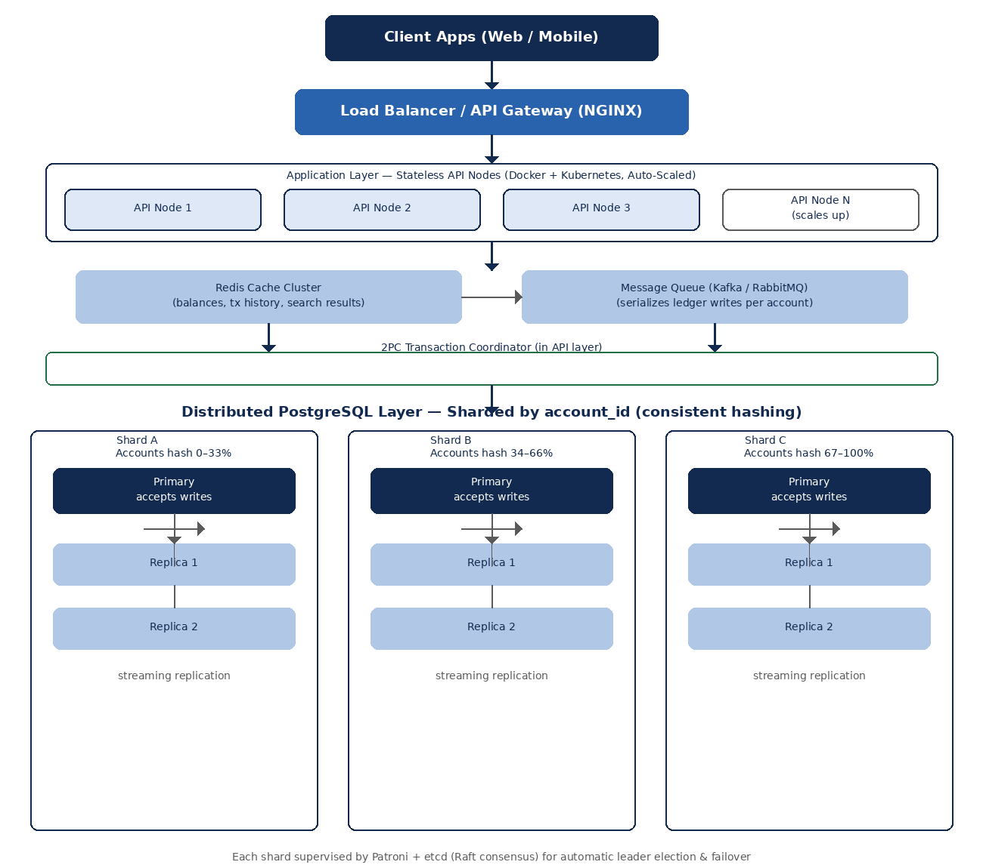
Figure 1: Layered distributed architecture — client, load balancer, auto-scaled API layer, cache/queue, 2PC coordinator, and a sharded, replicated PostgreSQL cluster.

4.1 Request Flow (Summary)
A client sends a request (search, sort, balance check, or transfer) to the load balancer, which forwards it to the least-busy healthy API node. Reads (search, sort, balance) are served from Redis where possible, falling back to a PostgreSQL read replica on a cache miss. Writes (transfers) are pushed onto the message queue, which serializes ledger writes per account so two concurrent transfers on the same account never race. Same-shard transfers commit as a single local ACID transaction; cross-shard transfers go through the 2PC coordinator, which prepares both legs, waits for both to vote yes, and only then commits — or aborts both. Each shard's primary replicates the write to its standby replicas before acknowledging, so data survives even if the primary fails immediately after.

4.2 Automatic Failover (Raft Consensus)
If a database primary node fails, the etcd/Raft consensus group, coordinated by Patroni, detects the failure and promotes a replica to take over within seconds, with no manual work and no data loss.
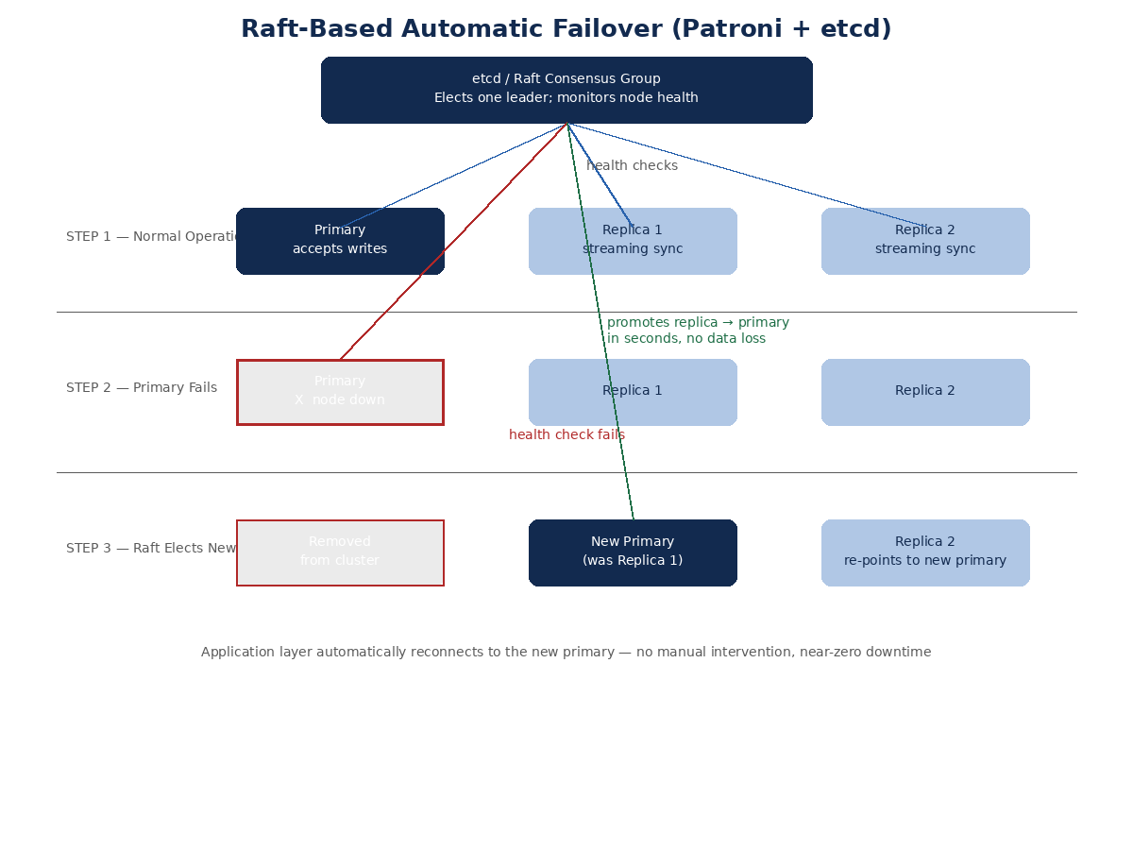
Figure 2: Raft-based leader election automatically promotes a replica to primary when the current primary fails.

4.3 Cross-Shard Atomic Transfers (2PC)
Unlike a system where each write touches a single row, a transfer between accounts on different shards must update two rows on two different machines as one operation. The team's 2PC coordinator asks both shards to prepare and lock the affected rows, waits for both to vote yes, and only then commits both — or tells both to abort and roll back if either votes no or times out. An account is never debited without the matching account being credited.
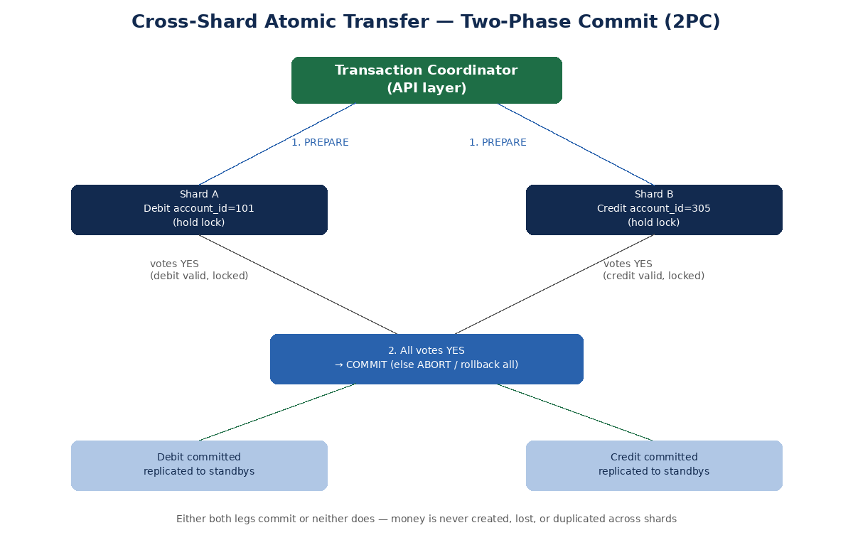
Figure 3: A cross-shard transfer commits on both shards or on neither. Money is never created, lost, or duplicated.

4.4 Security & Reliability
- Signed JWT on every request, validated at the gateway; server-side re-check of account ownership on every transfer; TLS between all layers.
- Idempotency keys on transfer requests so a client retry after a timeout returns the original result instead of double-applying the transfer. This solves the classic problem of not knowing whether a transfer actually went through when a request succeeds on the server but the response never reaches the client.

5. Distributed Database Design
- Sharding: accounts split across three shards by account_id via consistent hashing (Citus extension for PostgreSQL).
- Replication: each shard has one primary and two standby replicas (PostgreSQL streaming replication) for read scaling and fault tolerance.
- Consensus & failover: Patroni + etcd (Raft) monitor shard health and auto-promote a replica on primary failure.
- Cross-shard consistency: same-shard transfers use local ACID transactions; cross-shard transfers use the team's own 2PC logic (Section 4.3).

5.1 Core Tables
Table | Key Columns | Purpose
accounts | account_id (PK), user_id (FK), balance, shard_key | Wallet/account master data; also the shard key
users | user_id (PK), name, email, phone | Registered users
transactions | transaction_id (PK), from_account, to_account, amount, status, type, created_at | One row per transfer request; write-heavy, queue-serialized
ledger_entries | entry_id (PK), transaction_id (FK), account_id, entry_type, amount | Double-entry bookkeeping: each transaction produces one debit row and one credit row
merchants | merchant_id (PK), name, category | Merchant directory for search and categorization

5.2 Indexing for Search & Sort
- GIN/trigram (pg_trgm) index on merchants.name and transactions.type for fast text-based, partial-match search.
- B-tree composite index on (created_at, amount) for fast numerical filtering and sorting by date or amount.
- B-tree index on accounts(user_id) and transactions(from_account, to_account) for fast lookup of a user's accounts and transaction history.

6. Search & Sort Functionality
- Text-based search: users can search transaction history by merchant name or type using partial, case-insensitive matches, powered by PostgreSQL trigram indexes for fast fuzzy search even on large datasets.
- Numerical search / filtering: users can filter transactions by amount range and date range using indexed numeric predicates.
- Sorting: results can be sorted ascending or descending by date or amount; sort operations run on indexed columns, and repeated queries are served from the Redis cache so the database is not hit again.

7. API Design
Endpoint | Method | Description
/api/accounts/{id}/balance | GET | Current balance (cache-first)
/api/accounts/{id}/transactions?search=&sort=&order= | GET | Text search and sort over transaction history
/api/transfers | POST | Create a transfer (queued; same-shard ACID or cross-shard 2PC)
/api/transfers/{id} | GET | Check transfer/settlement status
/api/health | GET | Liveness/readiness probe for the load balancer

8. Preventing Server Downtime Under Load
- Horizontal auto-scaling: Kubernetes HPA adds/removes API replicas based on CPU or request rate.
- Load balancing and caching: NGINX routes only to healthy replicas; Redis absorbs most read traffic.
- Asynchronous queueing, rate limiting, circuit breakers, and read replicas separate write and read paths and stop any single client or shard from overwhelming the system.
Since real production traffic isn't available for a class project, high concurrency will be simulated with Locust/JMeter: ramping 100 to 5,000+ virtual users across balance, search, sort, and transfer endpoints, comparing the clustered system against a single-node baseline, and killing a database primary mid-test to demonstrate automatic failover. A post-test balance-conservation check verifies zero data loss.

9. Proposed Technology Stack
Component | Technology
Frontend | React.js
Backend / API | Node.js (Express) or Spring Boot
Database | PostgreSQL (Citus sharding, streaming replication)
HA / Consensus | Patroni + etcd (Raft)
Distributed Transactions | Custom two-phase commit (2PC) coordinator
Cache | Redis (cluster mode)
Message Queue | RabbitMQ or Apache Kafka
Load Balancer | NGINX
Orchestration | Docker + Kubernetes (HPA)
Load Testing | Locust or Apache JMeter
Monitoring | Prometheus + Grafana

10. Proposed Timeline
Week | Milestone
Wk 1 | Requirements, ER design, sharding/replication scheme
Wk 2 | PostgreSQL cluster: sharding + replication + Patroni/etcd
Wk 3 | API layer: balance, search, sort, transfer endpoints
Wk 4 | 2PC coordinator, caching, message queue, rate limiting
Wk 5 | Load balancer + Kubernetes auto-scaling
Wk 6 | Frontend integration and end-to-end testing
Wk 7 | Load simulation, failover testing, performance tuning
Wk 8 | Documentation, final report, and presentation

11. Expected Outcome & Conclusion
The system will demonstrate sharding and replication for scale, Raft-based consensus for automatic failover, two-phase commit for cross-shard atomicity, caching and queueing for burst absorption, and horizontal auto-scaling for availability. A software-driven load simulation will provide measurable proof — response times, throughput, and error rates under increasing concurrency, plus a balance-conservation check — showing the system stays up and correct under load while guaranteeing that no money is ever created, lost, or duplicated.

References
PostgreSQL, Citus, Patroni, etcd, Redis, Apache Kafka, and Locust official documentation.

