
COMSATS University Islamabad, Abbottabad Campus
Department of Computer Science
SOFTWARE DESIGN DESCRIPTION
(SDD DOCUMENT)
for
House Buying & Selling with AI-Based Price Prediction
Version 1.0
By

Shehzad Ahmad CIIT/SP-BSE-088/ATD

M. Ahmad Khan CIIT/SP-BSE-137/ATD
Abbas Khan CIIT/SP-BSE-115/ATD

Supervisor
Ahmed Ali
Bachelor of Science in Computer Science (2023–2027)

Table of Contents
Table of Contents 2
Revision History 3
Application Evaluation History 3
Supervised by 3
1. Introduction 4
2. Design methodology and software process model 4
3. System overview 5
3.1 Architectural Design 5
3.2 Process Flow / Representation 6
4. Design models [along with descriptions] 7
4.1 Class Diagram 7
4.2 Sequence Diagram 7
4.3 State Transition Diagram 10
5. Data design 10
5.1 Data Dictionary 11
6. Algorithm & Implementation 12
6.1 ListingService.searchProperties(filters) 12
6.2 PricePredictionService.evaluateListingPrice(askingPrice, predictedPrice, confidence) 12
6.3 RecommendationEngine.generateRecommendations(userId) 13
7. Software Requirements Traceability Matrix 14
8. Human interface design 14
8.1 Screen Images 15
8.2 Screen objects and actions 15
9. Appendix I 16

Revision History
Name | Date | Reason for Changes | Version
Project Team | 13-Jul-2026 | Initial SDD draft prepared for the 60% FYP evaluation | 1.0

Application Evaluation History
Comments (by committee) | Action Taken

Supervised by
Ahmed Ali
Signature: ______________________________

1. Introduction
This Software Design Description (SDD) presents the detailed design of House Buying & Selling with AI-Based Price Prediction, an AI-powered real-estate platform that lets users search, buy, sell, and rent residential properties. It builds directly on the Software Requirements Specification (SRS) completed for the 30% evaluation and covers the scope delivered up to this milestone (60% evaluation).
Modules covered in this document:
- User & Authentication Module – registration, login, and role-based access for Buyers, Sellers/Agents, and Admins.
- Property Search & Discovery Module – keyword/filter search, map-based browsing, and nearby-places lookup.
- AI Price Prediction Module – machine-learning based fair-value estimation with a confidence score.
- Listing Management Module – creation, editing, legal-document upload, and lifecycle management of property listings.
- Recommendation & Chatbot Module – personalized suggestions and conversational assistance.
- Messaging, Appointment & Mortgage Module – buyer–seller communication, site-visit scheduling, and mortgage calculation.
- Admin & Moderation Module – listing approval, user management, and platform analytics.
Sections 2–8 describe the design methodology, system architecture, detailed design models, data design, core algorithms, requirements traceability, and human interface design that realise these modules.

2. Design methodology and software process model
The system is designed using the Object-Oriented (OO) approach. Real-world entities in the domain — User, Property, Listing, PricePrediction, Inquiry, Appointment, Review, and Notification — map naturally onto classes with clear attributes and behaviours (see Section 4, Class Diagram). OO design was chosen over a procedural approach because it:
- Models the real-estate domain intuitively (a Buyer, a Seller, and a Listing are naturally objects with state and behaviour).
- Supports the microservices architecture (Section 3.1) cleanly, since each service owns a small, cohesive set of classes.
- Improves reusability and maintainability — e.g., the User class is specialised via inheritance into Buyer, Seller/Agent, and Admin, avoiding duplicated logic.
- Makes the AI integration points explicit as well-defined class interfaces (e.g., PricePrediction, RecommendationEngine) that can evolve independently of the rest of the system.
The team follows an Incremental / Agile process model, delivered in three graded iterations that mirror the FYP evaluation milestones:
- Iteration 1 (30%) – Requirements elicitation and the SRS document (actors, use cases, functional/non-functional requirements).
- Iteration 2 (60%) – System and detailed design (this SDD document), covering architecture, design models, data design, and core algorithms.
- Iteration 3 (100%) – Implementation, integration, testing, and deployment of a fully working increment.
An incremental model was chosen (rather than a strict waterfall) because it lets the team validate the AI price-prediction pipeline and core user flows early with the supervisor and committee, and fold their feedback into each subsequent iteration — reducing the risk of late-stage rework on a project with a significant machine-learning component.

3. System overview
House Buying & Selling is delivered as a Web application and a companion Mobile application (Android/iOS), backed by a common set of cloud-hosted backend services. A Buyer searches and filters listings using text, price range, location, and map-based discovery; every listing carries an AI-generated price estimate with a confidence score so buyers can judge whether the asking price is fair. A Seller or Agent creates and manages listings, uploads legal ownership documents, and receives AI-suggested optimal pricing together with listing analytics. An Admin moderates the marketplace by approving or rejecting listings and managing reported content and user accounts.
The context this system operates in includes three external dependencies that the design must accommodate: an AI Prediction Engine (a Python microservice serving the trained price-prediction and recommendation models), Google Maps API (for geocoding, nearby places, and map rendering), and Bank/Financial-Institution APIs (for indicative mortgage interest rates). These are treated as external actors/systems throughout the design (see the Use Case Diagram and Data Flow Diagrams in the accompanying SRS Diagrams Package).

3.1 Architectural Design
The system follows a layered, microservices-based architecture so that the Presentation, Application, AI/ML, and Data layers can be developed, scaled, and deployed independently. Client applications never call backend services directly — all traffic passes through an API Gateway, which handles authentication, routing, and rate-limiting before forwarding requests to the appropriate Node.js microservice. Business-logic services call the Python-based AI/ML layer over internal HTTP for price prediction, recommendations, and chatbot responses, and persist data through a common Data Access Layer backed by MongoDB/Firestore and cloud object storage.
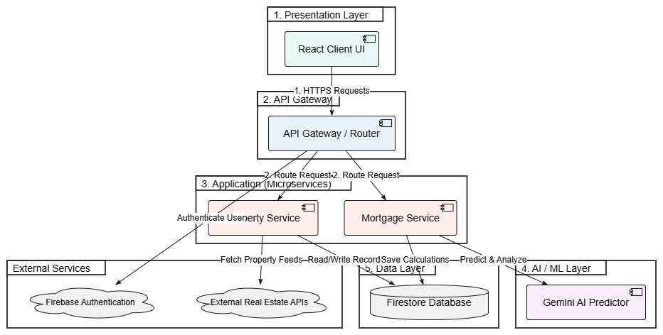
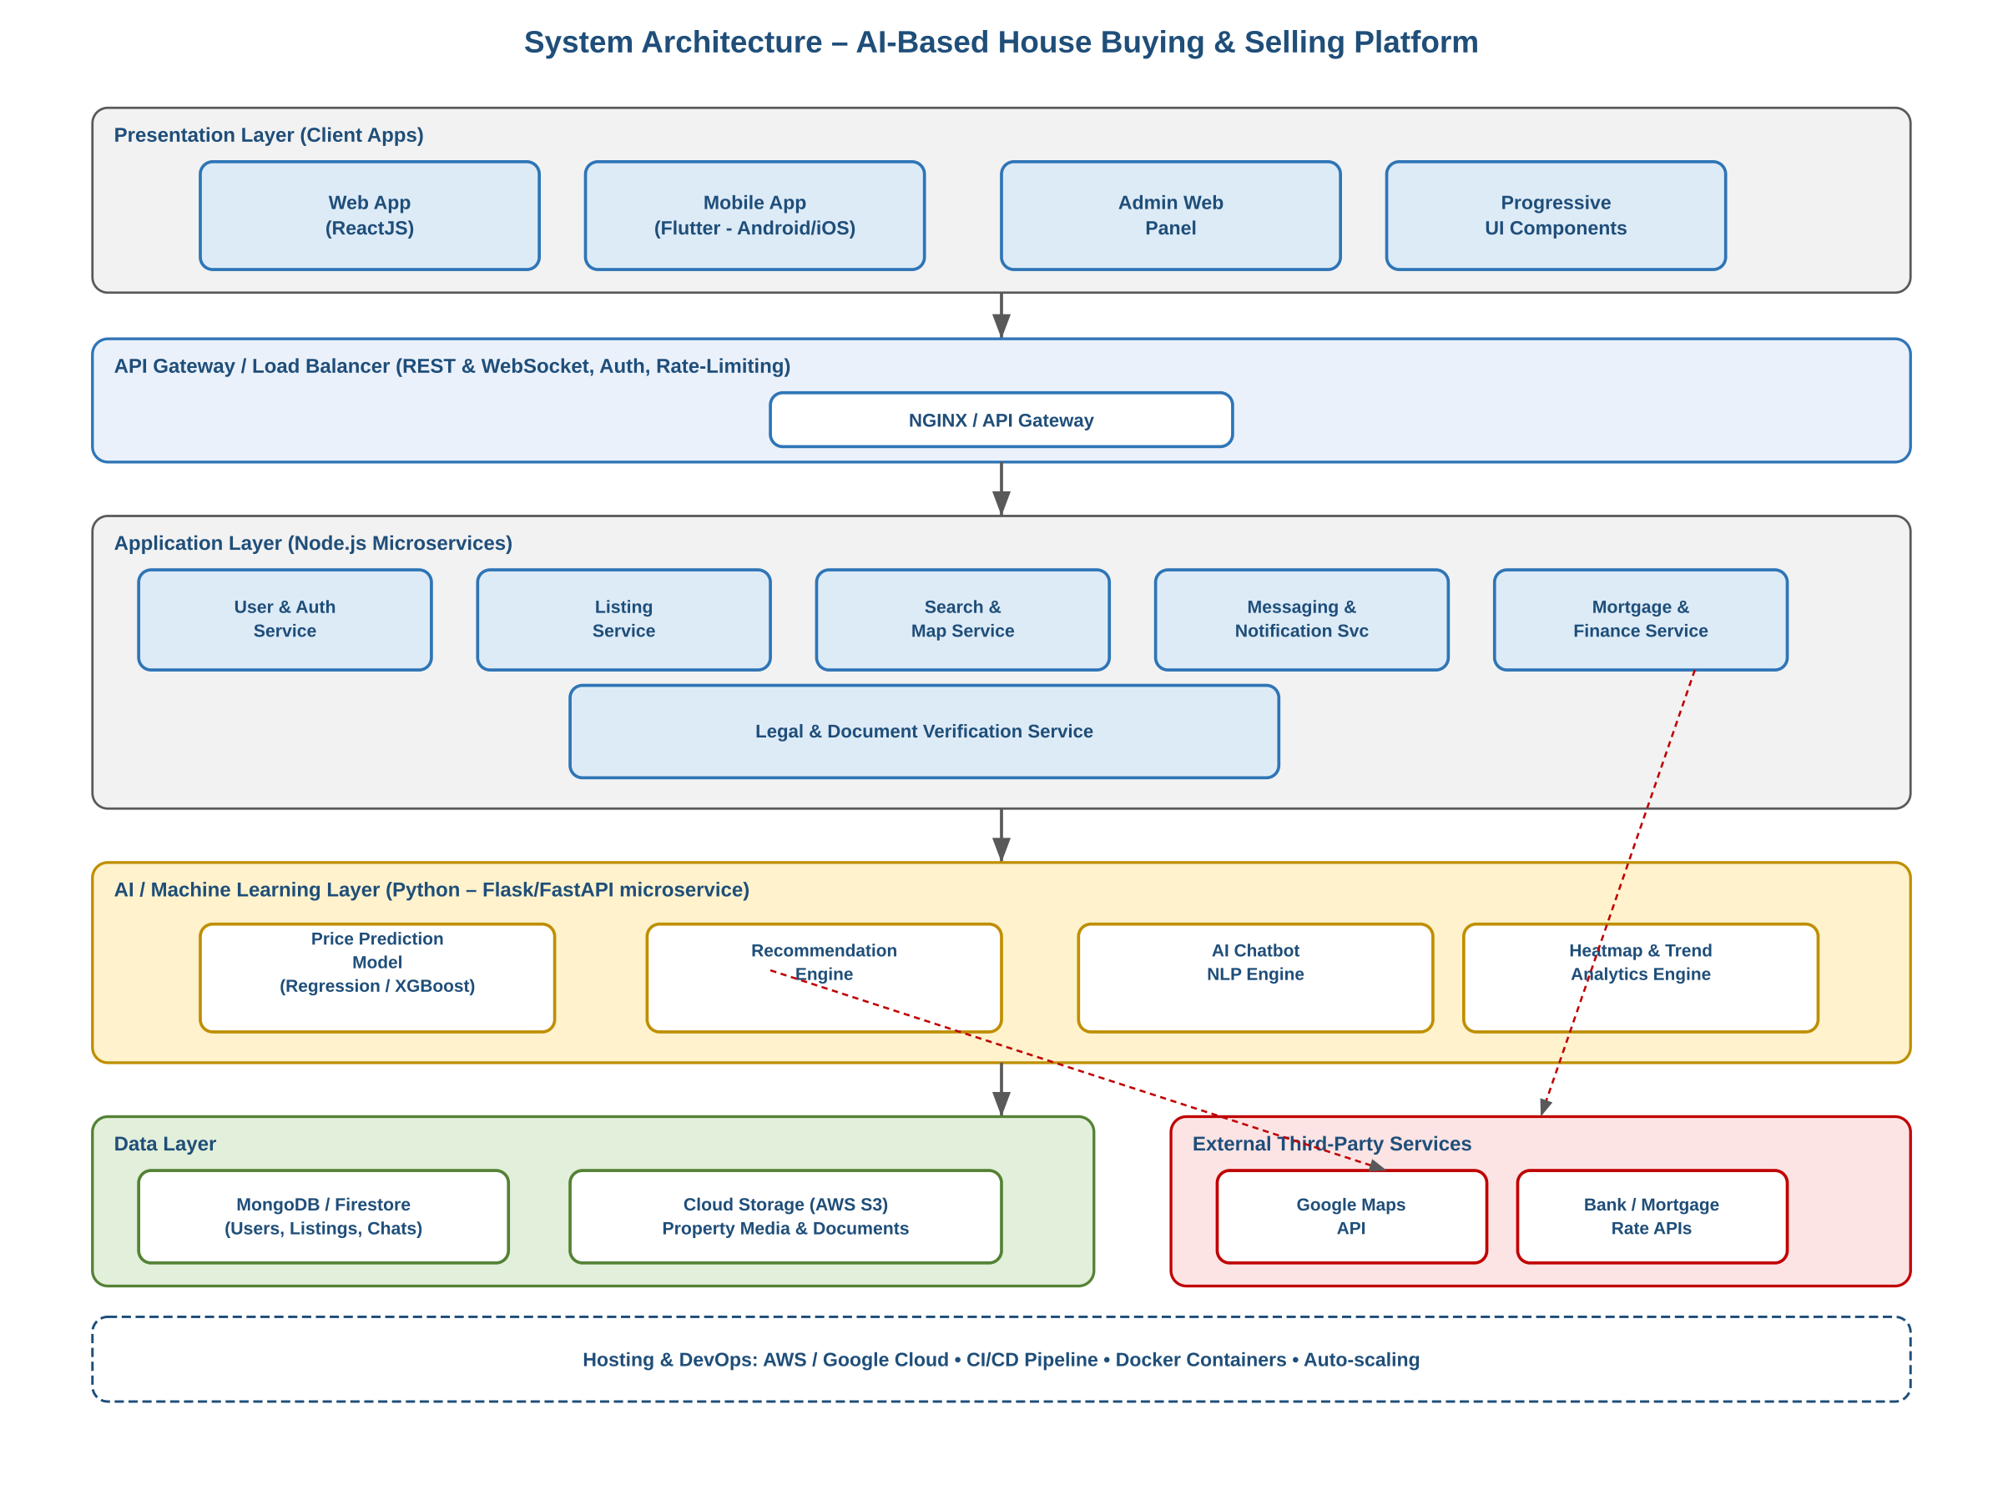
Figure 3.1: Layered system architecture – Presentation, API Gateway, Application (microservices), AI/ML, and Data layers, plus external services.
Module collaboration, in brief:
- Presentation Layer (Web/Mobile/Admin UI) sends REST/WebSocket requests only to the API Gateway; it holds no business logic.
- API Gateway authenticates each request (JWT), applies rate limiting, and routes it to the owning microservice.
- Application Layer microservices (User & Auth, Listing, Search & Map, Messaging & Notification, Mortgage & Finance, Legal Document Verification) each own a bounded part of the domain model and its own collection(s) in the Data Layer.
- AI/ML Layer exposes the Price Prediction Model, Recommendation Engine, Chatbot NLP Engine, and Heatmap/Trend Analytics Engine as internal endpoints consumed only by the Application Layer — never directly by clients.
- Data Layer (MongoDB/Fire store + cloud storage) is accessed exclusively through each service's Data Access Layer, keeping storage technology swappable without affecting business logic.

3.2 Process Flow / Representation
The listing lifecycle is the platform's major process: it is the workflow every property passes through from creation to becoming visible to buyers, and it is where the AI price-prediction step and the Admin moderation step both occur. The activity diagram below traces this flow across the Seller/Agent, System (AI + Backend), and Admin swim-lanes.
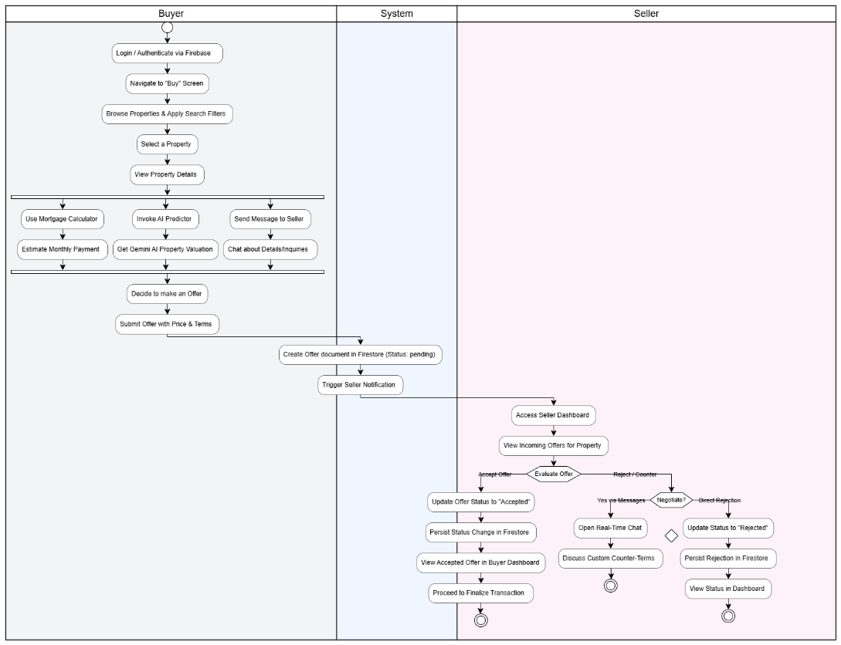
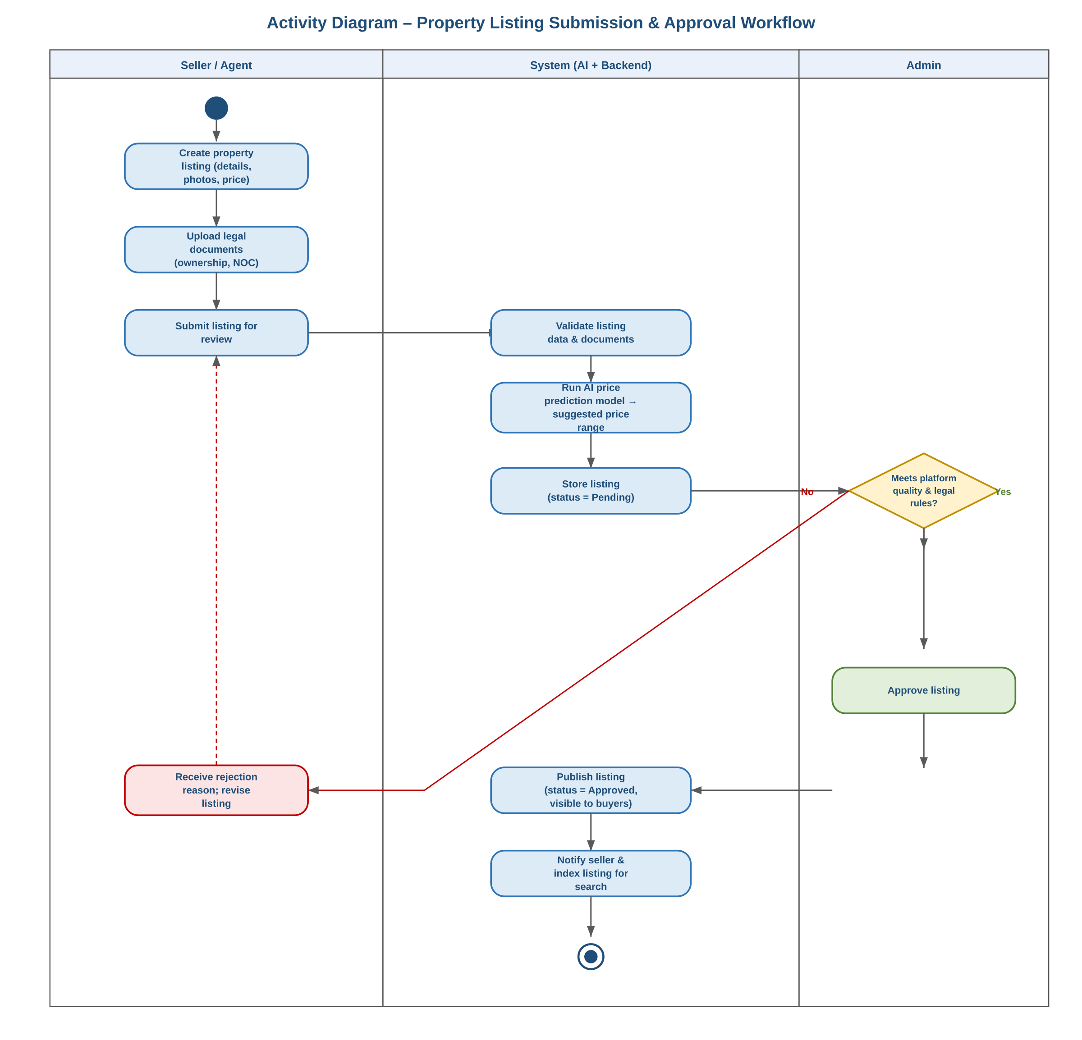
Figure 3.2: Activity diagram
A login/registration activity diagram is intentionally omitted, as that flow is a standard credential-check with no significant branching or complexity beyond the ordinary success/failure paths.

4. Design models [along with descriptions]
As the system follows an Object-Oriented design (Section 2), the applicable models are the Class Diagram, Sequence Diagram, and State Transition Diagram below. A Data Flow Diagram was not required for this OO design; DFDs for reference were nonetheless produced during requirements analysis and are included in the SRS Diagrams Package for completeness.

4.1 Class Diagram
The domain model below shows the system's core classes, attributes, key operations, and relationships. User is specialized via inheritance into Buyer, Seller/Agent, and Admin. Property and Listing are related by a 1-to-1 composition (a Listing cannot exist without its property), while Listing aggregates zero-or-more Inquiry, Appointment, Review, and exactly one Price Prediction. Association multiplicities are annotated on each relationship.
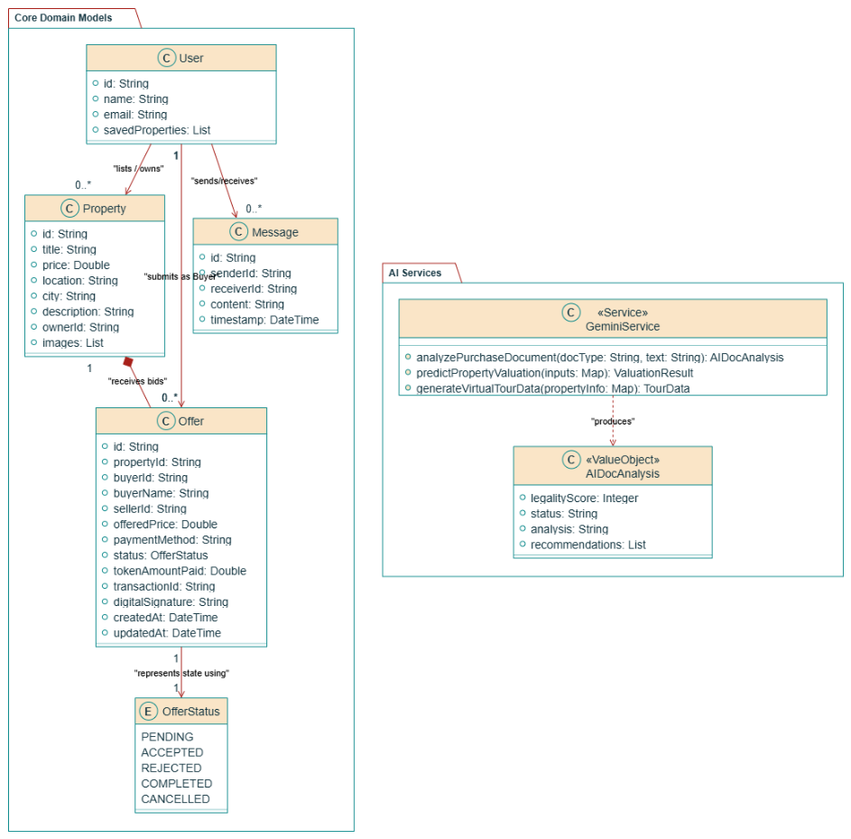
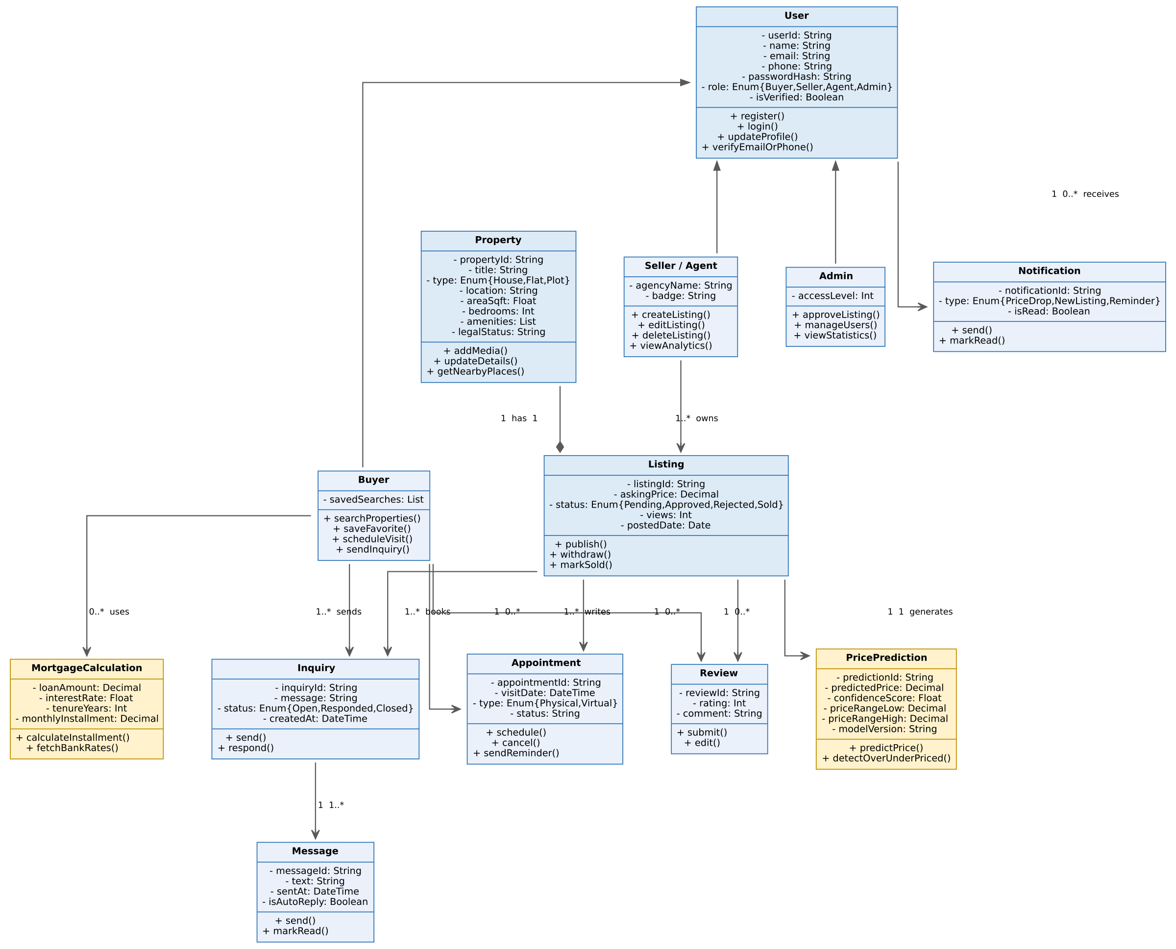
Figure 4.1: Domain class diagram, showing inheritance (User → Buyer/Seller/Admin), composition (Property–Listing), and associations to Inquiry, Appointment, Review, PricePrediction, and Notification.

4.2 Sequence Diagram
The sequence diagram below traces the platform's signature interaction — a Buyer searching for properties and requesting an AI price estimate — across the Web/Mobile UI, API Gateway, Listing Service, AI Prediction Service, Database, and Maps API.
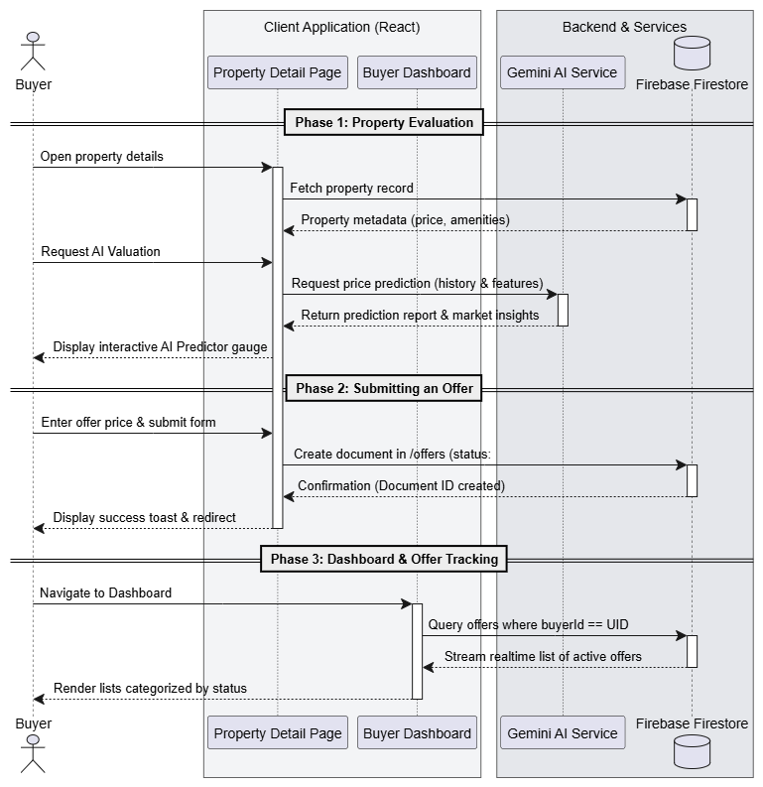
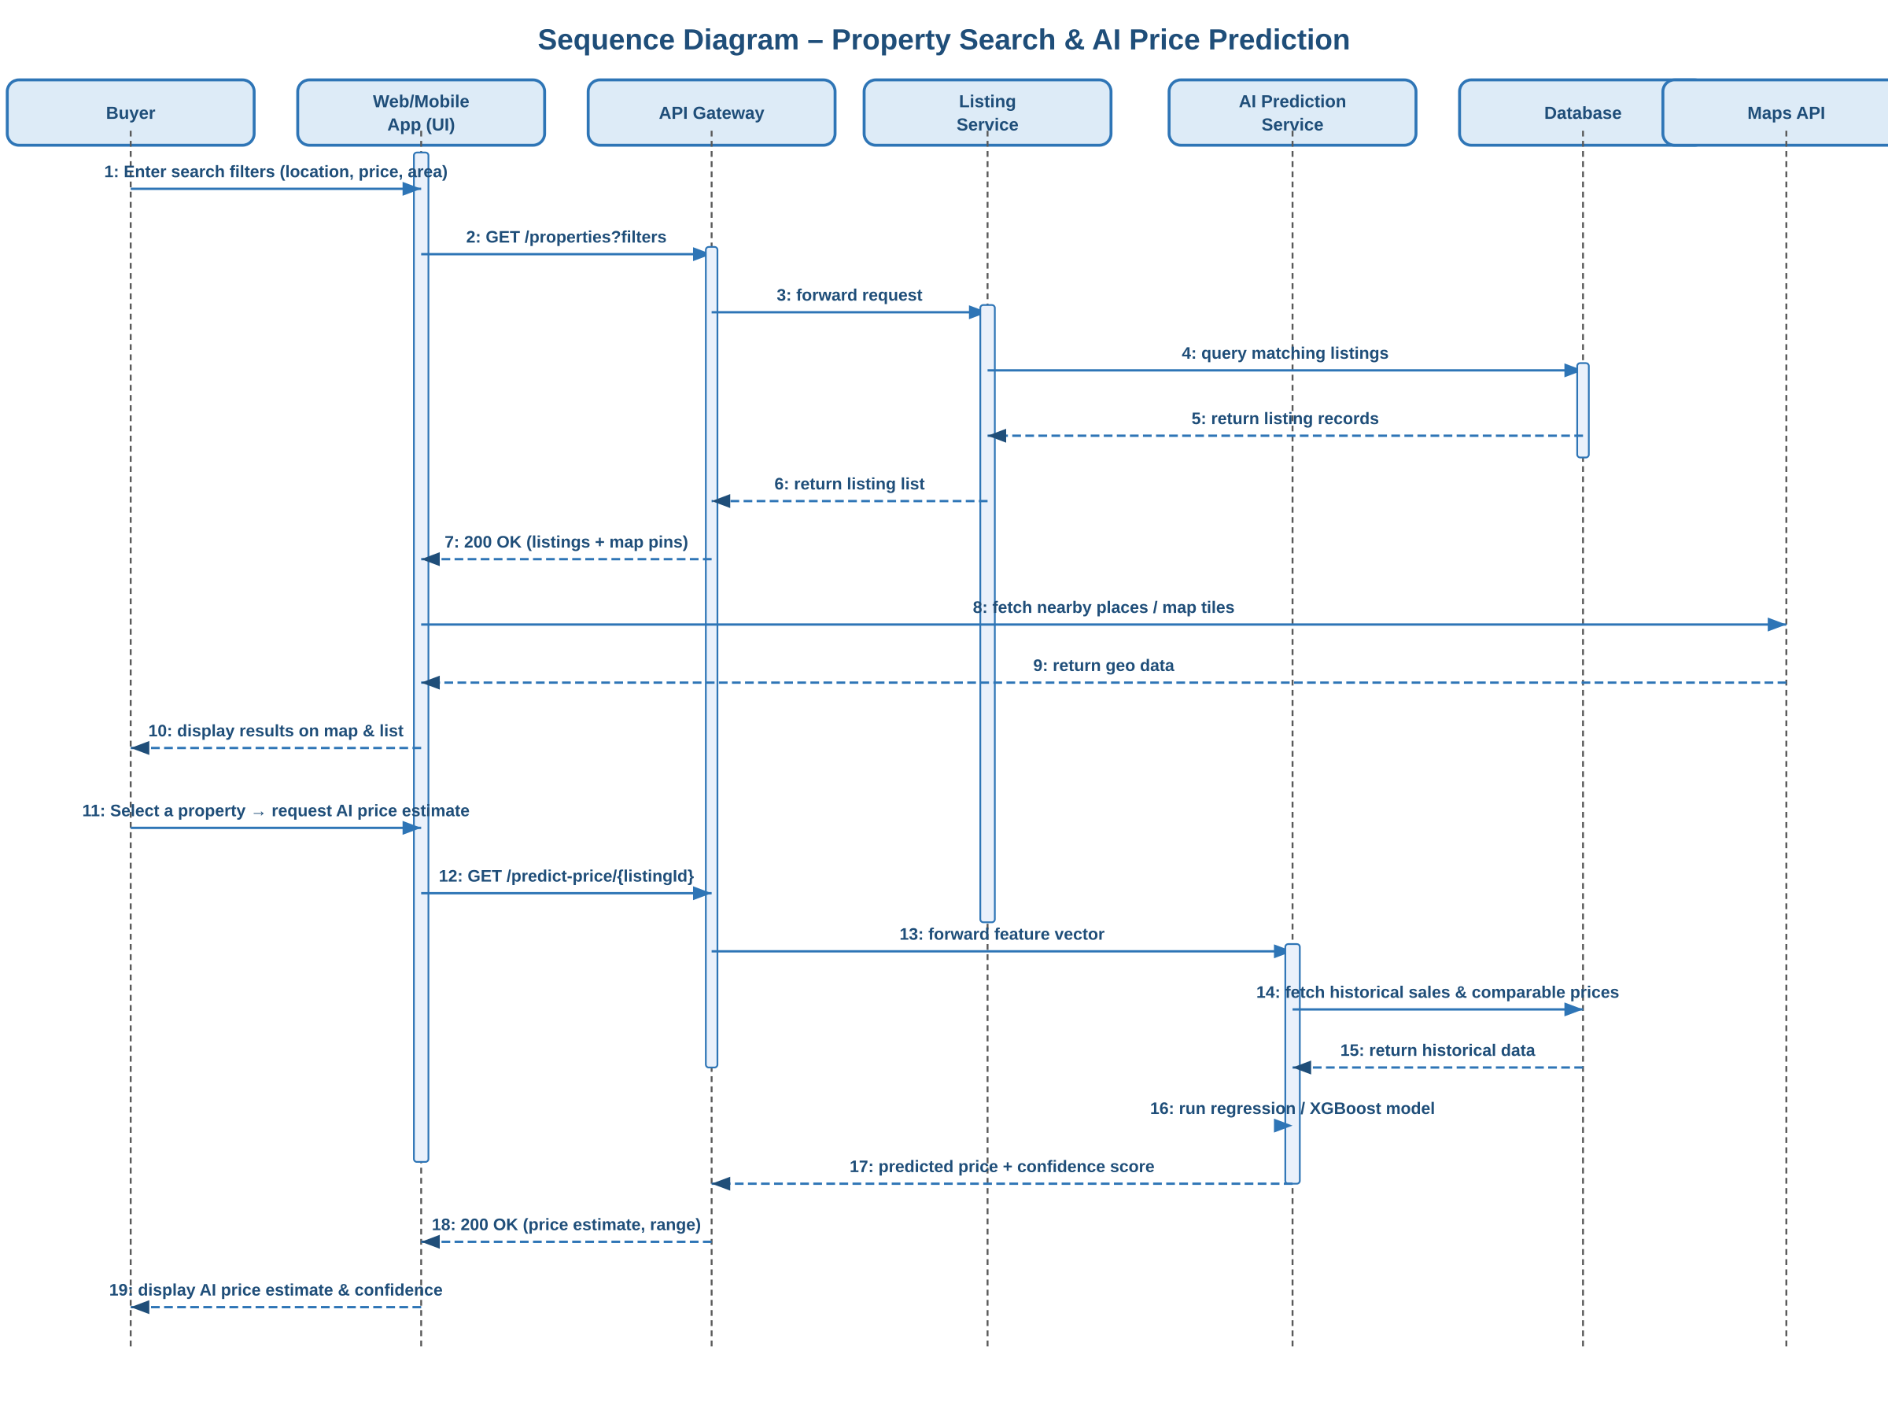
Figure 4.2: Sequence diagram – Property Search & AI Price Prediction.

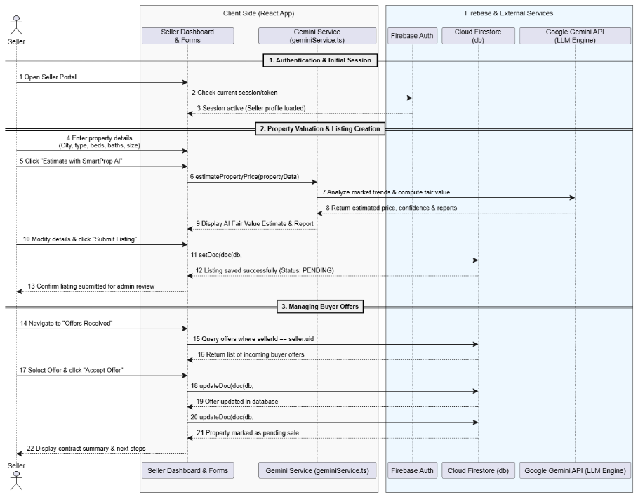
Figure 4.3: Sequence diagram for Seller
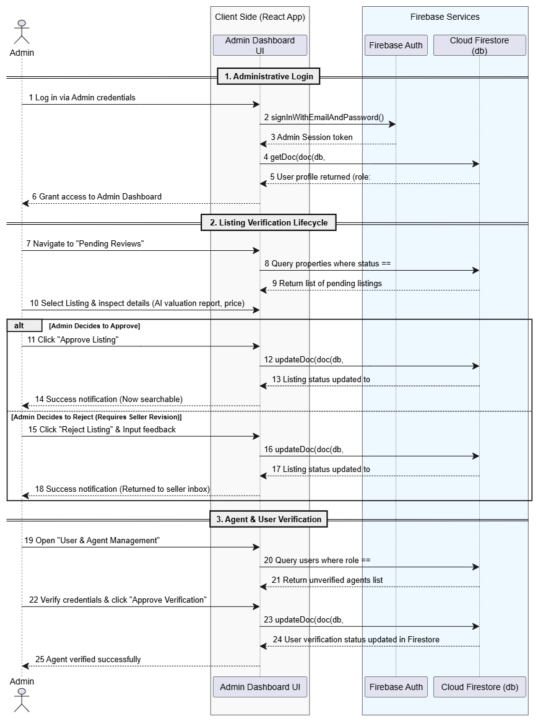
Figure 4.3: Sequence diagram for Admin

4.3 State Transition Diagram
A Listing is the entity with the richest lifecycle in the system, so its state machine is modelled explicitly. A listing moves from Draft through Submitted and Under Review; the Admin's decision either sends it to Be Rejected (returned to the seller for revision) or Approved, after which it is automatically Published and becomes searchable. From Published, a listing terminates in one of three states: Sold, Withdrawn (seller-initiated), or Expired (visibility timeout).
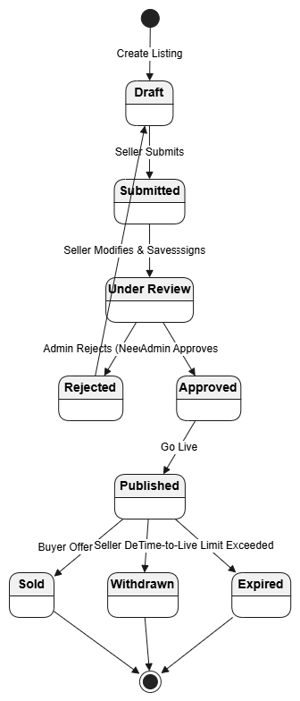

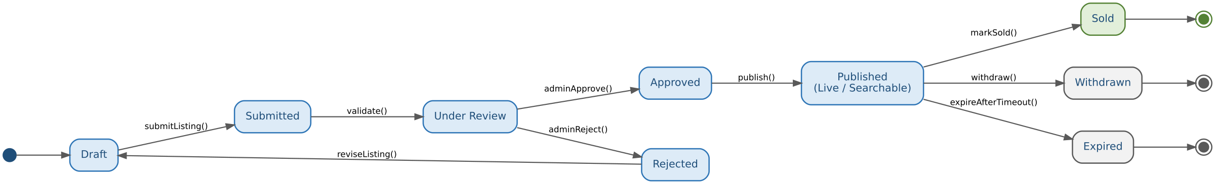
Figure 4.4: State transition diagram – Listing lifecycle.

5. Data design
The system's information domain is transformed into a set of document-oriented collections (MongoDB/Firestore), one primary collection per major entity, mirroring the classes in Section 4.1. Media files (property photos/videos) and uploaded legal documents are stored as binary objects in cloud object storage (AWS S3), with only their URLs/references kept in the corresponding database document — keeping the database itself lightweight and fast to query.
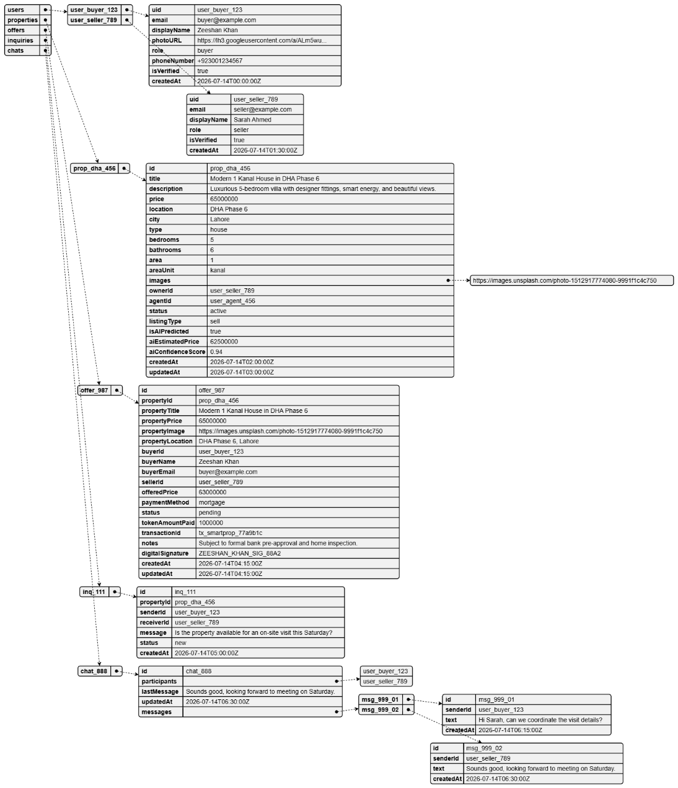
Figure 4.5: JSON Database Tree

5.1 Data Dictionary
Major system entities (alphabetical), their type, and description:
Entity / Field | Type | Description
Chat | Object | A messaging thread between a buyer and a seller; holds participants (the two user IDs), a lastMessage preview, updatedAt, and a messages subcollection.
Inquiry | Object | A buyer's question about a Property, sent directly to the owner/seller; holds propertyId, senderId, receiverId, message text, and status (e.g. New).
Message | Object (subcollection of Chat) | A single chat message inside a Chat thread; holds senderId, text, and createdAt.
Offer | Object | A buyer's formal purchase offer on a Property; holds offeredPrice, paymentMethod, tokenAmountPaid, transactionId, digitalSignature, notes, and status (e.g. Pending). Denormalizes buyer/seller/property summary fields (buyerName, propertyTitle, propertyImage, etc.) for fast display without extra lookups.
Property | Object | The core real-estate listing entity; holds physical details (title, description, location, city, type, bedrooms, bathrooms, area, areaUnit, images), ownership (ownerId, agentId), commercial fields (price, status, listingType), and the AI valuation fields below.
User | Object | Account entity for all roles; holds uid, email, displayName, photoURL, phoneNumber, role, and isVerified. Buyer, Seller/Agent, and Admin are distinguished by the role field rather than by separate collections/subclasses.
aiConfidenceScore | Float (0–1) | The AI model's certainty in its price estimate for a Property; drives the Fair/Over/Under-Priced decision logic in Section 6.
aiEstimatedPrice | Decimal | AI-predicted fair market value for a Property, compared against its listed price.
isAIPredicted | Boolean | Flags whether a Property has an AI valuation available yet.
paymentMethod | Enum | Cash │ Mortgage — how the buyer intends to pay on an Offer.
role | Enum | Buyer │ Seller │ Agent │ Admin — discriminates a User's permissions and available use cases.
status (Offer) | Enum | Pending │ Accepted │ Rejected │ Completed │ Cancelled — the offer's negotiation state.
status (Property) | Enum | Active │ Sold │ Withdrawn (or equivalent) — the listing's marketplace visibility state.

6. Algorithm & Implementation
This section summarises, in procedural description language (PDL/pseudocode), the core member functions behind the system's three most algorithmically significant use cases: property search, AI-based price evaluation, and personalized recommendations.

6.1 ListingService.searchProperties(filters)
FUNCTION searchProperties(filters):
query = buildQuery(filters.location, filters.priceRange,
filters.bedrooms, filters.propertyType)
candidates = ListingRepository.find(query, status = "Published")
IF filters.mapBounds IS NOT NULL:
candidates = filterWithinBounds(candidates, filters.mapBounds)
results = sortBy(candidates, filters.sortKey DEFAULT "relevance")
RETURN paginate(results, filters.page, filters.pageSize)
END FUNCTION

6.2 PricePredictionService.evaluateListingPrice(askingPrice, predictedPrice, confidence)
Implements the Decision Table used to flag a listing as Fair / Over- / Under-Priced (see Section 7 traceability to FR03–FR04):
FUNCTION evaluateListingPrice(askingPrice, predictedPrice, confidence):
deviation = (askingPrice - predictedPrice) / predictedPrice * 100
IF confidence < 80:
RETURN "Low Confidence - shown as reference only"
IF deviation > 10:
RETURN "Over-Priced - consider reducing price"
ELSE IF deviation < -10:
RETURN "Under-Priced - good deal for buyers"
ELSE:
RETURN "Fair Price - matches market estimate"
END FUNCTION

6.3 RecommendationEngine.generateRecommendations(userId)
FUNCTION generateRecommendations(userId):
profile = UserRepository.getPreferences(userId)
history = InteractionRepository.getRecentViews(userId, limit = 50)
candidateSet = ListingRepository.findSimilar(profile, history)
FOR EACH listing IN candidateSet:
listing.score = wLocation * locationMatch(listing, profile)
+ wPrice * priceMatch(listing, profile)
+ wBehaviour * behaviourMatch(listing, history)
ranked = sortDescendingByScore(candidateSet)
RETURN top(ranked, n = 10)
END FUNCTION

7. Software Requirements Traceability Matrix
Table 1 maps each functional requirement from the SRS to the design component(s) that realise it in this SDD.
Table 1: Requirements Traceability Matrix
Req. Number | Ref. Item | Design Component | Component Items
FR01 | Class Diagram | User, Buyer, Seller, Admin | register(), login(), verifyEmailOrPhone()
FR02 | Class Diagram | Buyer, Listing | searchProperties(filters)
FR03 | Class Diagram | PricePrediction | predictPrice()
FR04 | Class Diagram | PricePrediction | detectOverUnderPriced() / evaluateListingPrice()
FR05 | Class Diagram | RecommendationEngine (AI/ML Layer) | generateRecommendations(userId)
FR06 | Class Diagram | PricePrediction, Listing | predictPrice(), suggestOptimalPrice()
FR07 | Class Diagram | Seller, Listing | publish(), withdraw(), markSold()
FR08 | Class Diagram | Buyer, Appointment, Inquiry | saveFavorite(), scheduleVisit(), sendInquiry()
FR09 | Sequence Diagram | AI Prediction Service (Chatbot NLP Engine) | handleChatQuery()
FR10 | Class Diagram | MortgageCalculation | calculateInstallment(), fetchBankRates()
FR11 | Class Diagram | Notification | send(), markRead()
FR12 | Class Diagram | Listing, Seller | viewAnalytics()
FR13 | State Transition Diagram | Listing | adminApprove(), adminReject()
FR14 | Class Diagram | LegalDocument, Property | addMedia(), updateDetails()
FR15 | Architectural Design (3.1) | Heatmap & Trend Analytics Engine | getPriceTrends(area)

8. Human interface design
From the user's perspective, the system exposes three distinct interfaces — a Buyer-facing experience (search, property detail, AI price estimate, messaging, mortgage calculator), a Seller/Agent dashboard (listing management, analytics, document upload), and an Admin console (moderation, user management, platform statistics). Every screen that displays a price gives the user immediate, visible feedback from the AI Prediction Engine (predicted price, confidence score, and a Fair/Over/Under-Priced badge per the Decision Table in Section 6.2), so the AI's reasoning is never a black box to the end user.

8.1 Screen Images
Wireframes / screen mockups for the Buyer search & map view, the Property Detail + AI Price Estimate view, and the Seller Dashboard are planned and will be added to this section in the next revision of the document, ahead of the 100% evaluation.
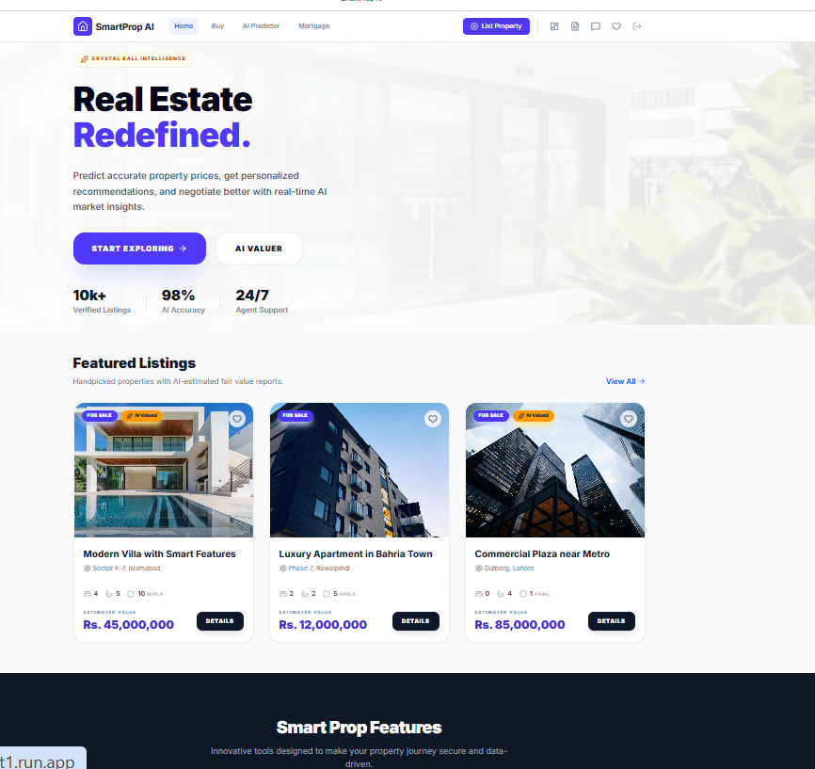

8.2 Screen objects and actions
Buyer – Search & Map Screen
- Search bar (object): free-text input; Action → on submit, calls searchProperties(filters) and refreshes the result list and map pins.
- Filter chips – Price / Bedrooms / Property Type / Area (objects): dropdown selectors; Action → each change re-runs the search with the updated filter set.
- Property card (object, repeated): photo, price, AI badge (“Fair Price” / “Over-Priced” / “Under-Priced”); Action → tap opens the Property Detail screen; the ♡ Save icon calls saveFavorite() without leaving the list.
- Map pins (objects): one per visible listing; Action → tap highlights the corresponding property card and centers the map.
Buyer – Property Detail Screen
- Photo gallery (object): swipeable image carousel sourced from Property media.
- AI Price Estimate card (object): predicted price, confidence bar, and price-flag badge; Action → “View Similar Properties” re-runs a similarity search seeded from the current listing.
- Chat with Seller / Schedule Visit / Save buttons (objects): Action → open a messaging thread (sendInquiry()), open the visit-scheduling dialog (scheduleVisit()), or toggle favorite status, respectively.
- Mortgage Calculator widget (object): loan amount, interest rate, and tenure inputs; Action → recalculates and displays the estimated monthly installment in real time (calculateInstallment()).

Seller – Dashboard Screen
- Listings table (object): one row per listing with Asking Price, AI Estimate, Status badge, and Views; Action → “Edit” opens the listing editor (updateDetails()), the eye icon opens viewAnalytics().
- + Add New Listing button (object): Action → opens the multi-step listing-creation form, ending in publish() once Admin-approved.

9. Appendix I
- How to design using UML (OOP): follow the guidance at http://agilemodeling.com/artifacts/
- How and when to design ER diagrams: Ullman, “The Complete Book” — http://people.inf.elte.hu/nikovits/DB2/Ullman_The_Complete_Book.pdf
- Software Engineering — A Practitioner's Approach, Roger Pressman
- Architecture diagram: Ian Sommerville — Software Engineering, 9th Edition, Chapter 6
- Companion artifacts: SRS_Diagrams_Package.docx (Use Case, ER, DFD Level 0/1) and the FYP presentation deck, both produced alongside this SDD.

