
COMSATS University Islamabad, Abbottabad Campus

(SCOPE DOCUMENT)
for
House Buying & Selling with Price Prediction

By

Shehzad Ahmad CIIT/SP23-BS-088/ATD Muhammad Ahmad Khan CIIT/SP23-BSE-137/ATD Abbas Khan CIIT/SP23-BSE-115/ATD

Supervisor
Ahmed Ali

Bachelor of Science in Software Engineering (2023-2027)

SCOPE DOCUMENT REVISION HISTORY

No. | Comment | Action

Supervisor Signature Date:

Table of Contents

Table of Contents

1. Introduction 5
2. Problem Statement 6
3. Problem Solution for Proposed System 6
4. Related System Analysis/Literature Review 7
5. Advantages/Benefits of Proposed System 7
6. Scope 8
7. Modules 9
7.1 Module 1: Property Search & Discovery 10
7.2 Module 2: AI-Based Price Prediction 10
7.3 Module 3: AI-Powered Recommendations………….………………………………………....11
7.4 Module 4: Property Listing Management ……………………………………………………...11
7.5 Module 5:Buying & Renting Module……… ………………………………………………….11
7.6 Module 6: Dashboard & Analytics……………………………………………………………..11
7.7 Module 7: Propert Details Page………………………………………………………………...11
7.8 Module 8: Alerts & Notifications………………………………………………………………11
7.9 Module 9: Messaging System………………………………………………………………….12
7.10 Module 10:Legal & Document Support………………………………………………………..12
7.11 Module 11:Secure User Authentication& Profile Management……………………………….12
7.12 Module 12:AI Chatbot Assistant……………………………………………………………….12
7.13 Module 13:Mortgage &Finance Calculator…………………………………………………….12
7.14 Module 14:Location Intelligence & Heatmaps…………………………………………………12
7.15 Module 15:Multilingual Support………………………………………………………………..12
7.16 Module 16:Mobile App Integration…………………………………………………………….12
7.17 Module 17:Admin Panel Features………………………………………………………………12
7.18 Module 18:Advanced Search Features………………………………………………………….13
8. System Limitations/Constraints 13
9. Software Process Methodology 13
10. Tools and Technologies 14
11. Project Stakeholders and Roles 15
12. Team Members Individual Tasks/Work Division 16
13. Data Gathering Approach 17
14. Concepts 18
15. Gantt chart 19
16. Mockups 20
17. Conclusion 22
18. References 22
19. Plaragism Report 23

Project Category: (Select all the major domains of proposed project)


B - Web Application / Web Application-based Information System

C - Problem Solving and Artificial Intelligence

Abstract
House Buying & Selling with AI-Based Price Prediction is an intelligent, full-stack real estate platform that directly addresses a structural gap in Pakistan's property market: the complete absence of data-driven price validation for buyers and sellers. Pakistan's real estate sector is valued at over PKR 1 trillion annually, yet it operates under severe information asymmetry — buyers routinely overpay and sellers routinely underprice because neither party has access to any objective, data-backed benchmark. Every pricing decision is mediated by a real estate agent whose compensation structure incentivizes inflated transaction values, and platforms like Zameen.com [1] offer listing aggregation but no analytical intelligence whatsoever.
This platform addresses that gap by embedding an XGBoost-based machine learning price prediction engine — trained on over 50,000 historical Pakistani property records — directly into a full-featured property marketplace. For every listed property, the system computes a predicted fair market value, attaches an 85% confidence interval, and renders an overpriced or underpriced verdict alongside the seller's asking price. This prediction layer is integrated into a comprehensive platform offering property search with Google Maps, buying, selling and renting workflows, an AI chatbot assistant, interactive area heatmaps, a mortgage calculator, real-time in-app messaging, smart notifications, and role-based authentication for Buyers, Sellers, Agents, and Administrators.
The platform is built on React.js and Next.js for the web frontend, Flutter for cross-platform mobile (iOS and Android), Node.js with Express.js for the backend REST API, MongoDB as the primary database, Redis for caching, and Python with Flask as the ML microservice that exposes the trained XGBoost model. The project is developed as a Final Year Project by three Software engineering students at COMSATS University Islamabad, Abbottabad Campus (BS Software Engineerings, 2023–2027), under the supervision of Sir Ahmed Ali.

Introduction
Pakistan's real estate sector is one of the most actively traded but least transparent asset classes in the national economy. Platforms such as Zameen.com, Graana.com, and OLX Pakistan provide listing discovery — sellers post advertisements and buyers browse them — but none of these platforms provides any mechanism for independently validating whether a listed price reflects fair market value. There is no Pakistani equivalent of Zillow's Zestimate or the UK's Rightmove Price Tracker. As a result, every property transaction in Pakistan depends entirely on the word of a real estate agent, a party whose commission is directly tied to the transaction value and who therefore has a structural incentive to present pricing in a manner that maximizes the transaction amount rather than accurately reflecting market conditions.
This project addresses that structural gap directly and comprehensively. By training an XGBoost machine learning model on a large dataset of historical Pakistani property transactions and embedding it inside a full-featured property marketplace, this platform gives buyers, sellers, and agents an objective, data-backed pricing benchmark for the first time in the Pakistani market.
The app is designed for three key user personas: home buyers that want honest pricing advice, home sellers that want accurate listing price suggestions based on data, and real estate agents that want digital-first professional tools.

Problem Statement
Pakistan's residential and commercial real estate market suffers from three deeply interconnected structural problems that have persisted for decades without a technology-driven solution. This project is designed to address all three simultaneously through a unified platform architecture.
Price Opacity: There is no publicly available, data-driven tool in Pakistan that allows any participant in a property transaction to independently verify whether a listed price reflects fair market value. The Federal Board of Revenue's own data reveals that declared property valuations across major Pakistani cities are consistently 30 to 50 percent below actual transaction values. A first-time buyer in Islamabad or Karachi has no objective reference point — no model, no benchmark, no comparable sales tool — with which to evaluate a seller's asking price.
Decision Fragmentation: A buyer who wants to research a property purchase in Pakistan must consult a minimum of five or six disconnected tools: Zameen.com for listing discovery, Google Maps for location context, a bank's website for mortgage rates, a separate calculator for instalment estimates, a news aggregator for neighbourhood price trends, and an agent's opinion for price benchmarking. None of these sources communicate with each other.
Agent Dependency and Conflict of Interest: Because no objective price benchmark exists, buyers and sellers are entirely dependent on real estate agents for pricing guidance. Agents are compensated as a percentage of the transaction value, creating a direct conflict of interest. No regulatory body enforces standardized pricing disclosures, and no technology platform provides either party with a neutral data-backed alternative to agent testimony.

Problem Solution for Proposed System
The proposed system addresses each of the three root causes through a cohesive, layered architecture built around three core solution pillars.
3.1 ML Price Prediction Engine — Solving Price Opacity
An XGBoost regression model is trained on the Pakistan House Price Dataset (Kaggle, 50,000+ records). The training pipeline applies systematic feature engineering: city, locality, property type, area in Marlas/Kanals, bedrooms, bathrooms, floor level, furnishing status, and amenities. The model is deployed as a Python/Flask REST API microservice that returns predicted fair market value in PKR, 85% confidence bounds, an overpriced/underpriced classification, and SHAP feature importance values for human-readable explanations.
Consolidated Platform — Solving Decision Fragmentation
The platform consolidates property search, Google Maps visualization, AI price assessment, mortgage calculation, area-level price trends, in-app messaging, and visit scheduling into one integrated interface, replacing 5–6 separate tools.
Transparent Price Signal — Solving Agent Dependency
By displaying a model-generated price estimate alongside every seller's asking price — visible simultaneously to buyers and sellers — the platform introduces a neutral, data-backed anchor into every property transaction for the first time.

Related System Analysis/Literature Review
Table: 1Related System
Application Name | Weakness | Proposed Project Solution
Zameen.com (Pakistan) | Dominant Pakistani listing platform with zero analytical intelligence. No AI pricing, no market benchmarks, no buyer guidance tools. | Provides model-generated price estimate on every listing page, area heatmaps, demand analytics, mortgage integration, AI chatbot, and in-app messaging.
Zillow (USA) | Entirely built on American property data; inapplicable to Pakistani conditions (Marla/Kanal units, locality patterns, legal framework). | Trained exclusively on Pakistani property datasets with Urdu language support and local area unit conventions.
Graana (Pakistan) | Basic search and listings but no AI price prediction, no ML model, no area-level market analytics. | Adds complete AI-powered analytics layer on top of standard marketplace features.
OLX Pakistan | General classifieds with no real estate specialisation; listings unstructured and unverified. | Purpose-built for real estate with structured listings, agent verification, and AI-powered price assessment.

Advantages/Benefits of Proposed System
AI-Driven Price Transparency — The Primary Differentiator
The ML price prediction engine computes an independent, model-generated price estimate for every listed property with confidence intervals, overpriced/underpriced verdicts, and SHAP-powered explanations. This removes the information asymmetry that has disadvantaged Pakistani property buyers for decades.
Consolidated Decision-Making Environment
The platform replaces five to six disconnected tools with a single integrated interface, reducing average time-to-decision and cognitive overhead.
Bilingual Support: English and Urdu
Full Urdu language support makes the platform accessible to the majority of Pakistani property buyers and sellers who are not comfortable conducting financial research in English.
Role-Based Intelligence for All Stakeholders
Four distinct user roles — Buyer, Seller, Agent, Admin — each receive tailored dashboards: AI-generated optimal listing prices for sellers, personalized recommendations for buyers, lead management for verified agents, and real-time monitoring for administrators.
Sustainable Microservice Architecture
The ML model is deployed as an independent Python/Flask microservice, fully decoupled from the main Node.js backend, allowing independent scaling and retraining without application disruption.
Full Audit Trail and Admin Governance
Every significant platform action is logged in MongoDB. The Admin Dashboard provides real-time monitoring with one-click moderation tools.

Scope
House Buying & Selling with AI-Based Price Prediction is a full-stack, cross-platform intelligent real estate marketplace. Its primary function is to provide AI-powered property price prediction and a comprehensive property transaction support environment for Pakistani users across both web and mobile platforms. The system is scoped to serve four principal user groups: home buyers seeking data-backed pricing guidance, property sellers seeking intelligent listing price recommendations, real estate agents seeking a digital-first platform for client management, and platform administrators responsible for content governance.
In Scope:
- Web Application (React.js / Next.js 14) — fully responsive
- Mobile Application (Flutter 3.x) — native iOS 13.0+ and Android 8.0+ with push notifications
- AI Price Prediction Engine (XGBoost + Flask) — REST API with price, confidence interval, and SHAP explanation
- Property marketplace — search, filters, listings, buying, selling, renting with Google Maps
- Role-based authentication — Buyer, Seller, Agent, Admin via JWT
- AI Chatbot assistant — context-aware guidance on pricing, mortgage, buying/selling
- Mortgage & Finance Calculator — monthly instalments with live bank interest rate integration
- Location Intelligence & Heatmaps — area price trends, demand/supply analytics, livability scores
- Real-time in-app messaging — Socket.io
- Smart Alerts & Notifications — price drops, new listings, mortgage alerts
- Session History & Audit Logging — persisted in MongoDB
- Admin Dashboard — listing moderation, user management, analytics, audit log
- Bilingual support — English and Urdu
- Legal & Document Support — guidance on property transfer, taxation, ownership
- Verified Seller and Verified Agent badge system

Modules
The system is composed of eighteen modules, reflecting the three-student team size and the breadth of the proposed feature set.
7.1 Property Search & Discovery
• Filter by location, price range, area, bedrooms, property type, city
• Map view of listings (Google Maps integration)
• Nearby places search (schools, hospitals, markets)
7.2 AI-Based Price Prediction
- Predict fair market price using features like:
- Location, area (sq. ft.), type, number of rooms, amenities
- Historical sales data and local price trends
• Confidence score or price range for each estimate
• Detect overpriced or underpriced listings
7.3 AI-Powered Recommendations
• For buyers:
o Personalized property suggestions based on search history, saved listings, and preferences
• For sellers:
o Optimal listing price
o Best time to sell
o Suggested improvements to increase property value
7.4 Property Listing Management (For Sellers/Agents)
• Add/edit/delete property listings
• Upload photos/videos, descriptions, location, amenities
• View performance analytics (views, likes, contact requests)
7.5 Buying & Renting Module
• Inquire about properties
• Save properties to favorites
• Schedule site visits or virtual tours
• Chat with sellers or agents
7.6 Dashboard & Analytics
• For buyers: Track saved properties, inquiries, price changes
• For sellers: See views, leads, price comparison with similar properties
• Admin dashboard: Monitor platform activity, approvals, user trends
7.7 Property Detail Page
• High-resolution media (photos/videos/virtual tour)
• Price history and AI-estimated price
• Nearby amenities (schools, malls, hospitals)
• Property features and legal status
7.8 Alerts & Notifications
• Price drop alerts
• New properties in your selected area
• Mortgage eligibility alerts
• Appointment reminders (site visits)

7.9 Messaging System
• In-app messaging between buyers and sellers/agents
• Auto-reply suggestions via AI chatbot
7.10 Legal & Document Support
• Upload and verify legal documents (e.g., ownership proof, NOC)
• Provide guidance on property transfer, taxation, and loans
7.11 Secure User Authentication & Profile Management
• Role-based logins: Buyer, Seller, Agent, Admin
• Email and phone verification
• Profile badges (Verified Agent, Trusted Seller)
7.12 AI Chatbot Assistant
• Guide users on searching, price estimation, or mortgage help
• Provide real-time assistance for buying/selling
7.13 Mortgage & Finance Calculator
• Calculate estimated mortgage rates and monthly installments
• Link to banks for real-time interest rate APIs
7.14 Location Intelligence & Heatmaps
• Show price trends by area
• Demand vs. supply insights in each city or locality
• Safety and livability scores
7.15 Multilingual Support
• English, Urdu, and regional languages for wider reach
7.16 Mobile App Integration
• Android/iOS support
• Push notifications for saved searches and listings
7.17 Admin Panel Features
• Approve/reject listings
• Manage reported properties
• Block spam users or listings
• View overall platform statistics
7.18 Advanced Search Features (Zameen.com Inspired)
• New Projects & Developers section
• Area/unit converters
• Home loan partner suggestions
• Blog/news feed on real estate trends

System Limitations/Constraints
Internet Connectivity Required — All AI predictions, real-time messaging, heatmap data, and database operations require an active internet connection (minimum 5 Mbps recommended). No offline mode.
Dataset Geographic Coverage — The ML model is trained primarily on Karachi, Lahore, and Islamabad (≈70% of dataset). Predictions for smaller cities use a generalized national model with lower confidence and visible reduced-confidence indicators.
No In-App Financial Transaction Processing — The platform facilitates discovery, negotiation, and scheduling but not financial payments between buyers and sellers.
Third-Party API Rate Limits — Google Maps API free tier supports 28,000 dynamic map loads per month; aggressive Redis caching is implemented. Bank interest rate feeds are not consistently available via public API; where unavailable, last-known published rate is displayed with timestamp.
Mobile Platform Minimum Requirements — Flutter app targets Android 8.0+ (API 26) and iOS 13.0+. Older OS versions may encounter rendering issues.
Single-User Sessions — No simultaneous multi-user editing of listings or shared research workspaces in current scope.

Software Process Methodology
The project will be developed using the Incremental methodology with two-week sprints across both semesters. Agile is selected because the ML model's optimal feature engineering and hyperparameter configuration cannot be fully specified upfront and will be determined empirically through iterative training cycles, and because the UI for presenting AI price predictions to non-technical users requires iterative usability testing.
The team will hold a sprint planning meeting at the start of each two-week cycle, a mid-sprint check-in with the supervisor, and a sprint review demo at the end of each cycle. GitHub Issues will be used for backlog management and GitHub Pull Requests for code review with mandatory approval from at least one other team member before merging to main.
Testing follows a three-tier strategy: unit tests for React hooks, Redux reducers, Node.js services, and Python ML functions using Jest and PyTest; integration tests for Express.js API routes using Supertest with a test MongoDB instance; end-to-end tests for critical user flows (listing submission, AI prediction request, message delivery, registration) using Playwright. A GitHub Actions CI/CD pipeline runs all tests on every pull request and deploys to cloud hosting automatically on merge to main.

Tools and Technologies

Mention all the hardware/software tools and technologies with version number which will be used in implementation of the project. Write about the APIs, language(s), SDK(s) etc. which you will use for implementation.
Table 1.2 Tools and Technologies for Proposed Project
Category | Tool / Technology | Version | Rationale
Frontend Web | React.js / Next.js | 18.x / 14.x | App Router, SSR, API routes, streaming
Frontend Web | Tailwind CSS | 3.4 | Utility-first CSS for rapid styling
Frontend Web | Redux Toolkit | 2.x | Global state management
Frontend Web | TypeScript | 5.4 | Type safety across frontend/backend
Mobile | Flutter (Dart) | 3.x | Cross-platform iOS & Android from single codebase
Mobile | Firebase Cloud Messaging | Latest | Push notification delivery
Backend | Node.js + Express.js | 20.x / 4.x | REST API and business logic
Backend | Socket.io | 4.x | Real-time WebSocket messaging
Backend | JWT (jsonwebtoken) | 9.x | Stateless authentication
Database | MongoDB Atlas | 7.x | Flexible document model for listings/profiles
Database | Redis | 7.x | API caching, session store, rate limiting
AI/ML | Python + XGBoost | 3.11 / 2.x | Core price prediction regression
AI/ML | Scikit-learn | 1.4 | Feature engineering, cross-validation, evaluation
AI/ML | Pandas + NumPy | 2.x / 1.x | Dataset preprocessing and numerical operations
AI/ML | SHAP | 0.44 | Model explainability — feature importance output
AI/ML | Flask | 3.x | REST API wrapper for ML microservice
Mapping | Google Maps JS API | Latest | Interactive maps, geocoding, heatmap overlays
Mapping | Google Places API | Latest | Nearby amenity data for livability scoring
Testing | Jest + Playwright | 29.x / 1.44 | Unit, integration, and end-to-end tests
Testing | PyTest | 8.x | Unit testing for Python ML pipeline
DevOps | GitHub Actions | Latest | Automated CI/CD on every PR and main merge
DevOps | Docker | 24.x | Containerised ML microservice for portable deployment
Cloud | AWS / Google Cloud | Latest | App hosting, object storage, scalability
Design | Figma | Web | UI/UX wireframes, component prototyping, mockups
Dev Tools | VS Code / WebStorm | Latest | Primary IDEs across team
Dev Tools | Git + GitHub | 2.44+ | Source control, branching, code review
Dev Tools | Notion | Web | Sprint planning, knowledge base, documentation.

11.Project Stakeholders and Roles

The project stakeholders and their roles are the following:

Table 1.3 Project Stakeholders for Proposed Project
Stakeholders | Role
COMSATS UNIVERSITY | Project Sponsor
Team Members:  Shehzad Ahmad  M. Ahmad Khan  Abbas Khan | Project Development
Supervisor | Guidance and Evaluation
FYP Committee | Evaluation

12.Team Members Individual Tasks/Work Division
Table1. 4: Team Member Work Division for Proposed Project
Student Name | Registration No. | Responsibility / Modules
Shehzad Ahmad | SP23-BSE-088/ATD | Module 1 (AI Price Prediction Engine) and Module 3 (Recommendations & Chatbot). Complete ML pipeline: dataset preprocessing, XGBoost training, city-stratified cross-validation, hyperparameter optimisation, SHAP explainability, Flask microservice, Docker containerisation. Also collaborative filtering recommendation engine, chatbot prompt engineering, GitHub Actions CI/CD, cloud deployment on AWS/GCP.
Abbas Khan | SP23-BSE-115/ATD | Module 2 (Property Marketplace) and Module 5 (Location Intelligence & Heatmaps). Property search engine with compound filtering and Google Maps integration, listing CRUD APIs, photo/video upload with cloud storage, property listing page with AI price overlay, heatmap data aggregation pipeline, demand/supply visualisations, livability score computation via Google Places API, React.js frontend architecture.
M. Ahmad Khan | SP23-BSE-137/ATD | Module 4 (Authentication & Profiles), Module 6 (Mortgage Calculator), Module 7 (Messaging & Notifications), Module 8 (Admin Dashboard), and Flutter Mobile App. JWT authentication, role-based access control, Socket.io real-time messaging, Firebase push notifications, mortgage amortisation logic and bank rate integration, admin moderation and governance dashboard, Figma UI/UX design, Urdu localisation layer, and all project documentation.

13.Data Gathering Approach

The primary data for this project is the Pakistan House Price Dataset obtained from Kaggle, which contains over 50,000 historical property records from major cities including Karachi, Lahore, and Islamabad. Key features in the dataset include:

Property type (house, flat, plot)

Location (city, locality/sector)

Area (Marla’s, Kanals, sq. ft.)

Number of bedrooms and bathrooms

Furnishing status and amenities

Listed price (target variable)

14.Concepts
Gradient Boosted Regression — XGBoost
XGBoost constructs a prediction function as the weighted sum of a sequence of decision trees, where each successive tree corrects the residual errors of all previous trees. XGBoost is selected because the dataset size (≈50,000 records) is in the regime where gradient boosting outperforms deep learning on tabular data; it natively supports SHAP-based explainability essential for user trust; and it runs efficiently on CPU without requiring expensive GPU compute.
SHAP — SHapley Additive exPlanations
SHAP is a game-theoretic framework computing the contribution of each input feature to a model prediction based on Shapley values. For any property prediction, SHAP values allow the platform to display not merely a price but a breakdown: e.g., "F-11 location adds PKR 380,000, 12-Marla area adds PKR 220,000, absence of parking subtracts PKR 140,000." This interpretable explanation distinguishes a trustworthy pricing tool from a black box.
RESTful Microservice Architecture
The ML model is deployed as an independent Python/Flask microservice rather than integrated directly into the Node.js backend. This allows retraining and redeployment without touching the main application, independent scaling, and using each technology stack where it is strongest (Python for ML, Node.js for application logic).
Real-Time Communication with WebSockets
WebSockets provide a persistent, full-duplex communication channel allowing the server to push messages to the client at any time. Socket.io implements WebSockets with automatic fallback to HTTP long-polling, powering the in-app messaging system with sub-second latency.
Role-Based Access Control (RBAC) with JWT
JSON Web Tokens encode user ID, role, and session expiry into a cryptographically signed token. The role claim enforces RBAC at the API route level: every Express.js route checks the decoded token's role against an allowlist before processing, ensuring that a Buyer cannot access Seller endpoints and a Seller cannot access Admin endpoints.

15.Gantt chart

The Gantt chart outlines the complete project timeline.

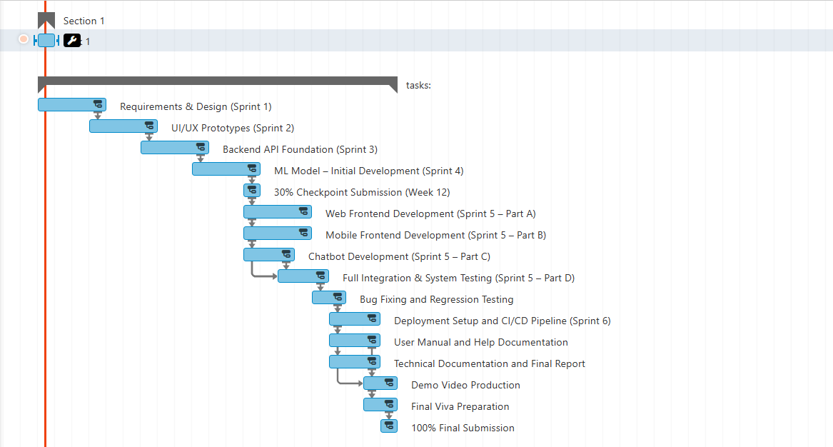

16.Mockups
The following wireframe mockups illustrate the six primary screens of Proactive AI Workspace. All mockups were designed in Figma and reflect the dark-mode aesthetic of the final implementation.
The following wireframe mockups illustrate the six primary screens of Proactive AI Workspace. All mockups were designed in Figma and reflect the dark-mode aesthetic of the final implementation.

Mockup 1: Landing Page (Hero Section)

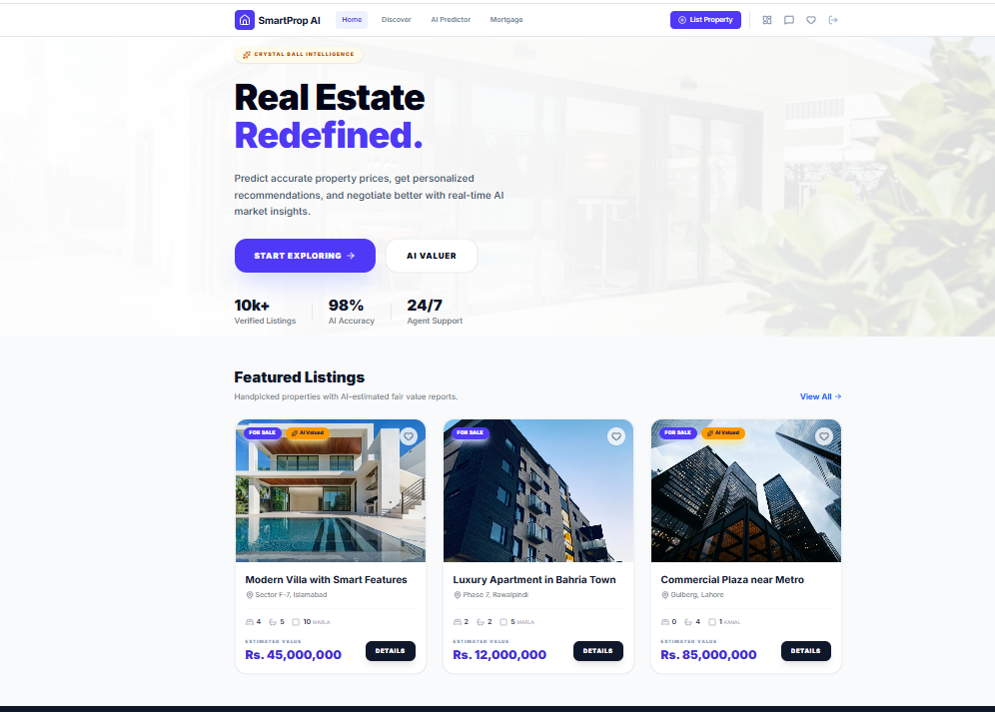

Mockup 2: Property Search Results with AI Price Overlay

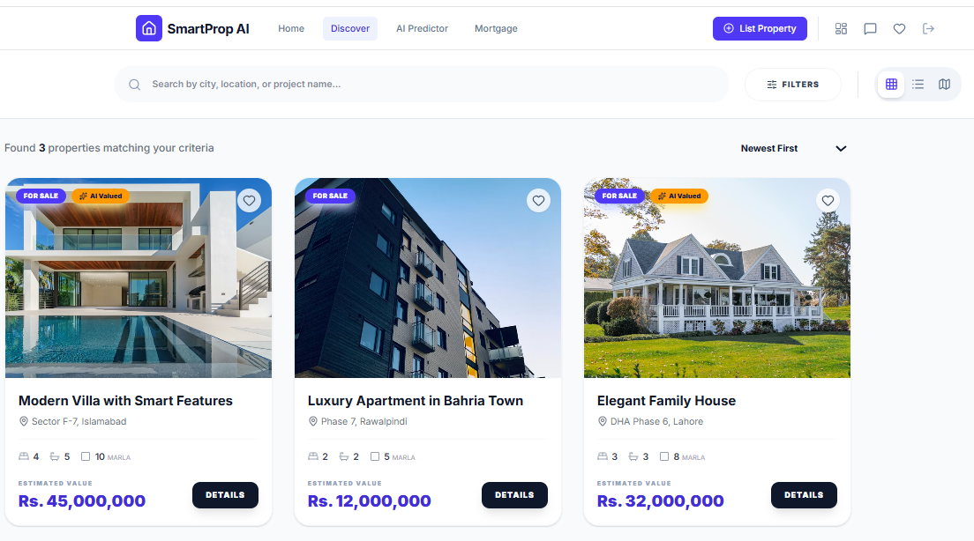

Mockup 3: listing Page

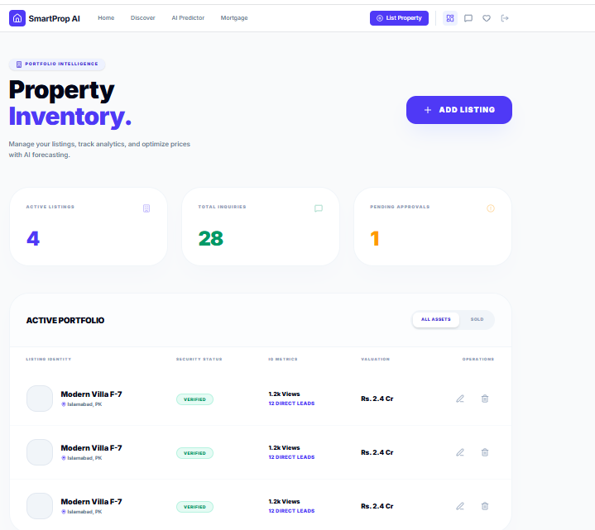

Mockup 4: AI Price Prediction Page

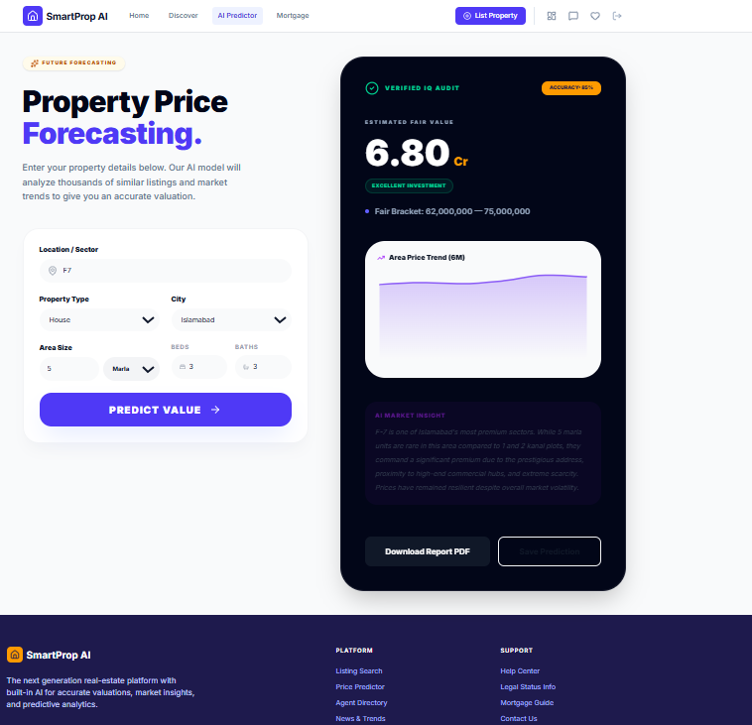

17.Conclusion

This project introduces Pakistan’s first AI-driven property price validation tool, addressing a decade-old market failure. An XGBoost model trained on 50,000+ local records provides transparent, data-backed price estimates alongside every listing — removing the information asymmetry that has long disadvantaged buyers and sellers. The platform consolidates search, mapping, mortgage calculation, messaging, and heatmaps into a single interface. Built with React, Flutter, Node.js, and Flask, the system is fully deployable and scoped for a three-student team across two semesters. Upon completion, it will demonstrate that modern AI and open-source tools can deliver measurable transparency to Pakistan’s real estate sector — a fitting contribution for a COMSATS Final Year Project.

18. References
- Kaggle, "Pakistan House Price Dataset — Zameen.com Listings," 2024. [Online].
- Mustafavi, H. (2025). Pakistan Real Estate Property Listings Dataset. Kaggle. https://www.kaggle.com/datasets/hassaanmustafavi/pakistan-real-estate-property-listings-dataset
- Federal Board of Revenue (FBR), Government of Pakistan. Property Valuation Tables for Major Cities. https://fbr.gov.pk
- Available: https://www.kaggle.com
- T. Chen and C. Guestrin, "XGBoost: A Scalable Tree Boosting System," in Proc. ACM SIGKDD, 2016.
- S. M. Lundberg and S. Lee, "A Unified Approach to Interpreting Model Predictions," in Advances in Neural Information Processing Systems (NeurIPS), 2017

